WINDOWS COMMANDLINE PART 1
The Command Line's Power:
The command line remains a powerful tool for system administrators and users, despite the GUI taking center stage. While the GUI can be convenient, it doesn’t give access to everything you need, and relying on it for certain tasks can be inefficient and error-prone.
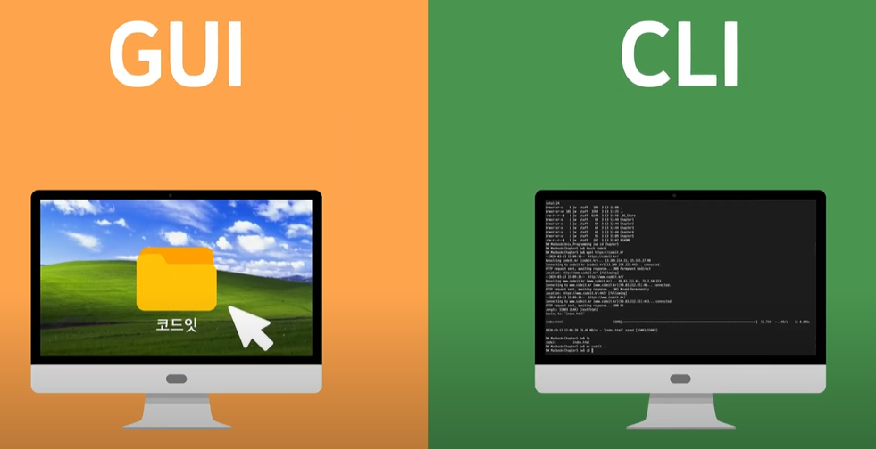
Automation and Efficiency:
The command line allows for automation of tasks, saving time and reducing the chances of mistakes. For instance, once you learn the right commands, you can execute multiple tasks quickly without repeating actions manually as you would in the GUI.


Windows PowerShell and the Command Line:
Though PowerShell is increasingly being used, the command line is still very much supported in Windows Vista. In fact, Vista introduced significant updates to the command line, and the book highlights these changes.
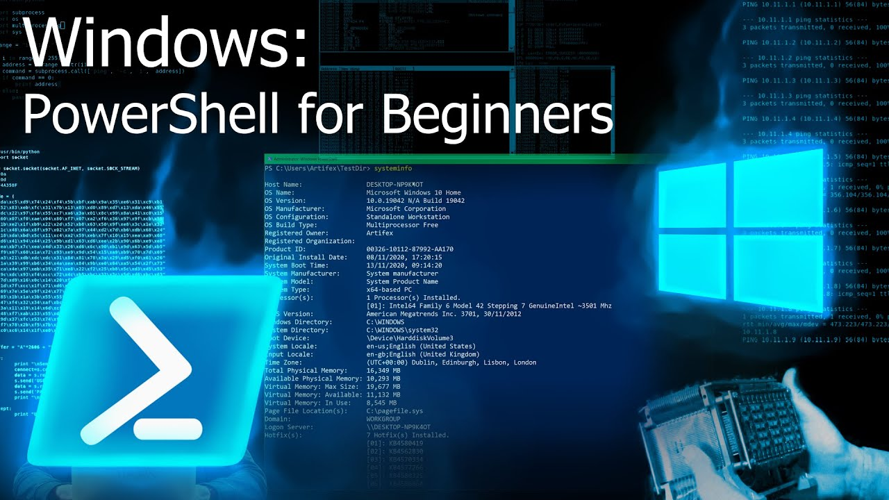
Why the Command Line is Better:
The GUI often fails in searching for specific files or tasks, especially when it comes to searching executables. Tools like the FindStr utility (explained in Chapter 4) offer high-speed searching that the GUI can’t match.
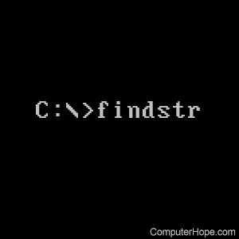

Detailed Information and Real-World Use:
The book doesn’t just teach basic command usage; it provides in-depth explanations, tips, and real-world scenarios to make the commands more useful. It’s designed for both beginners (with Chapter 1 for those new to the command line) and experienced users.
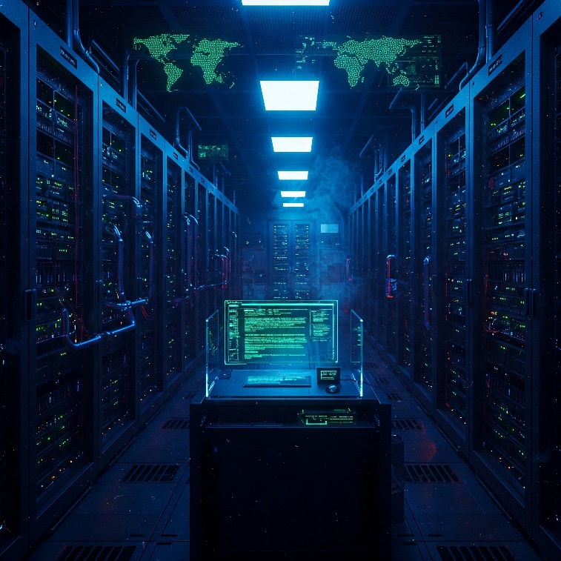
Real World Scenarios:
Each command and utility is backed by real-world stories, offering practical examples of how and why to use them, as well as potential pitfalls to watch out for.
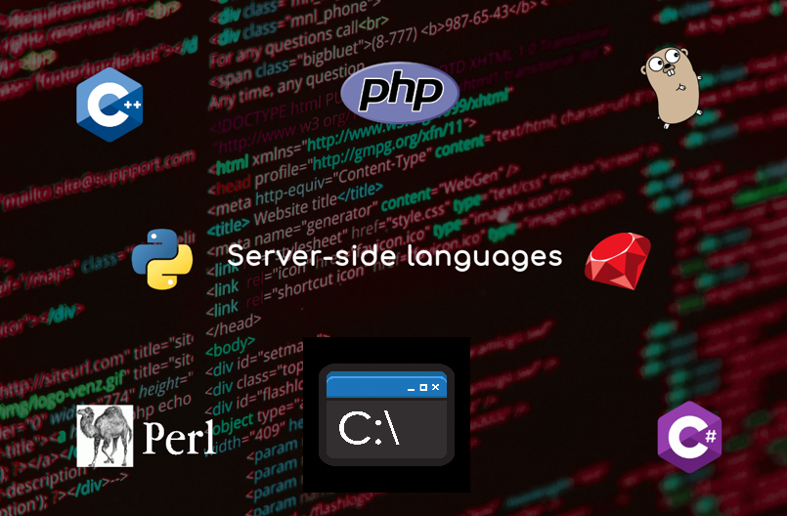
Scripts and Batch Files:
The author provides scripts and batch files based on personal experience, which readers can use or adapt for their needs. These tools are presented as real-world, tested solutions.
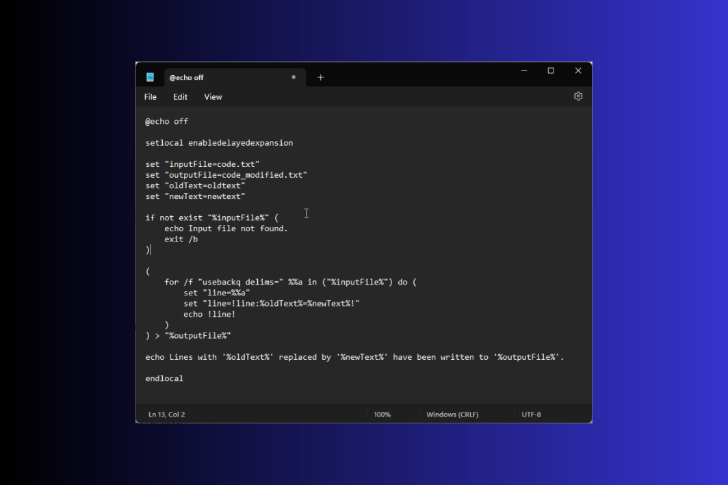

THE BOOK AND WHAT YOU’LL LEARN
Broad Appeal (Chapters 1-5):
The initial chapters are designed for anyone who uses Windows, regardless of their technical expertise. These chapters will introduce powerful command-line tools that can simplify everyday tasks.
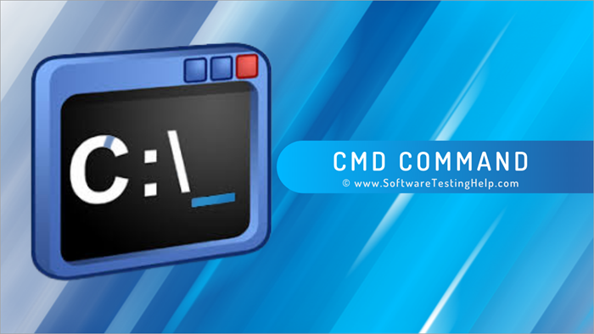
Basic Windows Knowledge Assumed:
While the early chapters are for everyone, the book assumes you have a foundational understanding of how to use Windows, such as navigating files and using basic input devices. It jumps directly into command-line usage without covering Windows basics.
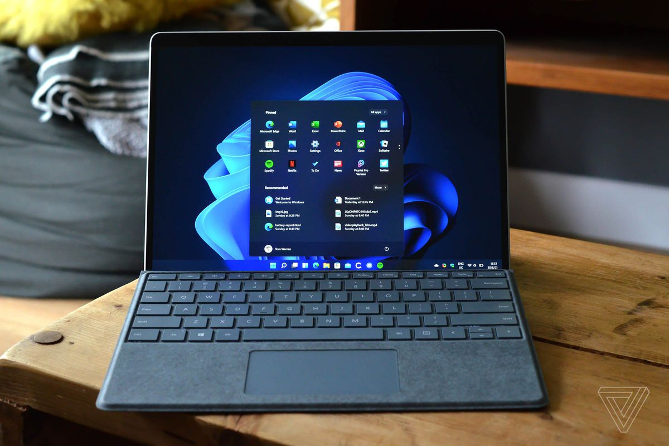
Developer and Administrator Focus (Chapters 6-17):
These chapters delve into more advanced topics specifically for developers and system administrators. This includes commands for tasks not possible in the GUI, accessing functions within DLL files, automating tasks, using helpful third-party applications, and exploring the .NET Framework (like compiling JScript).
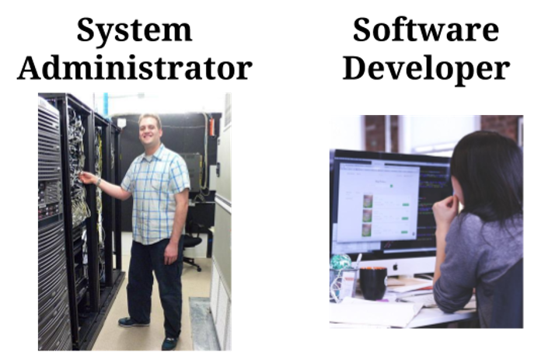

Looking Ahead to Vista and PowerShell (Chapters 18-19):
The final chapters provide a glimpse into the command-line experience in Windows Vista and introduce Windows PowerShell. PowerShell is presented as a significant advancement, offering more power, efficiency, and better security, similar to UNIX shells. It's also mentioned that PowerShell can be downloaded for older versions of Windows.
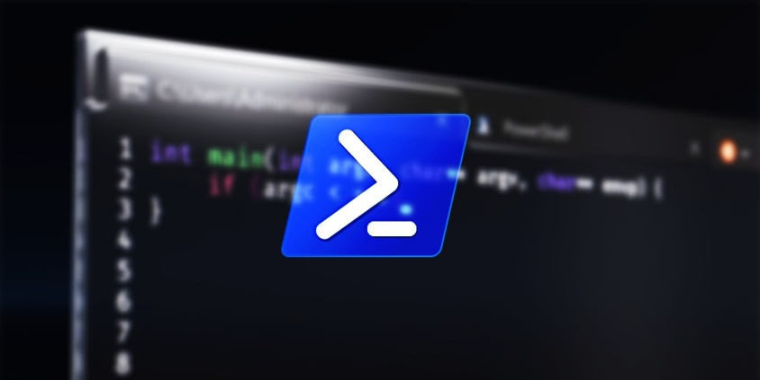

STANDARD WINDOWS UTILITIES
🔧 Standard Windows Utilities — Chapter Breakdown
Ch. 1: Using the Command Line Effectively
Ch. 2: Completing Data-Specific Tasks
Ch. 3: Discovering the System Status
Ch. 4: Locating Files & Other Resources
Ch. 5: Securing & Monitoring a System
Ch. 6: Developer & Low-Level Utilities

📘 Chapter 1: Using the Command Line Effectively
🧠 Why It Matters
- Command line = power tool. GUI = pretty but limited.
- The command line lets you work faster, automate, and make fewer mistakes.
- Many critical system features aren’t in the GUI at all—only accessible from the CLI.
🗨️ "It’s not outdated—it’s underground."

📉 Why People Dropped It
- GUI made computers more user-friendly—but it didn’t replace everything.
- Command line seems harder (syntax, memorization), but modern CLI is more scriptable and forgiving.
- Most people don't realize how much is missing from the GUI or how many tasks are easier from the CLI.

🔄 Evolution of the Command Line
- DOS: full command line days.
- Windows: GUI took over, but the command line never disappeared.
- Vista: introduced tons of new CLI tools, despite the rise of PowerShell.
⚡ This book covers ~280 command line utilities (standard + Vista-specific).

💡 What You Can Do with It
- Automate tasks with batch files or scripts (no need to remember commands every time).
- Run commands in background, on schedule, or without user input.
- Replace 3rd-party tools (especially sketchy search tools) with native ones like FindStr and Dir.

🛠️ Tools & Concepts Introduced in Chapter 1
- Viewing commands by purpose (instead of memorizing alphabetically)
- Internal vs External commands (Internal = built into cmd.exe, e.g., dir, cd; External = separate .exe files)
- Customizing the command window (font, size, colors, scrollback, etc.)
- Updating utilities via Microsoft Download Center
- Vista-specific command differences (new parameters, tools)

📌 Takeaways
- CLI is about efficiency, power, and control.
- Batch files/scripts save time and remove repetition.
- You already have a goldmine of tools on your system—this book helps you dig them out.

📌 Understanding Why the Command Line Is So Important
🖼️ A Little History
- Windows was born to:
  - Allow multitasking (DOS was one-app-at-a-time).
  - Be more “user-friendly” (no need to memorize commands).
- GUI succeeded in making interactive apps easier (word processors, dev tools).
- But many noninteractive/background tasks are still better handled with CLI.

🛠️ When GUI Just Ain’t It
- Example: Backups.
  - Should run in background.
  - Need speed, accuracy, and repeatability.
  - GUI = not ideal (you’re using files, it slows down, and not easily automated).
  - CLI = perfect (no need for user input, can run scheduled).
- CLI > GUI for automation.

🔍 Real Talk: Search is Broken in Explorer
- GUI search is slow, inaccurate, and doesn’t index everything (even on Vista).
- Want to search inside binaries or random file types? GUI fails.
- CLI tool like FindStr crushes it.
  - Searches inside any file, including executables.
  - Fast, direct, and accurate.
🕵️‍♂️ Security: What’s Actually Running?
- GUI’s Task Manager:
  - Limited view (SvcHost entries are vague).
  - Even Window’s “Services” tab helps a little.
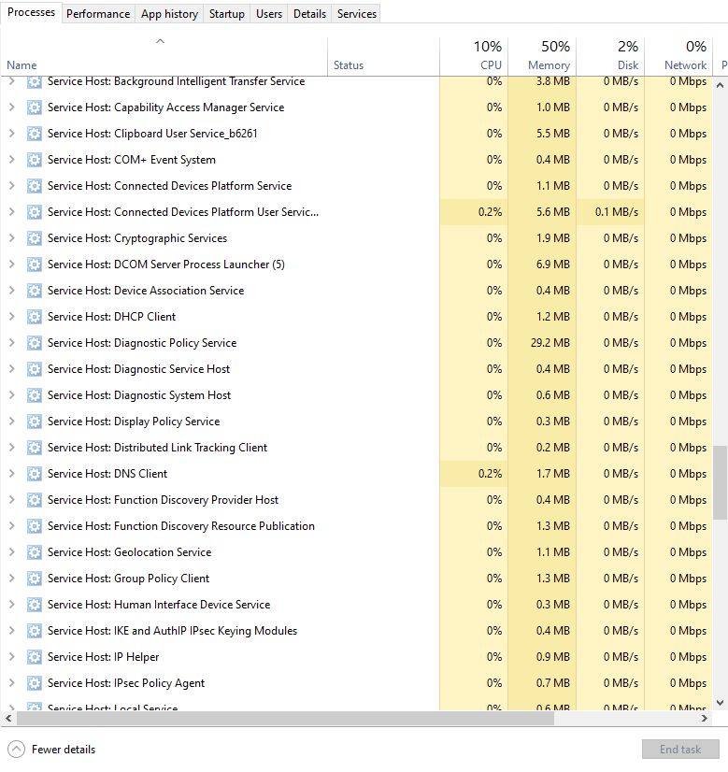

- CLI’s TaskList:
  - Shows exact services running inside each SvcHost.
  - Reveals PID (Process ID) so you can trace what's really happening.
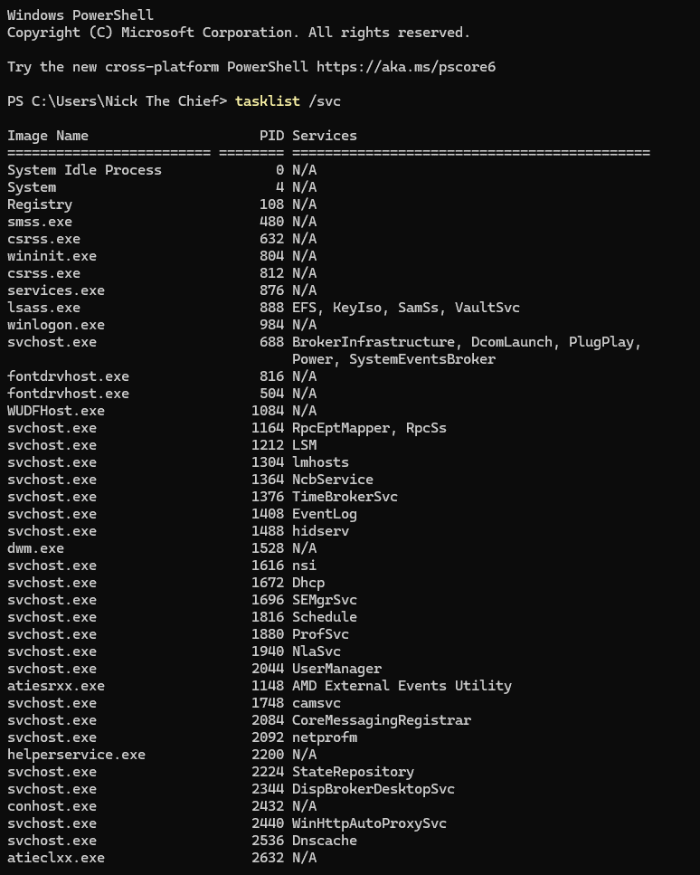
🧠 You can’t defend your system if you don’t know what it’s doing. CLI tells the truth, GUI hides it.

🧠 CLI: Your X-Ray Goggles for Windows
🌐 Network & Web Intelligence
- DNS Who? → Use CLI to resolve exact IP addresses behind friendly URLs.
  - Example: nslookup openai.com = no more guessing who’s spoofing your emails.
- Slow Internet? → Diagnose if it’s your Wi-Fi, your ISP, or a bad route on the web.
  - Tools like ping, tracert, and pathping tell the truth before you waste an hour on customer support.
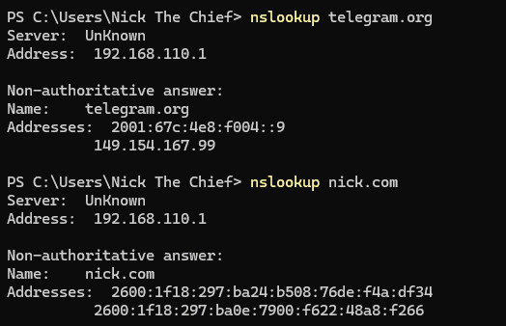
🏠 Local + Network Resource Discovery
- CLI doesn’t just talk to the web—it maps your local network too.
  - netstat, ipconfig, nbtstat, arp, and friends help you find rogue devices, hidden services, and weird traffic.
  - Forget the GUI’s “Network” tab—it only shows happy paths. CLI shows everything, including what shouldn’t be there.

💻 Deep System Visibility
- The command line sees stuff the GUI pretends doesn’t exist. You want actual disk usage? Real-time CPU info? Driver status? It's all there.
- CLI doesn’t assume what you’re trying to do—it just does what you tell it.
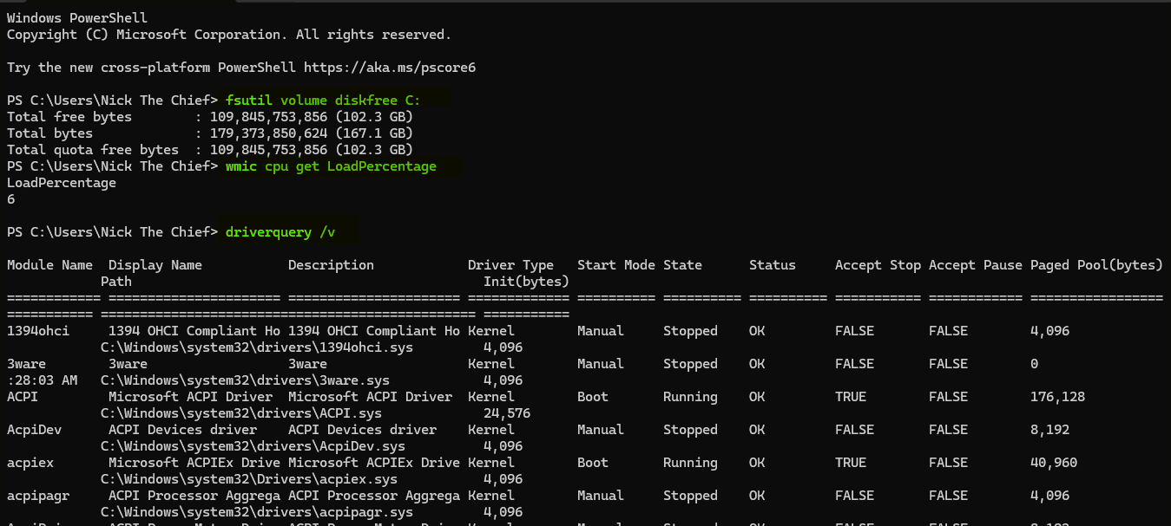

🏴‍☠️ Why CLI Is Essential (Even If You Don't Use It Daily)
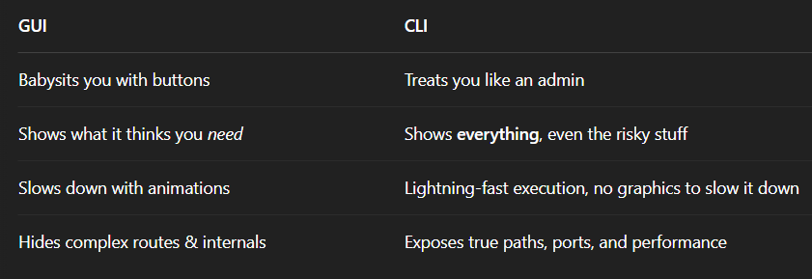
⚠️ Reality check:
If you’re serious about system security or performance, you can’t trust the GUI alone. The CLI ain’t dead. It’s just quiet. And like most quiet things in tech, it’s where the power lives. You don’t have to use it every day... but you should know it like a sidearm.
🎯 Command Line = NOT That Deep (If You Know the Vibe)
😴 What People Think the CLI Is:
“You just type a bunch of cryptic stuff, hope you don’t brick your machine, then stare at white text on a black screen like a hacker in a bad movie.”
Wrong. That’s the myth.

🚪 CLI Is Easy If You Know the Secret Knock
You don’t need to memorize commands like it’s the SAT.
You need just one trick:
🔑 Add /? to any command to get instant help.
🤯 That’s it.
- tasklist /?
- xcopy /?
- netstat /?
- shutdown /?
Almost every built-in Windows CLI tool responds to that magic switch and dumps a cheat sheet right in your terminal.
You’ll see all the options the command supports (scrollable if it's long).

🧠 Why You Should Use Commands Directly First
Yeah, scripting and batch files are cool...
But before you automate anything, you’ve gotta understand:
- What each command does
- What input it needs
- What output it gives
Once you get a few commands, stringing them together into automation is ✨child’s play✨.

⚡ Real Talk
If you know how to call a command with /? and read its output, you're already ahead of 90% of Windows users. Wanna keep the momentum going? Next up is how to view commands by purpose—so instead of guessing what tools exist, you’ll know where each one fits in the big picture (file ops, networking, diagnostics, etc.).
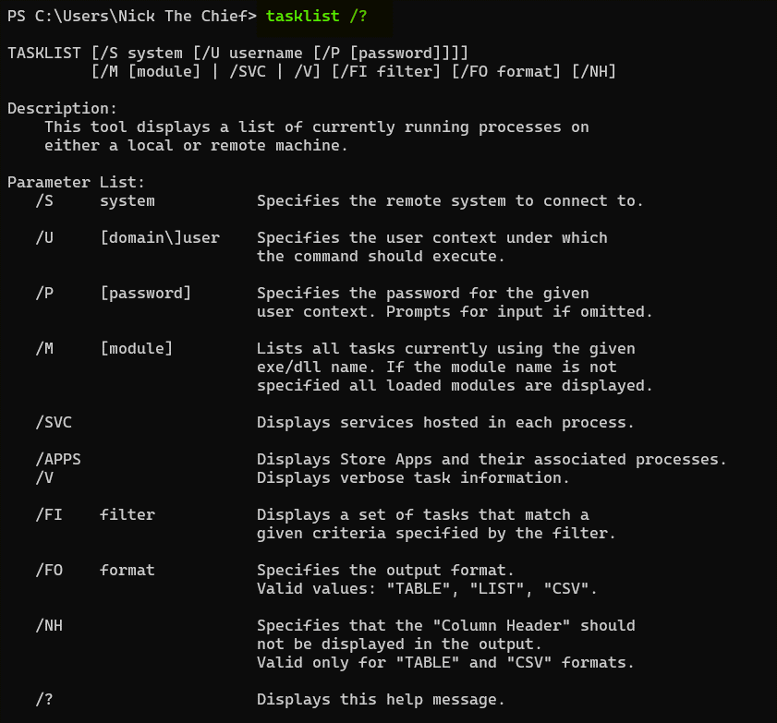
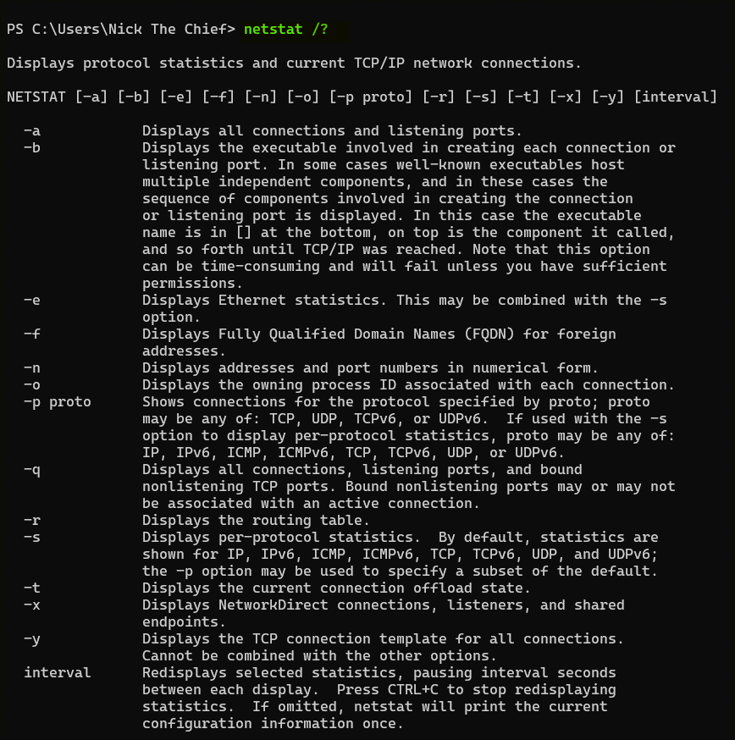

COMMANDLINE SWITCHES AND PIPES
Think of a command-line switch as an option or a modifier that you add to a command to change how it behaves or what information it displays. It's like adding extra instructions to the main command.
Switches allow you to customize the command's output or its actions. They let you be more specific about what you want the command to do.
Syntax: As the book mentioned, switches usually start with a forward slash (/) or sometimes a dash (-) followed by a letter or a word.

Dir
If you just type dir and press Enter, it will show a basic list. However, if you want to see more details, like the file size and the last modified date, you can use the /W switch (for "wide" format) or the /A switch (to display files with specific attributes). So, Dir /W would show a wider listing, and Dir /A:H would show hidden files.
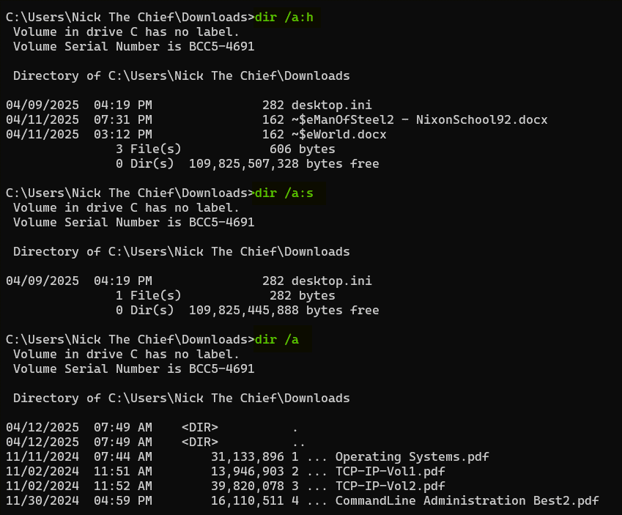
Pipes (|):
A pipe is a symbol (|) used on the command line to send the output of one command as the input to another command. It's like creating a connection between two commands, where the first command's result becomes what the second command works with.
Let's say you want to see a list of all the files in a directory, but you only want to see the ones that contain the word "Gemini" in their name.
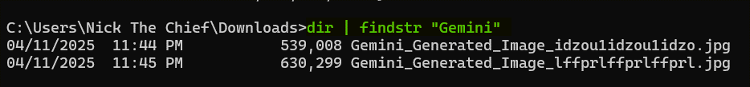
Switches modify the behavior of a single command. Use / or -
Pipes connect the output of one command to the input of another, allowing you to chain commands together for more complex operations. Use |

⚡ COMMAND LINE SYNTAX
Most Windows CLI commands follow this format:
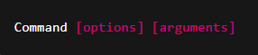
Understanding Optional Parameters (Square Brackets [ ])
In command syntax, square brackets [ ] mean that the enclosed parameter is optional—you can include it or omit it.

Example:

Means:
You can run just tasklist with or without options. Some might might misinterpret it as you write the command with the brackets, which is wrong, there’s nothing like writing the commands with brackets included. It means:
- Or add /S system (optional).
- If you use /S, you can optionally add /U username.
- If you use /U, you can optionally add /P password.
The square brackets ([ ]) are just documentation syntax — not something you actually write. They mean, “This part is optional.” They do not mean “copy me into your command.”

✅ Correct Ways to Run It:
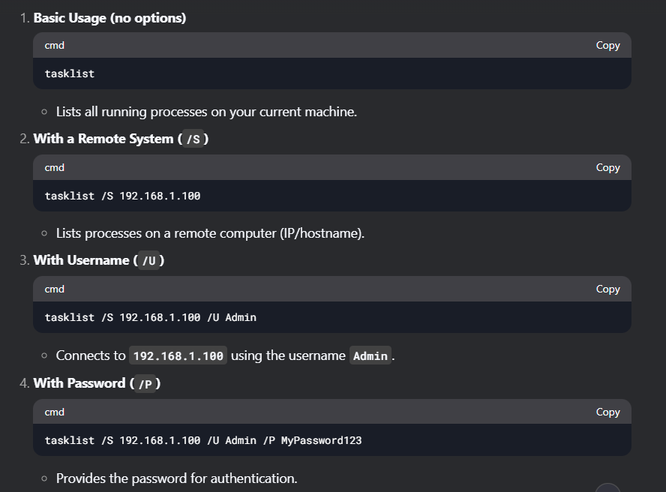
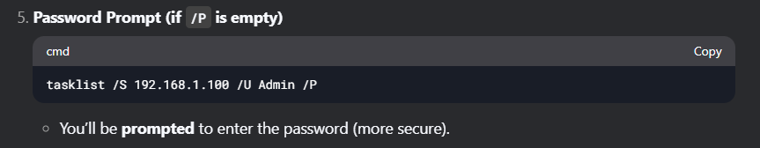
You can do this with Virtual Machines which is a simpler way to explore. Let’s do it, I have some VMs ready.
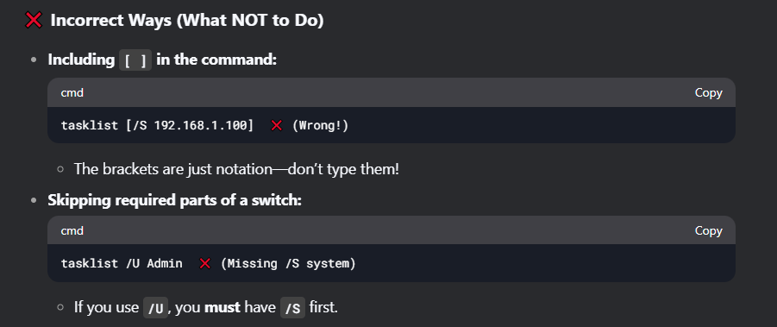
- [ ] means Optional switch(include or exclude as needed).
- Never type [ ] in the actual command.
- Order matters!
  - /S must come before /U.
  - /U must come before /P.
- If /P has no password, you’ll be prompted.
- Windows prefers /, not - like Linux.
- But PowerShell often accepts both.

PARAMETERS
Parameters are just values you provide to a command without using a / or – flag like in switches. They tell the command what to act upon.
Certain command-line commands accept a drive letter (followed by a colon, like D:) as a parameter to specify which storage location the command should operate on.
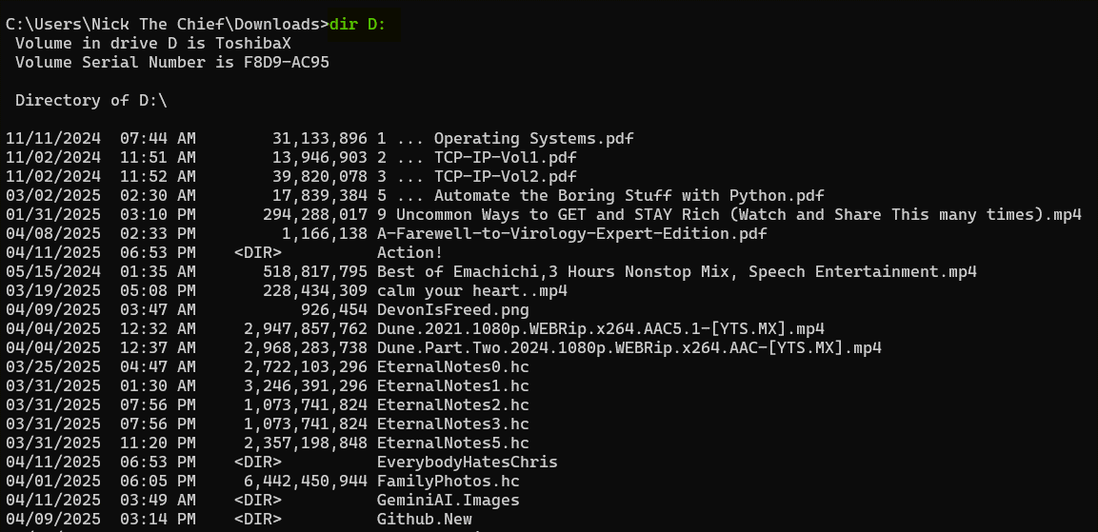
Here, D: is the parameter telling the cd command where you want to go.
If you want to see the files and folders at the root of your D: drive, you can use:
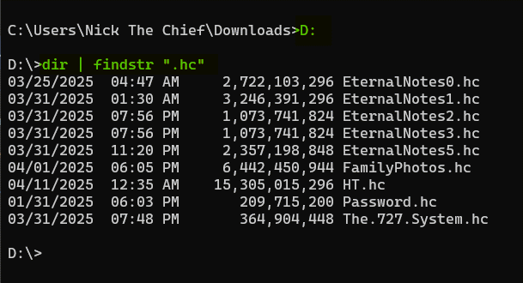

✅ Good Starter Commands to Try `/?” On
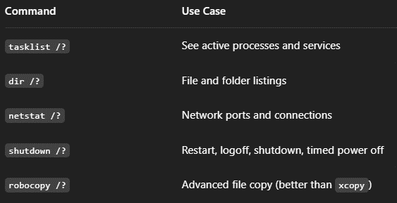
Back to parameters (Values we pass to the actual commands).
1. Path Parameters

No / is used—just the raw path.

2. Filename/Extension Parameter
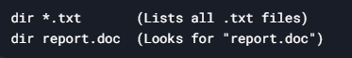
*.txt and report.doc are parameters (filtering files).

3. Drive Letter Parameter
D:\ is a parameter (the drive to scan).

🧾 Key Differences Between Parameters and Switches
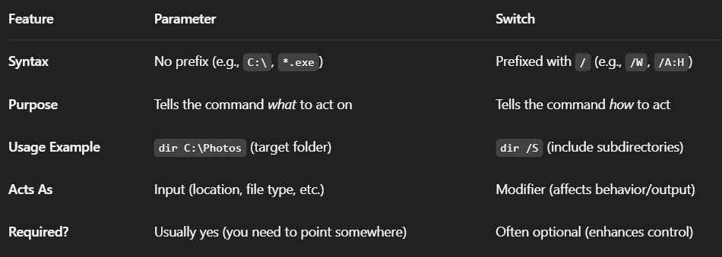
🧠 Quick Breakdown: Parameters vs. Switches in CMD
🔥 Parameters
- What they are: The where or what the command is working on.
- Purpose: They give the command the actual value or target it should operate on.
- Think of them as: The destination you're pointing to.
- Example:
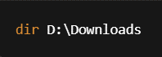
➤ “Show me what’s inside the Downloads folder.”
🧭 Parameter = destination.

🔥 Switches
- What they are: The how the command should behave.
- Purpose: They modify or enhance what the command does.
- Think of them as: The tools you bring with you to the destination.
- Example:
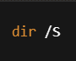
➤ “Include subfolders when listing files.”
🛠️ Switch = tools you bring with you.

✅ Put Together:
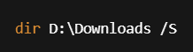
➤ “List everything in Downloads, including all its subfolders.”

WHY USE BATCH FILES? 📂
Batch files aren't just some relic from the MS-DOS era—they're still super useful for people who want to automate repetitive tasks without writing full-blown scripts or programs.
The author’s point is pretty clear: remembering every command and its switches is annoying.
Batch files act like your personal memory vault—they store complex or frequently-used command sequences so you don’t have to.
You write a command once, store it in a .bat file, and from then on? You just double-click or run the file from the command line. Done. ✅

✍️ What Is a Batch File, technically?
- A batch file is just a plain text file with the extension .bat or .cmd.
- It contains a list of command line commands that execute in order.
- You can open and edit them in any text editor (e.g., Notepad, Notepad++).

📌 Real-World Example
Let’s say you have to check the running processes on a remote computer every morning.
Typing this out every time:
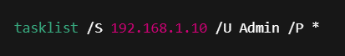
But you can write a batch script:
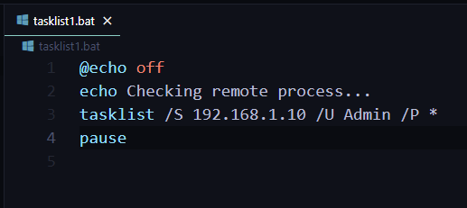
Now every time you run that file, it:
- Runs the command.
- Prompts for the password.
- Pauses so you can read the output.
Boom. 2 seconds of work.

🧠 What Makes Batch Files Special?
- No need for fancy compilers or runtimes. They run directly through cmd.exe.
- Flexible. You can add logic like IF, GOTO, and FOR to make them dynamic.
- Portable. You can carry them on a flash drive and run them on any Windows machine.
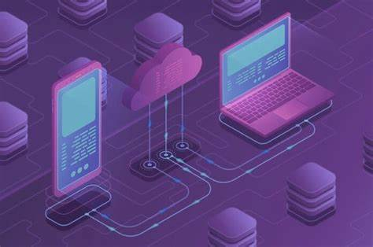
⚠️ Gotchas to Keep in Mind
- They're powerful, but not secure. Anyone can open the file and see your commands (and potentially passwords, if you store them).
- Limited error handling. If something fails mid-execution, you may not always get clear feedback.
- Not great for long-term scripting. If you need complexity or interaction, you might outgrow batch files and want PowerShell or Python.
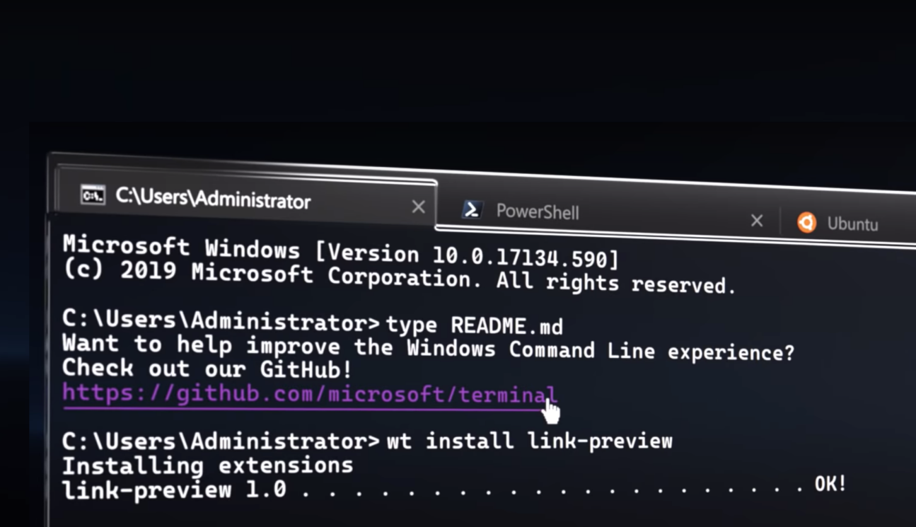
🧩 Coming Soon: Chapter 7 – Deep Dive into Batch Files
That chapter will show you:
- How to use variables in batch files.
- Conditional logic (yes, IF statements).
- Looping over files or input.
- Making them interactive (e.g., user input).
But we ain’t there yet. Still, this section plants the seed. Start thinking about commands you repeat—those are prime batch file material.

🧠 Writing Scripts — What’s the Big Deal?
Scripts are like batch files' smarter older siblings. They're still not “real” applications, but they can:
- Handle more logic (loops, conditionals, variables)
- Access Windows APIs or features directly (e.g., WMI, Active Directory)
- Work with objects, not just raw text or command output
- Be reused and maintained more easily
Batch files? Great for quick automation.
Scripts? Great when you want the OS to actually help you do smarter stuff.
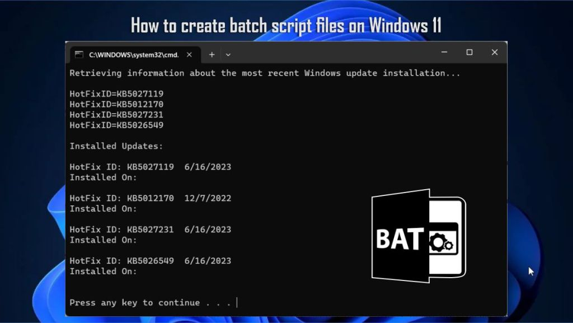
💡 What's a Script?
A script is a file written in a scripting language that gets run by a script interpreter. Windows ships with interpreters for:
- VBScript (Visual Basic Scripting Edition): .vbs
- JScript (Microsoft’s version of JavaScript): .js
- PowerShell (The king now): .ps1
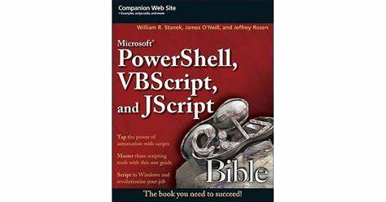
Each of these lets you do more than batch files ever could. Think:
- Reading from files.
- Creating GUIs.
- Interacting with Windows services.
- Querying network info, system health, etc.

📦 What You Get from Scripting (vs Batch)
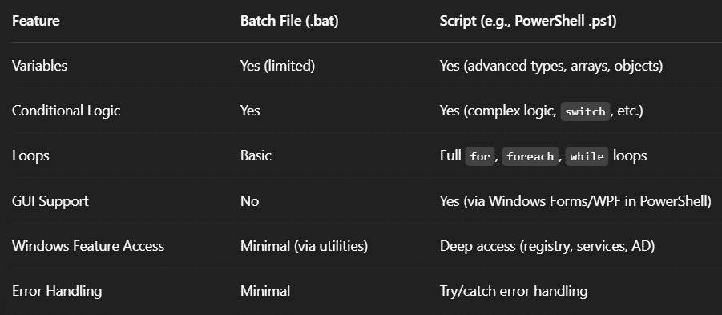
⚙️ Script Interpreter
Unlike batch files, scripts need an interpreter:
- .vbs → Run with wscript.exe or cscript.exe
- .ps1 → Run with powershell.exe or pwsh (PowerShell Core)
- .js → Also cscript.exe (yep, Microsoft’s JScript engine)

Example (PowerShell script):
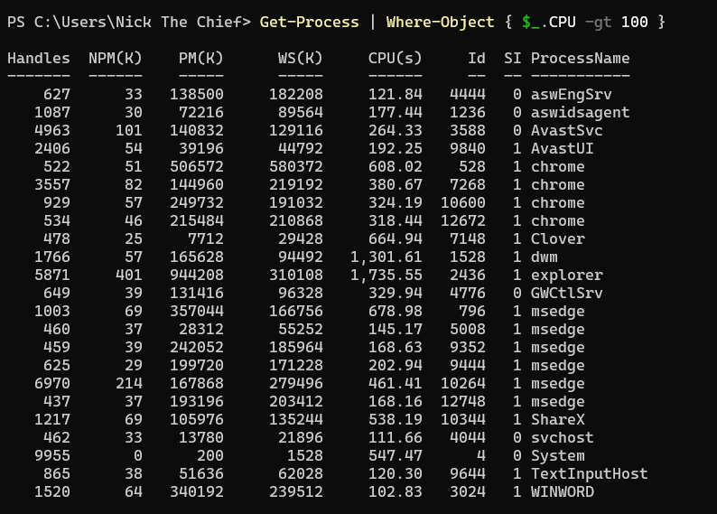
Get a list of all the running processes, and then filter that list to show only the processes where the CPU usage is greater than 100.
Here's a breakdown of each row (Not a must you know this stuff for now):
- Handles: This column shows the number of handles that the process has opened. Handles are references to system resources like files, registry keys, and other objects that the process is using. A high number of handles might indicate a process is doing a lot of work or has a resource leak in some cases.
- NPM(K): This stands for Non-Paged Memory (Kilobytes). This is the amount of virtual memory that the process has allocated and cannot be written to disk. It's memory that must stay in RAM.
- PM(K): This stands for Paged Memory (Kilobytes). This is the amount of virtual memory that the process has allocated and can be written to disk (to the page file) if RAM is needed for other processes.
- WS(K): This stands for Working Set (Kilobytes). This is the amount of physical RAM that the process is currently using. It's a subset of the paged and non-paged memory that is actively in use and residing in the computer's physical memory.
- CPU(s): As we discussed, this stands for CPU Time (seconds). It's the total amount of CPU time that the process has accumulated since it started running.
- Id: This is the Process Identifier (PID). It's a unique number assigned by the operating system to each running process. You can use this ID to specifically identify and manage a process.
- SI: This stands for Session ID. It indicates the session in which the process is running. For example, session 0 is usually for system services, while other sessions are for logged-in user accounts.
- ProcessName: This is the name of the executable file that started the process (e.g., chrome.exe, explorer.exe, AvastSvc.exe).

