Kali Linux VM: Task 1.4P

Name of Student

Institutional Affiliation

**Task 1**

The home directory is root

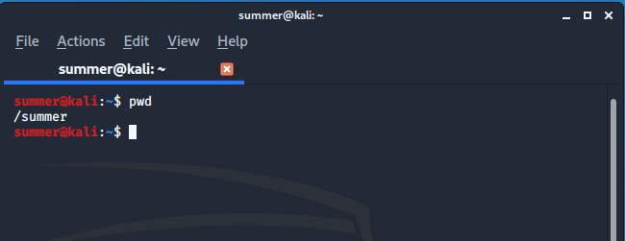

**Task 2**

Running commands:

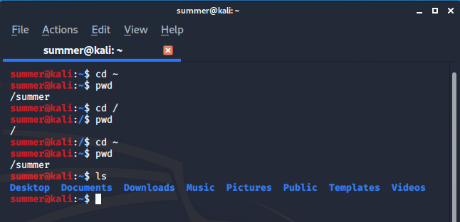

**Task 3**

Running commands:

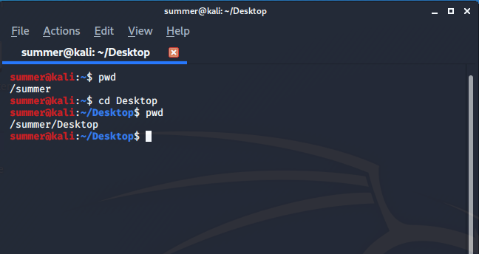

**Task 4**

Running commands:

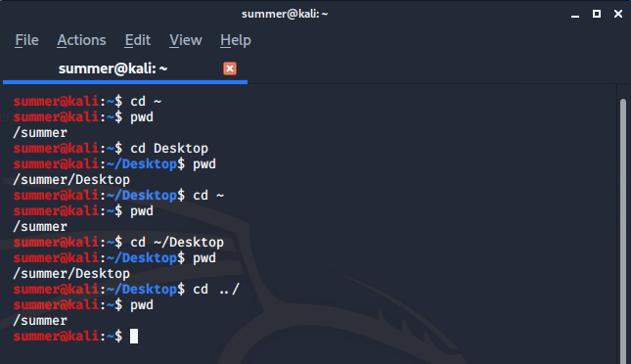

**Task 5**

Running commands:

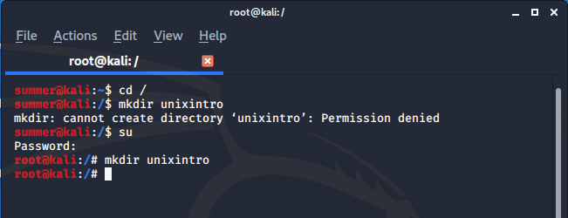

In order to create the directory, one has to switch to the root account. This is done by using the su command and then inputting the password.

**Task 6**

Running commands:

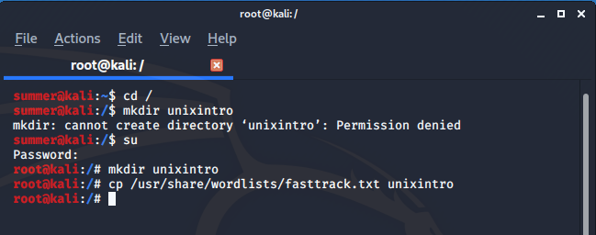

**Task 7**

Running commands:

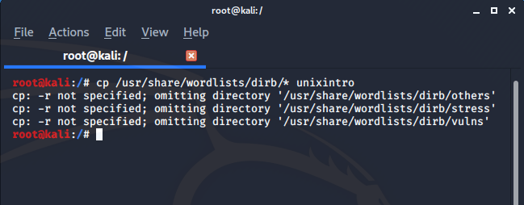

**Task 8**

Running commands:

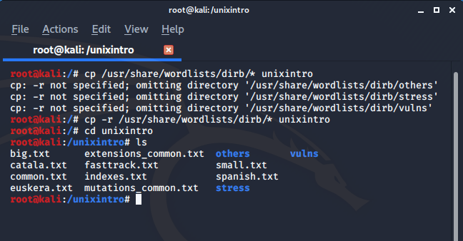

**Task 8**

1. Moving file into subdirectory:

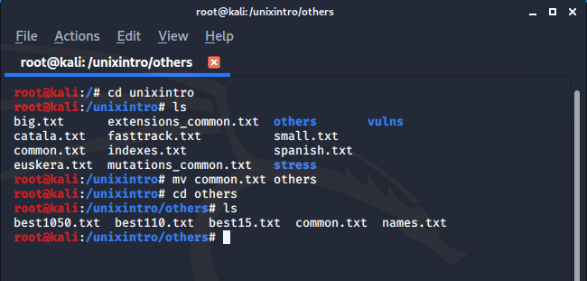

1. Listing and deleting the file

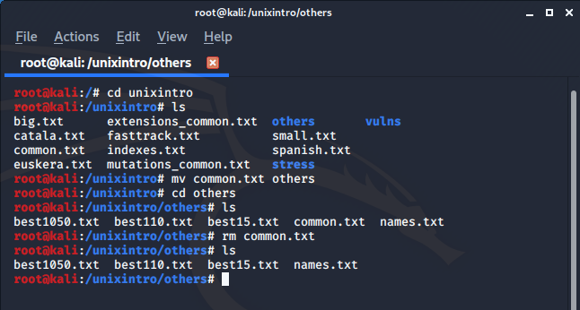

**Task 10: The Linux Kernel**

The Linux kernel represents the key component of the OS and the central link between the hardware and processes of a device. It interacts as easily as possible between the two. The kernel is called because it resides inside the OS, equivalent to a seed inside a hard shell, which handles all the main hardware functions. The Linux kernel serves as a translator with the aid of system drivers that enables communication between the software and the hardware user interface. Since the Linux kernel controls all of our hardware and software's interactions, it can control our system's functions.

**Task 11: Reflection**

Kali Linux offers both a GUI and a command line interface to perform certain commands. However, the command line interface provides more control over system and administrative functions. There are multiple commands which enable a user to change and edit the system as preferred. This lesson was important to aid me in working with Kali Linux and understanding the commands as well as operating a virtual machine.