Task 4.1P

Student Name

Institutional Affiliation

**Question 1**

**1.**

**A.**

**1)**

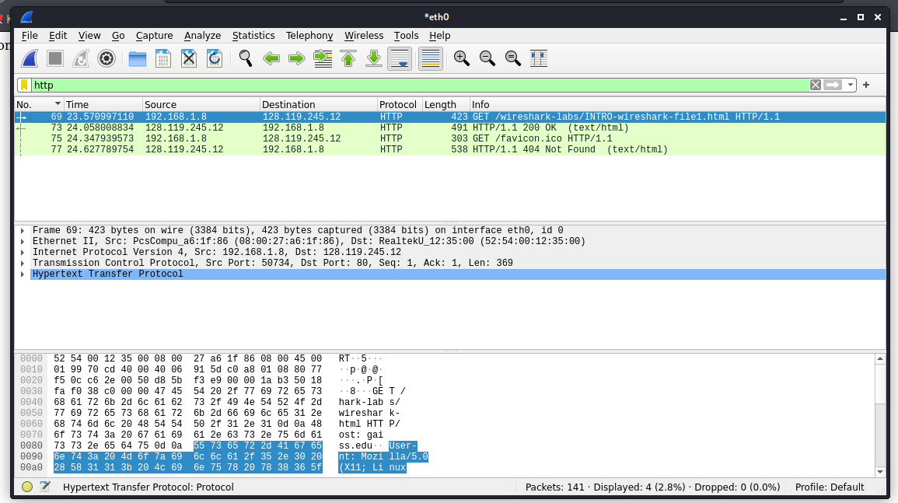

**2)**

What is the Internet address of the gaia.cs.umass.edu (also known as www-net.cs.umass.edu)?

128.119.245.12

What is the Internet address of your computer?

192.168.1.8

**3. Check the packet details for HTTP Get message (refer to `Details of the selected packet’ section of Wireshark window).**

**What type of Web browser issued the HTTP request?**

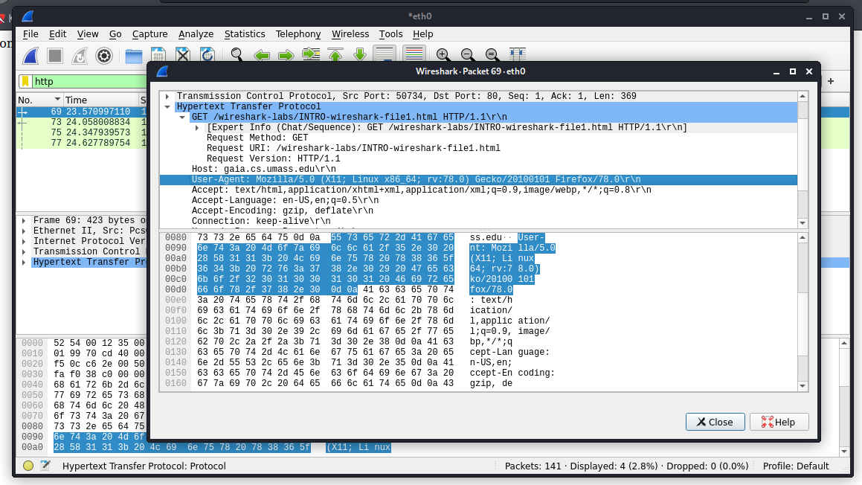

Mozilla Firefox

**4. What is the destination port number (Hint: the number following “Dest Port:” for the TCP segment containing the HTTP request) to which this HTTP request is being sent?**

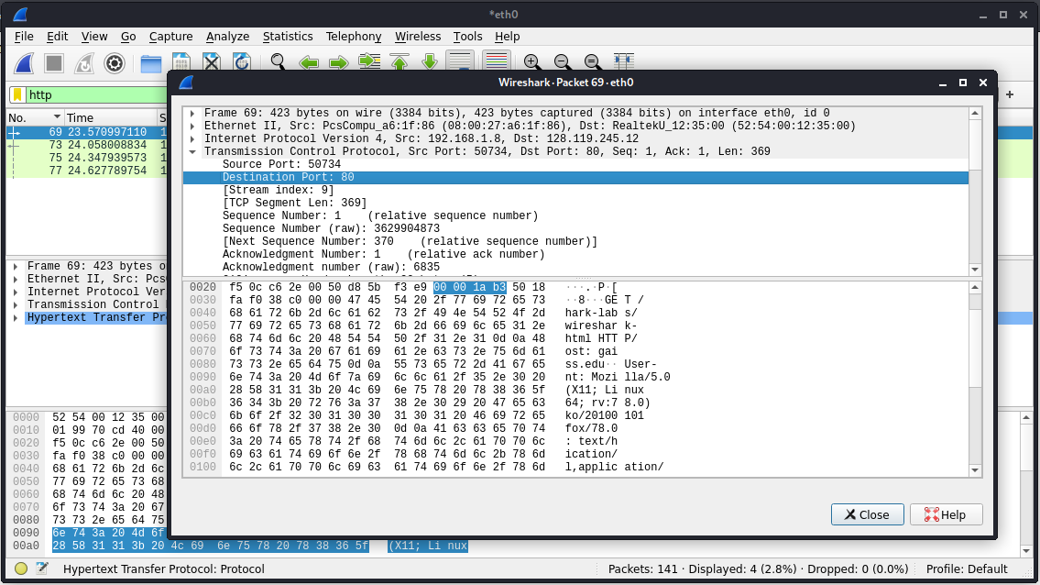

Destination Port: 80

**What is the source port number?**

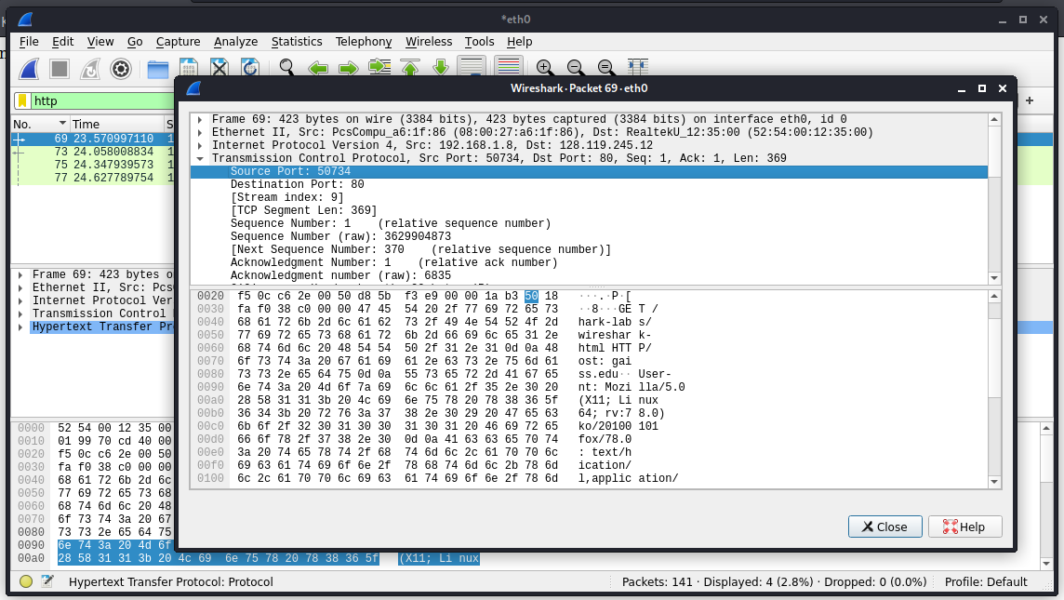

Source Port: 50734

HTTP was also referred to in Module 1 of Week 4.

1. What is HTTP used for in the world wide web?

HTTP is the basic 'language' used by web browsers and servers. WWW represents the World Wide Web and is mostly used as a prefix. WWW is the compilation of hyperlinked documents which can be viewed on web browsers

2. At what network-layer is HTTP located?

The application layer.

3. What is an HTTP request? What is included in a typical HTTP request?

As an intermediate method between client/application and server, HTTP requests are used. The client sends an HTTP request to the server and the server sends back a response after the message has been internalized. The response includes details on the status of the application.

4. What is an HTTP method? how do Get and Post methods differ.

HTTP methods show the actions that you want a particular resource to perform. While these request methods may also be nouns, often they are referred to as HTTP verbs. - of them has a different semantic, but a group of them share some similar characteristics.

5. What is an HTTP response? What is included in a typical HTTP response?

HTTP response status codes show whether a particular HTTP request has been completed successfully.

6. Is HTTP a stateless or a stateful protocol?

HTTP is a protocol that is stateless. This means that an HTTP server does not have a status tracking .

C. You were introduced to Denial-of-Service Attacks in Module 2 of Week 4. 1. Can HTTP be used to execute a DoS attack?

HTTP, DNS, and TCP/IP requests are common protocols used for DDoS attacks.

**Question 2**

A. What is the server’s response (status code and phrase) in response to the initial HTTP GET message from your browser? (i.e., before you provided the credentials)

GET /wireshark-labs/protected_pages/HTTP-wireshark-file5.html HTTP/1.1\r\n

B. Include a screenshot of the Wireshark window showing the relevant packet and its details.

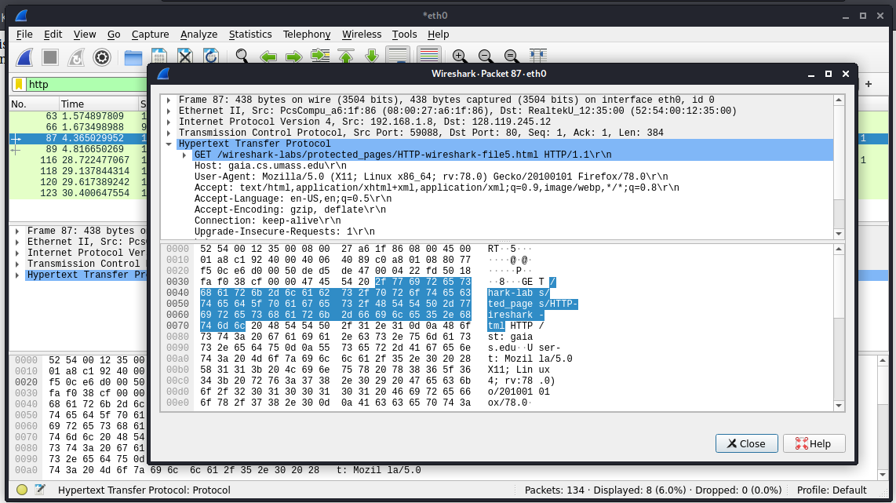

B. Was does “Connection: keep-alive” mean in Hypertext Transfer Protocol of HTTP GET message?

HTTP keep-alive is an instruction that enables a single TCP link to stay open to many HTTP requests and responses, a.k.a. persistent HTTP connection.

C. The packet length for HTTP GET message is showing as 506 bytes (if yours is different assume it was meant to be 506 bytes). How many bits is 506 bytes?

4048 bits

What is the difference between bit and byte?

A bit is the smallest unit of computer information. It's basically a single binary data point; on or off, up or down, either yes or no. On the other hand, a byte is an 8-bit memory device.

**Question 3**

A. Was techpanda.org using Base64 encoding?

Yes, encoding is used.

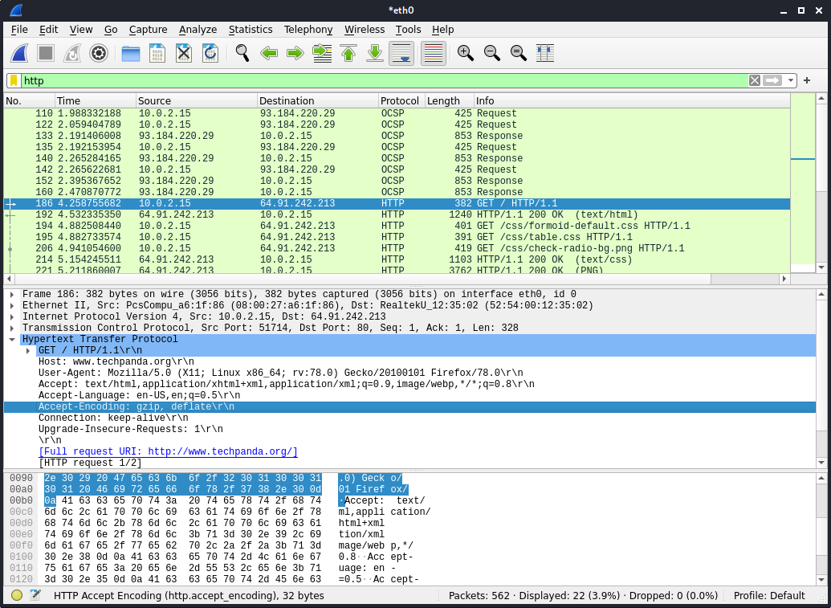

B. Did you find the password in an HTTP GET or POST message? Yes. Why? The data can be easily decoded.

C. Include a screenshot of Wireshark window that shows the packet with Email and Password you used (i.e., the email and password should be clearly visible in packet details section of Wireshark.)

