Task 4.2C

Student Name

Institutional Affiliation

**Question 1**

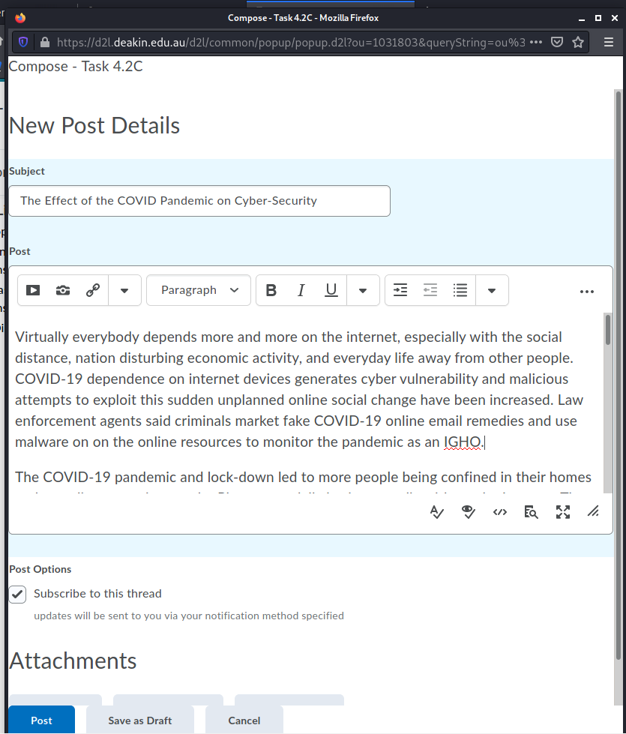

**Question 2**

Reflection point – Did you expect communication to be a success factor in this field?

Yes

As you continue your studies, how do you plan to further enhance your professional communication skills for your future career success?

Group discussion and communication helps you as a student to learn about and debate about the topic, to articulate your thoughts on serious issues and in formal situations. It enhances your ability to think, listen and speak. It encourages your degree of trust as well. It is a powerful tool to resolve problems, make decisions and evaluate personality. GD competencies can guarantee academic achievement, popularity and successful acceptance or work offering. It is therefore critical that we can participate effectively and confidently in a GD. Participants should be able to speak confidently, demonstrate their leadership skills and achieve the objectives.

**References**

Andreasson, K. J. (2020). Cybersecurity: Public Sector Threats and Responses. CRC Press.

Bourgeois, D. T. (2019). Information Systems for Business and Beyond. Saylor Foundation.

Capella, L. (2020). Cybersecurity Lessons From the COVID-19 Pandemic: How to Keep Yourself and Your Family Safe when Working, Learning, and Socializing Online. Amazon Digital Services LLC.