

ITECH 2001

Assignment part-B



September 6, 2020

student id:30381529

MIT-Federation university

Contents

High concept statement: 2

Game genre: 2

Highlights and hooks: 2

Story and settings: 3

Characters: 3

Mechanics: 5

➢ Rules: 5

➢ Skills: 5

➢ Actions: 6

➢ Time: 6

➢ Space: 6

➢ Object: 6

➢ Chance: 6

Design of level: 6

Prototype scope: 7

Game design concepts:

# High concept statement:

The name of game I am going to design is “The last escape”. I have thought this name because this game is related to escaping the princess from the monster. Basically, the story is about a princess from Geneva, who had been kidnapped by one of the monster. She is one of the prettiest girl who is really beautiful and attractive. So, in this game the king of Geneva had issued the notice which is about rescuing the princess from the monster. So, whoever will escape the princess from monster will get the biggest opportunity to marry king’s daughter. So, this offer is accepted by one of the brave person named “Gorkhe” who is from a common village living a simple life. Here, the monster had made a maze and kept the princess in a cage. The monster had kept a flying dragon which will try to protect the cage by throwing fire form mouth to the enemy which is guarding the cage. In this game to reach the final stage, one should collect at least “5 keys” out of 10 from different part of the maze. The most interesting thing while collecting the key is that he needs to solve the puzzle in which time limitation is being initiated. At last, the collected keys will be used to enter to the final stage and to escape the princess from a cage, the dragon had to be defeated which is only done by gun and the game will over.

# Game genre:

Talking about the genre, I have been inspired from one of the best adventurous and fighting game i.e. “Harry potter”. I thought it will be interesting for me too create a game which will be quite similar to one of the best games of all time i.e. “Harry potter”. I have seen most of the people aged between 16-24 are mainly interested in playing adventurous and fighting game. So, after evaluating this, I thought to make a similar game which will be fun to play as well as challenging to the players. The game consists of full entertainment because whoever will play this game have to come with broad mind. The player needs to find the way to reach each level and the most challenging thing is that the game is based on time limitation. Each level consists of solving puzzle which will be challenging as well as interesting to play. So, the player unable to complete the level in given time will result in elimination.

# Highlights and hooks:

Finding each level, solving puzzle, Time limitation, defeating dragon are the main obstacle being initiated in this game. The game scenario will be dark with little lightning due to this game will be much more interesting to play and player will have fear in their find while playing this game. The game will consist of 10 levels in which one should complete 5 levels to reach the final stage. To reach final stage one should collect the “key and gun” which is only provided after completing 5 levels. At last, the dragon had to be defeated to escape the princess from a cage.

# Story and settings:

The game begins when the princess from Geneva will be kidnapped by one of the monster. The monster also like the princess and also want to take revenge with king of Geneva. As the king had destroyed the habitat of the monster as well as had killed the family members. So, the main story begins from here. To escape the princess, the main character in the story will be played by “Gorkhe” who is brave and clever as well. He had promised the king to bring his daughter safely. The dragon is much stronger to be defeated, so “gorkhe” needs to come with brilliant strategy to get victory over the dragon.

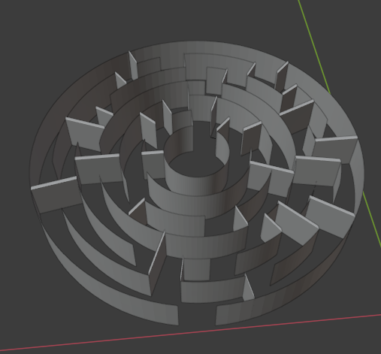 This game will be built in utility which will be in 3 dimensions i.e. 3D game. The graphics will be dark which makes game more interesting which will provide thrilling experience in the game. This is first player adventurous and strategy game which will consist of unlimited fun, scary moments and amazing experience.

# Characters:

* Princess:

She is one of the important character in this game. As the overall game is based on her story. She had been kidnapped by one of the monster and had kept in cage at the Centre of the well designed maze. Also, the cage is also being guarded by powerful dragon.



Source: <https://images.app.goo.gl/8r9vNFBdkLoCrUDbA>

* Gorkhe:

“Gorkhe” is the main character of this game because he has to escape the princess from a cage which is surrounded by a dragon and also need to survive with in the game. completing each level will not be so easy for him so it will be more challenging and thriller to complete the game. He is a simple boy from a common village who is brave and clever. In the game, he had took the responsibility to escape the princess from the cruel monster.

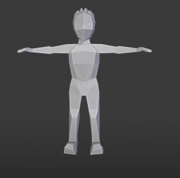

* Dragon:

It is one of the powerful flying fighter like a bird, which is taking command of monster to safeguard the cage from enemy. The dragon had to look after the princess so if anyone try to protect the princess will have to defeat to dragon which will be huge challenge and frightening.

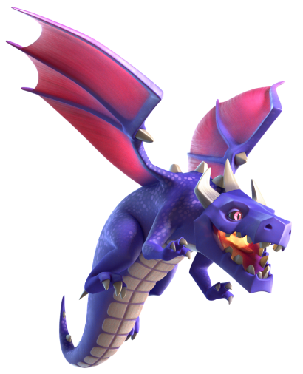

Source: <https://images.app.goo.gl/r4yAixS9MhWMBPmp8>

# Mechanics:

## Rules:

A set of rules is an important guide in any types of games which tells you how to continue with your next course of action. A game is said to be good if it has well planned rules, and similarly, it is determined how well we play the game by how well we obey the rules. What's so interesting about many of today's games is that there are sometimes no instruction books included — yet we know how to play them somehow. The Rules provide competition with an agreement of understanding. Here in this game there will also exist certain rules and regulation. Without any rules there will be no value of playing any game. considering this thing, the rules are provided below:

* Only one player can play at a time.
* Out of 10 puzzle 5 should be completed.
* Time limitation will be provided in each puzzle.
* 5 keys need to be collected to unlock weapon i.e. gun
* The dragon has to be defeated.

## Skills:

Each player playing this game has to come up with his own mindset. So, this can be recognized as personal skill. Certain skills such as solving puzzle, time management, shooting is really important in this game. If anyone has this kind of skill in themselves then it will be plus point for them to complete the game in given time. As the level increases the difficulty level also increases so it will be challenging for them who don’t have this kind of personal skills.

## Actions:

The main thing in the game is to defeat the dragon. Here, each player had to fight with dragon. For this, player will be provided gun with certain ammo. So, if any player misses the shot while shooting the dragon will result the particular player in elimination because the damage will not be sufficient to defeat the dragon with less ammo. Therefore, each player needs to keep this thing in mind while playing this game.

## Time:

Time limitation is one of the main aspects in this game. Every player has to keep in his/her mind that no one can continue the game after reaching the time limit. There will be function such as pause but you won’t be able to save the game and continue from the same place or same level.

## Space:

This game will be built in utility which will be in 3 dimensions. Basically, the surrounding will be wall covered and there will be little space for player to move. The design of the maze will be interesting as the game will be played in dark theme with little light. So, this will also provide horror sight and thrilling experience to the players.

## Object:

Considering the objects in this game there will be different obstacles in a way where play will perform the regular game. obstacles such as boxes will be kept in the maze in which the player has to jump over it and also need to roll down if obstacle is kept in upside in which player cannot go through. Also, there will be doors which need to be broken down by players themselves without the help of any weapon.

## Chance:

It all depends on game play of each player how he/she is going to continue the game. If he/she has ability to use the personal skills such as using mind to tackle the obstacle and solving puzzle is equally important. Beside this shooting skills will contribute a lot to get victory over the dragon. So, this game is based on personal skills, time management and also depends upon luck i.e. how fast he/she is going to find the different level. Hence, as a viewer it will be interesting to play this game which will provide unlimited fun as well as thrilling experience too.

# Design of level:

There will be 10 levels in this game out of which 5 needs to be completed to enter to the final stage. It has built with 10 levels in order to make this game more interesting because there will be hope in players mind that if he/ she cannot finish one level then he/she will have another chance to complete another level. In each level timer will be set so, every player has to complete each level in given time otherwise the game will be over if 5 levels are not completed. The 10 levels are all about solving puzzle which will be quite challenging but will provide unlimited fun. The final stage is about defeating the dragon which is only possible by shooting with the help of gun. Hence, completing all levels will result in victory and can able to escape the princess.

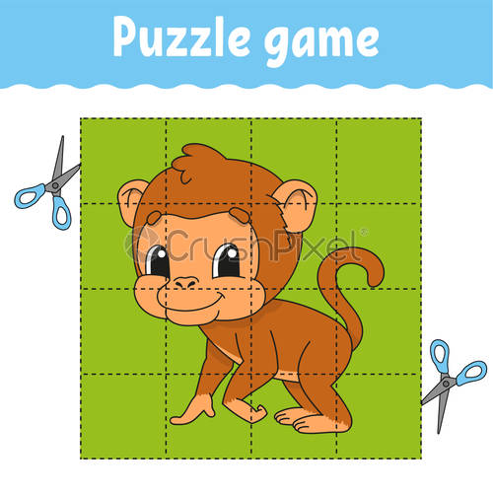

Source: https://images.app.goo.gl/1SzJCUGvJM4tZzXUA

# Prototype scope:

Basically, this game will start with a quick demo providing the rules of the game. it will show different levels of the game and the control setting to perform the game. It will give the overview of last level i.e. getting weapon and killing dragon with the help of weapon and finally, unlocking the cage with the help of a key and escaping the princess from a cage. The main components used in this game are characters, timer, obstacles, different levels and weapons. So, the game begins when a player reaches to the shadow part with a focus light on it. At last after the completion of the game it will say, “Thank you for escaping the princess”. Hence, this is a background information of my prototype which I am going to build in utility for upcoming project.