**Skincare Routine**

by:

Rianne Shiane Sangban

Renz Joshua Romano

Nhorie Lyn Pangilinan

Hanter John Ison

Ejay Serrano

Sir John Frederick Leabres

ITE 306 Adviser

Date Submitted: October 30, 2022

1. **Description of the Project**

Skin care is a range of practices that support skin integrity, enhance its appearance, and relieve skin condition. This are some common skin problem such as dark circle, dark spots, eye bags, dry skin, oily skin, dull skin, redness, large pores, rough texture, hormonal acne, blackheads. A skincare routine involves the step you take to care for your skin regularly. And since people have different skin concerns, it stands to reason that this routine looks different for everyone. Incorrect skin care will damage your skin barrier that cause skin diseases include clog or damage skin as well as skin cancer, as well as incorrect used of product can add more damage in your skin.

1. **Statement of the problem**

**General problem**

* The general problem of this study is on how to develop a website that will guide the user’s the right skincare routine.

**Specific Problem**

* How to choose the right product?
* What will happen when they choose the wrong products?
* How these website help the user’s?

1. **Objectives of the problem**

**General objectives**

* This project aims to develop a website that will help people in choosing the right product for their skin type.

**Specific Objectives**

* To develop a website that will help to choose the right skincare product.
* To develop a website that will show the proper step in skin
* To develop a website to help people about their skincare problem.

1. **Significance of the project**

* **To the user**

-This website will help the user to know their skin type and also gain knowledge in choosing the right product.

* **To the company**

-This website will help the company to advertise their product.

* **To the programmer**

-This website helps them to improve their skills and knowledge.

1. **Scope and Limitation**

* **Scope**

-This website proposal will be confined to giving the step-by-step of skincare routine, and as well as the right product for your skin type.

* **Limitation**

-This website is exclusive for educational purpose only.

1. **Site Structure**
2. **User Flow Diagram**

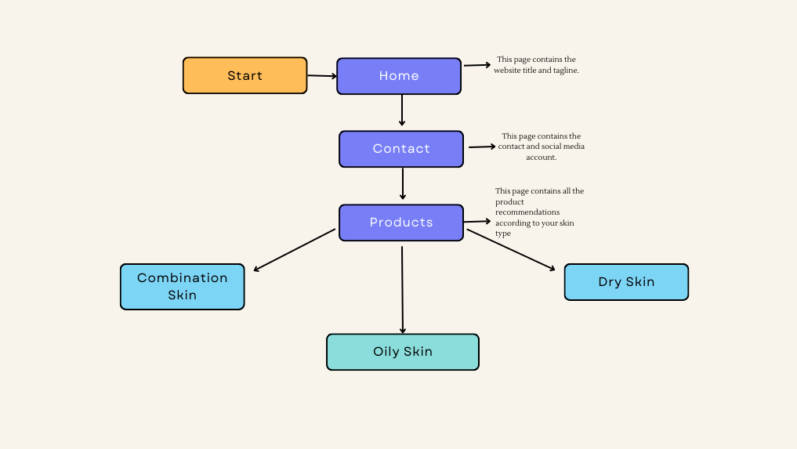

1. **Webpage Templates Design**

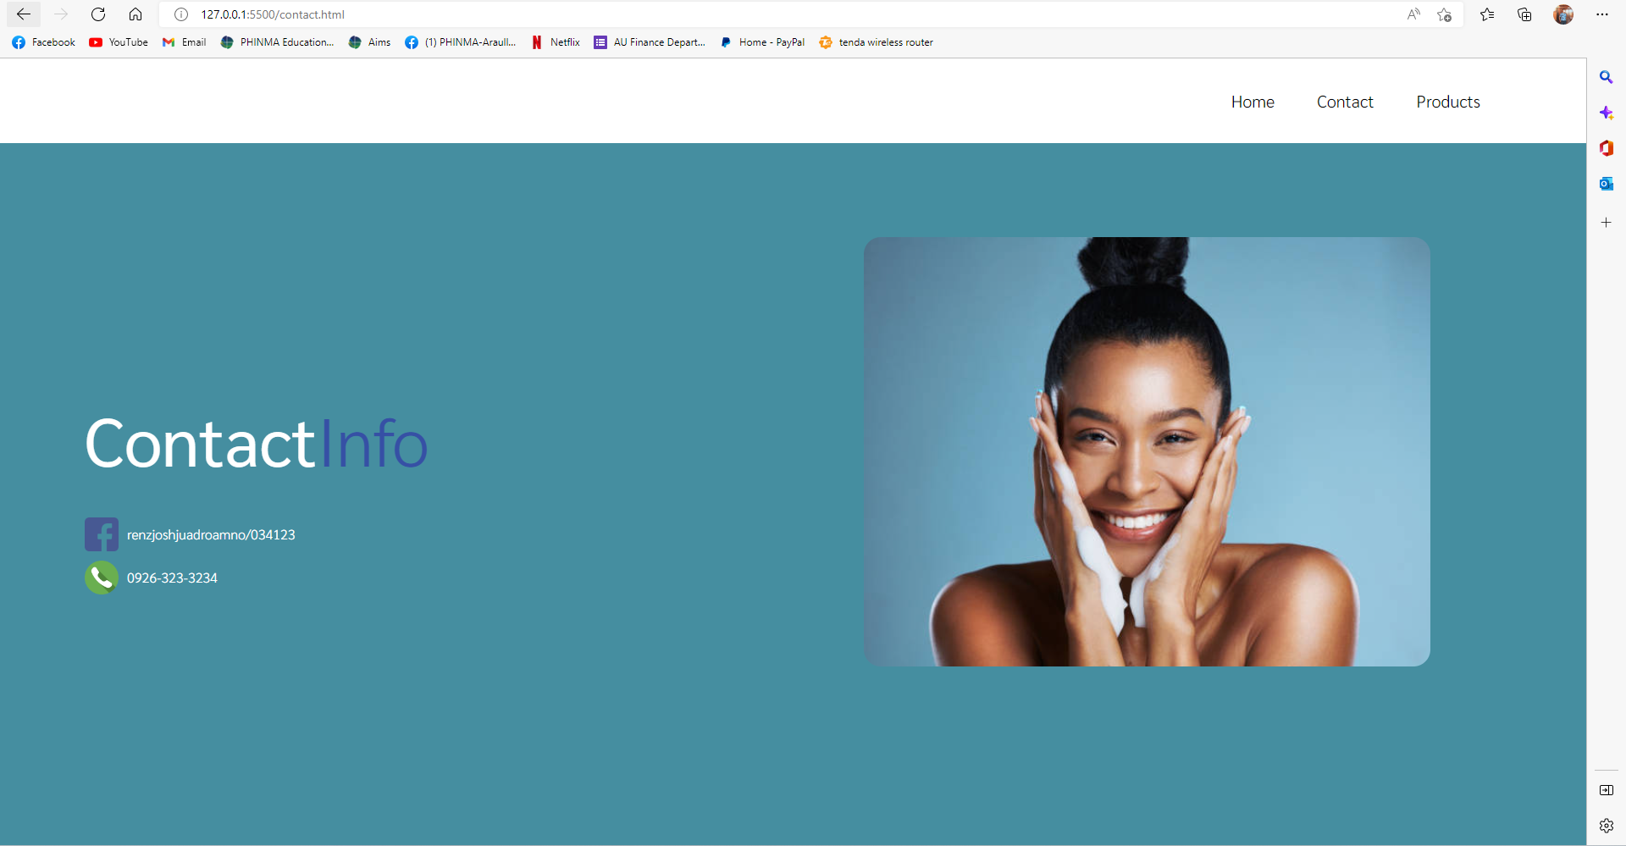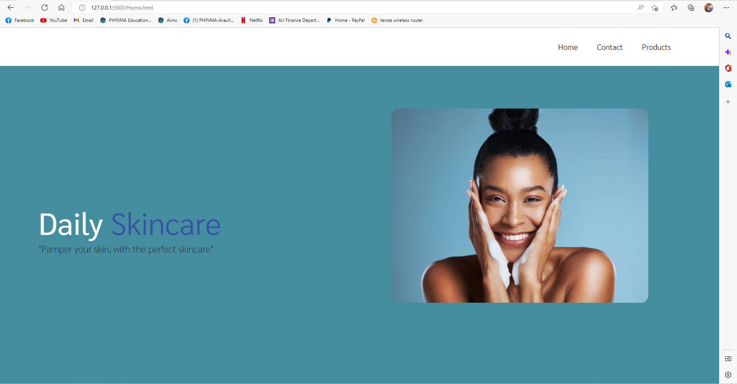

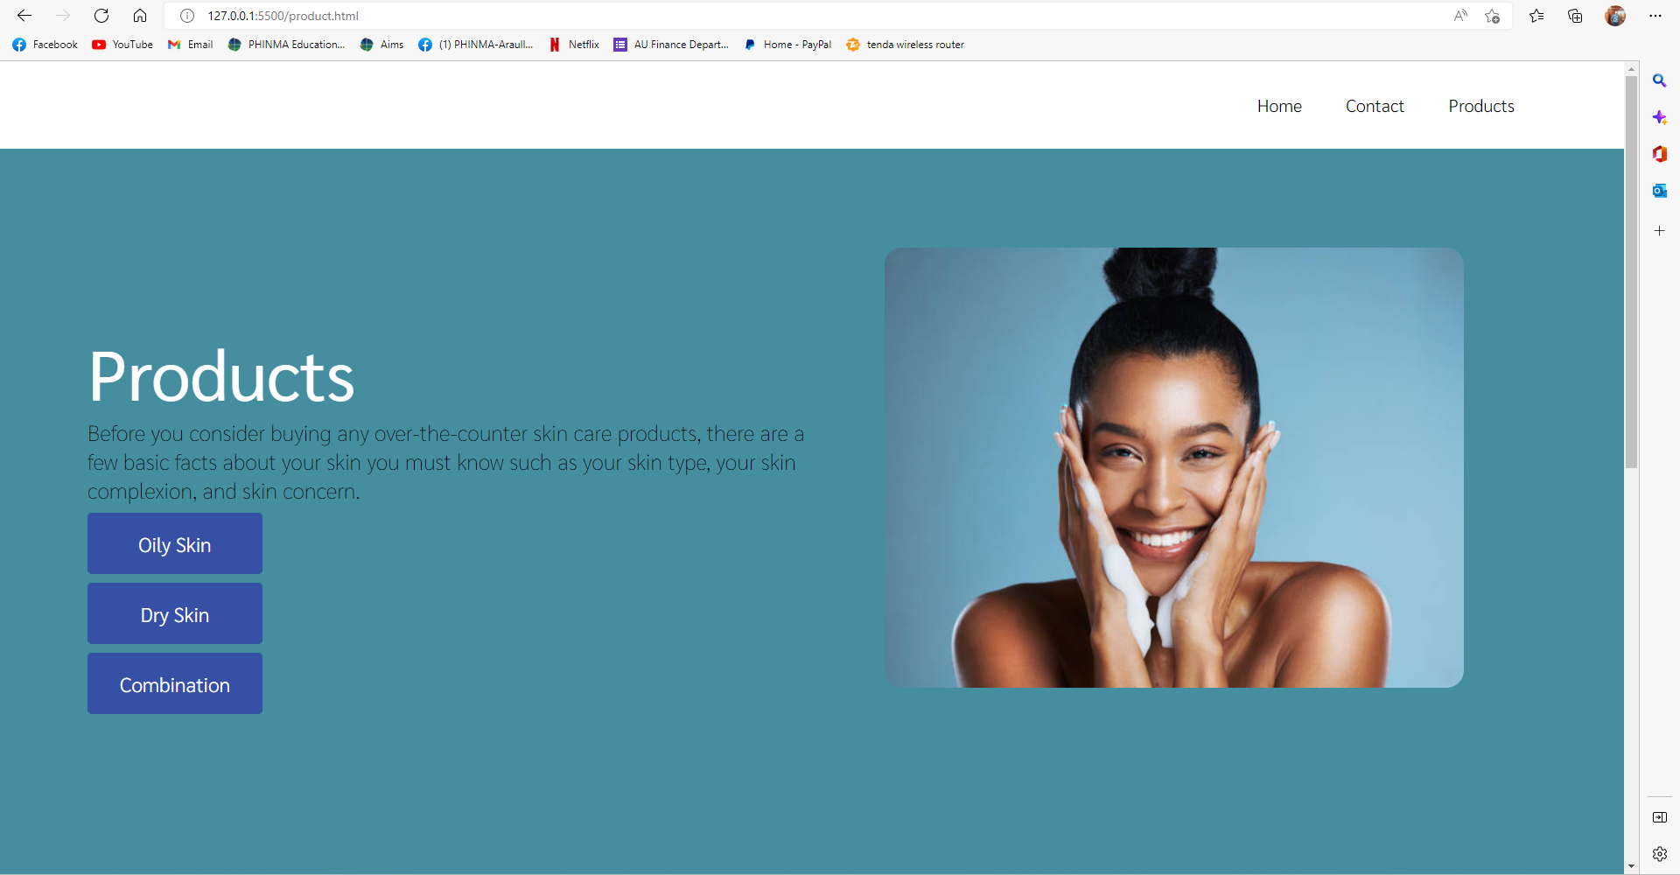



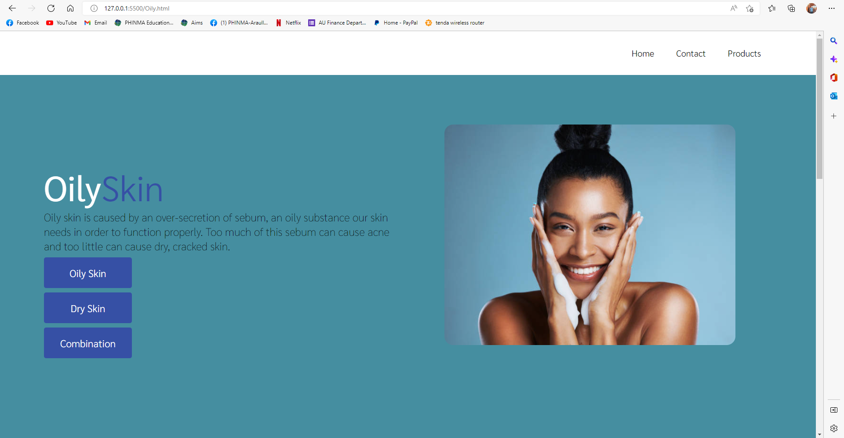

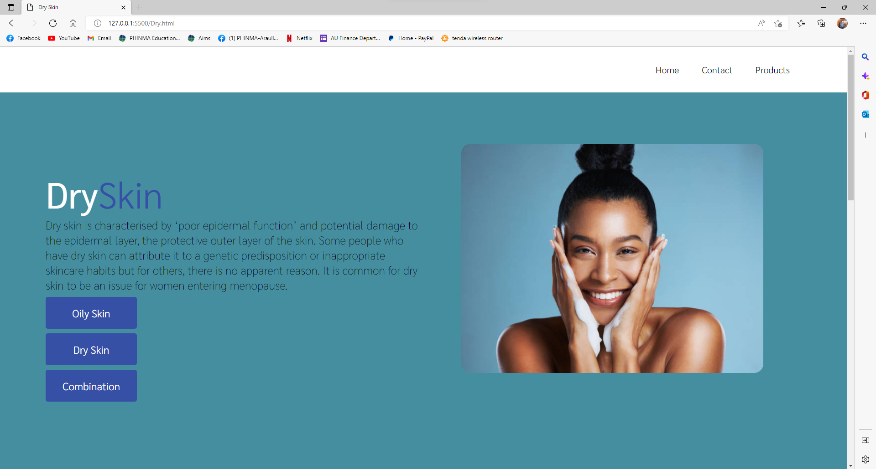

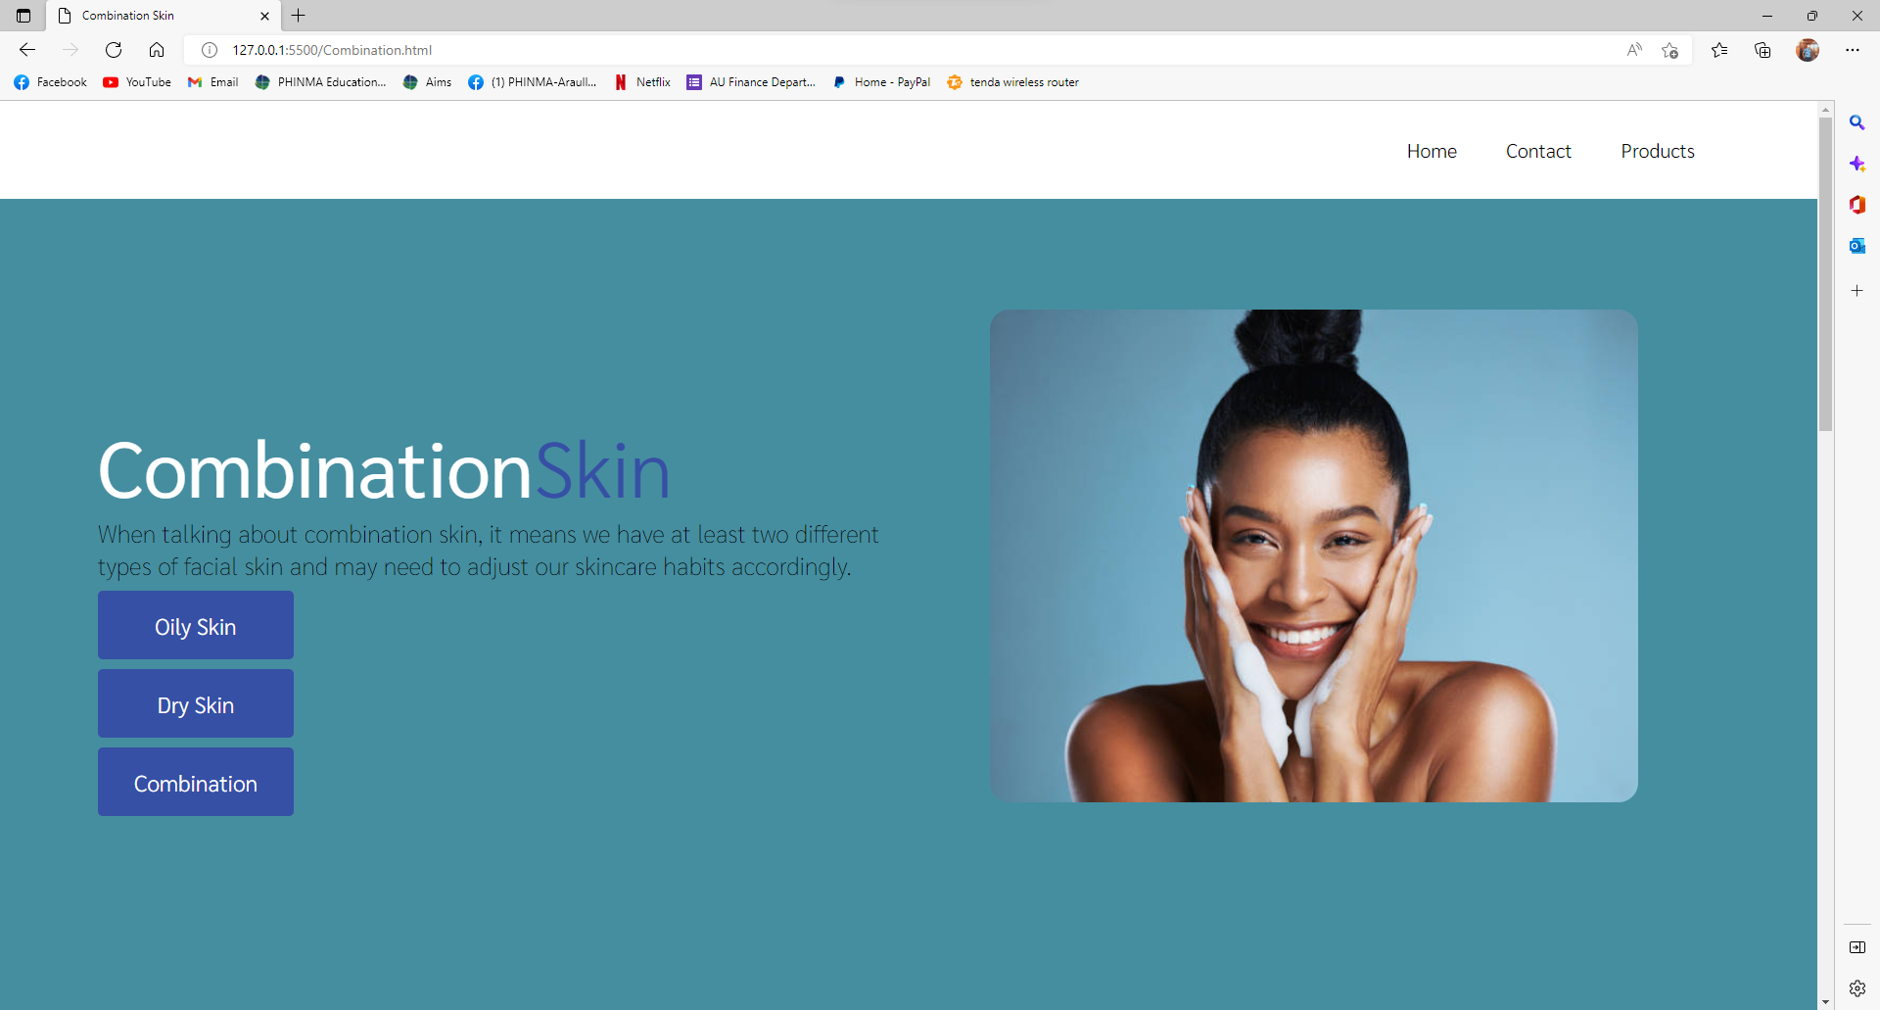

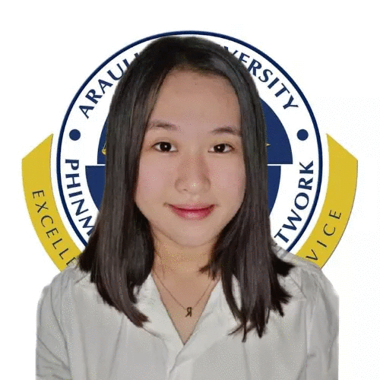

# Rianne Shiane Sangbaan

**Purok 3 Barangay Militar Palayan City**

**Contact Number**: *09070465838*

**E-mail Address**: shianesangbaan@gmail.com

|  |
| --- |
| Career Objectives |

A challenging position where I can contribute my knowledge and skills. A job where action takes place and thinking is always present. I wish to join a group of warm people that could help enhance and gain knowledge with great opportunity for professional growth.

|  |
| --- |
| Education |

* **BACHELOR OF SCIENCE- INFORMATION TECHNOLOGY**

*Araullo University*

S.Y.June 2020 – June 2024

* **TVL-ICT**

*Fort Magsaysay National High School*  
S.Y. 2019-2022

* **Pelagio Jabel Memorial School**S.Y. 2013-2014

|  |
| --- |
| Personal Information |

**Age : 20**  
**Civil status**: Single

**Date of birth**: June 18, 2002

**Height**: 4’11

**Weight**: 46 kgs

**Religion**: Catholic

**Father’s Name:** Marcelino Sangbaan

**Occupation:** Construction worker

**Mother’s Name:** Mary Jane Sangbaan

**Occupation:** Housewife

***I hereby certify that all above information’s are true and correct to the best of my knowledge, understanding and belief.***

**Rianne Shiane Sangbaan**

Student

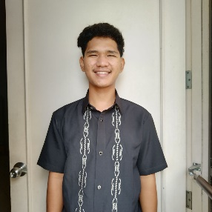

# Romano, Renz Joshua R

**Purok Centro, INC Compound Brgy. Bangad Cabanatuan City**

**Contact Number**: *09265330809*

**E-mail Address**: renzjoshuaromano24@gmail.com

|  |
| --- |
| Career Objectives |

I'm looking for a challenging position where I can contribute my expertise. a position that requires both action and constant thought. I want to be a part of a welcoming group of people that can help me learn and advance while providing excellent opportunities for career advancement.

|  |
| --- |
| Education |

* **PHINMA-Araullo University (PHINMA Education Network)**

***BACHELOR OF SCIENCE - INFORMATION AND TECHNOLOGY***

Brgy. Bitas Maharlika Highway Cabanatuan City, Nueva Ecija

S.Y. 2020 - present

* **TECHNICAL EDUCATION AND SKILLS DEVELOPMENT AUTHORITY (TESDA)**

***SMAW SHIELDED METAL ARC WELDING***

NC II

* **Camp Tinio National Highschool**

***SENIOR HIGH SCHOOL GRADUATE***

*Camp Tinio National High School Cabanatuan City*

S.Y. 2014-2020

* **Cabanatuan East Central School**

*Easy Central School Cabanatuan City*

S.Y.June 2008 – June 2014

|  |
| --- |
| Personal Information |

**Age : 20**  
**Civil status**: Single

**Date of birth**: March 24, 2002

**Height**: 5’5

**Weight**: 60 kgs

**Religion**: Iglesia Ni Cristo

**Father’s Name:** Orlando Romano

**Occupation:** Tricycle Driver

**Mother’s Name:** Marie Romano

**Occupation:** Housewife

***I hereby certify that all above information’s are true and correct to the best of my knowledge, understanding and belief.***

**Renz Joshua Romano**

Student

NHORIE LYN PANGILINAN

199 Purok 2, Valle Cruz Cabanatuan City, Nueva Ecija

Mobile Number: 09511527174

Email Address: pangilinanhorie@gmail.com

**OBJECTIVES**

* To use my enhanced skills and knowledge on the field and to be able to use these in a useful and beneficial workplace in order to help in attaining and maintaining its mission, vision, and goals.
* To grow professionally and personally with excellence, determination and confidence.

**PERSONAL PROFILE**

**AGE:** 19 years old

**DATE OF BIRTH:** December 28, 2002

**GENDER:** Female

**HEIGHT:** 5’4

**WEIGHT:** 50 kgs

**CITIZENSHIP:** Filipino

**CIVIL STATUS:** Single

**RELIGION:** Roman Catholic

**LANGUAGES:** English, Filipino

**EMPLOYMENT RECORD**

**Service Crew: Oh Mas Fried Chicken**

Banatu Box, Kapitan Pepe, Cabanatuan City, Nueva Ecija

June 2021- September 2022

**EDUCATIONAL ATTAINMENT**

**Primary Level: Valle Cruz Elementary School**

Valle Cruz Cabanatuan City, Nueva Ecija

(2008-2014)

**Secondary Level: San Isidro Integrated School**

San Isidro Cabanatuan City, Nueva Ecija

(2014-2018)

**Senior High School: Good Samaritan Colleges**

(2018-2020)

**Tertiary Level: PHINMA-Araullo University**

Brgy. Bitas Maharlika Highway Cabanatuan City, Nueva Ecija

(Present, third year college)

**SKILLS**

* A trustworthy individual that is good in time management and can easily adjust to the workplace.
* Has good communication skills both in English and Filipino.
* A fast learner that can understand tasks and follow commands easily.
* Can multitask, if necessary, in any given situation.

*I hereby that the above information is true and correct to the best of my knowledge and belief.*

NHORIE LYN PANGILINAN

Applicant’s Signature

# Hanter John O. Ison

**Purok Damayan, Brgy. Marawa Jaen Nueva Ecija**

**Contact Number**: *09277531488*

**E-mail Address**: hanterjohnison@gmail.com

|  |
| --- |
| Career Objectives |

A challenging position where I can contribute my knowledge and skills. A job where action takes place and thinking is always present. I wish to join a group of warm people that could help enhance and gain knowledge with great opportunity for professional growth.

|  |
| --- |
| Education |

* **BACHELOR OF SCIENCE- INFORMATION TECHNOLOGY**

*Araullo University*

S.Y.June 2020 – June 2024

* **Marawa National Highschool**

**Marawa Jaen**   
S.Y. 2013-2017

* **Marawa Elementary School**

**Marawa Jaen**S.Y. 2006-2012

|  |
| --- |
| Personal Information |

**Age : 20**  
**Civil status**: Single

**Date of birth**: December 18, 2001

**Height**: 5,8

**Weight**: 65 kgs

**Religion**: Iglesia Ni Cristo

**Father’s Name:** Edelino Ison

**Occupation:** Company worker

**Mother’s Name:** Analyza Odiza

**Occupation:** Housewife

***I hereby certify that all above information’s are true and correct to the best of my knowledge, understanding and belief.***

**Hanter John O. Ison**

Student

# SERRANO, EJAY M.

**Purok 7, Brgy. kalikid Norte Nueva Ecija**

**Contact Number**: 09367378925.

**E-mail Address**: ejayserrano0123@gmail.com

|  |
| --- |
| **Career Objectives** |

A challenging position where I can contribute my knowledge and skills. A job where action takes place and thinking is always present. I wish to join a group of warm people that could help enhance and gain knowledge with great opportunity for professional growth.

|  |
| --- |
| **Education** |

* **BACHELOR OF SCIENCE- INFORMATION TECHNOLOGY**

*Araullo University*

S.Y.June 2020 — June 2024

* **Camptinio National highschool**   
  S.Y. 2013-2017
* **Kalikid Norte Elementary School**S.Y. 2006-2012

|  |
| --- |
| **Personal Information** |

**Age : 22**  
**Civil status**: Single

**Date of birth**: July 1 2000

**Height**: 5,5

**Weight**: 65 kgs

**Religion**: Catholic

**Fathers Name:** Edwin Serrano

**Occupation:** Soldier

**Mothers Name:** Jeanbel Serrano

**Occupation:** Housewife

***I hereby certify that all above informations are true and correct to the best of my knowledge, understanding and belief.***

**EJAY M. SERRANO**

Student