DevOps Laboratory Report
Master of Computer Applications (MCA) – Version Control & CI Workflow
Student / GitHub User: | Reno07Matthew (renorejimatthew07@gmail.com)
Project / Repository: | Travel India (https://github.com/Reno07Matthew/travel-india)
Course: | DevOps Engineering Lab (MCA)
Date / Status: | September 2026 / Completed & Verified

1. Experiment Objectives
The objective of this laboratory exercise is to demonstrate real-world DevOps practices in version control and automated continuous integration:
1. Configure Git locally and link it securely with remote GitHub repository.
2. Implement branching strategies following the GitHub Flow model.
3. Perform branch merges including Fast-Forward merges.
4. Demonstrate Merge Conflict Resolution across TWO distinct environments:
• Conflict 1: Resolved locally via Git Command Line Interface (CLI).
• Conflict 2: Resolved remotely via GitHub Web Browser Conflict Editor.
5. Manage Pull Requests (creation, review, check validation, and merging).
6. Design and implement a commit-triggered CI pipeline using GitHub Actions.

2. Git Local & Remote Configuration
Configured user identity (name, email) and linked with GitHub CLI credentials helper. Verified repository remote pointing to https://github.com/Reno07Matthew/travel-india.git.
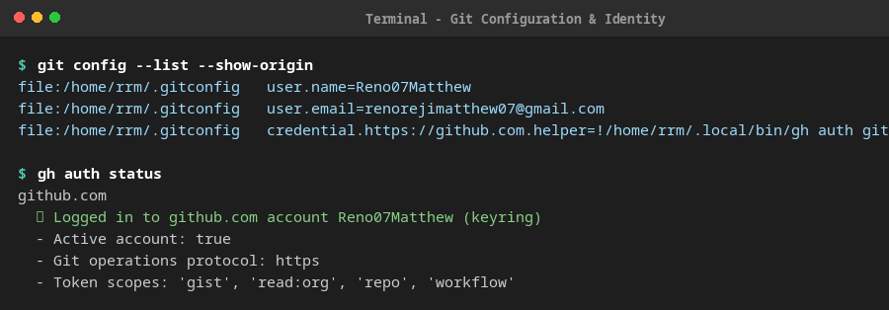
Figure 1: Local Git Configuration & GitHub CLI Authentication

3. Branching Strategy & Fast-Forward Merge
Created feature branch 'gallery' to develop the Photo Gallery module. Merged into 'main' using a fast-forward merge without creating unnecessary merge commits.
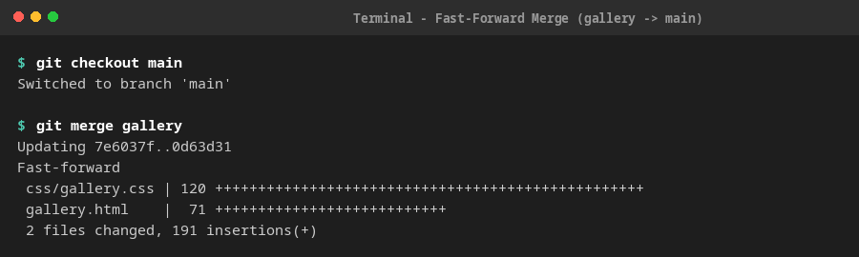
Figure 2: Fast-Forward Merge of Branch 'gallery' into 'main'

4. Conflict Resolution 1: Git Command Line Interface (CLI)
Simulated a merge conflict by editing the <footer> copyright line on branch 'conflict-demo' and modifying the identical line on branch 'main'. Running 'git merge conflict-demo' triggered a conflict. Inspected conflict markers (<<<<<<< HEAD, =======, >>>>>>> conflict-demo), consolidated the content, staged, and committed the merge resolution (commit 0e12dd5).
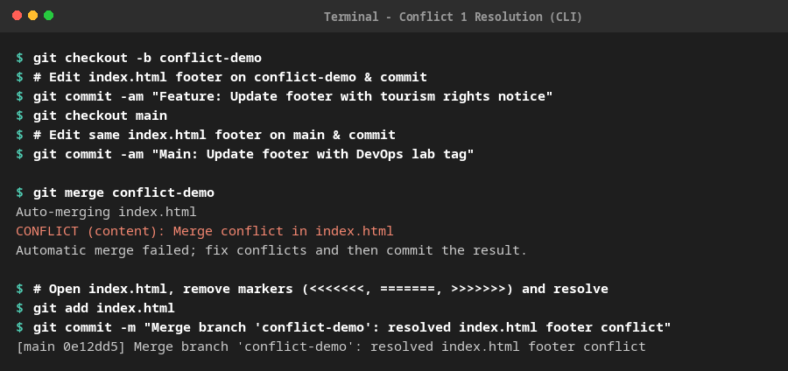
Figure 3: Git CLI Merge Conflict Simulation & Resolution Commit

5. Conflict Resolution 2: GitHub Web Browser Conflict Editor
Simulated a remote conflict by modifying line 23 (hero heading) divergently on branch 'feature/places-update' and 'main'. Pushed both branches to GitHub and opened Pull Request #2. GitHub flagged the PR as 'This branch has conflicts that must be resolved'.
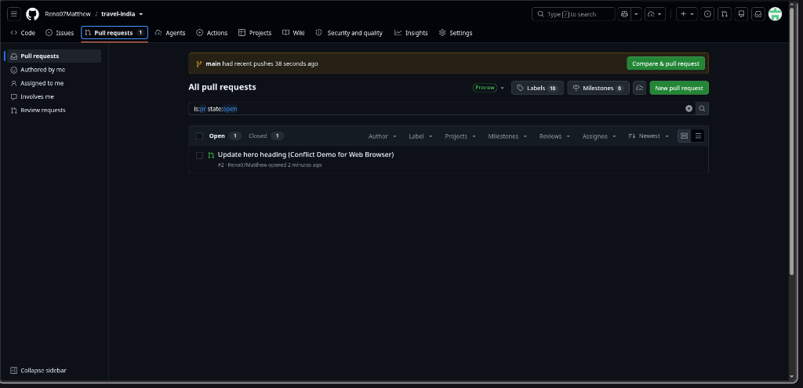
Figure 4: GitHub Pull Requests List displaying PR #2 with active conflict
Clicked 'Resolve conflicts' on GitHub to open the web conflict editor. Removed conflict markers, harmonized the heading text to 'Discover Incredible India - A Land of Endless Wonders, Culture & Nature', clicked 'Mark as resolved', and committed the resolution (commit 48e770f) directly in the browser.
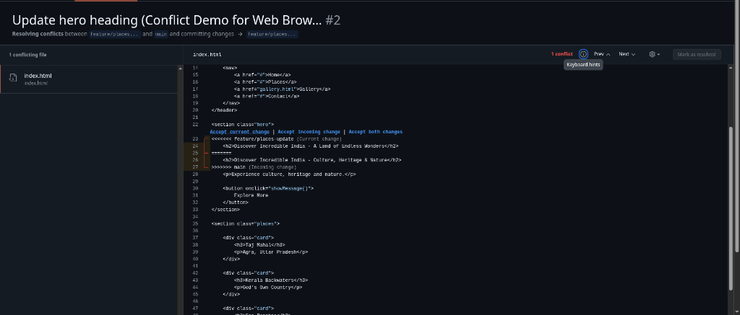
Figure 5: GitHub In-Browser Web Conflict Editor during Conflict Resolution
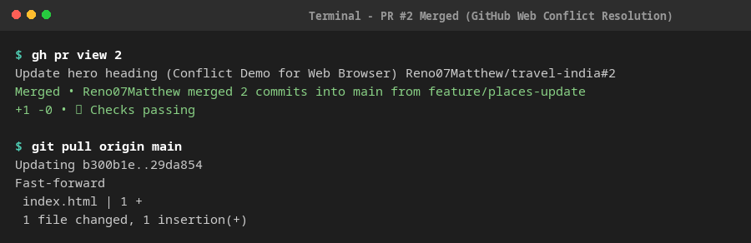
Figure 6: PR #2 Successfully Merged into 'main' via GitHub Web Interface

6. Pull Request Management (PR #1 & PR #2)
Practiced the full Pull Request lifecycle: branch creation, pushing upstream, opening PRs via GitHub CLI (gh pr create), monitoring CI pipeline check statuses, and merging (gh pr merge) with automated branch cleanup.
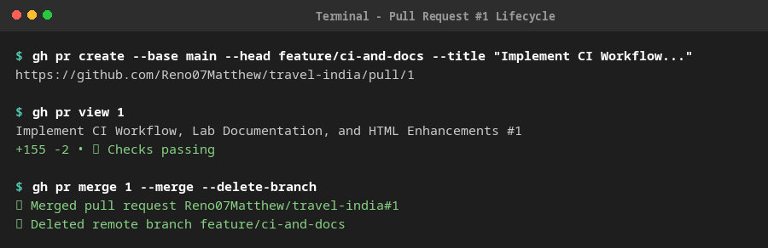
Figure 7: PR #1 Lifecycle with Passing Checks and Merge Completion

7. Continuous Integration (CI) Workflow via GitHub Actions
Configured .github/workflows/ci.yml triggered on push and pull_request events to 'main'. The pipeline checks out code, configures Node.js, runs HTMLHint validation, and asserts asset file integrity.
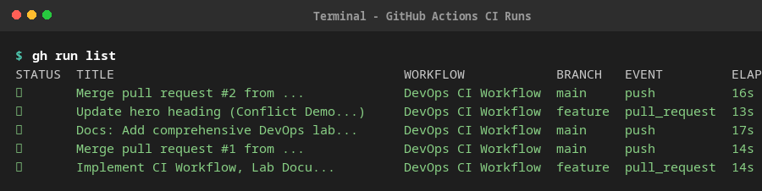
Figure 8: GitHub Actions Workflow Dashboard with Passing Runs

8. Final Git Commit History Graph
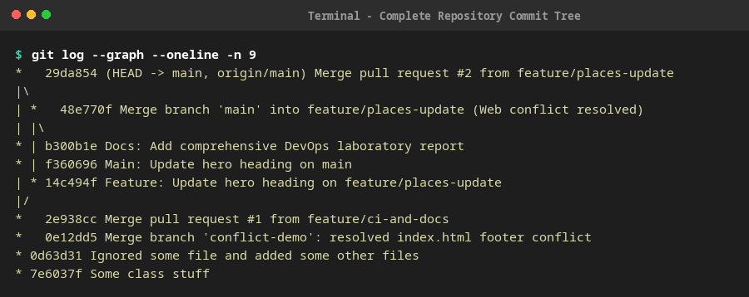
Figure 9: Complete Repository Commit Graph showing both Merges and Conflict Resolutions

9. Conclusion
All requirements of the DevOps Laboratory assignment were successfully executed and verified. The dual conflict resolution demonstrated mastery of both command-line Git operations and modern GitHub web-based collaboration tools. The GitHub Actions CI pipeline guarantees automated code quality checks on every future commit.

