
Resident Magistrates’ Courts
Children’s Registry System
System Requirements Document

Original Plan Date: April 22, 2015

Revision: 1.0

Table of Contents
Revision History 3
Purpose of This Document 4
Goals of the Project 5
System Scope 5
Stakeholders 5
Users of the System 6
Assumptions and Other Relevant Facts 7
Functional Requirements 8
Non-functional requirements 10
Use Case Diagram 14
Context Diagram 18
Data Requirements 21
Documentation Requirements 22
Requirement Constraints & Dependencies 22
Reference Material 23
Acronyms and Glossary 23

Revision History
Revision Number | Date | Comment
1.0 | April 22, 2015

Purpose of This Document
Introduction
This document states the system requirements for the proposed Children’s Registry System to be used mainly by the Resident Magistrates’, Clerks of the Courts and Court Administrator within the Family Courts. The proposed system should provide the users with an automated and efficient solution to track and manage the information within the Children’s Registry System. The system will allow users to log cases, demographic information cash card information for both accuse and victims and also be able to generate detailed reports to be used by the various stakeholders.

Problem Description
Currently the system being utilized at the Family Courts captures complaint information for accused and victims, the type of offense and all other information surrounding the accused. The current version of the children’s registry data is captured a using Microsoft Excel spreadsheet. There is no structure or formal system in place to record, search and provide reports from the information. Therefore they have the following challenges:
- Unable to provide a systematic report for specific period on the number of cases relating to the children’s registry;
- Clerks have to manually navigate through mount of paper or spreadsheets to ascertain information for cases;
- Providing statistical report on the number of cases on different categories;
- And generating a system court list.

Goals of the Project
The Children’s Registry System will address the need to efficiently enter, update, track and provide proper storage of the information being supplied. The system will incorporate new additions such as generating specific statistical report, through a very user friendly interface. The solution will lead to the following improvements:
- Improve the efficiencies and effectiveness of capturing the information,
- Updating and generating of specific reports,
- Proper data storage,
- Availability of information on a secured platform.

System Scope
The Information, Communication and Technology Division (ICT) of Court Management Services have been request to develop a Children’s Registry System that is capable of eliminating the issues within the problem definition. This system should be able to store and analyze data; provide reliable access to information based on assigned user roles, provide macro and micro level reports on all information pertaining to data captured, provide prompts to users on critical issues that need to be addressed.

Stakeholders
- Chief Justice
- Principal Executive Officer
- Magistrates’ – Family Court
- Court Administrator – Family Court
- Clerk of Court – Family Court
- The Supervisor/Data Entry – Family Court
- Assistant Clerk of Court/Data entry – Family Court
- System Administrator – Information, Communication and Technology (ICT)

Users of the System
Data Entry Clerk
Users with this role are responsible for entering and updating information in the system for a complaint.

Supervisors
Responsible for monitoring the day-to-day operations of the system, and verifying the accuracy of the data entered.

Resident Magistrates’
Responsible for entering and verify court dates for specific cases.

Court Administrator
Responsible for supervising the overall processes of the system.

System Administrator
Responsible for installation/configuration, establishing and managing user accounts; upgrading software; backup and recovery and maintenance of systems.

Assumptions and Other Relevant Facts
While conducting the detailed analysis of requirements and in the preparation of this report, the following assumptions are made:
- The project has the support of all stakeholders.
- The Courts/Data Entry Clerks are willing to change business operations to take advantage of the functionality offered by the proposed system.
- Accurate data is gathered and correctly enter in the system.
- Network infrastructure already in place will not change to hinder project completion.
- Users of the system will be sufficiently computer literate, having a basic knowledge of the use of computer systems, and require little or no training time, which should allow the system to be put in use soon after project completion.

Functional Requirements
Requirements ID | Requirements Statement
FR001 | The system shall be able to capture case information such as:  - Year and Information number.  - Court, Address – (Street number, Name, Community, Parish)  - Assigned Resident Magistrates’  - Email address
FR002 | - Accused Information list (last name, middle name, first name, alias, D.O.B, address, gender, case status, lawyer, investigating agency, previous offences, TRN, date of charge).
FR003 | - Offence Information list (type, date, and place).
FR004 | - Child’s information list (last name, middle name, first name, D.O.B, address, gender, school,)
FR005 | - Parent/Guardian Information list (last name, middle name, first name, D.O.B, address, gender, work, phone number, email).
FR006 | - Court information list (first court date, last court date, next court date, number of hearings, period of time cumulative number of days since the case has started, action to be taken, case status, judgment)
FR007 | - Probation Officers list (last name, first name, address, gender, place work, phone number, email, ID #).
FR008 | Court list (The system shall be able to generate a court list stating all the cases information for each week, and shall be email to the related correspondents such as the Probation Officer, Child Development Agency (CDA), Centre for Investigation of Sexual Offences and Child Abuse (CISCA) and the Judges).
FR009 | Search (The system shall have a search engine which will identify and pull the required item(s) from the database that correspond to keywords specified by the users).
FR010 | Report - The system shall able generate statistical report such as:  - Report showing the gender of the accused and victim.  - Report showing the Place, Offences and date of the incident.  - Report showing the addresses of both the accused and victim.  - Report showing Age group of both the accused and victim.  - Report showing the remarks/end results relating to specific offence.  - Report showing the start and end dates, or reason for postponement if the case was not closed.  - Adhoc reports based on specific criteria

Non-functional requirements
Requirement ID | Requirements Statement | Comments
NF001 | Accessibility and Availability:  The server that stores the data records shall run 24 hours per day to keep the system fully accessible. | The system shall be available to all stakeholders upon request. All requests and information required by others will be processed by the relevant stakeholders.
NF002 | Backup:  Data backup up shall be done as per ICT data backup policy.
NF003 | Capacity, current and forecast:
NF004 | Dependency:  The system shall be dependent on the Internet providers that provide data service to the courts. | The system shall be hosted and managed in a secured environment.
NF005 | Efficiency:  The system shall be able to report on all the information that is stored in the database and shall return results in a timely fashion.
NF006 | Exploitability:  All measure shall be taken to ensure that the system is not vulnerable and susceptible to malicious attacks. Stored procedures, prepared statements, user credentials and encryption shall be used to enforce this.
NF007 | Scalability:  The system shall be able to handle a growing amount of work and shall be able to grow in complexity as well to accommodate that work. | The ability to scale in size and work it is able to do is important to make light of the fact that not all functionality can be implemented in advance. An object oriented approach will be taken to further enforce this requirement.
NF008 | Fault Tolerance:  The system shall be designed to capture any exception generated by the system during execution and prevent crashes. | The system will utilize proper error handling, SQL-injection prevention and system maintenance as times goes on. System crashes shall be taken as priority and handled as soon as possible.
NF009 | Interoperability:  The system shall be designed with a web interface which will allow it to be accessed across various platforms.
NF010 | Price:  The system shall only accrue a cost associated with the hosting of the website. The development and maintenance team in house which does not affect the cost of developing the system.
NF011 | Privacy:  The data shall only be accessible to authorized users and shall not be shared unlawfully. | Usernames and passwords will be required to get access to the system. Other persons that need data from the system shall request same from the authorized users. User levels will also be used to ensure that users only have access to data that their user level permits.
NF012 | Portability:  The system shall be accessed on various devices and on different platform. The system shall be web-based. | Desktops, laptops, portable devices, etc shall be able to operate the system based on the fact that it will be developed with a web interface.
NF013 | Recoverability:  The system shall be accessible based on agreed standards in the event of a disaster.
NF014 | Reliability:  The system shall save and read data to and from the system as requested by the users. Proper error notification shall be provided in case an operation was not successful in order to aid troubleshooting. | In case of a system failure, the system shall be able to revert to its backed up data in order to have data present for use. Copies of the source code will also be stored in various locations to ensure that the system can be reinstalled in the case of a system failure.
NF015 | Reporting:  The system shall possess the ability to produce reports based on the needs of the users. | A varying number of reports shall be available to users.
NF016 | Reusability:  The system’s code shall be reused if needed to support other systems with similar functionalities. | The system shall be developed with a Object Oriented Approach. This will allow the classed to be reused in projects of a similar nature or require little modification in order to be used in such systems.
NF017 | Security:  The system shall be designed to prevent unauthorized access to its content and databases. | For example: physical security, stored procedures, prepared statements, user credentials and data encryption shall be used to enforce this.
NF018 | Stability:  The system shall remain operational for at least 98% of the time. | This can be done through proper error handling, SQL-injection prevention and system maintenance as times goes on. System crashes shall be taken as priority and handled as soon as possible.
NF019 | Testability:  The system shall be developed to facilitate various systems tests and required responses. | Development of standard data structures to support easy to user/understand PHP frameworks.
NF020 | User Friendliness:  The system shall be designed to be very easy to use. | Font size and images shall be fairly big to make seeing and clicking the options that are available much easier. All pages shall be no more than three pages from each other. The use of appropriate labels and instructions shall be used to aid user navigation.

Use Case Diagram


Provide information
Victim/Victim parent/Guardian

Add information to the system
Update information

Data Entry Clerk

Search for victim information

Generate court list
Print Court list

Supervisor RM
Email information

Populate the specific statistical report
View Reports

Fig.1: Use Case Diagram

Use Case – Function 1
Function name: Victim provide information about the incident
Primary Actor: Victim parent /guardian/victim
Goal: Provide information for system
Entry Condition: RM and Clerk of Court to decide on court date
Exit Condition: Case goes to trial

Use Case – Function 2
Function Name: Add the information that was retrieved from victim
Primary Actor: Data Entry Clerk
Goal: Ensuring all the required information is capture in the system
Entry Condition: Store the information
Exit Condition: Set date for first court appearance

Use Case- Function 3
Function Name: Update the information
Primary Actor: Data Entry Clerk
Goal: Ensuring that all updated information is on the system
Entry Condition: Search for specific record to update
Exit Condition: System shows information about the case

Use Case – Function 4
Function Name: Search the system for specific information
Primary Actor: Data Entry Clerk/Supervisor/RM
Goal: View information on specific case
Entry Condition: Enter keywords or information number for the case
Exit Condition: View and provide the information

Use Case – Function 5
Function Name: Generate the Court list
Primary Actor: Supervisor
Goal: Ensuring that a weekly court list is been generated for relevant persons
Entry Condition: Populating the Court list
Exit Condition: Court list is issued/emailed

Use Case – Function 6
Function Name: Print Court Lists
Primary Actor: Supervisor
Goal: Provide the RM with the Court Lists
Entry Condition: View/access
Exit Condition: Printed Court list

Use Case – Function 7
Function Name: Emailing the information
Primary Actor: Supervisor
Goal: Ensuring that the information is sent to the relevant persons
Entry Condition: Populating the information to be sent
Exit Condition: Emailing the information

Use Case – Function 8
Function Name: Populate the specific statistical report
Primary Actor: Supervisor
Goal: Providing different statistical report
Entry Condition: Populate the relevant report
Exit Condition: Report generated

Use Case – Function 9
Function Name: View Reports
Primary Actor: Supervisor/RM
Goal: View specific statistical report(s)
Entry Condition: Access the relevant report
Exit Condition: Report generated

Use Case Diagram
Judge
Collecting officer

Context Diagram

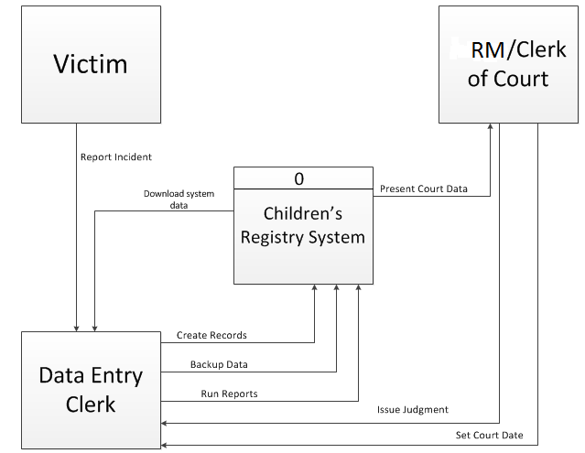

Fig.2: Children Registry System Context Diagram

The context diagram illustrated in Fig.2 shows the flow of data between the victims, clerks and RM and how they interact with the system.

Level 0 Diagram

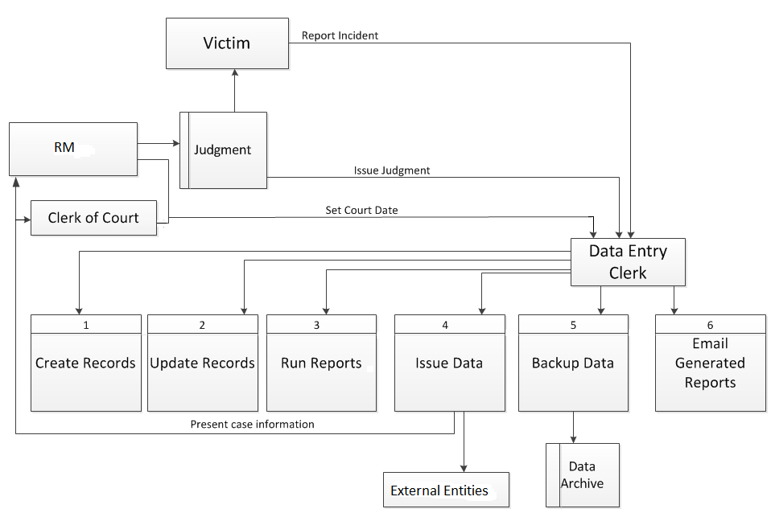
Fig.3: Children’s Registry System Level 0 Diagram
- People
- Victim: Initiates the process by reporting an incident.
- Data Entry Clerk: Creates new records and checks the database for returning cases.
- RM and Clerk of Court: Will be presented with case information and upon the completion of a session/case a judgment will be issued to the Data Entry Clerk to update in the system.
- Processes
- Create Records: New record will be created upon the receipt of an incident report by a victim.
- Update Records: Whenever there are any changes made to a case the information is updated in the system to reflect that change.
- Run Reports: Various reports will be generated for the relevant personnel to get access to.
- Issue Data: From time to time information of a case may be needed to be shared with different entities and the data entry clerks will be responsible for providing the data.
- Backup Data: Data backup will be done as per standard website and application backup.
- Email Generated Reports: There is a list of entities which will rely on the data that the system will provide. Clerks will have the ability to email reports to those entities.
- Data files
- Judgment: After a case is heard the RM will provide a judgment which will be logged in a log book and the data entry clerk will update the system with the relevant information.
- Victim Archive: This is an organized database used to securely store and manage the
Information for cases involving victims that are considered children.
Data Requirements
Input
The system will accept data entered relating to the Children’s Registry form which captures all details. The data to be entered will be captured from the forms filled out by the parent/guardian of the child/children, it will also capture information relating to the type of offence and court dates and judgment handed down.
Processing
The system will be required to fulfill the following functions:
- Authenticate users attempting to access the system
- Add/Update (Accused, Offence, child’s information)
- Addition and analysis of maintenance data

Outputs
The system will be required to generate outputs in the form of various end result to aid in evaluation and decision making. See Functional Requirements (FR010) for a sample listing of reports that will be generated by the system.

Documentation Requirements
To ensure fluidity in how the system is learned and utilized, printed and electronic forms of documentation will be provided to all users of the system. The following supporting document will be provided:
- User’s Manual;
- Sensitization session - ICT Division representative

Requirement Constraints & Dependencies
- The project should be completed by August 20, 2015.
- The cost associated with the system will be in regards to the hosting of the system.
- The availability of the internet will also affect the way and when the system is used. If internet connection goes down the system would not be available.
- Availability of the clerks for training will also be a concern as they have their regular work schedules to address. The software team members would also have to be available to conduct training.

Reference Material
Use this table to consolidate all reference documents, document name and description.

Document Name | Description
Intake Record | A word document that captures all information from the complainant.
Data Sheet | A excel spreadsheet that captures all information surrounding the entire case from initial stage to the end.

Acronyms and Glossary
The list of acronyms and definitions given below:

ICT | Information, Communication and Technology
CDA | Child Development Agency
CISCA | Centre for Investigation of Sexual Offences and Abuse
D.O.B | Date of Birth
NF | Non-Functional
F | Functional
TRN | Tax Registration Number
RM | Resident Magistrates’
ID | Identification

Question to ask
- List of all offences
- What is INF
- What Status represent in the spreadsheet and list of statues
Not reached
Counsel
Counsel\s request
Judgement reserved
Further and better part
Documents/Disclosure
To file counterclaim
To join defendants
Insufficient time to complete
Request probation report
For sentence/order
File incomplete
Accused not brought
Legal aid act(settle repr)
Pending settlement
Transferred to another court
No Jury/Juror absent
D.N.A - Defendant not appearing
Judge/Magistrate absent/ill
Placed on trial list
Witness absent
Psychiatric Evaluation
Outstanding maintenance money
Warrant ordered
Ref. to surveyor
No return/re-issue
Ref. to mediation
Warrent ordered and stayed
Note to enter
Compensation
Blood test
Placed on prelim
police absent/I.O
Medical certificate outstanding
New date
Other

