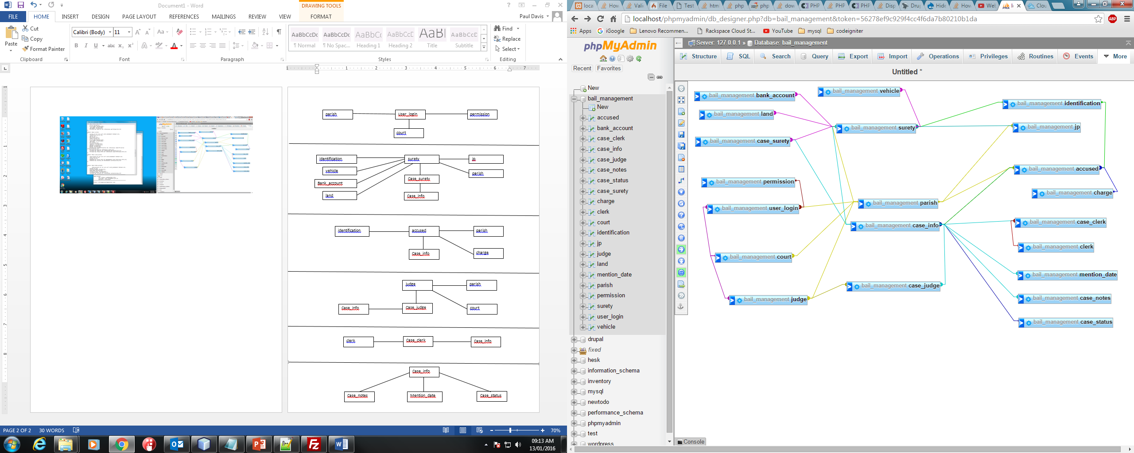

User_login

permission

court

parish

surety

identification

Case_surety

land

vehicle

jp

Bank_account

Case_info

parish

identification

Case_info

charge

parish

accused

Case_info

Case_judge

court

parish

judge

clerk

Case_info

Case_clerk

Case_info

Mention_date

Case_status

Case_notes