**Realigning climate-forcing players**

**Power Resources Mobilisation pathways in the Just Transition**

Research Note

(last version: 5th December 2024)

**TO DO LIST:**

**Aspect semantique pour parler aux deux audiences**

**Question de recherche qui doit parler aux deux**

**Theorical : insiders / outsiders**

**Conjoint attributes: insiders (indiv / group) + outsiders <->**

**2pages**

**Introduction**

Concerns are growing about the political backlash surrounding the distributional consequences of climate policies in a context where anti-climate political parties are winning elections (e.g. US election in 2024, Argentine election in 2023, the Netherlands in 2023, etc.).

Voters across the globe can be divided between 'climate-forcing asset holders’ (CFA), that are primarily negatively affected by decarbonization policies and ‘climate vulnerable asset holders’ (CVA) that are mostly negatively impacted by climate change (Colgan, Green, and Hale, 2021). Studies have shown that voters are highly responsive to price signals from decarbonization policies, as seen in examples like the rise in energy prices in the Netherlands (Voeten, 2024) and the ban on polluting cars in Milan (Colontone et al., 2023). These political dynamics may be counterbalanced in favorable economic conditions (Henriks et al., 2024) or when adequate compensation is provided (Bolet et al., 2023).

As a result, there has been increasing attention to public opinion regarding just transition policies. Studies indicate that fossil fuel communities would support climate policies if they were paired with just transition assistance (Gazmarian, 2024). Four key policy dimensions—sectoral scope, social spending, financing, and cross-country distribution—shape public support for these policies (Baute, 2024). Acceptance of redistributive schemes varies across contexts, with U.S. Democrats generally opposing such schemes, while German citizens are more supportive (Beiser-McGrath & Bernauer, 2024). Information interventions about coal's decline have also shifted preferences in favor of supporting the clean energy transition (Gazmarian, 2024). Rather than viewing public opinion as an immutable barrier to climate action, studies show that 66% of fossil fuel community residents would endorse climate policies if accompanied by just transition assistance (Gazmarian, 2024).

Public opinions have been underlined to affect significantly the formulation of public policy by legislators (Burstein, 2003), especially to their core supporters (Barbera et al., 2019). Nevertheless, the channels through which such preferences may shape just transition packages remain unclear. Bolet et al. (2023) suggests that the roles of unions in the negotiation and acceptance of just transition policies was critical in the phasing out of Spain coal mines. They hypothesize that when union density was high, they could effectively shape workers and community preferences by accepting just transition packages.

We aim to assess this claim by determining how and when unions shape workers and communities' preferences towards just transition assistance. Are unions an essential ally in shaping climate forcing asset holders?

To do so, we develop a vignette / conjoint experiment targeting workers of the aeronautic industry and coal mines, affected communities, and a representative sample of the national population of France, Germany, and Poland. We chose such settings because blablabla.

Overall, we contribute to the literature on climate politics aiming at deepening our understanding of the acceptance of just transition policies. Our study echoes Colgan et al. (2021) proposition that decarbonization success depends on how and when interests mobilize. Unions may take an important role in realigning interests by actively reducing the relative power of climate-forcing assets vis-a-vis climate vulnerable assets which may ultimately participate in a flipping mechanism where individual or communities’ assets shift from being dominated by climate forcing assets to climate neutral, or vulnerable assets. We bring empirical evidence and shade lights to show how unions may enable or hinder such processes.

1. **Assessing preferences for the Just Transition: Cognitive orientations as missing link**

The concept of Just Transition has gained traction across climate policy and social policy scholarship. It is widely acknowledged that climate-mitigating policies need to be complemented by social policies. In particular, ‘just transition’ policies are expected to help mitigate the social costs of the transition and pave the way for new, desirable ways of ‘organizing the commons’ in these turbulent times.

However, when looking at the means to achieve this ‘Just Transition’, different, individually-coherent, perspectives concur today. These views notably distinguish themselves in their conception of (i) the individual triggers of change (ii) the role of just transition interventions; and (iii) the what should be the main feature of social policies associated to climate policies.

On the one hand, an ***'egotropic school'*** focuses on the role of egotropic preferences in individual realignment. In this perspective, Just Transition interventions are essentially conceived as a barter between theoretically pre-established social groups: Decarbonization policies will create clearly identifiable ‘losers’. In this game-theoretical environment, social policies are viewed as compensation tools for the economic costs imposed on 'climate-forcing asset holders’.

On the other hand, a ***‘sociotropic school’*** emphasizes the importance of sociotropic preferences in individual realignment. In this view, Just Transition interventions are perceived as impacting local ecosystems: Decarbonisation may economically affect certain individual and sectors more than others, but its main social risks will reside in the wider social and political implications it creates. In response, social policies are conceived as capacitation tools that should contribute to revitalizing the social capital of most vulnerable places.

Just Transition packages are, by nature, multidimensional. This feature has prompted some scholars to assess individual support for different ‘just transition’ policy packages by means of conjoint experiments involving different climate and social policy attributes. As of today, relative preferences among the publics on these two alternative visions regarding the role of social policy in the climate transition however remain underexplored.

1. **Mobilising inclinations for the Just Transition: Unexplored power resource mobilization pathways**

Just Transition policy interventions do not happen in a vacuum. In the process of adoption, political actors can cue the publics through various policy frames with the aim to shape preferences, and mobilise, for example, sociotropic over egotropic inclinations. Organised groups play an important part in this process, as they can help widen political mobilization, by widening the scope of envisaged policy options and shape perceived chances of success of reforms – in a positive feedback loop reinforcing the likelihood of individuals supporting collective action (Korpi 1985).

Trade unions are a player at the crossroad of the just transition: They first represent a critical political and economic intermediary in climate-mitigating policies. Unions are often involved in decisions linked to firms’ restructuring pressured by mega-trends (from decarbonization to digitalization) and accordingly play a crucial role in the closure, consolidation, or greening of major CFAs. In this context, unions may decide to use the structural, institutional, and ideational power resources to follow the views and interest of their members. Yet unions are also locally-embedded, political intermediaries’ which make them particularly well placed to contribute to efforts aimed at upholding the social capital of places affected by climate change.

Notwithstanding these factors, limited attention has so far been drawn to the role unions may play in mobilizing either egotropic or sociotropic inclinations of the general population in the transition towards CMOs.

1. **Contributions and Expectations**

The first contribution of this project is to assess the publics preferences on Just Transition interventions appealing either to egotropic vs. sociotropic. Appeal to each of these cognitive inclinations will be assessed by testing individual preferences on trade-offs typically involved in various attributes conventionally featuring in Just Transition policies. Are policies targeting non-egotropic interests also contributing to the individual realignment of CFAs? We hypothesize that:

* **H1 (baseline). We expect socio-tropic attributes of just transition policies to matter for the support of climate-mitigating policies.**
  + **H1a** The higher the level of support for affected workers, the higher the support for the policy. (cash)
  + **H1abis** Retrained worker
  + **H1****b**  The higher the community investment in affected areas, the higher the support for the policy
  + **H1c** The higher the cost for the households, the lower the support for the policy
  + **H1d** The stronger the community are involved in the policy process, the higher the support for the policy
  + **H1e** When the policy is built across party lines, the stronger the support for the policy
* **H2 (heterogenous effect).** We expect systematic differences in stated preferences between affected workers and non-affected workers in affected communities
  + **H2a** Support for affected workers is higher for affected workers than non-affected workers
  + **H2b** Support for community investment is higher for non-affected workers than affected workers

The second contribution of this project is to assess the role played by unions in mobilizing the sociotropic vs. egotropic inclinations of their members. For this, we theorise a number of mechanisms whereby which unions may affect individual inclinations in ways which could contribute to collective realignment towards CMOs:

Unions, we posit, can dramatically change perception of climate policy interventions by predominantly acting either as a (i) responsive player, comforting 'climate-forcing asset holders’ in their resistance to decarbonization policies; or as (ii) responsible player, identifying the (social) conditions under which realignment of CFAs towards climate goals may be considered acceptable.

Unions’ actions as a responsible player may vary in the scope of policy interventions they defend. Specifically, we identify two plausible responsible actions. First, unions may follow an **insider-oriented logic**, seeking to garner support for climate-mitigation policies exclusively among workers by defending those employees most directly affected by the consequences of climate mitigation policies. Policies supported by unions in this perspective may, for instance, take the form of job securisation schemes or other retraining policies. Second, unions may alternatively adopt a **public-seeking logic**, with the aim to garner support for climate-mitigation policies across the general population by supporting wider access by the local population to a range of community services, ranging from better sanitation to public housing, etc.. According to which mechanisms is trade union support for just transition policies most likely to contribute to (non-egotropic?) individual realignment of CFAs? We expect the following:

* **H3. Baseline** – Unions policy position impact the stated policy preferences of voters within affected communities.
  + **H3a.** When unions are against any just transition policy, the likelihood to support the just transition policy diminishes
  + **H3b**. When unions support a minimalist just transition policy (worker support only), the likelihood of supporting the just transition policy increases.
  + **H3c**. When unions support a maximalist just transition policy (worker and community support), the likelihood of supporting the just transition policy increases.

The role of the unions in shaping just transition policy preferences may depend on a) the strength of union, b) how unions are institutionally embedded in the negotiation system with the national government and c) the targeted population. We also expect affected workers and non-affected workers in affected communities to respond differently to unions policy position.

* **H4 Heterogeneous effect**
  + **H4a.** We expect the effect of H3a and H3b to be higher among the affected workers rather than the non-affected workers in affected communities.
  + **H4b.** We expect the effect of unions to be higher in H3a to H3c in context where union role is stronger.

1. **Empirical Strategy** 
   1. **Population / sampling strategy**

The role of the unions in shaping just transition policy preferences may depend on the union strength in the a) sectoral area, b) how unions are institutionally embedded, and c) the targeted population. To test such elements, we need to adapt the population under study and the sectoral areas. We use a comparative study of three countries: France, Germany, and Poland, where the unions have distinct role in the bargaining process. Furthermore, we study the two sectors: the airplane industry and the coal mines where union strength differs. Finally, for each sector and country, we aim to target a representative sample of two main populations of interest that are likely to backlash when decarbonization policies are implemented: a) workers (insiders), and the affected communities around.

|  |  |
| --- | --- |
| **Stratification** | **Units** |
| a) Integration of unions in the social bargaining system | * France (not integrated) * **Germany (integrated)** * Poland (?) |
| b) Union strength differs by sector | * Airplane industry (low-medium ?) * Automobile * Coal mines (high ?) |
| c) Expected level of unions’ influence | * Workers (high) * Affected communities (medium) * National population (low) |

Such a sampling strategy will allow us to delineate the scope conditions of the theoretical argument we underlined in the previous section.

* 1. **The experiment design**

We design a vignette experiment and assess its impact on the preferences elicited inside a conjoint experiment. To test the effect of the unions, we use three scenarios:

*Decarbonization policies description (in case of danger)*

*Description de la politique publique (variation)*

*Description de l’union (for / against)*

Factorial design

H1: political strategy – insider or outsider too...

|  |  |  |
| --- | --- | --- |
| Public policy | Unions’ position | |
| Policy mix | (Against) the dec policy | For the decab policy |
| Decarbonization + Job guarantee | Vignette 1  TRADITIONALIST UNION | Vignette 2  GREEN-KEYNESIAN UNION |
| Decarbonization + Community development | Vignette 3  TRADITIONALIST UNION | Vignette 4  SOCIO-ECOLOGICAL UNION |

Prochaines etapes:

1. Completer la factorial vignette et le conjoint, clarifier les politiques publiques, Rafiner “community development” (en lien avec les attributs du conjoint); utilisation d’articles de presse etc. (automobile; aerien)
2. Etayer / justifier les hypotheses sur la base de la difference entre les vignettes

* Commencer par v1 vs. V2
* Commencer par v3 vs. V4

Rafiner “community development” (en lien avec les attributs du conjoint)

3) Considerer l’effet heterogene sur les types de compensation

4) Completer la factorial vignette et le conjoint

5) Ecrire le document pragmatique pour les unions

Simple vignette

|  |  |
| --- | --- |
| **Experimental arm** | **Description** |
| **Treatment 1 –** | The unions do not support any policies aiming at decarbonization of the sector. |
| **Treatment 2 –** | The unions support the decarbonization of the sector if and only if there are financial compensations for workers. |
| **Treatment 3 –** | The unions support the decarbonization of the sector if and only if there are job guarantees for the workers. |
| **Treatment 4 –** | The unions support the decarbonization of the sector if and only if there is community development. |

**Dependent variables:**

* Do you support the *reduction of flight by 50%*/*closure of coal mines* with job guarantee for workers
* Do you support the *reduction of flight by 50%*/*closure of coal mines* with job guarantee for workers and community development scheme?
* Participation in union meetings
* Participation in protest

We then ask respondents’ opinions towards just transition policies and then field a conjoint experiment.

|  |  |  |
| --- | --- | --- |
| **Attributes** | **Levels** | **Source** |
| **Worker support** | a. None, b. Affordable Housing, c. Health insurance, d. 15$ minimum wage, e. Free college | Bergquist et al. 2020 |
| **Community investment 1** | a. None, b. Job guarantee, c. Retrain fossil fuel workers, d. unionized clean energy jobs | Bergquist et al. 2020 |
| **Community investment 2** |  |  |
| **Costs for households** | a. 10$/month, b. 35$/month, c. 55$/month | Bergquist et al. 2020 |
| **Financing** | a) By cutting expenditures in other areas of the public budget, b) By increasing taxes on fossil fuels such as oil, gas and coal, c) By increasing taxes on the rich, d) By increasing public debt that will have to be paid back in the future | Baute, 2024 |
| **Community involvement** | (a) No involvement of the local population, (b) Annual reporting available to the public + veto right, (c) Consultation (d) Policies coming from a citizens assembly | Kostyuchenko et al. 2024 |
| **Partisan support** | a) Left only, b) Center only, c) right only, d) Left + Center, e) Center + right, f) multipartisan (left to right) | Bergquist et al. 2020 |
| **Union support?** |  |  |

**Number of profiles**: The conjoint displays pair of policies that respondents will assess.

**Dependent variable:** We will elicit preferences about policies in multiple ways as advised by Druckman and Green (2021) with ranking profiles within group and individually (assess how concretely it is done). Respondents are asked to choose whether they prefer policy A or B as well as how strongly they feel about their preference from 1-3 similarly to Blankenship et al. (2022).

* 1. **Analysis and power**

To test hypothesis 1, we will assess the following model:

To test hypothesis 3, we will assess the following model:

**Conclusion**

Overall, the project may help us identify public support for stereotypical Just Transition pathways. At this stage, we could – for example, consider whether empirical evidence would support an analytical distinction between:

* **An individual compensation path**
* **A group-securisation path**
* **A collective capacitation path**

Our findings should further help us engage with the rich Just Transition literature on discussions linked to 1) desirable policy mix to facilitate the re-alignment of CFAs; 2) cognitive orientations at play in individual decision-making on Just Transition policies; 3) political drivers of / mechanisms of power resource mobilization in shaping individual realignment.

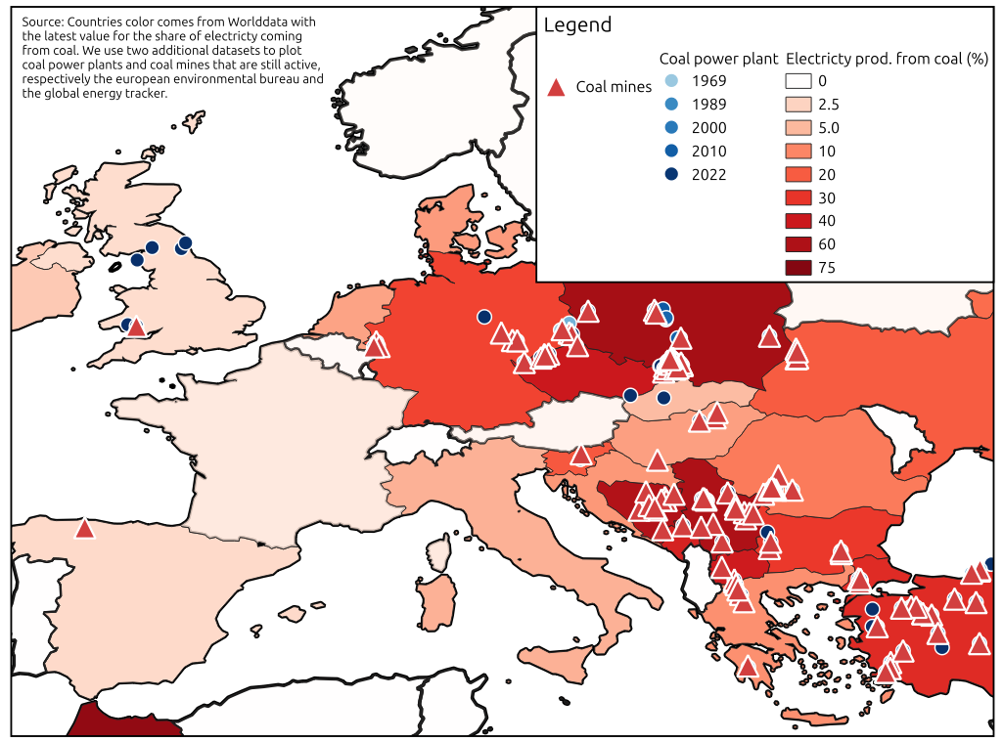***Fig: map of coal production facilities and share of electricity produced by coal in the EU***

Map on oil refinery: <https://www.concawe.eu/refineries-map/>

**Important other references**

Birch, Sarah. “Political Polarization and Environmental Attitudes: A Cross-National Analysis.” Environmental Politics 29, no. 4 (June 6, 2020): 697–718. <https://doi.org/10.1080/09644016.2019.1673997>.

Guber, Deborah Lynn. “A Cooling Climate for Change? Party Polarization and the Politics of Global Warming.” American Behavioral Scientist 57, no. 1 (January 1, 2013): 93–115. https://doi.org/10.1177/0002764212463361.

Kono, Daniel Yuichi. “Compensating for the Climate: Unemployment Insurance and Climate Change Votes.” Political Studies 68, no. 1 (February 1, 2020): 167–86. <https://doi.org/10.1177/0032321719836066>.

Maestre-Andrés, Sara, Stefan Drews, and Jeroen van den Bergh. “Perceived Fairness and Public Acceptability of Carbon Pricing: A Review of the Literature.” Climate Policy 19, no. 9 (October 21, 2019): 1186–1204. <https://doi.org/10.1080/14693062.2019.1639490>.

Vona, Francesco. “Job Losses and Political Acceptability of Climate Policies: Why the ‘Job-Killing’ Argument Is so Persistent and How to Overturn It.” Climate Policy 19, no. 4 (April 21, 2019): 524–32. <https://doi.org/10.1080/14693062.2018.1532871>.

**References**

Baute, Sharon. “The Distributive Politics of the Green Transition: A Conjoint Experiment on EU Climate Change Mitigation Policy.” Journal of European Public Policy 0, no. 0 (n.d.): 1–29. <https://doi.org/10.1080/13501763.2024.2304609>.

Beiser-McGrath, Liam F., and Thomas Bernauer. “How Do Pocketbook and Distributional Concerns Affect Citizens’ Preferences for Carbon Taxation?” The Journal of Politics 86, no. 2 (April 2024): 551–64. <https://doi.org/10.1086/727594>.

Bolet, Diane, Fergus Green, and Mikel González-Eguino. ‘How to Get Coal Country to Vote for Climate Policy: The Effect of a “Just Transition Agreement” on Spanish Election Results’. American Political Science Review, 4 December 2023, 1–16. <https://doi.org/10.1017/S0003055423001235>.

Colantone, Italo, Livio Di Lonardo, Yotam Margalit, and Marco Percoco. ‘The Political Consequences of Green Policies: Evidence from Italy’. American Political Science Review 118, no. 1 (February 2024): 108–26. <https://doi.org/10.1017/S0003055423000308>.

Gazmararian, Alexander F. “Fossil Fuel Communities Support Climate Policy Coupled with Just Transition Assistance.” Energy Policy 184 (January 1, 2024): 113880. <https://doi.org/10.1016/j.enpol.2023.113880>.

Henriks, Sofia, Niklas Harring, and Nils Droste. “Voters Do Not Punish Their Government for Climate Policies under Favorable Conditions.” Environmental Politics 0, no. 0 (n.d.): 1–24. <https://doi.org/10.1080/09644016.2024.2373606>.

Schaffer, Lena Maria. “Who’s Afraid of More Ambitious Climate Policy? How Distributional Implications Shape Policy Support and Compensatory Preferences.” Environmental Politics 33, no. 4 (June 6, 2024): 567–90. <https://doi.org/10.1080/09644016.2023.2247818>.

Srivastav, Sugandha, and Ryan Rafaty. “Political Strategies to Overcome Climate Policy Obstructionism.” Perspectives on Politics 21, no. 2 (June 2023): 640–50. <https://doi.org/10.1017/S1537592722002080>.

Voeten, Erik. ‘The Energy Transition and Support for the Radical Right: Evidence from the Netherlands’. Comparative Political Studies, 11 March 2024, 00104140241237468. <https://doi.org/10.1177/00104140241237468>.

Vormedal, Irja, and Jonas Meckling. “How Foes Become Allies: The Shifting Role of Business in Climate Politics.” Policy Sciences 57, no. 1 (March 1, 2024): 101–24. <https://doi.org/10.1007/s11077-023-09517-2>.

**References on unions**

Thomas, Adrien. “Framing the Just Transition: How International Trade Unions Engage with UN Climate Negotiations.” Global Environmental Change 70 (September 1, 2021): 102347. <https://doi.org/10.1016/j.gloenvcha.2021.102347>.

Stevis, Dimitris, and Romain Felli. “Global Labour Unions and Just Transition to a Green Economy.” International Environmental Agreements: Politics, Law and Economics 15, no. 1 (March 1, 2015): 29–43. https://doi.org/10.1007/s10784-014-9266-1.

Jordhus-Lier, David, Judith Marguerite Henriksson, Camilla Houeland, Genver Quirino, and Ingrid Andrea Holland. “Anchoring a Just Transition: The Ambivalent Roles of Norwegian Trade Unions.” Energy Research & Social Science 114 (August 1, 2024): 103619. https://doi.org/10.1016/j.erss.2024.103619.

Normann, Håkon E., and Silje M. Tellmann. “Trade Unions’ Interpretation of a Just Transition in a Fossil Fuel Economy.” Environmental Innovation and Societal Transitions 40 (September 1, 2021): 421–34. https://doi.org/10.1016/j.eist.2021.09.007.

Meadowcroft, James, and Daniel Rosenbloom. “Governing the Net-Zero Transition: Strategy, Policy, and Politics.” Proceedings of the National Academy of Sciences 120, no. 47 (November 21, 2023): e2207727120. https://doi.org/10.1073/pnas.2207727120.