**Wayne State University**

**CSC 4421 - Winter 2025**

**Computer Operating Systems Labs** **Lab**

**05 - File System**

Points Possible: 100

# Tasks ∗ (100 points)

For this Lab, create a single Microsoft Word .docx document or compile to .pdf. Name the file ”L06 aa0000” (replacing aa000 with your access ID). **Make sure the document has a .docx or .pdf file extension.** When you are ready to submit, submit only this document to blackboard, there is no need to place it in a folder or compress it with .zip.

**At the beginning of the document, list the following information:**

HH2781

Rensildi Kalanxhi

CSC 4420

Winter 2025

Lab06

**For each of the following steps listed below:**

Label the number of each step / part of the assignment in your .docx document. (e.g., 1, 2, 3, ...)

Include a screenshot of your terminal output for each execution of *df* .

Indicate what is happening at each step, what is depicted in each screen shot.

Answer any and all questions.

1

1. **[Screen Shot, Answer - Explanation]** *df* is a command that displays the amount of disk space available on the file system containing each file name argument. Read man page of *df* command. Run the command

*df* to find out how many disk blocks are available and how many are in use. Does the sum of these equals the total number of disk blocks on the disk? If not, explain why there is a difference.

Yes the sum does equals the total number of disk blocks on the disk.

1. Next run the command *df -i* to find out how many inodes are available and in use. **[Screen Shot]**   
     
   For the C:\ drive it shows that there are 999 Inodes, the IUsed is showing -999001 and for IFree is showing 1000000. From what I am observing it seems as IFree is being subtracted from Inodes (999 – 1000000 = -999001). For the following questions I will answer while observing other Filesystems such as tmpfs or /dev/sdc.  
   A computer screen shot of a program

   AI-generated content may be incorrect.
2. Now create a new file with just a few characters in it, and again run *df* and *df -i* commands. **[Screen Shot x2]**   
   A screenshot of a computer program

   AI-generated content may be incorrect. A computer screen shot of a program

   AI-generated content may be incorrect.
3. Explain the effect of creating this new file. **[Answer - Explanation]**

In df command the available of 1K-blocks have increased by 10292. While in df -I command no Inodes have been used.

1. Now increase the size of this new file by entering a large number (*>* 5000) of characters, and again run df and df –i commands. Do you notice a difference? **[Screen Shot x2, Answer - Explanation]**   
     
   After adding around 5000 characters in the file, there was 34532 1k-blocks used.   
    Meanwhile Inodes have not been used at all.  
     
   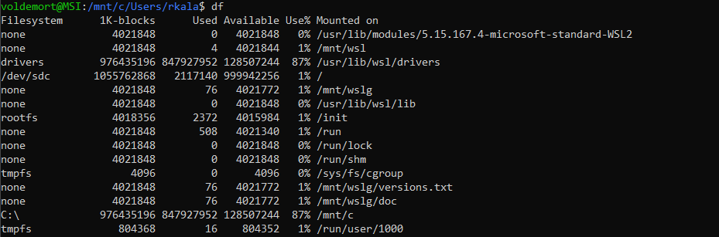  
   A computer screen shot of a program

   AI-generated content may be incorrect.
2. Repeat the last step, this time entering (*>* 50*,*000) characters. **[Screen Shot x2, Answer - Explanation]**   
     
     
     
     
   After adding 50000 characters the usage of 1K-blocks decreased by 10000 resulting in only 20664 used. No Inodes have been used or freed even after adding 50000 characters.  
     
   A screen shot of a computer

   AI-generated content may be incorrect. A screenshot of a computer program

   AI-generated content may be incorrect.
3. Repeat the last step, this time entering (*>* 500*,*000) characters. **[Screen Shot x2, Answer - Explanation]**   
     
   After increasing the number of characters to 500000 there were 1K-blocks more that were being used. As for the Inodes usage, it did not change at all in any of the drivers.  
     
   A computer screen shot of a program

   AI-generated content may be incorrect. A screenshot of a computer program

   AI-generated content may be incorrect.  
   8. Explain the effect of increasing the size of the new file. **[Answer - Explanation]**   
   In the beginning when the increase was not big, more 1k-blocks became available, the reason could be because those 1k-blocks shared the space with each other making more availability. But when the characters drastically increased, more 1k-blocks were being used. In conclusion the number of I nodes did not change because they track files, but 1k-blocks check the space usage of file content.

Grading:

1. (*80 points) Five points for each **[Screen Shot]** and each **[Answer - Explanation]**. There are 16 total, for 80 points.
2. (*20 points) For a complete solution (all 16 **[Screen Shot]** and **[Answer - Explanation]**), a document that is well formed, includes the specified information at the beginning of the document, and is saved with the appropriate file name and document type (.docx or .pdf).