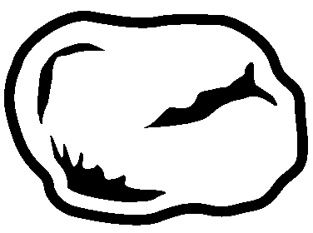

Rock beats Scissors
Remember, if your opponent has the following traits, they will favor throwing rock*:
Aggressive | Strong | Impatient | Masculine
Rugged | Angry | Obese | Vengeful
Frustrated | Hostile | Bitter | Primitive
Simple | Hairy | Extroverted | Alcoholic

Paper beats Rock
Remember, if your opponent has the following traits, they will favor throwing paper*:
Literary | Small | Deceptive | Passive
Weak | Sad | Skinny | Melancholy
Apathetic | German | Affable | Humble
Short | Friendly | Soft | Insecure

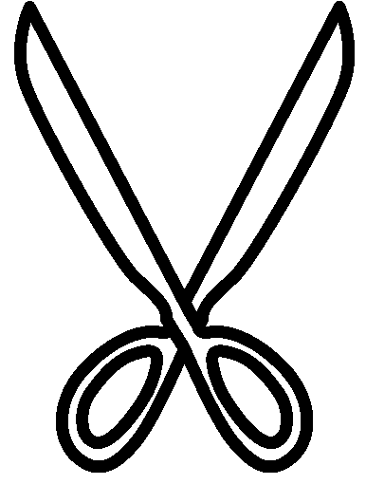
Scissors beats Paper
Remember, if your opponent has the following traits, they will favor throwing scissors*:
Sneaky | Cunning | Courageous | Manipulative
Devious | Sly | Sharp | Calculating
Intelligent | Feminine | Controlled | Centered
Thoughtful | Introspective | Deep | Bald

