**Activity 5**

**Name:** Elcito Jr. A. Gador

**Section:** ARC224

1. **Predictive Analytics**

Predictive analytics utilizes both past and current data to predict upcoming patterns and occurrences. This tool finds wide application across various sectors such as finance, healthcare, and online commerce. It aids in tasks such as anticipating stock market fluctuations, projecting patient prognosis, and estimating consumer demand for products. Through predictive analytics, organizations can make informed decisions in advance, mitigate potential risks, and fine-tune their business processes for optimal efficiency.

Example:

**Bank Assets of other countries**

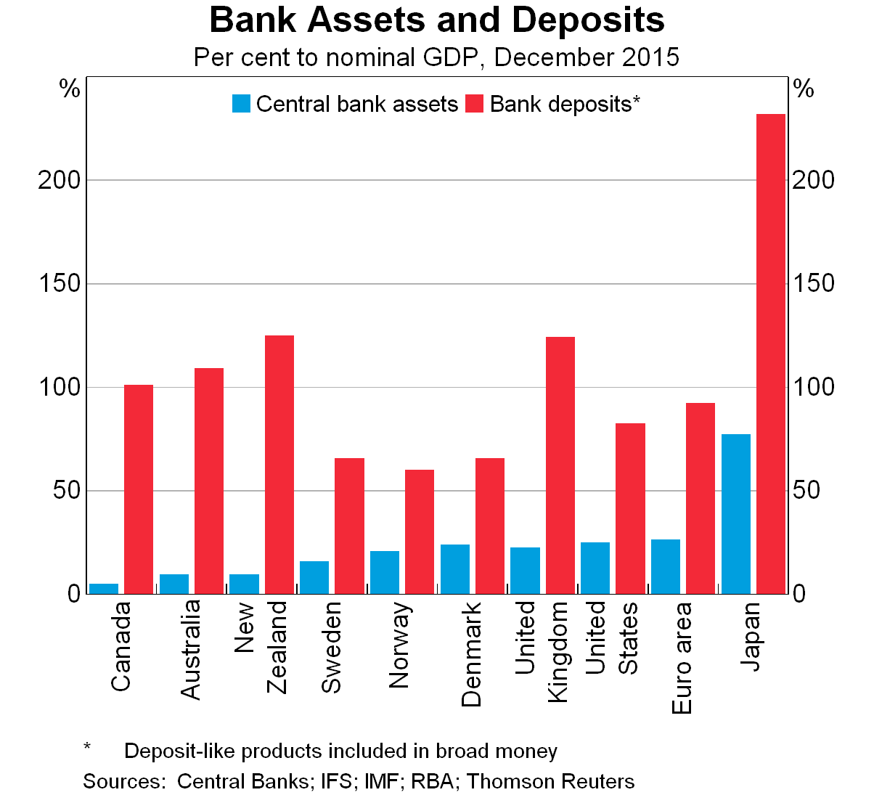

1. **Graph Description**:
   * The graph represents the **percentage** of central bank assets and bank deposits in various countries as of **December 2015**.
   * It compares these percentages to the respective countries’ **nominal GDP** (Gross Domestic Product).
2. **Countries Included**:
   * The countries listed on the graph, from left to right, are:
     + Canada
     + Australia
     + New Zealand
     + Switzerland
     + Sweden
     + Norway
     + Denmark
     + United Kingdom
     + United States
     + Euro area
     + Japan
3. **Data Representation**:
   * The blue bars represent **central bank assets** as a percentage of nominal GDP.
   * The red bars represent **bank deposits** as a percentage of nominal GDP.
4. **Noteworthy Observations**:
   * **Japan** stands out significantly:
     + Its central bank assets are exceptionally high compared to other countries.
     + The percentage of central bank assets in Japan exceeds **200%** of its nominal GDP.
   * Other countries have varying levels of central bank assets and bank deposits relative to their GDP.
5. **Additional Notes**:
   * The graph includes **deposit-like products** in the calculation of broad money.
   * Sources for the data include central banks, IFS, IMF, RBA, and Thomson Reuters.
6. **Fraud Detection**

Fraud detection analytics utilizes sophisticated algorithms and machine learning techniques to detect and deter fraudulent behaviors, including but not limited to credit card fraud, insurance scams, and cyberattacks. Through analyzing patterns and irregularities in transactional data, businesses can mitigate financial losses and uphold the trust of their clientele.

Example: Steps for detecting Frauds

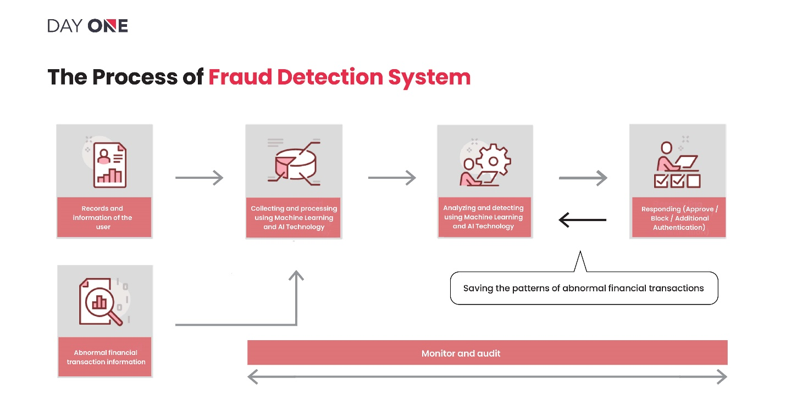

The flowchart delineates the stages of a fraud detection mechanism, encompassing tasks from data recording and collection to surveillance and audit. Machine learning and AI technologies are pivotal in scrutinizing data and rendering decisions within this process.

1. **Sentiment Analysis**

Sentiment analysis, also known as opinion mining, uses natural language processing and machine learning techniques to assess public sentiment and opinions from sources like social media, customer reviews, and surveys. Companies can gain insights into how their brand is perceived and use this information to shape marketing strategies and product development.

Example:

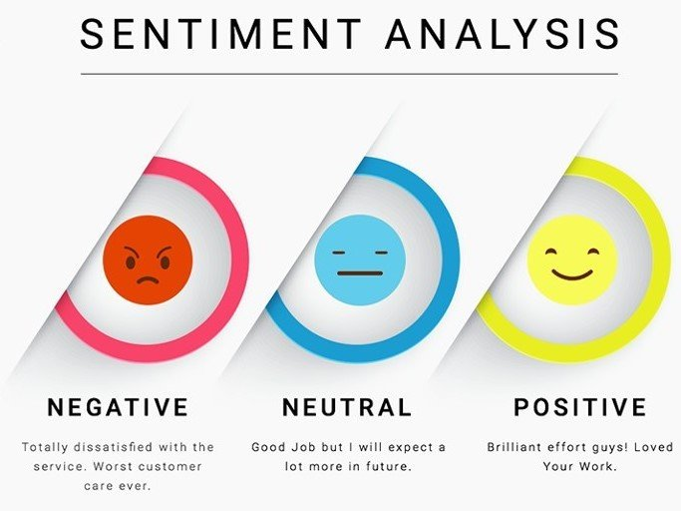This image illustrates the critical aspects of customer sentiment towards the company, its applications, or services, aggregating feedback to help the company gain insights and identify areas for improvement.