SOFTWARE ANALYSIS DOCUMENTATION — USE CASES
PROJECT: RENTAMOVIL — PLATFORM FOR A VEHICLE RENTAL COMPANY
TEAM MEMBERS: Thiago Fabian Rojas Guevara — David Santiago Erez Rodríguez — Nicole Dayana Ramírez Vargas
SERVICIO NACIONAL DE APRENDIZAJE — SENA — SOFTWARE ANALYSIS AND DEVELOPMENT 3145556
2026

1. Introduction
This document presents RentaMovil's use cases: what each actor can do and under what conditions. It is the first of the four dynamic views of the software analysis; the other three —sequence, activity and state diagrams— are in separate documents inside this same folder.
Each use case is presented as an individual card: its own diagram, actor, description, precondition, postcondition and the SRS functional requirement it implements.

2. System actors
Actor | Description
Visitor | A person without a session; can only browse the catalog and sign up
Customer | Authenticated user with the CLIENT role; manages their own reservations, payments and profile
Administrator | Authenticated user with the ADMIN role; manages the fleet, reservations and payments for the whole company
Super Admin | Authenticated user with the SUPER_ADMIN role; everything the Administrator can do, plus managing administrative users and bank accounts

An Administrator or Super Admin can also hold their own reservations, using the same account — the role determines what they can administer, not what they can use.

3. Use case catalog
ID | Use case | Actor
UC01 | Browse vehicle catalog | Visitor
UC02 | Sign up | Visitor
UC03 | Log in | Customer
UC04 | Recover password | Customer
UC05 | Manage my profile | Customer
UC06 | Create a reservation | Customer
UC07 | View and modify my reservations | Customer
UC08 | Cancel a reservation | Customer
UC09 | Pay for a reservation | Customer
UC10 | View my invoices | Customer
UC11 | View my notifications | Customer
UC12 | Manage vehicles | Administrator
UC13 | Manage branches | Administrator
UC14 | Manage fleet maintenance | Administrator
UC15 | Register pickup and return | Administrator
UC16 | Review payment receipts | Administrator
UC17 | Manage company reservations | Administrator
UC18 | Track vehicle location | Administrator
UC19 | Manage insurance plans | Administrator
UC20 | Manage administrative users | Super Admin
UC21 | Manage bank accounts | Super Admin

4. Use case cards

UC01 — Browse vehicle catalog
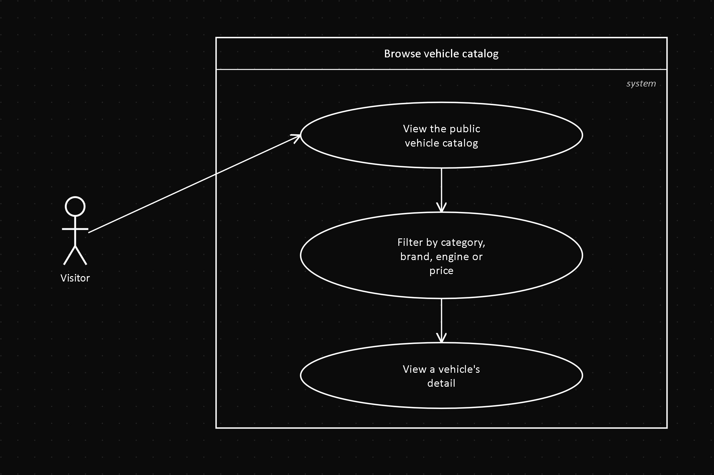
Field | Value
Actor | Visitor
Related FR | FR2.1
Precondition | None — no session required
Postcondition | The list of AVAILABLE vehicles is shown, with optional filters

Description: any visitor can view and filter (category, brand, engine, price, dates) the public vehicle catalog, without needing to register.

UC02 — Sign up
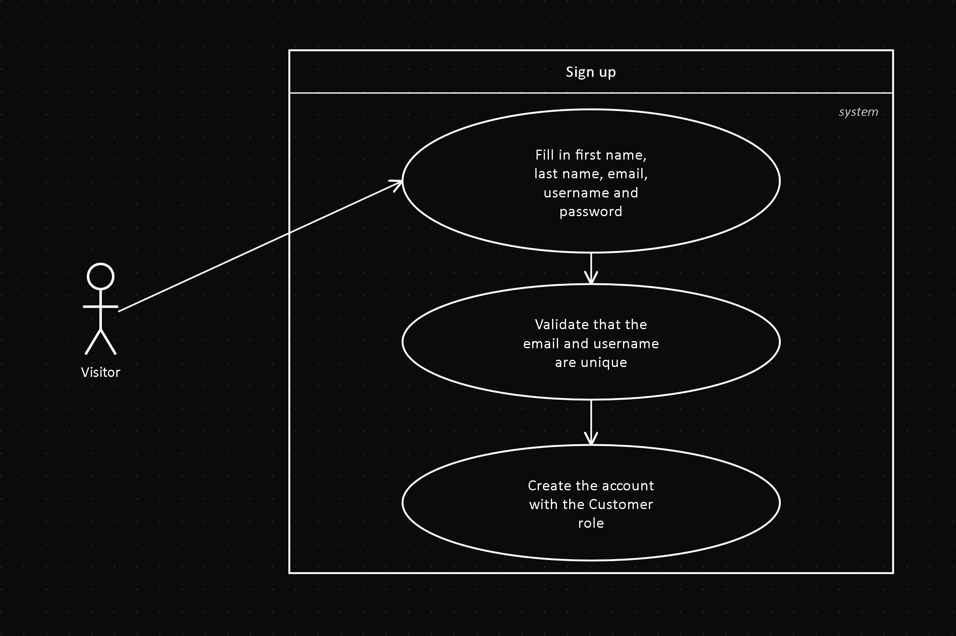
Field | Value
Actor | Visitor
Related FR | FR1.1
Precondition | The visitor has no account in the system
Postcondition | A Person and a User are created with the CLIENT role

Description: the visitor fills in first name, last name, email, username, password and, optionally, a phone number, to create their Customer account.

UC03 — Log in
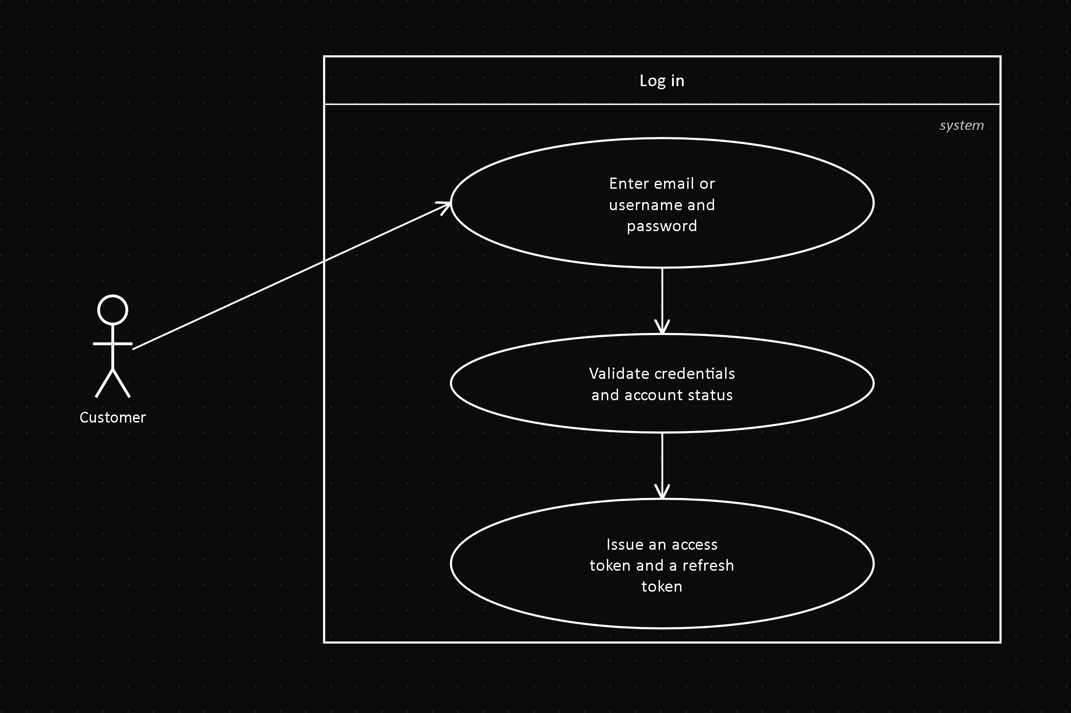
Field | Value
Actor | Customer
Related FR | FR1.2
Precondition | The user has an account with status = ACTIVE
Postcondition | An access token (30 min) and a refresh token (7 days) are issued

Description: the user authenticates with their email or username and their password.

UC04 — Recover password
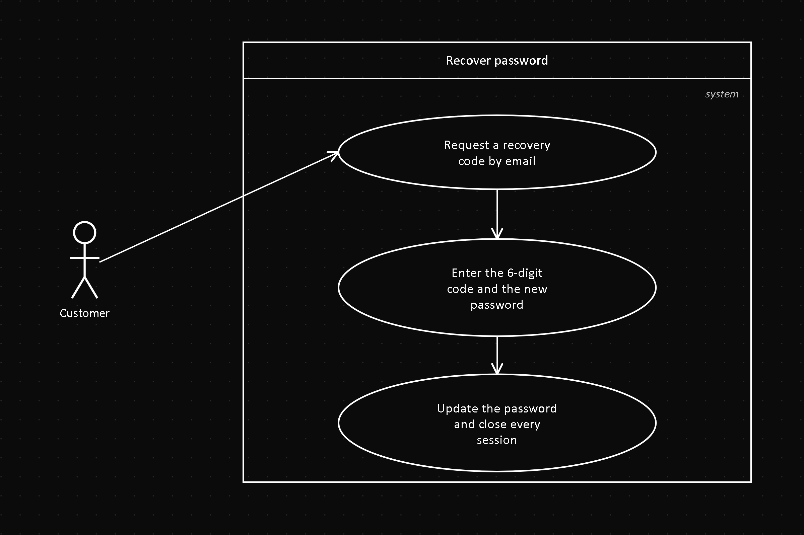
Field | Value
Actor | Customer
Related FR | FR1.3
Precondition | The user forgot their password and has a registered account
Postcondition | The password is updated and all of their sessions are closed

Description: the user requests a recovery code by email (6 digits, valid for 15 minutes) and uses it together with a new password.

UC05 — Manage my profile
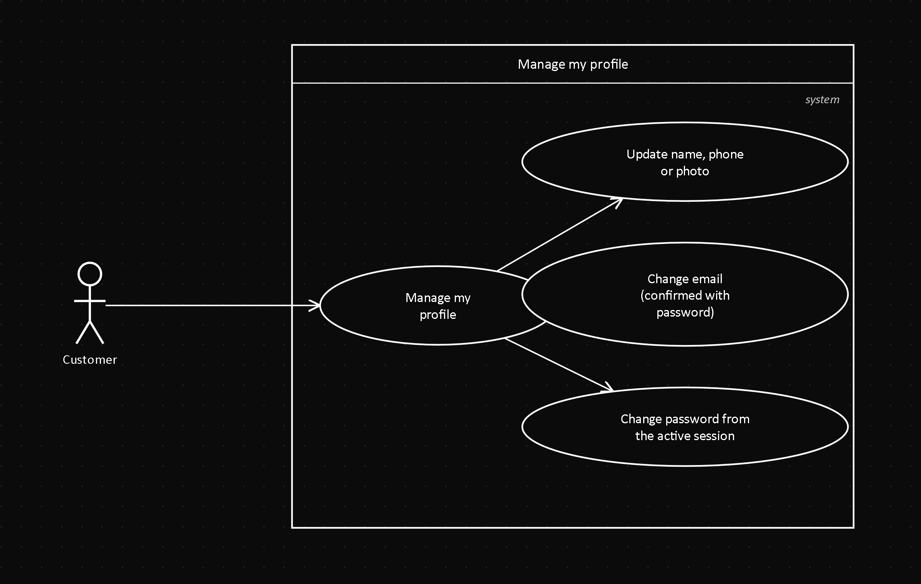
Field | Value
Actor | Customer
Related FR | FR1.4, FR1.5
Precondition | The Customer is authenticated
Postcondition | The profile data is updated

Description: the Customer updates their name, phone, photo or email (the latter, confirmed with their current password), and can change their password from the active session.

UC06 — Create a reservation
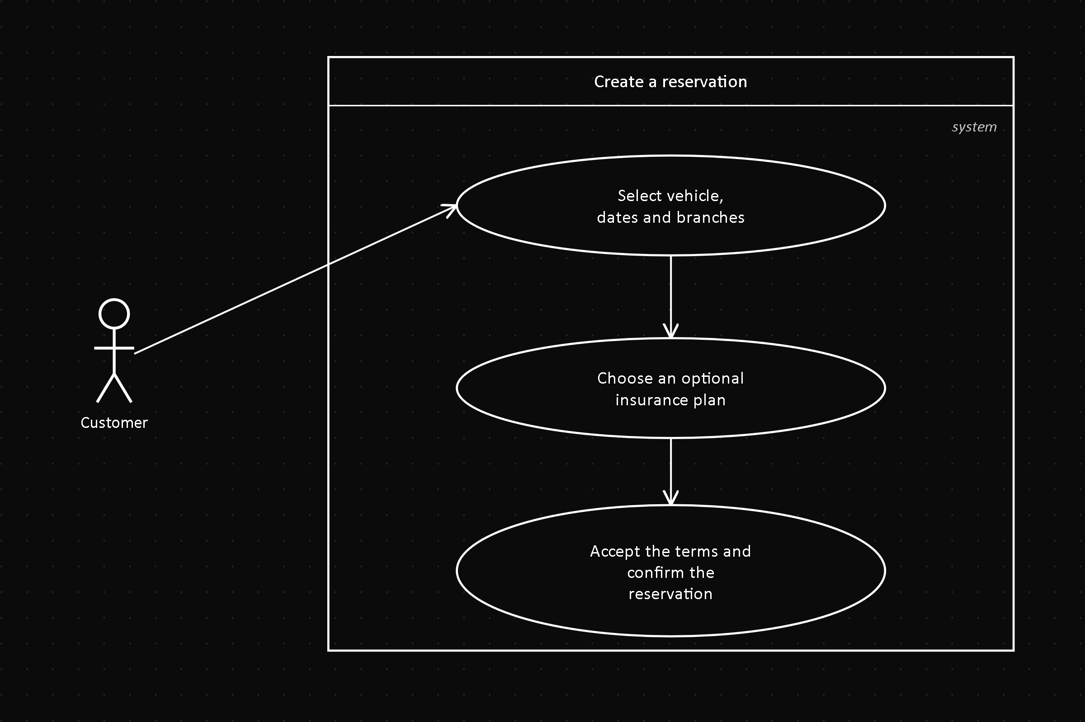
Field | Value
Actor | Customer
Related FR | FR3.1, FR2.2
Precondition | Customer authenticated; the chosen vehicle is available for the requested dates
Postcondition | A Reservation is created in PENDING_PAYMENT status

Description: the Customer selects a vehicle, dates, pickup/return branches and, optionally, an insurance plan, and accepts the terms and conditions.

UC07 — View and modify my reservations
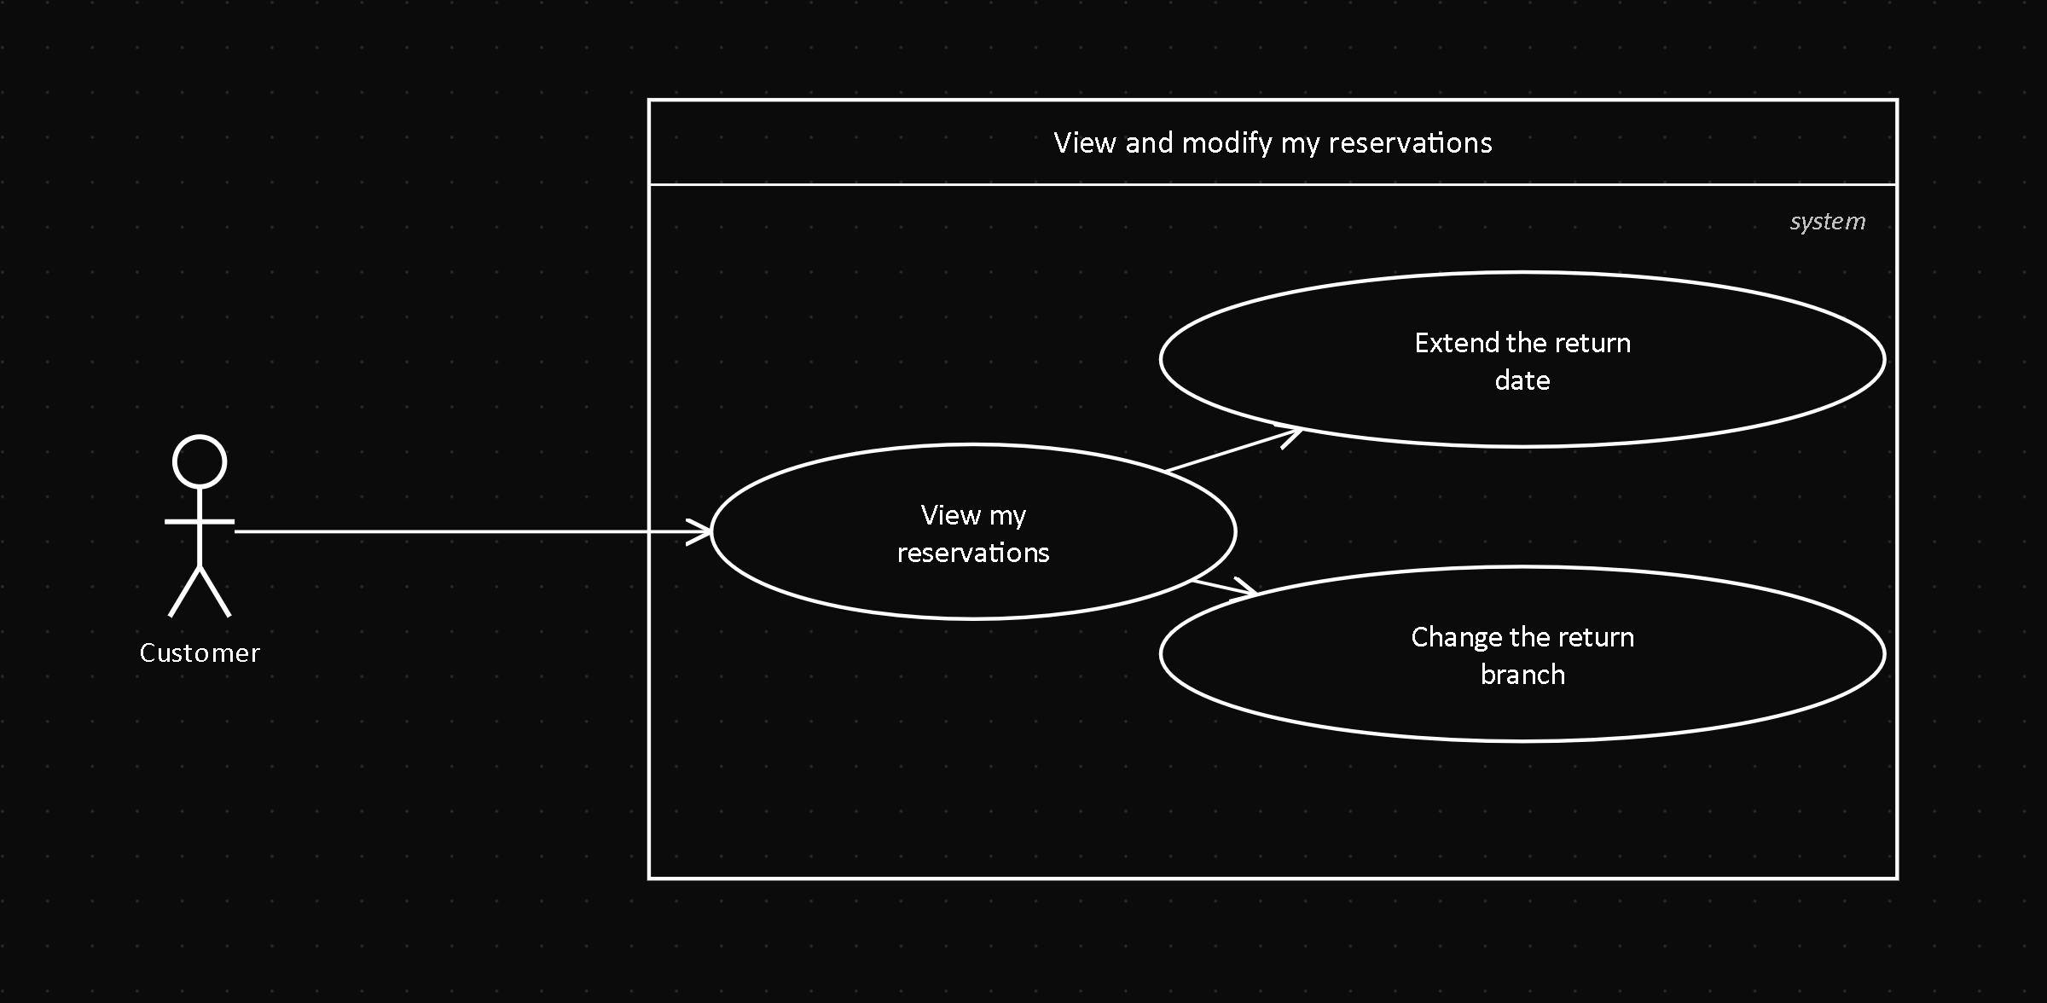
Field | Value
Actor | Customer
Related FR | FR3.2
Precondition | The Customer has at least one reservation
Postcondition | The return date or the return branch is updated

Description: the Customer views their reservations and can extend the return date or change the return branch, always with at least 3 days of notice.

UC08 — Cancel a reservation
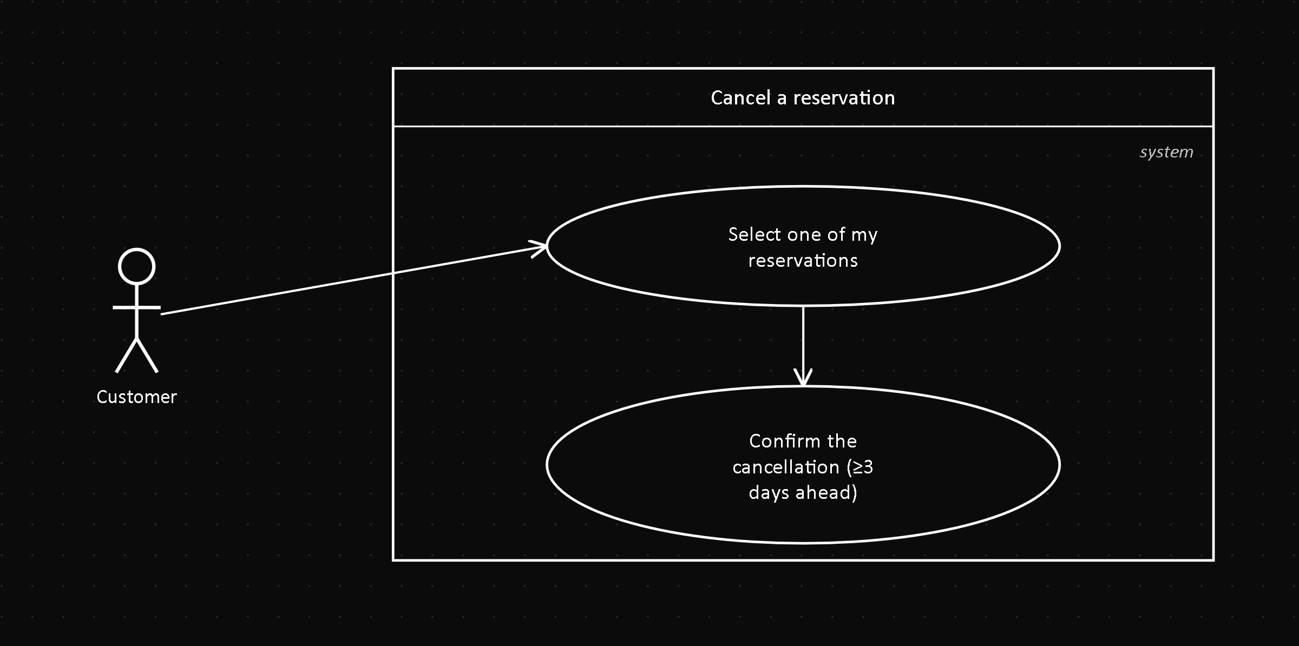
Field | Value
Actor | Customer
Related FR | FR3.3
Precondition | There are 3 or more days left before start_date
Postcondition | Reservation.status = CANCELLED, with no charge

Description: the Customer cancels their own reservation with no penalty, as long as there are at least 3 days left before the pickup date.

UC09 — Pay for a reservation
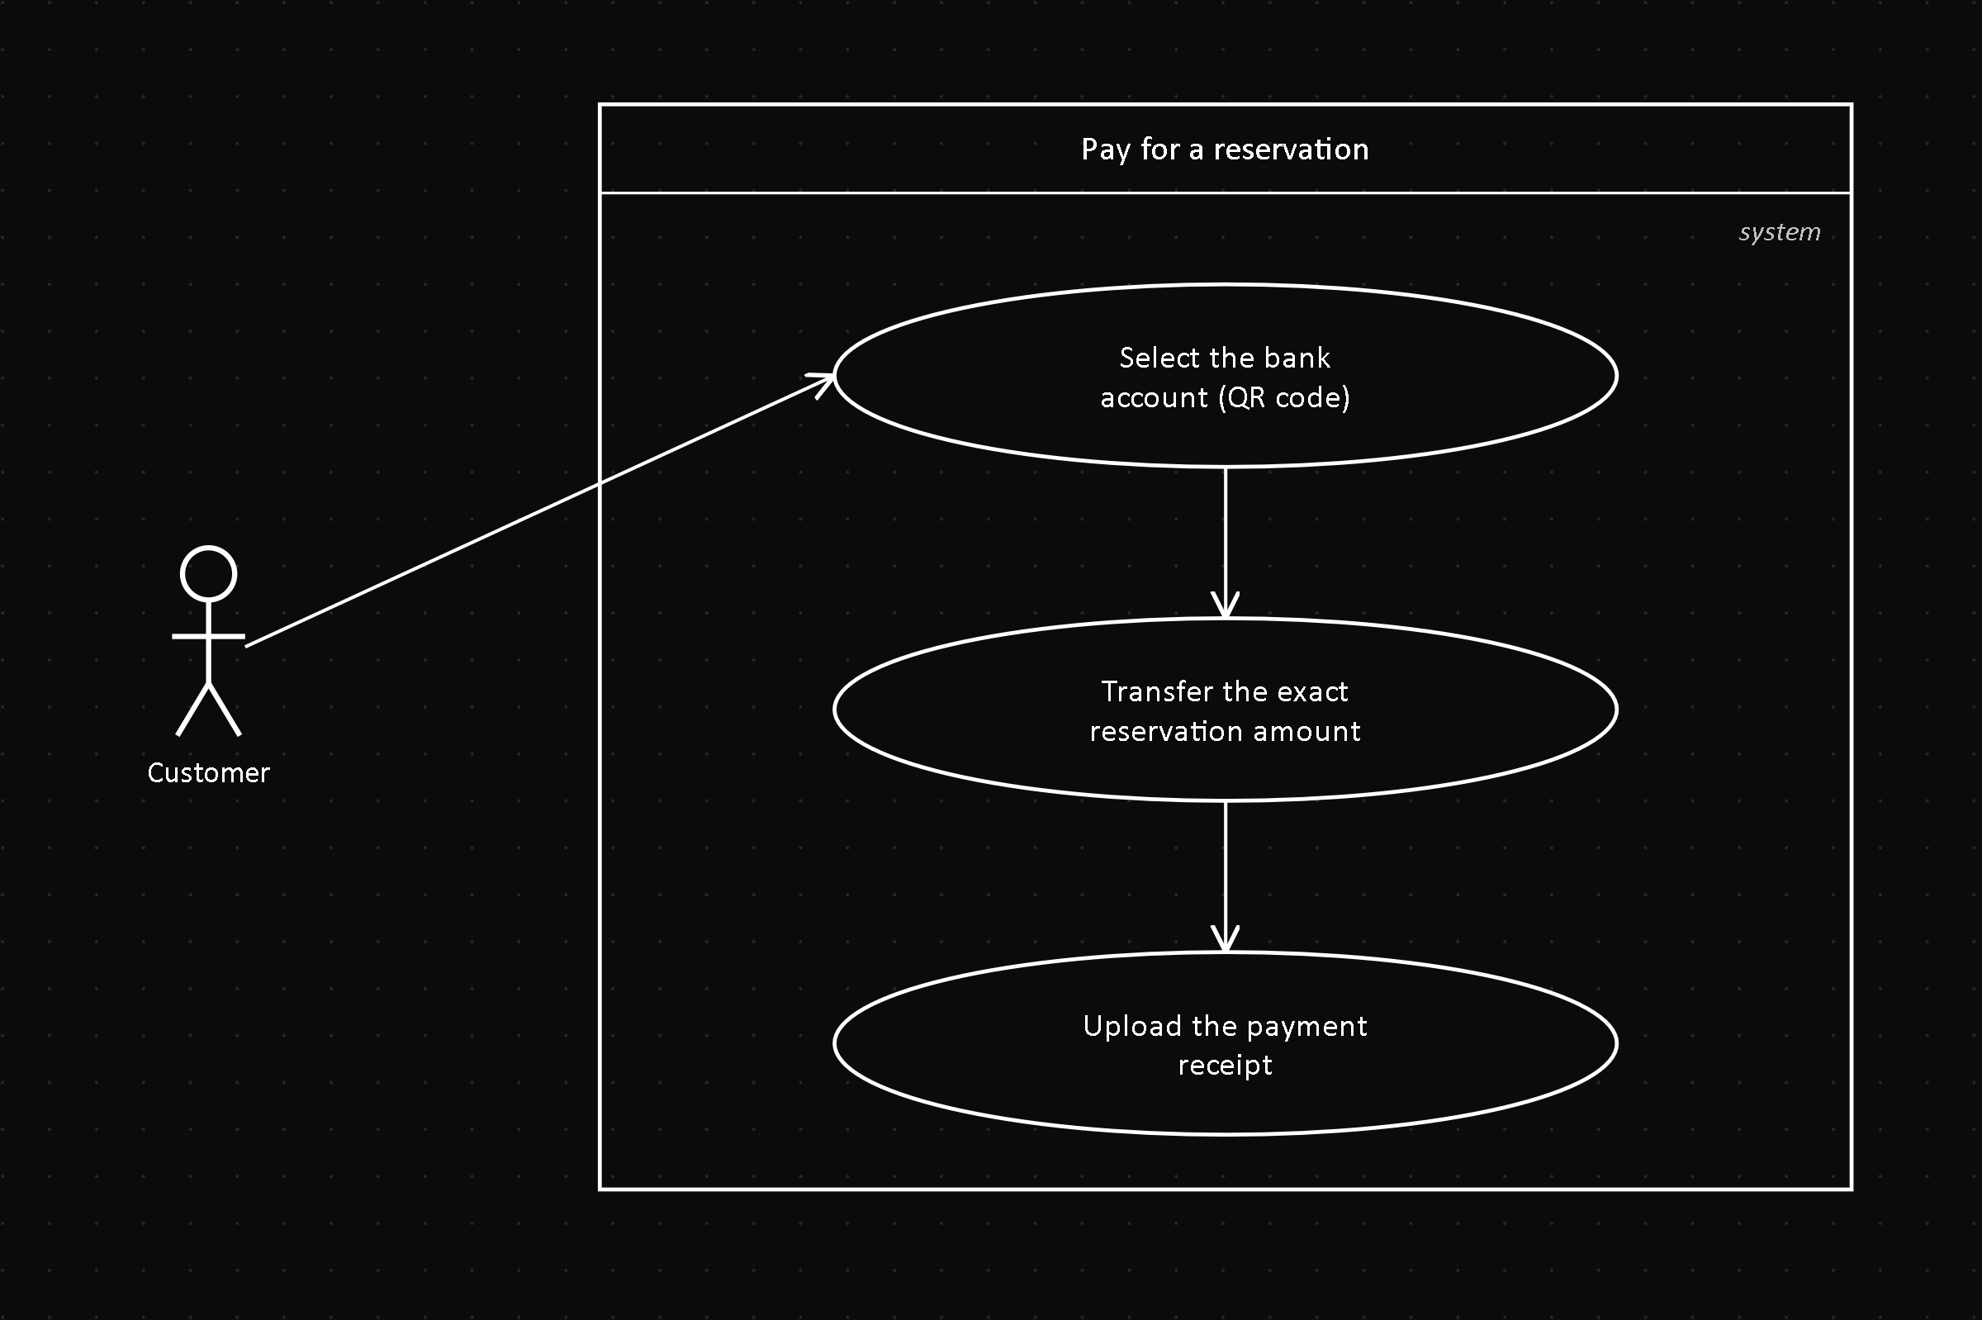
Field | Value
Actor | Customer
Related FR | FR5.1
Precondition | Reservation in PENDING_PAYMENT
Postcondition | A Payment is created in PENDING_REVIEW; the reservation moves to PENDING_REVIEW

Description: the Customer transfers to the bank account shown as a QR code and uploads the payment receipt for an Administrator to review.

UC10 — View my invoices
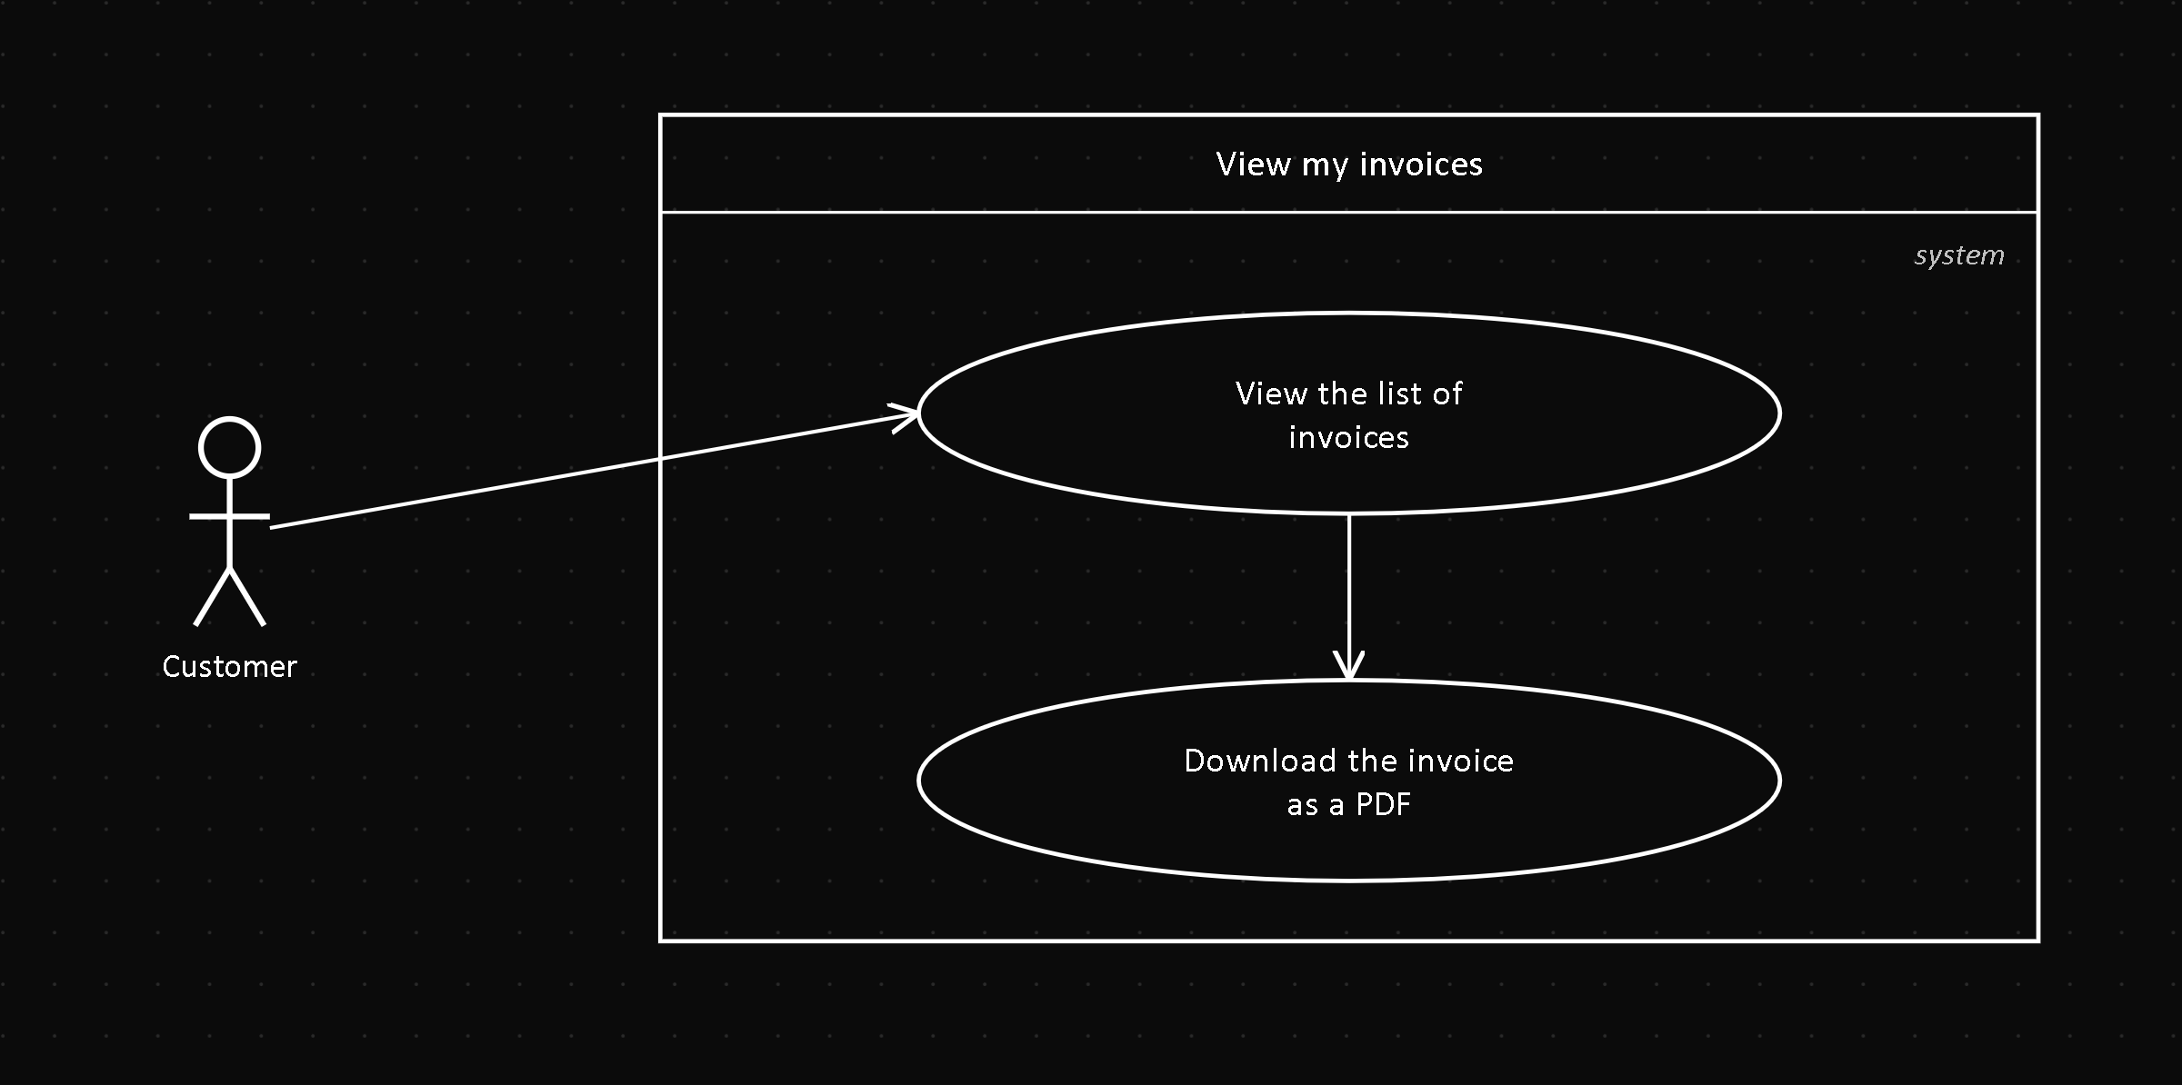
Field | Value
Actor | Customer
Related FR | FR5.2
Precondition | The Customer has at least one approved payment
Postcondition | The invoice PDF is shown or downloaded

Description: the Customer views and downloads the invoices automatically generated after an approved payment.

UC11 — View my notifications
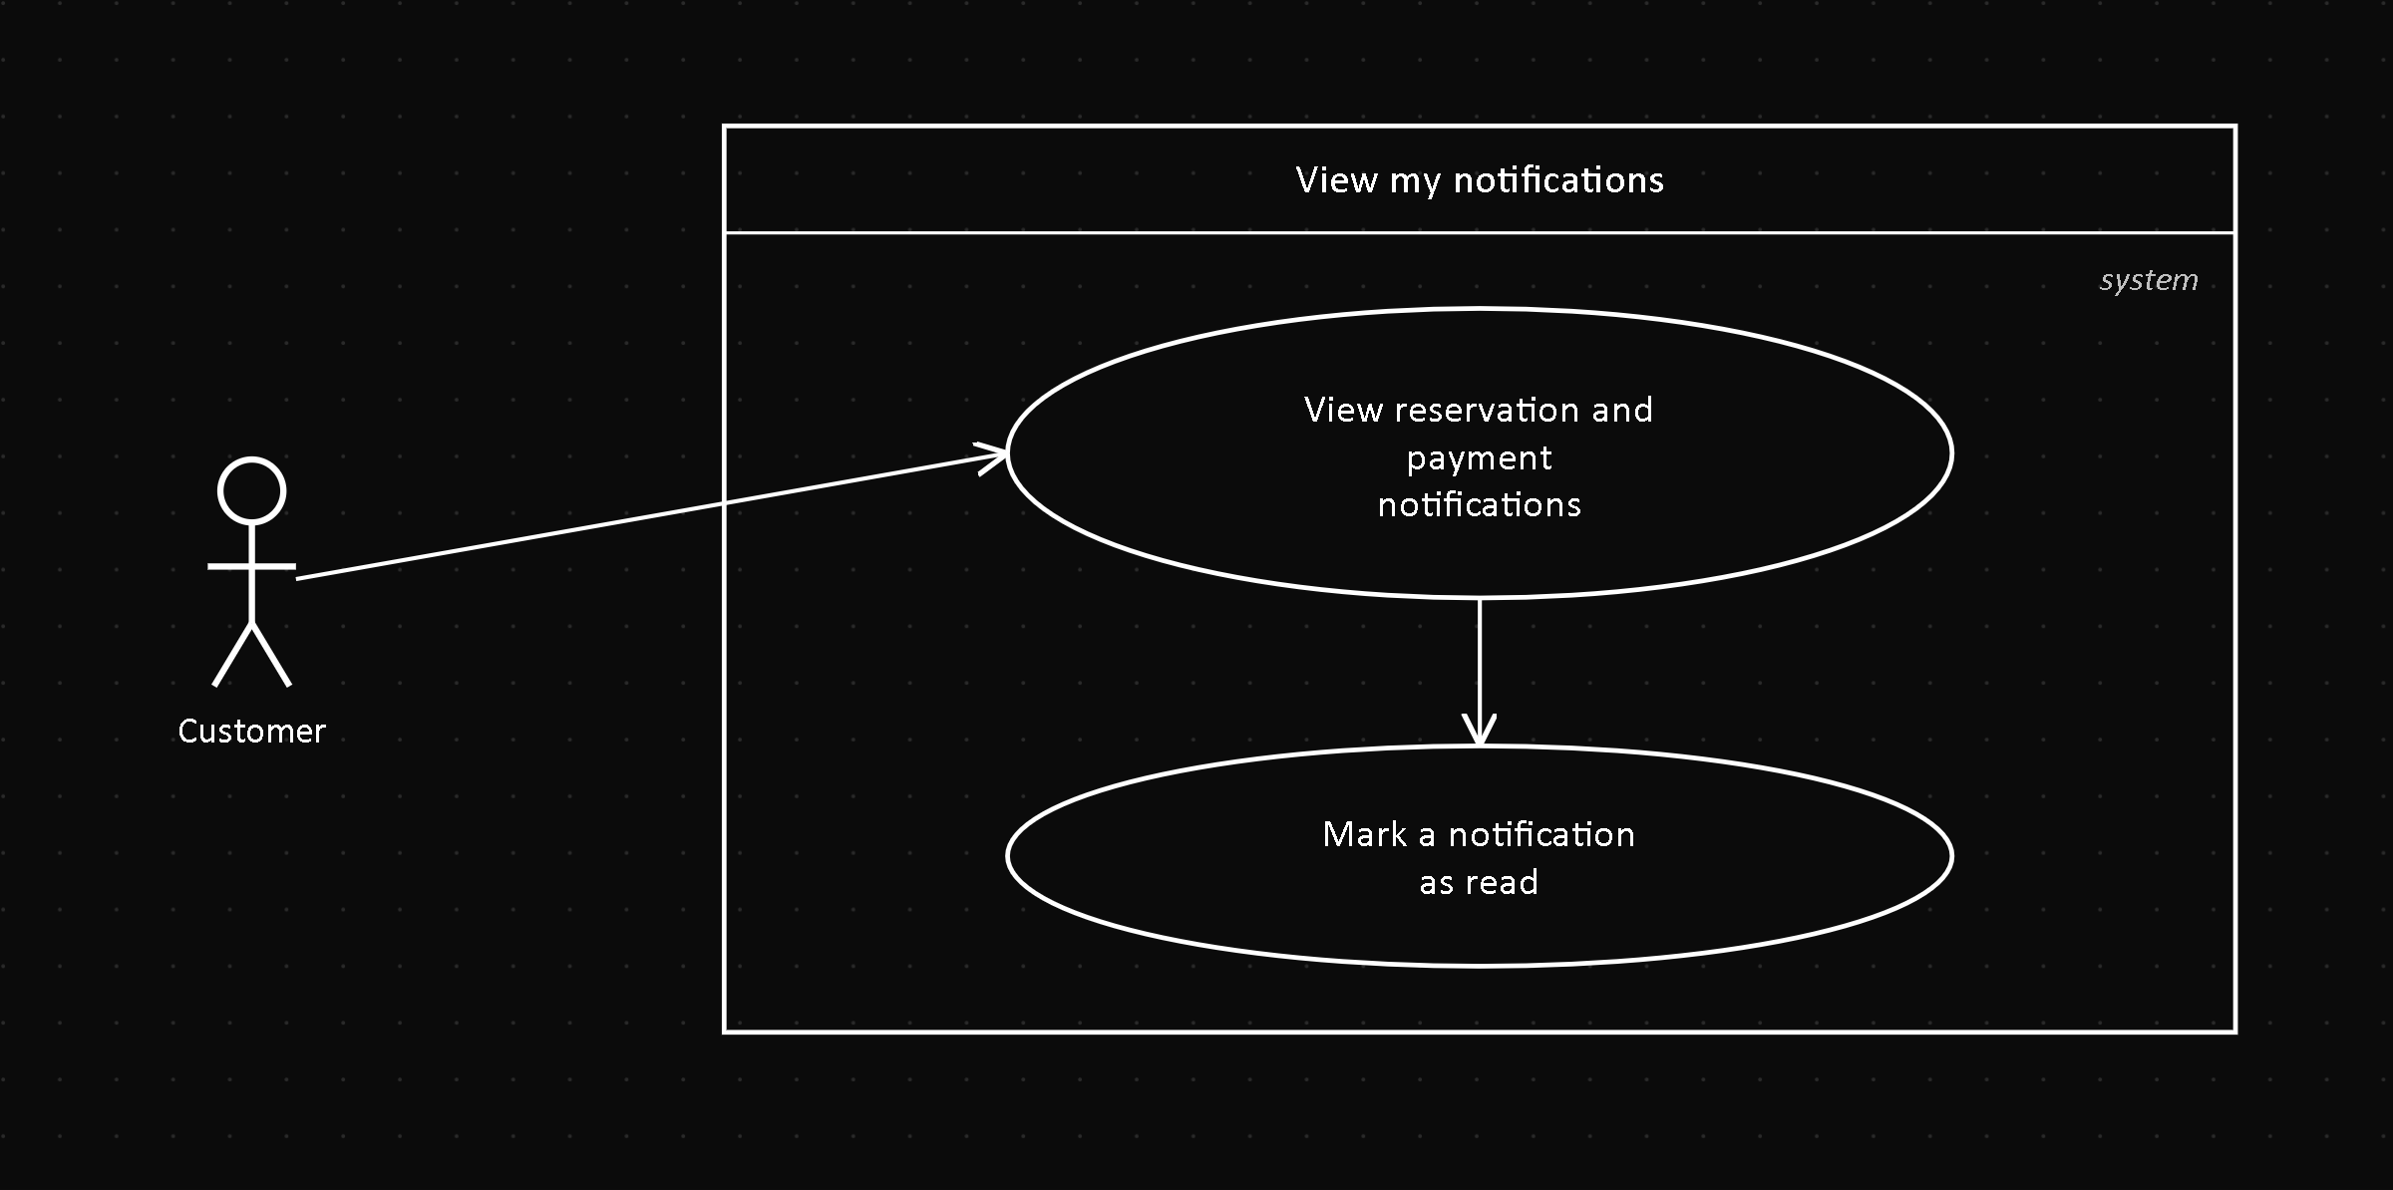
Field | Value
Actor | Customer
Related FR | FR7.1
Precondition | The Customer is authenticated
Postcondition | The viewed notifications can be marked as read

Description: the Customer sees, inside the application, the notifications generated by events on their reservations and payments.

UC12 — Manage vehicles
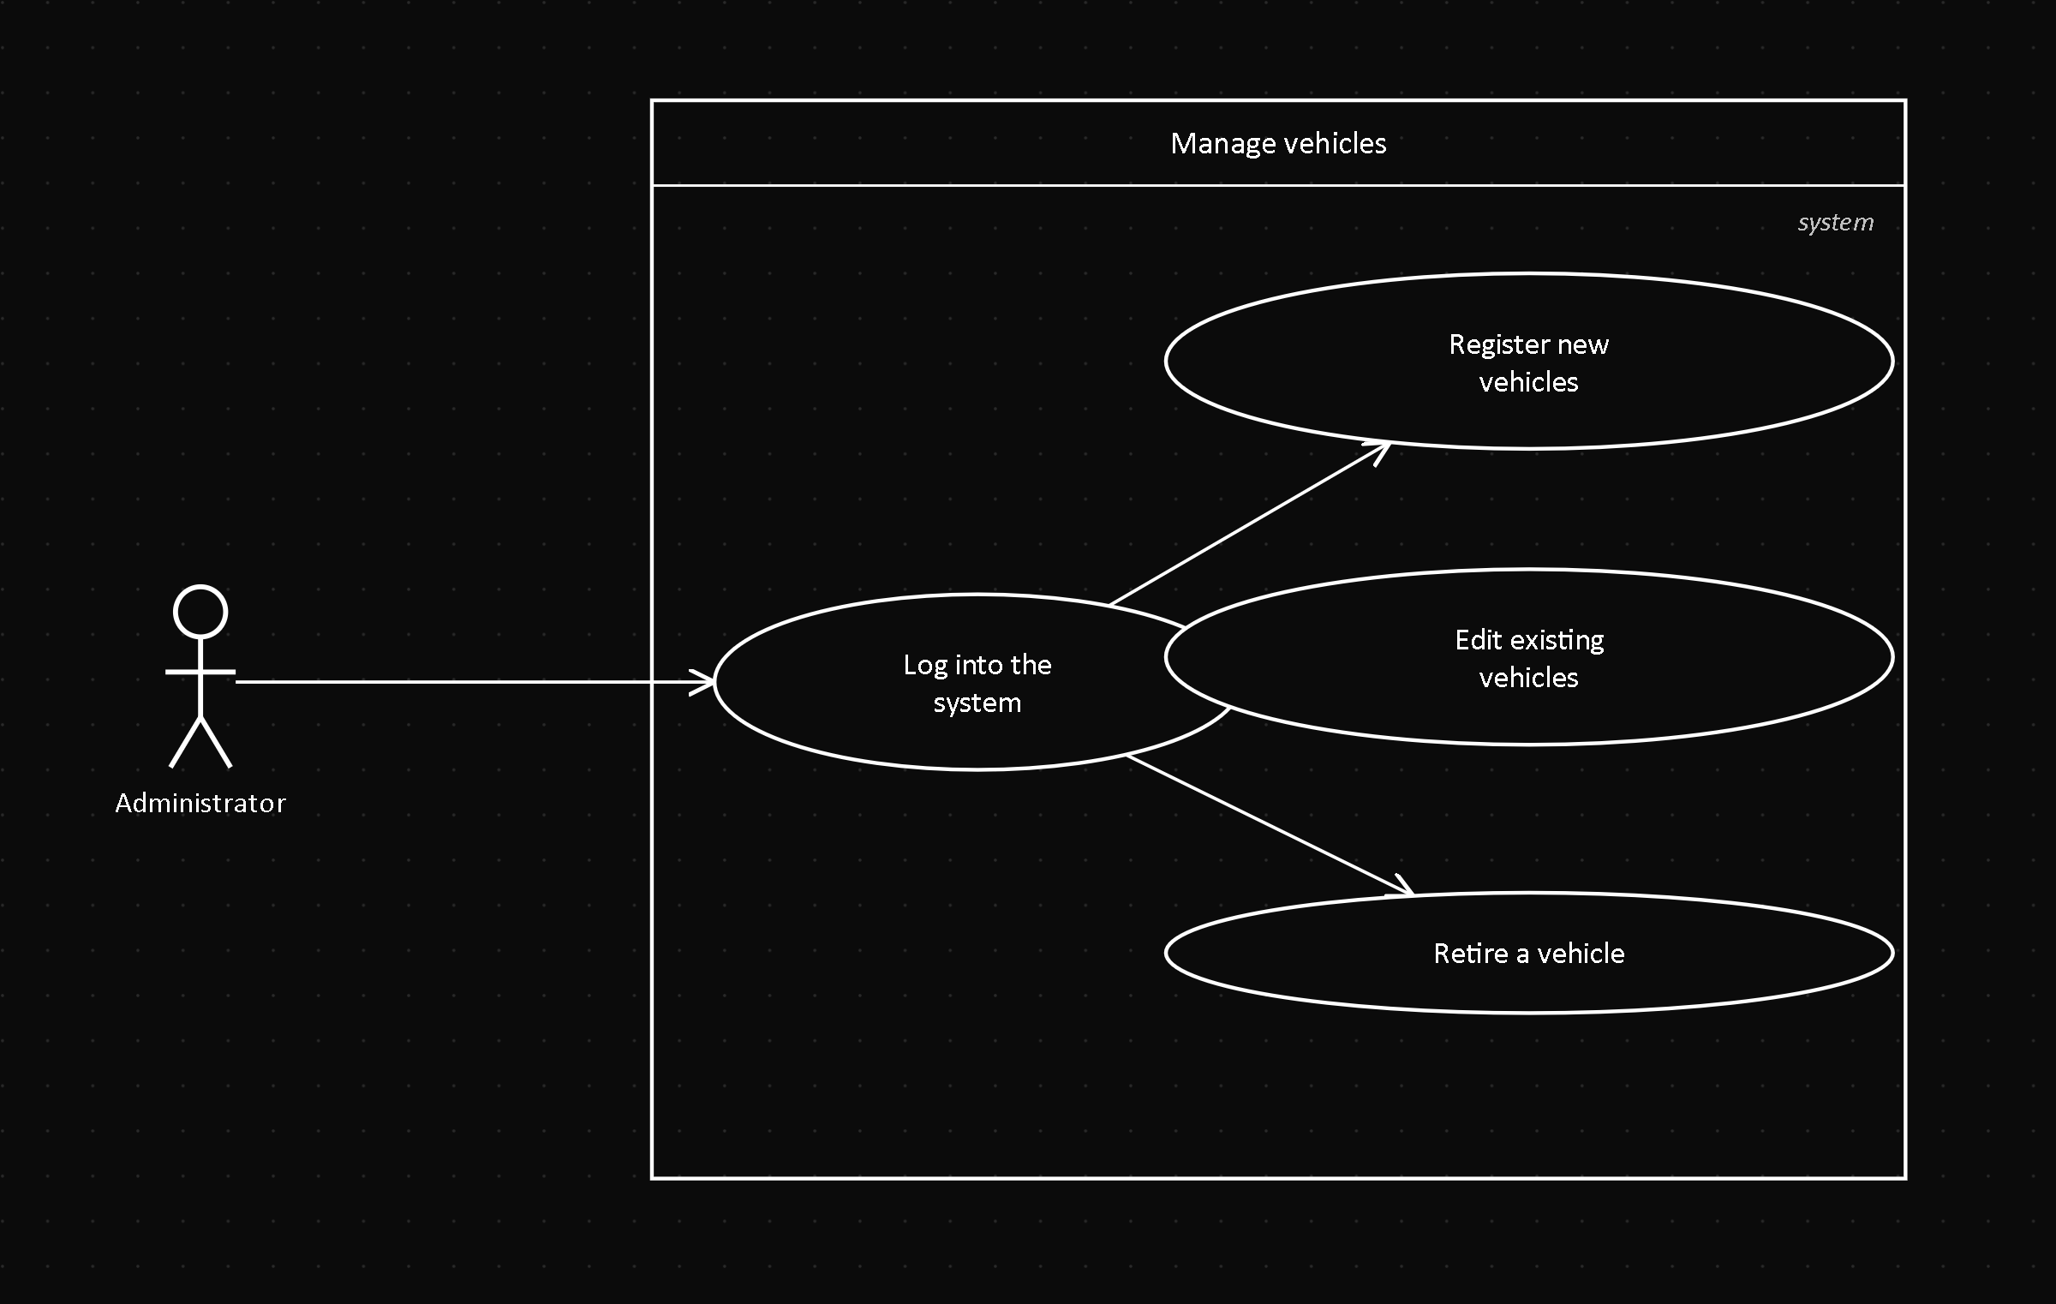
Field | Value
Actor | Administrator
Related FR | FR8.2
Precondition | The Administrator is authenticated
Postcondition | The vehicle catalog is updated

Description: the Administrator registers, edits or removes vehicles, and views the full inventory filtered by status.

UC13 — Manage branches
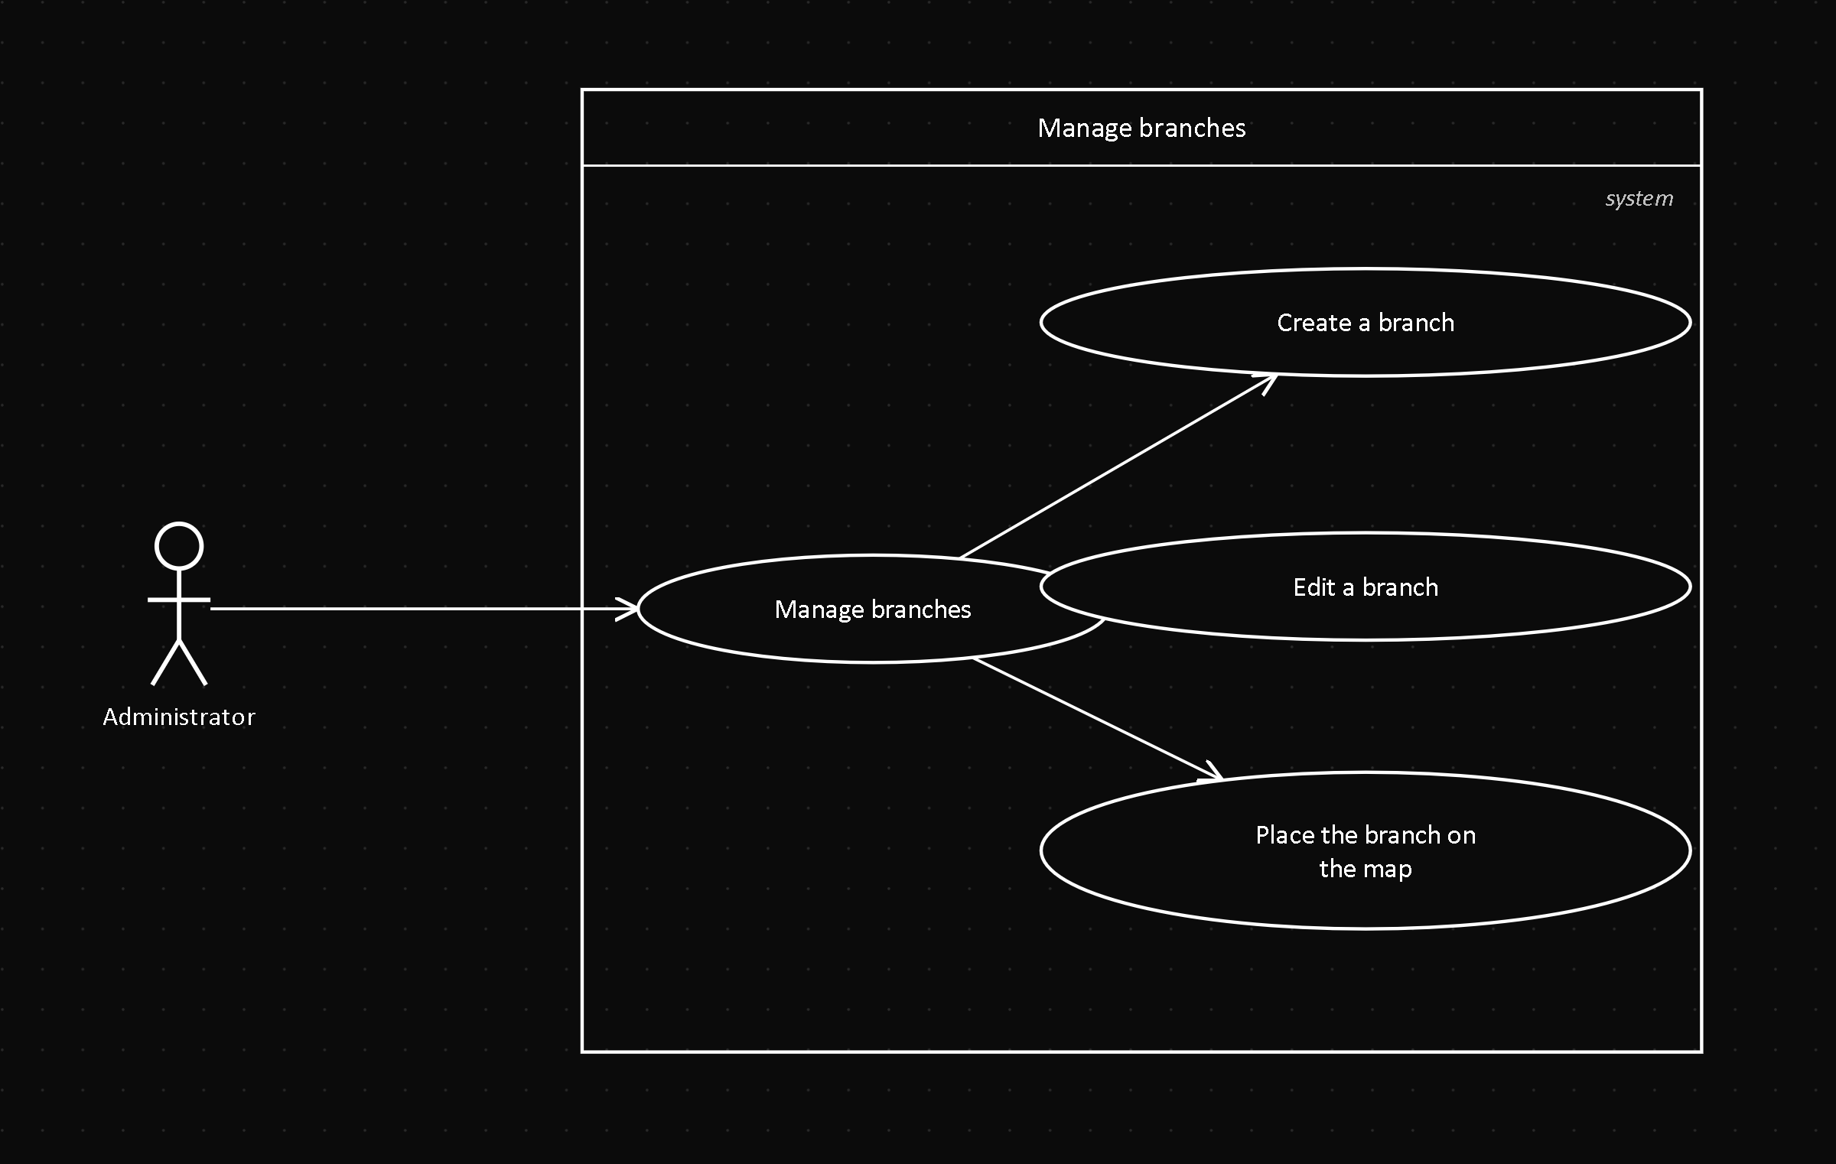
Field | Value
Actor | Administrator
Related FR | FR8.4
Precondition | The Administrator is authenticated
Postcondition | The branch is created, edited or removed

Description: the Administrator creates, edits or removes branches, and can place them on a map.

UC14 — Manage fleet maintenance
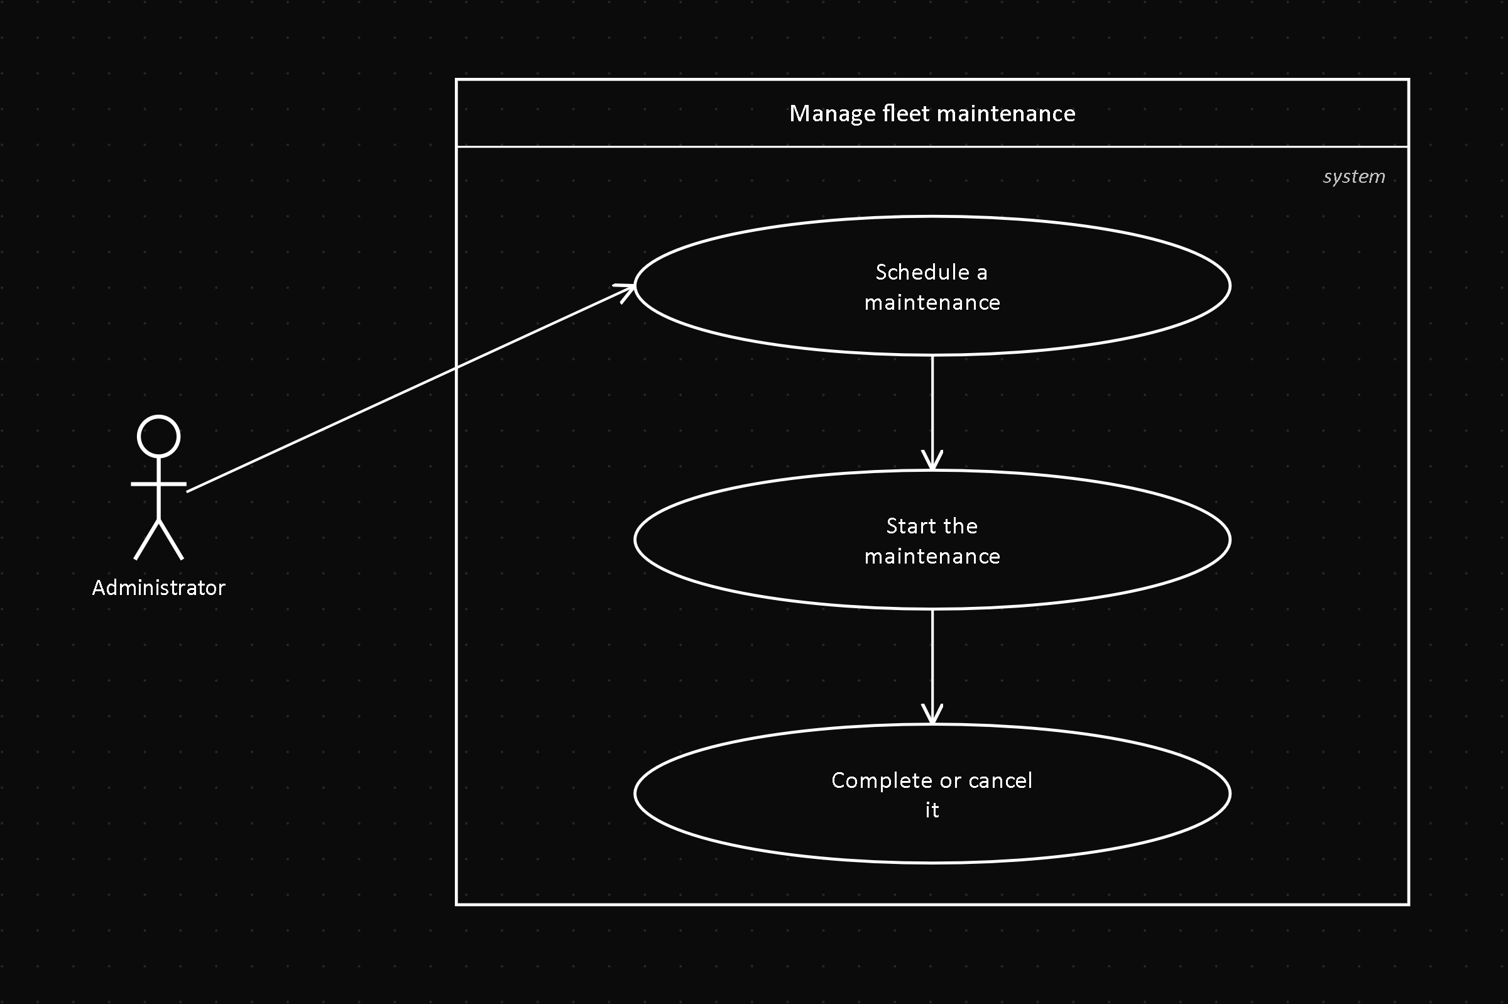
Field | Value
Actor | Administrator
Related FR | FR8.3, FR8.7
Precondition | The vehicle is not RETIRED
Postcondition | The maintenance is scheduled, started, completed or cancelled

Description: the Administrator schedules, starts, completes or cancels a vehicle's maintenance, and views its history.

UC15 — Register pickup and return
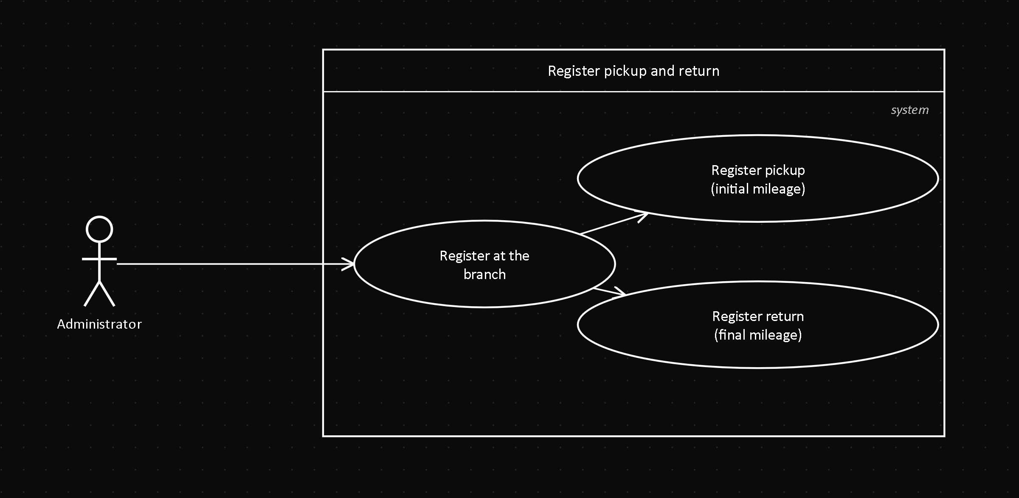
Field | Value
Actor | Administrator
Related FR | FR4.1, FR4.2
Precondition | Reservation in CONFIRMED (for pickup)
Postcondition | A Rental is created or completed; the vehicle's status changes

Description: the Administrator registers, at the branch, the physical delivery and return of the vehicle, with the initial and final mileage.

UC16 — Review payment receipts
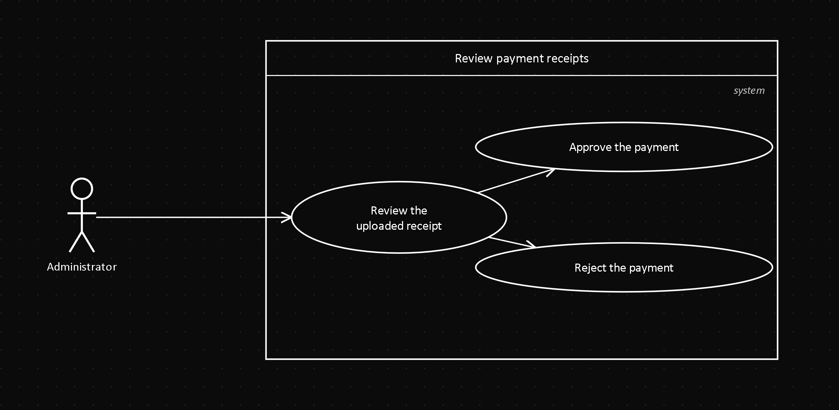
Field | Value
Actor | Administrator
Related FR | FR5.1, FR8.5
Precondition | There is a Payment in PENDING_REVIEW
Postcondition | The payment ends up APPROVED or REJECTED

Description: the Administrator reviews the receipt uploaded by the Customer and decides to approve or reject it.

UC17 — Manage company reservations
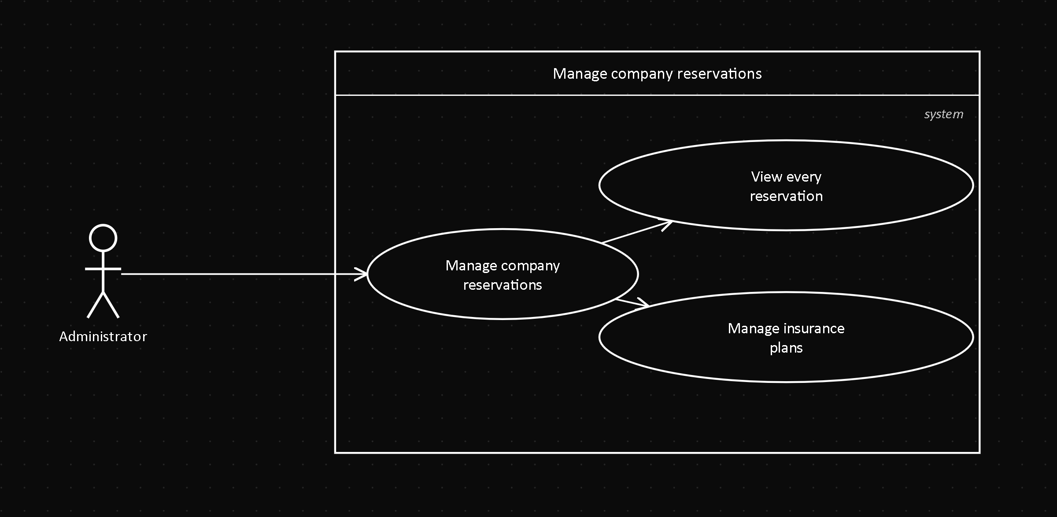
Field | Value
Actor | Administrator
Related FR | FR8.5
Precondition | The Administrator is authenticated
Postcondition | The full list of reservations is shown, with its payment information

Description: the Administrator views every reservation in the system, not only their own, and manages the available insurance plans.

UC18 — Track vehicle location
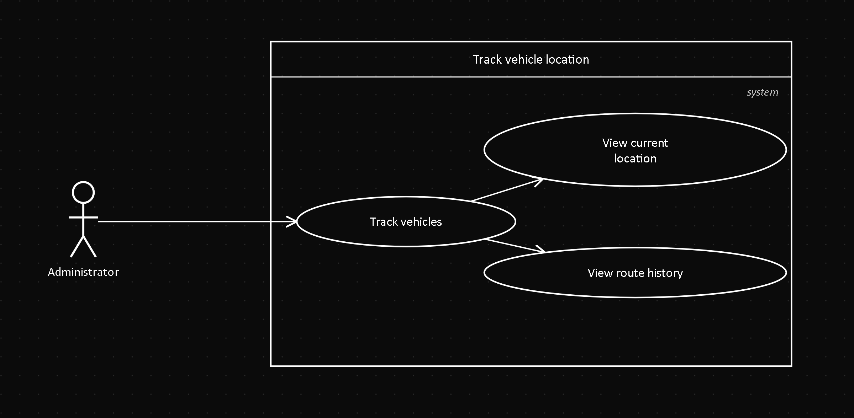
Field | Value
Actor | Administrator
Related FR | FR6.1, FR6.2
Precondition | The vehicle is, or was, in RENTED status
Postcondition | The current location or the route history is shown

Description: the Administrator views the last known location of a rented vehicle, or the full route history of an already-finished rental.

UC19 — Manage insurance plans
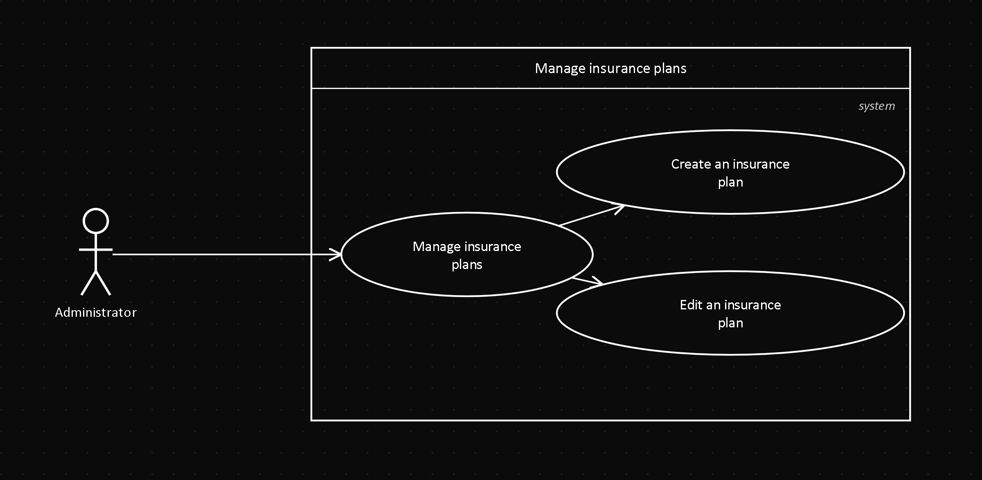
Field | Value
Actor | Administrator
Related FR | FR8.5
Precondition | The Administrator is authenticated
Postcondition | The insurance plan is created or edited

Description: the Administrator creates or edits the insurance plans (First Aid, Standard, All-Risk) that the Customer can choose when reserving.

UC20 — Manage administrative users
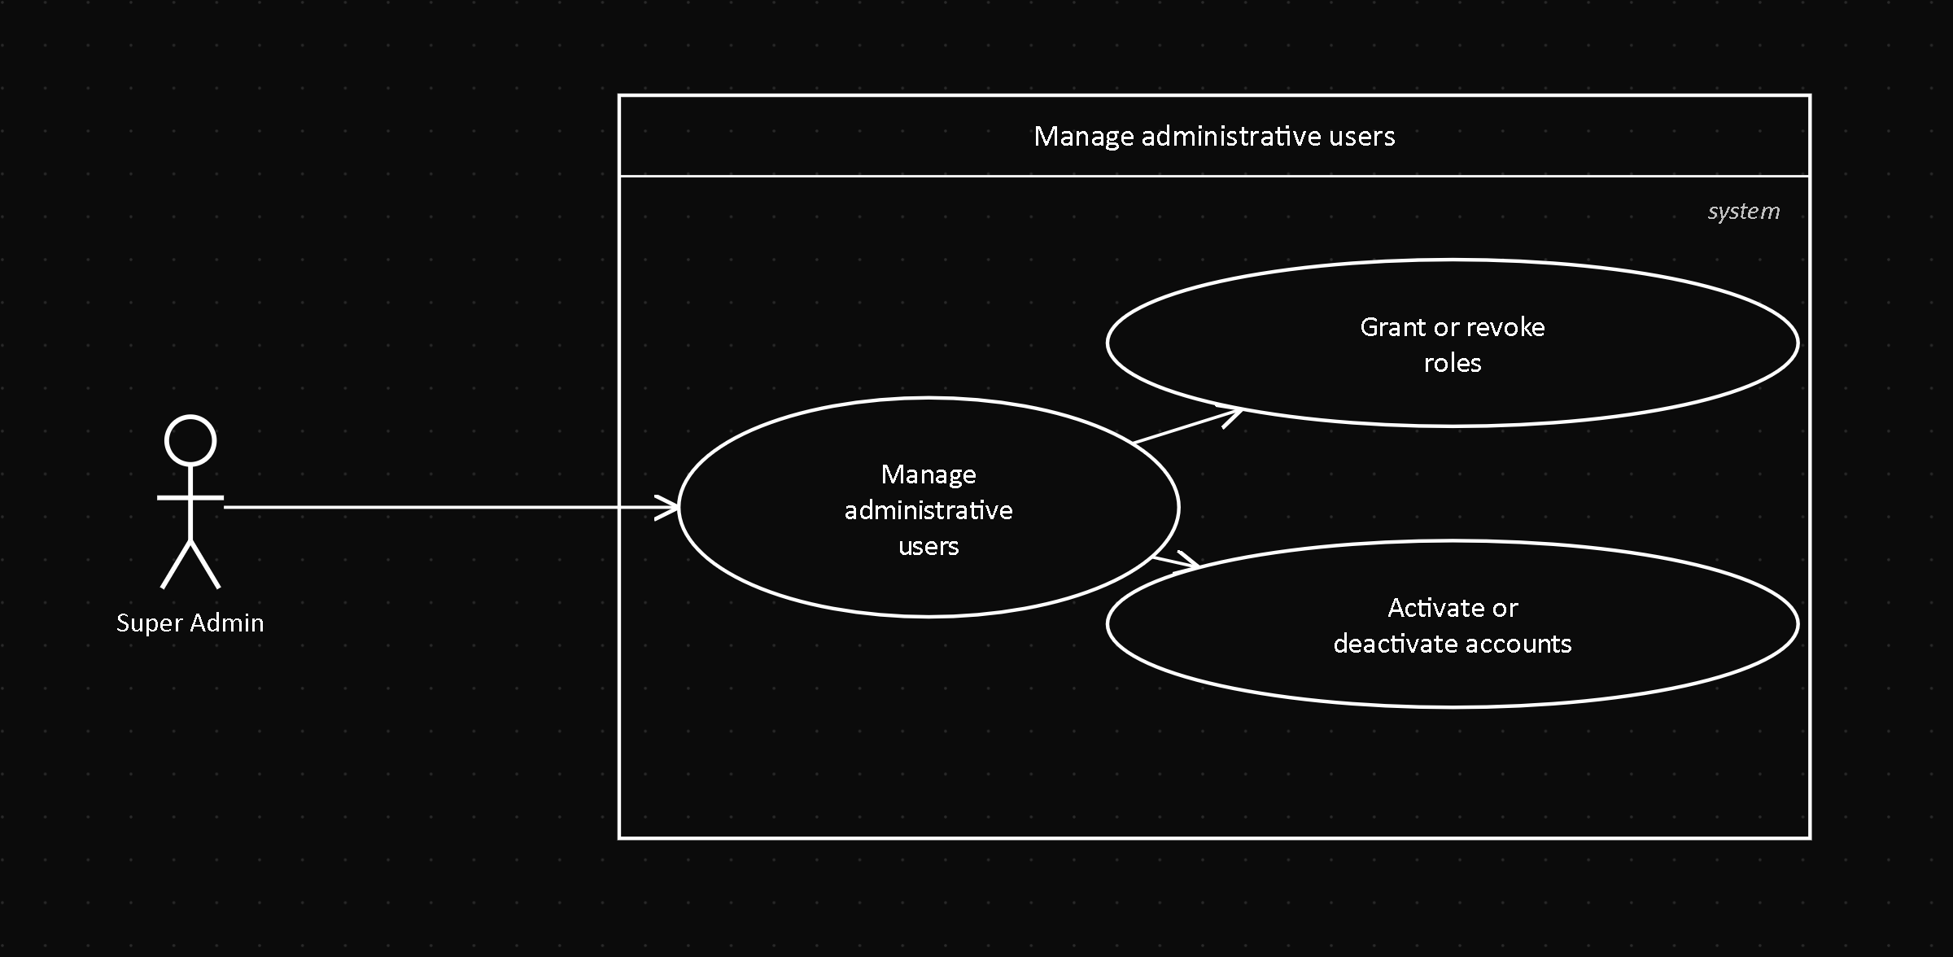
Field | Value
Actor | Super Admin
Related FR | FR8.1
Precondition | The Super Admin is authenticated
Postcondition | The account's role or status is updated

Description: the Super Admin grants or revokes administrative roles, and activates or deactivates user accounts.

UC21 — Manage bank accounts
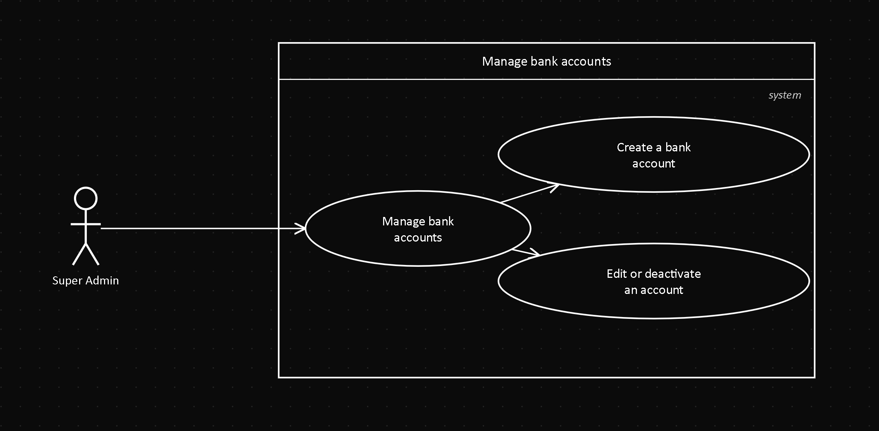
Field | Value
Actor | Super Admin
Related FR | FR8.6
Precondition | The Super Admin is authenticated
Postcondition | The bank account is created, edited or deactivated

Description: the Super Admin manages the company's bank accounts offered as a payment destination at checkout.

5. References
Document title | Reference
Software Requirements Specification | 01-informe-especificacion-requisitos/SRS.md (this repository)
Sequence diagrams | 02-Sequence-Diagrams.md (this folder)
Activity diagrams | 03-Activity-Diagrams.md (this folder)
State diagrams | 04-State-Diagrams.md (this folder)

