SOFTWARE ANALYSIS DOCUMENTATION — SEQUENCE DIAGRAMS
PROJECT: RENTAMOVIL — PLATFORM FOR A VEHICLE RENTAL COMPANY
TEAM MEMBERS: Thiago Fabian Rojas Guevara — David Santiago Erez Rodríguez — Nicole Dayana Ramírez Vargas
SERVICIO NACIONAL DE APRENDIZAJE — SENA — SOFTWARE ANALYSIS AND DEVELOPMENT 3145556
2026

1. Introduction
This document presents the sequence diagrams of RentaMovil's main flows: the messages exchanged between the actor, the API Gateway, the microservices and the database for each operation. It is the second of the four dynamic views of the software analysis; the use cases, the activity diagrams and the state diagrams are in separate documents inside this same folder.
Note on service names: the diagrams use the physical deployment names of the microservices (api-gateway, iam, fleet-maintenance, booking-reservation, payment-billing, telemetry-gps), not the conceptual Bounded Context names from the SRS. The Rental Execution and Notification flows, which appear as their own contexts in the SRS, physically run inside booking-reservation — they are part of the same lifecycle and don't need to be deployed as separate services.

SEQ-01 — Customer registration
Field | Value
Actor | Visitor
Related FR | FR1.1
Precondition | The visitor has no account in the system
Postcondition | A Person and a User are created with the CLIENT role

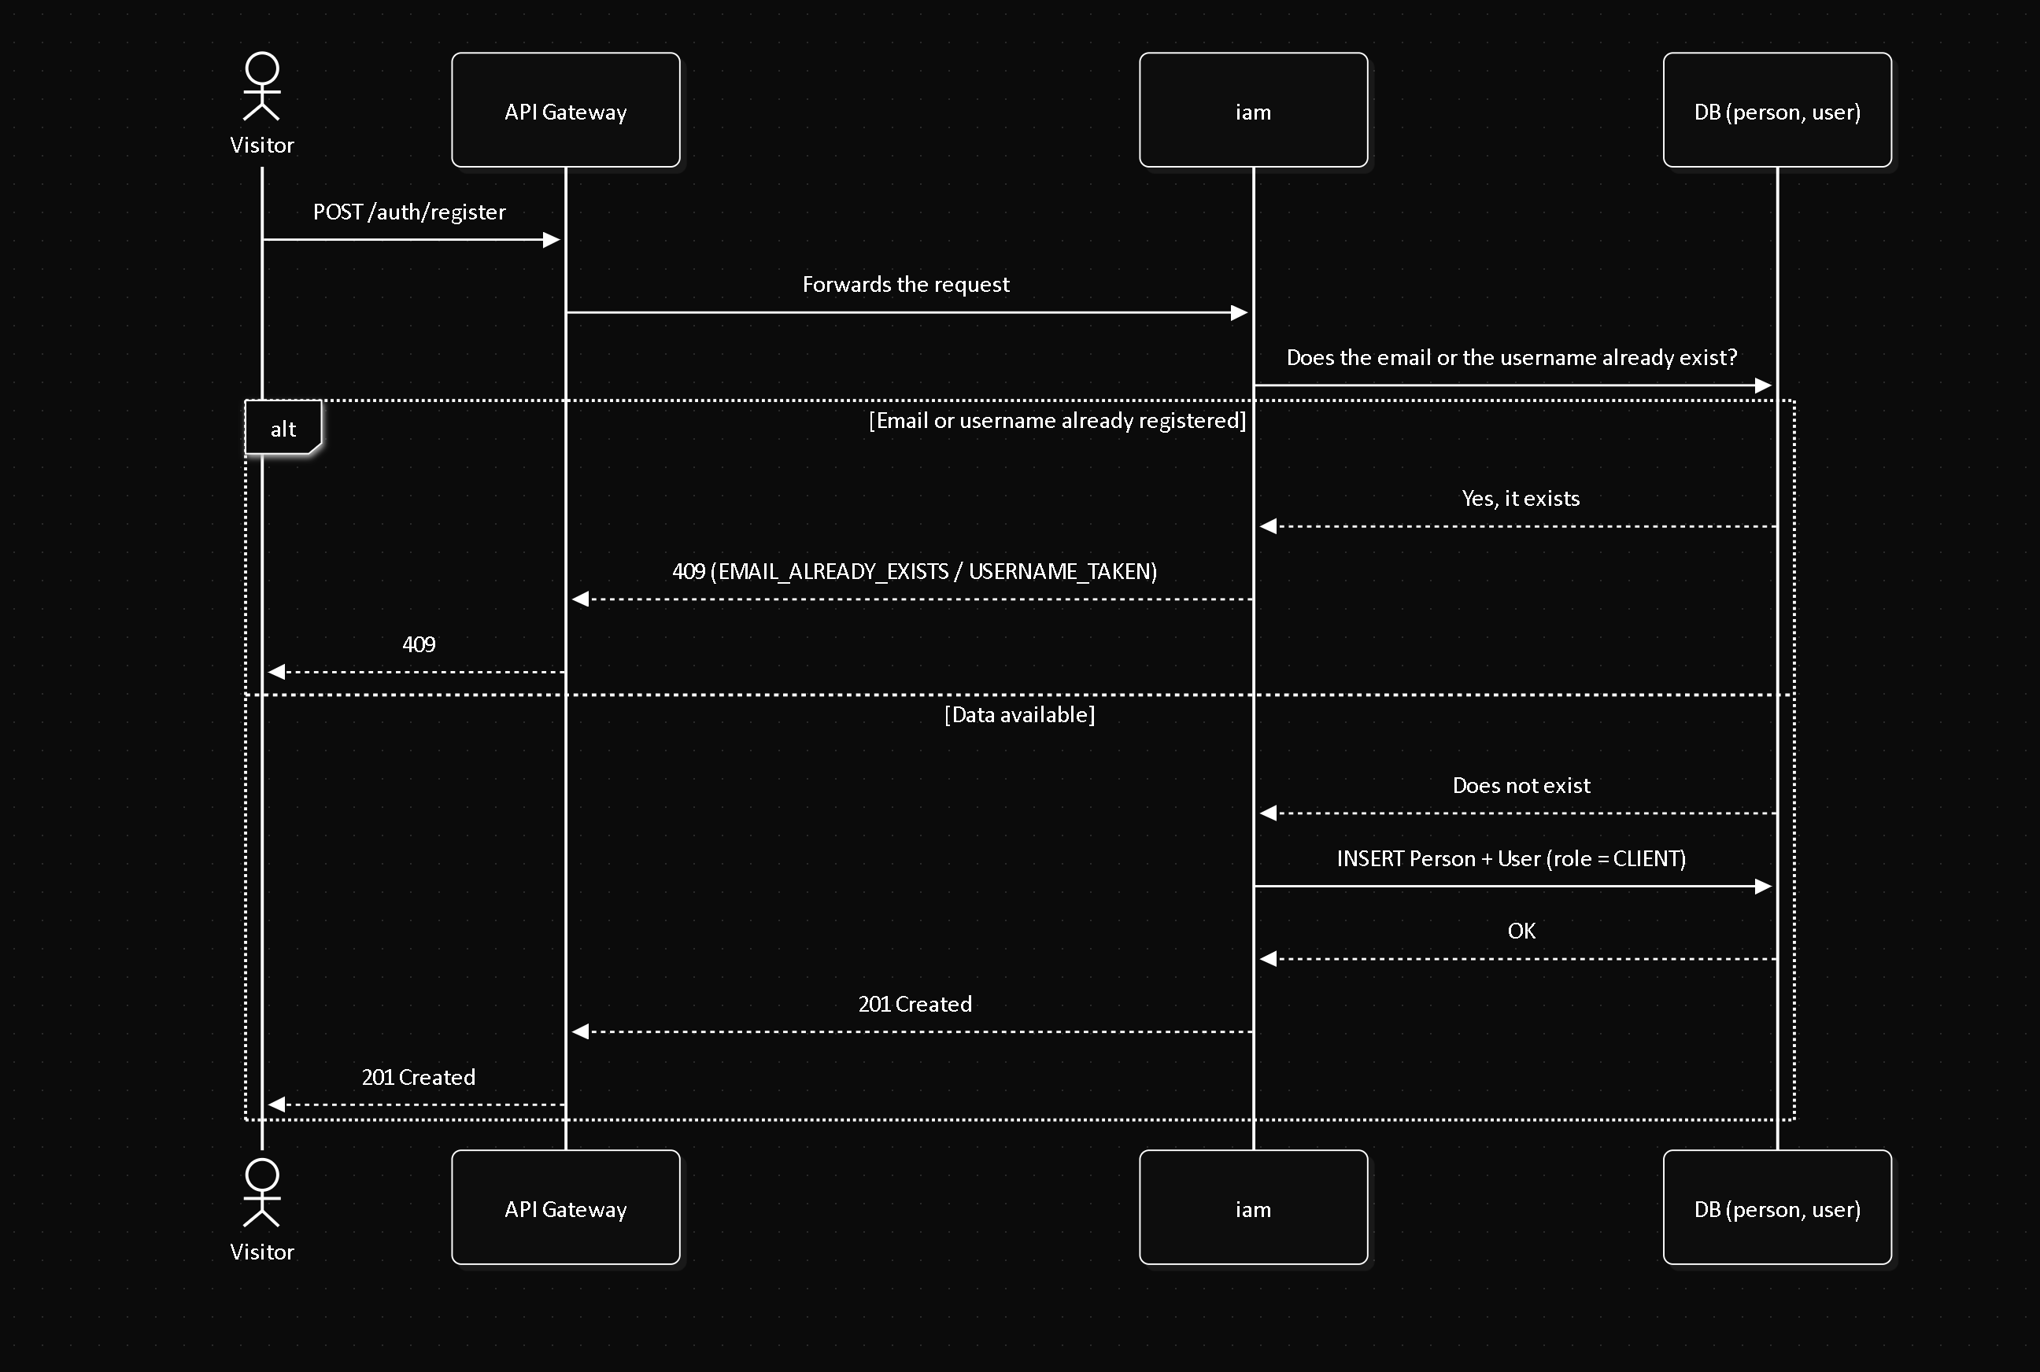

SEQ-02 — Login
Field | Value
Actor | Customer (or any registered user)
Related FR | FR1.2
Precondition | The user has an active account
Postcondition | An access token and a refresh token are issued

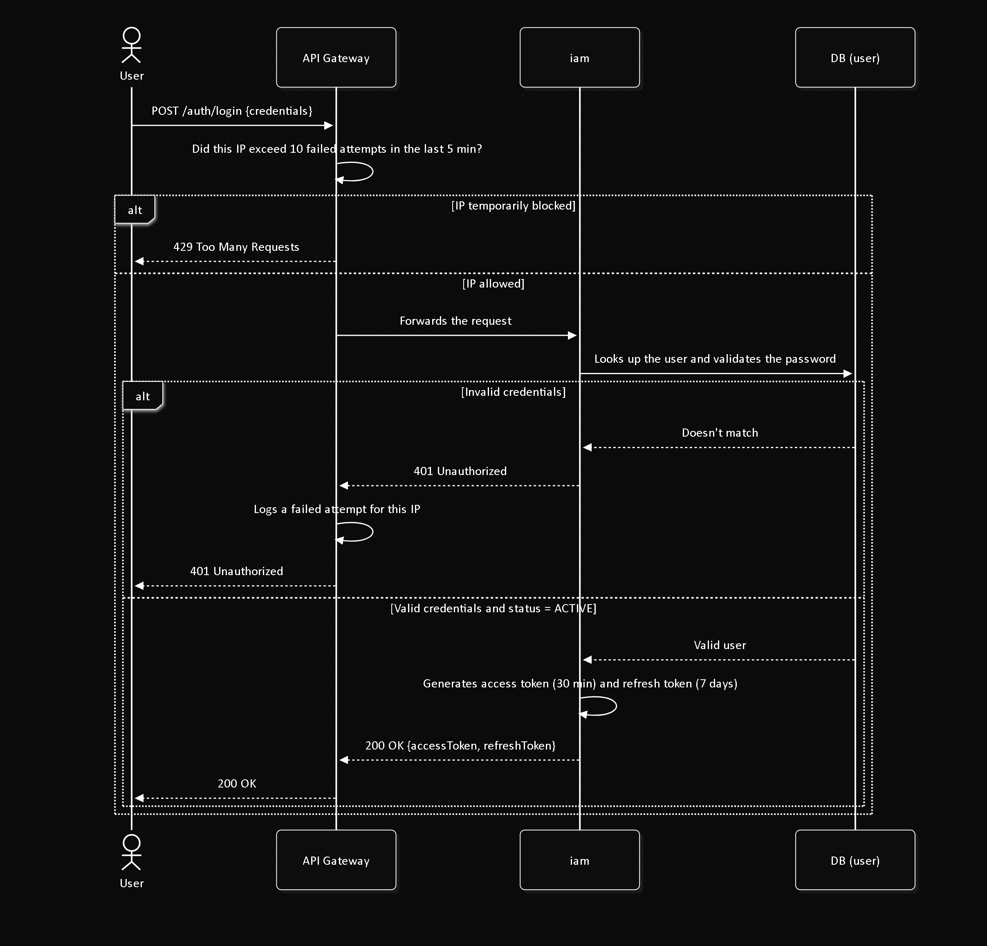

SEQ-03 — Create a reservation
Field | Value
Actor | Customer
Related FR | FR3.1, FR2.2
Precondition | Customer authenticated; the vehicle exists
Postcondition | A Reservation is created in PENDING_PAYMENT; the Administrator is notified

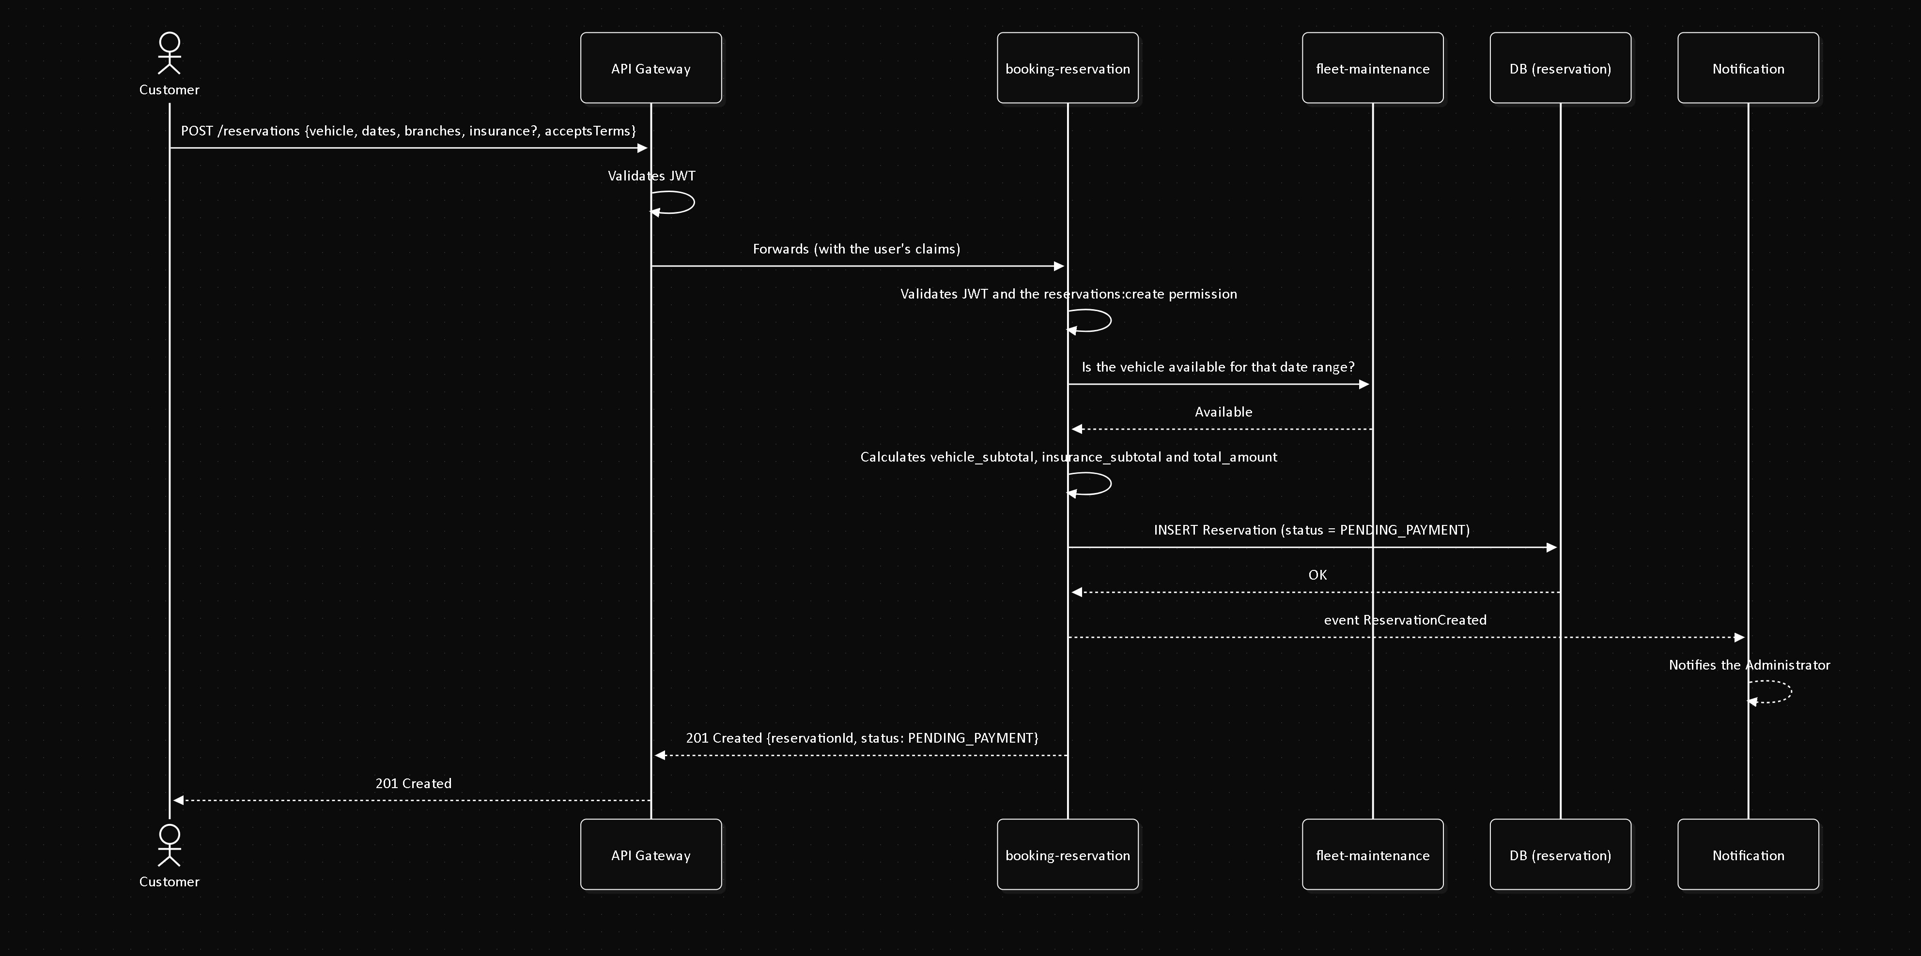

SEQ-04 — Pay for a reservation (receipt review)
Field | Value
Actors | Customer, Administrator
Related FR | FR5.1
Precondition | Reservation in PENDING_PAYMENT
Postcondition | Reservation CONFIRMED (approved) or PENDING_PAYMENT/CANCELLED (rejected)

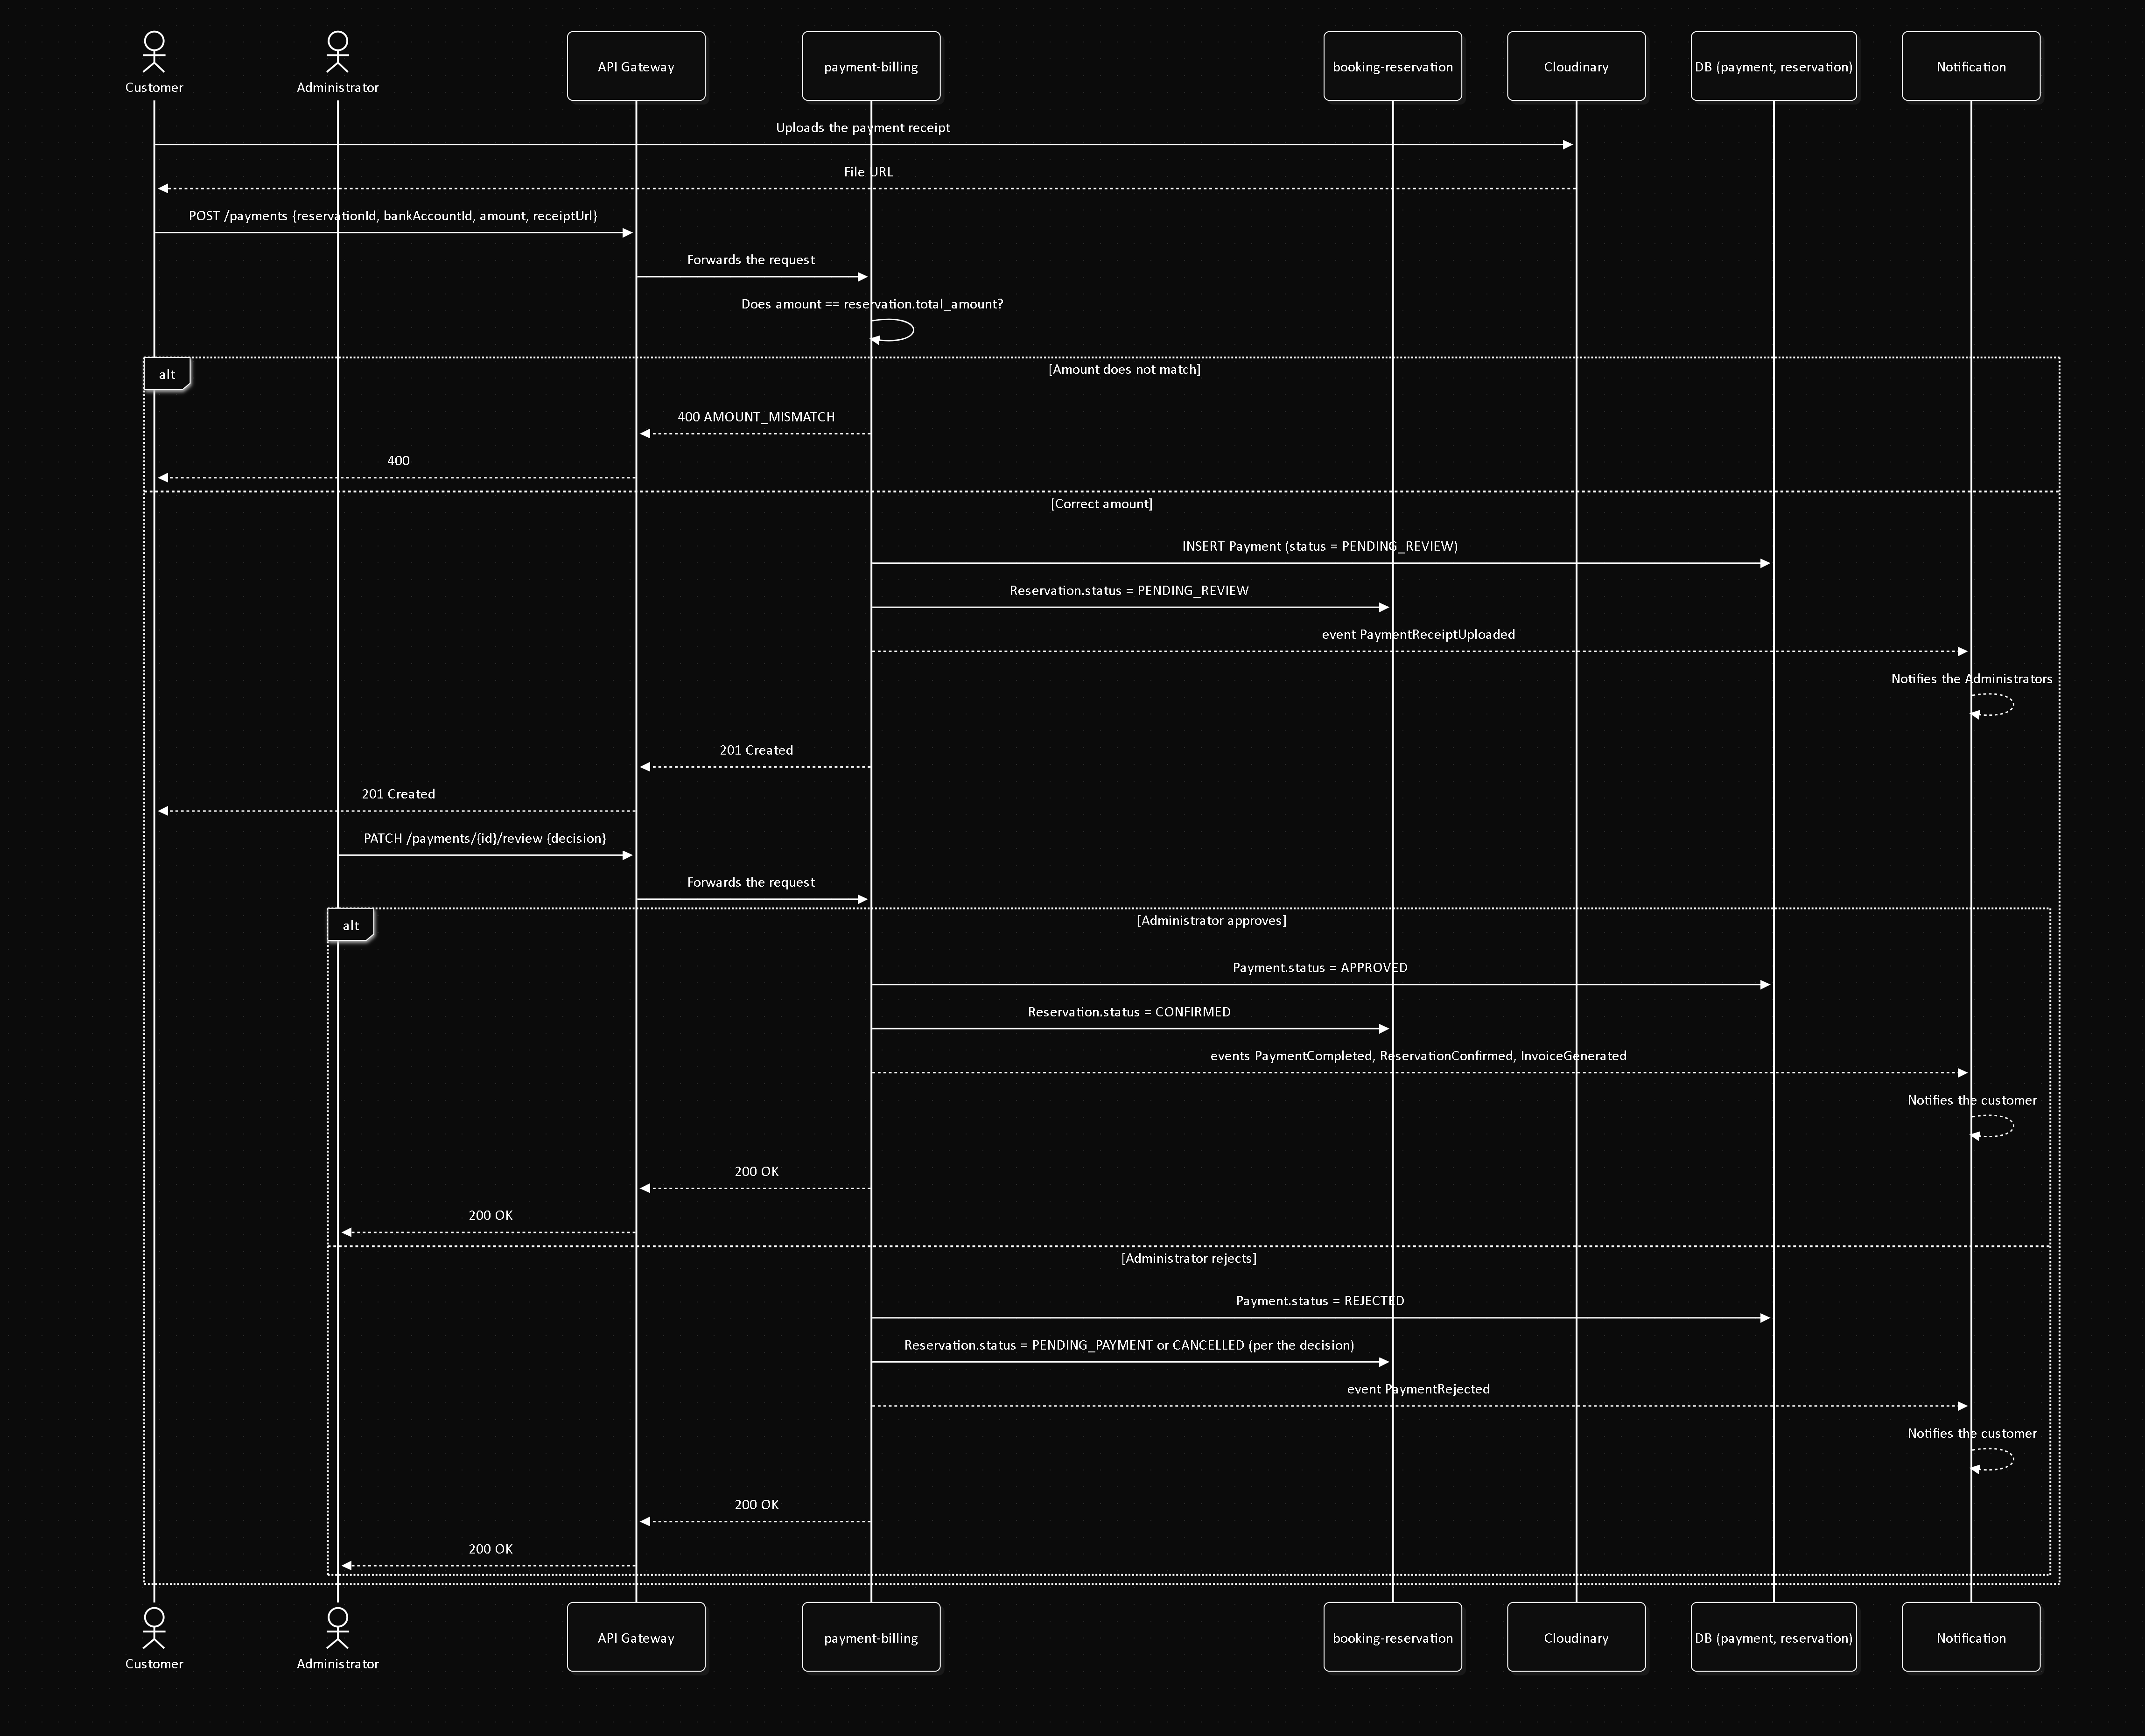

SEQ-05 — Execute the rental (pickup, return and invoice)
Field | Value
Actor | Administrator
Related FR | FR4.1, FR4.2, FR5.2
Precondition | Reservation in CONFIRMED
Postcondition | Rental completed, Vehicle available again, invoice generated

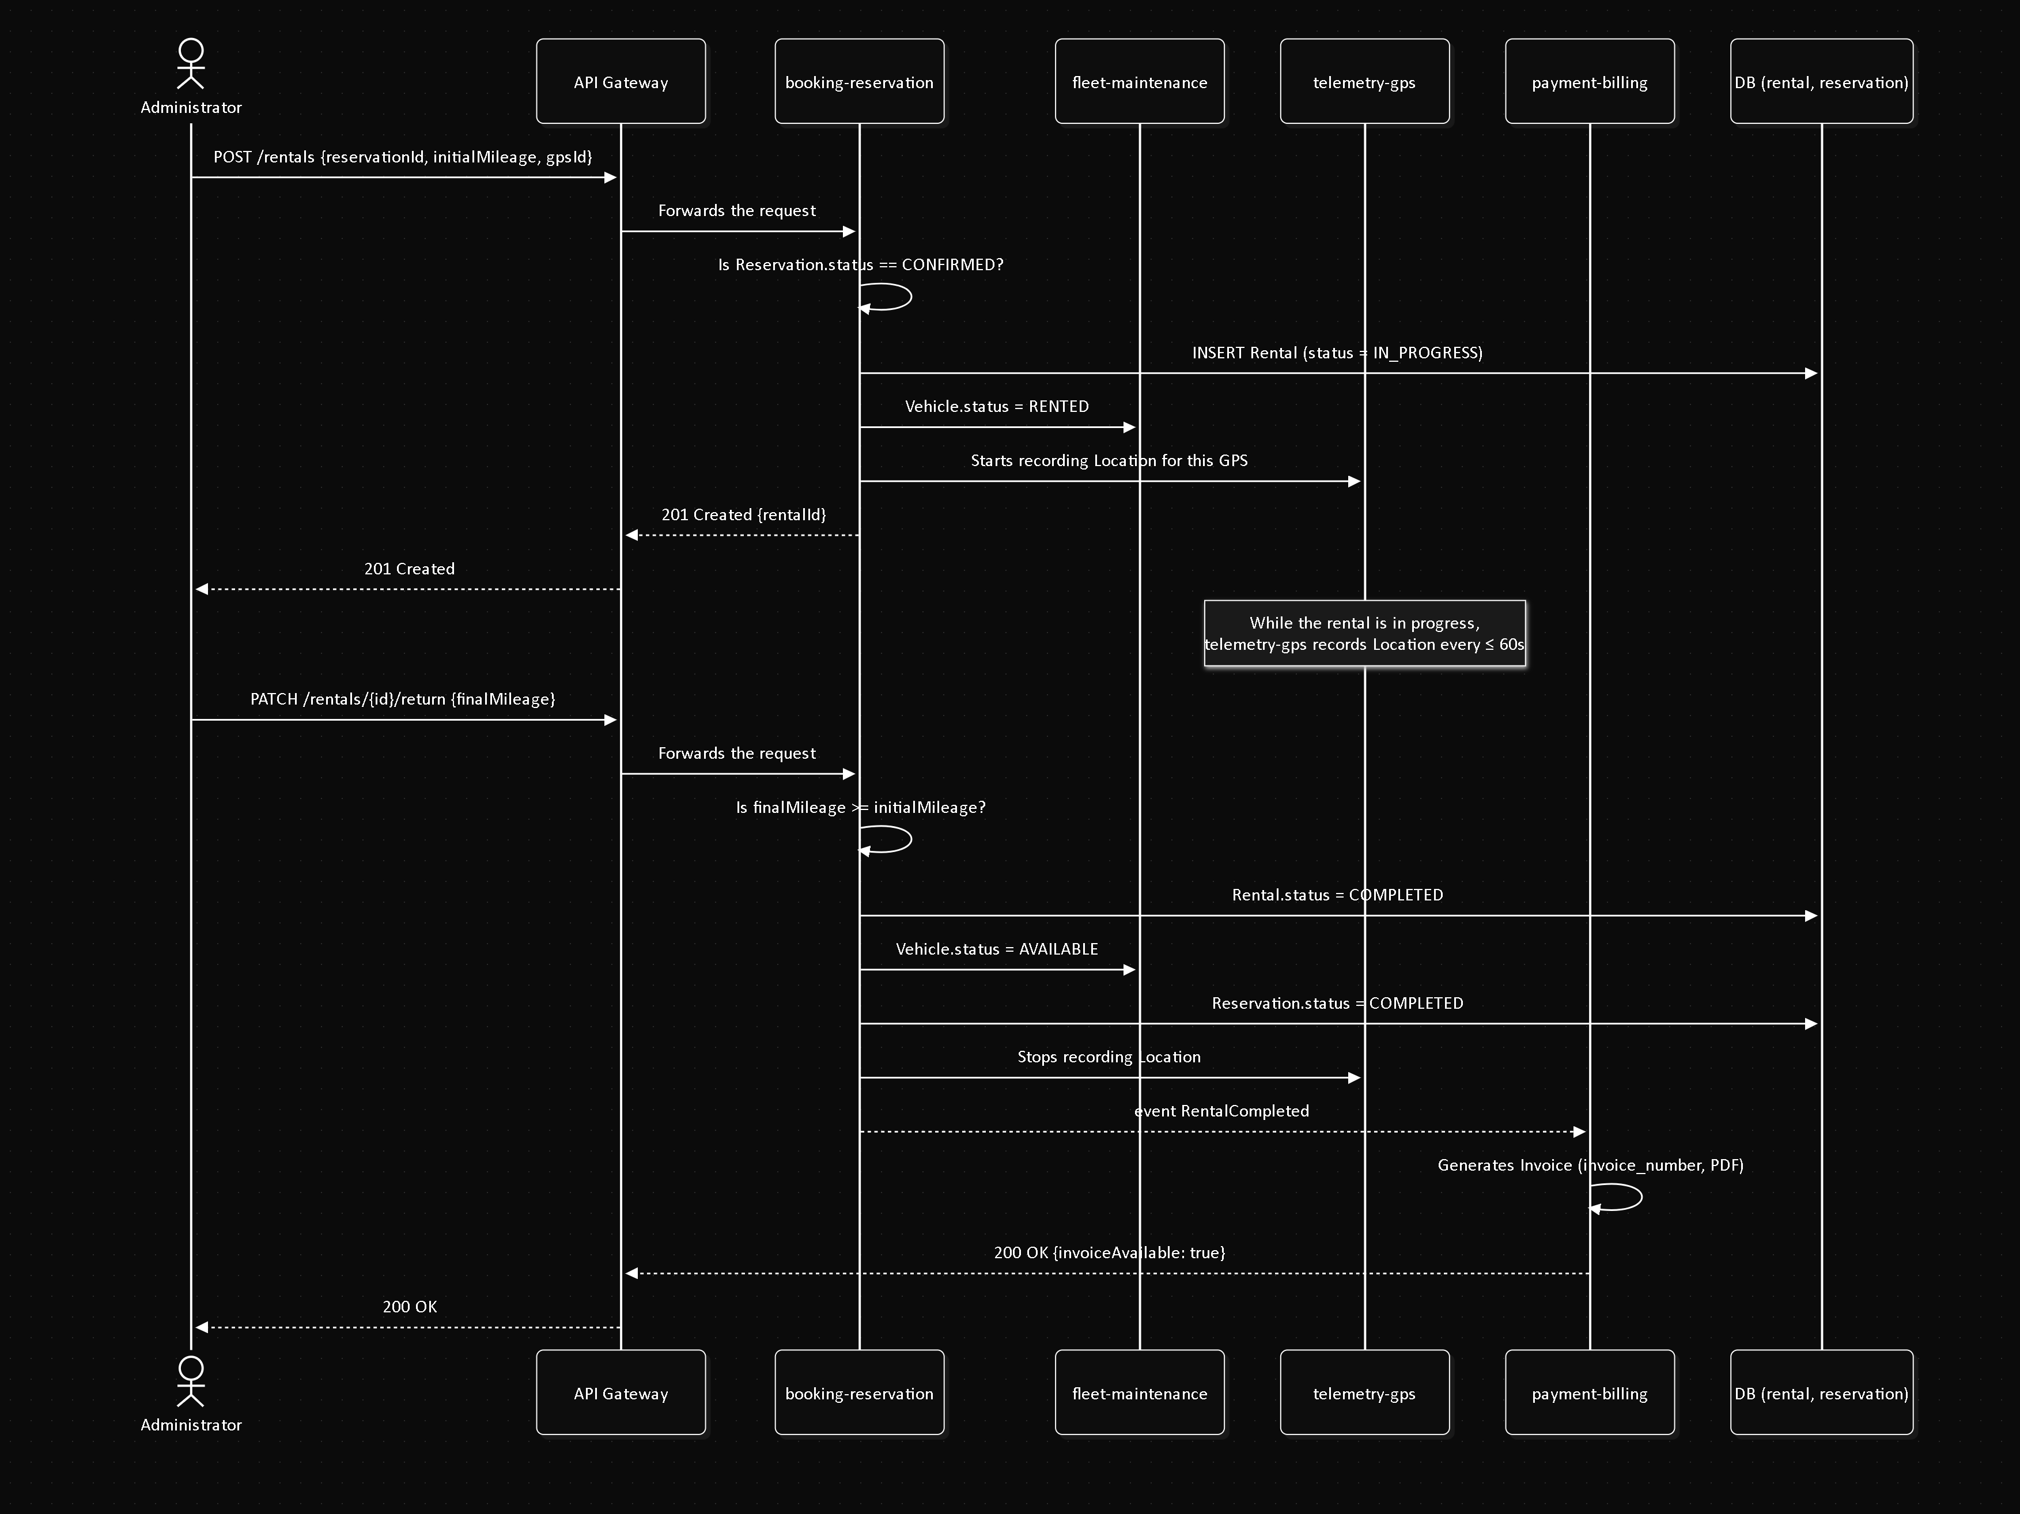

SEQ-06 — Schedule and complete a maintenance
Field | Value
Actor | Administrator
Related FR | FR8.3, FR8.7
Precondition | The vehicle is not RETIRED
Postcondition | Maintenance COMPLETED; vehicle AVAILABLE again

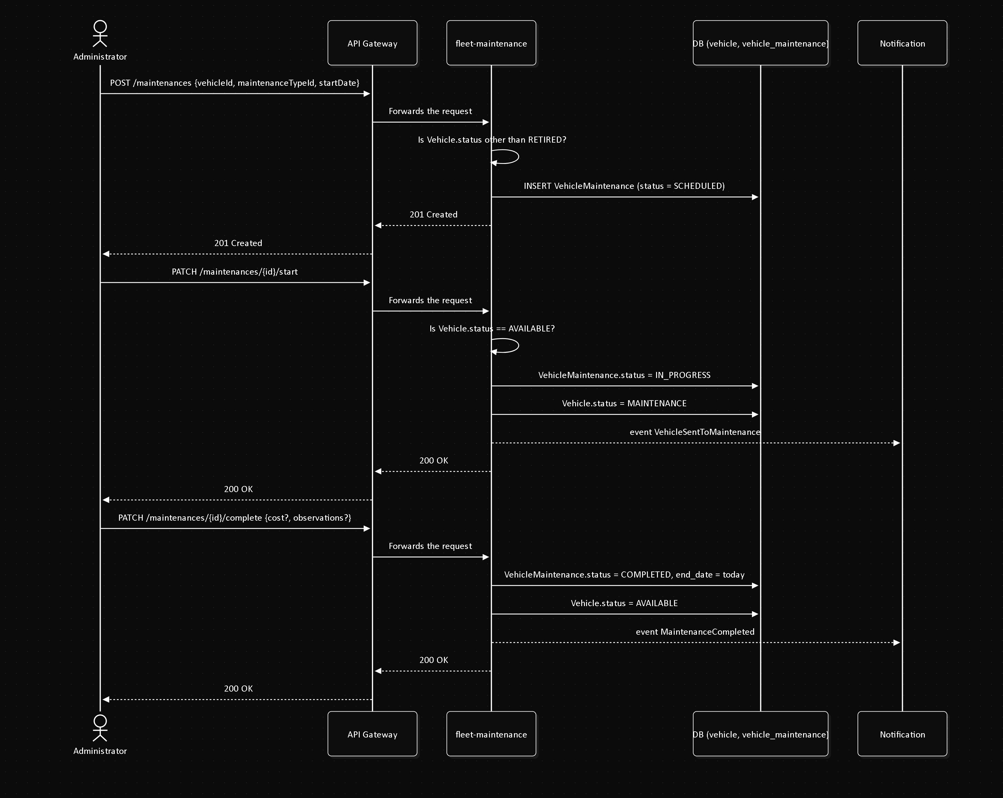

SEQ-07 — Real-time GPS tracking
Field | Value
Actor | Administrator
Related FR | FR6.1
Precondition | The vehicle is in RENTED status
Postcondition | The last recorded location is returned

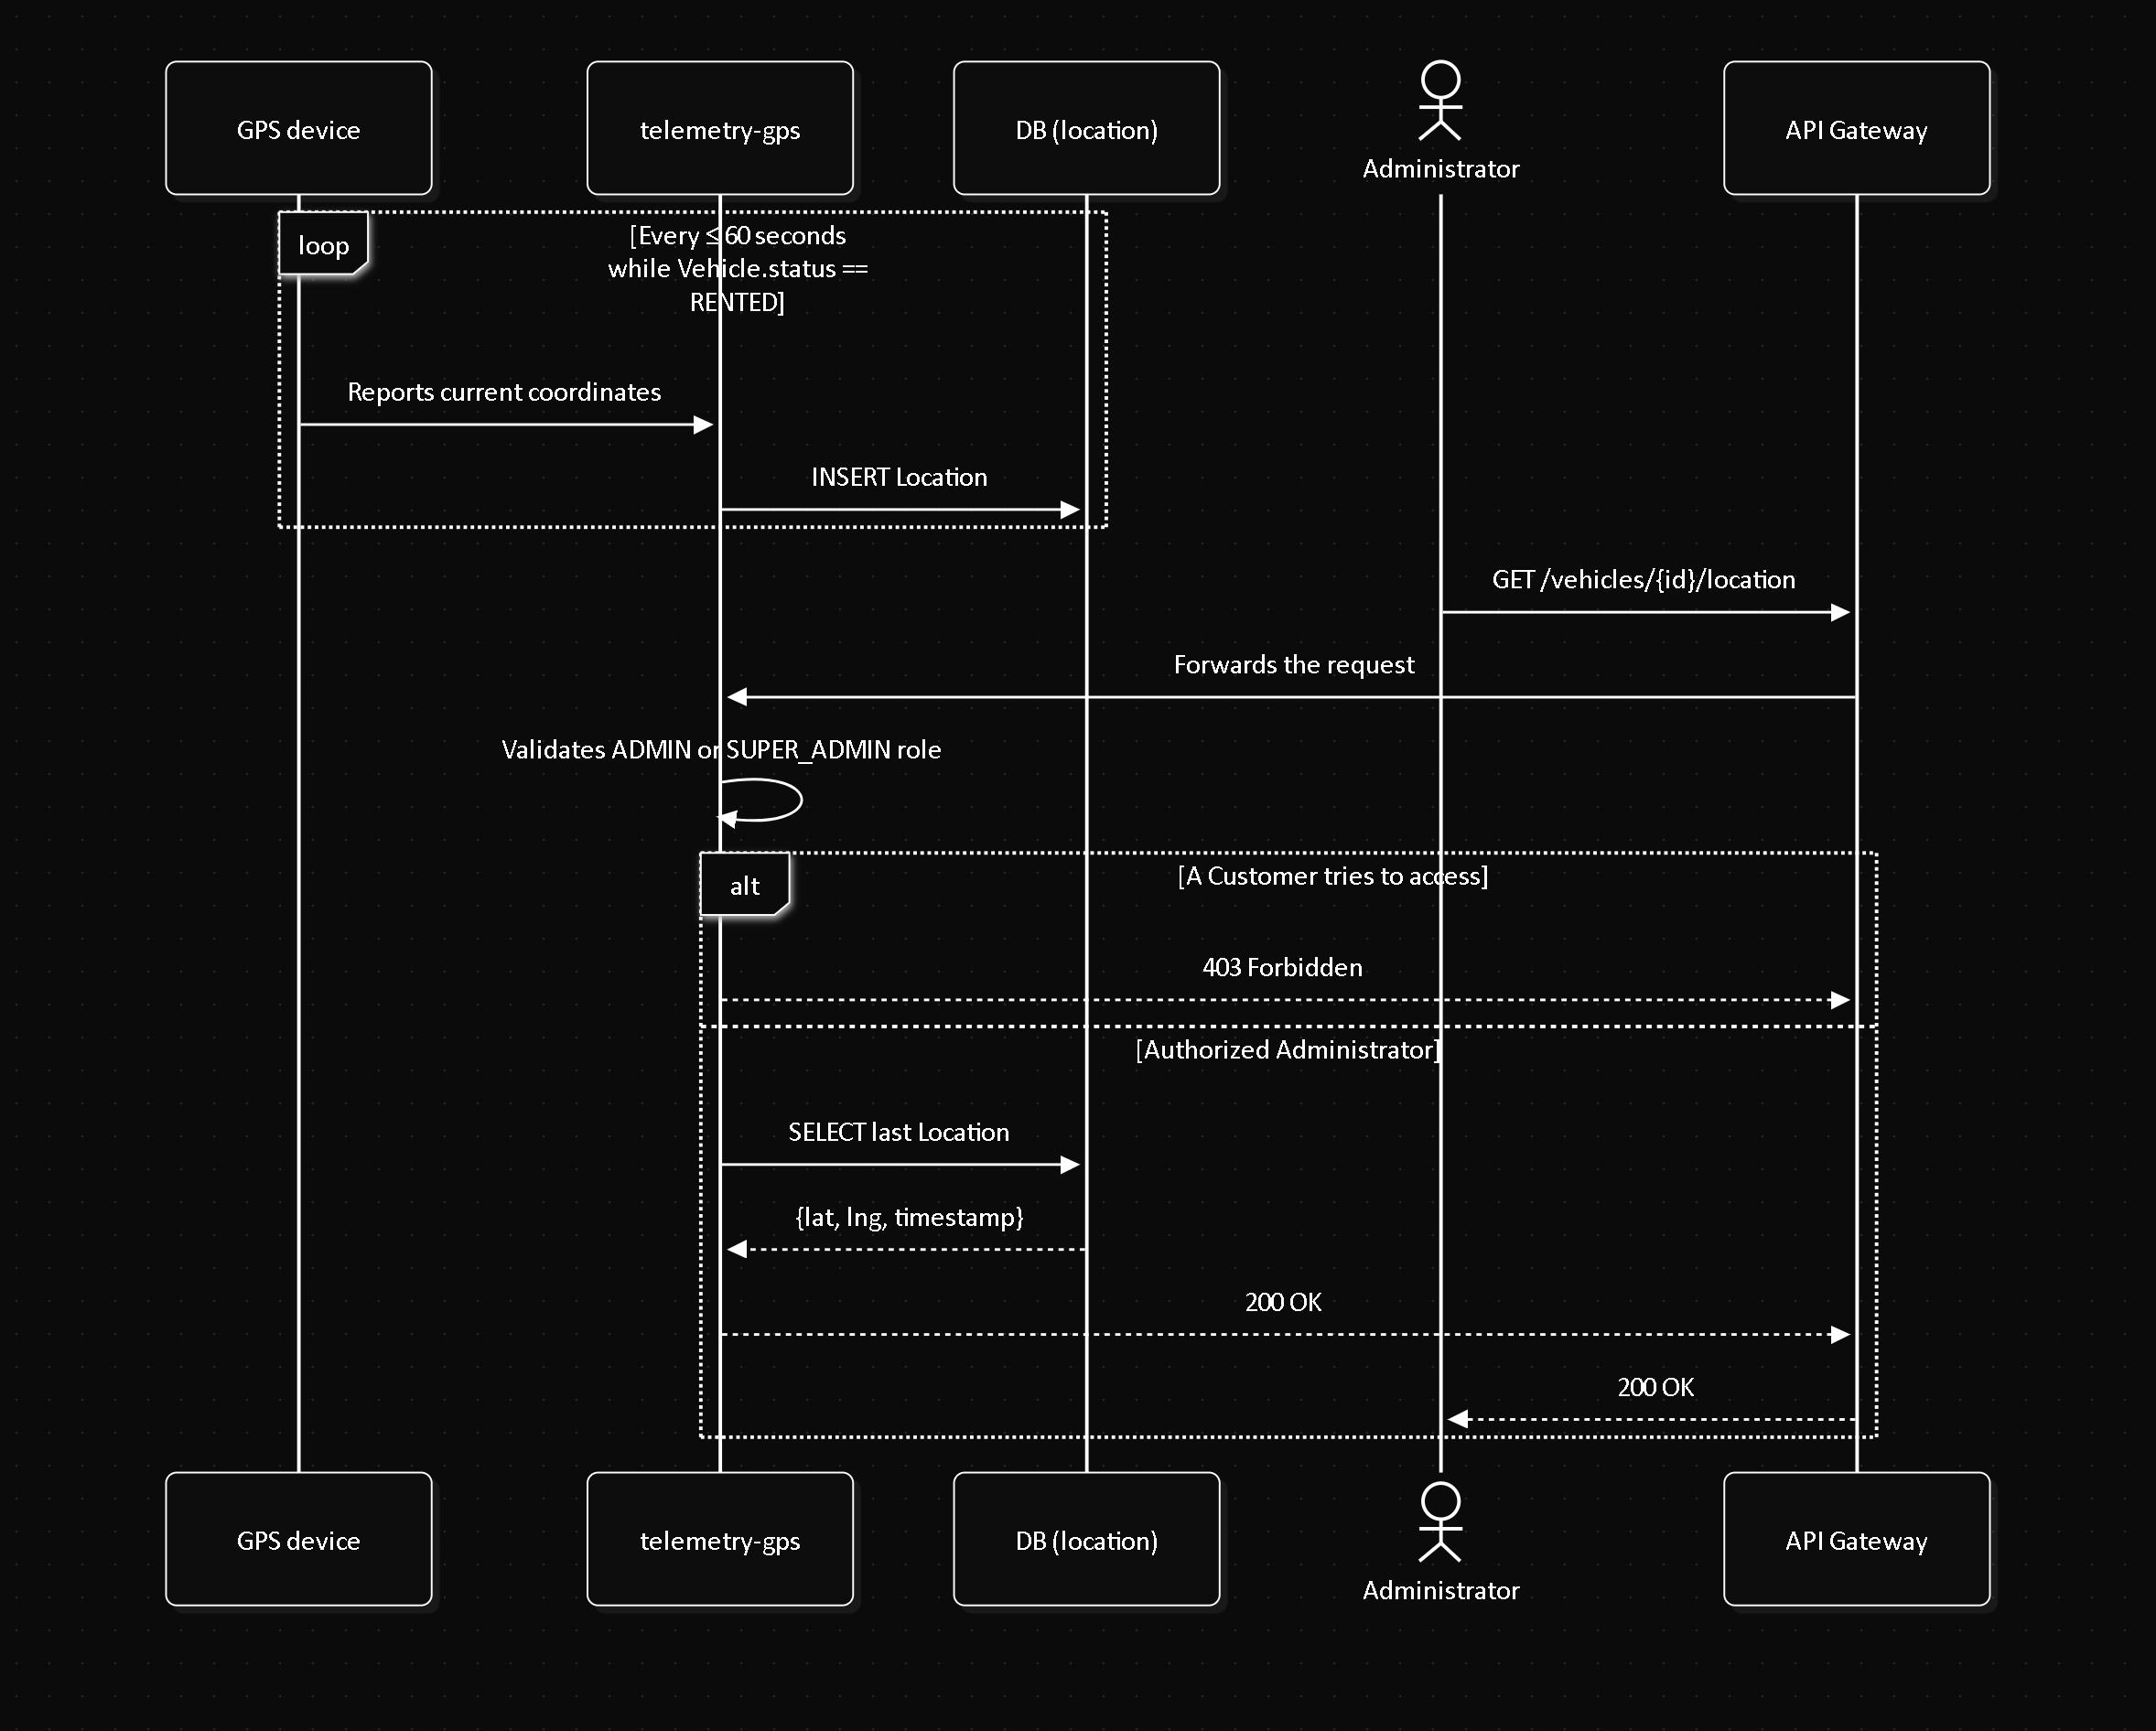

References
Document title | Reference
Software Requirements Specification | 01-informe-especificacion-requisitos/SRS.md (this repository)
Use cases | 01-Use-Cases.md (this folder)
Activity diagrams | 03-Activity-Diagrams.md (this folder)
State diagrams | 04-State-Diagrams.md (this folder)
Domain events catalog | rtm-docs repository, 02-domain/domain-events.md
Microservices catalog (physical deployment) | rtm-docs repository, 09-microservices/service-catalog.md

