SOFTWARE ANALYSIS DOCUMENTATION — ACTIVITY DIAGRAMS
PROJECT: RENTAMOVIL — PLATFORM FOR A VEHICLE RENTAL COMPANY
TEAM MEMBERS: Thiago Fabian Rojas Guevara — David Santiago Erez Rodríguez — Nicole Dayana Ramírez Vargas
SERVICIO NACIONAL DE APRENDIZAJE — SENA — SOFTWARE ANALYSIS AND DEVELOPMENT 3145556
2026

1. Introduction
This document presents the activity diagrams of RentaMovil's two most complex business processes: the full reservation cycle and the vehicle maintenance cycle. It is the third of the four dynamic views of the software analysis; the use cases, the sequence diagrams and the state diagrams are in separate documents inside this same folder.

ACT-01 — Reservation and payment process
Field | Value
Related FRs | FR3.1, FR3.3, FR5.1, FR5.2, FR4.1, FR4.2
Description | Walks through a reservation from the moment the Customer picks the vehicle until the rental ends and is invoiced, including the rejection, retry, cancellation and automatic expiration paths

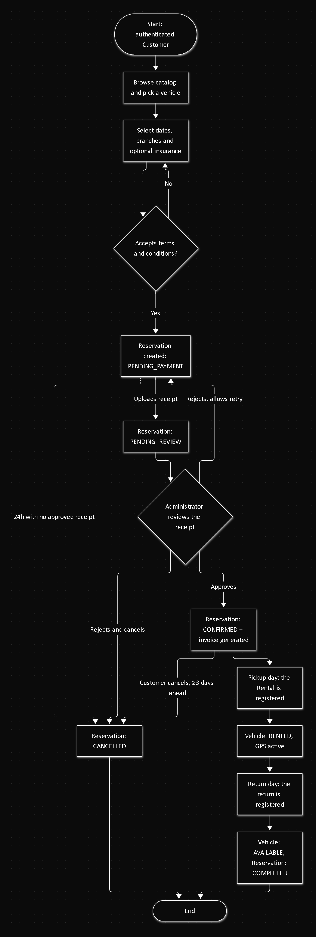

ACT-02 — Vehicle maintenance process
Field | Value
Related FRs | FR8.3, FR8.7
Description | Walks through a maintenance's lifecycle, from when it is scheduled until it is completed or cancelled

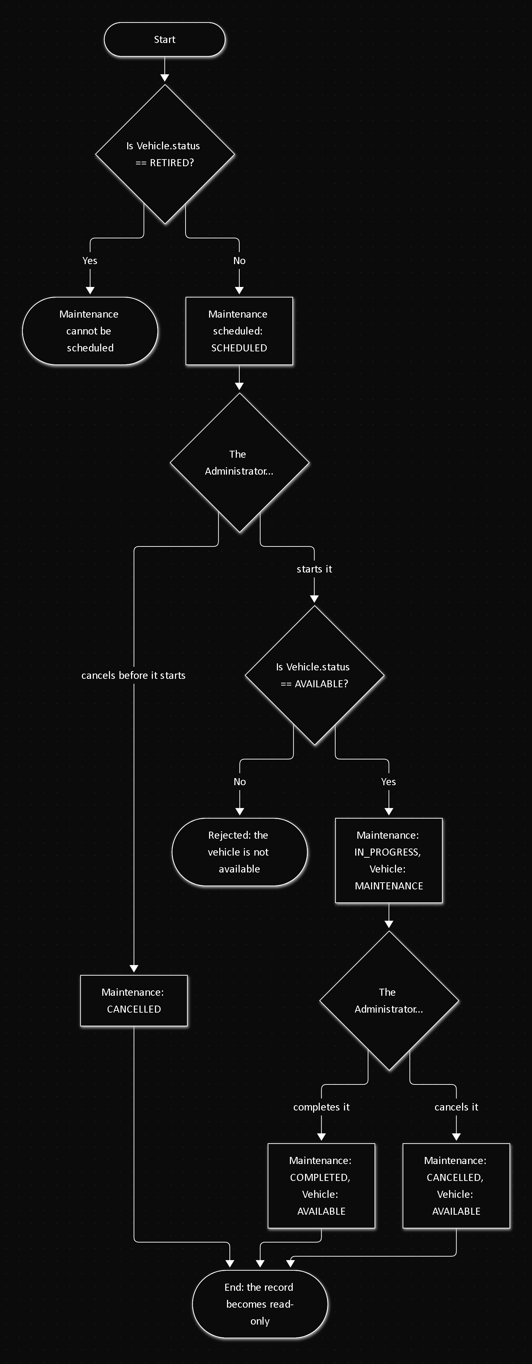

References
Document title | Reference
Software Requirements Specification | 01-informe-especificacion-requisitos/SRS.md (this repository)
Use cases | 01-Use-Cases.md (this folder)
Sequence diagrams | 02-Sequence-Diagrams.md (this folder)
State diagrams | 04-State-Diagrams.md (this folder)

