SOFTWARE ANALYSIS DOCUMENTATION — STATE DIAGRAMS
PROJECT: RENTAMOVIL — PLATFORM FOR A VEHICLE RENTAL COMPANY
TEAM MEMBERS: Thiago Fabian Rojas Guevara — David Santiago Erez Rodríguez — Nicole Dayana Ramírez Vargas
SERVICIO NACIONAL DE APRENDIZAJE — SENA — SOFTWARE ANALYSIS AND DEVELOPMENT 3145556
2026

1. Introduction
This document presents the lifecycle of RentaMovil's five central business entities. It is the fourth of the four dynamic views of the software analysis; the use cases, the sequence diagrams and the activity diagrams are in separate documents inside this same folder.

EST-01 — Reservation
Field | Value
Related FR | FR3.1, FR3.2, FR3.3, FR5.1

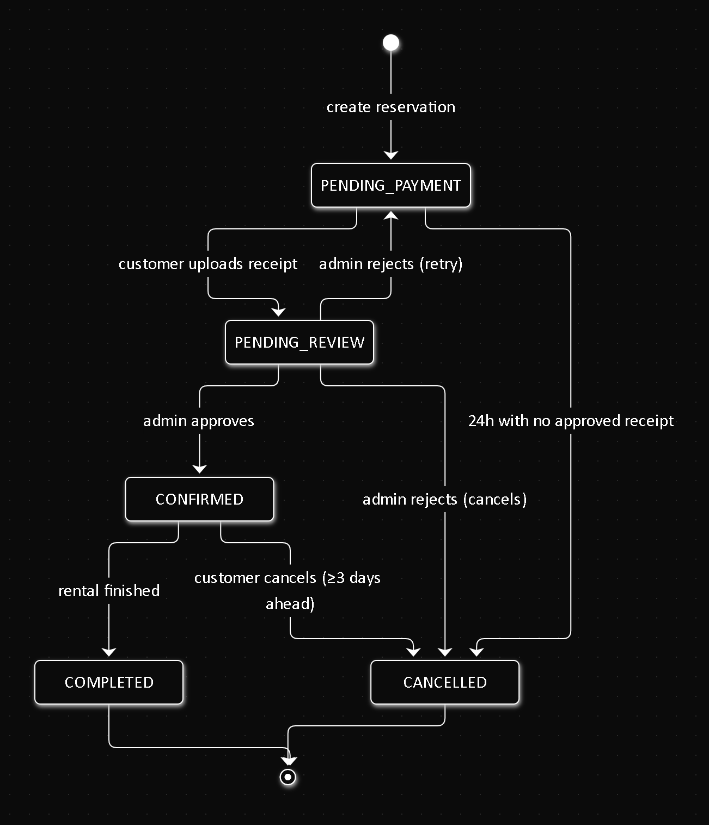

EST-02 — Payment
Field | Value
Related FR | FR5.1

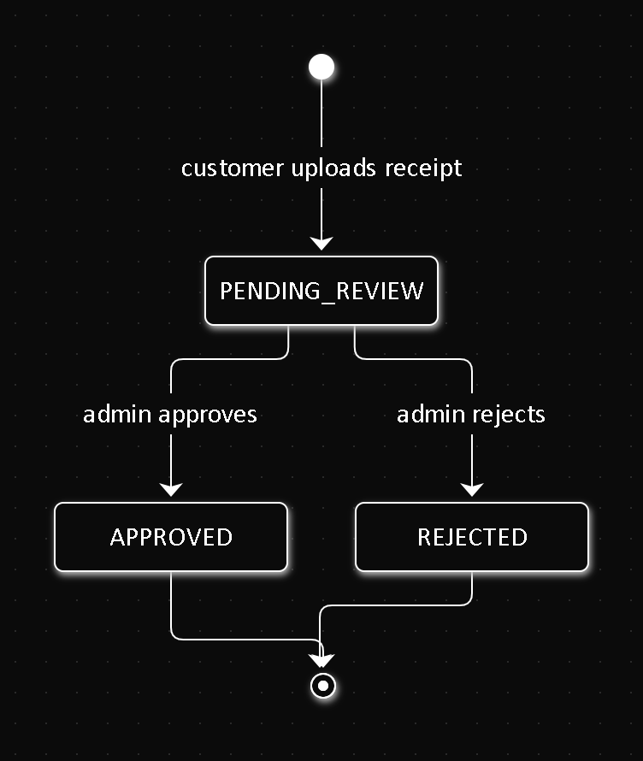

EST-03 — Rental
Field | Value
Related FR | FR4.1, FR4.2

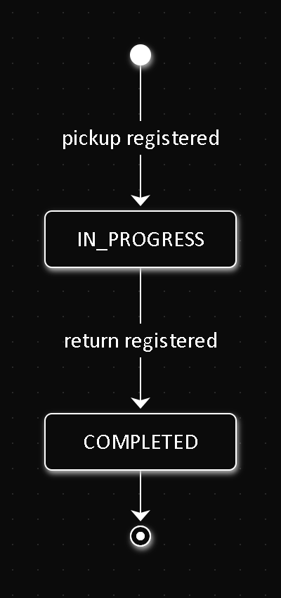

EST-04 — Vehicle
Field | Value
Related FR | FR8.2, FR8.3

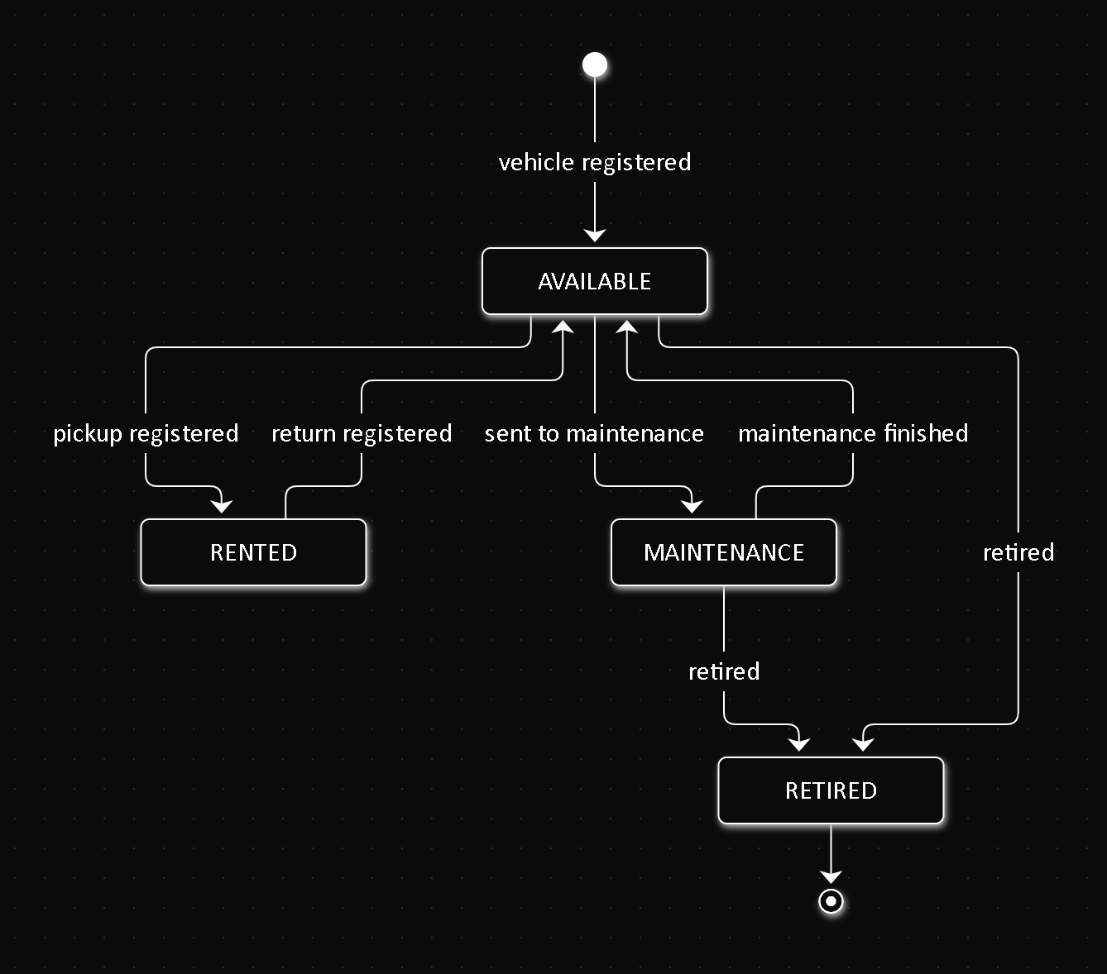

EST-05 — VehicleMaintenance
Field | Value
Related FR | FR8.7

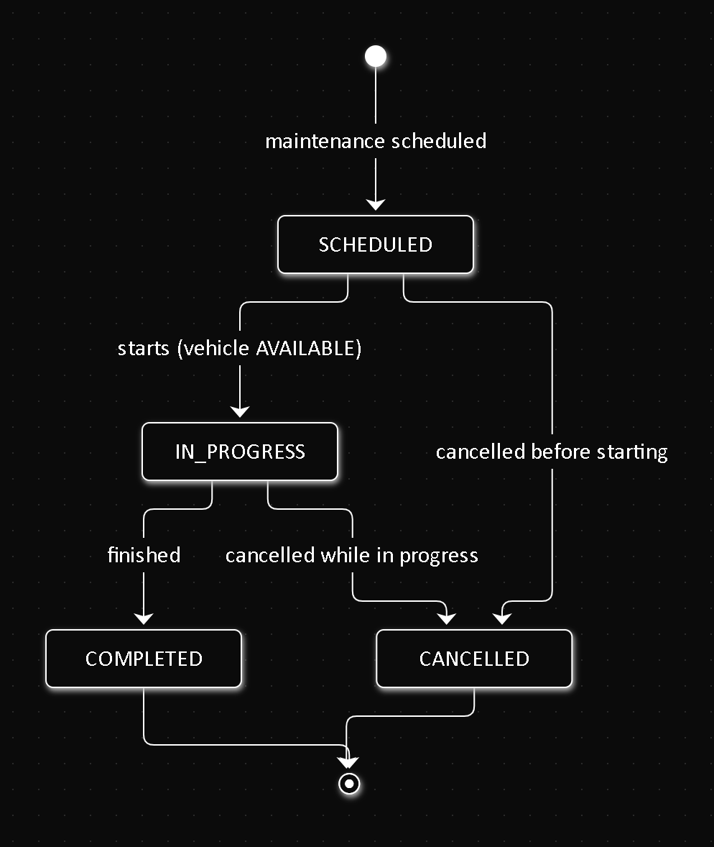

References
Document title | Reference
Software Requirements Specification | 01-informe-especificacion-requisitos/SRS.md (this repository)
Use cases | 01-Use-Cases.md (this folder)
Sequence diagrams | 02-Sequence-Diagrams.md (this folder)
Activity diagrams | 03-Activity-Diagrams.md (this folder)
Business rules and entity lifecycles | rtm-docs repository, 02-domain/entities-and-rules.md

