Work features for FreeCAD : Documentation

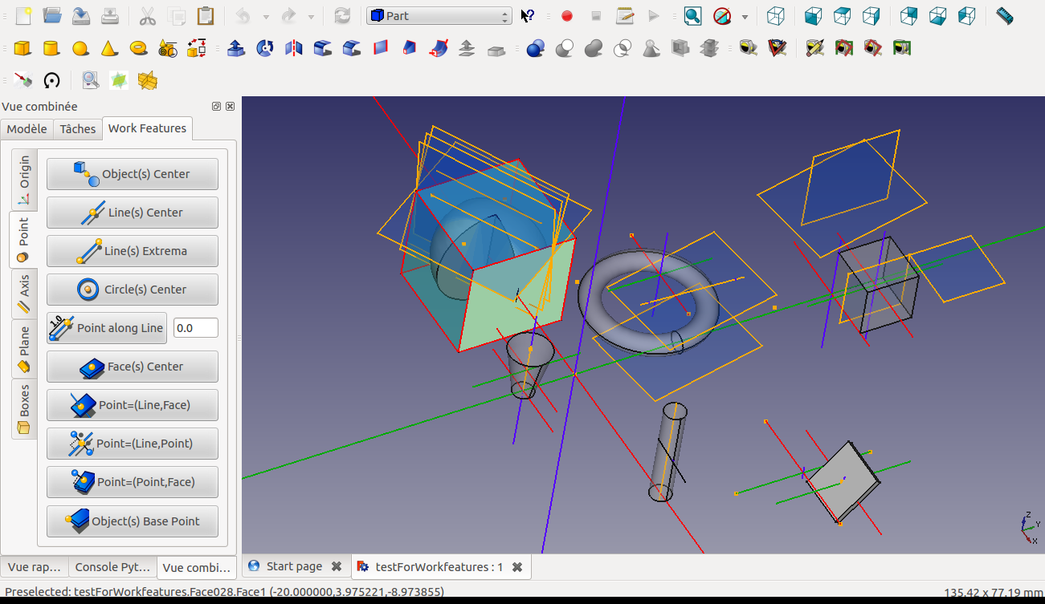

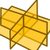

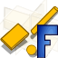

Version 2024-12 by Rentlau_64

Table des matières
Introduction: 3
Prerequisite : 3
General presentation : 4
List of TABs : 7
Ori. Pref. 7
Point 8
Axis 9
Wire 10
Circle 14
Plane 15
Sweep 16
Object 17
Image 18
Modif. 19
View 20
Check 21

Introduction:

Tool utility to create Points (mid points, center of circle, center of object(s), array of points...), Axes (from 2 points, Normal of a plane...), Planes (from 3 points, from one axis and a point...), Circles , Objects , Parametric curves... and many other useful features to facilitate the creation of your project.

The idea behind this python MACRO for FreeCAD was to give users some "quick" access tiny tools available with all the workbenches.

Except some complex tools like Cut, Rotate and Translate, most of the tools are few "clicks" behavior to give the user quick access to functionalities.

Up to 2018 01 24 release no parametric objects are created (but the willing is to move into this behavior in next future). At January 2018 a first prototype of parametric WF workbench development is on going.

This big macro was developped using original ideas, codes, and support from :
- Javier Martinez Garcia 2014, 2015 for ideas and first WF codes
for tje code on parallelism of two faces, forTour camera code...
- Jonathan Wiedemann for Gui ideas and for view codes 2014
and support
- NormandC for his support
- Yorick for his support
- galou_breizh for macro which creates a circle from 3 selected points
- Eriossoltero for macro Ellipse-Center+2Points
- Ulrich Brammer for Geodesic dome code
- Wmayer Many Thanks for active help on testing and debbuging
- Gaël Ecorchard for HighlightDifference Macro
- lorenz_l for Beam tool Macro
Thanks to all of these people, and special thanks to Mario52 for diverse MACRO codes as FCCamera, cutCircle, cutWire, Delta xyz, bounding box ... and other diverse pieces of codes and all discussions, support, advices, help...merci Mario

Thanks also to those I forget.

Prerequisite :

- Install MACRO Work Feature on your system:
https://github.com/Rentlau/WorkFeature.git

To learn how to install a MACRO into FreeCAD:
see Macro Install HowTo
see Customize ToolsBar HowTo

- Or use the Addons installer.FCMacro for Customizing FreeCAD:
https://github.com/FreeCAD/FreeCAD-addons

General presentation :
Once installed, the macro is launched by the click on the general icon button :


After activating Work Features, the tool moves in a Widget with a Tab view.
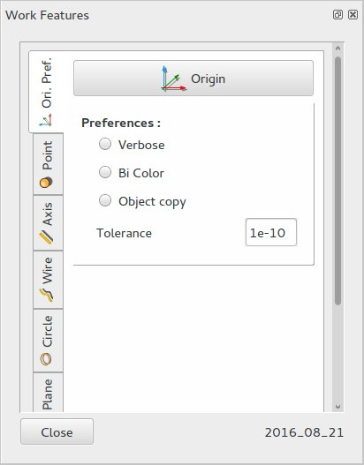

This utility is docked in the “combo view” of FreeCad with "Work Features" label.
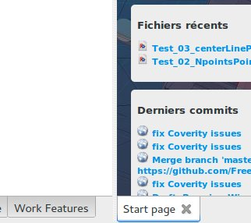

But the widget can be moved and located any place you want.

The set of tab widgets will appear, the different functions are grouped by type of output.
If one would like to create a point, go to tab widget “Point” to find all functions generating points.
Most of the time a function is accessible by a few clicks:
first by selecting already existing graphic entities in graph view, then
by a final click on one button (with icon and text).
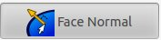

The convention used for the Icons is :
Blue for already existing graphics objects to select and
Orange for the entities to be created.
Hereafter one icon explanation:
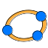

You must select 3 existing points in order to create a circle.

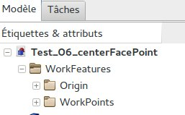
Each time a new object is created, a new subGroup is created below WorkFeatures Group in “Model tab” of FreeCad.
The possible sub Groups are :
'Origin','WorkPoints','WorkAxis','WorkPlanes','WorkCircles','WorkArcs','WorkBoxes', 'WorkWires','WorkImages','WorkObjects',
'Rot_Trans'

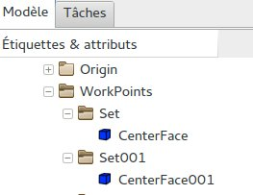
Once a sub Group is created the entities will be placed below (some time in a sub set).
is a group created in the name of Tag used. The Axis, Point and Planes origin are directly keyed to hidden.
All functions regarding point creations are sorted under the “Point” tab.
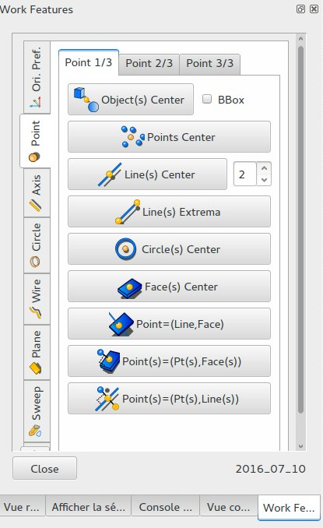

In general tool tips are visible with a short description of the function when the mouse is located above one button.
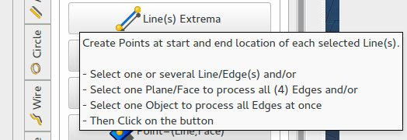

List of TABs :
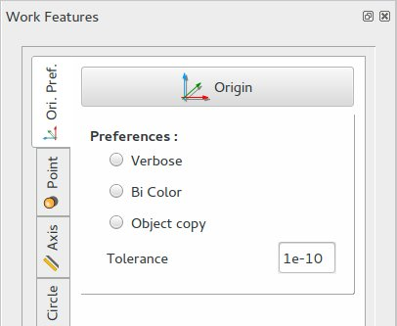

Ori. Pref.
This tab is dedicated to generate the origin point, axis and planes (X, Y, Z axis, XZ, XY, YZ planes) and to set some preferences.

Point
All functions to generate Points. Last tab propose to save and load points in ASCII text files.
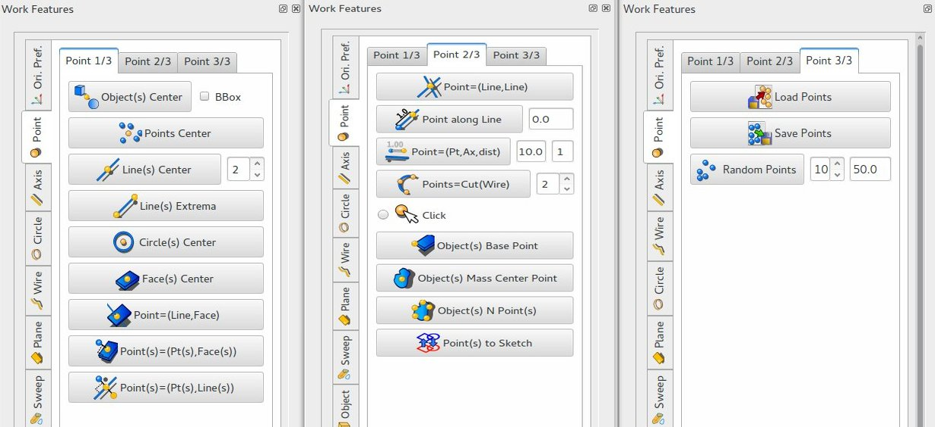

Axis
All functions to generate Axis.
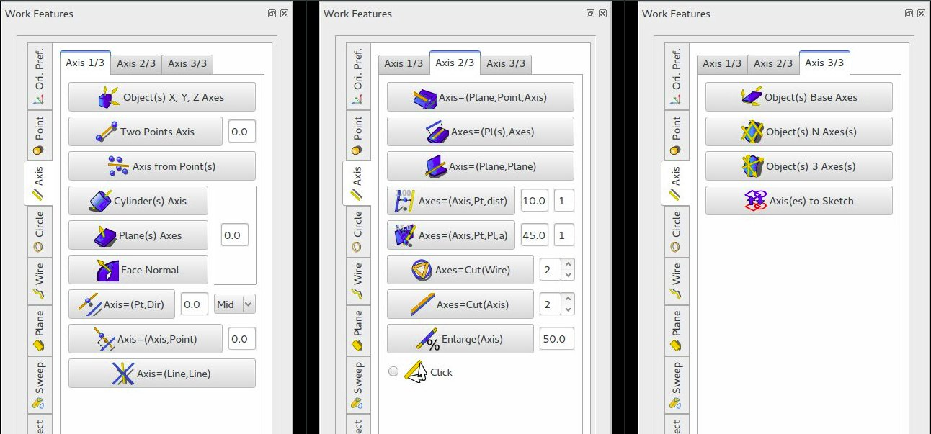

Wire
All functions to generate Wire.
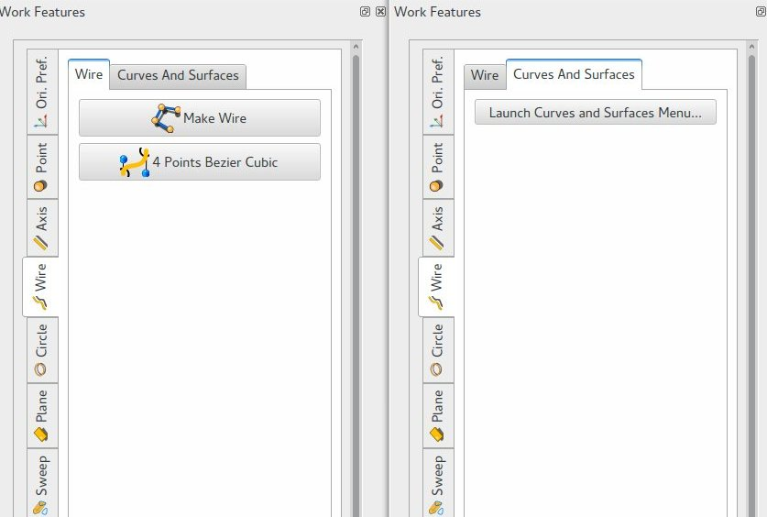
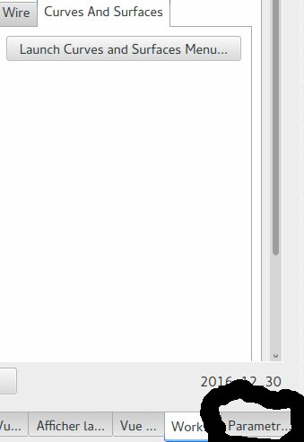

Especially in the last tab the new button :”Launch Curves and Surfaces Menu" will open a new tool for Regression 2D,
Parametric curves 2D
Parametric curves 3D
Parametric Surfaces
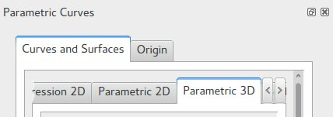

Origin tab will help you to select one (or several) point(s) as reference point(s). This point is used to “attach” the parametric object. If one select several points then several parametric curves will be generated regarding these references points.
The parametric curve and surface objects are defined by formula.
For example let us describe the “Cylindrical Helix”
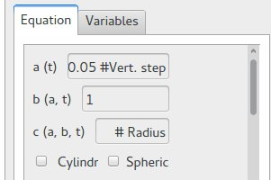
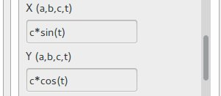

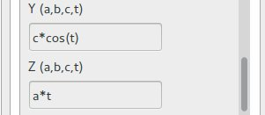

the equation is defined by :
X(a,b,c,t) = c * sin (t)
Y(a,b,c,t) = c * cos (t)
Z(a,b,c,t) = a * t
with a(t) = 0.05 for the vertical step and c(a,b,t) = 10 for the radius (here b is not used).
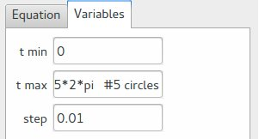
The variable t is defined for 5 circles:
from 0 to 2 pi (5 times) with a step of 0.01

In parameter fields instead of constant values, it is also possible to set list or ranges.
The function 'range' from Python and 'np.arange' from numpy module can be used here:
range([start,] stop[, step])
start : Starting number of the sequence. The interval includes this value. The default value is 0
stop : Generate numbers up to, but not including this number.
step : Difference between each number in the sequence. The default value is 1.
np.arange([start,] stop[, step,]dtype=None)
Return evenly spaced values within a given interval.
start : Starting number of the sequence. The interval includes this value. The default value is 0
stop : End of interval. The interval does not include this value, except in some cases where step is not an integer and floating point round-off affects the length of out.
step : Difference between each number in the sequence. For any output out, this is the distance between two adjacent values. The default value is 1.
If step is specified, start must also be given.
dtype : The type of the output array. if dtype is not given, infer the data type from the other input arguments.
Here are one result:
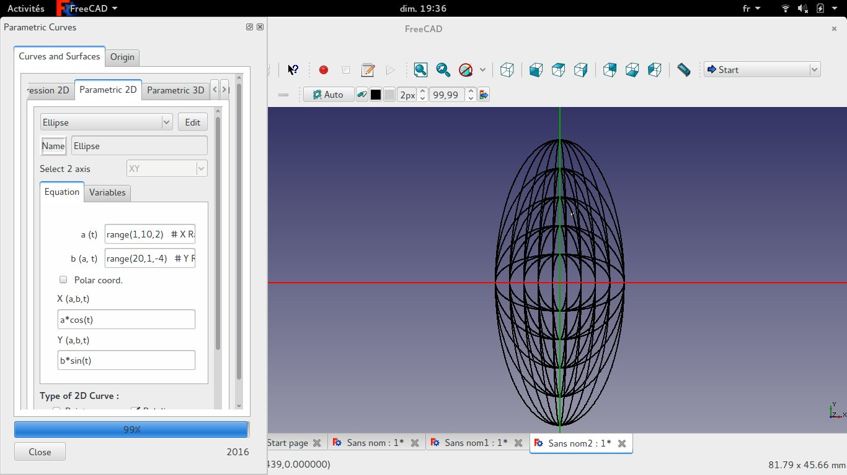
The function from Python math module can be used for parametric definition:
safe_list = ['acos', 'asin', 'atan', 'atan2', 'ceil', 'cos', 'cosh', 'degrees', 'e', 'exp', 'fabs', 'floor', 'fmod', 'frexp', 'hypot', 'ldexp', 'log', 'log10', 'modf', 'pi', 'pow', 'radians', 'sin', 'sinh', 'sqrt', 'tan', 'tanh']

The type of curve/surface can be :
Points
Polygon
Bezier
Bspline
Nurbs (for surface only)

Parametric curves 2D can be Cartesian or Polar.
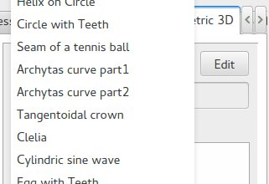
Parametric curves 3D can be Cartesian, Cylindrical or Spheric.

A set of predefined functions is available via a combo box.:

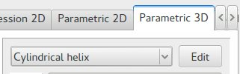

With possible saving of your parametric functions into a file in the home directory.

Here a flavor of this new tool:
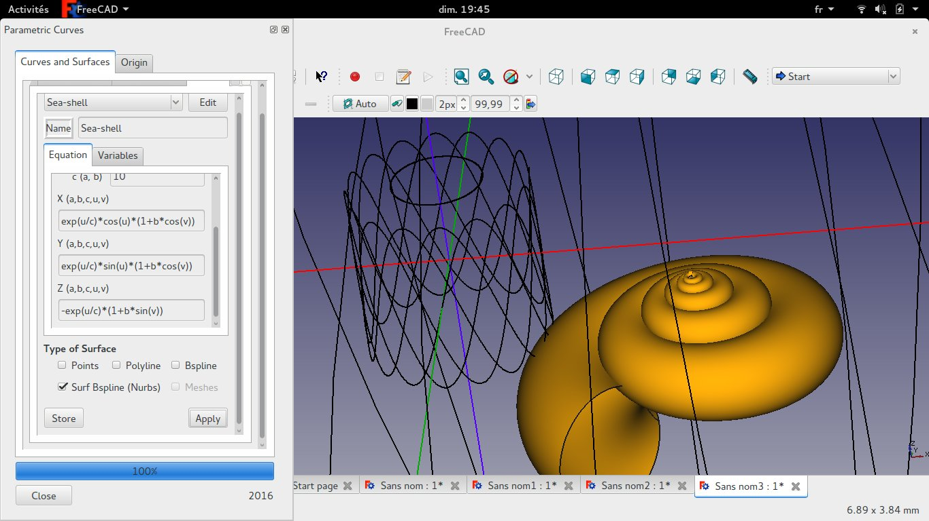
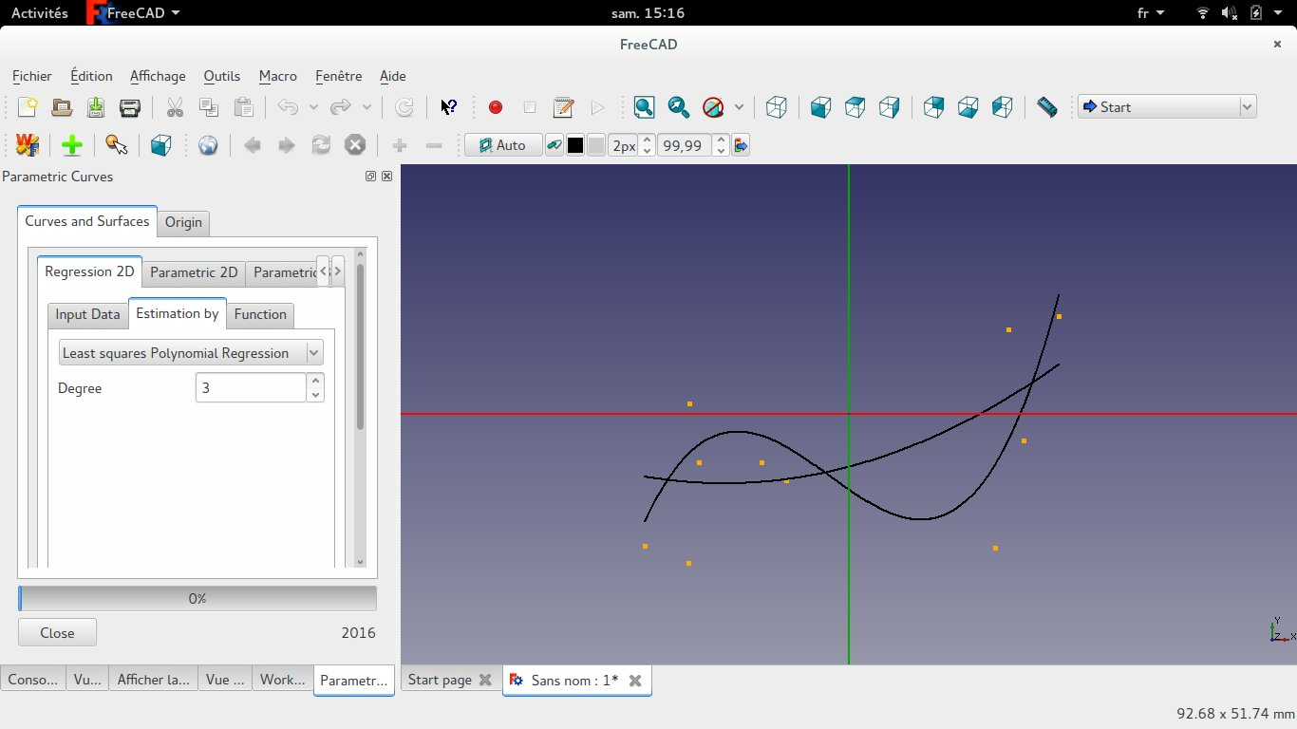

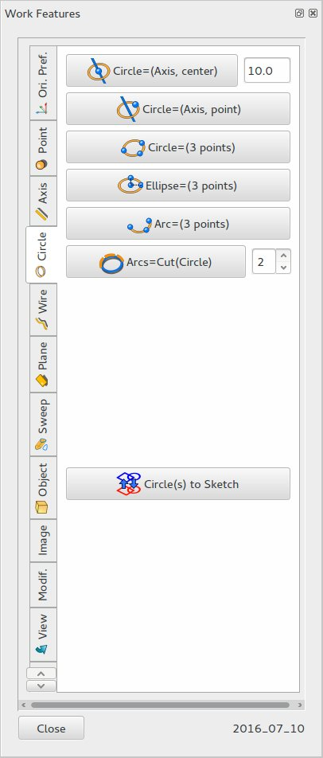
Circle

Plane
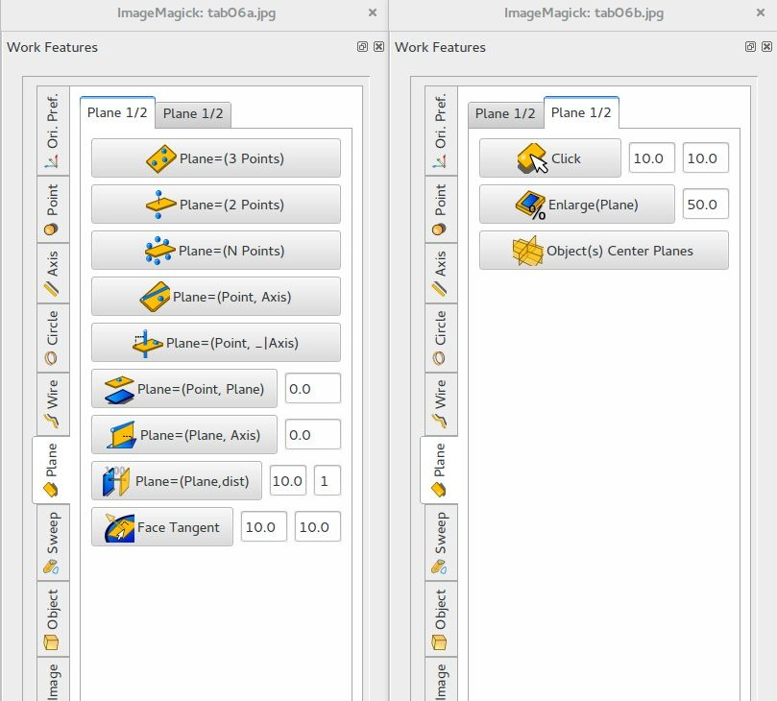

Sweep
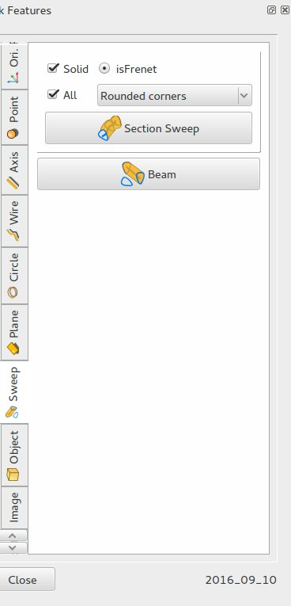

Object
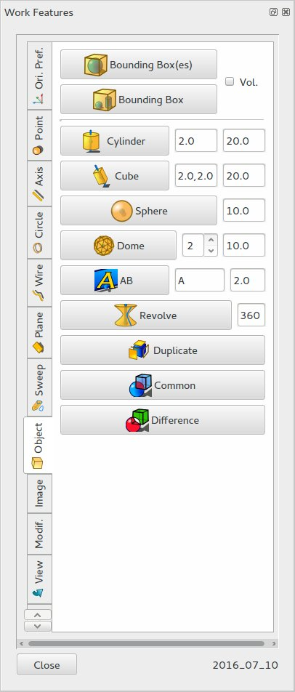

Image
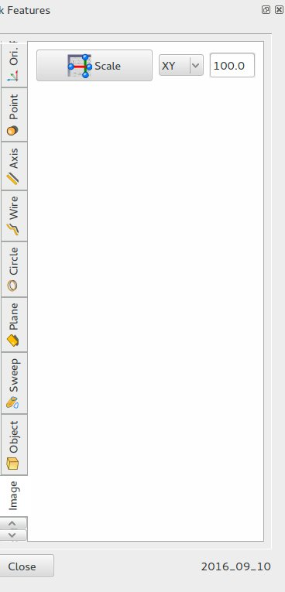

Modif.
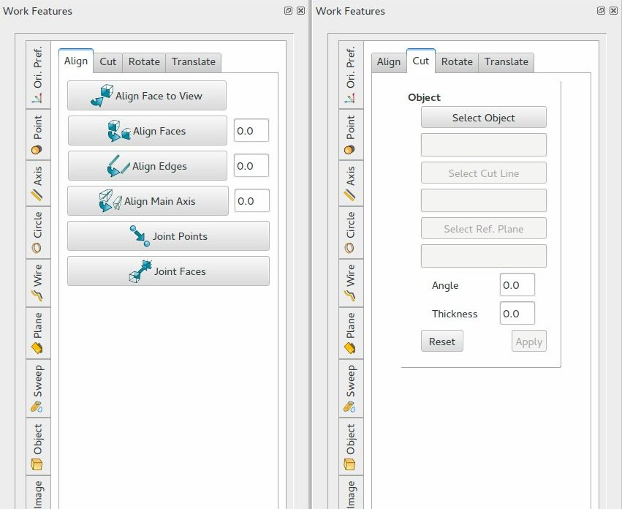
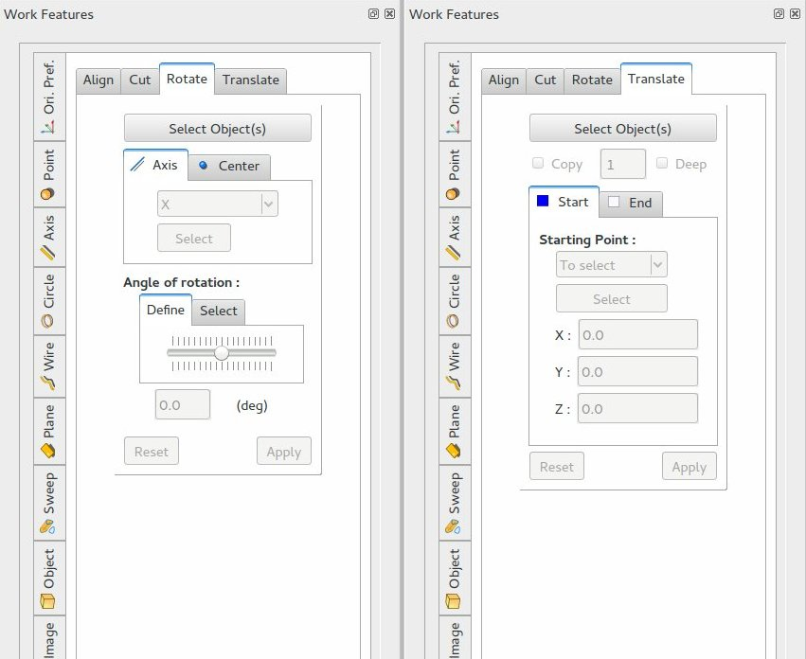

View
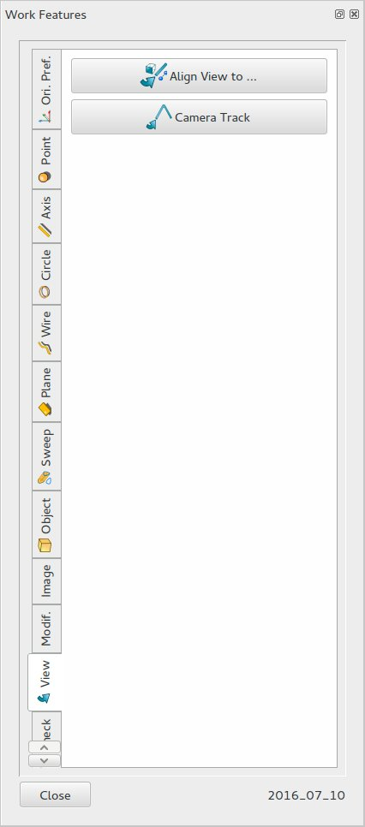

Check
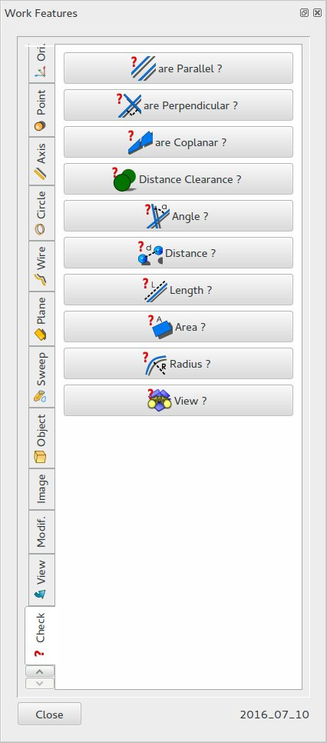
To be continued…

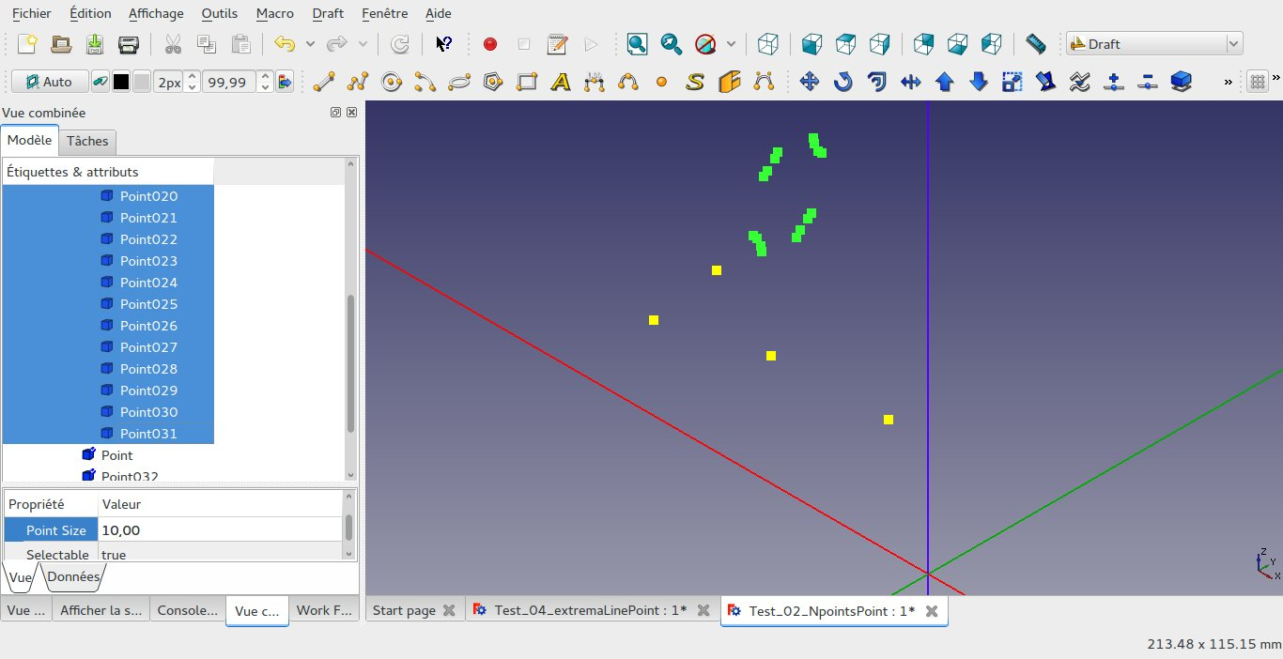

 |  | Vertex | Edges | Wires | Faces | Objects
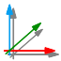 | plot_originObject() | 0 | and 0 |  | and 0 | and 0
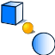 | plot_centerObjectPoint() | 0 | and 0 |  | and 0 | and >0
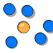 | plot_NpointsPoint() | >=2 | and 0 |  | and 0 | and 0
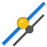 | plot_centerLinePoint() | >=2 | or >0 |  | or >0 | or >0
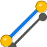 | plot_extremaLinePoint() | 0 | and ( >0 |  | or >0 | or >0)
 | plot_centerCirclePoint()

