Work features for FreeCAD :

releases Documentation

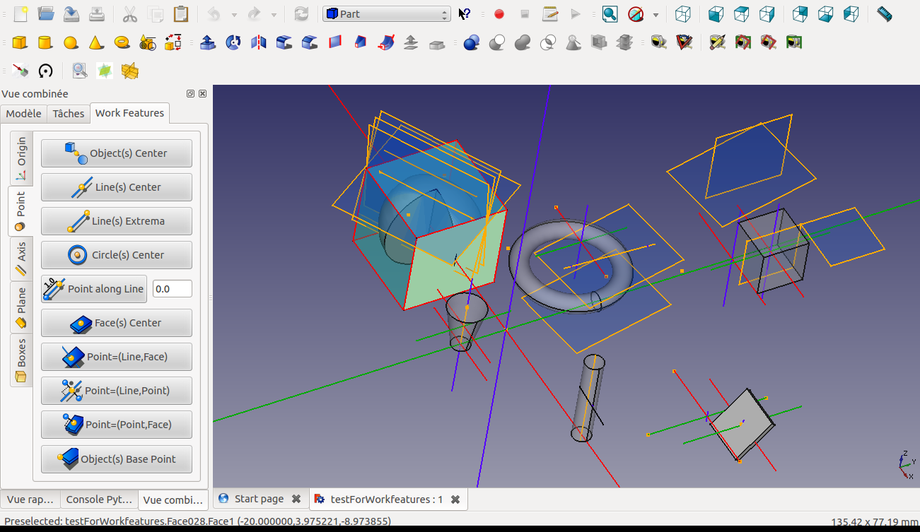

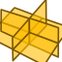



Version 2024-12-18 by Rentlau_64

Table of Contents
Release of 2015-02-26 : 3
Release of 2015-03-08 : 5
Release of 2015-03-09 : 6
Release of 2015-03-15 : 6
Release of 2015-03-31 : 8
Release of 2015-04-03 : 13
Release of 2015-05-23 : 13
Release of 2015-05-31 : 14
Release of 2015-06-22 : 17
Release of 2015-09-02 : 19
Release of 2015-10-05 : 23
Release of 2015-11-04 : 25
Release of 2015-11-08 : 30
Release of 2015-12-16 : 31
Release of 2016-03-29 : 33
Release of 2016-09-10 : 37
Release of 2016-12-31 : 40
Release of 2017-02-05 : 43
Release of 2018-01-24 : 45
Release of 2024-12-18: 46

Release of 2015-02-26 :

Addition :
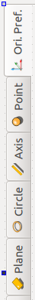
into Point TAB :

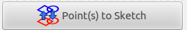

Transform Point(s) in Sketch's Point(s) by projection onto the Sketch's Plane:
- First select an existing Skecth;
- Select as much as Points needed;
Then click on this button.

into Axis TAB :
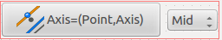

Create an Axis parallel to an Axis and crossing a Point.

The Point will be at :
Start of the line;
Mid of the line;
End of the line.

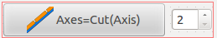

Create Axes:
Cut the selected Line in 2(n) parts and create 2(n) Axes.
The number indicates in how many parts to cut.

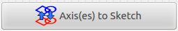

Transform Line(s) in Sketch's Line(s) by projection onto the Sketch's Plane:
- First select an existing Skecth;
- Select as much as Lines needed;
Then click on this button.

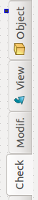
a new Check TAB:


Check if two faces are Parallel:
- Select the 2 faces/planes and
Click this button

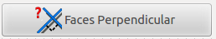

Check if two faces are Perpendicular:
- Select the 2 faces/planes and
Click this button

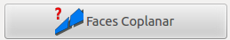

Check if two faces are Coplanar:
- Select the 2 faces/planes and
Click this button

Release of 2015-03-08 :
New icon for the macro WORK FEATURE :

Addition :
into Ori. Pref. TAB :
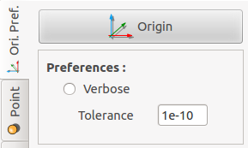

Possibility to set the tolerance (ie for comparison with Zero)
into Axis TAB :
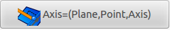

Create an Axis Perpendicular to an Axis, crossing a Point and Parallel to a Plane.
-Select one Plane, one Axis and one Point ON the previous Axis.

into Circle TAB :

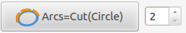

Create Arcs:
Cut the selected Circle(s) or Arc(s) in 2(n) parts and create 2(n) Arcs.
The number indicates in how many parts to cut.
- First select as many Circles and Arcs you want
- Second set the number of parts
- Third push this button

The function is not yet developped for Cylinders.

Correction :
into Check TAB:
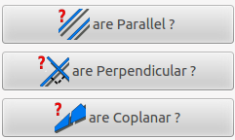

Functions available for two faces or two Edges

Release of 2015-03-09 :
add of missing icons and link with buttons

Release of 2015-03-15 :
Modification :

Cut in two parts TAB "Points" and TAB "Axis"

Addition :
into "Ori. Pref." TAB :
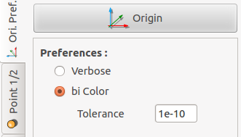

bi Color flag
Change the successive lines to be bicolor (red and white) for the following functions:
- in "Axis 1/2" TAB:
Axes=Cut(Wire)
- in "Circle" TAB:
Arcs=Cut(Circle)

into "Points 1/2" TAB :

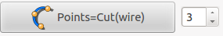

Points = Cut (wire)
Create Points by Partition:
Cut the selected wire(s) in 2(n) parts and create 2(n) Points with function discretize.
The number indicates in how many parts to cut.
Wires can be:
Line
Circle
Arc
Ellipse
An object must also be seleted but before any Wire to cut all his edges!

into "Axis 1/2" TAB :
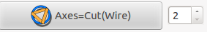

Axes=Cut(Wire)
Create Axes by Partition:
Cut the selected wire(s) in 2(n) parts and create 2(n) Axes with function discretize.
The number indicates in how many parts to cut.
Wires can be:
Line
Circle
Arc
Ellipse
An object must also be seleted but before any Wire to cut all his Edges!
NB: You can change the successive lines to be bicolor (red and white)
in "Ori. Pref." TAB
into "Check" TAB :
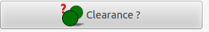

Clearance ?
Check for two Objects Clearance distance:
Quick measurements between parallel faces and similarly placed objects
- Select the 2 Objects and
Click this button

Release of 2015-03-31 :

Modification :
Cut in two parts TAB "Plane"
Addition :
into "Ori. Pref." TAB :

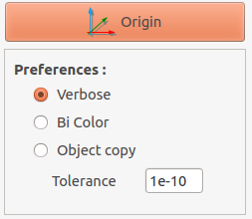

Object copy flag
Force the duplication of the Parent Object for the following functions:
- in "Axis 2/2" TAB:
Axes=(Axis,Pt,dist)
If an Edge of a Cube is selected the Cube is duplicate
with the corresponding
Edge at the defined distance from the original.
- in "Plane" TAB:
Plane=(Plane,dist)
into "Points 2/2" TAB :

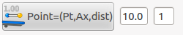

Point=(Point,Ax,dist):
Create a Point along the given Axis, at a given distance of the slected Point.
The Axis indicate the direction along where the Point is duplicate.
(you can also select several axes to define different directions)
- First select a Point (you can select several points) and one or several Axis
- Second push this button

NB:
- The distance between points can be defined first.
Positive number in one direction and negative in the other one.
The second number indicates the number of Points to create.

into "Axis 2/2" TAB :
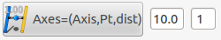

Axes=(Axis,Pt,dist):
Create an Axis parallel to a given Axis, Point at a given distance.
The Axis is created along the Plane defined by the given Axis and Point.
- First select an Axis (or several Axes) and a Point
(you can also select several points to define different Planes)
- Second push this button

NB:
- The distance to the Axis created can be defined first.
Positive number in one direction and negative in the other one.
The second number indicates the number of Axes to create.
With option "Object copy" in "Ori. Pref." TAB
- If an Edge of a Cube is selected the Cube is duplicate with the corresponding
Edge at the defined distance from the original.
Several Edges of the cube can be selected.

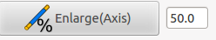

Enlarge(Axis):
Extend an Axis at two extrema.
- First select an Axis (or several Axes)
- Second push this button

NB:
- The percentage of the extension can be defined first.

into "Plane 1/2" TAB :
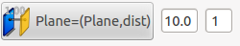

Plane=(Plane,dist):
Create a Plane parallel to a Plane at a given distance.
- First select a plane or several Planes
- Second push this button

NB:
- The distance to the plane created can be defined first.
Positive number in one direction and negative in the other one.
The second number indicates the number of planes to create.
With option "Object copy" in "Ori. Pref." TAB
- If a Face of a Cube is selected the Cube is duplicate with the
corresponding Face at the defined distance from the original.
Several Faces of the cube can be selected.
into "Plane 2/2" TAB :
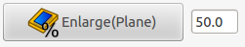

Enlarge(Plane):
Extend a Plane in each dimension.
- First select a Plane (or several Planes)
- Second push this button

NB:
- The percentage of the extension can be defined first.

into "Modif." TAB :
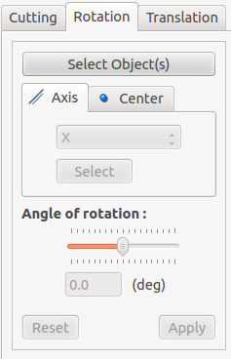

A new rotation tool with selection of Axis and center of rotation
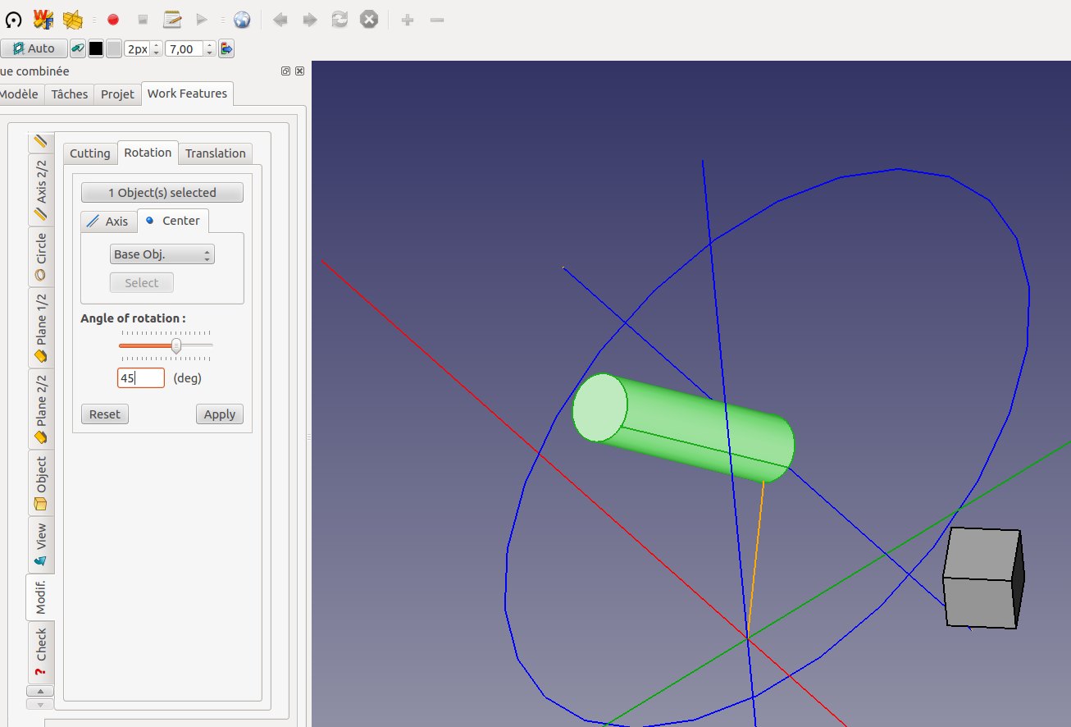
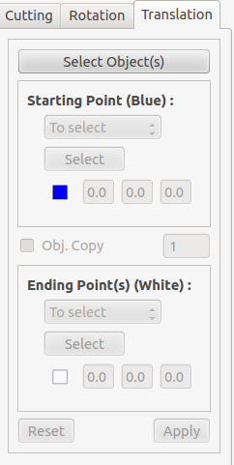

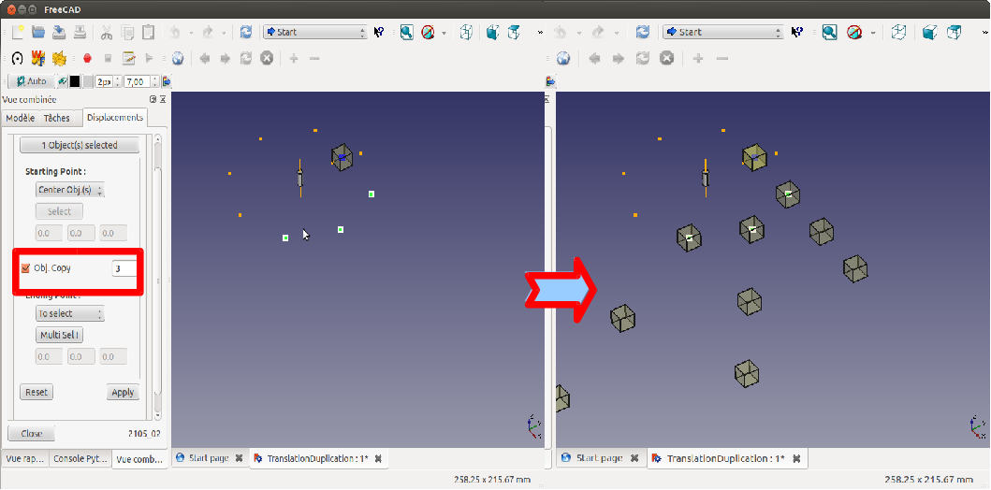
A new translation tool with duplication

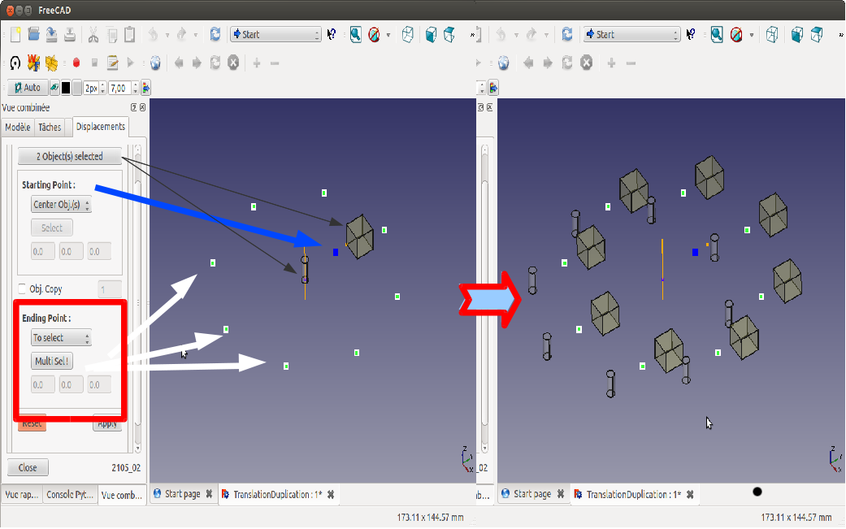

Release of 2015-04-03 :

Traceback (most recent call last):
File "/home/jo/.FreeCAD/Macros/start_WF.FCMacro", line 16, in <module>
import WorkFeature
File "/home/jo/.FreeCAD/Macros/WorkFeature/__init__.py", line 53, in <module>
from WF_ObjRot_2015 import *
File "/home/jo/.FreeCAD/Macros/WorkFeature/WF_ObjRot_2015.py", line 8, in <module>
import ObjRotGui_2015 as ObjRotGui
<type 'exceptions.ImportError'>: No module named ObjRotGui_2015
Modification :
WF_ObjRot_2015.py
line 8 import ObjRotGui_2015 as ObjRotGui (deleted)
line 9 import __init__ as func (changed into)

Release of 2015-05-23 :
Bug correction :
QT Icons path for FreeCAD was replaced inducing a "not found icon" error message.

Release of 2015-05-31 :
Modification :
Add sub Tab Align into Modif. Tab
Modification of Tool Rotate
new angle definition by selection of Edges
Modification of Tool Translate
Posibility to make a "deep" copy of objects
Add definition relative of ending point by user input
Addition :

into "Axis 2/2" TAB :
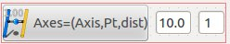

Axes=(Axis,Pt,Pl,a)
Create an Axis with an Angle to a origin Axis.
- First select an Axis to rotate, then a Plane and a rotation Point
- Second push this button
or
- First select an Axis to rotate, then a rotation Axis and a rotation Point
- Second push this button
NB:
The Axis is created by rotation using :
The Normal of the selected Plane as rotation Axis
and selected Point as rotation Point.
or
The second selected Axis as rotation Axis
and selected Point as rotation Point.
- The angle (in degrees) of rotation can be defined first.
Positive number in one direction and negative in the other one.
- The second number indicates the number of Axes to create.

into "Object" TAB :
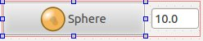

Sphere
Create a Sphere shell:
- First select one or several Center Point(s).
- Define Diameter if needed.
Then Click the button...
It will create Sphere shell(s) centered
at the selected point(s).

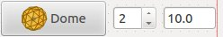

Dome
Create a full geodesic dome shell:
- First select one or several Center Point(s).
- Define Diameter and Frequency Parameter (Integer between 1 to 10) if needed.
Then Click the button...
It will create full geodesic dome shell(s) with a X-Y-symmetry plane
for even frequencies and centered
at the selected point(s).
If Frequency Parameter = 1, the code create an icosahedron.
An icosahedron is a polyhedron with 20 faces.
Original code from : Ulrich Brammer

into "Modif." TAB :
Add of Align Tab

into "Align" TAB :
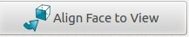

Align Face to View
Align the face of selected object(s) to the actual view Plane.
- Click first to select a Face of one or several objects.
Then Click the button.
NB:
The center of rotation is the center of the bounbing box if possible or
the center of the Face.
if the Face of the object selected is already aligned to the view Plane,
a rotation of 180 deg is applied to the object.
In this case the Axis of rotation is Z vector : Base.Vector(0, 0, 1)

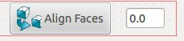

Align Faces
Align the Face(s) from selected object(s) to the last Face selected.
- Click first to select a Face of an object or several Faces from several objects.
- Click second to select a Face to align to.
Then Click the button.
NB:
The center of rotation is the center of the bounbing box if possible or
the center of the Face.
if the Face of the object selected is already aligned to the last one,
a rotation of 180 deg is applied to the object.
In this case the Axis of rotation is Z vector : Base.Vector(0, 0, 1)

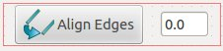

Align Edges
Align the Edge(s) from selected object(s) to the last Edge selected.
- Click first to select an Edge of an object or several Edges from several objects.
- Click second to select an Edge to align to.
Then Click the button.
NB:
The center of rotation is the center of the bounbing box if possible or
the center of the Edge.
if the Edge of the object selected is already aligned to the last one,
a rotation of 180 deg is applied to the object.
In this case the Axis of rotation is Z vector : Base.Vector(0, 0, 1)



Joint Points
Joint Point(s) from selected object(s) to the last Point selected.
- Click first to select a Point of an object or several Points from several objects.
- Click second to select an Point to joint to.
Then Click the button.

into "Check" TAB :
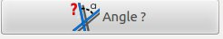

Angle
Check for two Edges/Planes angle:
Angle measurement between two Edges or two Planes
- Select the 2 Edges and
- Click this button
or
- Select the 2 Planes and
- Click this button
or
- Select one Edge and one Plane and
- Click this button
NB:
Normals of Planes will be used.


Distance
Check for two Points distance:
Distances measurement and Delta values (on main Axes) between two Points
- Select the 2 Points and
Click this button
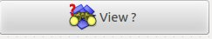

View
Detect the position of the camera.
The returned value is the value provided
by the function getCameraOrientation().

Release of 2015-06-22 :
Modification :
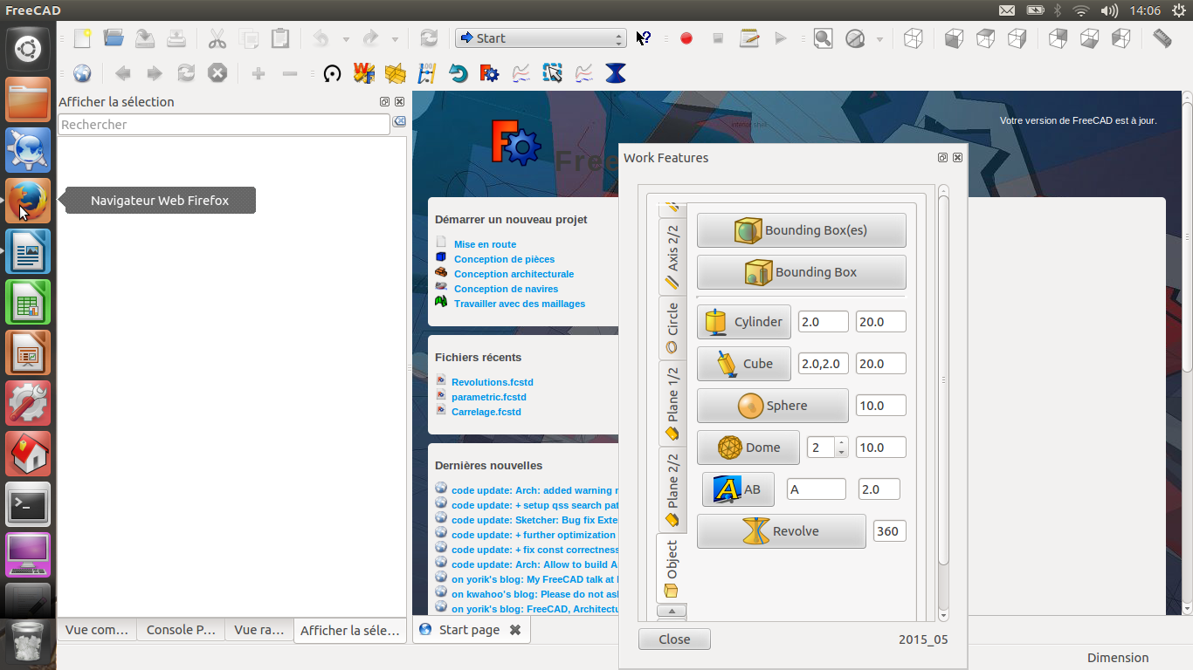
A new dock window version for Work Feature widget

Addition :

into "Circle" TAB :



Transform Circle(s) and Arc(s) in Sketch's object(s) by projection onto the Sketch's Plane:
- First select an existing Skecth;
- Select as much as Circles and arcs needed;
Then click on this button.

into "Object" TAB :

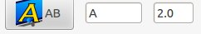

AB:
Create 3D Text attached to a Point.
- First select a Plane
- Then push this button
in this case the center of the text is attached to center of the Plane;
or
- First select a Plane and a Point on the Plane
- Then push this button
NB:
Change the text and his size if needed

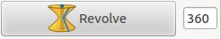

Revolve:
Make the revolution of Edge(s) or Wire(s) around an Axis:
- Select one or several wire(s)
- Then push this button
or
- Select FIRST one Point as center of rotation and one Axis as rotation axis !
- Select one or several wire(s)
- Then push this button

NB:
You can also define the angle of revolution if needed
If no Axis is selected the Z axis is considered as Axis of rotation !
If no Point is selected the Origin is considered as Center of rotation !

into "Check" TAB :
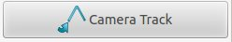

Select a Wire a the camera will follow the track.
Originalcode : Tour camera by Javier Martinez Garcia November 2014

into "Check" TAB :


Check for surface Area:
Area measurement for a Plane or a set of Planes.
- Select One or several Planes and
Click this button

Release of 2015-09-02 :
Modification and addition:

into "Circle" TAB :
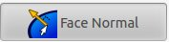

Create a normal Axis of a Face.
New handle of mesh objects.
To create a Normal at click location on a Face:
- Click first in the view to select and object,
- then push the button,
- then click on a location on the selected Face.
or
To create several Normal of the face:
- Click first in the view to select and object,
- then select one or several points of the face
- then push the button.
(These selections can also be done into the Combined View)

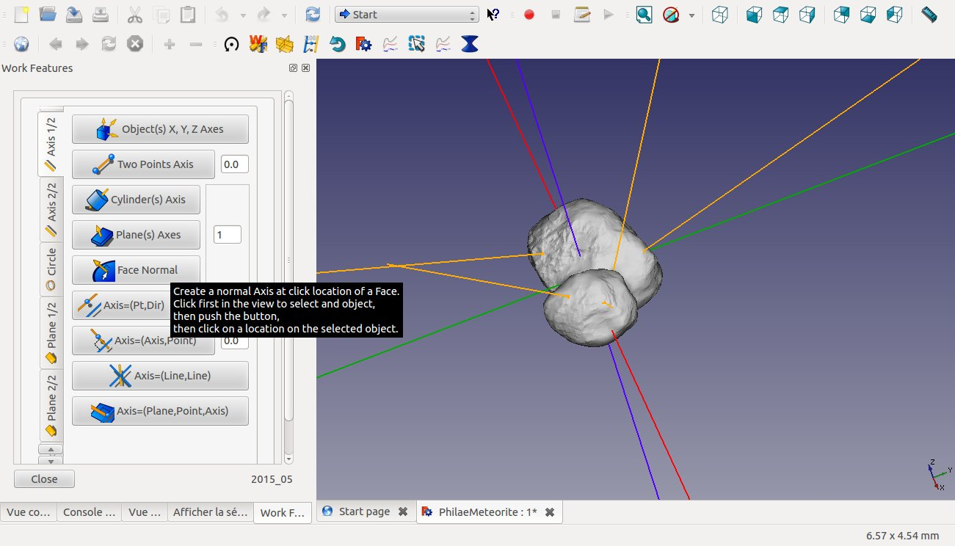

into "Object" TAB :
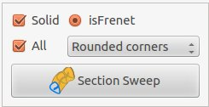

Section Sweep:
# Make a loft defined by a list of profiles along a wire.
Will extrude/sweep a Section along a Trajectory like sweep from Part Workbench but:
- the Section center (of Mass) is move at the first point of the Trajectory and;
- the "plane" of the Section is rotate to be perpendicular to the Trajectory.

- Select first one Section wire (Closed wire will generate volumes by default)
(This Section can be a compound from sketch to realize "tube")
- Select one or several wire(s) as Trajectory(ies)
- Then push this button

NB: You can change first:
- Solid option (if toggled will generate a solid for Closed wire Section only)
- isFrenet option
- All option (means if the trajectory selected is a compound, all sub wires will be used for the sweep)
- Transition Option (Select a Transition option in case of trajectory with several wires; Transition can be:
# 0 (default), 1 (right corners) or 2 (rounded corners).)

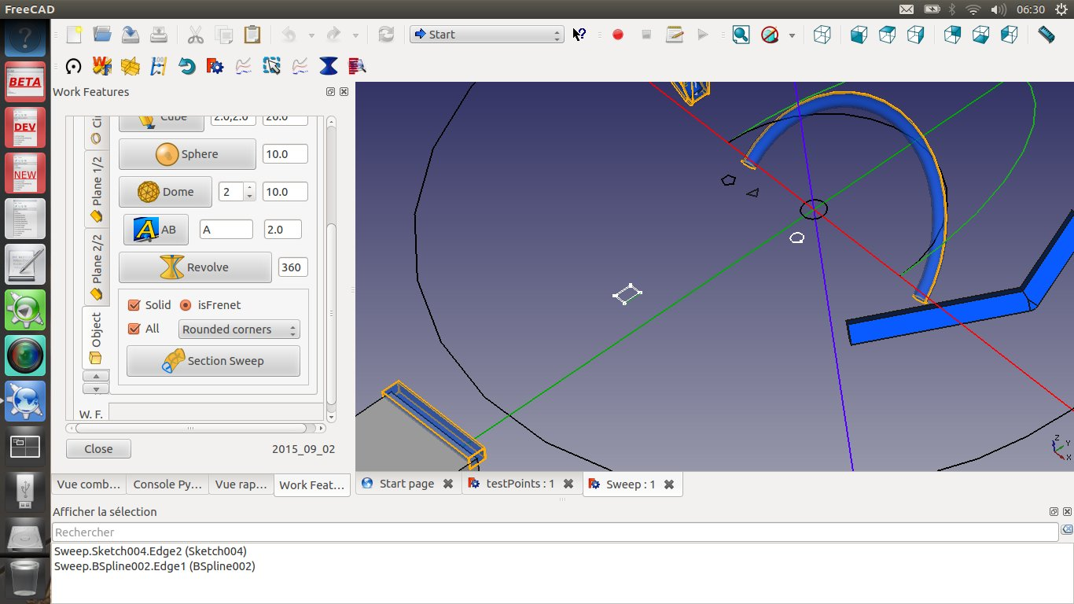

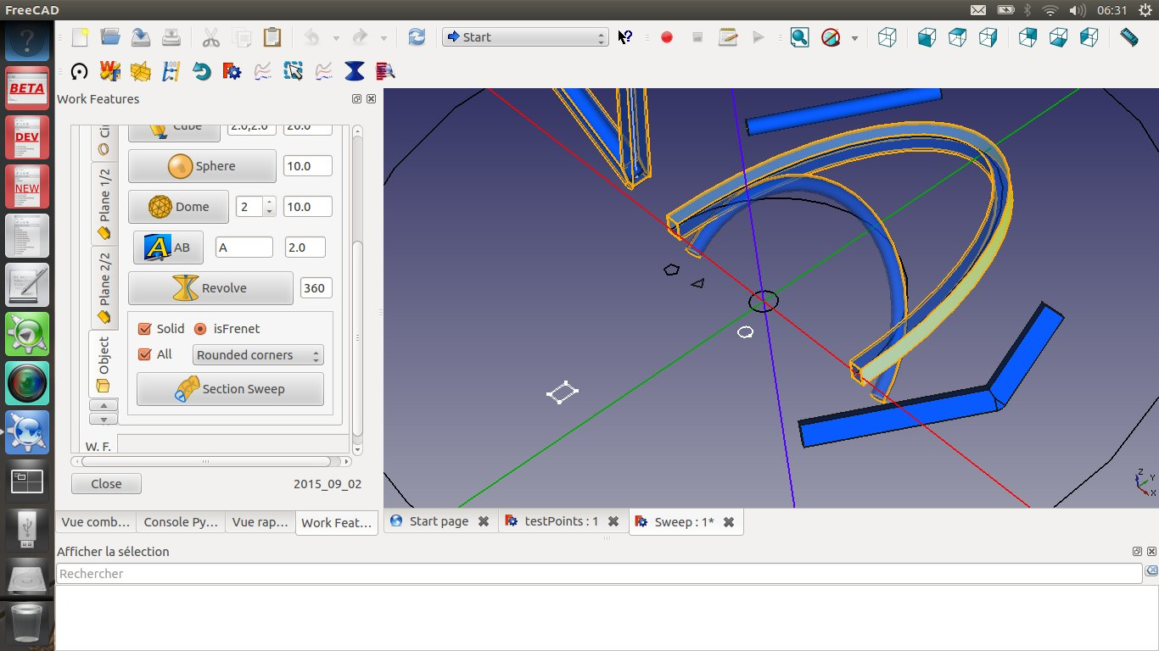
Hereafter the results

into "Align" TAB :

Align the Face(s) from selected object(s) to the last Face selected.
- Click first to select a Face of an object or several Faces from several objects.
These objects will be moved.
- Click second to select a Face to align to (the last object is fixed and will never move).
Then Click the button.

NB:
The center of rotation is the center of the bounbing box if possible or
the center of the Face.
if the Face of the object selected is already aligned to the last one,
a rotation of 180 deg is applied to the object.
In this case the Axis of rotation is Z vector : Base.Vector(0, 0, 1)

Two clicks will rotate by 180 deg the moving objects.

Align the Edge(s) from selected object(s) to the last Edge selected.
- Click first to select an Edge of an object or several Edges from several objects.
These objects will be moved.
- Click second to select an Edge to align to (the last object is fixed and will never move).
Then Click the button.

NB:
The center of rotation is the center of the bounbing box if possible or
the center of the Edge.
if the Edge of the object selected is already aligned to the last one,
a rotation of 180 deg is applied to the object.
In this case the Axis of rotation is Z vector : Base.Vector(0, 0, 1)

Two clicks will rotate by 180 deg the moving objects.

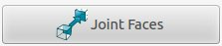

Joint Face(s) from selected object(s) to the last Face selected.
- Click first to select a Face of an object or several Faces from several objects.
These objects will be moved.
- Click second to select a Face to joint to (the last object is fixed and will never move).
Then Click the button.

Two clicks will rotate by 180 deg the moving objects.

Release of 2015-10-05 :
Bug correction: Projection of points and Edges onto an Sketch. It worked correctly when the Sketch was aligned on one of the 3 main planes (ie XY, XZ or YZ)
but failed when the Sketch was aligned in an other direction.

Correction done for Point(s) to Sketch and Edge(s) to Sketch (not yet for circle To Sketch, correction on going)

into Point TAB :

Transform Point(s) in Sketch's Point(s) by projection onto the Sketch's Plane:
- First select an existing Skecth;
- Select as much as Points needed;
Then click on this button.
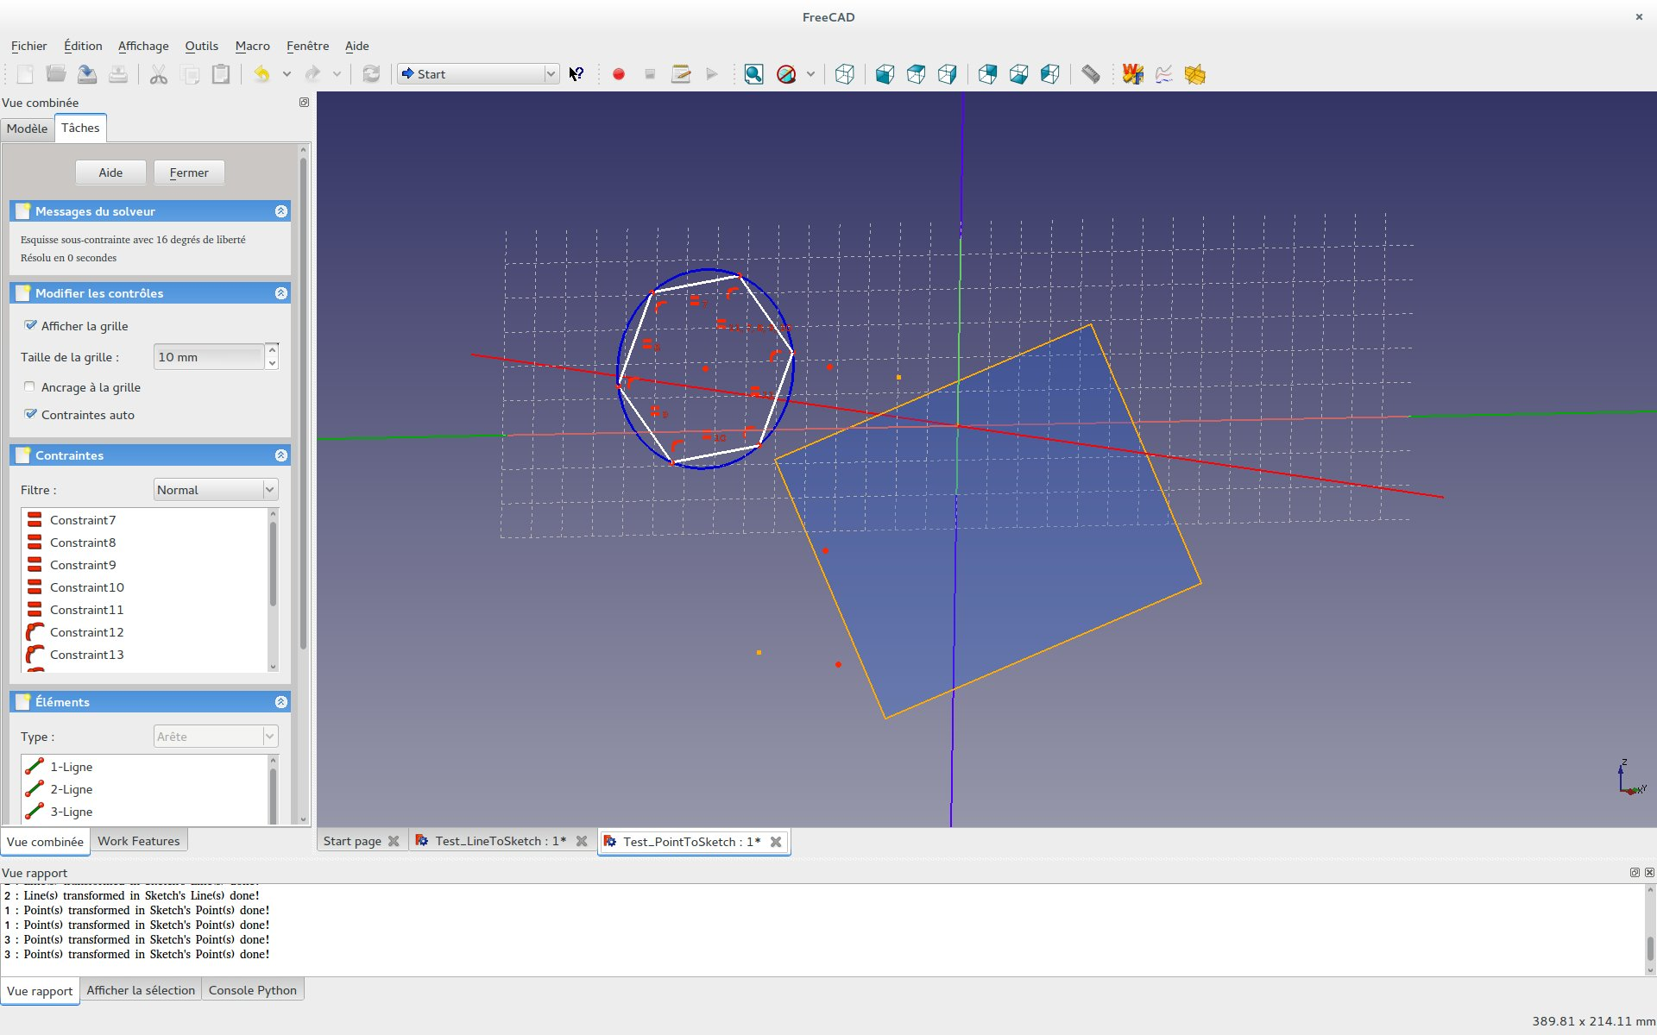

into Axis TAB :

Transform Line(s) in Sketch's Line(s) by projection onto the Sketch's Plane:
- First select an existing Skecth;
- Select as much as Lines needed;
Then click on this button.
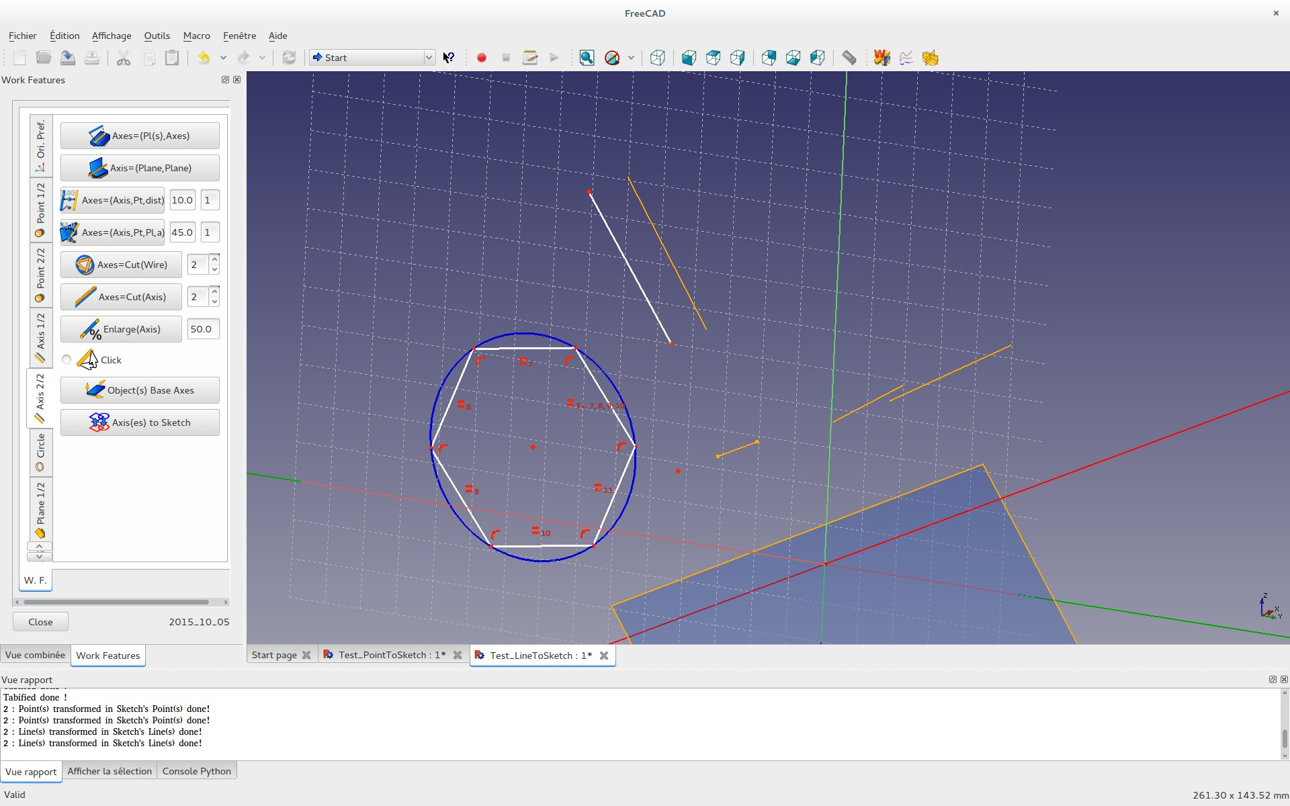

Release of 2015-11-04 :

Modification and addition:

Creation of TAB : Wire

2D and 3D parametric functions panel.
A set of predefined functions is available via a combo box.
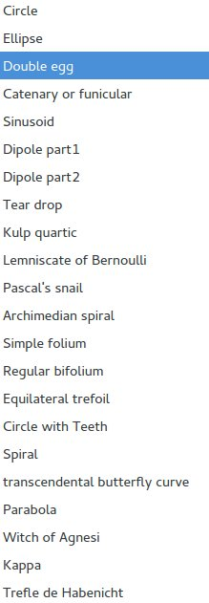
With possible saving of your parametric functions into a file in the home directory.
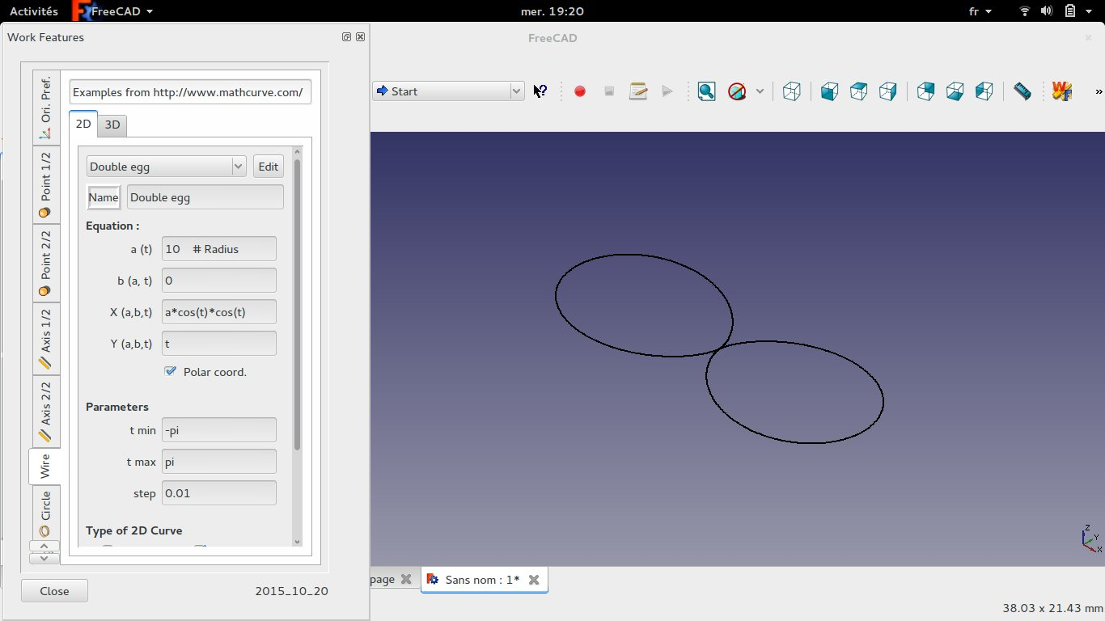
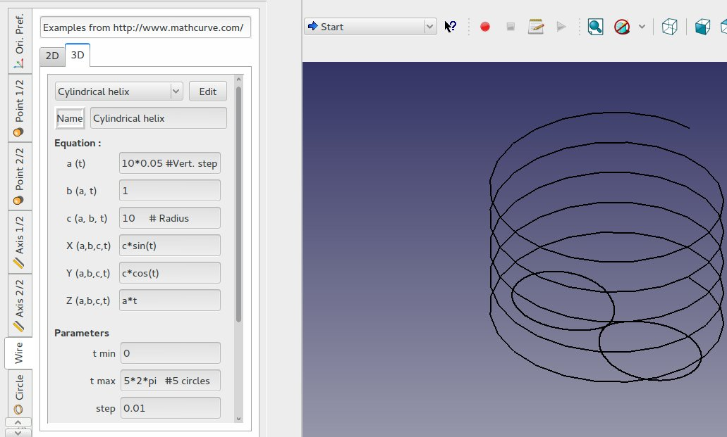
Creation of TAB : Sweeping
Move of Section Sweep from "Object" TAB into "Sweeping" TAB:

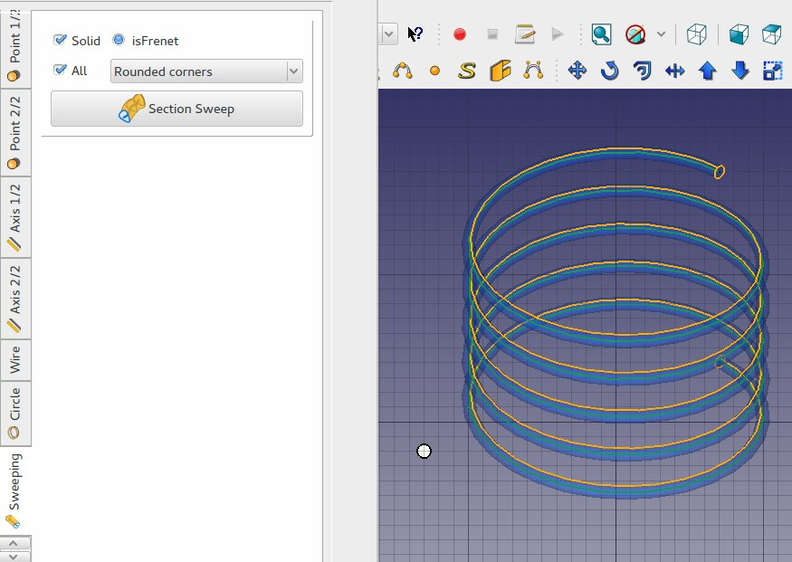

into "Object" TAB :

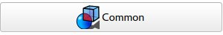

Compute the common parts between selected shapes.
- Select at least two objects and click.

Highlight common parts by showing the common shape in red and setting half-t ransparency on original parts (the original objects are not modified).
Original code from HighlightCommon.FCMacro
https://github.com/FreeCAD/FreeCAD- macros/blob/master/Utility/HighlightCommon.FCMacro
Authors = 2015 Javier Martinez Garcia

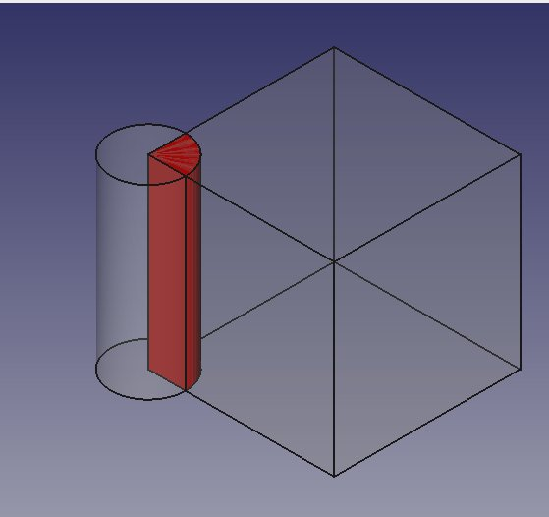

into "Object" TAB :


Compute the difference parts between selected shapes.
- Select two objects and click.

Compute the difference between two shapes. Additions are marked red, removals are marked green. Both original parts will be half transparent. The volume of the additions and removals are printed in the console.
Original code from HighlightDifference.FCMacro
https://github.com/FreeCAD/FreeCAD- macros/blob/master/Utility/HighlightDifference.FCMacro
Authors = 2015 Gaël Ecorchard (Galou)
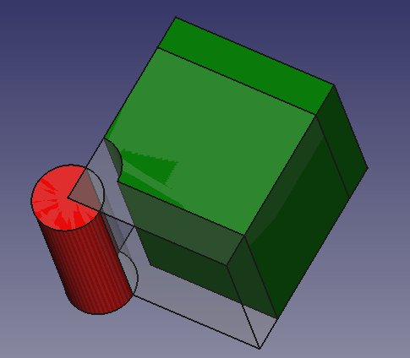

into "Axis 1/2" TAB :


Axis=(Points):
Create a "best fit" line from a set of points using Singular Value Decomposition..
- First select several Points
- Then push this button

The 3 eigenvectors are generated.
Orange one is the best fit line.

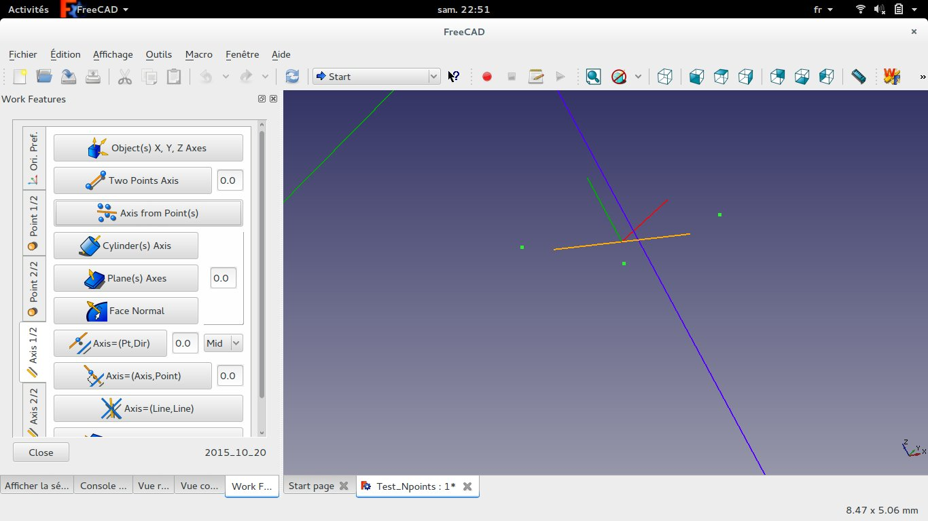
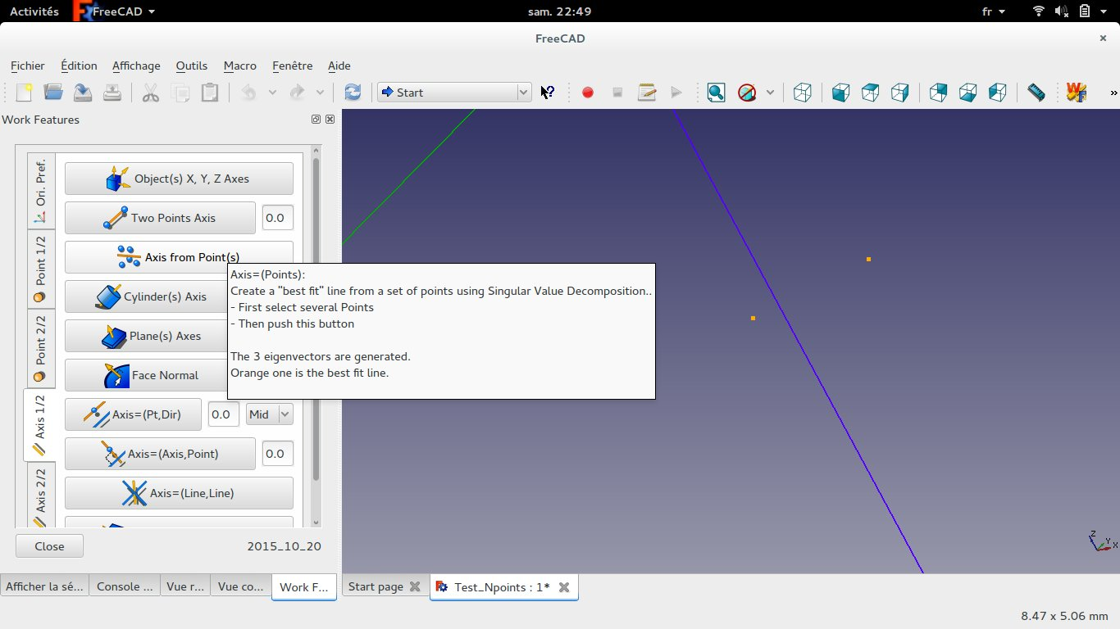

Release of 2015-11-08 :

Modification and addition:

into "Axis 1/2" ans "Axis 2:2" TAB :

In "Enlarge"
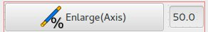

Extension of the Line in percentage of original length of the Line.
If the extension is 50% it means that each side is extended with 25% length.

Positive values will enlarge the Axis.
Negative values will start to shrink it.

In "Two Points Axis", "Cylinder(s) Axis", "Planes(s) Axes", "Face Normal" and "Axis=(Axis,Point)"
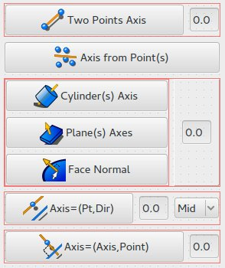

Extension values can be:
Positive values will enlarge the Axis toward OUTSIDE of the Face Object;
Negative values will enlarge the Axis toward INSIDE of the Face Object.

Release of 2015-12-16 :

Correction bug Bounding box

Addition:

into "Sweeping" TAB :
Beam (thanks to lorenz_l for Beam tool Macro)



Will extrude a Section along a Linear Trajectory.
- Select first one Section wire (Closed wire will generate volumes by default)
(This Section can be a compound from sketch to realize "tube")
- Select one or several wire(s) as Trajectory(ies)
- Then push this button

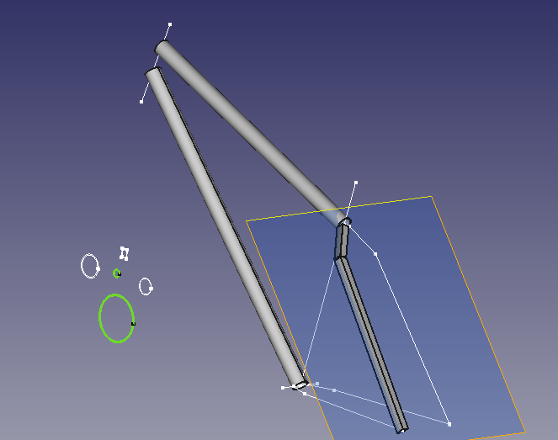

into "Object" TAB :
Duplicate


Make a copy of an object or a selected subObject part:
- Select one or several object(s) or subobject(s)
- Then push this button

into "Check" TAB :
Radius


Check for Radius:
Radius measurement for a Circle or an Arc.
- Select One Circle or Arc
- Then click this button

Release of 2016-03-29 :

Modification:
"Point 1/2" TAB and "Point 2/2" TAB gathered into sub tabs of one "Point" TAB
idem for "Axis" and "Plane" TABs.

Addition:

into "Point"/"Point2/3" TAB :
Object(s) Mass Center Point
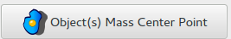

Create Center of Mass Point of all selected Object(s).

Object(s) N Point(s)


Create a set of points from selected Objetcs:
- Select object(s)
to create points from these object(s) !
If you select an Edge : 2 points will be created;
if you select a Plane : 4 points will be created;
if you select an Object : many points will be created.
- Then click on this button.

into "Point"/"Point3/3" TAB :
Load Points
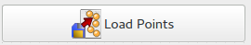

Load a set of points from an ASCII file:
ASCII format is 3 values by line seperated by blank as :
15.3f 15.3f 15.3f
Values are read as float.
Lines starting with characeter : # or / are considered as comment lines

Save Points


Save a point or a set of points into an ASCII file:
One (x, y, z) triplet per line seperated by blank.

- Select as much as Points as needed and/or select object(s)
to save points from these object(s) !
If you select an Edge : 2 points will be saved;
if you select a Plane : 4 points will be saved;
if you select an Object : many points will be saved.
- Then click on this button.

into "Axis"/"Axis3/3" TAB :
Object(s) N Axes(s)
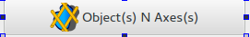

Create a set of axes from selected Objetcs:
- Select object(s)
to create axes from these object(s) !
if you select a Plane : 4 axes will be created;
if you select an Object : many axes will be created.
- Then click on this button.

Object(s) 3 Axes(s)


Create a set of 2 or 3 main axes from selected Objetcs:
The most representative axes will be selected from all axis.
The length of main axes will be the cumulative length of all axes with the same direction.
- Select object(s)
to create axes from these object(s) !
if you select a Plane : 2 axes will be created;
if you select an Object : 3 axes will be created.
- Then click on this button.

into "Modif." TAB :
Align Main Axis
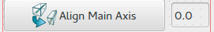

Align the main Axis (first of the 2 axis set) from selected object(s) to the last Edge (or 2 main Axis from an object) selected.
- Click first to select at least one object!
This or These first object(s) will be rotated.
- Click last to select an Edge (or an Object) to align to (this last object is fixed and will never move).
Then Click the button.

NB:
The 2 main first axis are calculated using scan and sort from all axis of the object.
The center of rotation is at center mass location of each selected object.

In case of several objects selection :
The 2 main Axis of the first object(s) will be aligned on the 2 main Axis of the last one.
In case of several objects selection plus one Edge :
The first main Axis of the object(s) will be aligned on the Edge.
- One click will align first main Axes.
- Second click will also align the second main Axes if exists on last object or
will rotate by 180 deg the moving objects on first main axes.
- Third and following clicks will rotate by 180 deg the moving objects on first main axes.

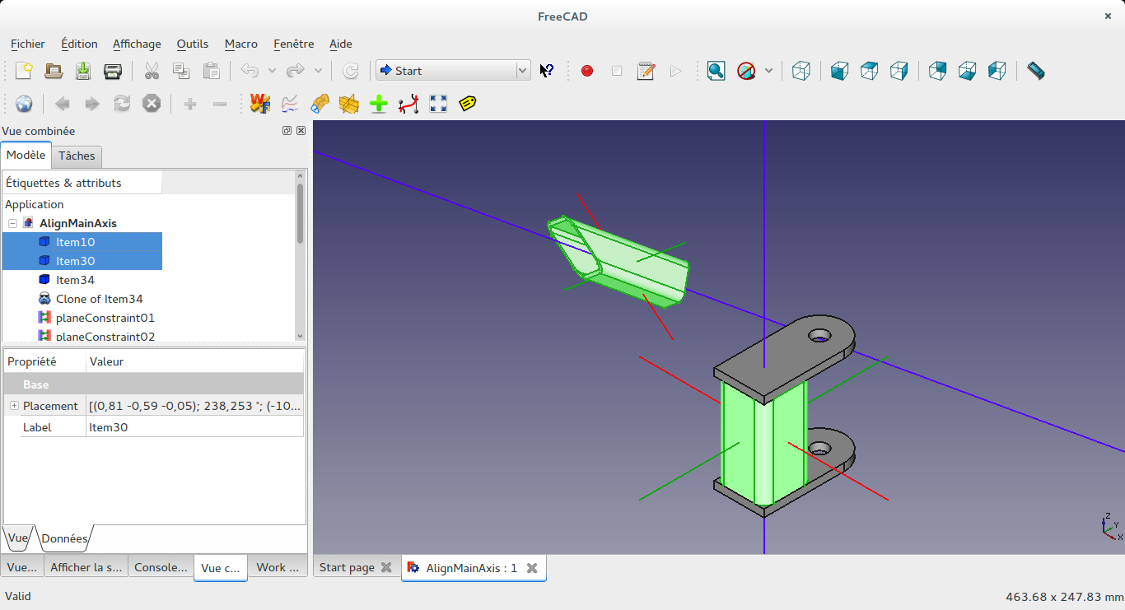

Select first and last object and click once the button.
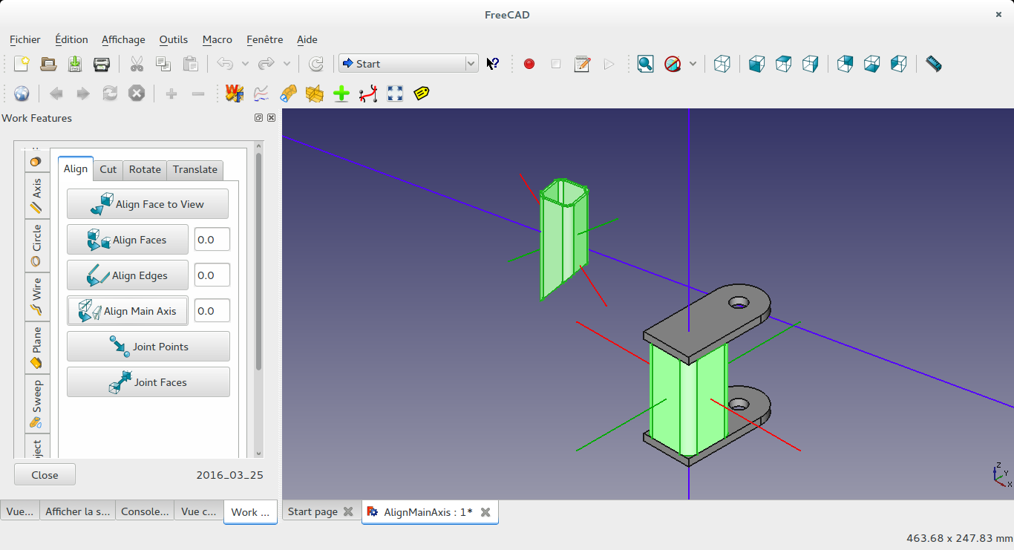
The Main "blue" axis are aligned.

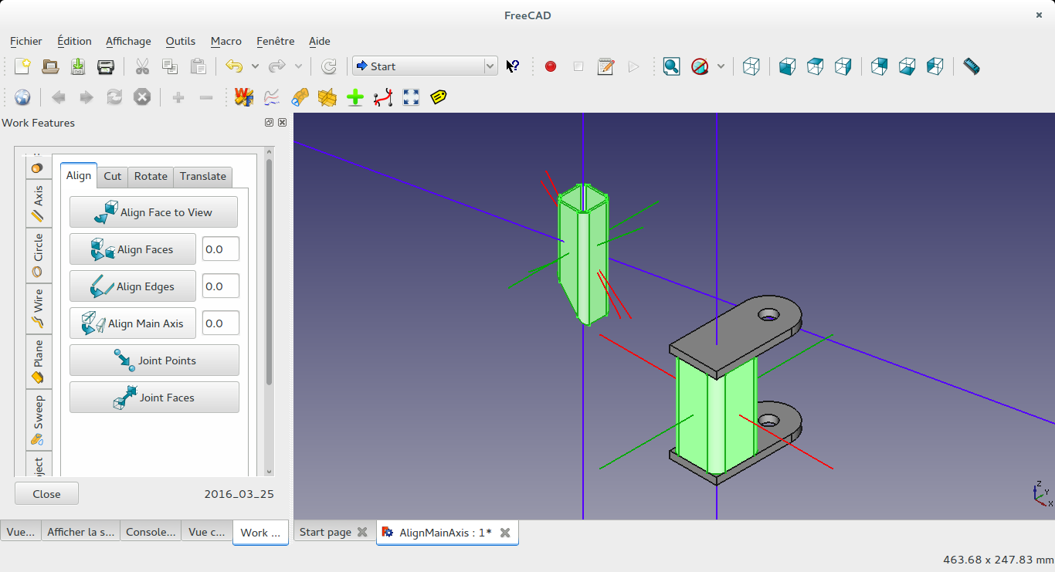
Click a second time will align main "blue" and second main "green" axis.

into "Plane"/"Plane1/2" TAB :
Plane=(N Points)
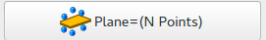

Plane=(N Points):
Create a "best fit" Plane from a set of points using Singular Value Decomposition.
- First select several Points (at least 3);
- Then push this button

Plane=(2 Points)


Plane=(2 Points):
Create a Plane in the middle of 2 points.
PLANE is perpendicular to line (P1 P2) and contains the midpoint of P1 and P2.
The direction of the normal of PLANE is the same as the vector from P1 to P2.
- First select 2 different points
- Second push this button

Release of 2016-09-10 :

Bug Fix:
Correction of home directory path by default (for txt file selection widget) on "Save" and "Load Points" functions not handled previpusly for Window version.

Modification:
For "Point tab" changes for allowing more complex multi objects selections, same improvements ongoing for other tabs for next release.
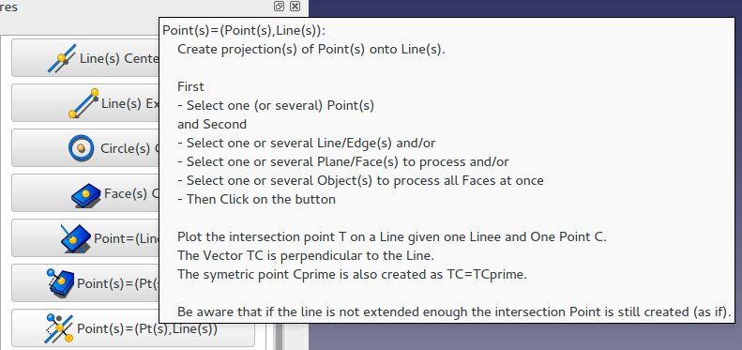

Addition:

into "Circle" TAB :
Arc=(3 Points):
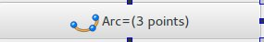

Create one Arc depending on 3 points.
- First select 3 Points
- Then Click on the button

into "Wire 1/3" TAB :
Bezier Cubic=(4 Points):

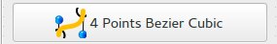

Create a Wire (Bezier Cubic) from 4 selected points.
- First 4 Points
- Then push this button

into "Image" TAB (new tab):
Copy and Scale Image(s) :

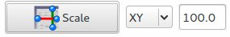

Scale an image along desired direction(s) (make a copy first of the original Image).
- First define the direction(s) on the right combo (default is XY):
if X is selected then only X direction will be scaled
if XY is selected then the scale will be squared in X and Y directions together
- Select one or several Images (in combo view)
- Select one Line (or 2 Points) (close to the Image) you want to define new dimension.
(better to select a Line strictly in X direction if you want to enlarge/squize the Image in X direction)
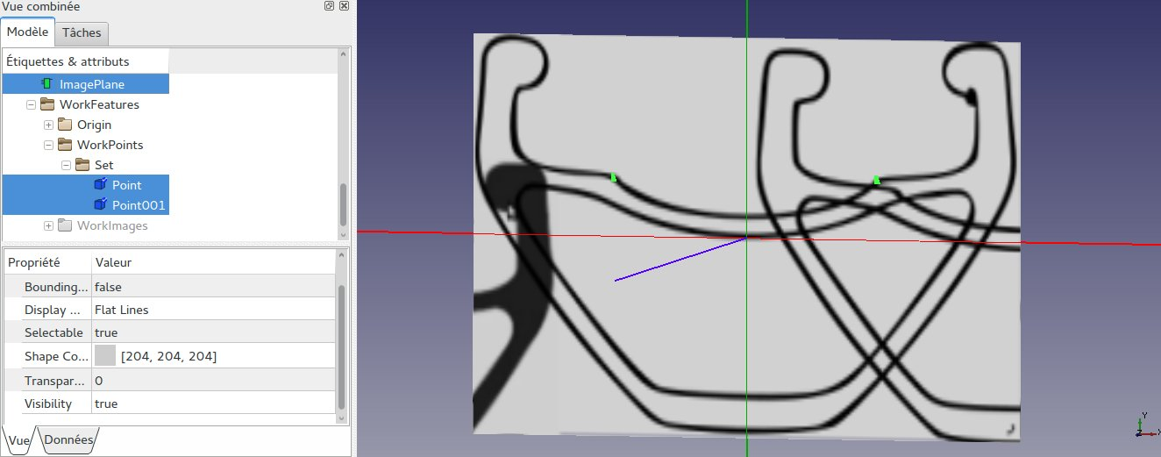
- Then give the target dimension of the Line (on the last right LineEdit).
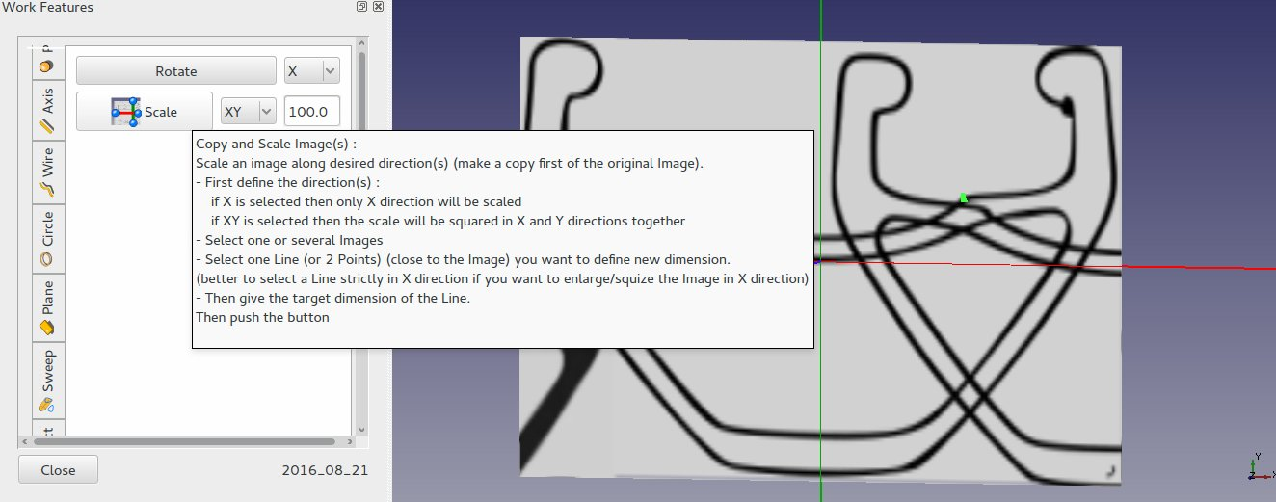
Then push the button

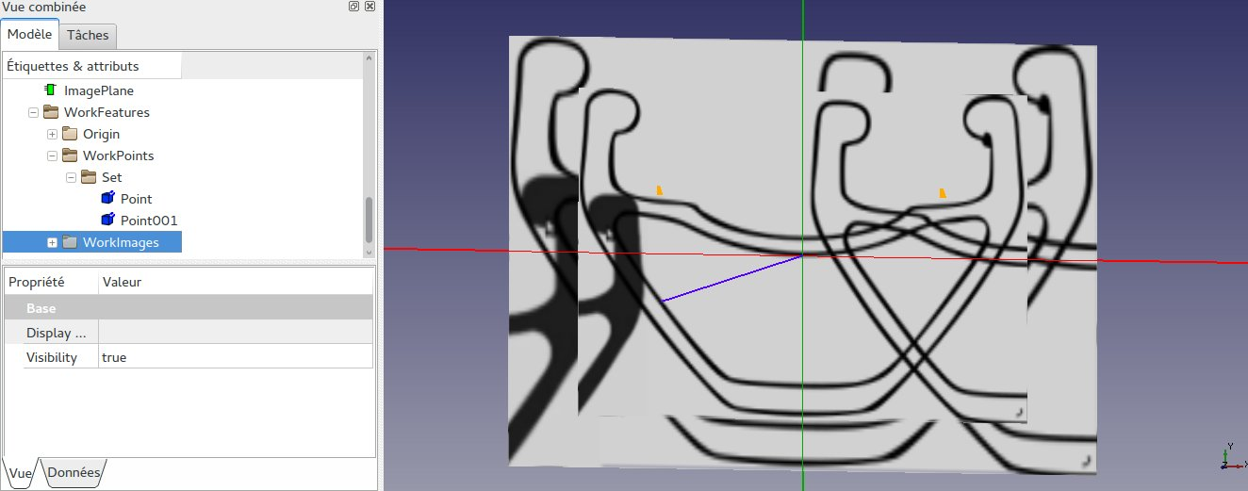

Release of 2016-12-31 :

Addition:

into "Point 3/3" TAB :
Random Point(s):
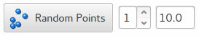

Create random Point(s).
Define first the number of points to create and the coordinates limits.
- Then push the button,
or
- Select first one point to the center desired location;
- Then push the button.
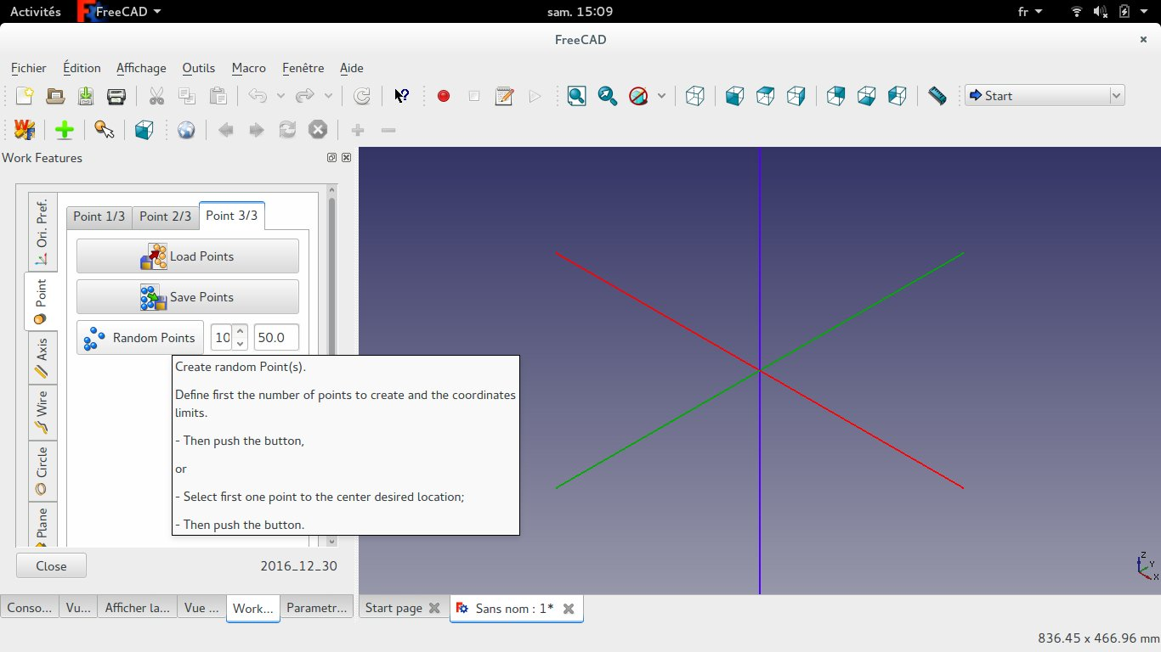
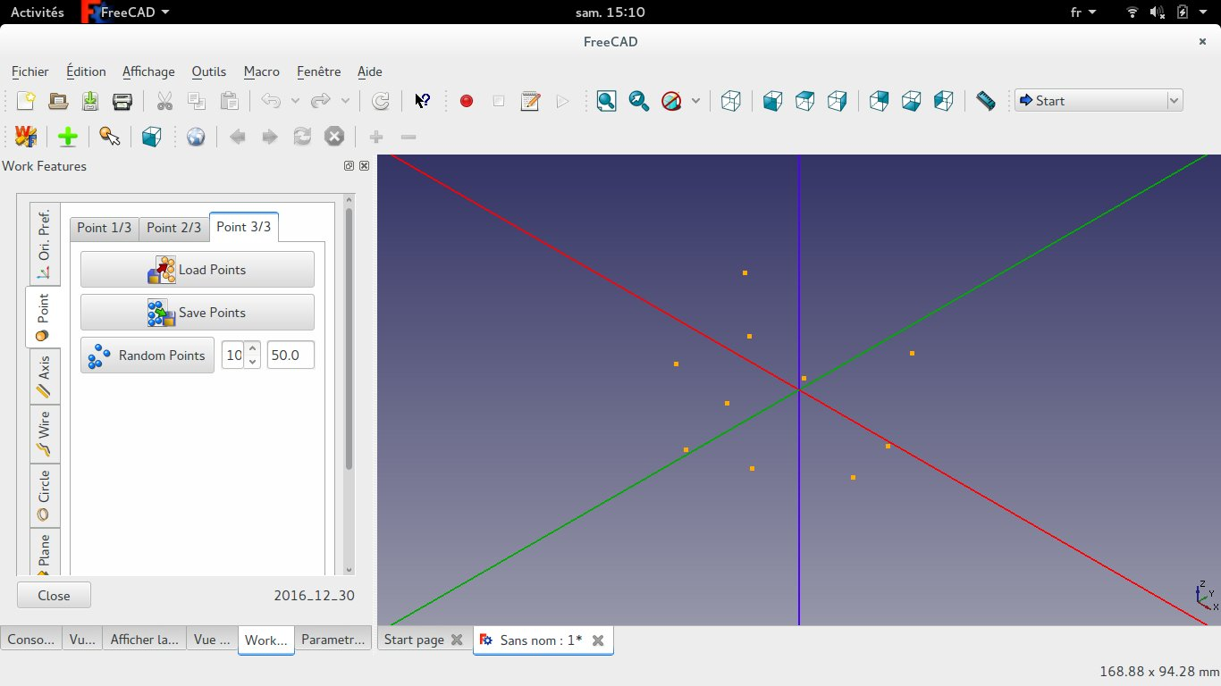
into "Wire 1/3" TAB :
Make Wire:


Wire=(N Points):
Create a Polygon (wire) from a set of points.
- First select several Points (at least 2);
- Then push this button
Modification:

Suppression of "Wire 2/3 and 3/3" TABs and replacement by "Curves And Surfaces" TAB :
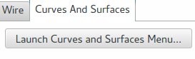

Addition:

into "Curves And Surfaces " TAB :
Launch Curves and Surfaces Menu:
Click to launch a new tool for Curves and Surface
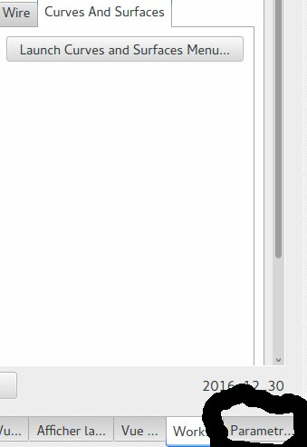

See WF_documentation.pdf for more details on the new tool.

Release of 2017-02-05 :

Addition:
into "Point 1/3" TAB :
Projected Point(s):
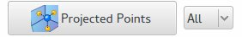

Create projected point(s) on the choosen main planes.
- Select one (or several) Point(s) and/or one (or several) Axis.
Define the projection plane if needed.
It can be either
XY plane,
YZ plane,
XZ plane or
All 3 planes

into "Wire 1/2" TAB :
Convex 2D Polygon:
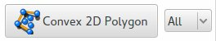

Create a Convex 2D Polygon (wire) from a set of points.
The Convex Polygon is the outer limit of all selected Points.
- First select several Points (at least 3);
Define the projection plane if needed.
It can be either
XY plane,
YZ plane,
XZ plane or
All 3 planes
- Then push the button.

Update:
into "Modif." TAB:
Translate:

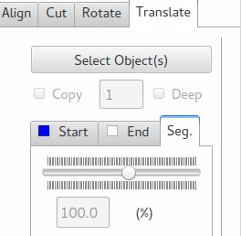

Add of Translation based on selection of a Axis/segment

Tutorials (into Doc/Tutorials directory):
WF_Tuto_MODIF_TranslationBySegment.mp4
WF_Tuto_POINTS_ProjectedPoints.mp4
WF_Tuto_POINTS_RandomPoints.mp4
WF_Tuto_WIRE_2DConvexPolygon.mp4
WF_Tuto_WIRE_CreatePolygon.mp4
WF_Tuto_WIRE_Regression2D.mp4

Release of 2018-01-24 :

Bug correction:

1 - When selection of a circle and button "Align View to... "
Traceback (most recent call last):
File "C:\Users\Mario\AppData\Roaming\FreeCAD\Mod\WorkFeature\WorkFeature\WF_2015.py", line 10702, in view_align
m_Vertex2 = SubObject.Vertexes[1]
IndexError: list index out of range

Correction done !

2 - 3D Text feature of the WF WB when I came across it. Unfortunately I did not succeed in finding any surface which did not cause the error message " Non Planar Surface !".

Issue with location of Font file : correction done !

Modification:
into "Point 1/3" TAB :
Projected Point(s):
Add functions of annotation "Macro_BoundingBox_Tracing" (from Mario) into Bounding Box buttons.
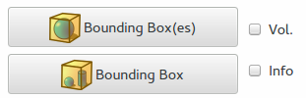

To activate this option, toggle "Info" check box.

Add functions of creation of a Voume in addition to rectangles into Bounding Box buttons.

To activate this option, toggle "Vol" check box.

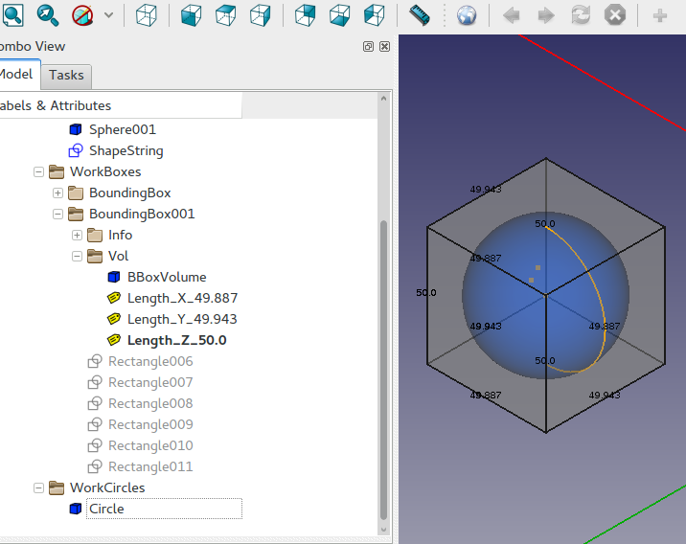

Release of 2024-12-18:
Main modifications: Adapt the tool to FreeCAD 1.0

Bug correction:

https://github.com/Rentlau/WorkFeature/issues/31
Projection points several bugs: objects can now be selected and projection points created even if some of these points are already on a projected plane; Correction done !

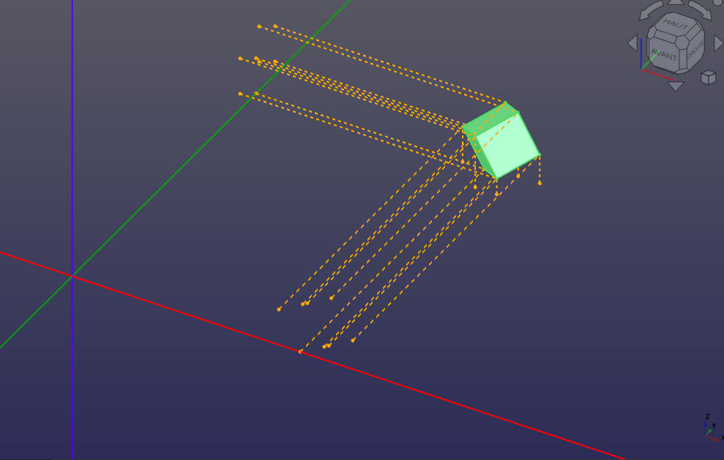

Modification:
into "Curves And Surfaces " TAB :
Bug found when creating surfaces: correction done
