Playing Tougher for One’s Size:
Calibrated Size Above Expected in the NHL
Rento Saijo¹, Sian Lee², Jeff Moher¹, Yeongjun Seo³
¹ Connecticut College; ² Michigan State University; ³ University of Tennessee, Knoxville

Introduction
Adding size to an NHL roster does not guarantee tougher play. Toughness emerges through contact and battles for the puck and space, yet size and hit counts cannot measure it relative to a player’s frame. We develop calibrated size above expected (CSAx), a position-specific measure of playing tougher for one’s size. We examine its agreement with scouting reports and links to special-teams deployment, postseason hitting, and next-season continuation.

Methods
NHL events and All Three Zones’ tracked five-on-five data cover 1,485 forward- and 829 defenseman-seasons from 2021–22 through 2024–25. Separate ridge models predict listed height-and-weight size using shared direct measures (e.g., hits delivered and received) and position-specific indirect measures (e.g., dump-in recoveries for forwards, entry-denial share for defensemen). We calibrate held-out predictions against listed size and standardize the residual within position and season:
$$CSAx=\frac{\hat{S}−\hat{m}(S)−\overline{r}}{s_{r}}, r=\hat{S}−\hat{m}(S).$$
Here, $S$ is standardized listed size, $\hat{S}$ is behavior-implied size, $\hat{m}(S)$ is its training-based expectation for that frame, and $\overline{r}$ and $s_{r}$ summarize held-out residuals by position-season. Higher CSAx indicates a tougher profile more characteristic of a larger player than expected for that frame. One rater, blinded to identity and CSAx, codes mentions of checking, puck battles, and other toughness traits in official NHL draft-year scouting reports published before the studied seasons. Linear models assess special-teams shares and returner ice time; logistic models assess next-season continuation (at least 300 NHL minutes); and Poisson models compare hit rates within player-seasons with ice-time offsets. These analyses account for listed size, age and age squared, current-season games dressed and ice time per game, five-on-five points per 60, relative shot attempts, and season. We compare regular-season games excluded from CSAx construction with each team’s first four postseason games, a common window regardless of advancement.

Results
Players whose earlier scouting reports mention toughness traits average +0.87 CSAx standard deviations higher among forwards and +0.65 among defensemen than peers without such mentions (Figure 1).
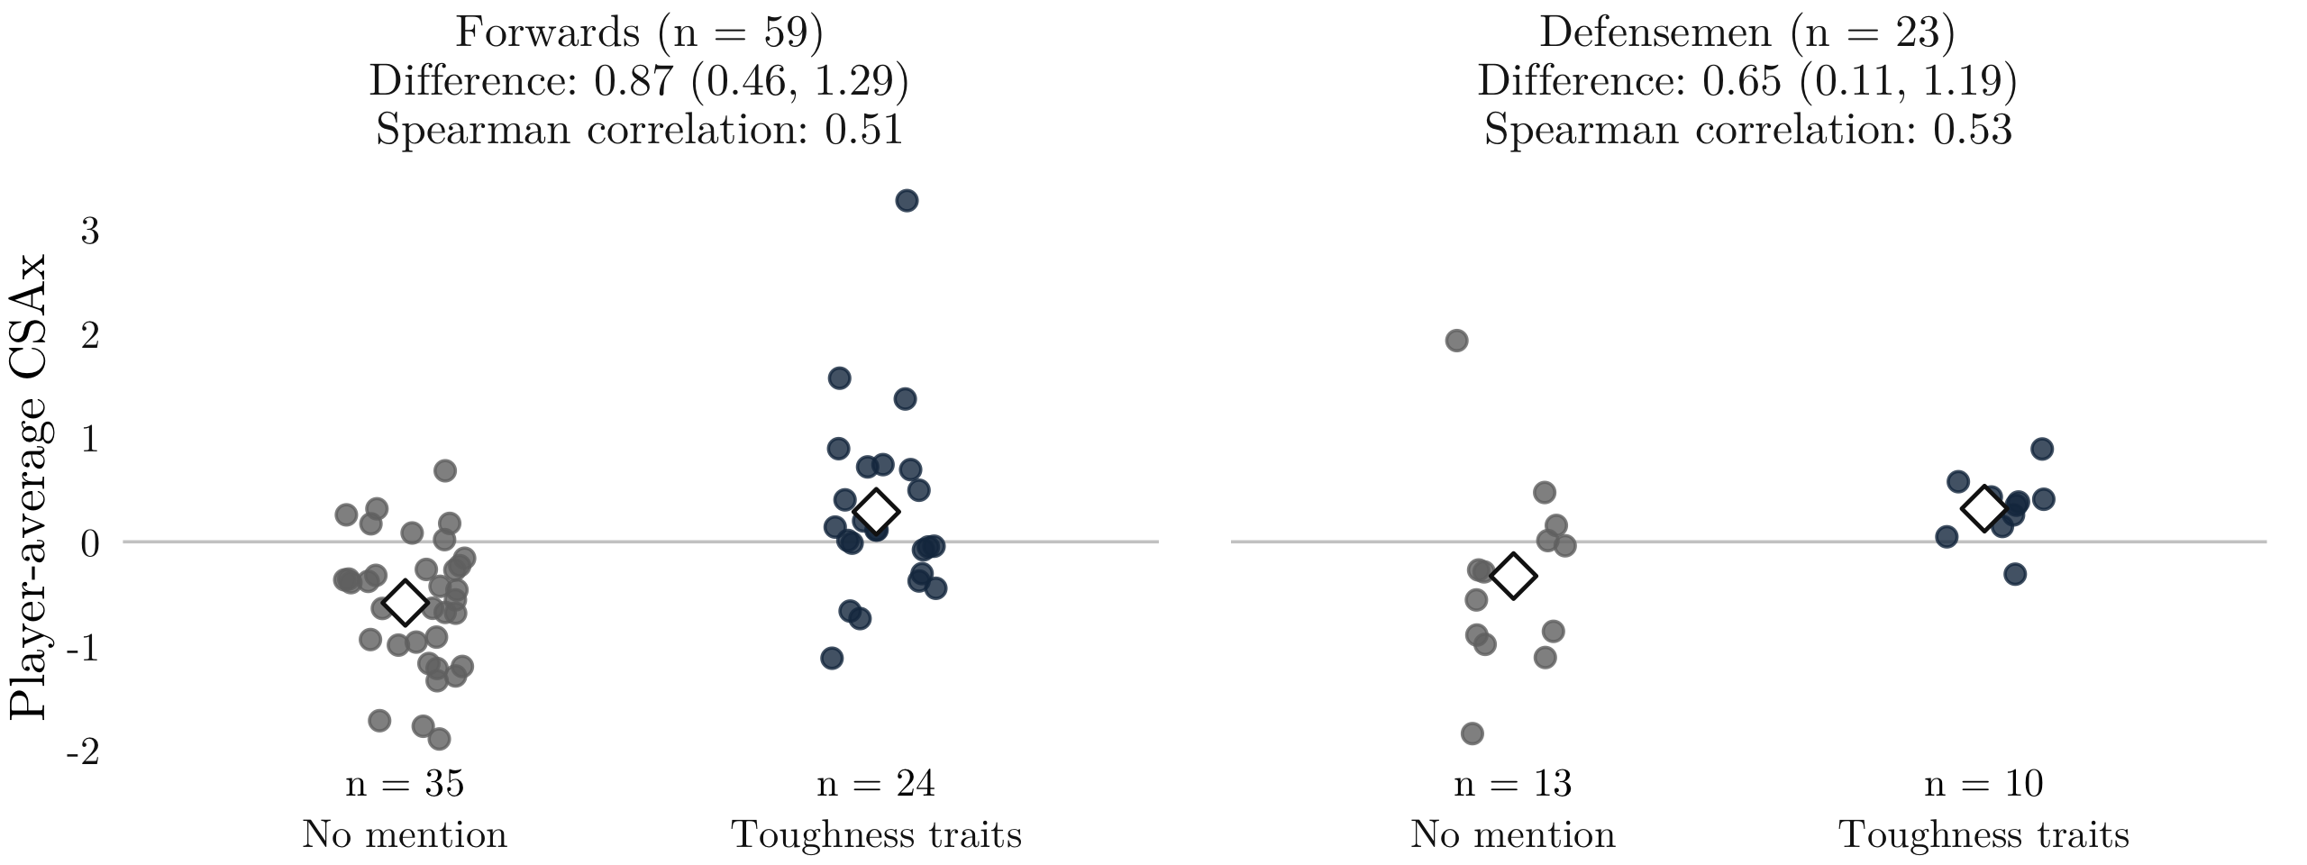
Figure 1. Player-average CSAx by whether an earlier scouting report mentions toughness traits. Points represent players; diamonds mark group means. Mean differences, with 95% confidence intervals, suggest general agreement with earlier scouting descriptions. The high-CSAx defenseman without the toughness description may serve as an example of how our metric can evaluate tough players who are sometimes overlooked by scouts due to their relative size; we examine this case further in the full paper.
Teams assign higher-CSAx players in both positions a smaller power-play share and a larger penalty-kill share (Table 1). Forwards hit more often in the postseason, but the proportional rise is smaller at higher CSAx; their higher regular-season rates may leave less room for further proportional growth. The defenseman contrast remains uncertain. Finally, higher CSAx is associated with a greater chance of next-season continuation, but not with clearly greater ice time among returners.
Table 1. Adjusted CSAx +1 versus -1 comparisons (95% player-clustered confidence intervals in parentheses). The postseason value compares postseason-to-baseline hit-rate ratios; below one indicates a smaller proportional increase.
Outcome | Forwards | Defensemen
Power-play share (percentage points) | -1.22 (-1.78, -0.67) | -0.88 (-1.51, -0.25)
Penalty-kill share (percentage points) | 1.40 (0.74, 2.06) | 1.31 (0.74, 1.89)
Postseason hit-rate (ratio) | 0.78 (0.69, 0.88) | 0.90 (0.77, 1.05)
Next-season continuation (percentage points) | 2.92 (0.03, 5.81) | 4.23 (0.60, 7.86)
Ice time (min/game) | -0.18 (-0.36, 0.00) | -0.14 (-0.43, 0.14)

Conclusion
CSAx measures how tough players play for their listed size. Its agreement with scouting and links to penalty-kill use and next-season continuation may help teams assess specialized roles. Used with hit counts and scoring, CSAx may help balance toughness with skill without equating contribution with ice time. Selectively tracked games, one scouting rater, and weak defensive size prediction in 2024–25 limit generalization.

