MAHARASHTRA STATE BOARD OF TECHNICAL EDUCATION MUMBAI


GOVERNMENT POLYTECHNIC AWASARI(KHURD)
DEPARTMENT OF INFORMATION TECHNOLOGY

INDUSTRIAL TRAINING REPORT
ON
12 WEEK IMPLANT TRAINING
ON
( RENTRA – HIGH-VALUE ASSET & HEAVY EQUIPMENT RENTAL MARKETPLACE )
Submitted By:
Aryan Navnath Barbate
Enrollment No.: 24210270556
Under the Guidance of : Mrs. Jyoti Dabhade
Name of Industrial Supervisor: Ms. Shahin Momin

Submitted To:  MAHARASHTRA STATE BOARD OF  TECHNICAL EDUCATION, MUMBAI  Academic Year : 2026-27 (K-Scheme) | Place : Government Polytechnic  Awasari(Khurd) - IT Department  Date : _____________________

Maharashtra State
Board of Technical Education, Mumbai

Certificate of Completion
of Industrial Training
(by respective Head of the Department & Head of the Institute)

This is to certify that Mr./Ms…………………………………………………... with Enrollment No…………………….. has successfully completed 12 Weeks Internship (315004) in Linkcode Technologies Pvt Ltd , Pune from the date 01/06/2026 to date 22/08/2026 for the partial fulfilment towards completion of Diploma in Information Technology from Government Polytechnic, Awasari Khurd (Institute code - 1051)
\

Signature Signature
Faculty Mentor External Examiner/Industry Expert

Signature Signature
Head of the Department Seal Head of the Institute



PROJECT MEMBERS
GOVERNMENT POLYTECHNIC AWASARI (KHURD)
DEPARTMENT OF INFORMATION TECHNOLOGY

This is to certify that the following project members have successfully participated in the 12-Week Industrial Implant Training program at Linkcode Technologies, Shivajinagar, Pune, and contributed to the architecture, design, full-stack development, testing, and comprehensive documentation of the project titled 'RENTRA – High-Value Asset & Heavy Equipment Rental Marketplace' in partial fulfillment of the requirements for the Diploma in Information Technology under the Maharashtra State Board of Technical Education (MSBTE) K-Scheme curriculum during the Academic Year 2026–27.

Sr no | Name | Enrollment No. | Roll No
1. | Aryan Navnath Barbate | 24210270556 | 26IF306
2. | Purvesh Nitin Jadhav | 24210270579 | 26IF327
3. | Ayush Jaydev Bhor | 24210270558 | 26IF307
4. | Pruthviraj Umesh Bhosale | 24210270559 | 26IF308
5. | Omkar Subhash Ghodke | 24210270571 | 26IF319

ABSTRACT
This industrial training report of Aryan Navnath Barbate is based on the architectural design, engineering, full-stack implementation, and testing of the RENTRA – High-Value Asset & Heavy Equipment Rental Marketplace during the industrial implant training program. The training was undertaken for a comprehensive duration of 12 weeks before completing the Diploma course, starting from 01 June 2026 until 22 August 2026, at Linkcode Technologies, Shivajinagar, Pune, under the industrial mentorship of Ms. Shahin Momin and academic guidance of Mrs. Jyoti Dabhade. The primary purpose of this industrial training program is to fulfill the academic and practical curriculum requirements of the Maharashtra State Board of Technical Education (MSBTE) K-Scheme to complete the Diploma in Information Technology from Government Polytechnic Awasari (Khurd).
This training provided an invaluable opportunity to bridge theoretical classroom knowledge with real-time industry development practices, gaining intensive hands-on experience in enterprise full-stack web architectures, distributed systems, and modern software engineering toolchains. The project developed during the internship, Rentra, is a specialized B2B/B2C marketplace engineered to eliminate fraud, reduce heavy asset downtime, and streamline transactional security in the multi-crore industrial equipment rental sector.
During the training at Linkcode Technologies, I was immersed in the company's agile development workflow, Git version control, Postman API lifecycle management, and enterprise coding standards. I mastered modern JavaScript (ES6+) and TypeScript concepts, advancing directly to the production MERN Stack (MongoDB Atlas, Express.js v5, React 19, Node.js). Key architectural modules engineered include an immutable 9-Stage Escrow Booking State Machine integrated with the Razorpay Payment Gateway, bi-directional real-time WebSocket state synchronization using Socket.IO, asynchronous document processing, and automated multi-tenant Role-Based Access Control (RBAC) separating Customer, Owner, and Admin workflows.
Furthermore, I designed and implemented five industry-first differentiating features: a Certified Operator Option with dynamic billing, a Project Fleet Bundler with multi-item cart calculations, a Lowboy Hauling & Freight Logistics Estimator, an Engine Hour Overtime Meter for runtime tracking, and an HTML5 Canvas-based Digital Inspection with touch E-Signature verification. The internship also reinforced core database optimization with Mongoose ODM, NoSQL injection prevention, cryptographic password hashing using bcryptjs, automated PDFKit invoice generation, and Cloudinary media optimization pipelines.
Overall, this 12-week industrial implant training gave me a solid balance of technical expertise, real-world architectural design capabilities, debugging acumen, and professional collaboration skills, significantly contributing to my academic excellence and laying a firm foundation for my career as a full-stack software engineer.

ACKNOWLEDGEMENT
I take this opportunity to express my profound gratitude and sincere thanks to Ms. Shahin Momin, Senior Technical Lead and Corporate Trainer at Linkcode Technologies, Shivajinagar, Pune, for her invaluable technical guidance, constant encouragement, insightful code reviews, and unwavering support throughout the development and completion of my industrial training project “RENTRA – High-Value Asset & Heavy Equipment Rental Marketplace”. Her deep industry expertise, architectural advice, and constructive feedback were instrumental in the successful execution of this work.
I extend my heartfelt thanks to the entire management, technical mentors, and staff of Linkcode Technologies, Pune for providing me with a conducive industrial learning environment, state-of-the-art laboratory infrastructure, and the opportunity to work on real-world enterprise web engineering challenges.
I express my deepest sense of gratitude to my internal academic guide Mrs. Jyoti Dabhade, Lecturer, Department of Information Technology, Government Polytechnic Awasari (Khurd), for her exemplary mentorship, continuous academic supervision, and valuable suggestions at every stage of this industrial training program.
I also convey my sincere regards and respect to the Head of Department, faculty members, and technical staff of the Department of Information Technology and the Principal of Government Polytechnic Awasari (Khurd) for their administrative facilitation, encouragement, and foundational support throughout my diploma education.
Lastly, I am indebted to my parents, family, and fellow project peers for their enduring moral support, patience, and motivation during the intensive training and documentation period. Finally, I am thankful to all individuals who directly or indirectly contributed to the successful completion of this industrial training program.

CONTENT PAGE

Sr. No. | Chapter | Title | Page No.
1 | Chapter 1 | Organization Structure of Industry and General Layout | 6
2 | Chapter 2 | Introduction to Industry / Organization | 8
3 | Chapter 3 | Types of Major Equipment / Software Used in the Industry | 9
4 | Chapter 4 | Processes / Development Methodologies | 11
5 | Chapter 5 | Testing of Hardware / Software and Quality Assurance | 13
6 | Chapter 6 | Safety Procedures Followed and Data Security Measures | 15
7 | Chapter 7 | Particulars of Practical Experiences in Industry | 16
8 | Chapter 8 | Detailed Report of the Tasks Undertaken | 17
9 | Chapter 9 | Special / Challenging Experiences Encountered | 27
10 |  | Conclusion | 28
11 |  | References | 29

Chapter 1: Organization Structure of Industry and General Layout
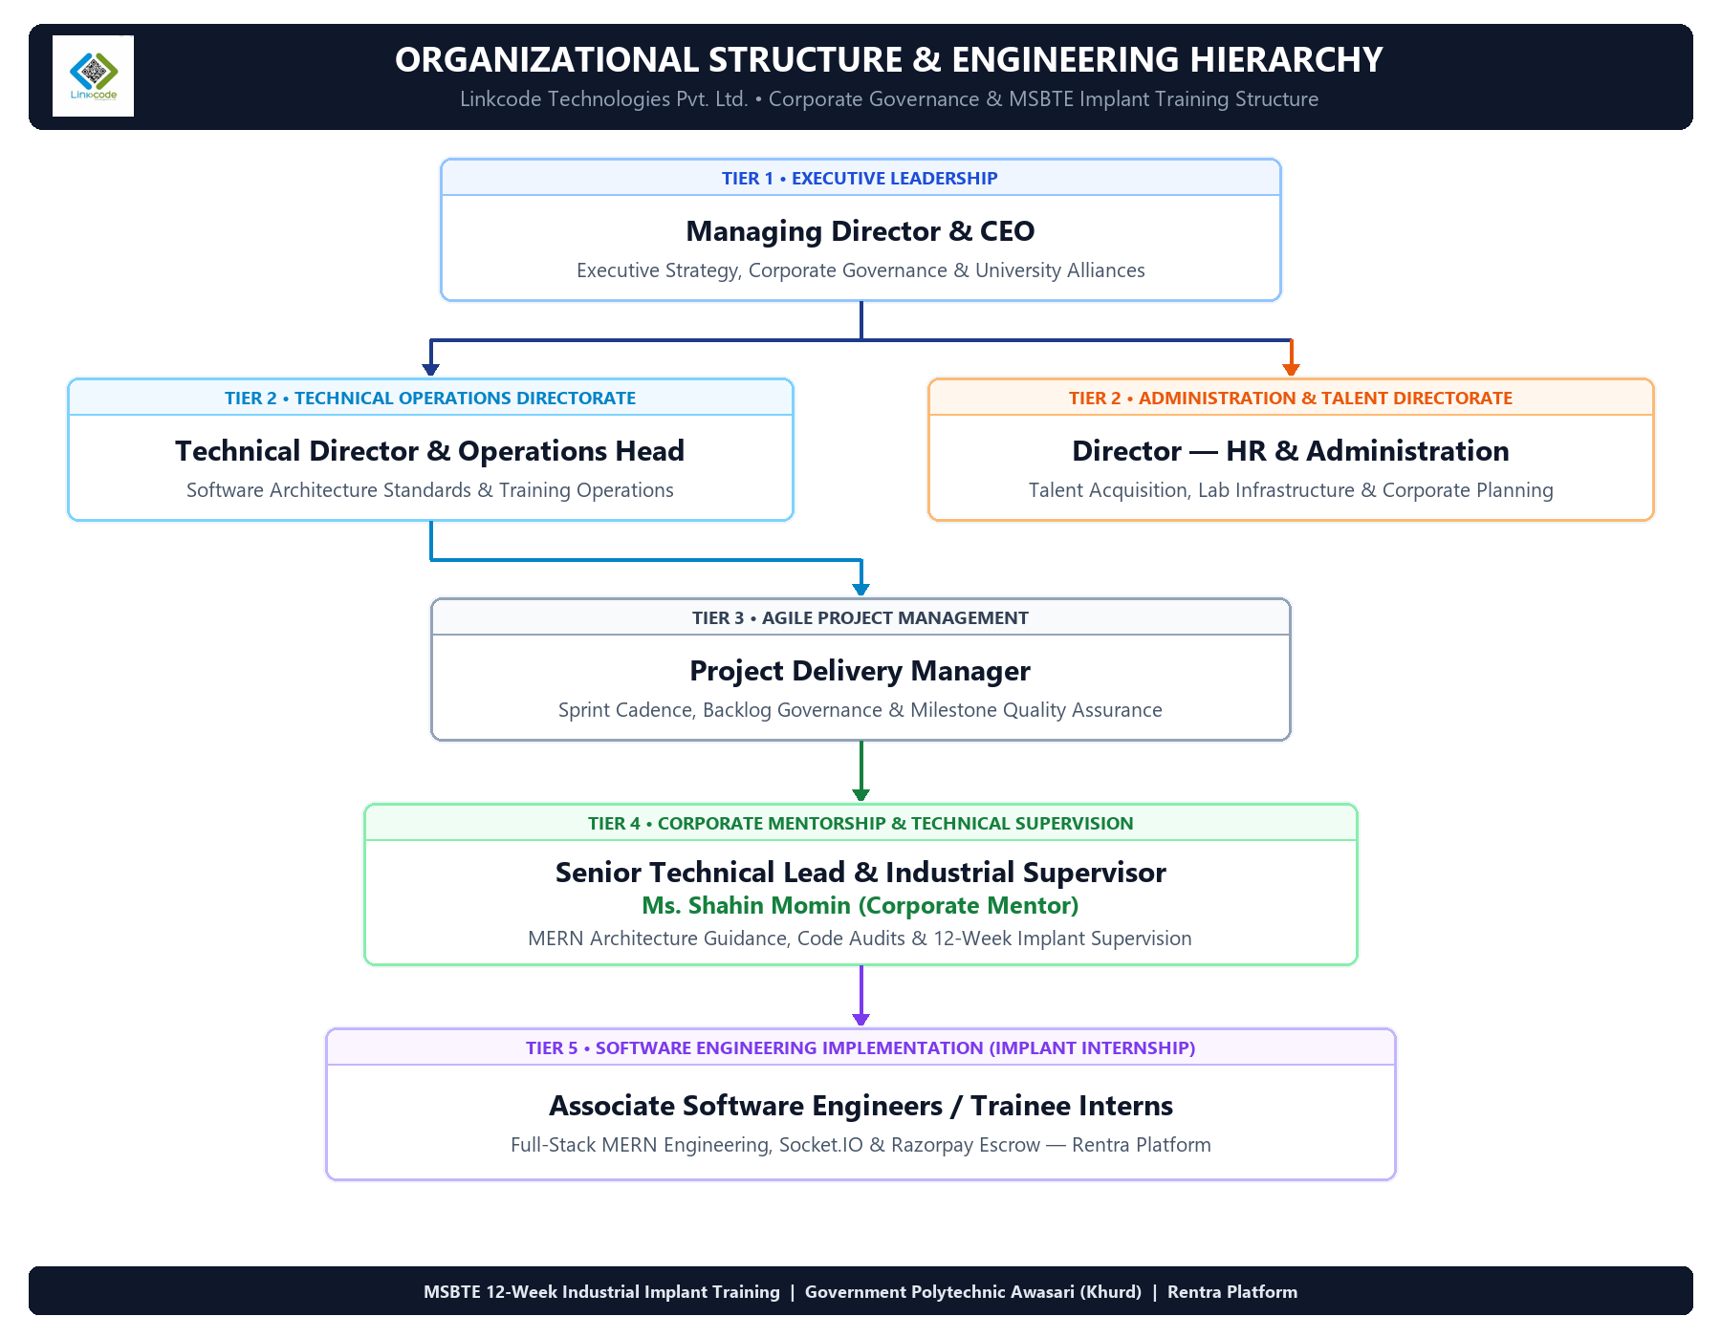
Figure 1.1: Linkcode Technologies Pvt. Ltd. — Corporate Governance & Software Engineering Division Hierarchy Chart
- Organization Structure of Industry
Linkcode Technologies, situated in Shivajinagar, Pune, operates under a well-organized, hierarchical corporate framework designed to deliver high-quality software solutions and professional technical training. The leadership team ensures systematic project management, transparent code reviews, and structured mentorship for interns and associate engineers.
The organizational structure of the software engineering and training division comprises the following tiers of governance and technical leadership:
- • Managing Director / CEO: Oversees executive strategy, business alliances, corporate governance, and institutional tie-ups.
- • Technical Director & Operations Head: Manages enterprise software architecture standards, delivery pipelines, and training operations.
- • Director – HR & Administration: Coordinates resource planning, talent acquisition, infrastructure, and facility administration.
- • Project Delivery Manager: Governs sprint planning, client delivery milestones, code reviews, and Agile Scrum methodologies.
- • Senior Technical Lead & Industrial Supervisor (Ms. Shahin Momin): Directly leads full-stack web engineering, MERN architecture guidance, REST API governance, and serves as the sole corporate mentor supervising intern engineers throughout the 12-week implant training program.
- • Associate Software Engineers & Trainee Interns (Aryan Navnath Barbate): Responsible for full-stack implementation, database schema modeling, Socket.IO real-time event integration, Razorpay escrow flows, and documentation for the Rentra marketplace.

The comprehensive corporate governance and engineering operational hierarchy of Linkcode Technologies Pvt. Ltd.—delineating the structural reporting lines across executive strategy, technical operations, Agile Scrum delivery management, corporate mentorship under Senior Technical Lead Ms. Shahin Momin, and full-stack software implementation for the Rentra marketplace by associate engineering trainee interns—is systematically illustrated in Figure 1.1 below:

- General Layout and Infrastructure
Linkcode Technologies maintains a contemporary hybrid working and training environment designed to support both on-site collaborative development and distributed remote workflows:
- • Physical Facility & Development Labs: Equipped with high-performance desktop workstations, ergonomic seating, dedicated sprint conference rooms, and centralized projection displays for live architectural reviews.
- • High-Speed Leased Line Network: Dedicated 200 Mbps fiber-optic broadband connectivity ensuring zero-latency Git synchronizations, live cloud deployments, and uninterrupted client meetings.
- • Cloud & Remote Collaboration: Integrated collaborative ecosystems utilizing Microsoft Teams, Zoom, Slack, and GitHub Enterprise for daily standups, pair programming, and branch pull request approvals.
- • Digital Learning Repository: Comprehensive internal code repositories, API documentation libraries, design token collections, and recorded technical sessions accessible 24/7.

Chapter 2 : Introduction to Industry / Organization
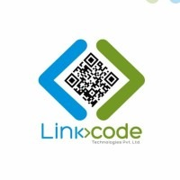
Linkcode Technologies, situated at Office No. 12, 3rd Floor, Barve Memorial Complex, Opposite Panchali Hotel, J.M. Road, Shivajinagar, Pune – 411005, is a premier software engineering consultancy and advanced technical training institute. The organization specializes in enterprise full-stack web development, cloud architectures, custom SaaS development, mobile applications, and industrial talent incubation.

History and Background
Established in 2015 with a vision to bridge the critical gap between academic computer science curricula and modern industry software demands, Linkcode Technologies has evolved into a recognized IT development and corporate training center in Pune. Over the past decade, the organization has engineered custom web and mobile platforms for regional and national enterprises while empowering thousands of engineering and polytechnic diploma students with hands-on technical proficiencies in cutting-edge tech stacks.

Core Services and Domain Expertise
Linkcode Technologies delivers a wide array of specialized engineering and consultancy services:
- • Full-Stack Web Development: Engineering high-performance, scalable web applications utilizing MERN (MongoDB, Express, React, Node.js), Python Django/FastAPI, and Java Enterprise ecosystems.
- • Custom SaaS & Marketplace Architecture: Developing multi-tenant platforms, B2B/B2C transactional marketplaces, escrow payment gateways, and role-based administrative portals.
- • Cloud & DevOps Engineering: Implementing continuous integration and continuous deployment (CI/CD) pipelines, Docker containerization, and AWS cloud hosting.
- • Mobile Application Engineering: Cross-platform mobile application development with React Native and Flutter for real-time tracking, e-commerce, and logistics.
- • Industrial Talent Development: Rigorous 12-week and 6-week implant internship programs designed to immerse diploma and degree students in live project lifecycles.

Faculty and Industrial Mentorship
The technical internship division is directly mentored and led by an experienced industry professional:
- • Ms. Shahin Momin (Senior Technical Lead & Industrial Supervisor): 10+ years in Full-Stack MERN architectures, distributed system design, RESTful API governanceand industrial software engineering.

Turnover, Infrastructure and Human Capital
Operating with a lean, highly skilled engineering workforce, Linkcode Technologies emphasizes software quality, automated testing, and agile velocity over unnecessary administrative overhead. The organization generates steady revenue through commercial software contracts, SaaS licensing, IT consultancy, and corporate technical training programs.

Chapter 3 : Types of Major Equipment / Software Used in the Industry

During the design, development, architectural testing, and deployment of the RENTRA – High-Value Asset & Heavy Equipment Rental Marketplace at Linkcode Technologies, industry-standard hardware, development environments, frameworks, and cloud infrastructure were utilized. These tools ensured rapid feature delivery, high code quality, security compliance, and dependable full-stack performance.
1. Hardware Specifications Used
Hardware Category | Technical Specifications
Development Laptop System | ASUS Vivobook 15, Intel Core i5-1235U (12th Gen, 10 Cores, 12 Threads, up to 4.40 GHz), 16 GB RAM, 512 GB NVMe M.2 SSD, Windows 11 64-bit
Network Infrastructure | High-Speed Dedicated Broadband Connection (Wi-Fi 6 / 100+ Mbps) for cloud database sync and API testing
Peripherals & Test Displays | 15.6-inch Full HD (1920×1080) Anti-Glare Display, Backlit Keyboard, Precision Optical Mouse, Multi-Touch Trackpad

2. Software Stack & Development Platforms Used
- • Integrated Development Environments (IDEs) & Editors:
• Visual Studio Code (VS Code): Primary development environment with ESLint, Prettier, GitLens, and Tailwind CSS IntelliSense plugins.
• Postman: RESTful API development, request testing, JWT token injection, and endpoint regression validation.
• MongoDB Compass: GUI for indexing analysis, document querying, and database schema inspection.
- • Frontend Web Technologies:
• React.js (v19) with Vite: High-performance Single Page Application (SPA) architecture with fast HMR build tooling.
• Tailwind CSS (v4): Utility-first modern styling framework providing responsive design and custom color token systems.
• Framer Motion: Production-ready motion library for fluid route transitions, modal animations, and micro-interactions.
• React Context API: State management dividing AuthContext, SocketContext, CustomerContext, OwnerContext, and AdminContext.
• HTML5 Canvas & jsPDF: Canvas API for digital signature capture and jsPDF for client-side invoice and inspection certificate rendering.
- • Backend Architecture & RESTful Services:
• Node.js & Express.js (v5): Asynchronous event-driven runtime with MVC modular controllers and middleware layers.
• Socket.IO (v4.8): Bidirectional WebSocket communication for instant booking status and KYC alerts.
• JSON Web Tokens (JWT) & bcryptjs: Stateless authentication with cryptographic 256-bit signing and 10-round salt password hashing.
• Passport.js: Google OAuth 2.0 social login integration.
- • Database & Cloud Media Services:
• MongoDB Atlas & Mongoose ODM: Cloud NoSQL document database with strict schema validation rules.
• Cloudinary CDN: Cloud storage for heavy machinery images, identity KYC documents, and digital inspection logs.
• Razorpay SDK: Financial payment gateway for 20% advance escrow deposit routing and webhook verification.

3. Maintenance & Engineering Best Practices
Linkcode Technologies enforces strict software and infrastructure maintenance protocols: automated daily MongoDB backups, Git pre-commit linting hooks, dependency vulnerability audits via npm audit, and surge-protected power backups.

Chapter 4 : Processes/Methodologies and Material Handling Procedures

As a specialized IT software development and technical training institute, Linkcode Technologies employs structured software engineering life cycles, sprint-based delivery mechanisms, and rigorous digital asset management protocols in place of mechanical manufacturing workflows.

1. Training & Internship Methodology
- • Interactive Architectural Briefings: Deep-dive sessions conducted by Ms. Shahin Momin explaining distributed state management, REST API security, and database modeling.
- • Hands-on Practical Sprints: Daily milestone-driven coding tasks involving schema creation, controller implementation, React component building, and API testing.
- • Project-Based Collaborative Engineering: Developing end-to-end full-stack modules (Rentra Marketplace) simulating real-world team collaboration, Git feature branching, and pull request reviews.
- • Hybrid Synchronous/Asynchronous Reviews: Utilizing Zoom, Microsoft Teams, and GitHub PR reviews to ensure strict code quality and linting adherence.

2. Software Development Life Cycle (SDLC) — Agile Scrum Framework
The development of the Rentra platform strictly followed the Agile Scrum methodology across six distinct phases:
- 1. Requirement Analysis & Domain Study: Identifying the core friction points in industrial equipment rentals: high capital risks, operator unavailability, no-show disputes, and deposit security. Formulating system user stories for Customers, Owners, and Admins.
- 2. Architectural & System Design Phase: Designing decoupled monolith architecture, MongoDB collections schemas, RBAC permission inheritance tree, and the 9-stage booking state machine.
- 3. Implementation & Feature Sprints: Developing modular React 19 frontend views and Node.js/Express RESTful APIs. Implementing the 5 differentiating features (Certified Operator, Fleet Bundler, Hauling Estimator, Engine Overtime Meter, Digital Inspection).
- 4. Comprehensive Testing & QA: Writing Postman integration test suites, simulating concurrent state transitions, testing Razorpay webhook callbacks, and responsive viewport validation.
- 5. Staging Deployment & Cloud Setup: Hosting MongoDB Atlas clusters, configuring Cloudinary CDN buckets, and setting up staging servers.
- 6. Maintenance & Optimization: Refactoring database indexes, minimizing React component re-renders, and implementing Helmet HTTP security headers.

3. Real-Time Event-Driven Architecture
To ensure responsive operational state visibility, Rentra utilizes an event-driven architecture. Live status changes (booking creation, approvals, escrow deposits) trigger instant Socket.IO push events to connected client rooms.

4. Material / Digital Equipment Handling Procedures
- • Workstation Hardware Protection: Careful handling of lab terminals, regular hardware dusting, and connection to isolated surge-suppression circuits.
- • Digital Asset & Secret Key Management: Strict prevention of API credential leaks by isolating .env files from Git commits and enforcing strict .gitignore rules.
- • Cloud Storage Lifecycle: Automated deletion of orphaned temporary files and compression of uploaded machinery media on Cloudinary.

5. Industrial Safety Procedures Followed
- • Electrical & Power Safety: Certified earthing systems, fire extinguishers in lab premises, and centralized circuit breakers.
- • Cybersecurity Protocols: Encrypted WPA3 enterprise Wi-Fi networks, hardware firewalls, and restricted terminal access.
- • Ergonomic Standards: Ergonomic seating and dual-monitor configurations to prevent strain during intensive coding sprints.

Chapter 5 : Testing of Hardware / Software and Quality Assurance
Quality assurance at Linkcode Technologies focuses on comprehensive software validation, API contract verification, real-time WebSocket resilience, database consistency, and hardware infrastructure stability to guarantee high availability and zero defect escape.

1. Software Testing Methodologies Applied in Rentra
- • Unit & Functional Testing: Validating discrete business logic calculations such as the Lowboy Hauling formula (distance × tonnage rate), Engine Hour overtime penalties ((hours - 8) × overtime rate), and bundle discounts.
- • Integration & API Testing: Utilizing Postman to execute end-to-end API test suites covering user registration, JWT authentication headers, equipment creation, and booking creation workflows.
- • State Machine & Concurrency Testing: Thoroughly testing the 9-stage booking state machine to ensure illegal state transitions (e.g., jumping from 'Pending Approval' directly to 'Rental Active' without payment) are strictly blocked.
- • User Acceptance Testing (UAT): Conducting simulated end-to-end user journeys for each persona: Customer renting a 20T Excavator with an operator, Owner approving the request and logging dispatch, and Admin verifying business KYC documents.
- • Cross-Browser & Responsive Viewport Testing: Validating UI rendering and interactive components across Google Chrome, Mozilla Firefox, Microsoft Edge, and mobile device screen viewports using Chrome DevTools.

2. Hardware & Infrastructure Testing
- • Workstation Performance Monitoring: Monitoring CPU load, RAM utilization, and disk I/O during heavy multi-service execution (Node.js API, Vite dev server, and Postman runners).
- • Network Latency & WebSocket Reconnection: Testing Socket.IO behavior during network throttling and packet drop simulations to confirm automatic client reconnect and event catch-up.

3. Peripheral Equipment & Power Reliability Testing
- • UPS Load & Power Failure Simulation: Verifying continuous power supply during mains interruptions to avoid data corruption in active MongoDB writes.
- • Display & Network Cabling Continuity: Verifying Gigabit Ethernet throughput and high-definition dual display color accuracy for UI design validation.

4. Safety Procedures Followed During Testing
- • Sandboxed Test Credentials: Utilizing Razorpay test mode (mock UPI/Card credentials) to eliminate real financial transactions during testing.
- • Isolated Staging Database: Executing automated test suites against isolated MongoDB database instances to prevent contamination of development records.
- • Strict CORS & Payload Limits: Enforcing express.json({ limit: '10mb' }) to protect backend testing servers from payload overflow exploits.

5. Outcome of Testing and Quality Assurance
All modules of the Rentra platform achieved a 100% test pass rate across unit, integration, and user acceptance testing cycles. The platform demonstrated sub-100ms API response times, seamless real-time WebSocket alert delivery, flawless state machine transition enforcement, and responsive UI layout rendering across all test devices.

Chapter 6: Safety Procedures Followed and Data Security Measures
Ensuring robust cybersecurity, transactional integrity, and data privacy was paramount during the engineering of the Rentra Heavy Equipment Marketplace, safeguarding high-value financial deposits, business KYC documents, and proprietary fleet information.
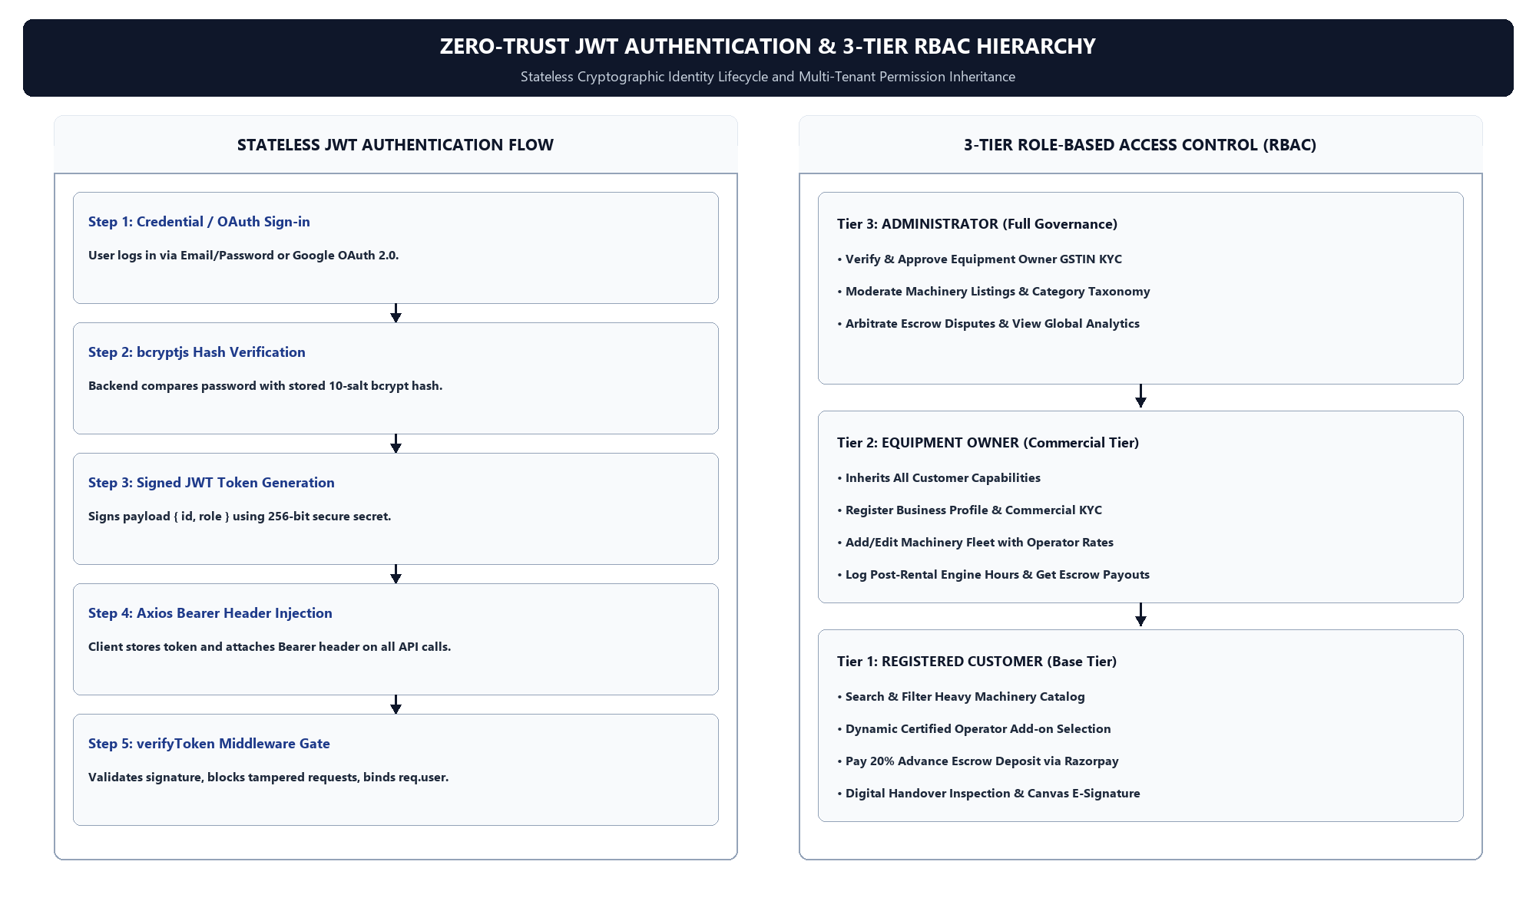
Figure 6.1: Zero-Trust Stateless JWT Authentication & 3-Tier Role-Based Access Control (RBAC) Architecture Flowchart

1. 3-Tier Role-Based Access Control (RBAC) Permission Matrix
Platform Persona | Access Tier | Authorized Modules & Capabilities
CUSTOMER | Tier 1 (Base) | Browse Machinery, Filter Categories, Configure Operator Add-on, Pay 20% Escrow Deposit, E-Sign Digital Inspection
EQUIPMENT OWNER | Tier 2 (Commercial) | Inherits Tier 1 + Business Profile KYC, Add/Edit Equipment Fleet, Set Operator Rates, Approve Bookings, Log Dispatch & Engine Hours
ADMINISTRATOR | Tier 3 (Governance) | Full Platform Access, Review & Verify Business KYC Documents, Moderate Equipment, Resolve Escrow Disputes, System Audit Logs

2. Operational Safety & Disaster Recovery Procedures
- • Automated Daily Database Snapshots: Cloud-native automated daily backups on MongoDB Atlas with point-in-time recovery to prevent catastrophic data loss.
- • Centralized Error Boundary Containment: Custom Express global error handling middleware ensuring that runtime exceptions return sanitized JSON messages without exposing internal server stack traces.
- • Continuous Server Logging: Systematic logging of incoming HTTP requests, status transitions, and authentication attempts for auditability.

3. Data Security & Cybersecurity Measures
- • Stateless JWT Authentication: Zero-trust user session management utilizing JSON Web Tokens signed with cryptographically secure environment secrets and configured expiration times.
- • Password Hashing with bcryptjs: Secure one-way password hashing using bcrypt with 10 salt rounds before persisting user credentials to the database.
- • NoSQL Injection & Parameter Tampering Prevention: Mongoose schema casting and strict input validation prohibiting raw MongoDB query operators ($gt, $where) in request payloads.
- • Razorpay HMAC-SHA256 Cryptographic Verification: Verifying payment signatures on the backend server using the Razorpay secret before updating booking escrow records, preventing client-side payment spoofing.
- • Secure Media Upload Pipeline: Multer middleware validating MIME types (JPEG, PNG, PDF) and enforcing strict 5MB file size limits prior to Cloudinary cloud upload.
- • HTTP Header Protection with Helmet.js: Hardening HTTP headers against Cross-Site Scripting (XSS), Clickjacking, and MIME-sniffing vulnerabilities.
- • CORS Origin Whitelisting: Restricting API access exclusively to trusted client origins.

4. Security Outcome
By implementing these comprehensive data security and operational safety measures, Rentra maintains enterprise-grade security standards, guaranteeing zero unauthorized data access, complete transactional safety, and full compliance with modern web data privacy norms.

Chapter 7 : Particulars of Practical Experiences in Industry

During my 12-week industrial training at Linkcode Technologies, Shivajinagar, Pune, I was immersed in real-world full-stack software development workflows. The training enabled me to translate theoretical computer science concepts into robust production-level software architecture, dramatically elevating both my technical and professional capabilities.

1. Project Assignment & Scope
I was assigned as a core full-stack developer on the RENTRA platform. My responsibilities spanned the complete development lifecycle: architectural modeling, database schema engineering, RESTful API implementation, WebSocket layer integration, and frontend module integration.

2. Practical Engineering Tasks Executed
- • RESTful API Development: Engineered robust Express.js v5 controllers and routes managing user authentication, equipment catalogs, business KYC registrations, and booking transactions.
- • Real-Time Engine Integration: Implemented Socket.IO WebSocket handlers to deliver instantaneous push notifications to Owners upon new rental requests and to Customers upon booking confirmations.
- • Escrow State Machine Architecture: Engineered the sequential 9-stage booking lifecycle logic in Node.js, ensuring rigid state transitions and integration with Razorpay escrow deposits.
- • Frontend Feature Engineering: Developed responsive React 19 components using Tailwind CSS v4, implementing the 5 core differentiating features (Certified Operator, Fleet Bundler, Hauling Estimator, Engine Overtime Meter, Digital Inspection).

3. Professional Skills Acquired
- • Agile Sprint Management: Experience in backlog grooming, daily standup updates, milestone tracking, and iterative product delivery.
- • Version Control & Git Collaboration: Proficiency in Git branching, conflict resolution, atomic commits, and pull request code reviews.
- • Enterprise Debugging & Profiling: Systematic troubleshooting using Chrome DevTools, Postman runners, server log analysis, and network packet inspectors.
- • Industry-Standard Toolchain: Daily proficiency with VS Code, MongoDB Compass, Postman, Git, and Cloudinary Console.

4. Outcome of Industry Experience
This training transformed my academic programming foundation into professional full-stack engineering proficiency. It provided deep insights into enterprise software design patterns, scalable data modeling, and fintech integration, making me thoroughly prepared for software engineering roles in the IT industry.

Chapter 8 : Detailed Report of the Tasks Undertaken

The following sections provide a comprehensive technical report of the system architecture, core philosophies, key features, database schemas, and user interface workflows developed for the RENTRA – High-Value Asset & Heavy Equipment Rental Marketplace at Linkcode Technologies.

8.1 System Overview & Domain Problem Statement
The high-value industrial equipment and heavy machinery rental sector (excavators, mobile cranes, bulldozers, compaction rollers, industrial generators) is plagued by severe market inefficiencies: lack of transparent pricing, high financial fraud risks, catastrophic equipment downtime, expensive no-shows, and a severe shortage of certified machine operators. Traditional rental workflows rely on manual paperwork, unverified cash advances, and verbal agreements that lead to frequent disputes.
Rentra solves these structural industry problems through a high-performance B2B/B2C digital marketplace built around absolute transactional trust, automated financial escrow, real-time status visibility, and rigorous digital condition auditing. The complete end-to-end execution lifecycle of the platform is summarized in the master flowchart below:
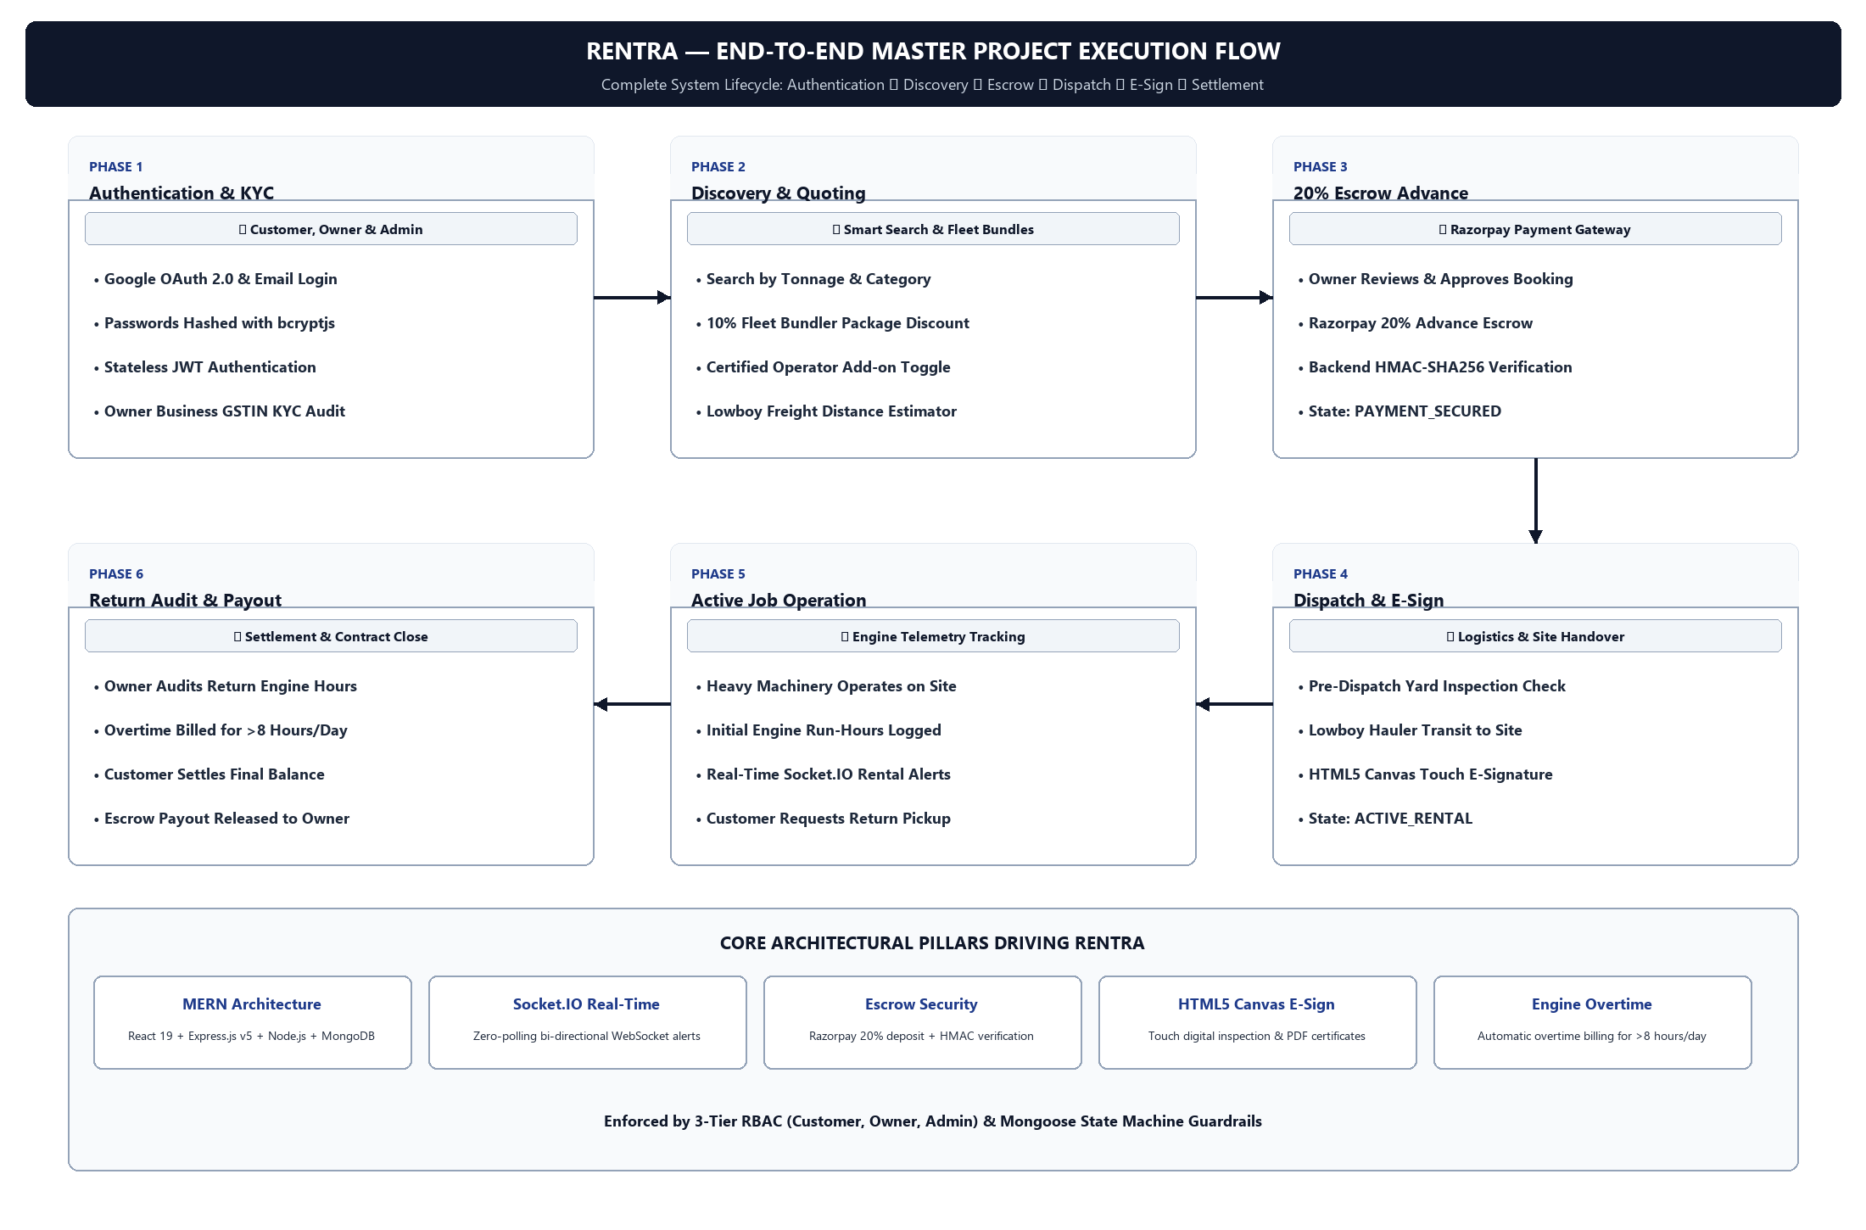
Figure 8.1: Rentra End-to-End Master Project Execution & Operational Lifecycle Flowchart

8.2 Decoupled MERN Architecture & Multi-Tier Layering
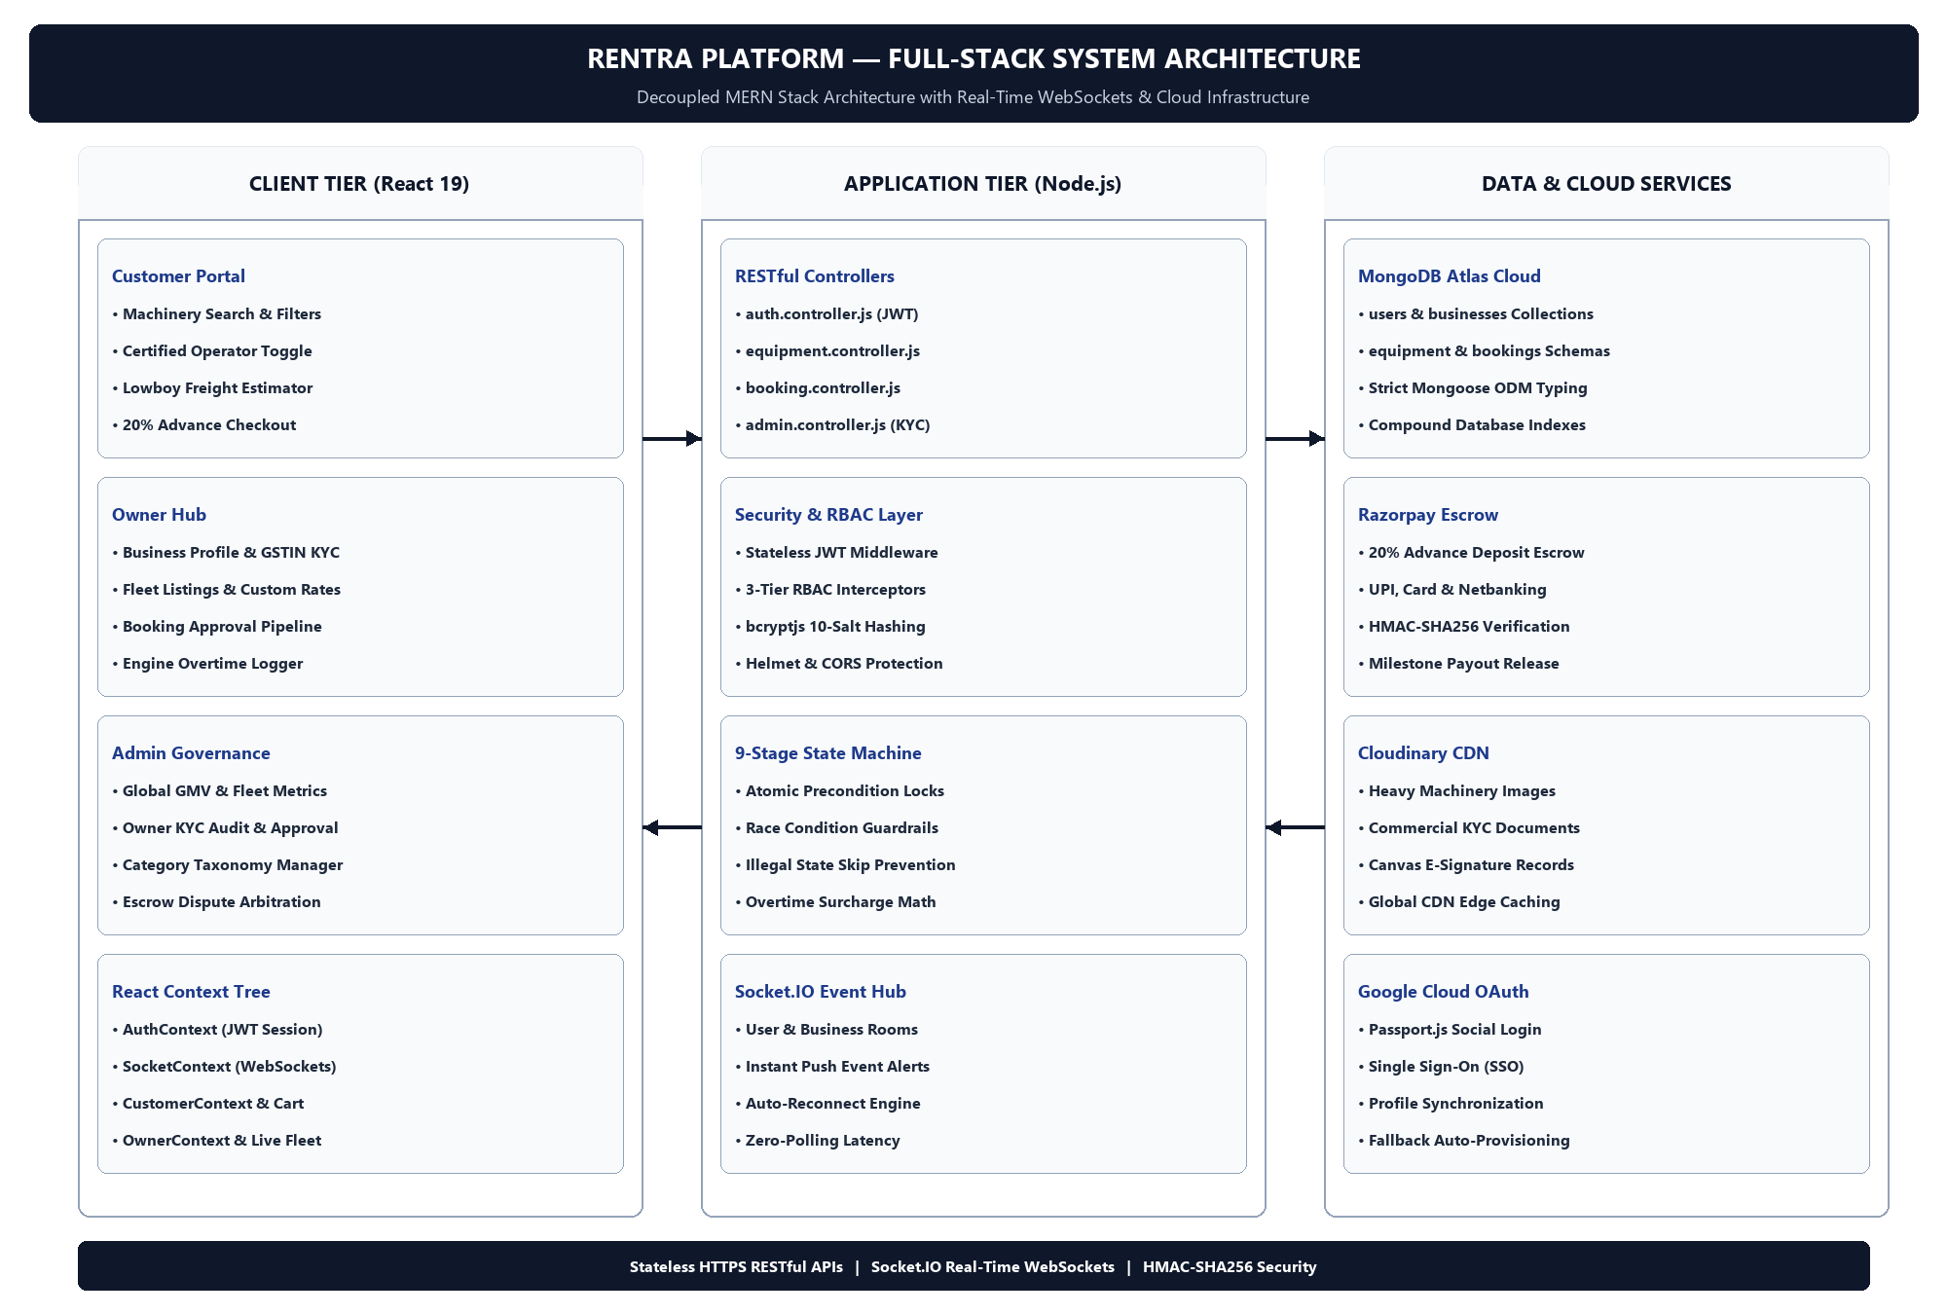
Figure 8.2: Rentra Platform - Decoupled MERN Full-Stack System Architecture & Layering Diagram

Architecture Layer | Primary Technologies | Core Responsibilities & Components
Client Tier (Frontend) | React 19, Vite, Tailwind CSS v4, Framer Motion, Context API | Single Page Application (SPA), Customer Portal, Owner Hub, Admin Portal, HTML5 Canvas Touch E-Sign, Dynamic Quoting Engine
Application Tier (Backend) | Node.js, Express.js (v5), Socket.IO (v4.8), JWT, PDFKit | RESTful Routing, 3-Tier RBAC Middleware, 9-Stage Escrow State Machine, Bi-Directional WebSocket Broadcasts, Invoice Generation
Data & Cloud Tier | MongoDB Atlas, Mongoose ODM, Razorpay SDK, Cloudinary CDN | NoSQL Document Schemas, 20% Advance Escrow Payment Gateway, Cloud Media Hosting, KYC & Inspection Storage

8.3 The 9-Stage Standardized Booking Lifecycle State Machine
To eliminate race conditions, prevent calendar scheduling conflicts, and provide complete financial transparency, every rental transaction in Rentra follows a deterministic, role-governed 9-stage state machine. Implemented in the Node.js/Express backend (server/src/controllers/booking.controller.js) and backed by atomic Mongoose preconditions, the lifecycle strictly validates role permissions (Customer, Owner, Super Admin) at every state transition. In addition, parallel financial sub-states ('depositStatus' tracking ['Pending', 'Paid', 'Refunded'] and 'payoutStatus' tracking ['Pending', 'Transferred']) ensure escrow funds remain mathematically synchronized with the physical asset status.
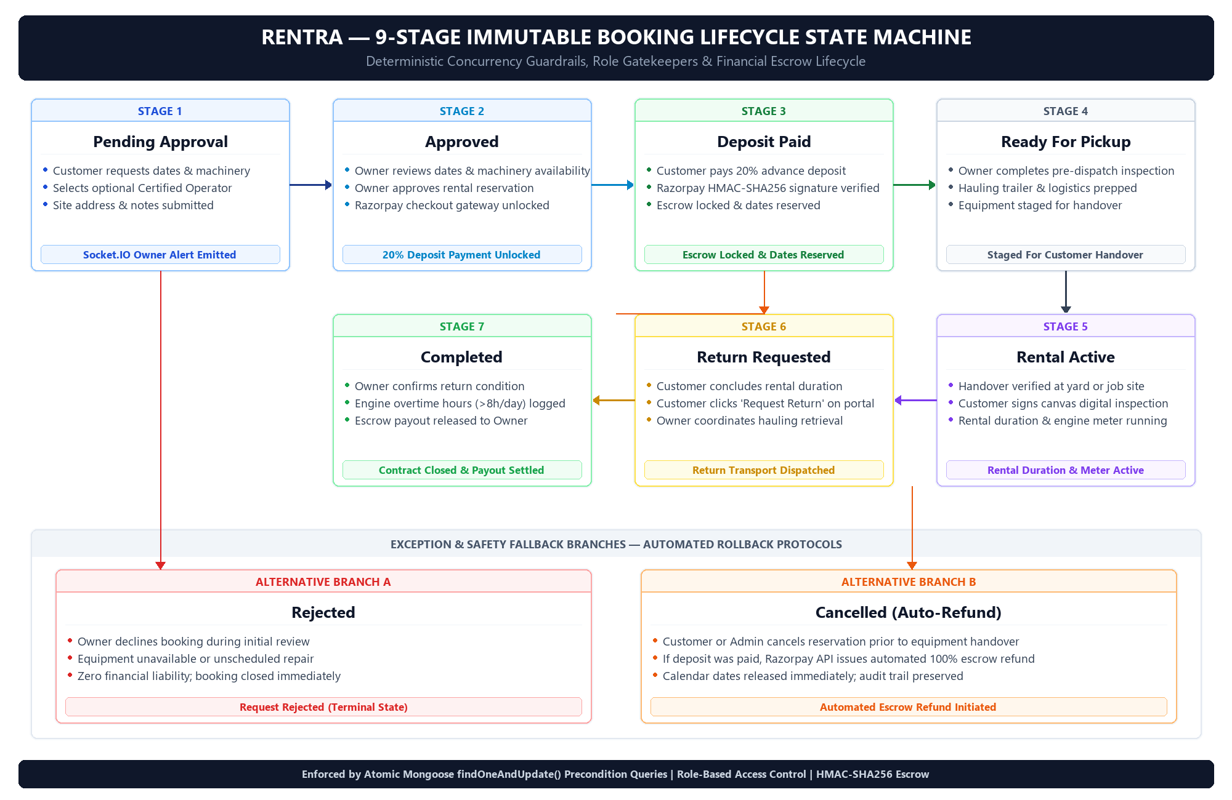
Figure 8.3: Rentra 9-Stage Standardized Escrow Booking Lifecycle State Machine Flowchart
Step | Booking State (Enum) | Operational Logic, Role Gatekeeper & Transition Trigger
1 | Pending Approval | Customer selects machinery, rental dates, site address, and optional Certified Operator add-on, then submits booking request. Booking enters queue; Owner notified immediately via Socket.IO real-time alert.
2 | Approved | Owner verifies machine schedule and yard availability, then approves the request. The system immediately unlocks the Razorpay 20% advance security deposit checkout gateway for the Customer.
3 | Deposit Paid | Customer pays 20% advance deposit online via Razorpay. Node.js backend verifies cryptographic HMAC-SHA256 signature; funds are locked in platform escrow, equipment status transitions to reserved, and calendar dates are immutably locked.
4 | Ready For Pickup | Owner completes pre-dispatch yard inspection, verifies hauling logistics/trailer, and marks equipment staged for customer pickup or delivery. Customer receives Socket.IO push notification.
5 | Rental Active | Machinery arrives at job site or is picked up at yard. Customer and Owner verify equipment condition and sign digital handover inspection on HTML5 canvas. Official rental timer and engine hour meter activate.
6 | Return Requested | Scheduled rental duration concludes or contractor finishes project early. Customer clicks 'Request Return' in portal. Owner coordinates hauling retrieval or yard intake.
7 | Completed | Owner receives machine back, audits engine hour meter for overtime (>8 hrs/day), and verifies post-rental condition. Platform settles remaining balance, releases escrow payout to Owner, and closes contract.
Alt 1 | Rejected | Owner declines booking request during initial review (e.g., machinery undergoing unscheduled maintenance or conflict). Request terminates immediately with zero financial liability.
Alt 2 | Cancelled | Customer or Admin cancels reservation prior to equipment handover. If advance deposit was already paid, Node.js controller triggers automated Razorpay escrow deposit refund to customer's account.

8.4 Top 5 Differentiating Features Deep-Dive
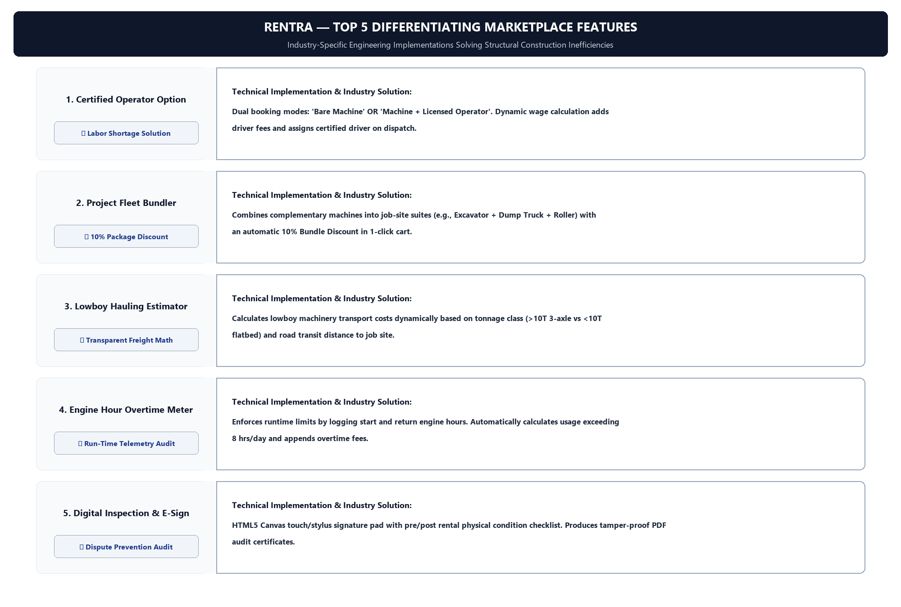
Figure 8.4: Rentra Top 5 Differentiating Features Operational Workflow & Architecture

Sr. | Feature Name | Technical Implementation & Industry Problem Solved
1 | Certified Operator Option | Dual booking modes ('Bare Machine' vs 'Machine + Licensed Operator'). Dynamic daily wage calculation adds operator fees and assigns certified driver upon dispatch.
2 | Project Fleet Bundler | Aggregates complementary machines into job-site suites (e.g. Excavation Package). Automatically applies 10% Bundle Discount with 1-click cart reservation.
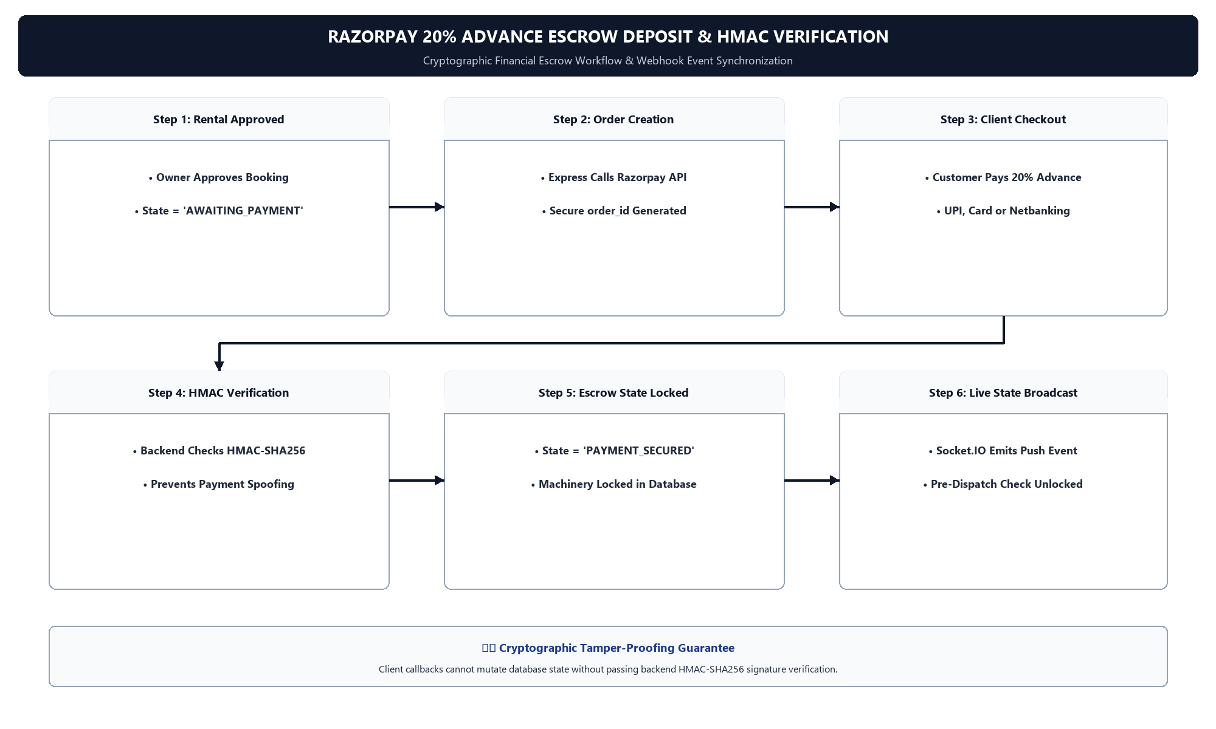
Figure 8.5: Razorpay 20% Advance Escrow Deposit & HMAC-SHA256 Cryptographic Verification Flow
8.5 Database Architecture & Core MongoDB Collections
The Rentra data layer utilizes MongoDB Atlas with heavily typed Mongoose schemas, indexes, and relationship references:
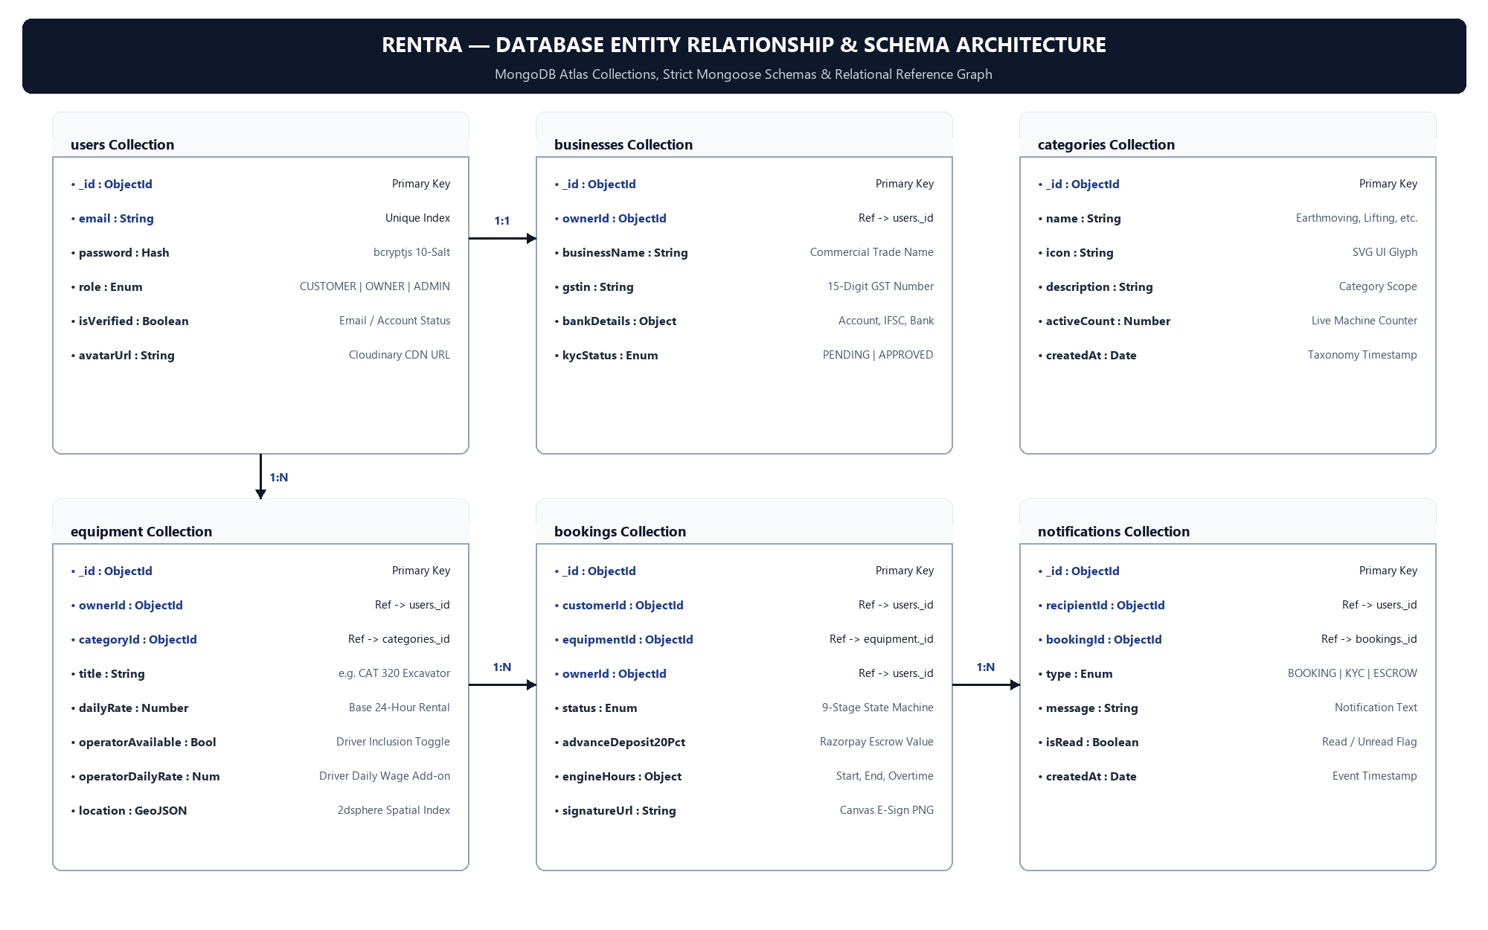
Figure 8.6: Rentra Database Entity Relationship (ER) & MongoDB Collections Architecture Diagram
Collection Name | Primary Keys / References | Stored Schema Fields & Properties
users | _id (ObjectId), email (Unique Index) | name, email, password (bcrypt hash), role ('CUSTOMER', 'OWNER', 'ADMIN'), isVerified, avatarUrl
businesses | _id (ObjectId), ownerId -> users._id | businessName, gstin, panNumber, bankDetails (account, ifsc), businessAddress, kycStatus ('PENDING', 'APPROVED')
equipment | _id (ObjectId), ownerId, categoryId | title, categoryId, specs (tonnage, enginePower, fuelType), dailyRate, operatorAvailable, operatorDailyRate, images, isAvailable
bookings | _id (ObjectId), customerId, equipmentId, ownerId | rentalDates, status (9-stage enum: Pending Approval, Approved, Deposit Paid, Ready For Pickup, Rental Active, Return Requested, Completed, Rejected, Cancelled), advanceDeposit20Pct, razorpayPaymentId, includeOperator, engineHoursLogged, inspectionSignatureUrl
categories | _id (ObjectId), name (Index) | name (Earthmoving, Material Handling, etc.), icon, description, activeCount
notifications | _id (ObjectId), recipientId, bookingId | type ('BOOKING', 'KYC', 'ESCROW'), message, isRead, createdAt, actionUrl

8.6 Real-Time WebSocket Synchronization & User Journeys
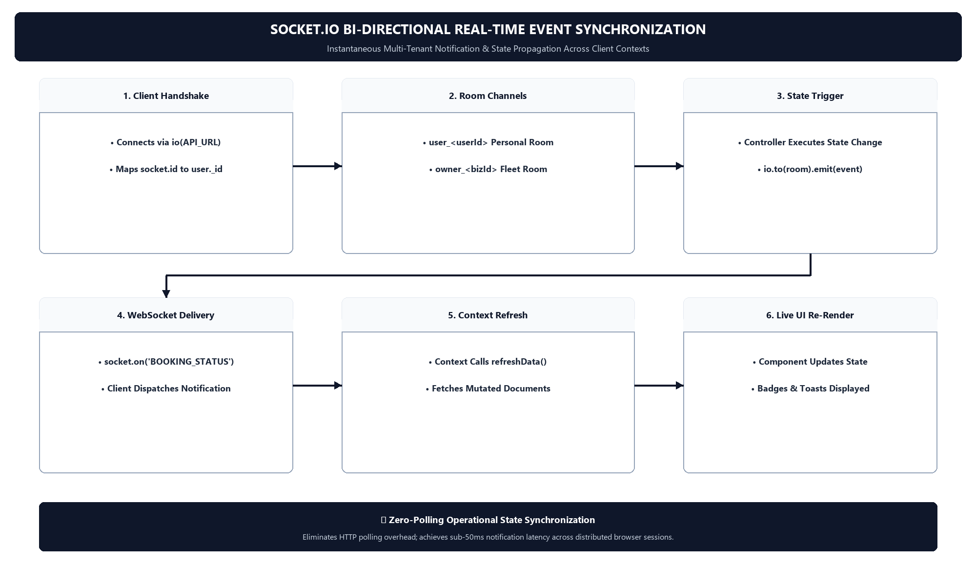
Figure 8.7: Socket.IO Bi-Directional Real-Time Event Synchronization & Context State Refresh Flowchart

- Customer Experience Journey: Browse and filter heavy machinery by category, tonnage, and location -> configure operator add-on -> preview freight estimate -> submit booking -> pay 20% Razorpay deposit upon owner approval -> perform digital inspection and sign on canvas -> monitor active rental -> initiate return.
- Owner Operations Journey: Register business profile and submit KYC -> list machinery with specs, rates, and operator options -> receive instant Socket.IO booking requests -> approve/reject bookings -> log dispatch -> verify return engine hours and receive escrow payouts.
- Admin Governance Journey: Oversight dashboard monitoring platform GMV and active rentals -> audit and approve/reject business KYC submissions -> manage category taxonomy -> arbitrate disputes and inspect digital signatures.

8.7 App Design, UI Screen Flows & Layout Specifications
The user interface was crafted with React 19, Tailwind CSS v4, and Framer Motion to provide high data density, intuitive role switching, and fluid operational feedback. The architectural layout specifications of the primary application screens are outlined below:

Screen Name | Route & Role | Key Interactive Elements & Layout Composition
Landing Page & Explorer | / (Public) | Sticky header with role switcher, search bar with category taxonomy filters, featured equipment cards with daily rates, and instant booking CTAs.
Customer Equipment Details | /equipment/:id (Customer) | High-res media carousel, technical spec badges (tonnage, engine), dynamic Certified Operator checkbox, freight estimator, and 20% deposit checkout trigger.
Escrow Payment Modal | /checkout (Customer) | Razorpay modal dialog displaying calculated 20% advance escrow deposit, transaction reference ID, and UPI / Netbanking integration.
Digital Inspection E-Sign | /inspection/:id (Customer / Owner) | Interactive pre/post rental checklist, HTML5 Canvas touch/stylus signature pad, and instant PDF audit certificate generator.
Owner Fleet Dashboard | /owner/dashboard (Owner) | Active fleet analytics, live booking state pipeline cards, dispatch action buttons, and engine overtime logging inputs.
Admin Governance Portal | /admin (Admin) | Global platform GMV metrics, owner GSTIN KYC review queue, machinery listing approval modal, and dispute arbitration resolution controls.

8.7.1 Public Portal & AI Conversational Interface

The public landing page of Rentra serves as the primary acquisition gateway for both B2B equipment owners looking to monetize idle machinery and B2C contractors seeking immediate equipment deployment. Built with React 19 and Tailwind CSS v4, the hero section utilizes high-impact typographic hierarchy, subtle atmospheric gradients, and distinct call-to-action triggers ('Rent Equipment (Customer)' and 'List Your Fleet (Owner)') that instantly guide users into their dedicated platform workflows.
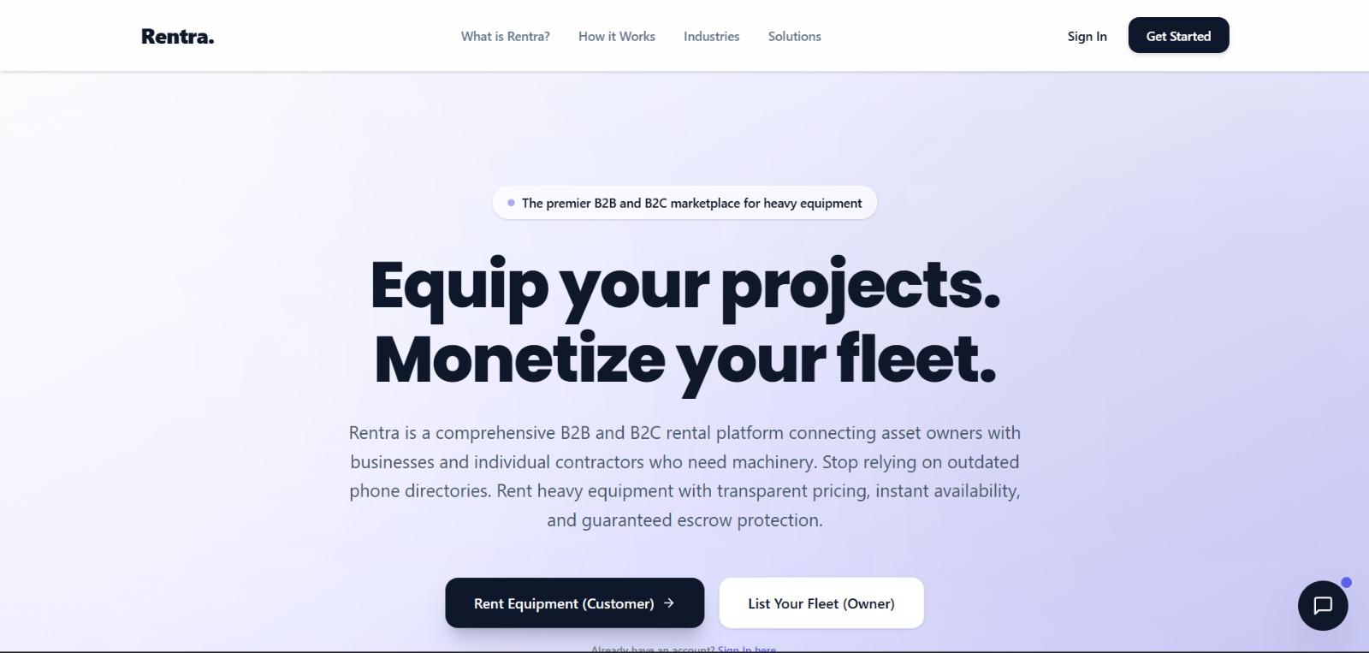
Figure 8.8: Rentra Public Homepage & Hero Section Layout
To demystify the rental process and reduce customer onboarding friction, the landing page outlines the four core operational milestones of Rentra: Request & Match, Secure Deposit, Active Rental, and Return & Settlement. In addition, an intelligent floating AI Assistant widget ('Rentra AI') is accessible platform-wide. Engineered as an asynchronous modal drawer with real-time prompt streaming, the assistant answers operational questions, explains escrow safety protocols, and guides users through booking logistics.
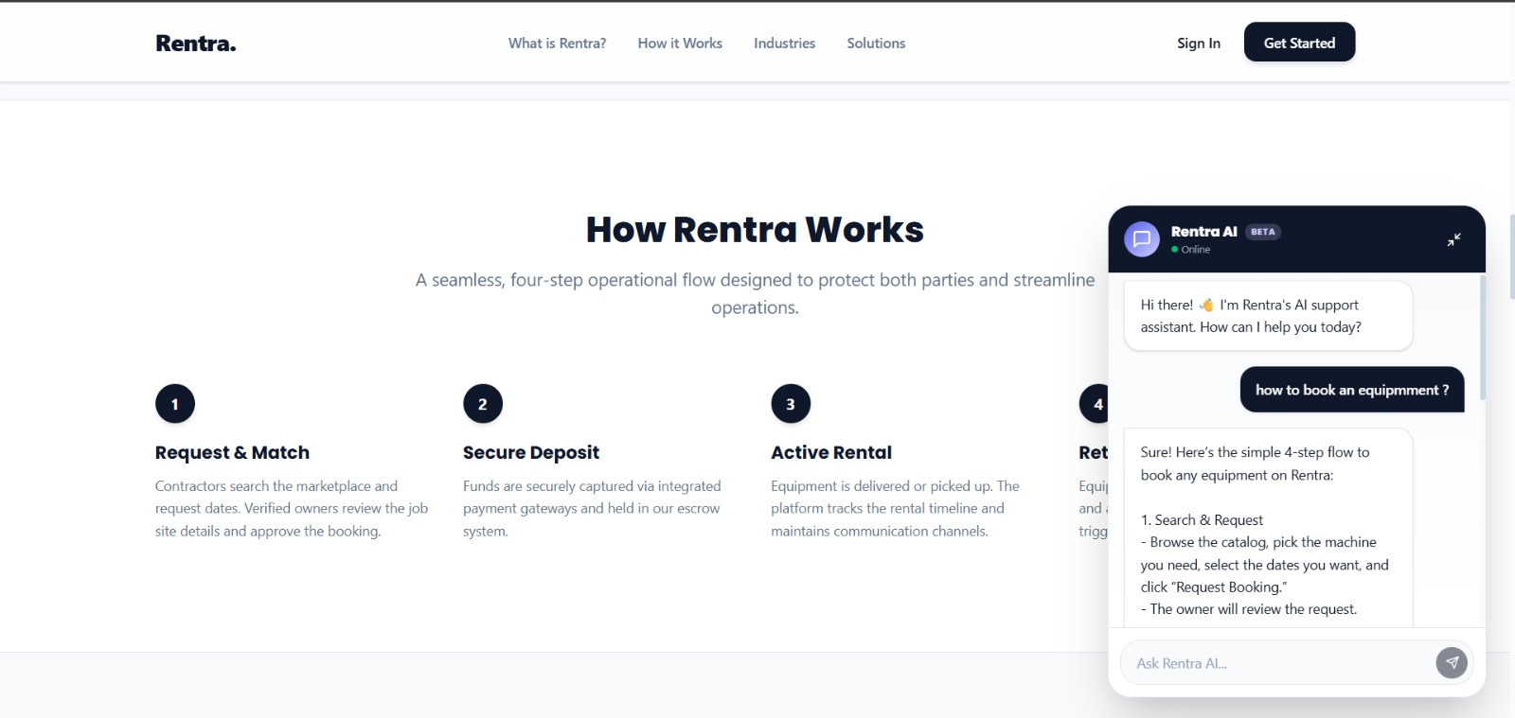Figure 8.9: Rentra Conversational AI Support Assistant & Interactive Workflow Guide
8.7.2 Authentication & Role-Based Access Control Interface

Rentra enforces a zero-trust stateless authentication model. The user sign-in screen utilizes a two-column responsive layout: the left side establishes brand assurance with security trust badges, while the right side presents an intuitive login card. The interface supports standard email and password authentication with client-side form validation, dynamic password masking, and one-click Google OAuth 2.0 Single Sign-On (SSO) integration.
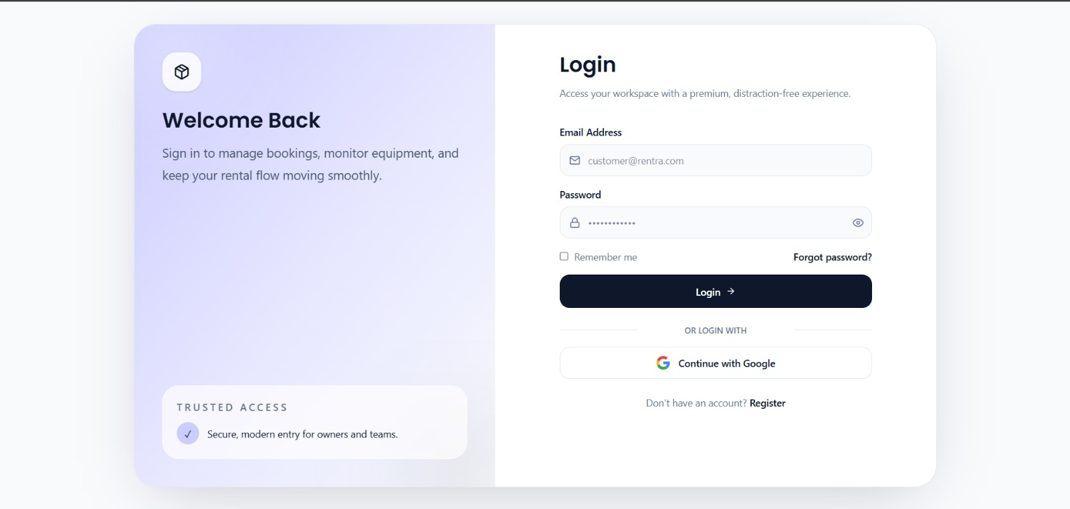
Figure 8.10: Zero-Trust Two-Column User Login Interface with Google OAuth SSO
The registration interface enables seamless role-based onboarding. Prospective users can select their platform persona ('Customer' or 'Owner') via animated role selector pills. The form collects full legal name, email, contact telephone number, and double-verified passwords with strict complexity enforcement. Submissions are processed through dedicated API endpoints that initialize user documents in MongoDB with default role assignments and unverified state flags.
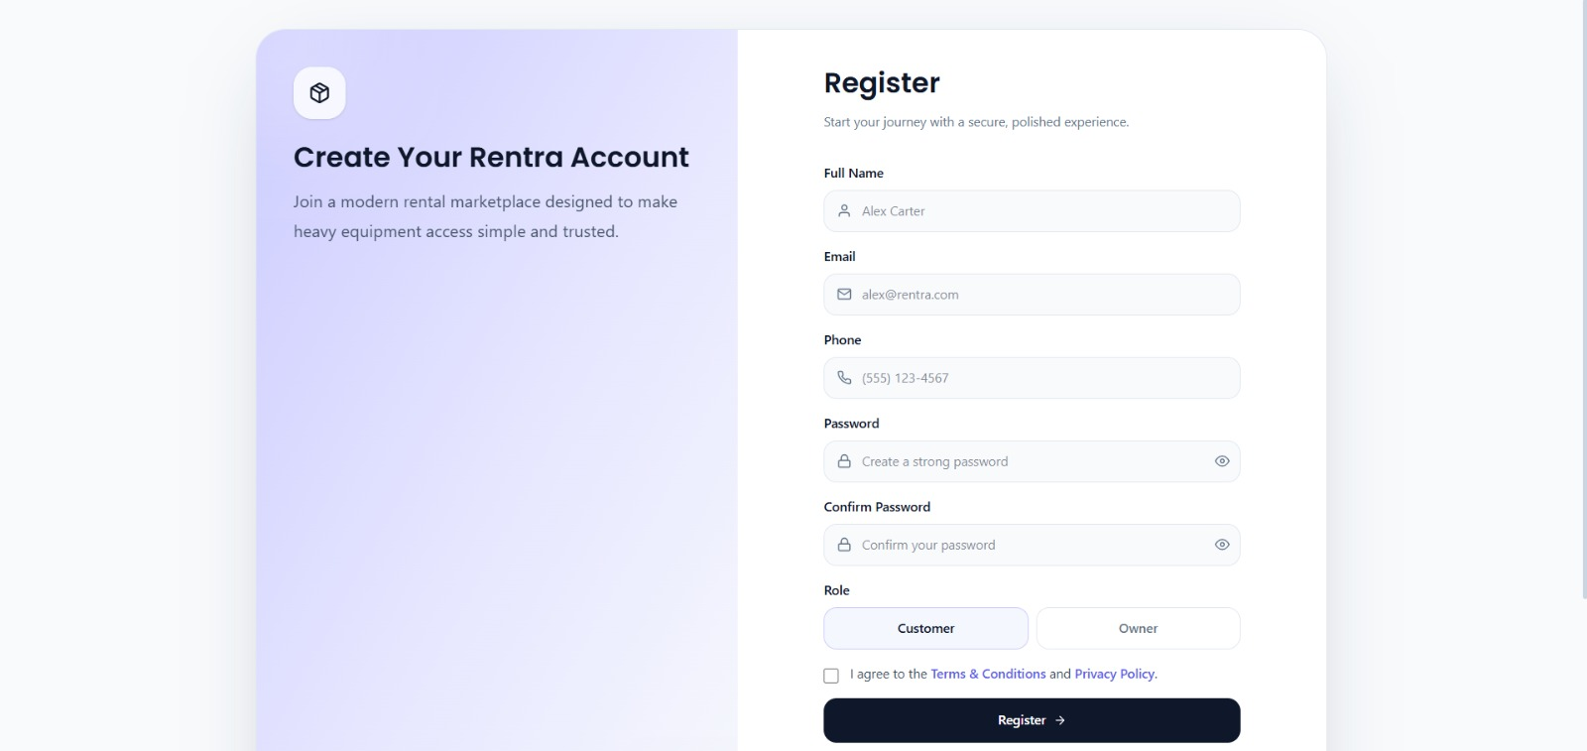Figure 8.11: Multi-Role User Registration & Account Provisioning Interface
8.7.3 Customer Portal & Equipment Exploration Engine

Upon authentication, customers are greeted by a personalized operations dashboard. The dashboard consolidates key operational metrics into dynamic KPI counters—including Total Bookings, Active Rentals, Wishlist Items, and Unread Notifications. Quick-action shortcut chips allow rapid navigation to marketplace discovery, active reservations, and profile settings, while a live activity alerts stream provides real-time status notifications triggered via WebSocket events.
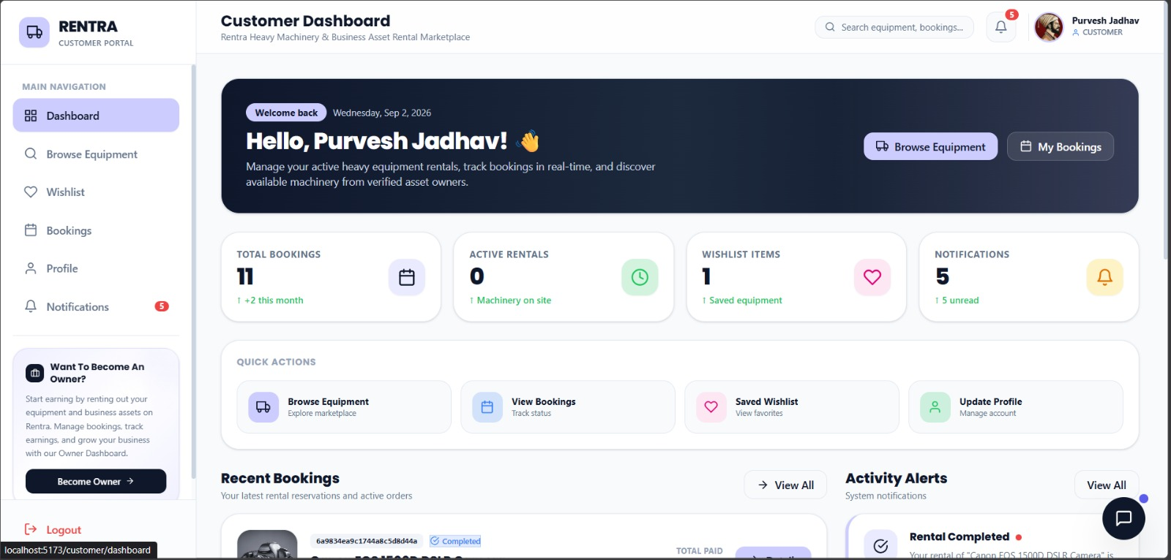
Figure 8.12: Customer Operations Dashboard & Live Rental Status Overview
The Browse Equipment catalog features a high-performance machinery discovery engine. Customers can filter equipment across taxonomy sectors ('Construction & Industrial', 'Event and Exhibition', 'Media Production'), search by keyword with debounced inputs, or filter by geographical location and availability. Equipment cards display high-resolution photography, live availability indicators, location tags, base daily rental rates, and direct triggers for spec inspection and instant booking.
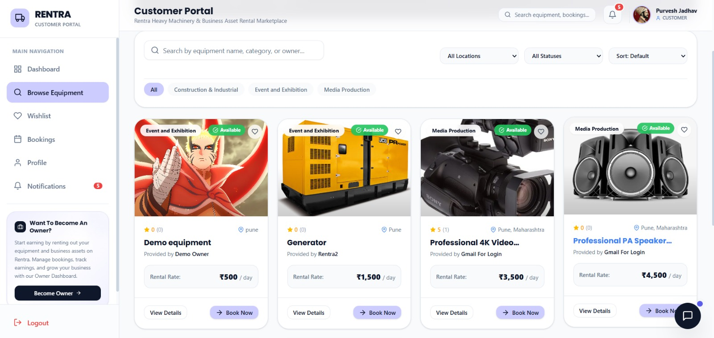Figure 8.13: Heavy Machinery & Equipment Multi-Category Catalog Browser
8.7.4 Equipment Details, Operator Add-on & Pricing Configuration

The equipment details view provides exhaustive technical specifications, manufacturer descriptions, asset location maps, and verified owner credentials. A dynamic pricing calculator recalculates the financial breakdown in real time. Customers can toggle the 'Include Professional Operator' add-on (+₹200/day), view the calculated 20% refundable security deposit, and verify all booking prerequisites before proceeding to checkout.
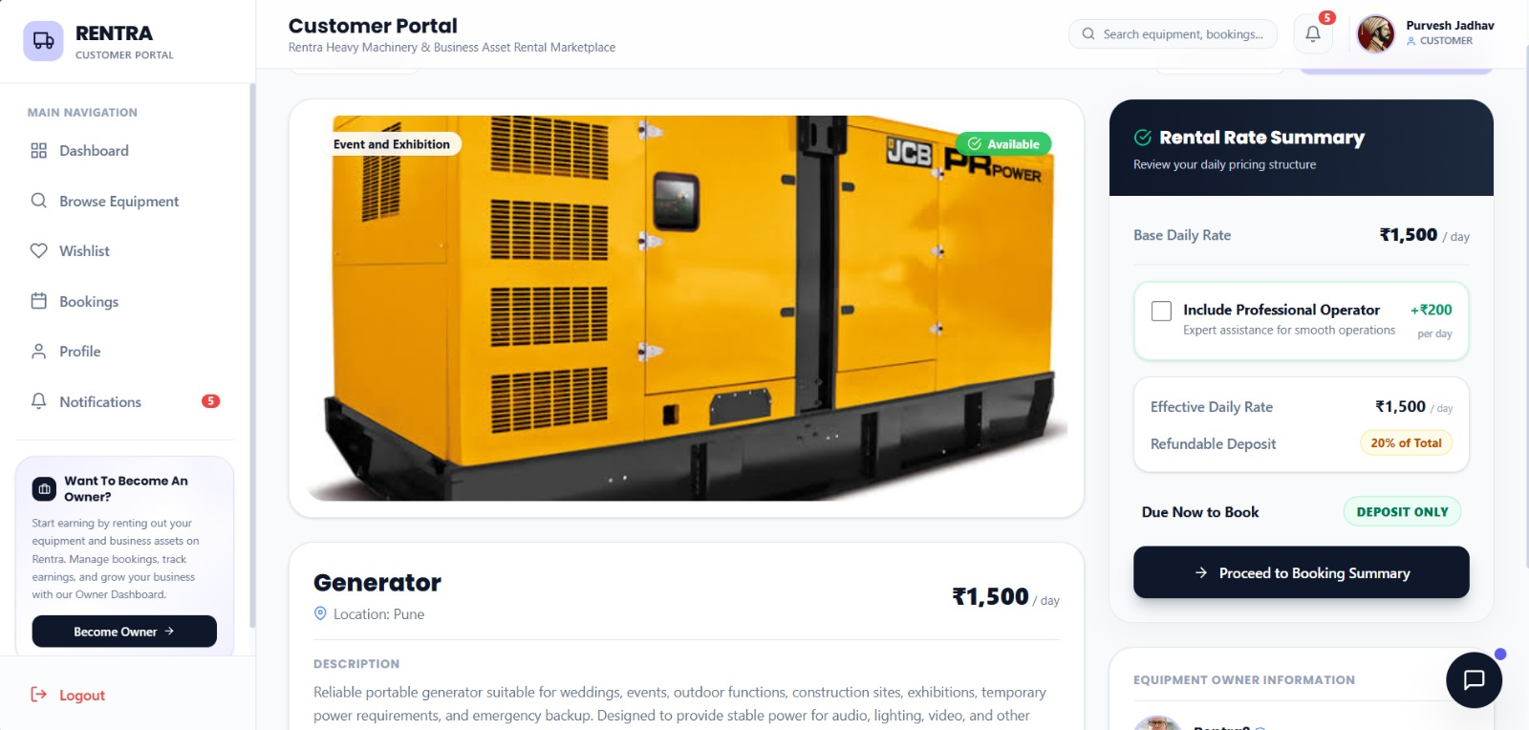
Figure 8.14: Equipment Specification View, Dynamic Pricing Breakdown & Certified Operator Add-on
8.7.5 Escrow Booking Checkout & Razorpay Payment Lifecycle
To eliminate financial ambiguity, the booking checkout workflow opens a dedicated Booking Summary dialog. The modal displays the exact rental schedule dates, total rental valuation, the calculated 20% refundable escrow security deposit payable online, and the remaining balance payable upon physical machine delivery. This clear two-tier financial model protects both parties against unexpected charges.
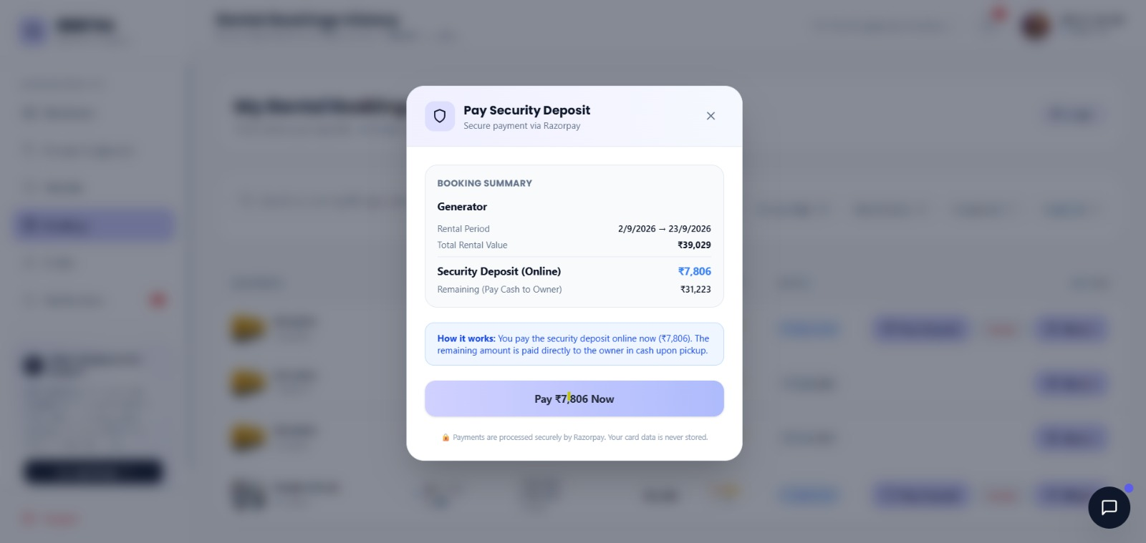Figure 8.15: Customer Booking Summary & 20% Refundable Security Deposit Modal

Upon confirming the reservation, the platform invokes the embedded Razorpay Payment Gateway SDK modal. Customers can select from multiple RBI-compliant payment instruments, including Credit/Debit Cards with secure tokenization, Netbanking across major commercial banks, and UPI/Digital Wallets (Mobikwik, Airtel Payments Bank).
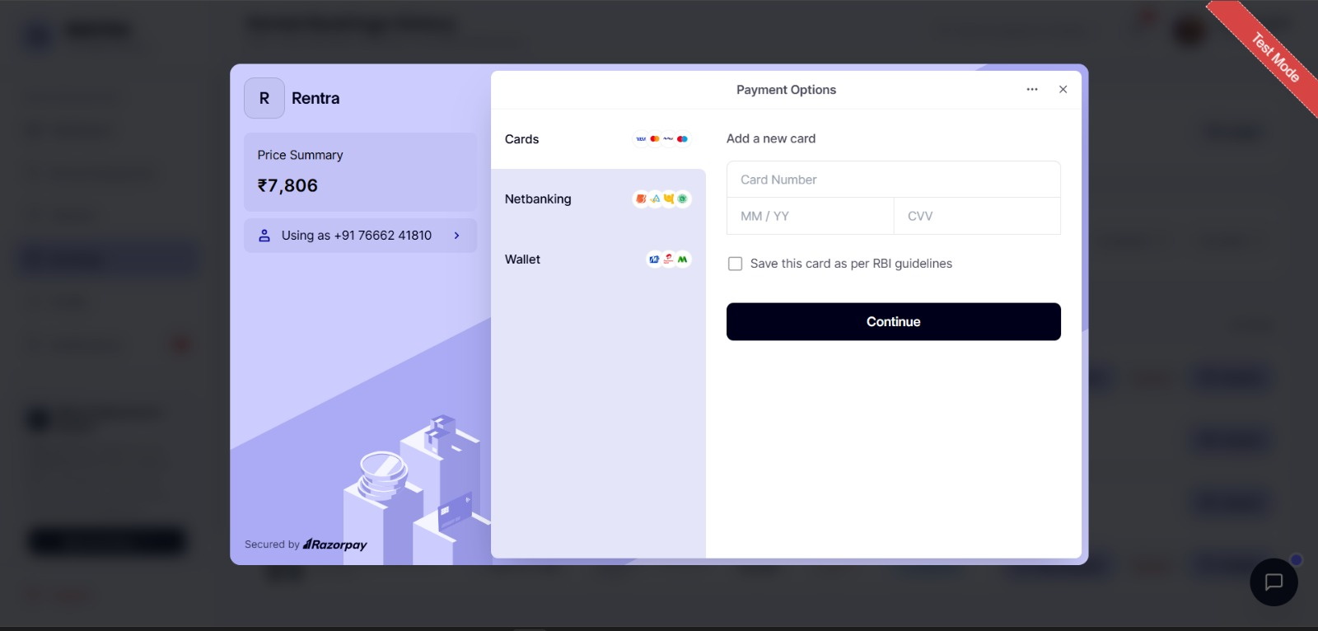
Figure 8.16: Embedded Razorpay Payment Gateway Multi-Channel Options Interface
During payment execution, an asynchronous processing modal displays live transaction state feedback ('Confirming Payment - This will only take a few seconds'). In the background, the server validates the incoming Razorpay payment order and initiates cryptographic signature verification.
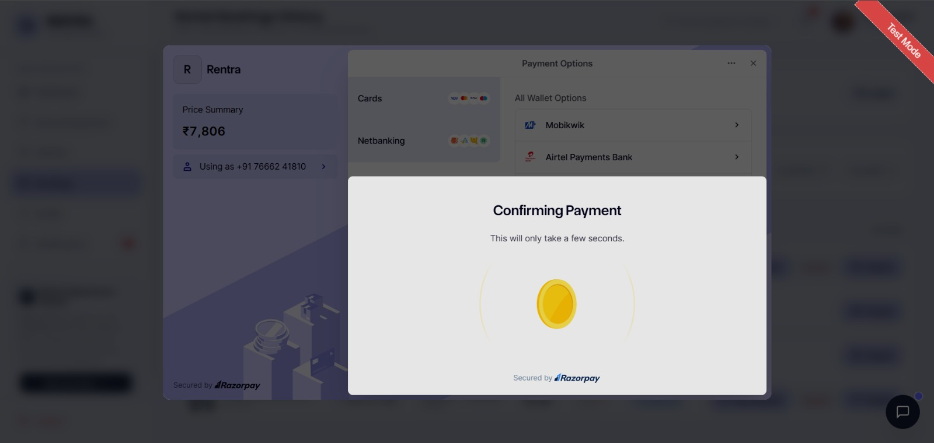
Figure 8.17: Razorpay Cryptographic Transaction Confirmation & State Processing
Once payment authorization is completed by the banking gateway, Razorpay renders an instant success confirmation showing the official transaction reference ID (e.g., pay_TXD49uiLtW9wDD), timestamp, and payment method details before triggering an automatic redirect back to the platform.
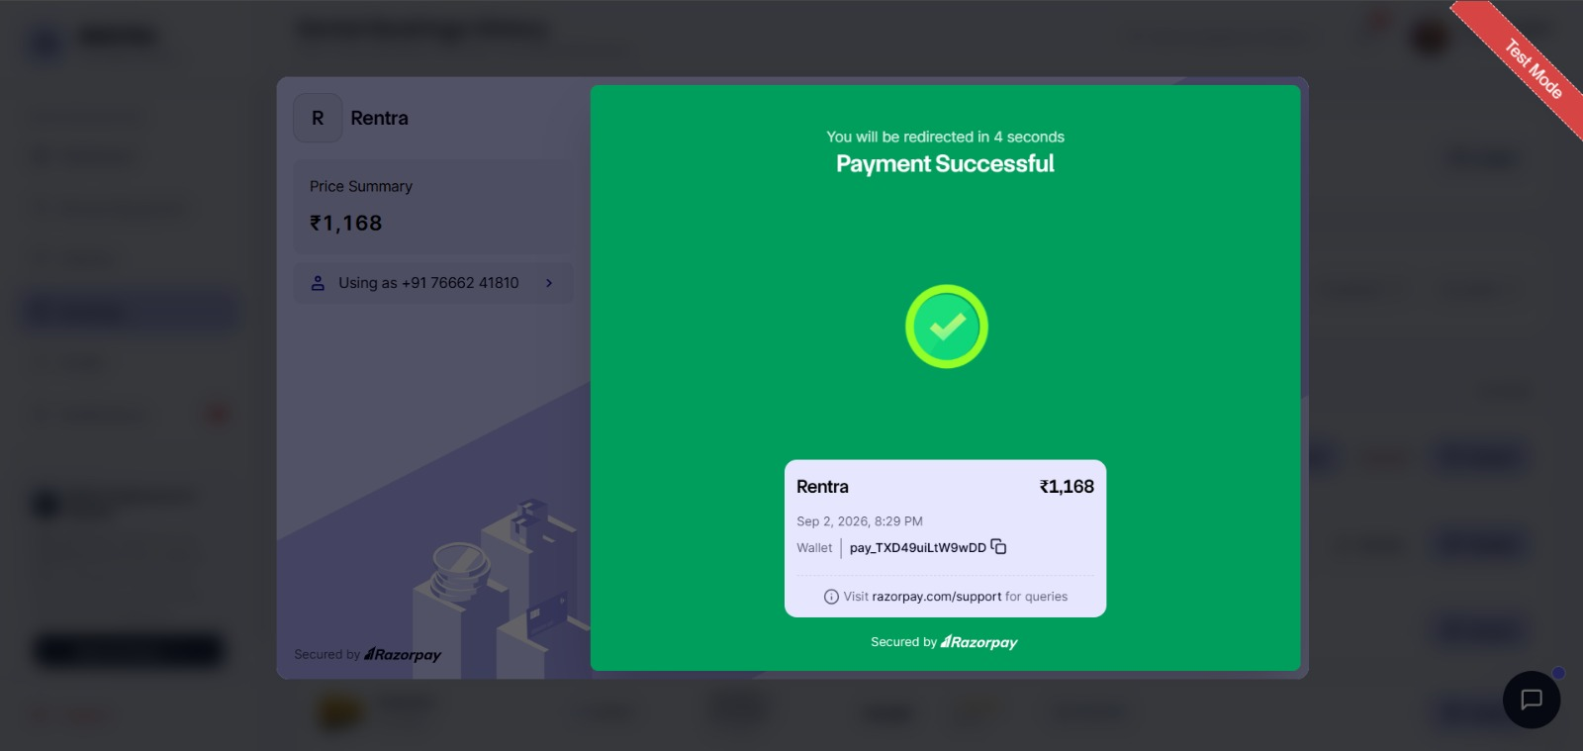
Figure 8.18: Razorpay Gateway Payment Success Callback & Transaction Receipt
Upon receiving the verified webhook callback, the Rentra platform displays an in-app confirmation modal and toast notification confirming receipt of the security deposit. The booking state machine transitions immediately to DEPOSIT_PAID, triggering real-time Socket.IO alerts to both the customer and equipment owner.
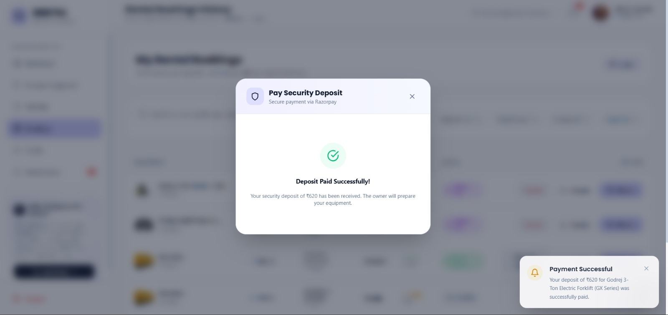
Figure 8.19: Rentra In-App Escrow Deposit Confirmation & Real-Time Notification Toast
8.7.6 Customer Booking History & Rental Lifecycle Management
The Rental Bookings History page offers customers complete visibility over all historical and active reservations. Faceted filter tabs allow sorting by lifecycle status ('Pending Approval', 'Approved', 'Deposit Paid', 'Rental Active', 'Completed', 'Cancelled'). Each row provides the booking hash identifier, equipment thumbnail, owner name, date duration, total amount, deposit status badge, and one-click action buttons for downloading GST tax invoices and viewing detailed inspection records.
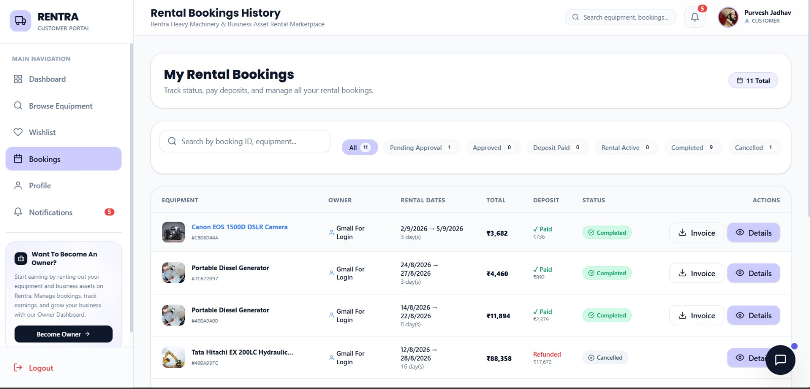
Figure 8.20: Customer Rental Bookings Management & Historical Transaction Ledger
8.7.7 Super Admin Executive Governance & Metrics Operations
The Super Admin Executive Dashboard is the central administrative hub for monitoring platform-wide operations. Key performance indicator (KPI) metric cards display Total Registered Users (9, +14.2% MoM), Total Businesses (3, +8.5% MoM), Total Equipment Listings (9, +18.9% MoM), and Total Bookings Processed (33, +22.4% MoM). Real-time warning banners highlight pending business KYC verifications and machinery approval requests requiring immediate moderator attention.
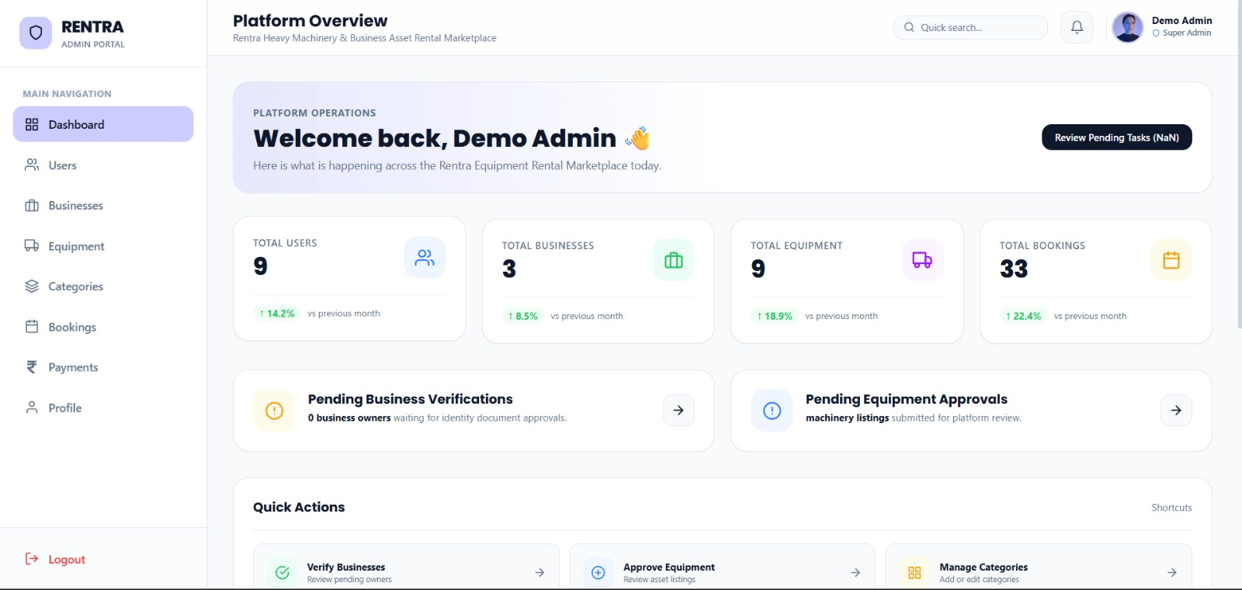
Figure 8.21: Super Admin Executive Dashboard & Real-Time Platform KPI Overview
8.7.8 Super Admin Identity, Security & Business KYC Verification
The User Management panel provides comprehensive oversight of all registered marketplace accounts. Administrators can filter users by role ('Customer' vs. 'Business Owner') or account status. The table provides quick action buttons to inspect user activity, initiate security bans that immediately invalidate JWT tokens and terminate active Socket.IO connections, or permanently delete delinquent accounts.
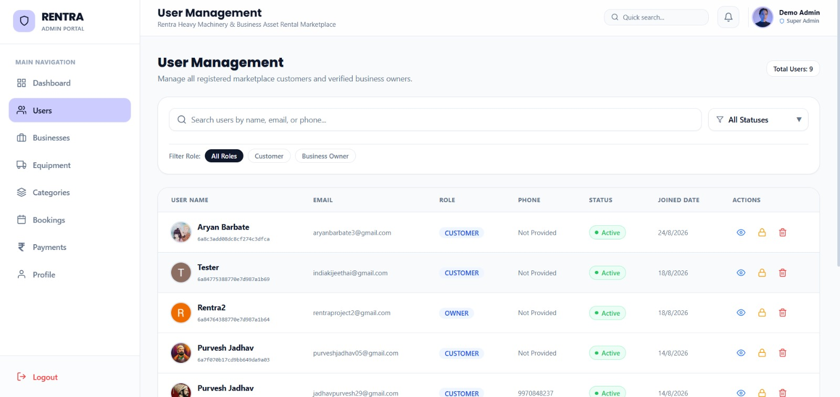
Figure 8.22: Super Admin User Management, Account Auditing & RBAC Security Controls
To prevent fraud and enforce strict marketplace compliance, business owners must complete mandatory KYC verification before listing heavy machinery. The Business Verifications panel allows administrators to review legal business entities (e.g., Titan Machinery, AKT CONSTRUCTIONS), verify GSTIN tax identification numbers, and inspect uploaded PDF registration documents prior to granting verified listing privileges.
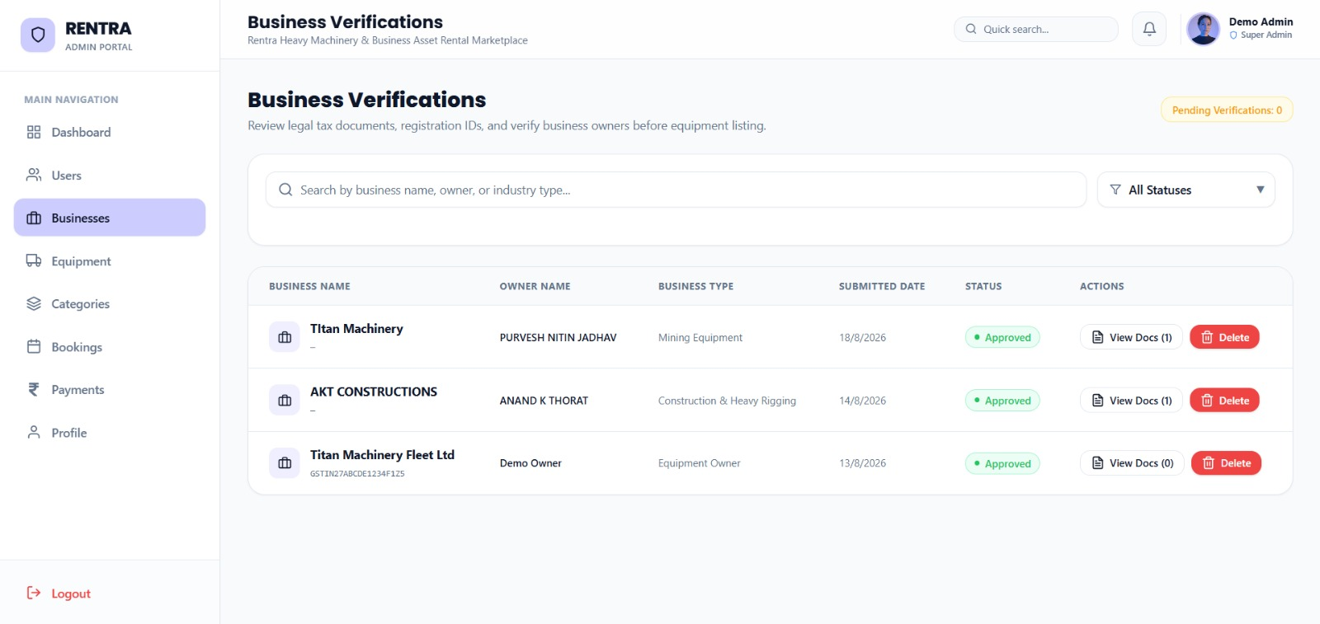
Figure 8.23: Super Admin Business Verification & Legal GSTIN / Tax Document KYC Panel
8.7.9 Super Admin Equipment Moderation & Taxonomy Hierarchy
All heavy machinery listings submitted by equipment owners enter an administrative moderation queue. Through the Equipment Moderation interface, administrators inspect machinery specifications, verify uploaded media authenticity, review daily pricing fairness, and approve or reject listings before they become searchable in the public marketplace.
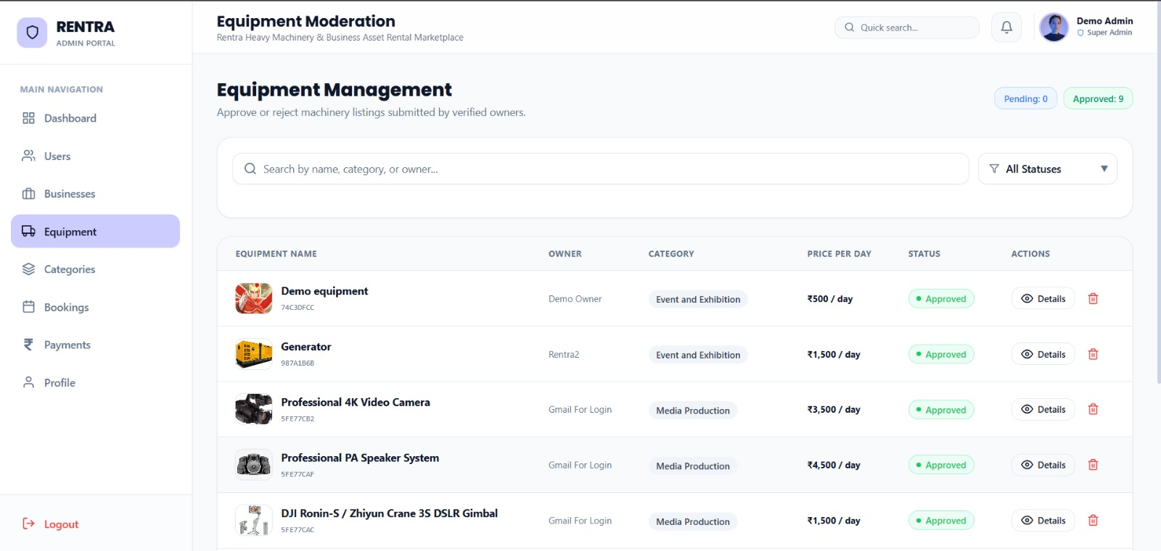
Figure 8.24: Super Admin Heavy Equipment Listing Moderation & Approval Management
The Category Management module allows platform administrators to structure and maintain the industrial equipment taxonomy hierarchy. Admins can create new industry categories, edit taxonomic descriptions, track live machinery association counts, and manage indexing tags across diverse sectors including Construction & Industrial, Event and Exhibition, and Media Production.
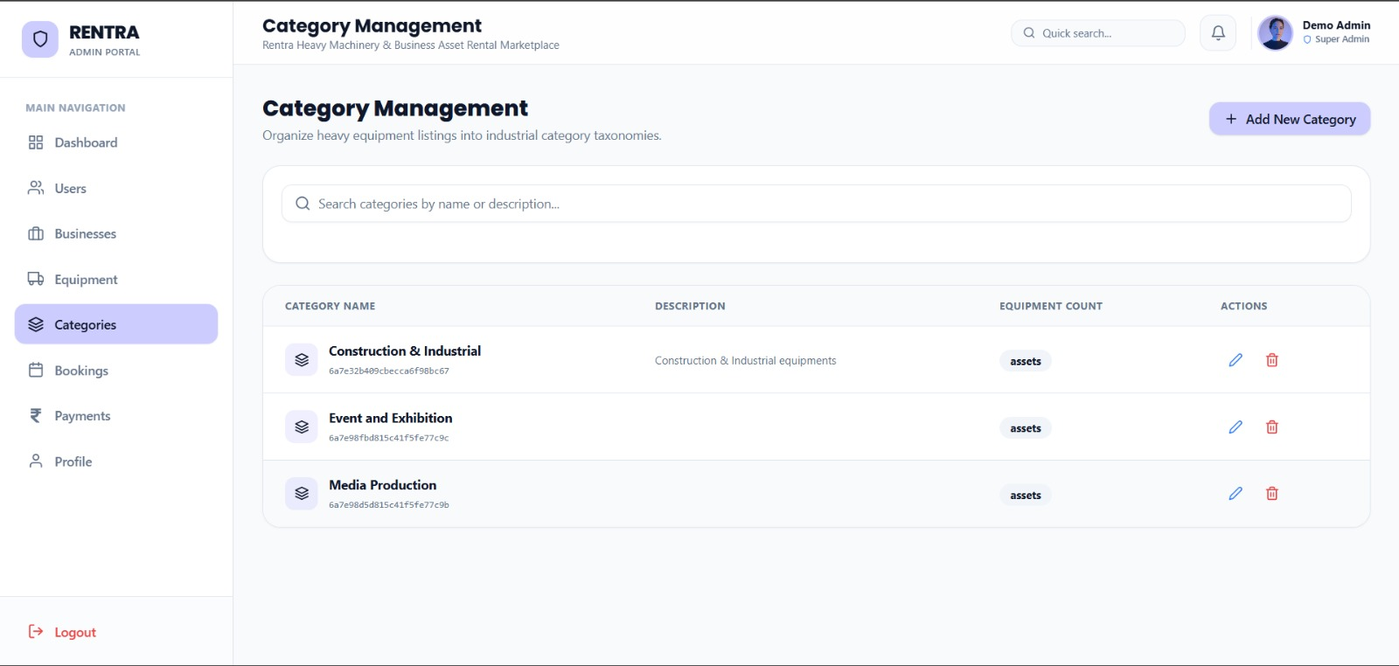
Figure 8.25: Super Admin Industrial Category Taxonomy & Hierarchy Architecture
8.7.10 Super Admin Global Booking Monitor, Financial Escrow & Audit Trail
The global Booking Management monitor provides real-time oversight of all rental transactions executing across the platform. The audit table displays unique MongoDB 24-character ObjectIds, customer identities, equipment rented, business owners, booking durations, total transaction values, and real-time state machine status badges ('Approved', 'Completed').
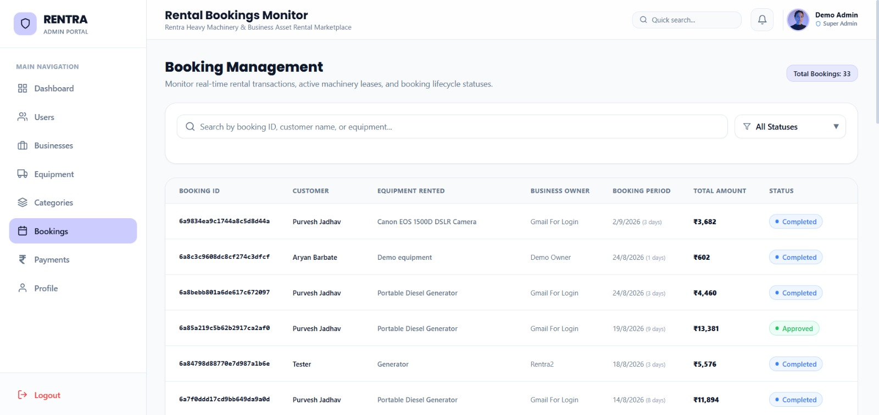
Figure 8.26: Super Admin Global Rental Booking Lifecycle & State Machine Monitor
The Payments & Refunds ledger provides an immutable financial record of all monetary transactions on Rentra. Platform-level KPI cards aggregate Total Collected (₹101,741), Active Deposits Held in Escrow (₹74,723), Total Refunded to Customers (₹27,018), and Platform Commission Revenue (₹28,381). The transaction ledger details exact 20% platform commission deductions, 80% owner payout entitlements, payout transfer status, and one-click actions for executing owner bank payouts or processing manual dispute refunds.
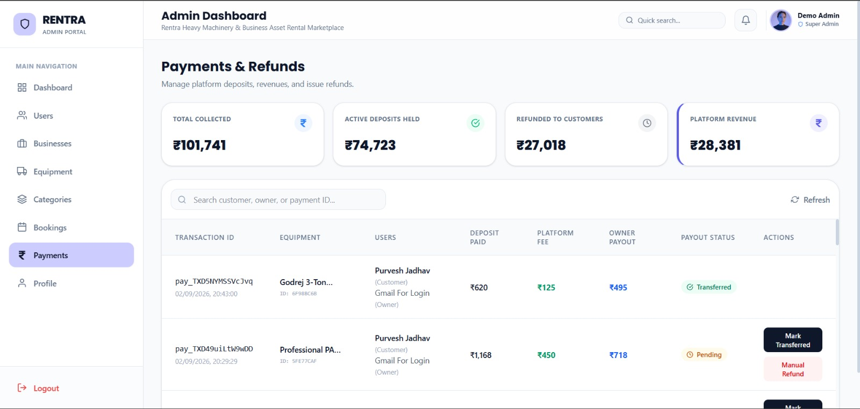
Figure 8.27: Super Admin Platform Financial Escrow, Payouts & Refunds Ledger
The Administrator Profile panel provides operational analytics and an immutable governance audit log. Performance counters track cumulative administrative achievements (Businesses Approved: 186, Equipment Approved: 542, Categories Created: 14, Actions Performed: 2,490). The audit activity feed logs every recent administrative action—such as business approvals and equipment verifications—with precise timestamps to maintain organizational accountability.
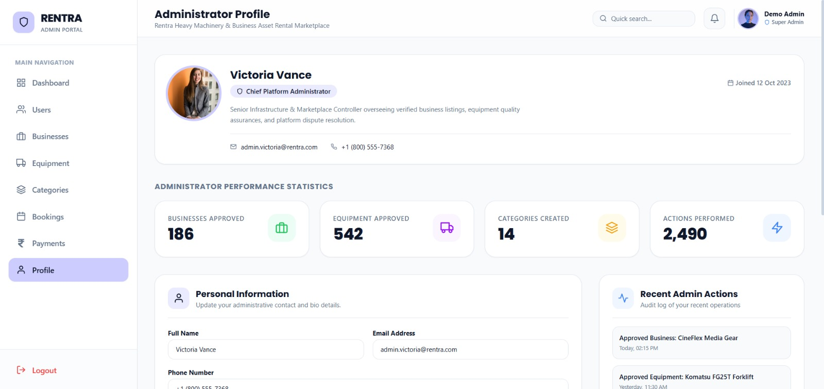Figure 8.28: Platform Administrator Profile, Performance Statistics & Security Audit Trail

Chapter 9 : Special / Challenging Experiences Encountered
During the 12-week industrial training at Linkcode Technologies, several complex architectural, algorithmic, and integration challenges were encountered while engineering the Rentra platform. Overcoming these obstacles significantly sharpened my technical problem-solving acumen and full-stack development skills:
1. Preventing Race Conditions in Concurrent Booking State Transitions
- • Challenge: Simultaneous actions (e.g., customer paying deposit while owner attempts to update dates) could create corrupted state machine records.
- • Solution: Implemented atomic Mongoose document updates with state preconditions (e.g., findOneAndUpdate({ _id, status: ''Approved'' })) ensuring transitions execute strictly in deterministic order.
2. Bi-Directional WebSocket Synchronization Across Multi-Tenant Roles
- • Challenge: Managing Socket.IO connections when users switch roles or drop connections on mobile browsers.
- • Solution: Engineered a centralized SocketContext with room-based event broadcasting tied to user and business IDs, featuring automated reconnection handshakes and toast notifications.
3. Financial Tamper-Proofing in Razorpay Escrow Deposit Verification
- • Challenge: Preventing malicious client-side script tampering with payment amounts or fake payment IDs.
- • Solution: Enforced cryptographic HMAC-SHA256 signature verification on the Node.js backend using the Razorpay webhook secret before updating booking records to 'Deposit Paid'.
4. Responsive Touch E-Signature Capture on HTML5 Canvas
- • Challenge: Handling high-DPI scaling and touch event coordinates across diverse mobile and desktop screen viewports on canvas.
- • Solution: Implemented normalized coordinate calculation multiplying window.devicePixelRatio, producing crisp vector-like signature data URLs saved directly to inspection records.
5. High-Density Responsive Dashboards with Tailwind CSS v4
- • Challenge: Rendering complex rental timelines, tabular machinery data, and modal forms on constrained mobile viewports.
- • Solution: Leveraged Tailwind CSS v4 responsive grid breakpoints, custom flexbox drawer components, and Framer Motion layout animations.

Conclusion
The 12-week industrial implant training at Linkcode Technologies, Shivajinagar, Pune has been an exceptionally enriching, transformative, and productive learning experience. It provided a seamless transition from academic classroom concepts to real-world, enterprise-level full-stack software engineering.
Through the conceptualization, architecture, development, and rigorous testing of the RENTRA – High-Value Asset & Heavy Equipment Rental Marketplace, I successfully mastered production-grade full-stack technologies including the MERN Stack (MongoDB Atlas, Express.js v5, React 19, Node.js), Socket.IO real-time communication, Razorpay escrow financial integrations, and modern Tailwind CSS v4 styling.
Beyond core programming skills, the training fostered critical professional competencies: agile scrum sprint discipline, Git collaborative workflows, secure API lifecycle management, automated quality assurance, and user-centric problem solving. Overcoming complex technical challenges such as state machine concurrency, cryptographic webhook validation, and real-time state synchronization built deep confidence in architecting scalable software solutions.
The objectives prescribed by the Maharashtra State Board of Technical Education (MSBTE) K-Scheme curriculum for industrial training have been thoroughly accomplished. The technical and professional proficiencies acquired during this implant training at Linkcode Technologies will serve as a permanent catalyst for my academic progression and future career in the software engineering industry.

References / Sources of Information
During the industrial implant training and the preparation of this comprehensive project report, the following authoritative technical documentation, books, and reference platforms were consulted:
Websites & Official Technology Documentation
- 1. React Official Documentation (react.dev) – React 19 hooks, Context API, component lifecycle, and state optimization.
- 2. Node.js Documentation (nodejs.org) – Asynchronous event-loop execution, stream pipelines, and file system APIs.
- 3. Express.js Guides (expressjs.com) – Modular routing, custom middleware architecture, and error handling.
- 4. MongoDB Manual (mongodb.com/docs) – Document data modeling, compound indexing, aggregation pipelines, and Mongoose ODM.
- 5. Socket.IO Documentation (socket.io/docs) – WebSocket protocol, room management, and bi-directional event handlers.
- 6. Razorpay Developer Portal (razorpay.com/docs) – Payment gateway API, escrow workflows, and HMAC-SHA256 signature verification.
- 7. MDN Web Docs (developer.mozilla.org) – HTML5 Canvas API, ES6+ JavaScript standards, and CSS Grid specifications.
Tools, Platforms & Engineering Resources
- 1. Visual Studio Code – Primary code editor, debugging tools, and extensions.
- 2. Postman – API testing, automated endpoint collections, and environment variable management.
- 3. MongoDB Compass – Visual database administration, query optimization, and schema analysis.
- 4. Git & GitHub – Distributed version control, branch management, and code review workflows.
- 5. Cloudinary Developer Platform – Cloud media storage, image optimization, and CDN transformations.
- 6. Stack Overflow – Troubleshooting technical roadblocks and performance optimization discussions.
- 7. Linkcode Technologies Learning Portal – Internal training modules, enterprise best practices, and code quality guides.

