Material properties:
- Density : 8910 kg/m^3
- Young Modulus : 75.854 GPa
- Poisson’s Ratio : 0.34
- Bulk Modulus : 79.015 GPa
- Shear Modulus : 28.304 GPa

Simulated modal analysis ANSYS in AIR (free boundary condition)
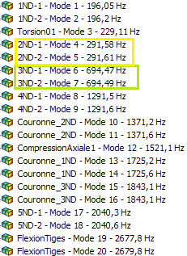

Experimental modal analysis in AIR (free boundary condition)
Mode | Natural frequencies (Hz)
1 ND | 191.6
 | 192.8
Torsion | 226
2 ND | 293.625
 | 299.125
3 ND | 703.25
 | 712
4 ND | 1310.875
 | 1320

