PodMate: A Role-Based Podcast Management and Streaming Platform
N.Yadagiri  Department of Computer Science and Engineering  CVR College of Engineering  Hyderabad, India  yadagiricse@cvr.ac.in | T.Renuka  B.Tech Student, Dept  CVR College of Engineering  Hyderabad, India  22B81A0529@cvr.ac.in | I.Sneha  B.Tech Student, Dept  CVR College of Engineering  Hyderabad, India  22B81A0541@cvr.ac.in | M.Sreeja  B.Tech Student, Dept  CVR College of Engineering  Hyderabad, India  22B81A0547@cvr.ac.in

Abstract— Podcasts have emerged as a widely used medium for sharing information, education, and entertainment content over the internet. However, most existing podcast platforms primarily focus on content distribution and provide limited control for content creators and administrators. These platforms lack efficient tools for content organization, moderation, and analytics, making them less suitable for structured environments such as educational institutions and community platforms. Additionally, users often face challenges in organizing, discovering, and tracking podcast content across multiple applications. This paper presents PodMate, a role-based podcast management and streaming platform designed to address these limitations. The system enables users to stream and interact with podcasts, allows creators to manage and publish content, and provides administrators with tools for monitoring and moderation. PodMate incorporates features such as secure authentication, podcast uploading and streaming, search functionality, and user interaction through likes, bookmarks, comments, and subscriptions. The platform is developed using the MERN stack (MongoDB, Express.js, React.js, and Node.js) and implements secure authentication using JSON Web Tokens (JWT). The proposed system offers a scalable and flexible solution for efficient podcast management and content delivery.
Index Terms - Podcast Streaming, Web Application, MERN Stack, Role-Based Access Control, Content Management System, Audio Streaming.

INTRODUCTION
The rapid growth of the internet has significantly transformed the way digital content is created, distributed, and consumed. Among various forms of digital media, podcasts have gained considerable popularity as a medium for knowledge sharing, storytelling, education, and entertainment. Users can access podcast content anytime and anywhere through various devices such as smartphones and computers.
Despite their widespread usage, existing podcast platforms such as Spotify and Apple Podcasts are primarily designed for large-scale content distribution and offer limited control to content creators and administrators. These platforms provide basic features such as subscription and playback but lack advanced capabilities for content organization, moderation, and centralized management. As a result, users often find it difficult to efficiently manage and track podcast content.
Web-based applications provide an opportunity to address these limitations by integrating content management, user interaction, and secure access control within a unified system. By combining backend services, databases, and interactive user interfaces, it is possible to design a platform that supports multiple user roles and enhances the overall user experience.
To address these challenges, this paper proposes PodMate, a role-based podcast management system. The platform enables users to discover and stream podcasts, allows creators to upload and manage content, and provides administrators with tools for monitoring and control. The system is implemented using the MERN stack and follows RESTful architecture, ensuring efficient communication between system components.

LITERATURE REVIEW
Podcasting has evolved significantly with advancements in internet technologies and multimedia streaming systems. Earlier, digital audio content was distributed as downloadable files, requiring users to download complete media files before playback. With the development of high-speed internet and cloud-based services, streaming technologies have enabled real-time access to audio content, improving accessibility and user experience.
Modern podcast platforms allow users to subscribe to content and receive updates from creators. However, these systems are primarily designed for large-scale distribution and lack structured mechanisms for content management and administrative control. There is limited support for content moderation, analytics, and role-based access within such platforms.
Content Management Systems (CMS) have been widely used in web applications to efficiently manage digital content. These systems provide functionalities such as authentication, data storage, and interactive user interfaces. Role-Based Access Control (RBAC) has become a critical component in modern applications, enabling controlled access to system resources based on user roles.
Despite these advancements, existing podcast platforms do not provide a unified solution that integrates streaming, content management, user interaction, and administrative control. Therefore, there is a need for a scalable and structured podcast management system that incorporates these features within a single platform. PodMate addresses this gap by providing a comprehensive web-based solution.

PROPOSED MODEL
This paper introduces PodMate, a web-based podcast management and streaming platform that integrates content management, user interaction, and administrative control within a unified system. The platform is designed to support multiple user roles and provide a scalable architecture for efficient content delivery.
A. System Architecture
PodMate follows a three-tier architecture consisting of:
- Presentation Layer (Frontend)
- Application Layer (Backend)
- Data Layer (Database)
User requests are processed through the React-based frontend and forwarded to the backend server via RESTful APIs. The backend processes requests, interacts with the database, and returns responses to the frontend. Authentication is enforced using JWT tokens to ensure secure access.
Fig. 1 illustrates the overall system architecture.
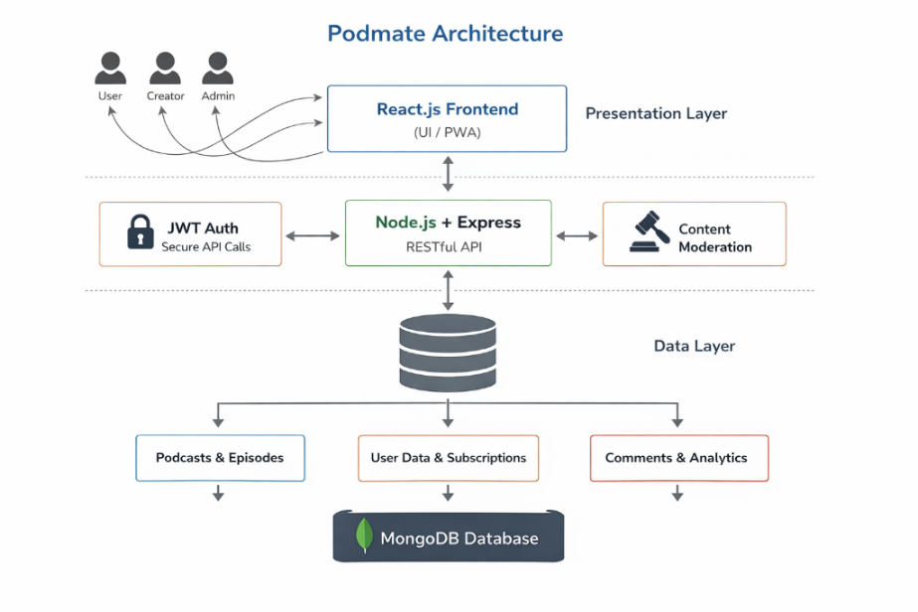
Fig. 1 System Architecture of PodMate
B. Layered Architecture Design
To keep things modular and reduce dependencies, the system has three primary layers:
1. Presentation Layer
Implemented using React.js, this layer provides interactive dashboards for users, creators, and administrators. It supports features such as podcast search, playback, bookmarking, and subscription management.
2. Application Layer
Developed using Node.js and Express.js, this layer handles business logic including authentication, content management, and API processing. Middleware ensures secure access to protected routes.
3. Data Layer
MongoDB is used for storing data such as users, podcasts, episodes, and interactions. Relationships are maintained using ObjectId references, ensuring efficient data management.
C. Authentication Workflow
The system implements JWT-based authentication. After successful login, a token is generated and used for subsequent requests. Additional security measures include password hashing, input validation, and protected API routes.
D. Role-Based Access Control
PodMate uses role-based access control (RBAC) to define permissions for Users, Creators, and Administrators.
- Users can browse, stream, like, bookmark, and comment on episodes.
- Creators can upload, edit, and manage podcast content.
- Administrators can moderate content, manage users, and monitor platform analytics.
Middleware functions validate user roles before permitting access to role-specific actions.
E. Podcast Streaming and Management
The platform supports audio streaming through a built-in player. Users can interact with content through likes, comments, bookmarks, and subscriptions, enhancing engagement.
F. Security and Scalability Considerations
Security measures include password hashing with bcrypt, JWT-based authentication, protected API routes, and input validation. Error-handling middleware manages responses to invalid requests.
The modular MERN architecture allows for horizontal scaling and effectively handles multiple users at once. The system can be deployed on cloud platforms for better availability and performance.
G. Advantages of the Proposed Model
The proposed system offers several benefits:
- A unified platform for users, creators, and administrators
- Secure authentication and role-based access control
- A modular and scalable architecture
- Organized content moderation
- Integrated analytics and engagement features.

RESULTS
The system was tested to evaluate functionality, usability, and performance. Key features such as authentication, streaming, content management, and administrative control were validated.
Users were able to browse and stream podcasts efficiently, with smooth playback and responsive controls. Creators successfully uploaded and managed content, while administrators effectively monitored platform activity.
The system demonstrated stable performance under multiple operations, including streaming and user interactions. Security testing confirmed that unauthorized access was prevented through proper authentication mechanisms. Database operations were performed accurately without data inconsistency. Overall, the results indicate that PodMate provides a reliable and efficient solution for podcast management and streaming.
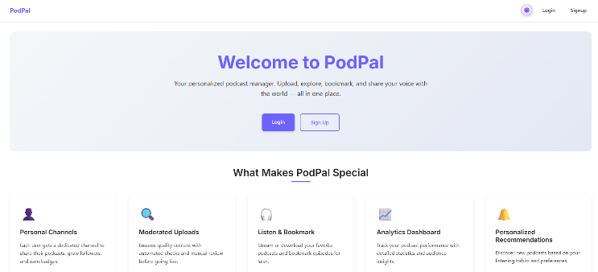
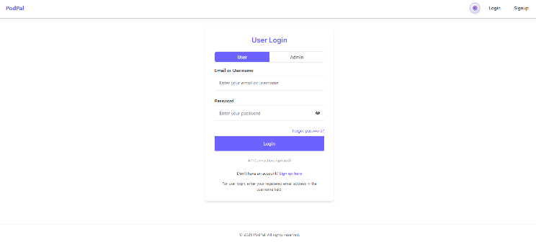
A. User Engagement and Streaming Efficiency
Users could search for episodes, peruse the available podcasts, and uninterruptedly stream audio content. Playback controls such as play, pause, and seek functioned properly, and the audio player successfully loaded episodes.
Likes, bookmarks, and comments are examples of engagement features that worked as planned. Under typical usage circumstances, the response time for data retrieval and page navigation was adequate.
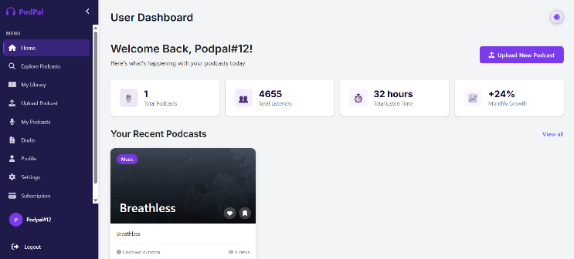
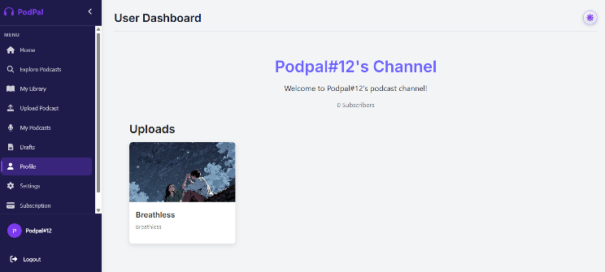
B. Content Management for Creators
Through the creator dashboard, creators could manage their published content, upload podcast episodes, and supply metadata. After being approved, uploaded audio files were successfully stored and made accessible to listeners. Through dashboard data, the platform's creators could monitor interaction activity and modify or remove episodes.
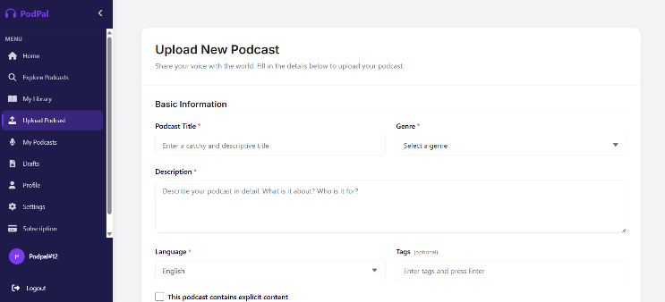
C. Administrative Control and Moderation
Managing and monitoring users and content was made possible by the administrator module. Administrators have the ability to view registered users, approve or reject uploaded podcasts, and moderate inappropriate content. The analytics data provided a summary of platform activity, including user interaction and content consumption.
D. Reactivity of the System
During several concurrent operations, such as streaming, commenting, and uploading, the application's performance remained steady. Database operations were carried out without data inconsistency, and backend APIs correctly responded to client requests. The platform's overall performance was unaffected by the independent operation of various system modules thanks to the modular architecture.
E. Testing for Security and Authentication
Through both successful and unsuccessful login attempts, testers assessed authentication mechanisms. Token verification was used by the system to prevent unauthorized access while granting access to registered users. The backend middleware rejected tokens that were invalid or expired.
Without appropriate authentication, protected routes like content upload and administrative functions remained unreachable. No client response revealed the passwords that were safely hashed and kept in the database.
F. Verification of Database Operations
For a variety of collections, including users, podcasts, and comments, database operations like insertion, update, retrieval, and deletion were tested. Podcast metadata and user registration information were accurately stored by the system. The user interface instantly updated when content was added or removed.
During repeated operations, no data duplication or inconsistency was found. In order to properly link episodes, creators, and user interactions, references were used to maintain object relationships between collections.
G. Features for Search and Discovery
Podcasts were queried using keywords, titles, and creator names in order to test the search module. Based on the entered search parameters, the system successfully produced pertinent results. Users were able to browse and filter content with ease. This made podcasts more accessible and made it easier to locate particular episodes.
The PodMate platform successfully combines podcast streaming, user interaction, and administrative management into a single web application, according to the testing results. Reliable authentication, appropriate role-based access control, and seamless audio streaming were all demonstrated by the system. The platform provides a scalable and practical way to manage podcast content in a controlled setting.
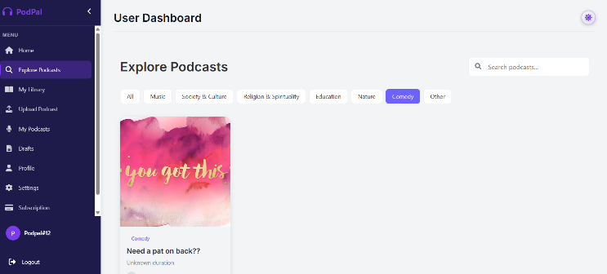

CONCLUSION AND FUTURE SCOPE

A. Conclusion

This paper introduced PodMate, a role-based platform for managing and streaming podcasts that integrates user interaction, content distribution, and administrative control into a single web application. By providing organized access control, content moderation, and creator management, the system sought to address the drawbacks of conventional podcast platforms. JSON Web Tokens were successfully used by the platform to implement secure authentication. It offered different features for administrators, creators, and users.

Finding and streaming podcast episodes, interacting with features like likes, bookmarks, and comments, and controlling their listening preferences were all available to users. While administrators could keep an eye on platform activity and moderate content, creators were given tools to upload and manage their podcast content. Effective communication between the frontend and backend components was made possible by the MERN stack architecture.

Information about users and podcasts was reliably stored thanks to the database. The system successfully handled role-based operations, audio streaming, and authentication, according to functional testing. All things considered, PodMate provides an organized and scalable solution for managing and hosting podcasts, making it appropriate for both community and institutional contexts.

The system demonstrated the efficiency of combining different modules, such as user interaction, content management, and authentication, on a single platform in addition to streaming.

The role-based design improved system security and maintainability by ensuring that each type of user could only access the functionalities that were permitted to them. Additionally, the modular design makes updates and extensions easier in the future without interfering with other components.

The created platform can function effectively in regulated settings where organized content distribution and oversight are crucial, such as educational institutions, training facilities, and community networks. The system links basic media streaming services with structured content management systems by combining podcast hosting, interaction features, and administrative oversight. Additionally, the project offered hands-on training in database design, secure authentication procedures, API integration, and full-stack development.

B. Upcoming Improvements

Even though the current system achieves its primary objectives, future iterations could include a number of enhancements. Based on a user's listening preferences, an AI-powered recommendation system might provide tailored podcast recommendations. Including voice search capabilities could improve user convenience and accessibility.

Subscription services and creator monetization would be supported by integrating online payment gateways. Accessibility across devices could be further enhanced with a mobile app version of the platform. Large audio file streaming would be optimized and latency would be decreased by putting in place cloud-based media storage and content delivery networks (CDN). Real-time alerts, live podcast streaming, and sophisticated analytics dashboards are examples of extra features that could improve platform monitoring and user engagement.

All these upgrades would take the system way beyond just a web podcast platform. Imagine it as a full-blown audio content hub—where everything feels interconnected and a little smarter. If the platform learns your listening habits, it can actually start recommending podcasts you’d care about. Machine learning can dig into what people do in the app and suggest episodes that really click with them.

You want transcripts for accessibility and easier searching? Automatic speech-to-text does the trick, giving everyone a written version of every episode. Push notifications would help listeners stay on top of new uploads, so they don’t miss anything. And with social media integration, sharing episodes is just a tap away.

Handling huge audio files gets much smoother with cloud storage and content delivery networks—no more bottlenecks or slowdowns. Admins can get in-depth analytics showing listening times, trends, and how creators perform. Throw in multi-language support, and suddenly you have a platform that welcomes a much wider audience.

Down the road, PodMate could become more than podcasts. It could turn into an audio learning center, hosting lectures, recorded classes, even broadcasting for schools and institutions. The possibilities are pretty exciting.

REFERENCES
- R. Fielding and R. Taylor, “Principled design of the modern web architecture,” ACM Trans. Internet Technol., vol. 2, no. 2, pp. 115–150, 2002.
- T. Berners-Lee, R. Fielding, and H. Frystyk, “Hypertext Transfer Protocol – HTTP/1.1,” IETF, RFC 2616, 1999.
- M. Richardson and S. Ruby, RESTful Web Services. Sebastopol, CA: O’Reilly Media, 2007.
- MongoDB Inc., “MongoDB documentation,” 2024. Available: https://www.mongodb.com/docs
- Node.js Foundation, “Node.js documentation,” 2024. Available: https://nodejs.org/docs
- Express.js, “Express – Node.js web application framework,” 2024. Available: https://expressjs.com
- React, “React: A JavaScript library for building user interfaces,” 2024. Available: https://react.dev
- J. Reschke, “HTTP/1.1: Semantics and content,” IETF RFC 7231, 2014.
- Auth0, “JSON Web Token (JWT) introduction,” 2024. Available: https://jwt.io/introduction
- N. Mavridis, “A review of verbal and non-verbal human–robot interactive communication,” Robot. Auton. Syst., vol. 63, pp. 22–35, 2015.
- A. Silberschatz, P. B. Galvin, and G. Gagne, Operating System Concepts, 9th ed. Hoboken, NJ: Wiley, 2013.
- I. Sommerville, Software Engineering, 10th ed. Boston, MA: Pearson, 2016.
- Google Developers, “Progressive Web Apps documentation,” 2024. Available: https://developer.chrome.com/docs/workbox
- OWASP Foundation, “OWASP Top 10: Web application security risks,” 2021. Available: https://owasp.org

