ASSIGNMENT 11.2
Ques 1) Find the number of students who scored less than 5(50%).
Commands:
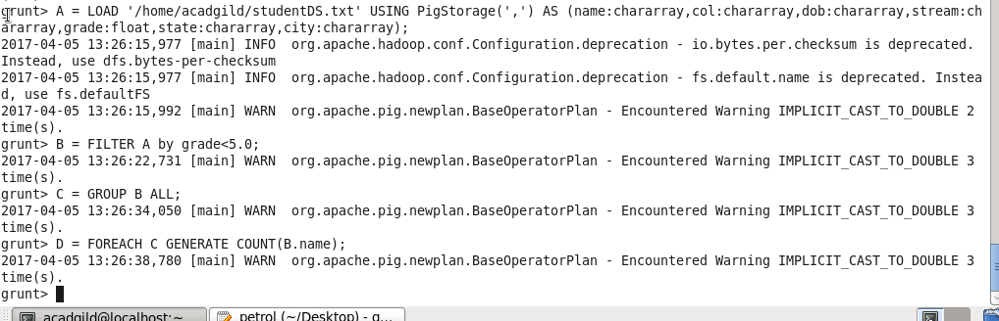
Output:
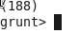
Ques 2.) List the name of students who are from Alaska.
Commands:
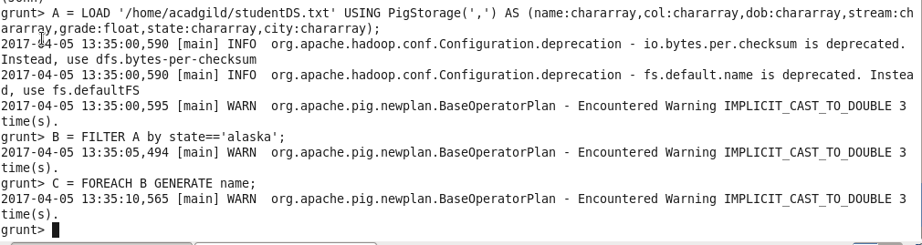
Output:
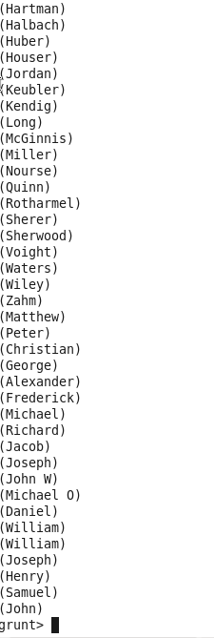

Ques 3.) How many government colleges are there in Alabama?
Commands:
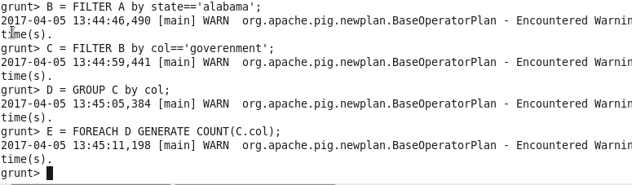
Output:
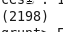

Ques 4.) List the name of students who are from Oregon and persuing BE.
Commands:
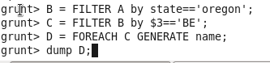
Output:
