**Write a mapreduce program to find the total number of people travelled in titanic.**

**MAPPER**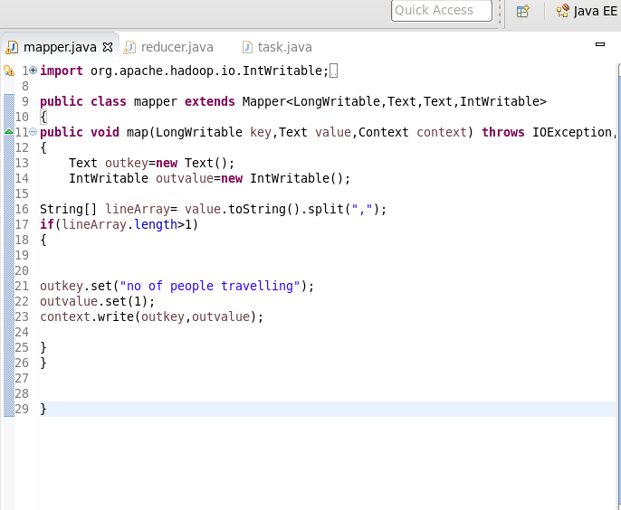

**REDUCER**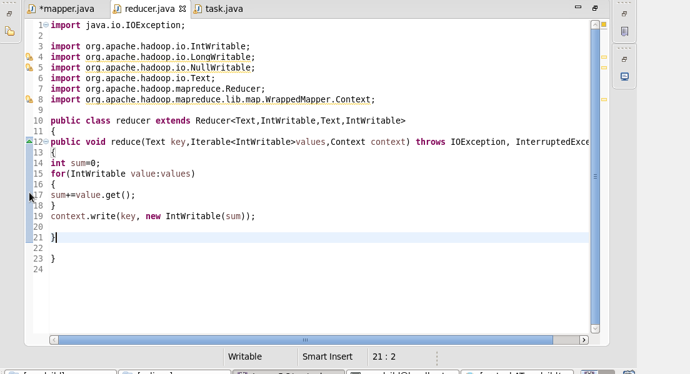

**DRIVER**

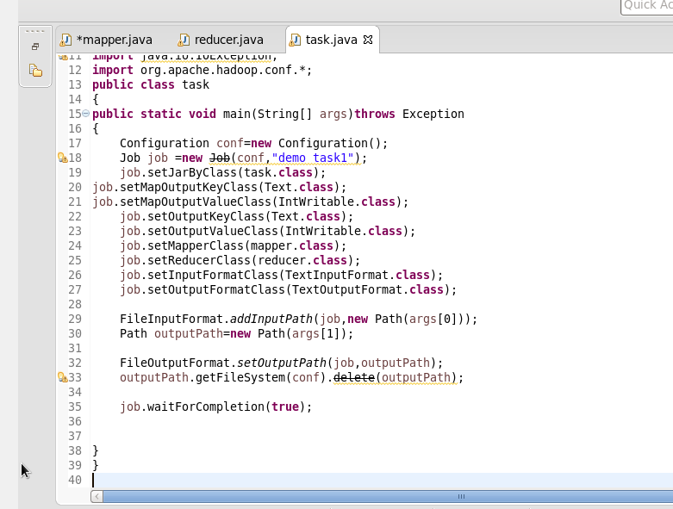

**COMMANDS**



**OUTPUT**

