**ASSIGNMENT 6.1**

**1: Find out how many people has chosen their destination as MIA and MCO Problem statement**

**2: Find out the number of people undertaken the trips from the places MIA and HOU Problem statement**

**3: Find out how many people has chosen airline mode of travel for the places LAS and LAX**

**DRIVER**

**Q1**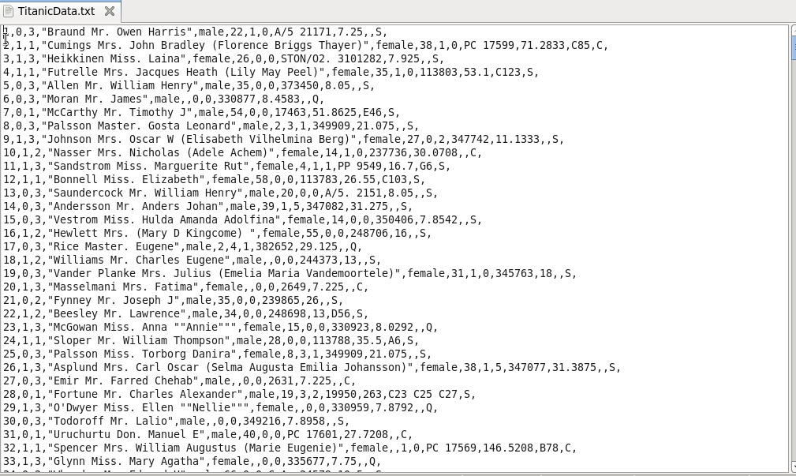

**DRIVER**

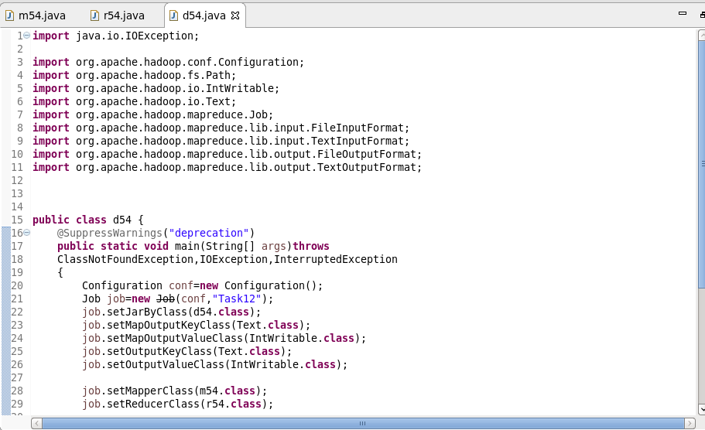

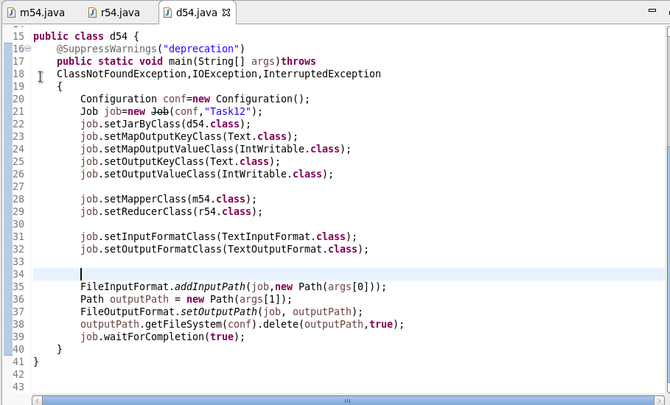

**MAPPER**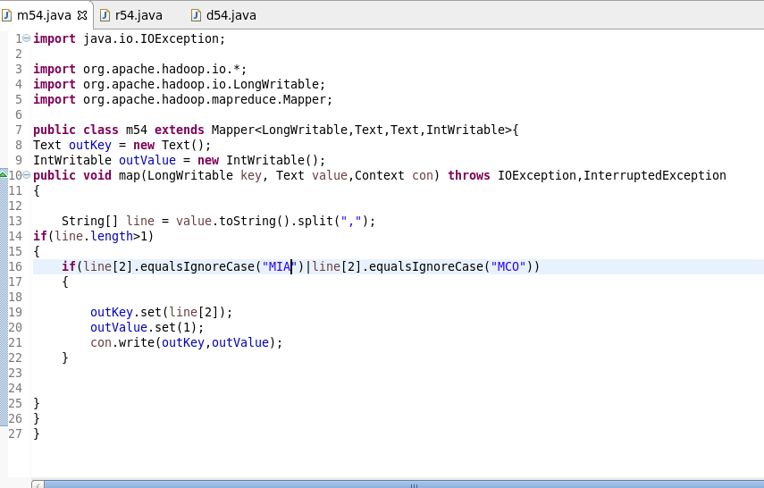

**REDUCER**

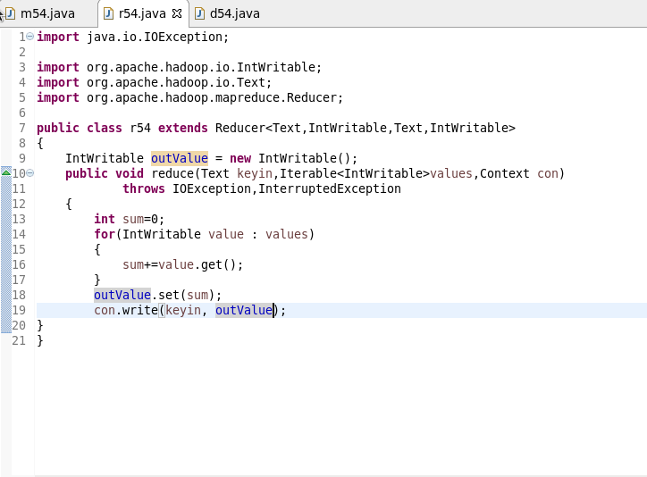

**OUTPUT**

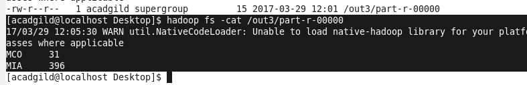

**Q2**

**MAPPER**

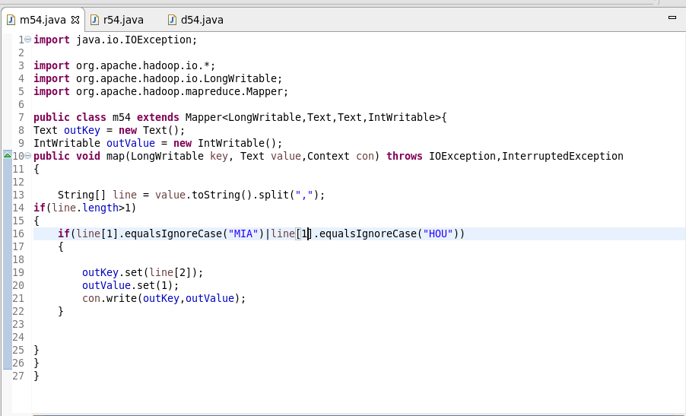

**REDUCER**



**OUTPUT**

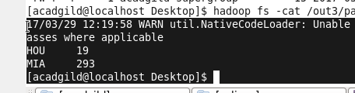

**Q3**

**MAPPER**

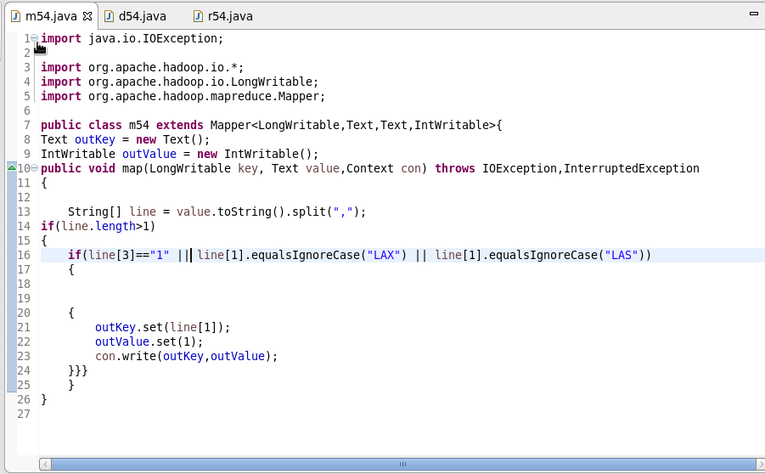

**REDUCER**



**OUTPUT**

