**X table:**

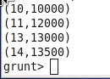

**Y table:**

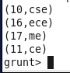

**Left outer join:**

**Cmd:**

**C:\Users\613000\Desktop\leftcmd.PNG**

**Output:**

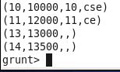

**Right outer join:**

**Cmd:**

**C:\Users\613000\Desktop\rightcmd.PNG**

**Output:**

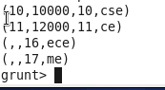

**Inner join:**

**Cmd:**

**C:\Users\613000\Desktop\innercmd.PNG**

**Output:**

**C:\Users\613000\Desktop\innerout.PNG**

**Full Outer join:**

**Cmd:**

**C:\Users\613000\Desktop\fullcmd.PNG**

**Output:**

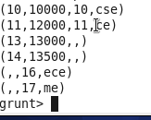

**Self join:**

**X table:**

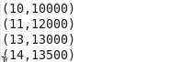

**Y table:**



**Cmd:**

**C:\Users\613000\Desktop\self.PNG**

**Output:**

