**PROJECT 2:**

**(II)**

**QUES 1) Write a pig script to find no of complaints which got timely response**

**COMMANDS:**

**C:\Users\613000\Desktop\pro2acmd1.PNG**

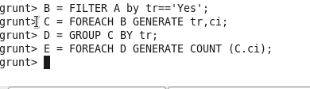

**OUTPUT:**

**C:\Users\613000\Desktop\pro2aout.PNG**

**QUES 2) Write a pig script to find no of complaints where consumer forum forwarded the complaint same day they received to respective company**

**COMMANDS:**

**C:\Users\613000\Desktop\pro2acmd1.PNG**

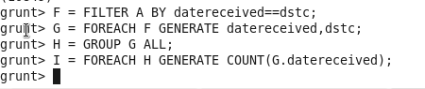

**OUTPUT:**

**C:\Users\613000\Desktop\pro2bout.PNG**

**QUES 3) Write a pig script to find list of companies topping in complaint chart (companies with maximum number of complaints)**

**COMMANDS:**

**C:\Users\613000\Desktop\pro2acmd1.PNG**

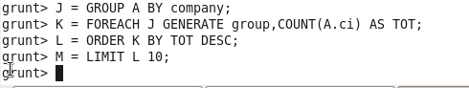

**OUTPUT:**

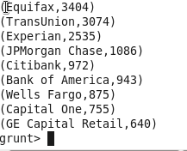

**QUES 4) Write a pig script to find no of complaints filed with product type has "Debt collection" for the year 2015**

**COMMANDS:**

**C:\Users\613000\Desktop\pro2acmd1.PNG**

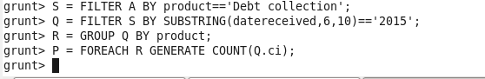

**OUTPUT:**

**C:\Users\613000\Desktop\pro2dout.PNG**

**(I)**

**QUES 1) 1. Write a mapreduce program to remove commas present inside the double quotes.**



