Chapter-1

INTRODUCTION
The Algorithm Visualizer is an innovative tool aimed at simplifying the process of understanding algorithms through visual and interactive representation. Algorithms form the backbone of computer science and programming, yet many learners find them challenging to grasp due to their abstract nature. This mini-project bridges that gap by providing a hands-on, visual approach to demystify complex algorithmic concepts. By visualizing the step-by-step execution of algorithms, the project empowers students, educators, and programming enthusiasts to deepen their understanding of how algorithms work and why they behave the way they do.
The main objective of this project is to create an intuitive platform where users can observe the working of various algorithms in real time. Whether it’s sorting data, searching through arrays, or navigating through graphs, the Algorithm Visualizer provides an interactive environment to explore and experiment. Such a tool not only enhances conceptual clarity but also fosters curiosity, helping users appreciate the elegance and efficiency of algorithms.

1.1 Problem statement
Algorithms are fundamental to solving problems in computer science, yet their abstract nature often makes them difficult to understand, particularly for beginners. Traditional methods of teaching algorithms, such as lectures, textbooks, and static code examples, fail to capture the dynamic processes involved. For example, understanding how sorting algorithms like Quick Sort or graph algorithms like Depth First Search operate can be challenging without a step-by-step breakdown of their execution.
Learners often struggle to visualize how data structures change during algorithmic operations, making it difficult to grasp key concepts and connect theory to practice. Additionally, traditional approaches rarely allow for experimentation, preventing students from exploring edge cases, testing performance, or analyzing behavior under various conditions.

Comparing the efficiency of algorithms, particularly in terms of time and space complexity, is another challenge. Without tools that provide real-time metrics and animations, learners may find it hard to understand why certain algorithms perform better in specific scenarios.
The Algorithm Visualizer solves these problems by offering an interactive platform that visually represents algorithms in action. It enables learners to input custom data, observe dynamic changes, and analyze performance metrics, bridging the gap between theoretical learning and practical application while making the process more engaging and effective.

1.2 Motivation
Understanding algorithms is a fundamental skill in computer science and programming, yet many students and developers struggle to grasp their concepts when relying solely on theoretical explanations or static code examples. The abstract nature of algorithms, combined with the difficulty in visualizing their operations, creates a significant learning barrier. This often leads to confusion about how algorithms work, their efficiency, and their practical applications.
The motivation behind the Algorithm Visualizer mini project is to bridge this gap by providing an intuitive, interactive, and visually appealing platform. By watching algorithms execute step by-step, learners can better understand their inner workings, such as decision-making processes, data manipulations, and efficiency. Visual tools foster active learning, making complex topics like recursion, sorting, and graph traversal easier to comprehend.

1.3 Scope of the project
The Algorithm Visualizer project is designed to provide a dynamic and interactive platform for visualizing algorithms, catering to students, educators, and programming enthusiasts. It covers a wide range of algorithms, including sorting, searching, and graph traversal, providing users with a clear understanding of their step-by-step execution and internal workings.
The tool allows users to input custom data, select from pre-defined data sets, and control the visualization speed, fostering an engaging and hands-on learning experience. It is equipped

with real-time performance metrics, such as the number of comparisons, swaps, or execution time, enabling users to analyze and compare the efficiency of different algorithms.
This project has applications in educational institutions as a teaching aid, where instructors can use it to demonstrate algorithm behavior during lectures or workshops. It is also valuable for students preparing for technical interviews or competitive programming, as it provides a practical way to master algorithms. Additionally, the platform serves as a resource for developers and researchers to experiment with algorithm optimizations and explore new ideas.
Scalable and extensible, the project can be expanded to include more algorithms, advanced data visualization techniques, and user-driven features like algorithm customization, making it a versatile and impactful educational tool.

1.4 Subsections

1.4.1 Challenges in algorithm visualization
Developing an Algorithm Visualizer mini project presents several challenges, ranging from technical complexities to user experience considerations. Below are the primary challenges faced during the development of such a project:

1. Complexity of Visualizing Algorithms
Challenge: Algorithms, especially advanced ones like graph traversal or dynamic programming, involve intricate operations that are difficult to animate effectively. Impact: Poor visualization can lead to confusion rather than clarity.
Solution: Use robust visualization libraries (e.g., D3.js, p5.js) and design detailed step-by-step animations to highlight each operation.

2. Performance Optimization
Challenge: Real-time execution and visualization of algorithms on large datasets can result in performance bottlenecks or slow animations.
Impact: A leggy interface can detract from user experience and make the tool less useful.

Solution: Optimize the implementation of algorithms and use efficient data structures to handle large inputs without affecting animation speed.

3. Designing an Intuitive User Interface
Challenge: Ensuring that the interface is simple enough for beginners but feature-rich for advanced users.
Impact: A cluttered or overly complex UI may discourage users.
Solution: Prioritize user experience (UX) by designing a clean, modular layout with clear labels, intuitive controls, and helpful tooltips.

4. Handling User Inputs
Challenge: Users may input invalid or complex data that algorithms cannot process correctly.
Impact: This can lead to errors or crashes, disrupting the visualization process.
Solution: Validate user inputs rigorously and include error-handling mechanisms to guide users with appropriate feedback.

1.4.2 Significance of Visual Learning
Visual learning plays a crucial role in enhancing understanding, retention, and application of complex concepts, especially in fields like computer science. Humans are inherently visual creatures, and research has shown that information presented visually is more easily processed and remembered compared to text-based information alone. In the context of algorithm learning, visualizations help bridge the gap between abstract theory and practical understanding by providing learners with a tangible, step-by-step representation of algorithm execution.
For algorithms, which often involve intricate and abstract operations, visual learning is particularly powerful. It allows learners to see the transformations occurring within data structures as algorithms run, making complex concepts like recursion, sorting, and graph traversal easier to grasp.

Additionally, visual learning promotes active engagement. Interactive visualizations enable students to experiment with different inputs, adjust parameters, and observe outcomes in real time. This hands-on approach encourages exploration, trial-and-error learning, and fosters a deeper connection with the material.

1.5 Contribution of the Project
The Algorithm Visualizer project offers several significant contributions to both the educational and software development communities:

1. Enhanced Learning Experience
The project transforms the way algorithms are taught and understood by providing interactive, step-by-step visualizations. This hands-on approach helps learners grasp abstract concepts more effectively by visualizing data structures and algorithm operations in real-time

2. Improved Engagement in Algorithm Studies
The interactive nature of the platform fosters active learning. Students can experiment with different data sets and observe how algorithms behave under various conditions, allowing them to test edge cases and better understand performance differences.

3. Performance Analysis
By integrating real-time performance metrics such as comparisons, swaps, and execution time, the visualizer enables users to analyze the efficiency of different algorithms. This feature helps students compare algorithms based on time and space complexity, promoting a deeper understanding of algorithm efficiency and optimization.

4. Educational Tool for Instructors
The visualizer provides instructors with a powerful teaching tool, allowing them to visually demonstrate algorithms in classrooms or online lectures. This enhances teaching effectiveness and provides a clearer understanding of complex algorithmic concepts.

Chapter-2

LITERATURE SURVEY
A literature review is a thorough overview of earlier studies on a subject. The literature review examines academic books, journals, and other materials that are pertinent to a specific field of study.

[1] This Paper Focuses on implementing real-time visualizations of sorting algorithms, including Bubble Sort, Merge Sort, and Quick Sort, using JavaScript. This paper emphasizes step-by-step learning for better comprehension of algorithmic processes.
[2] This paper provides an in-depth exploration of sorting algorithms and computational problem-solving through interactive visualizations. It highlights innovative techniques for making algorithmic concepts accessible and engaging for learners
[3] This paper Presents the development of a web-based tool designed to help beginners understand algorithms through dynamic visualization. The tool incorporates a Chat Engine SDK to provide interactive guidance and enhance the learning experience
[4] The paper focuses on the development and implementation of a visualizer that helps users comprehend the step-by-step execution of various algorithms. The tool is designed to provide a more interactive and intuitive learning experience, making complex algorithms easier to grasp for students and learners.
[5] The paper presents for an algorithm visualizer, this scheme can be visualized step-by-step, showing how a color image is split into visually encrypted shares, embedded with watermarks, and reconstructed securely This interactive approach helps users understand the balance between security, imperceptibility, and efficiency in visual cryptography and watermarking techniques.

[6] In the context of an algorithm visualizer mini-project, these schemes could be visualized step-by-step, showcasing processes like embedding watermarks, splitting data into shares, and testing robustness under attacks. This visualization aids in understanding how watermarking schemes handle data security challenges, making it a valuable tool for educational and practical purposes
[7] This paper focuses In an algorithm visualizer, this concept can be demonstrated interactively, showing the step-by-step process of splitting an image into shares, embedding watermarks, and reconstructing the image securely. Visualizing these algorithms can providing a clear understanding of the decision-making process behind choosing the meaningful number of shares. This enhances learning and comprehension of watermarking techniques.
[8] The paper focuses on how visualizing algorithms, particularly those related to spatial data, can significantly enhance learning and understanding. The system aims to provide students with a clear, interactive, and intuitive way to visualize complex spatial data processing techniques, thus improving their comprehension and practical application of these algorithms.

Chapter-3

OBJECTIVES
The Algorithm Visualizer project aims to create a dynamic and interactive platform that helps learners and educators understand and visualize the execution of various algorithms.
The objectives of this project are divided into primary and secondary goals, each contributing to the overall success of the tool.

3.1 Primary Objectives

1. Enhance Understanding of Algorithms
The core objective is to simplify the understanding of complex algorithms by providing real-time, step-by-step visualizations. This will allow learners to see how data structures evolve and how algorithms operate on data, thereby making abstract concepts more concrete and accessible.

2. Interactive Learning Platform
The platform should foster active engagement by allowing users to input custom datasets and modify algorithm parameters. The interactive environment encourages hands-on learning, where users can experiment with different configurations and observe how the algorithms behave in real-time.

3. Real-time Performance Analysis
The visualizer will integrate performance metrics such as the number of comparisons, swaps, or execution time to help users evaluate and compare the efficiency of different algorithms. This will assist in understanding not only how algorithms work but also how their performance scales with varying input sizes.

4. Support for a Variety of Algorithms
The platform will support a wide range of fundamental algorithms, including sorting, searching, and graph algorithms. This diversity ensures the tool's applicability to a broad audience, from beginners to more advanced learners.

3.1.2 Key Features
- Customizable Inputs: Users should be able to enter custom datasets or choose from predefined ones, allowing them to explore different algorithm behaviors.
- Adjustable Speed and Controls: The visualization speed should be adjustable so users can slow down or speed up the execution for better observation.
o Step-by-Step Execution: Users can advance through the algorithm one step at a time, providing a more detailed view of each operation.

3.2 Project Constraints

1. Platform Compatibility
The visualizer will be built using web-based technologies (JavaScript, HTML, CSS), ensuring that it works across different platforms, including desktops, tablets, and smartphones.

2. Resource Limitations
The project must strike a balance between interactive features and performance, particularly when visualizing large datasets or complex algorithms.

Chapter-4

SOFTWARE AND HARDWARE REQUIREMENTS

4.1 Software Requirements
The Algorithm Visualizer project requires a range of software tools and technologies for both development and deployment. These include programming languages, libraries, frameworks, and software environments, ensuring that the application is functional, efficient, and user-friendly.
Below are the primary software requirements for the project
- Operating System:
  - Any modern OS like Windows 10/11, macOS, or Linux is sufficient for development.
- Programming Languages:
  - JavaScript for algorithm logic and visualization.
  - HTML/CSS for building and styling the user interface.
- Frameworks/Libraries:
  - Optional frameworks like React.js for creating dynamic interfaces.
  - Bootstrap or Tailwind CSS for designing responsive layouts.
- Code Editor:
  - Visual Studio Code is recommended for its rich extensions and debugging features.
- Browser:
  - A modern browser like Google Chrome, Firefox, or Microsoft Edge for testing and running the visualizer.

4.2 Hardware Requirements
- Processor:
  - Minimum: Intel Core i3 (or equivalent).
  - Recommended: Intel Core i5/i7 or AMD Ryzen 5/7.
- RAM:
  - Minimum: 4 GB.
  - Recommended: 8 GB or more for smoother multitasking and handling large datasets in visualization.
- Storage:
  - Minimum: 10 GB of free space for the project files and software.
  - Recommended: SSD for faster read/write operations.
- Graphics:
  - Minimum: Integrated graphics (sufficient for 2D visualizations).
  - Recommended: Dedicated GPU (like NVIDIA GeForce GTX 1050 or better) for more complex visualizations.
- Monitor:
  - Minimum: 1280x720 resolution.
  - Recommended: Full HD (1920x1080) or higher for better visualization clarity.
- Input Devices:
  - Keyboard and mouse for coding and testing.
- Network:
  - Stable internet connection for downloading dependencies, accessing online resources, and using version control platforms.

Chapter-5
METHODOLOGY

5.1 Methodology Overview

The Algorithm Visualizer is a tool designed to dynamically illustrate the step-by-step execution of algorithms. It focuses on providing a visual understanding of sorting, searching, graph, and pathfinding algorithms. The project is developed using JavaScript and incorporates interactive visualizations for user engagement.

Problem Understanding

System Design

Implementation

Testing and Optimization

Deployment

Fig 5.1: Methodology for Algorithm Visualizer

1. Problem Understanding:

Define the scope of the visualizer by selecting key algorithms (e.g., Bubble Sort, Binary Search, Dijikstra’s Algorithm). Establish the features required, such as adjustable speed, input customization, and step-by-step execution.

2. System Design:

The system consists of three main components:

User Interface (UI): Built with HTML and CSS, this provides interactive elements for algorithm selection, input size, and visualization speed.

Algorithm Logic: JavaScript implementations of the chosen algorithms, adapted to return intermediate steps for visualization.

Visualization Engine: Uses DOM manipulation or a library (e.g., Canvas or SVG) to render visual representations of algorithm progress.

3. Implementation:

Algorithms are coded to expose their internal states after each significant operation. These states are passed to the visualization engine, which updates the UI in real-time.

4. Testing and Optimization:

Test each algorithm and its visualization for accuracy, responsiveness, and edge cases, such as large data sets or invalid inputs. Optimize performance for smooth rendering.

5. Deployment:

Host the application on a platform like GitHub Pages for public accessibility

5.2 Algorithm Implementation
The implementation phase begins with coding the algorithms in JavaScript. The algorithms are selected to cover a range of common data structures and algorithmic paradigms, such as:
- Sorting Algorithms: Quick Sort, Merge Sort, Bubble Sort, etc.
- Searching Algorithms: Binary Search, Linear Search.
- Graph Algorithms: Depth First Search (DFS), Breadth First Search (BFS), Dijkstra’s Algorithm.
- Pathfinding Algorithms: A*, Dijikstra’s Shortest Path.
Each algorithm will be implemented with full support for visualization. For example, in sorting algorithms, users can observe how elements move as the algorithm progresses, and in graph algorithms, the algorithm’s traversal across nodes and edges will be displayed.

5.3 Visualization Techniques
The visualizer will include options for users to adjust the input data and control the speed of execution, providing a more flexible and engaging experience. The use of Canvas API or similar technologies will ensure smooth rendering of dynamic changes during algorithm execution.
This methodology ensures that the visualizer is built iteratively, focusing on user engagement, educational value, and technical robustness. Each phase is designed to create a seamless experience for learning algorithms through interactive, real-time visualizations.

Chapter-6
RESULTS
The Algorithm Visualizer mini-project is an interactive tool showcasing sorting, searching, graph traversal, and pathfinding algorithms. It visually represents each algorithm’s step-by-step process, making complex concepts easier to understand. Users can control playback, adjust speed, and input custom data for tailored experiences.
With responsive design, performance metrics, and dynamic animations, the tool enhances educational value. It bridges theory and practice, offering insights into algorithmic behavior in real-time. Stretch features like algorithm comparisons or live code execution could further elevate the experience. This project highlights skills in JavaScript, UI/UX design, and asynchronous programming, serving as a valuable learning resource.

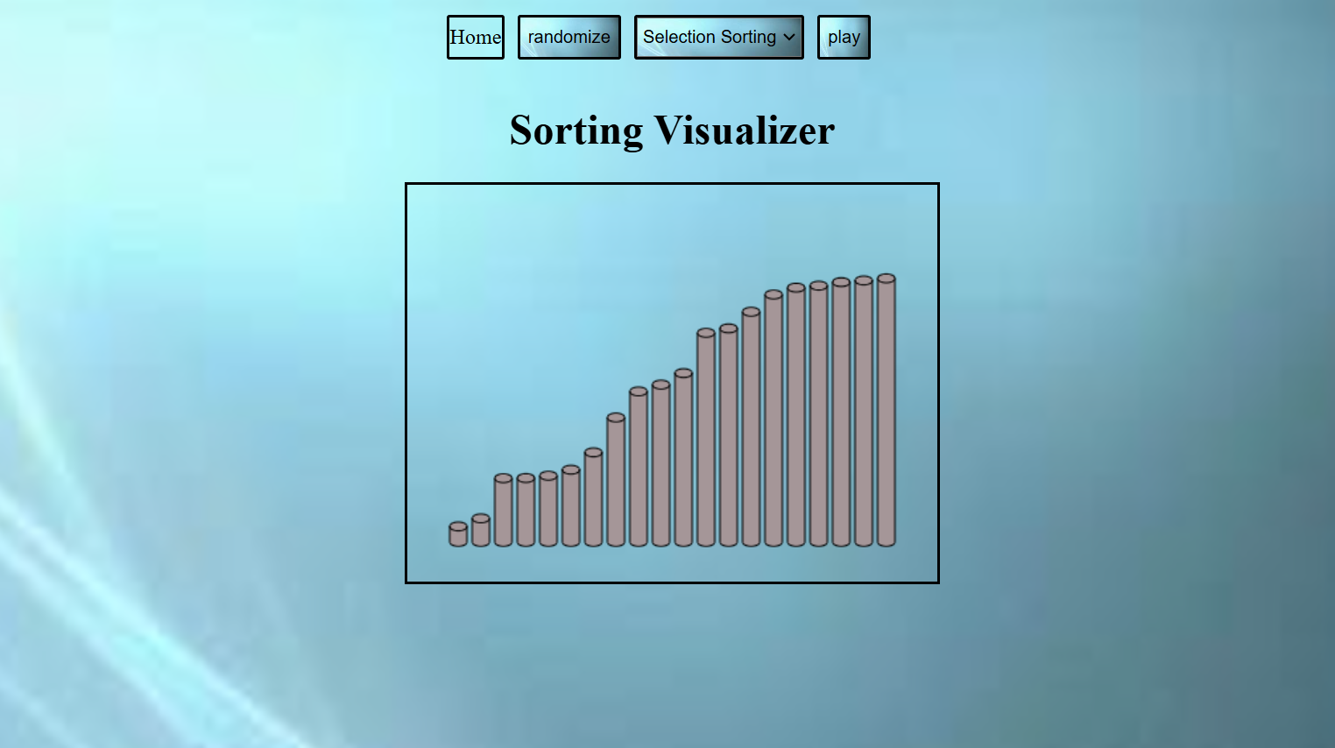
Fig .6.1: Selection Sorting

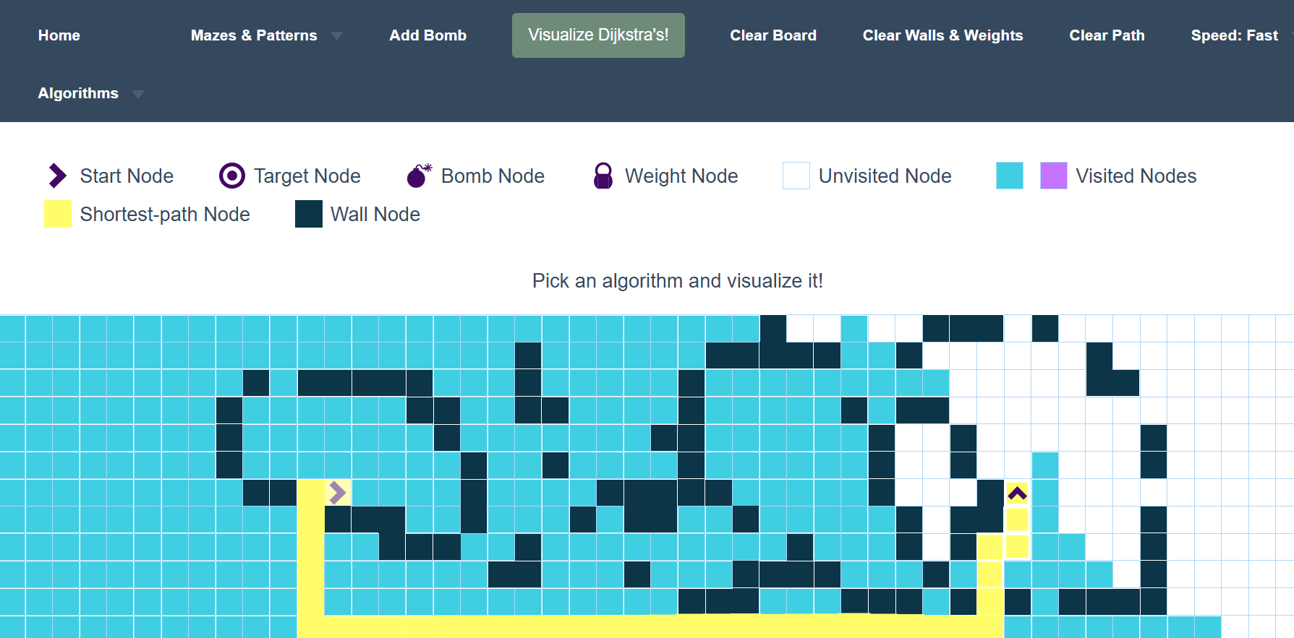
Fig.6.2: Dijkstra Algorithm

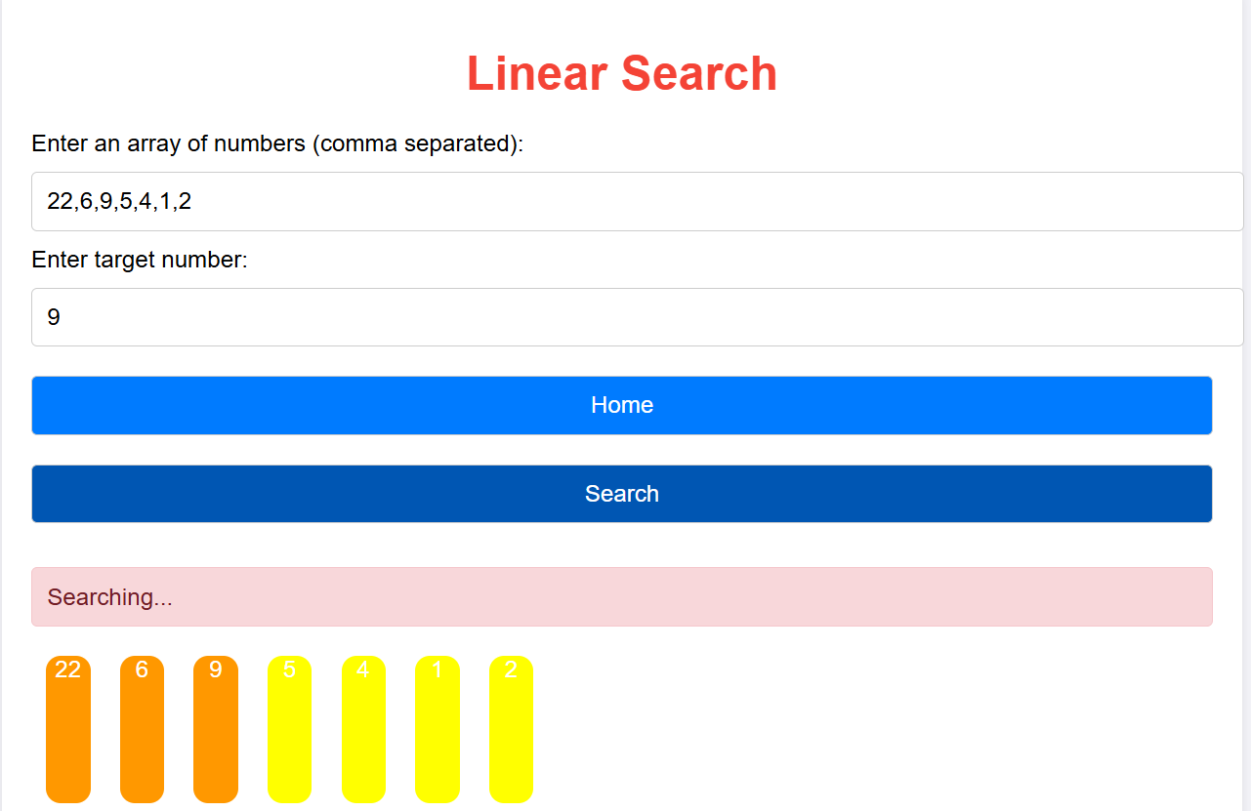
Fig .6.3: Linear Search

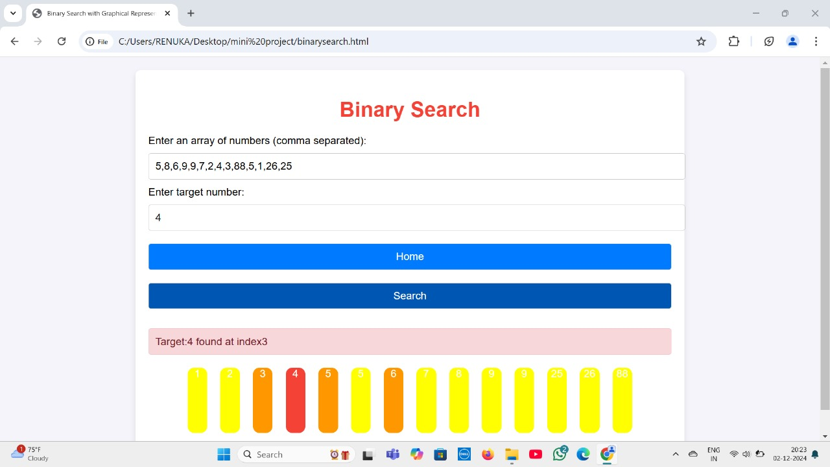
Fig.6.4: Binary Search

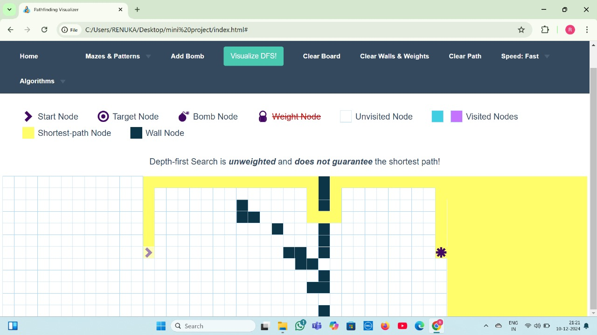
Fig.6.5: DFS Algorithm

CONCLUSION
The Algorithm Visualizer project aims to bridge the gap between theoretical knowledge and practical understanding of algorithms by providing an interactive platform that visualizes algorithm execution in real time. The visualizer enables users to witness the inner workings of algorithms as they process data, providing a more intuitive and engaging learning experience. By offering real-time visualizations, step-by-step execution, and customizable features such as input size and speed adjustments, the tool empowers users to experiment with various algorithms and explore their efficiency.
The development of this project was guided by a clear focus on accessibility, user-friendliness, and educational effectiveness. The visualizer supports a wide range of algorithms, from basic sorting and searching algorithms to more complex graph and pathfinding algorithms. Its interactive features, such as customizable inputs and adjustable speed, enhance the learning process by allowing users to engage actively with the content.
Overall, the Algorithm Visualizer is a powerful tool that can significantly enhance the learning experience for students, educators, and anyone interested in deepening their understanding of algorithms. It has the potential to become a valuable educational resource, promoting active learning, experimentation, and a deeper grasp of algorithmic principles.

REFERENCES
[1] International Journal of Creative Research Thoughts (IJCRT) ,“Interactive Sorting Algorithm Visualizer",2024.
[2] IEEE Xplore, “Visualizing Algorithms: A Comprehensive Exploration of Sorting and Computational Problem-Solving",2024.
[3] Arijit Goswami, Biswarup Bhattacharjee, Rahul Debnath, Ankita Sikder, “Web-Based Dynamic Algorithm Visualizer Along with Chat Engine SDK for Neophyts”, International Journal of Engineering Science and Computing (IJESC), 2021.
[4] Barnini Goswami, Anushka Dhar, Akash Gupta, Antriksh Gupta, “ALGORITM VISUALIZER”, International Research Journal of Engineering and Technology (IRJET), 2021.
[5] Jitendra Saturwar, Dr.D.N.Chaudhari “Secure Visual Secret Sharing Scheme for Color Images Using Visual Cryptography and Digital Watermarking”, Published in IEEE digital explore ISBN No. 978-1-5090-3239-6/17©2017 IEEE.
doi: 10.1109/ICECCT.2017.8117849
[6] J.H.Saturwar, Dr. D.N.Chaudhari “Performance Evaluation of Watermarking Schemes to Decide Meaningful Number of Shares”, Published in International Journal of Technology & Engineering ISSN 2455-4480 pp. 93-100.2017
[7] Jitendra Saturwar, Dr. D.N.Chaudhari “Deciding meaningful number of shares in digital watermarking scheme for secret images”, Published in IEEE digital explore ISBN No. 978-1-5090-4620-1©2016 IEEE.doi:10.1109/SCOPES.2016.7955504
[8] Jussi Nikander, Juha Helminen, and Ari Korhonen, “Algorithm Visualization System for Teaching Spatial Data Algorithms”, Journal of Information Technology Education (JITE,) 2010.

