Heart Disease Classification: MLOps Project Report

Abstract
This report documents a reproducible binary-classification workflow built on the processed Cleveland subset of the UCI Heart Disease dataset. The implementation acquires and profiles source data, compares Logistic Regression and Random Forest pipelines, tunes them using stratified cross-validation, logs run metadata and model artifacts in MLflow, evaluates a held-out sample, and exports a fitted preprocessing and model pipeline. A FastAPI service exposes predictions and health status, while Prometheus metrics support basic operational visibility. Tests, linting, and model training are connected through GitHub Actions.
The measured results are educational and are not clinical validation. The small, historical Cleveland sample cannot support claims about present-day patients or other populations. Cloud deployment and video capture are described as outstanding manual steps because no cloud credentials or recording artifact were supplied.

1. Problem and scope
The prediction task is to distinguish records indicating the presence of angiographic heart disease from records indicating its absence. The source outcome, num, has values zero through four. This implementation converts it to a binary label: zero maps to class 0 and values one through four map to class 1. The probability returned by the service is the selected model's estimated probability for class 1; it is not a patient's probability of a future heart attack, a causal estimate, or a diagnosis.
The engineering objective is to maintain one pipeline definition from training through serving. Data-dependent operations are fitted inside scikit-learn pipelines so that cross-validation does not fit imputers, scalers, or category encoders using validation-fold rows. Training is repeatable through fixed random seeds and an explicit stratified split. Model comparison, tuning, held-out evaluation, artifact creation, and service contracts are separate and testable components.
This project is a portfolio and workflow example. It does not establish clinical utility, safety, or regulatory suitability. A deployment must not be used to make care decisions. The data lack the scale, recency, population breadth, and prospective design needed for clinical use. Any such use would require domain-owner review, external validation, privacy and security assessment, calibrated risk estimates, human oversight, and an approved regulatory pathway.

2. Data source and preparation
The source is the processed Cleveland file from the UCI Machine Learning Repository's Heart Disease dataset. The official UCI page describes four source databases and identifies Cleveland as the subset used by most published experiments. It records 303 rows, 13 predictors, missing values, and an ordinal diagnosis. The source, DOI, license, citation, and official archive URL are recorded in data/SOURCE.md. The dataset DOI is 10.24432/C52P4X and its listed license is CC BY 4.0.
The downloader fetches the official zip archive and extracts only processed.cleveland.data. It does not unpack arbitrary archive members to disk. The loader assigns explicit column names, translates ? to missing values, coerces each column to numeric, checks the expected 14-column shape, rejects missing targets, and maps the diagnosis to the binary label. The original predictor values are preserved; missing predictors are not imputed in the loader.
Running python -m heart_disease.data writes the named, binary-labeled table to data/processed/cleveland_cleaned.csv. The original four-level target_original column is replaced with target; missing predictor entries remain blank in the CSV so imputation is still learned inside each training fold. This processed file is included as a reproducible assignment deliverable.
The dataset is small enough that all six missing predictor values can be inspected directly. Four values are missing in ca and two in thal; no other feature or target values are missing. The two affected features are categorical for the modeling pipeline. Their imputers are fitted on each training fold, not across the complete dataset. This preserves the missingness information in the EDA output while keeping the evaluation procedure leakage-aware.

3. Exploratory analysis
The generated profile reports 303 rows and 13 predictors. The target distribution is 164 class-0 records and 139 class-1 records, or approximately 54.1% and 45.9% of the sample. This is not a large imbalance, but both stratified splitting and stratified cross-validation are retained so each evaluation fold has a representative class mix. Predictor dtypes are reported in reports/data_profile.json; source values are read as numeric, while the feature roles used in the model are declared separately.
The numeric histograms make the distributions and value ranges reviewable. The correlation heatmap is a descriptive pairwise view of numerically encoded variables; it should not be read as evidence of causal relationships. The class-balance chart shows the absolute count per binary label. Together, these plots are useful for detecting obvious data problems and communicating dataset composition, not for selecting a clinical threshold or establishing scientific hypotheses.
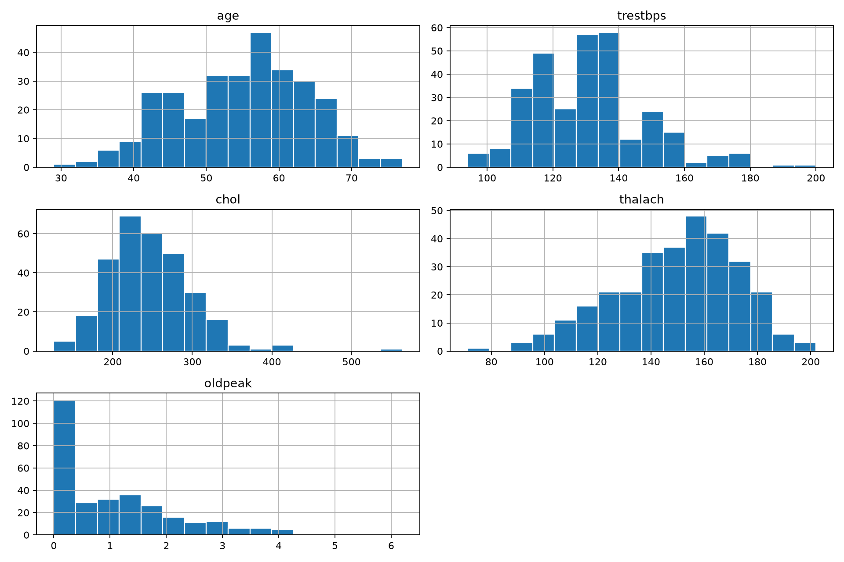  Numeric feature histograms | 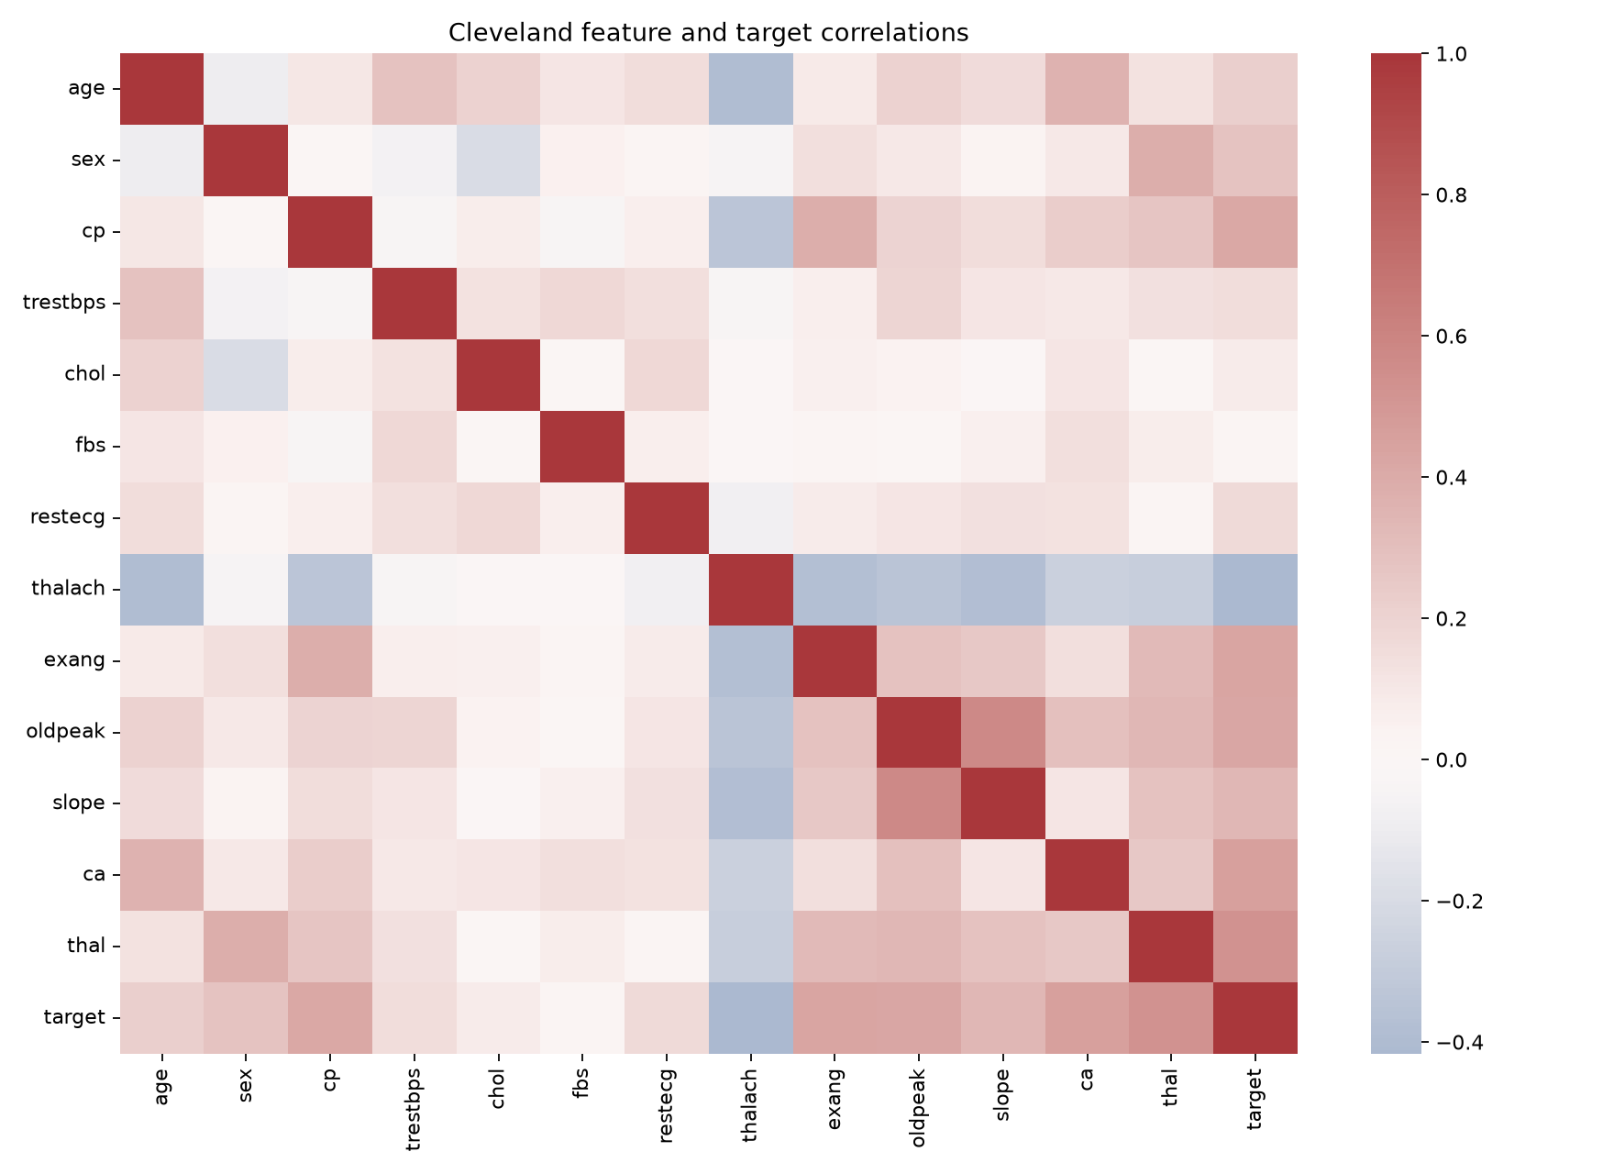  Correlation heatmap
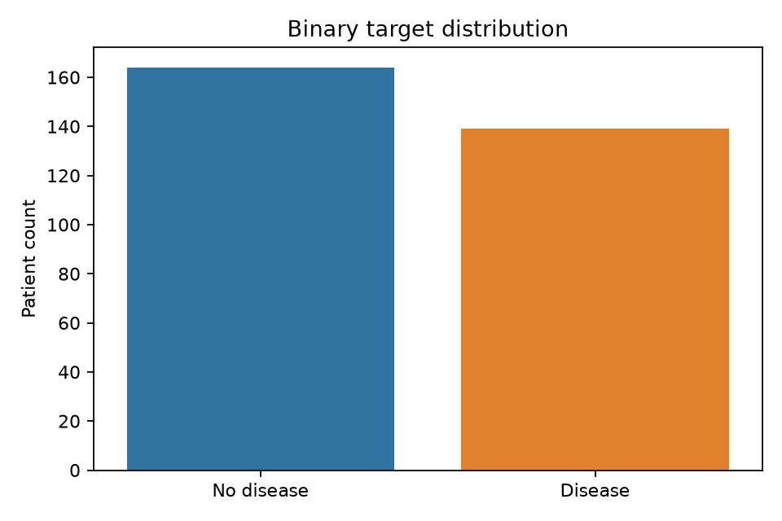
Binary class balance

4. Architecture
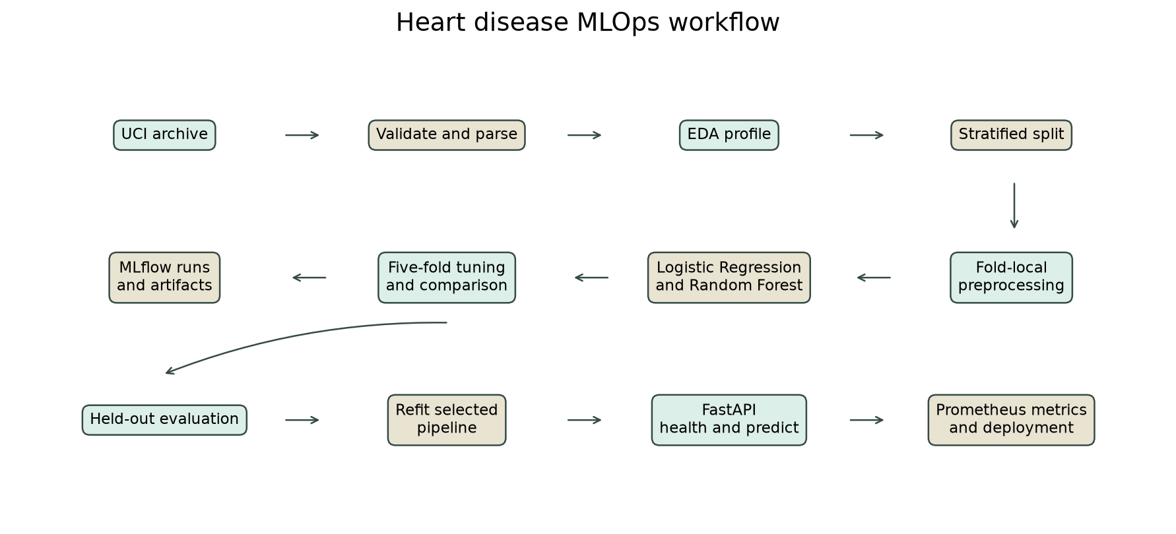
flowchart LR UCI[Official UCI archive] --> D[Download, parse and validate] D --> E[Profile and EDA figures] D --> S[Stratified 80/20 split] S --> P[Fold-local imputation, scaling and encoding] P --> C[Logistic Regression and Random Forest] C --> V[Five-fold comparison and grid search] V --> M[MLflow SQLite tracking and artifacts] V --> H[Held-out evaluation] H --> A[Refit selected full pipeline] A --> J[Joblib model artifact] J --> API[FastAPI health and prediction] API --> OBS[Prometheus counters and latency] API --> DEP[Docker and Kubernetes manifests]

Data acquisition, EDA, model construction, training, and API code are separated into modules under src/heart_disease/. The package structure lets a developer execute a stage directly while retaining a single canonical loader and pipeline definition. Generated metrics and figures go to reports/, the selected deployable artifact goes to models/, and MLflow metadata is stored in SQLite with artifacts under mlartifacts/ by default.
The preprocessing object is serialized with the estimator. The API therefore accepts the original 13 feature fields and applies the exact learned transformations used at training time. It does not independently recreate category encodings or scaling rules. The service records only aggregate predicted-class counts and latency; it does not record patient feature values in application logs or custom metrics.

5. Preprocessing and model development
The five continuous measurements are age, resting blood pressure, serum cholesterol, maximum heart rate, and ST depression. Each uses median imputation followed by standard scaling. The remaining eight fields are treated as categorical: sex, chest pain type, fasting blood-sugar flag, resting ECG, exercise-induced angina, ST slope, number of vessels, and thal result. These use most-frequent imputation and one-hot encoding with unknown-category tolerance. The categorical values are not treated as equally spaced numeric quantities by the models.
The first candidate is Logistic Regression with a liblinear solver, a fixed random seed, and a high iteration ceiling. The second is a Random Forest with a fixed seed and a single worker for reliable local and CI execution. Candidate pipelines share the same preprocessing transformer. This makes the estimator comparison meaningful and makes the selected output directly deployable.
The Logistic Regression search evaluates regularization strengths of 0.01, 0.1, 1, and 10. The Random Forest search evaluates 100 or 250 trees, unlimited depth or maximum depths of 5 or 10, and minimum leaf sizes of 1, 2, or 4. Both use the same five stratified folds and report accuracy, precision, recall, and ROC-AUC. ROC-AUC is the predeclared selection metric; the held-out set does not participate in tuning.

6. Validation protocol and results
Before cross-validation, the full labeled data are divided into an 80% training partition and a 20% held-out partition using stratification and seed 42. Candidate comparison and grid search use only the training partition. For each candidate, the baseline pipeline is evaluated with stratified five-fold cross-validation; the selected parameter configuration is then measured with the same folds. Means and standard deviations are written to the metrics JSON and comparison CSV.
Model and stage | CV accuracy | CV precision | CV recall | CV ROC-AUC
Logistic Regression, baseline | 0.8471 | 0.8768 | 0.7834 | 0.9025
Logistic Regression, tuned | 0.8471 | 0.8768 | 0.7834 | 0.9025
Random Forest, baseline | 0.8181 | 0.8173 | 0.7826 | 0.8972
Random Forest, tuned | 0.8139 | 0.7975 | 0.8008 | 0.9013
Logistic Regression was selected because its tuned mean cross-validation ROC-AUC was the highest at 0.9025. The Random Forest tuned mean was 0.9013, close enough that the difference should not be interpreted as proof of meaningful superiority. The Logistic Regression search selected C=1.0, so the tuning result matches the baseline parameterization. Random Forest tuning slightly increased recall while reducing accuracy and precision in these folds.
The selected tuned estimator was evaluated once on the 61-row held-out partition. It achieved accuracy 0.8852, precision 0.8387, recall 0.9286, and ROC-AUC 0.9665. These are point estimates from one small split and can vary substantially with the sample. The ROC curve and confusion matrix are generated from this evaluation. After the holdout scores were computed, the selected preprocessing-plus-model pipeline was refit on all 303 rows and exported for service use. Thus, the final artifact is not the same fitted object that generated the holdout measurements.
Selected model | Holdout accuracy | Holdout precision | Holdout recall | Holdout ROC-AUC
Logistic Regression, tuned (C=1.0) | 0.8852 | 0.8387 | 0.9286 | 0.9665
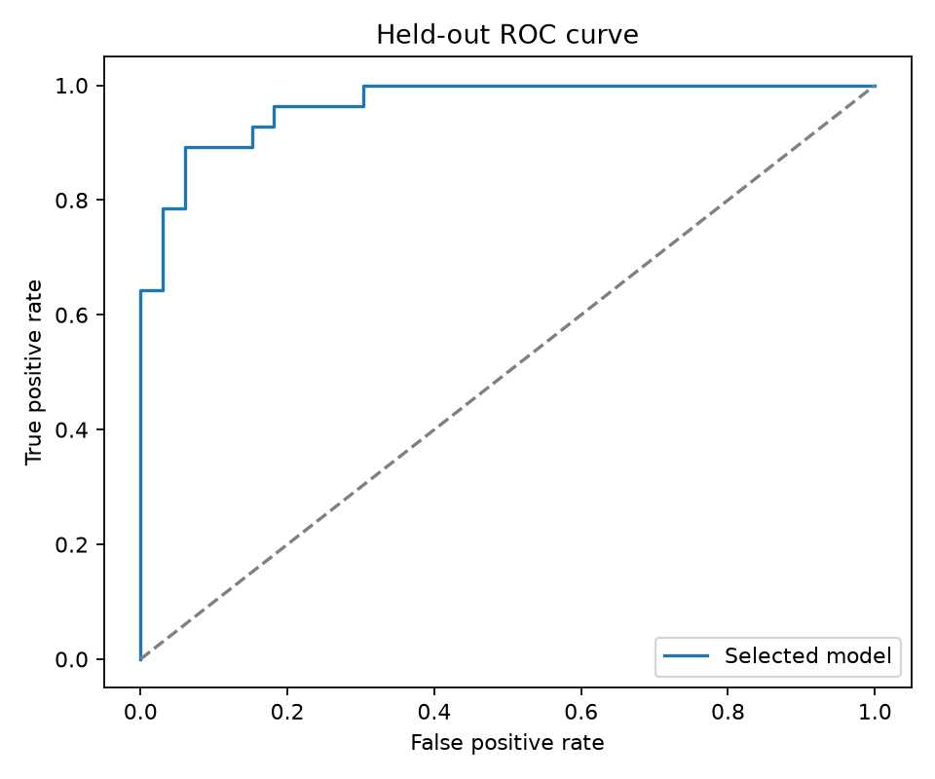  Held-out ROC curve | 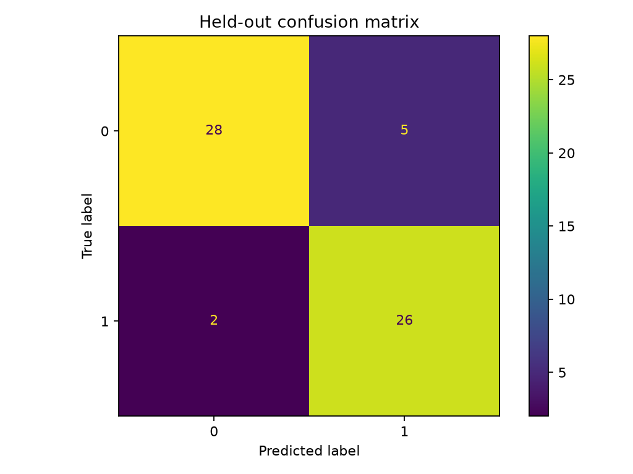  Held-out confusion matrix
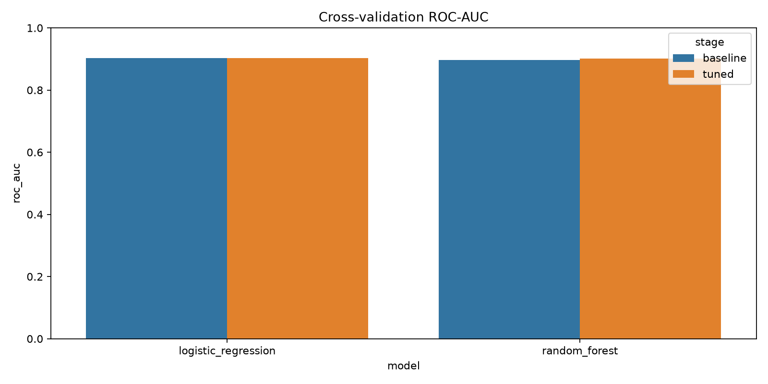
Cross-validation model comparison

7. Experiment tracking and reproducibility
MLflow uses the uci-heart-disease experiment and a local SQLite backend by default. Each baseline and tuned candidate run stores model identity, stage, tuned parameters when applicable, four cross-validation metric means, the metric summary JSON, and a joblib pipeline artifact. A final evaluation run stores held-out metrics, the selected pipeline artifact, metrics JSON, and generated plots. SQLite is used instead of the legacy filesystem tracking store, which current MLflow rejects by default.
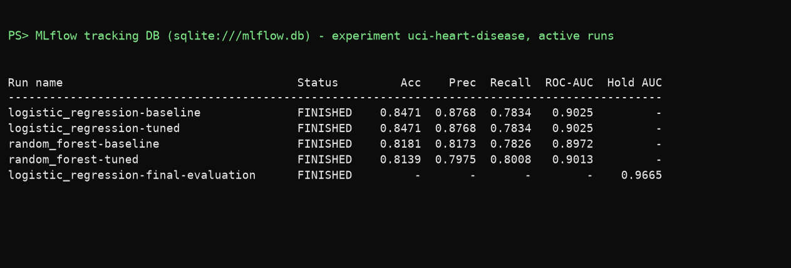
MLflow runs for the uci-heart-disease experiment, read from the tracking database
The table above is rendered from the SQLite tracking database rather than from the MLflow web page, because the MLflow interface could not be captured legibly in the available browser. It lists the five active runs and their logged metrics.
The joblib files are generated locally from the project's own pipeline objects and logged as run artifacts. They are not loaded through MLflow's sklearn flavor, avoiding a broad trust exception for scikit-learn's native Random Forest tree storage. As with any pickle-based format, joblib artifacts must only be loaded from a trusted source. The serving container builds from the artifact produced by this training workflow.
Seeds are fixed for the split, cross-validation folds, and estimators. The data source is documented, and the generated profile, metrics, model comparison, figures, and tracked run artifacts make the result reviewable. Dependency versions are not fully pinned in this initial setup; long-term reproductions should use a lock file or versioned environment and should record the dataset archive checksum and code commit with each approved run. A remote MLflow server can be configured with MLFLOW_TRACKING_URI when its database and artifact store are provisioned.

8. Serving, deployment, and monitoring
The FastAPI application has three operational routes. GET /health returns success only when the model artifact was loaded; absence of the model returns HTTP 503. POST /predict validates all 13 expected inputs, rejects unexpected fields, and returns a binary class plus positive-class probability. GET /metrics exposes Prometheus request counters by predicted class and a prediction-latency histogram. The contract tests exercise the endpoint response, readiness, invalid inputs, and metrics route.
The Dockerfile uses Python 3.12 slim, installs only the API runtime dependencies, includes the selected model, and runs as a non-root user. The image heart-disease-api:local built successfully at 691,290,174 bytes. It was run on host port 8001; health returned HTTP 200, the synthetic example returned class 0 with probability 0.1498261687, and metrics returned HTTP 200 with prediction and latency series. Container logs showed the health, prediction, and metrics requests.
The API writes one api_request log line per request containing the method, path, status code, and latency in milliseconds; request bodies and patient values are not logged. Verifying the deployed pods showed that these lines were initially missing, because uvicorn does not configure application loggers. A stream handler was added to the API logger, the image was rebuilt, and the lines now appear in container and pod logs.
A one-node kind v1.37.0 cluster was created with context kind-heart-disease. The image was loaded into the node, and the Kubernetes Deployment and ClusterIP Service were applied. The rollout completed with two of two replicas ready and no restarts. The Service was forwarded to host port 8002 and passed the same health, prediction, and metrics checks. The Swagger capture below is a real /predict call against the Kubernetes Service, and the pod-log capture is rendered from the actual kubectl logs output. The remaining captures (Docker image and container, deployment status, metrics, health, and the second Swagger view) are in screenshots/ and indexed in reports/local_api_evidence.md.
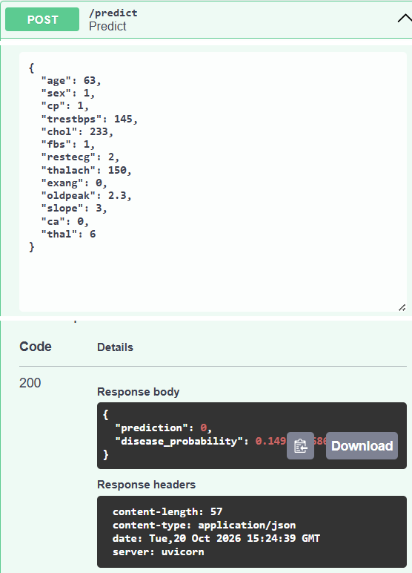  Swagger /predict on the Kubernetes service: HTTP 200 | 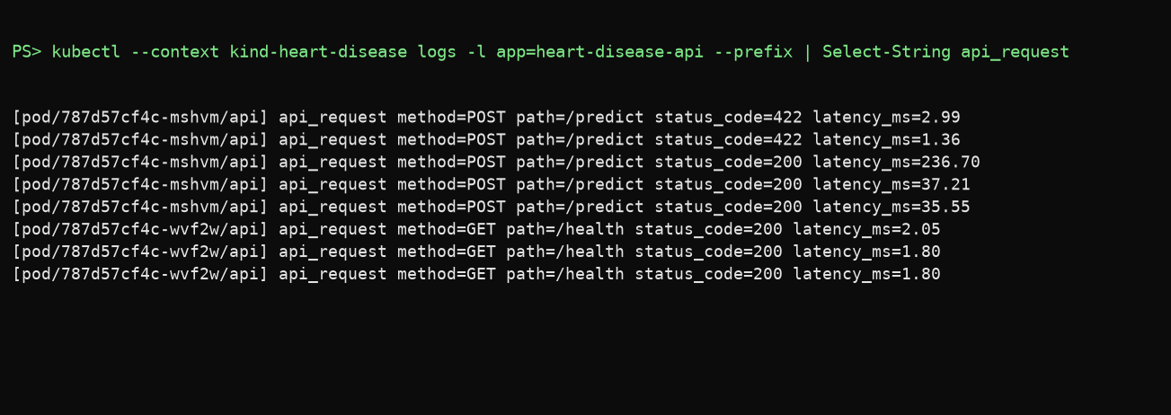  Pod request logs with status and latency (command output)
No cloud provider, registry, account, or deployment secret was supplied, so this is a local Kubernetes deployment, not a public-cloud deployment. The local setup also does not provide TLS, authentication, or production monitoring. A short demonstration video still needs to be recorded by the student from this local deployment; the screenshots and evidence table are not represented as a video.

9. CI, quality, and limitations
The GitHub Actions workflow installs Python 3.12 and runs Ruff, the unit and API contract tests, and the full training pipeline. It uploads the selected model, evaluation JSON/CSV, plots, and MLflow database/artifacts. Local validation completed with five passing tests and a clean Ruff check. Training completed successfully and generated the results in this report. The installed FastAPI/Starlette test client emits a deprecation warning about the current httpx integration; this is not a test failure, but the dependency combination should be reviewed during upgrades.
The dataset is only 303 historical records from one source cohort. It is vulnerable to sampling bias, shifts in clinical practice, missing-data assumptions, coding differences, and population changes. The split-derived scores are not a substitute for external validation, calibration analysis, uncertainty estimates, subgroup evaluation, threshold selection with domain experts, prospective testing, or temporal validation. Precision and recall also depend on the chosen classification threshold.
The service is a technical example, not a medical device. Before real use, the organization would need clinical governance, privacy review, access control, secure transport, audit and incident procedures, data retention controls, model approval, and documented human oversight. Monitoring currently measures service availability and aggregate prediction traffic; it does not monitor data drift, labels, clinical outcomes, calibration, or fairness. Those require approved, privacy-aware data and additional operational design.

10. Conclusion and next steps
The checklist's data, EDA, model development, experiment tracking, artifact saving, unit tests, API, CI, architecture/report, and local deployment preparation now have concrete implementations. The measured comparison selects Logistic Regression by mean cross-validation ROC-AUC, while the holdout provides a separate, explicitly limited estimate. The trained pipeline is saved at models/heart_disease_pipeline.joblib, and MLflow contains metrics and model artifacts for candidate runs.
The local image and kind deployment have been built, exercised, and documented. The remaining submission work is to publish to a public cloud if required, record the short end-to-end video, push the project to the student's own GitHub repository, and review the hosted Actions run. Before final submission, preserve the MLflow artifacts and add a lock file and source-data checksum if strict reproducibility is required.

