**SpringBoot Pipeline:**

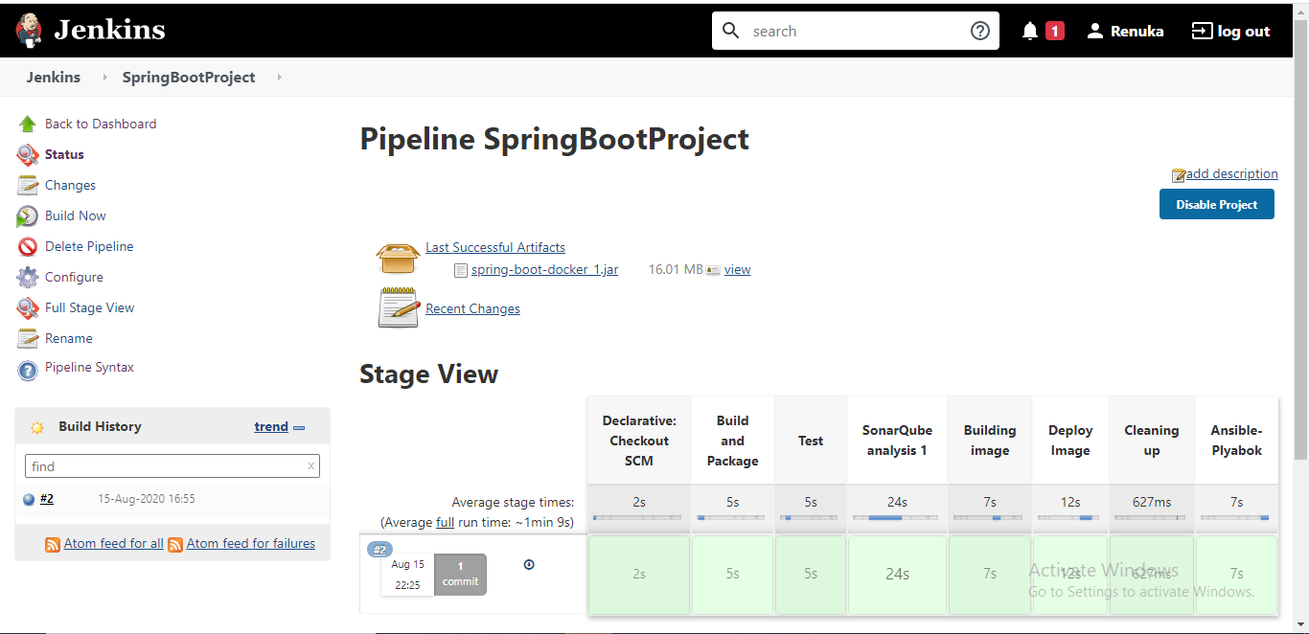

**WebProject Pipeline:**

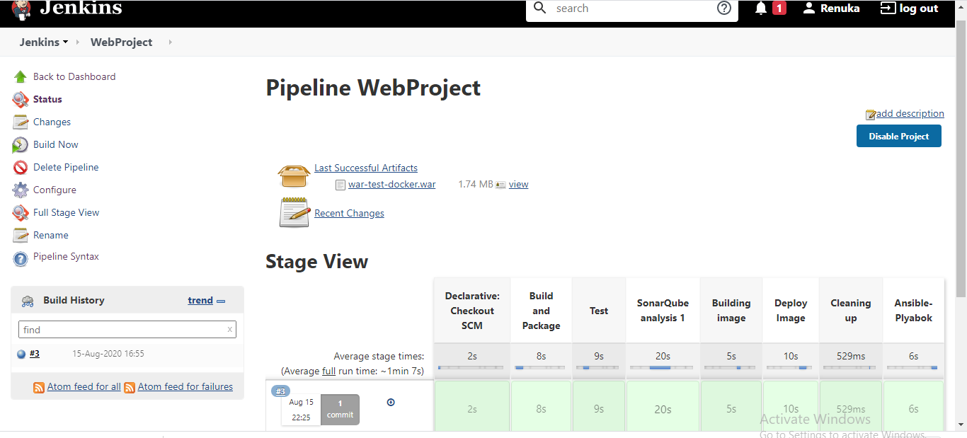

**Sonar:**

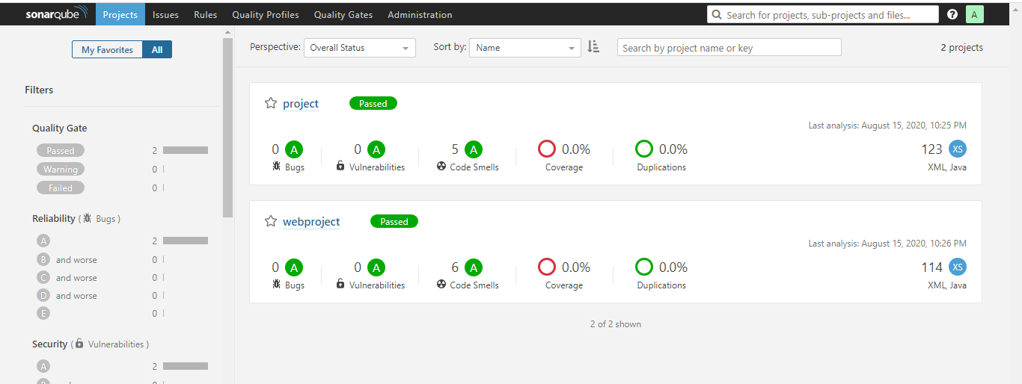

**DockerHub:**

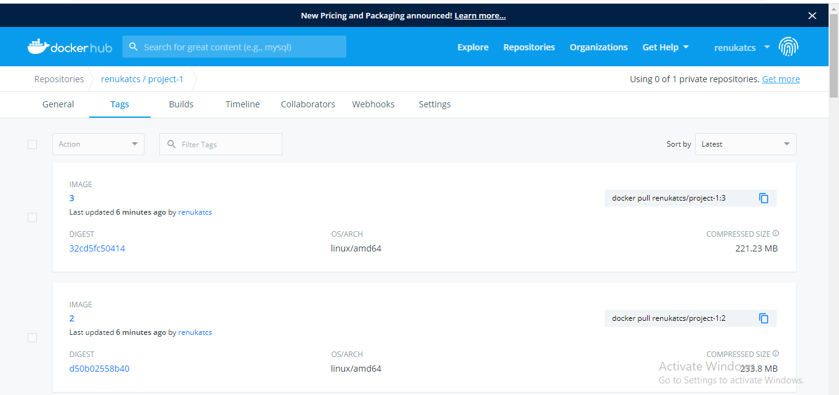

**Amazon EC2 Instances:**

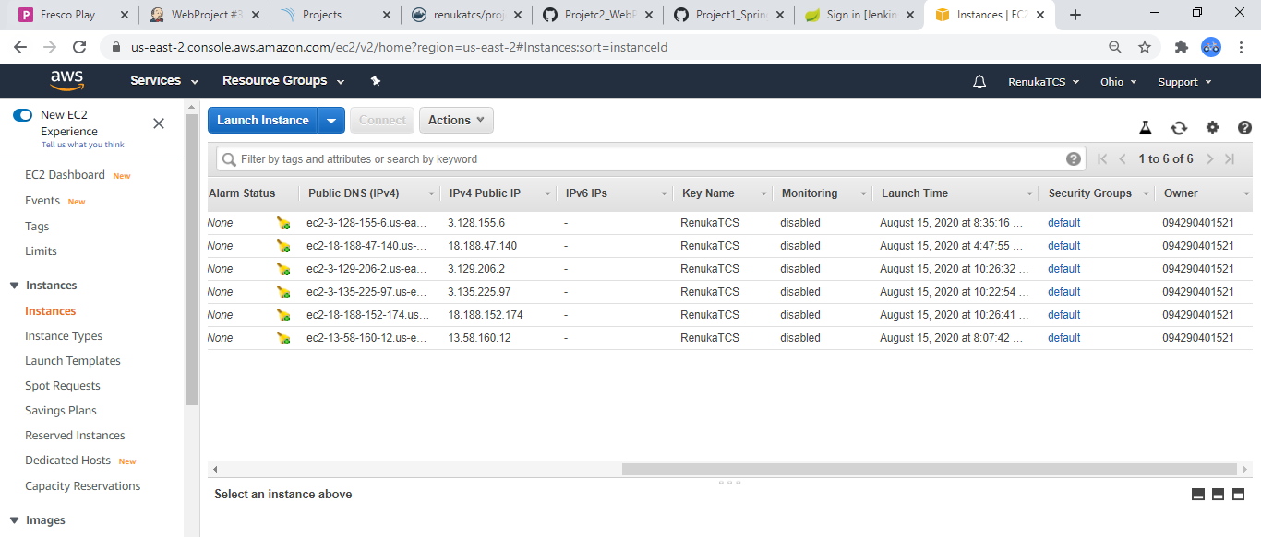

**Build Failure Screenshot:**

