Q1 WA function to take a number as parameter and print True if given number is even else print False

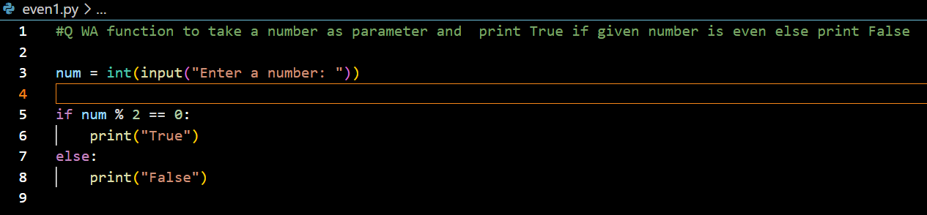

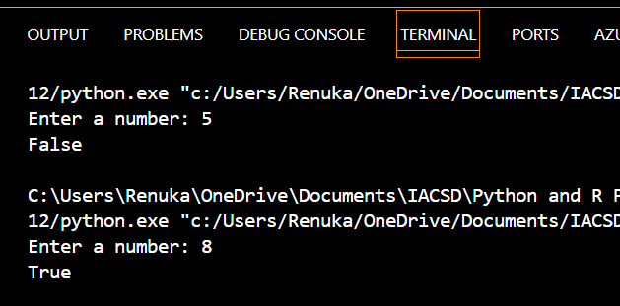

Q WA function to take list as parameter and print all numbers of given list which are divisible by 11

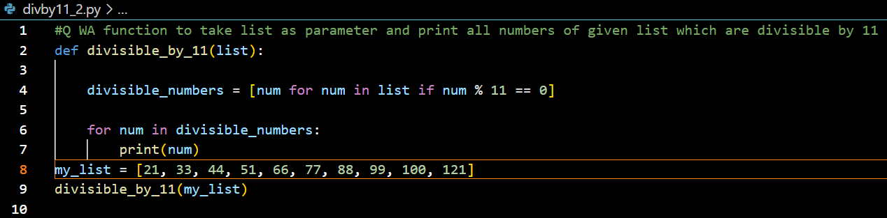

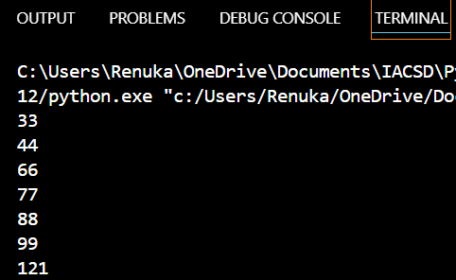

Q WA function to take string as parameter

Check if string is palindrome or not

If palindrome return 1

if not palindrome return 0

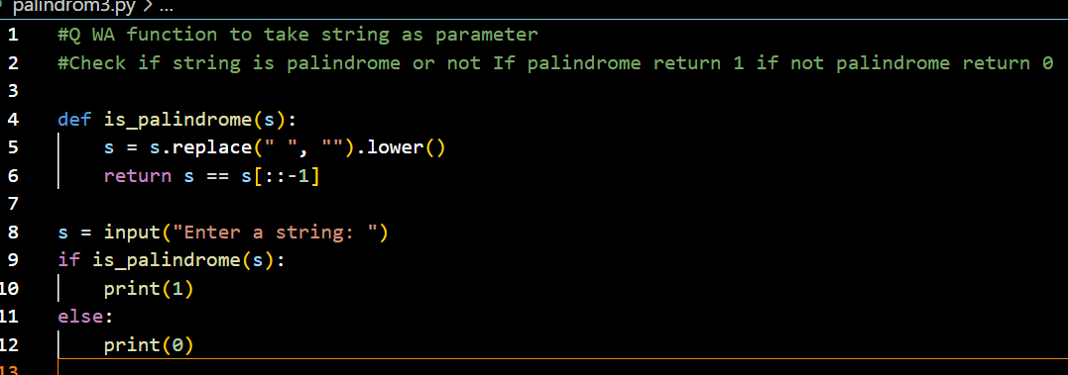

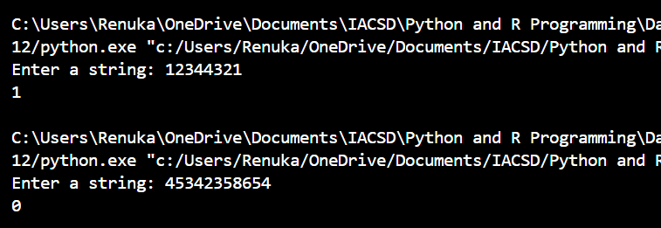

Q WA function to check if number is prime or not. Return True if number is prime and false if number not prime.

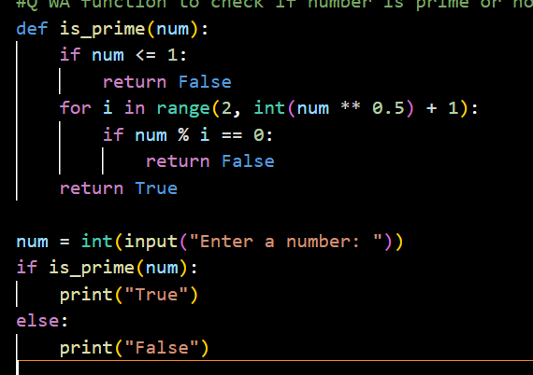

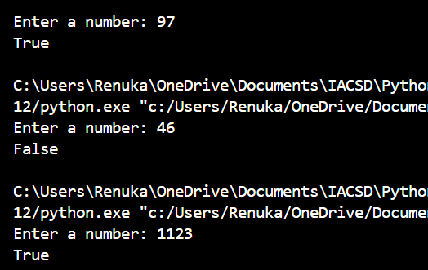

Q WA function to take a string as parameter. Print its alternate characters starting from 2nd character

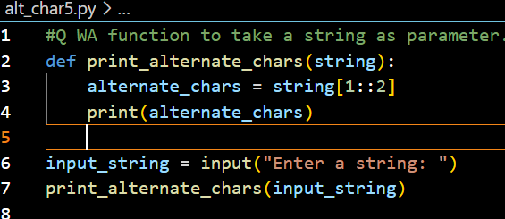

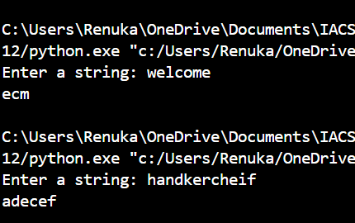

Q WA function to take dictionary as parameter. Print all keys of the dictionary

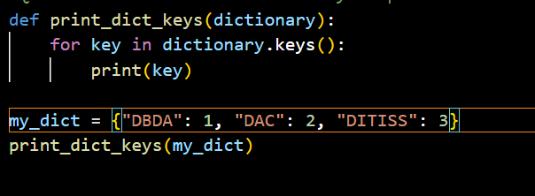

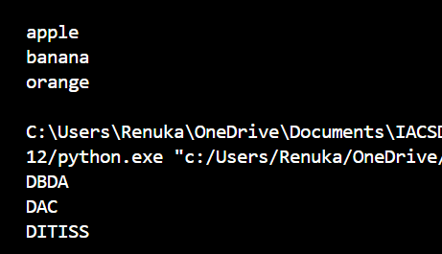

Q WA function to take a dictionary as parameter. Print value of key "name" if key "rollno" is having value 100.

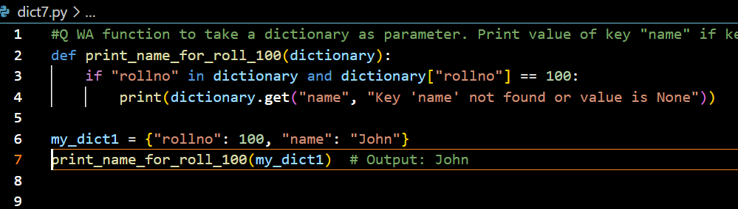

Q WA function to take list of strings as parameter and print all strings which have character 's' 2 times

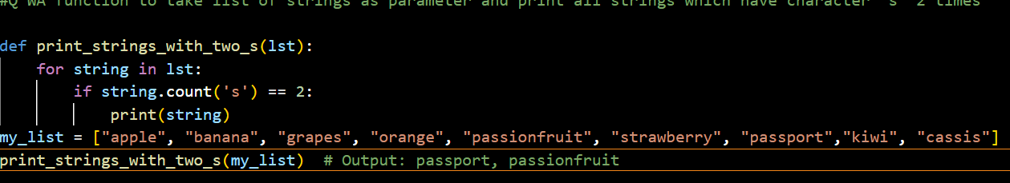

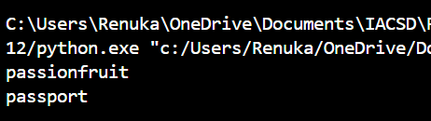

Q WA function to take list of dictionaries. Print all dictionaries which contain key "id".

