Name: Renuka Rathod

Roll No.:243542

Q1. Write difference between SAAS,PAAS,IAAS.

Ans.: 1. Software as a service(SAAS)

* It gives users online access to software applications that are hosted and controlled by a different supplier.
* Used by End Users.
* Scalable and accessible, affordable, easy to upgrade, easy deployment
* Insufficient data security, less control
* Example services: Google Workspace, Salesforce, Dropbox

2. Platform as a Service(PAAS):

* It gives developers a platform to create and deploy apps without having to manage the underlying infrastructure.
* Used by Developers.
* Cost-effective, increased productivity, easy scalability, easy accessibility
* It has issuses with Compatibility issue, vendor changes.
* Example Services: Heroku, OpenShift, Beanstalk, Apache Stratos

3. Infrastructure as a Service(IAAS):

* It provides virtualized computing resources (server, storage, and networking) over the internet.
* Used by Network Architect.
* It is Affordable, flexible, accessible, reliable.
* It has Lack of control, Data security issue.

Example Services: Amazon Web Service (AWS), Microsoft Azure, Google Cloud Platform.

Q2.  Explain with diagram architecture of cloud(public) any provider.

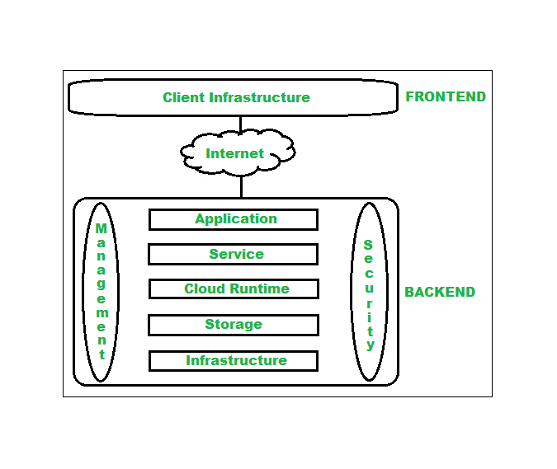

The cloud architecture is divided into two parts:

1. Frontend
2. Backend

The prime components of backend cloud architecture are:

* Application : is a substantial part of the backend architecture. It refers to the user interface that the backend offers to the end-user to send queries. This layer of the backend takes care of the client’s requests and requirements.
* Service:  This is a magical area of the backend cloud architecture. It adds utility to the entire backend architecture.
* Cloud Runtime: The term ‘Cloud Runtime’ is the concept where the services run. It’s like a cloud operating system where technology like virtualization is used.
* Storage:  Storage in the cloud is where the data resides of a cloud application.
* Infrastructure: The engine that steers all the cloud software services is called infrastructure.
* Management: The management software allocates specific resources to specific tasks and responsible for the flawless functioning of any cloud environment.

Q3.  Study about five services from AWS ,GCP,Azure and Heroku.

* Amazon EC2(Elastic Compute Cloud): EC2 provides resizable compute capacity in the cloud, allowing users to launch virtual servers, known as instances, and scale capacity up or down as needed.
* Azure Virtual Machines: Azure VMs provide on-demand, scalable computing resources in the cloud.
* Azure Blob Storage: Blob storage offers scalable object storage for storing unstructured data such as documents, images and videos. It provides high availability, durability, and multiple access tiers.
* Heroku Postgres: Heroku offers a fully managed PostgreSQL database service with features such as continuous protection, rollback, and follower databases for read scalability.
* Google App Engine: App engine is a Platform as a service(PAAS) offering that simplifies application development and deployment. It supports multiple programming languages and automatically manages infrastructure resources.

Q4. Write the difference between database services of AWS , GCP Azure,Heroku.

Ans.: 1.

* With Microsoft Azure, you can create virtual machines and scale sets for virtual machines.
* With Amazon EC2 (Elastic Compute Cloud) provides all the computing administration. The program oversees virtual machines, which can either be designed by the owner or have pre-configured settings for convenience.
* As part of GCP (Google Cloud Platform), GCE (Google Compute Engine) does a similar function.
* Heroku is a container-based cloud platform as a service. Developers use Heroku to deploy, manage , and iscale modern apps.our platform is a flexible, elegant and easy to use, offering developers the simplest path to grtting their apps to market.

2.

* Azure uses ID drives (transient capacity), and Page Blobs VM-based volumes are stored in Block Storage (Microsoft's choice). Object Storage uses Square Blobs and Files.
* AWS provides apportioned, transient (brief) stockpiling. As soon as an instance begins, it is demolished at the end of the case.
* Comparatively, Google's Cloud Platform offers both brief stockpiling and constant circles. For Object stockpiling, GCP has Google Cloud Storage.