**THINK-CHAMP PRIVATE LIMITED**

INTERNSHIP REPORT on

**PYTHON PROJECT-6: YouTube Video Downloader**



SUBMITTED TO:

CEO OF THINK CHAMP PVT LTD

**GURU LOKESH SIR**

**SUBMITTED BY:**

**K.Lavanya**

INDEX

S.NO CONTENTS

1. Project-6

1.1 Introduction

1.2 Steps

1.3 Software requirements specification

1.4 Coding

1.5 Output

1.6 Conclusion

**Project-6**

**1.1. Introduction:**

Generally we can download the youtube video using the third party app.there we we need to maintain the video link and app. Inorder to download the video without using the third party app we are using the python and tkinter by providing the location where it is going to be installed.

**1.2.Steps:**

**In command Prompt:**

We need to install pytube library using the pip install pytube. we can give the location where the video is saved. Suppose we want to visible the video on the desktop we can give the location as cd desktop like this we can give the location.

**In Idle**:

After installing the libraries in command prompt we can make use of them in idle.

Finally We are going to writing the code for video download and to reset the paths or links where we are providing the urls.

**1.3 Software requirements specification**

S0FTWARE REQUIREMENTS:

• Operating System: Windows 10

• Coding Language: PYTHON

• Software: IDLE Python

HARDWARE REQUIREMENTS:

• System: PAVILION

• Hard Disk: 512 GB

• Ram: 8GB

**1.4.Coding**

# Importing all the necessary modules for Python YouTube Video Downloader project

from tkinter import *

from tkinter import messagebox as mb

from pytube import YouTube

# Defining the downloader function for YouTube Video Downloader project using Python

def downloader(link, directory, filename):

yt_link = link.get()

save_path = directory.get()

aftersave_filename = filename.get()

try:

yt = YouTube(yt_link)

video = yt.streams.first()

video.download(save_path, aftersave_filename)

except:

mb.showerror('Error', 'Connection Error! You are offline!')

def reset(l_strvar, d_strvar, fn_strvar):

l_strvar.set('')

d_strvar.set('')

fn_strvar.set('')

# Initializing the window

root = Tk()

root.title('Thinkchamp Youtube Video Downloader')

root.geometry('700x200')

root.resizable(0, 0)

root.config(bg='Coral')

# Heading label

Label(root, text='Thinkchamp Youtube Video Downloader', font=("Comic Sans MS", 15), bg='Coral').place(relx=0.25, rely=0.0)

# Creating the main window

Label(root, text='Enter the Youtube link:', font=("Times New Roman", 13), bg='Coral').place(relx=0.05, rely=0.2)

link_strvar = StringVar(root)

link_entry = Entry(root, width=50, textvariable=link_strvar)

link_entry.place(relx=0.5, rely=0.2)

Label(root, text='Enter the save location:', font=("Times New Roman", 13), bg='Coral').place(relx=0.05, rely=0.4)

dir_strvar = StringVar(root)

dir_entry = Entry(root, width=50, textvariable=dir_strvar)

dir_entry.place(relx=0.5, rely=0.4)

Label(root, text='Enter the filename:', font=("Times New Roman", 13), bg='Coral').place(relx=0.05, rely=0.6)

filename_strvar = StringVar(root)

filename_entry = Entry(root, width=50, textvariable=filename_strvar)

filename_entry.place(relx=0.5, rely=0.6)

# Creating the buttons

download_btn = Button(root, text='Download', font=7, bg='Aquamarine',

command=lambda: downloader(link_entry, dir_entry, filename_entry)).place(relx=0.3, rely=0.75)

reset_btn = Button(root, text='Reset', font=7, bg='Aquamarine',

command=lambda: reset(link_strvar, dir_strvar, filename_strvar)).place(relx=0.5, rely=0.75)

# Finalizing the window of Python YouTube Video Downloader project

root.update()

root.mainloop()

**1.5.Output**

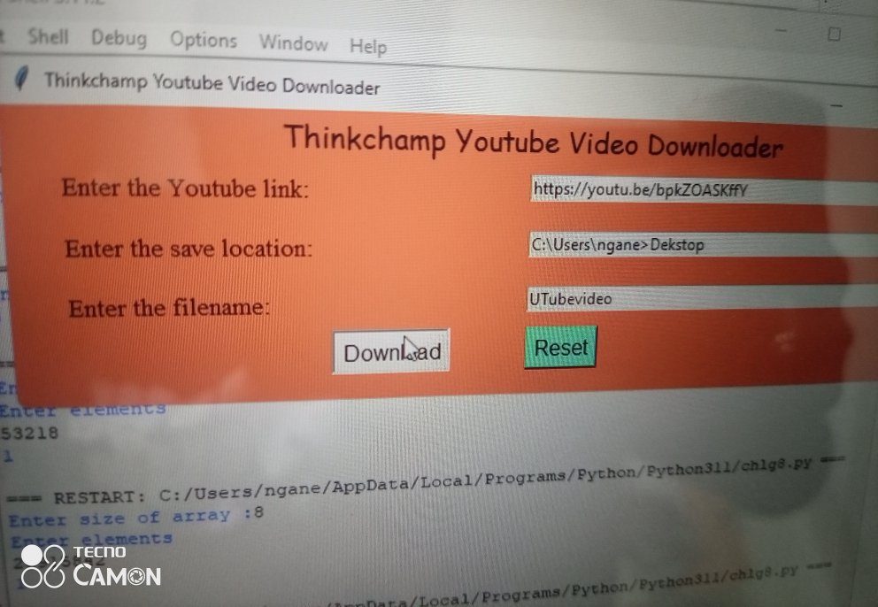

**1.6.Conclusion**

Finally , YouTube video downloaded in the particular location using python and tkinter without using the third party app. This is very helpful to people.