

**FOOD MUNCH: A SIMPLE AND STATIC FOOD ORDERING WEB PAGE**

**A CAPSTONE PROJECT REPORT**

*Submitted to*

**SAVEETHA SCHOOL OF ENGINEERING**



Submitted by

POTHAMSETTI REDDY RENUKA(192311062)

Course Code: **CSA1087**

Course Name: Software Engineering for Web Development

**INDEX**

|  |  |  |
| --- | --- | --- |
| S.NO | TOPIC | PAGENO |
| 1 | ABSTRACT | 1 |
| 2.0 | INTRODUCTION | 1 |
|  | 2.1 Problem Statement | 1 |
| 2.2 Objectives | 1 |
| 3.0 | METHODOLOGY | 2 |
| 4.0 | DIRECTORY STRUCTURE | 3 |
| 5.0 | ADVANTAGES & APLLICATIONS | 3 |
| 6.0 | WEBSITE VISUALIZATION | 4,5 |
| 7.0 | RESULT & DISCUSSIONS | 6 |
| 8.0 | CONCLUSION | 7 |
| 9.0 | REPORT | 7 |

## 1.0 ABSTRACT:

The **"Food Munch"** project is a static website designed to showcase the menu and offerings of a restaurant. Developed using HTML and CSS, the website emphasizes simplicity, efficiency, and an attractive user interface. The static nature of the website ensures fast loading times, minimal security risks, and cost-effectiveness, making it an ideal solution for small businesses or startups. This project follows the Waterfall Model, ensuring a systematic and structured development process. The "Food Munch" website highlights the potential of basic web technologies in creating impactful, user-friendly digital platforms.

**2.0 INTRODUCTION:**

The "Food Munch" static website project aims to create a simple yet visually appealing platform for showcasing a restaurant's food menu and engaging potential customers. By leveraging HTML and CSS, the project demonstrates how basic web development tools can be used to design a fast, efficient, and user-friendly website. This project is particularly suited for small businesses that seek an affordable and secure online presence without the complexity of dynamic web technologies.

**2.1 Problem Statement**

Small businesses, especially restaurants, often face challenges in establishing an online presence due to budget constraints and technical complexities. Dynamic websites require backend integration, increasing development costs and security risks. The need for a simple, cost-effective, and static web solution becomes evident for startups or small-scale businesses to showcase their offerings and engage customers effectively.

* 1. **Objectives**

1. To design and develop a visually appealing static website using only HTML and CSS.

2. To provide an easy-to-navigate layout that highlights the restaurant's menu and special offers.

3. To ensure the website is lightweight, secure, and responsive to different screen sizes.

4. To create a cost-effective solution suitable for small businesses or startups.

5. To follow the Waterfall Model for a structured development process, ensuring quality and reliability.

**3.0 METHODOLOGY:**

The development of the "Food Munch" static website follows the **Waterfall Model, a linear and** **sequential software development approach**. This methodology is particularly suited for projects with clearly defined requirements and a simple implementation process, making it ideal for static web pages like "Food Munch."

*Phases of the Waterfall Model in "Food Munch" Development:*

1. **Requirements Gathering and Analysis:**
   * In this phase, the goals and scope of the "Food Munch" project were defined.
   * Requirements were gathered to ensure the website offers key features such as navigation, a visually appealing banner, and sections for menu highlights, customer engagement, and contact information.
   * The focus was on simplicity and user-friendliness.
2. **System Design**:
   * A blueprint for the static website was created, outlining the structure and design.
   * Design elements included:
     + A responsive banner section for first impressions.
     + Clear navigation links for easy access to different sections.
     + Static sections for menu details, "Why Choose Us," and customer engagement.
     + Footer information for contact and social media links.
3. **Implementation:**
   * HTML and CSS were used to implement the design.
   * Features such as buttons, cards, and sections were styled for uniformity using CSS.
   * Minimal tools were used, emphasizing simplicity and efficient coding practices.
4. **Integration and Testing:**
   * The static pages were integrated and tested to ensure responsiveness, proper layout, and functioning links.
   * Testing was carried out on multiple devices and browsers to verify compatibility and performance.
   * Accessibility checks were also conducted to ensure a broader reach.
5. **Deployment:**
   * The finalized website was deployed on a local server or hosting platform.
   * Deployment ensured that all design elements were intact and displayed as intended to the end-user.
6. **Maintenance:**
   * Even though static websites have minimal maintenance needs, provisions were made for minor updates, such as updating menu items or adding new static content if required.

**4.0 DIRECTORY STRUCTURE:**

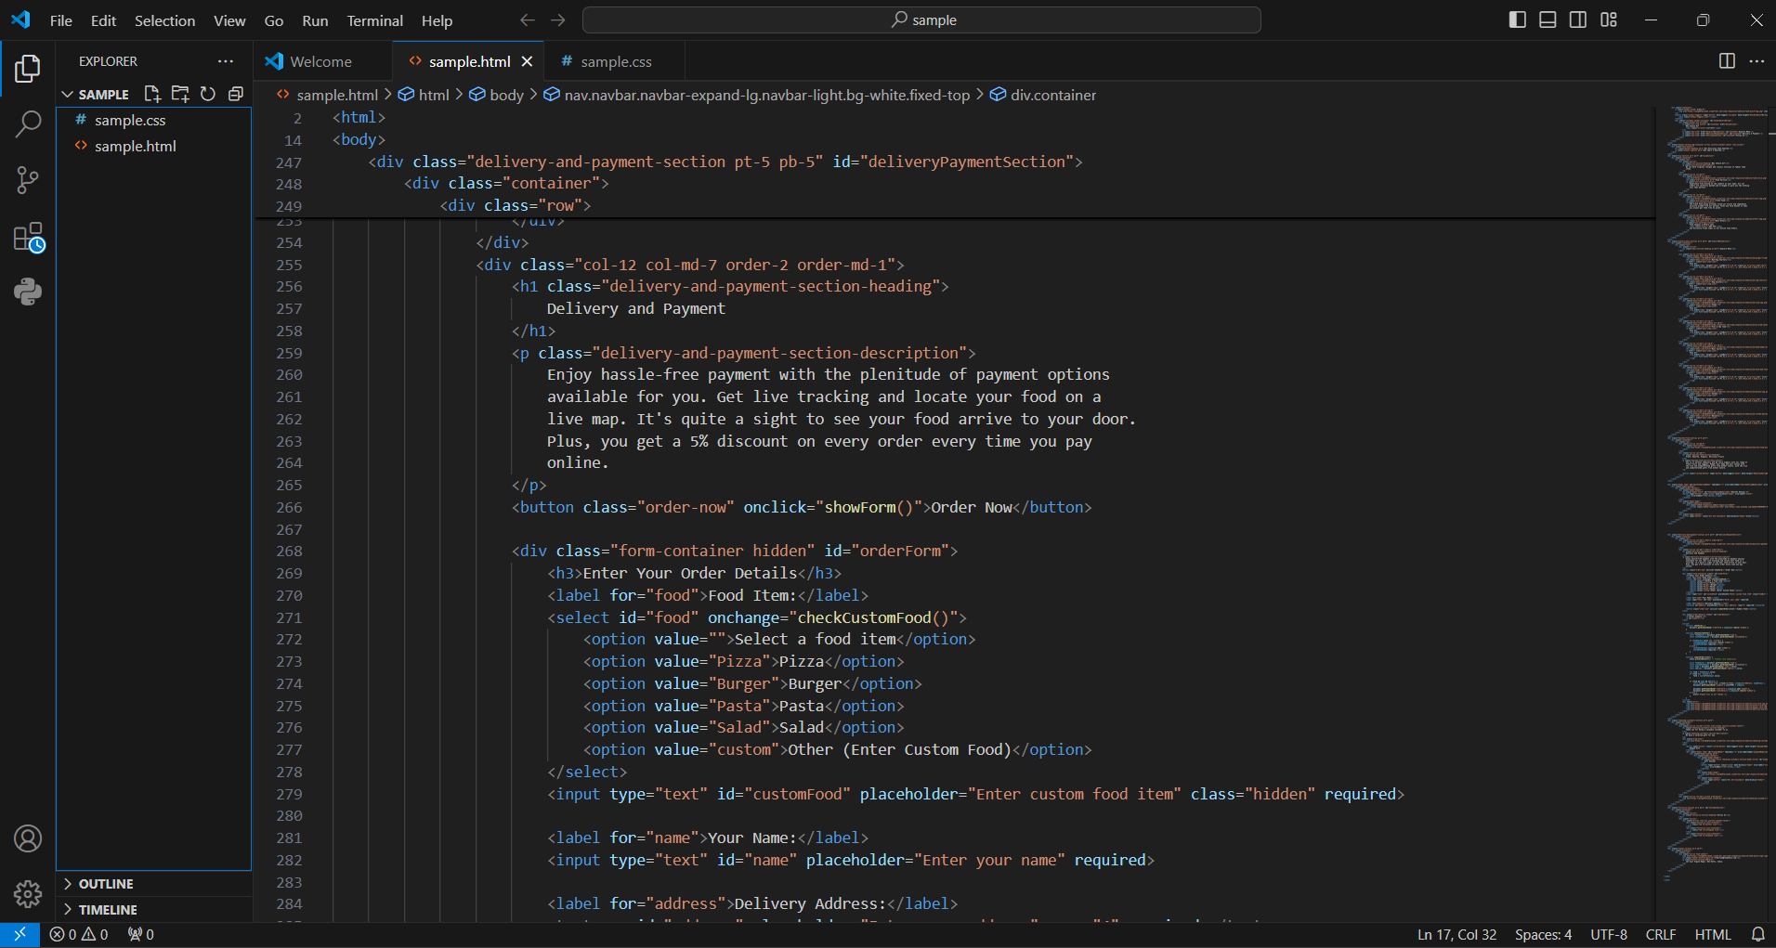

**5.0 ADVANTAGES & APPLICATIONS:**

* Simplicity: Each phase is clearly defined and executed sequentially, aligning well with the project's scope.
* Clarity of Requirements: All features were predetermined, reducing ambiguity and simplifying development.
* Ease of Testing: As the entire project was built in phases, testing became straightforward and systematic.
* Cost-Effective: The use of HTML and CSS alone minimized the need for additional tools or resources.
* Ideal for Static Content: The Waterfall Model is perfect for projects with a fixed scope and limited interactivity.

**Practical Applications**

Showcasing Food Menus:

* Restaurants can display their menu items, special offers, and promotions effectively.

Brand Identity:

* The visually appealing design helps establish a strong brand presence.

Customer Engagement:

* Features like the "Order Now" button and social media links improve customer interaction and engagement.

Information Portal:

* It serves as a source of information for customers looking for restaurant details like contact info, menu highlights, or delivery options.

Marketing Tool:

* The website can be used to attract new customers by showcasing enticing images of food and a professional layout.

Cost-Effective Solution:

* Ideal for small businesses or startups looking for an affordable web presence.

**6.0 WEBSITE VISUALIZATION:**

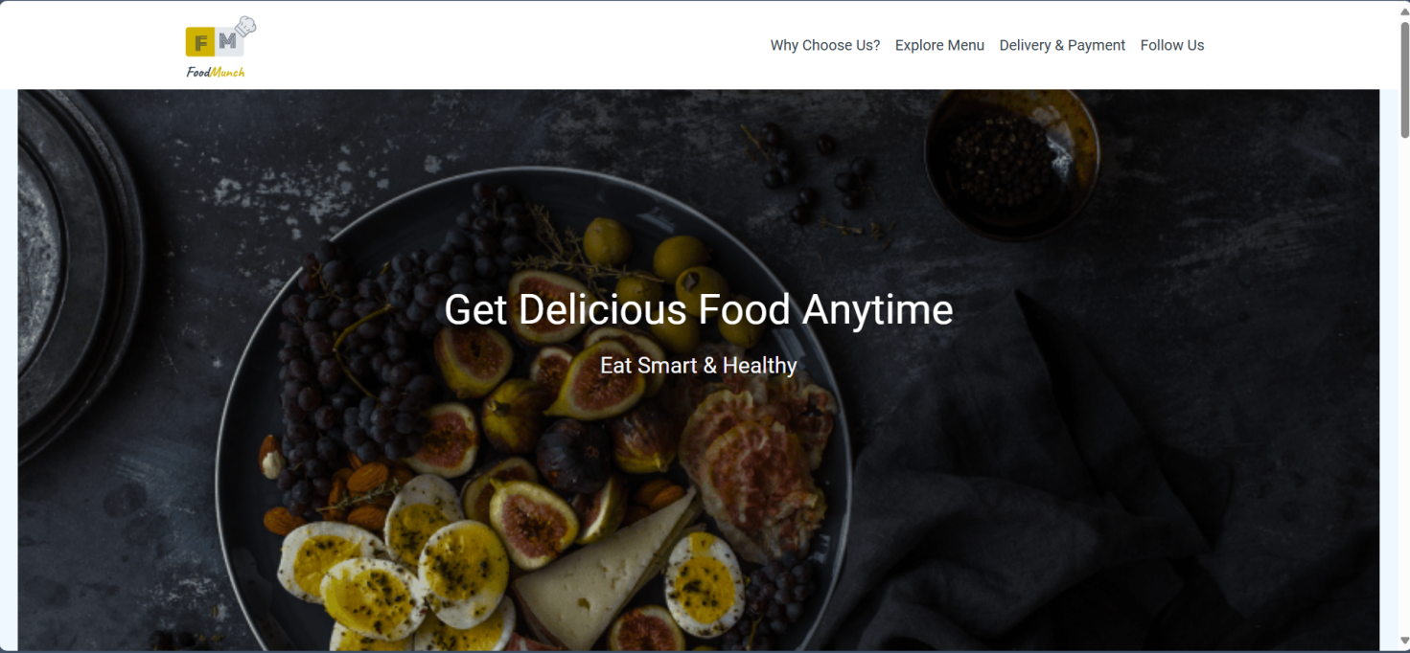

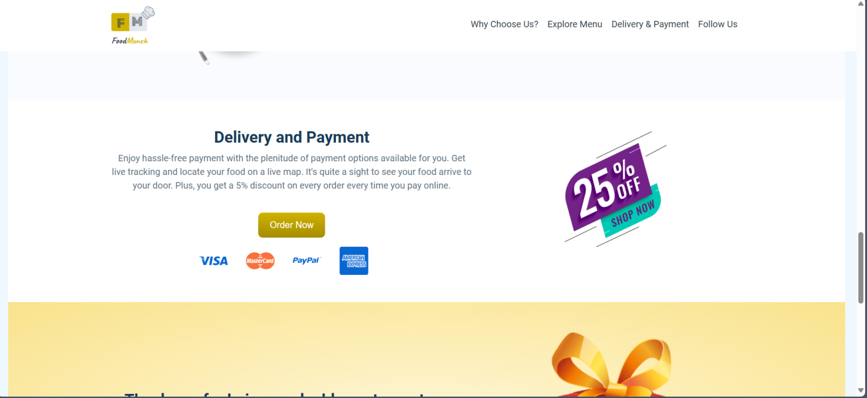

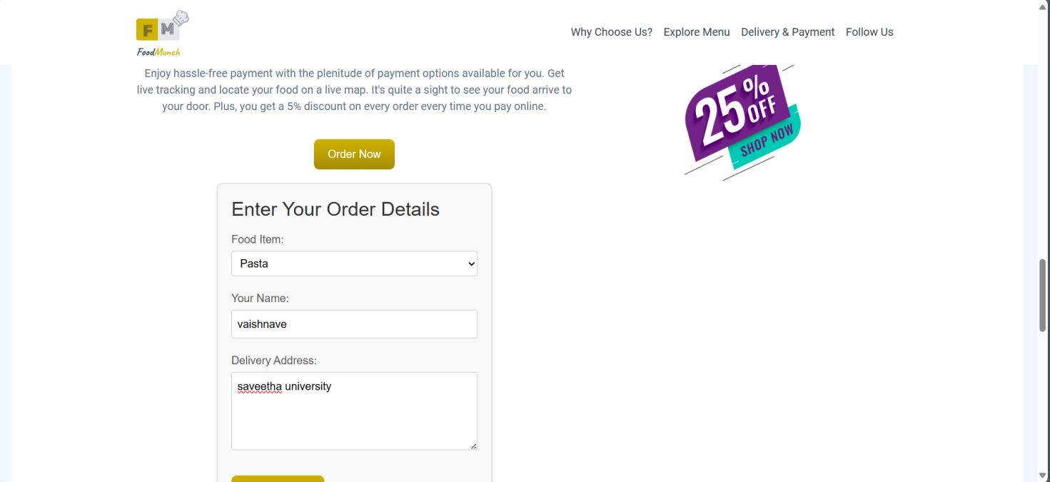

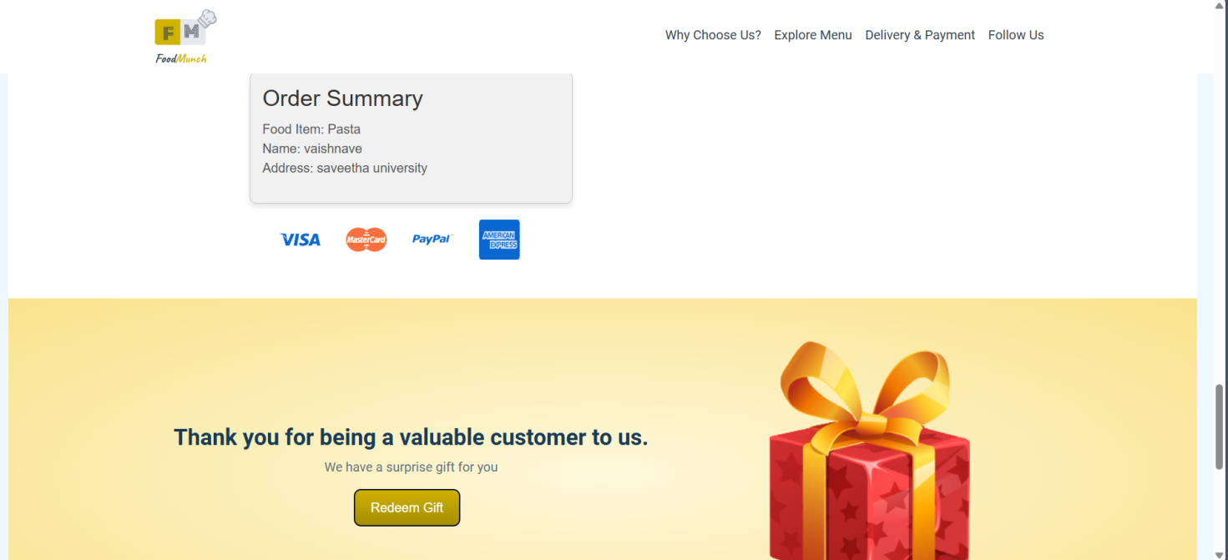

**7.0** **RESULTS & DISCUSSION:**

Results:

1. Functional Static Webpage:
   * The project resulted in a fully functional, visually appealing static website called "Food Munch," implemented using HTML and CSS.
2. User-Friendly Layout:
   * The simple design ensures easy navigation for users.
3. Responsive Design:
   * The website adapts well to different screen sizes, enhancing the user experience.
4. Fast Loading Time:
   * Being static, the website has minimal loading time, providing a smooth browsing experience.
5. Attractive Features:
   * Includes a visually appealing banner, “Order Now” button, and dedicated sections for menu highlights, “Why Choose Us,” and customer engagement.

Discussion:

* Strengths:
  + The simplicity of the design ensures that users can quickly access the information they need.
  + The exclusive use of HTML and CSS reduces complexity and ensures fast page loading.
  + Static websites are inherently secure, as there is no backend to exploit.
* Limitations:
  + The lack of interactivity and dynamic features means that the website cannot process user input (e.g., online ordering or feedback).
  + Updates to content require manual changes to the HTML and CSS code.
* Future Scope:
  + The project can be extended by incorporating JavaScript for interactivity, adding a backend for dynamic content, or integrating a content management system (CMS) for easier updates.

**8.0 CONCLUSION:**

The "Food Munch" static website successfully meets the project objectives by delivering a simple, efficient, and visually appealing platform for showcasing a food menu and engaging customers.

* By leveraging **HTML and CSS** the project demonstrates the power of basic web technologies in creating functional and attractive websites.
* The use of the Waterfall Model ensured a structured and sequential approach to development, minimizing errors and maximizing efficiency.

While the website is static and limited in functionality, it provides a strong foundation for further enhancements. Overall, the project highlights the potential of simple web design techniques to create impactful solutions for small businesses and startups.

**9.0 REPORT:**

This report highlights the development of *Food Munch*, a static food ordering web page created using HTML and CSS. The project emphasizes simplicity, user-friendly design, and adaptability for small-scale food businesses. Following the Waterfall Model, the site delivers an efficient and visually appealing platform suitable for exploring menus and placing orders with ease.