1. Mail2Tor
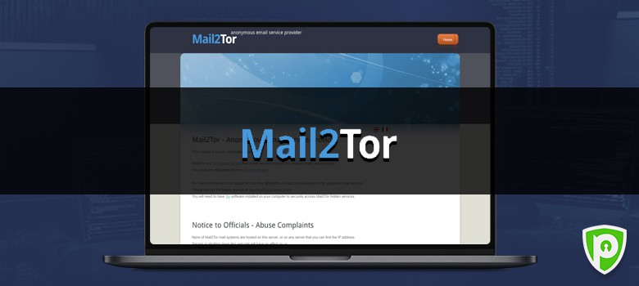
Link: http://mail2tor2zyjdctd.onion/
Let’s face it – email isn’t a secure means of communication! The contents of your inbox are accessible to email providers. Take, for instance, Gmail scans your emails to show you more relevant search results and advertisements.
Mail2Tor makes a good alternative as it allows users to send/receive messages anonymously through webmail or an email client. What’s more, all mail is secured using encryption, and the provider doesn’t store your IP address either.

2. Facebook

Link: https://www.facebookcorewwwi.onion/
Though Facebook knows a lot about you than you can imagine, it isn’t keen on sharing this data with others. The social media giant has also been the target of censorship from repressive governments time and time again. After all, it enables users from around the world to connect, communicate, and collaborate with each other freely.
So, it’s no surprise that Facebook has a .onion URL. It doesn’t do much in terms of maintaining an anonymous account, but lets you access the social media network from restricted countries.

Attention Dark Web Users!
You should always protect your data and identity when accessing the dark web with a VPN. Get started now by signing up for PureVPN’s 7-day trial for free.

3. The Hidden Wiki
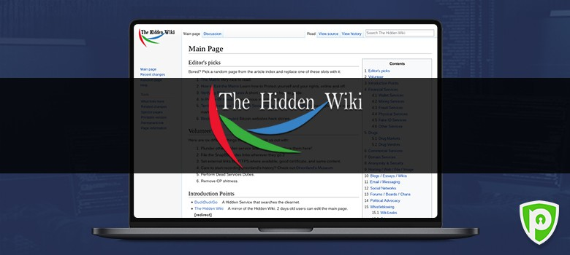
Link: http://zqktlwiuavvvqqt4ybvgvi7tyo4hjl5xgfuvpdf6otjiycgwqbym2qad.onion/wiki/index.php/Main_Page
If you’re looking to find active .onion websites and their URLs, you have a few ways to go about it. One of the most convenient is to use a dark web link directory, such as The Hidden Wiki. Some sites are completely legit (like domain services), and some (like whistleblowing tools) might be censored in your country.
Then, you also have others that might not be as legal. That’s why you should be cautious about which .onion links you click on!

4. ProPublica

Link: https://www.propub3r6espa33w.onion/
The aim of the five-time Pulitzer Prize winner ProPublica is “To expose abuses of power and betrayals of the public trust by government, business, and other institutions, using the moral force of investigative journalism to spur reform through the sustained spotlighting of wrongdoing.”
It’s the first major online publication to have a .onion address. The non-profit newsroom is funded by organizations such as the Sandler Foundation and has made countless contributions in the fight for free speech and privacy.

5. DuckDuckGo

Link: http://3g2upl4pq6kufc4m.onion/
Do you want to search for something privately? Then, DuckDuckGo is one of the best alternatives to Google. Your search activity isn’t stored, and you get decent answers for most queries without all the tracking. The search engine is also available on the dark web and offers an additional layer of anonymity and privacy with fast search results.

6. SoylentNews
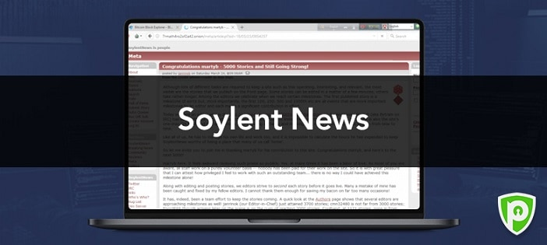
Link: http://7rmath4ro2of2a42.onion/
Unfortunately, most of the mainstream media today can’t be trusted because it’s rarely unbiased and accurate. The best way to stay up-to-date with the latest happenings is to use an open-source and community-oriented news aggregator like SoylentNews. Users can submit their stories from anywhere in the globe and even engage in insightful conversations on public discussion forums.

7. TorLinks
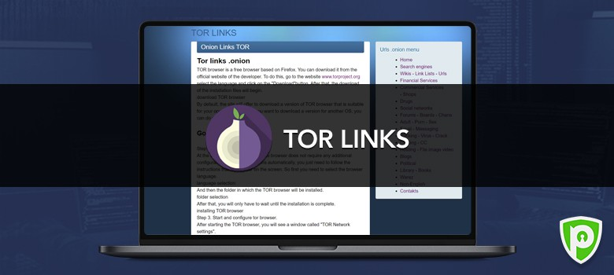
Link: http://torlinksd6pdnihy.onion/
TorLinks is a great alternative to The Hidden Wiki and provides a list of .onion websites across various categories. Sure, there’s some overlap between the two, but the list of sites on TorLinks is widely different. Considering how regularly dark web sites vanish and go offline, it’s better to have more than one source to help you find .onion URLs.

8. The CIA

Link: http://ciadotgov4sjwlzihbbgxnqg3xiyrg7so2r2o3lt5wz5ypk4sxyjstad.onion/
Tor’s history is an unlikely tale. It was created by the U.S Navy with the purpose of helping informants in foreign nations to communicate safely over the Internet. The Central Intelligence Agency (CIA), in that spirit, released a .onion site so that people from across the globe can browse their resources securely and anonymously.

