Docker

Docker is a platform that enables developers to package applications and their dependencies into containers, which can then be deployed and run consistently across various environments.

1. What is Docker?

At its core, Docker is an open-source platform that automates the process of building, shipping, and running applications inside lightweight containers. Containers are isolated environments that package an application and its dependencies, which ensures that the application runs consistently on any system.

Docker Engine: The core of Docker, which runs containers.

Docker Image: A snapshot or blueprint of a container, typically built using a Dockerfile. It contains everything needed to run an application, such as libraries, dependencies, and the application code.

Docker Container: A running instance of a Docker image. Containers are lightweight and share the host OS kernel but run in isolated environments.

Docker Hub: A cloud-based registry service where you can find and share Docker images.

Docker Compose: A tool to define and manage multi-container Docker applications using a YAML configuration file.

2. Docker Architecture

Docker’s architecture consists of several components working together to facilitate containerization. Here are the key components:

Docker Client: The command-line interface or graphical interface that communicates with the Docker daemon (server) to execute commands like build, run, stop, etc.

Docker Daemon (dockerd): The background service that manages Docker containers. It listens for API requests and controls Docker containers, images, networks, and volumes.

Docker Registry: A service that stores Docker images. The most popular registry is Docker Hub, but others like Google Container Registry (GCR) and AWS Elastic Container Registry (ECR) are also used.

Docker Images: Templates for creating containers. An image is a static specification that includes the app code, libraries, and dependencies.

Docker Containers: A running instance of a Docker image. A container is an isolated environment where the application runs.

Docker Volumes: Persistent storage that allows data to persist across container restarts. Volumes can be shared between containers.

Docker Networks: Allow containers to communicate with each other and external resources.

3. Basic Docker Commands

→docker --version: Shows the installed Docker version.

→docker pull <image>: Pulls an image from a registry (e.g., Docker Hub).

→docker build -t <image-name> .: Builds a Docker image from a Dockerfile.

→docker run <image-name>: Runs a container from an image.

→docker ps: Lists running containers.

→docker stop <container-id>: Stops a running container.

→docker rm <container-id>: Removes a stopped container.

→docker exec -it <container-id> /bin/bash: Executes commands inside a running container.

→docker logs <container-id>: Views logs for a container.

4. Docker Networking

Docker provides several network modes for container communication:

Bridge Network: Default network mode. Containers on the same host can communicate using their IP addresses or container names.

Host Network: The container shares the host system’s network stack.

Overlay Network: Used for multi-host networking in Docker Swarm or Kubernetes environments.

None Network: The container has no network connectivity.

5.Docker Swarm and Kubernetes

For orchestrating large-scale containerized applications, Docker Swarm and Kubernetes are two popular tools.

Docker Swarm: A native clustering and orchestration tool for Docker. It allows you to manage multiple Docker engines and deploy applications across multiple machines.

docker swarm init: Initializes a new Swarm.

docker service create: Deploys a service in the Swarm.

Kubernetes: An open-source orchestration system for automating the deployment, scaling, and management of containerized applications. Kubernetes works with any container runtime, including Docker.

6.Benefits of Docker

Consistency: Docker ensures the application runs the same way on any machine.

Portability: Docker containers can run on any platform that supports Docker (Linux, macOS, Windows).

Isolation: Each container runs independently, ensuring that one container’s failure doesn’t affect others.

Scalability: Docker allows easy scaling of applications by running multiple containers.

Efficiency: Containers are lightweight compared to virtual machines, which saves resources.

CI/CD Integration: Docker fits well in Continuous Integration/Continuous Deployment (CI/CD) pipelines.

Why do we need an Docker?

**1. Consistency Across Environments**

One of the biggest challenges in software development is ensuring that applications run the same way across different environments. For instance, an application might work perfectly on a developer's machine but fail in testing or production due to differences in configurations, libraries, or operating system versions.

**2. Portability**

With Docker, you can package an application into a container that includes everything it needs to run (libraries, runtime, environment variables, etc.). This makes it highly portable.

Docker containers can run on any system that has Docker installed, regardless of the underlying operating system (e.g., from your laptop to a cloud server or even on different cloud providers like AWS, Google Cloud, or Azure).

**3. Scalability and Efficiency**

Containers are lightweight and use fewer resources compared to virtual machines (VMs), making them ideal for scalable applications. Unlike VMs, which require a full operating system to run, Docker containers share the host system’s kernel but run isolated from each other.

Containers are fast to start because they don’t need to boot a full OS.

They are resource-efficient because multiple containers can run on a single host without needing separate operating systems.

**4. Isolation**

Running applications in isolated environments (containers) provides several benefits:

Process and file system isolation: Each container runs in its own isolated environment, so the processes in one container can't directly interfere with those in another.

**5. Resource Efficiency**

Docker containers are much lighter than virtual machines because containers share the host operating system's kernel. This means you can run many more containers on the same hardware compared to VMs.

Docker's low overhead makes it well-suited for high-density environments where multiple applications need to share the same physical resources.

**6. DevOps and Collaboration**

Docker is a fundamental technology for DevOps practices, as it encourages collaboration between development and operations teams. Since both teams work with the same containerized applications, it helps break down silos and reduce friction.

Developers can define the application's environment using a Dockerfile and build a Docker image, making it easy to share that environment with operations.

Operations teams can deploy applications in a consistent manner across different environments, ensuring smooth transitions from development to production.

Difference between virtual box and docker

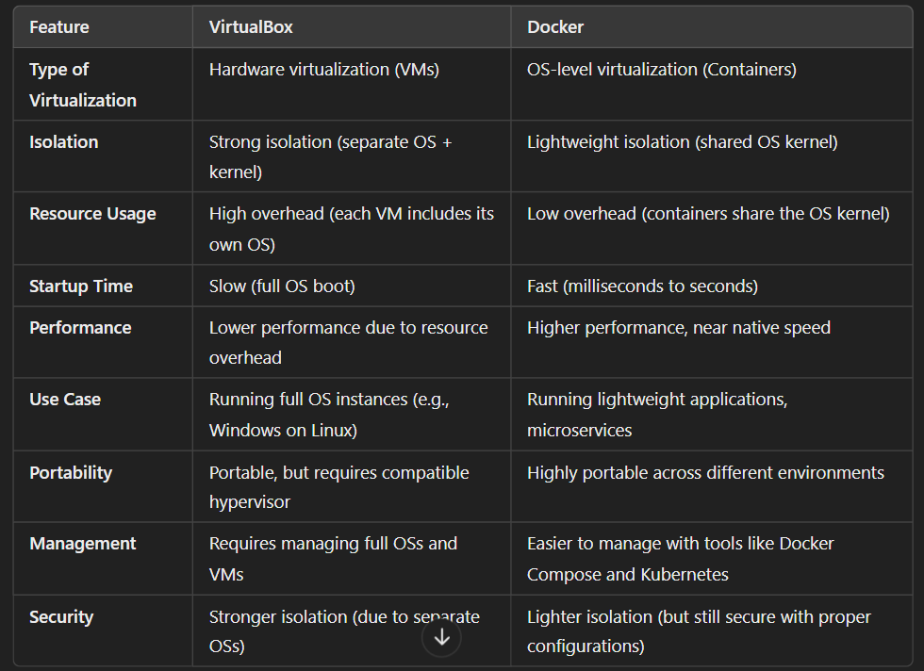

Docker file

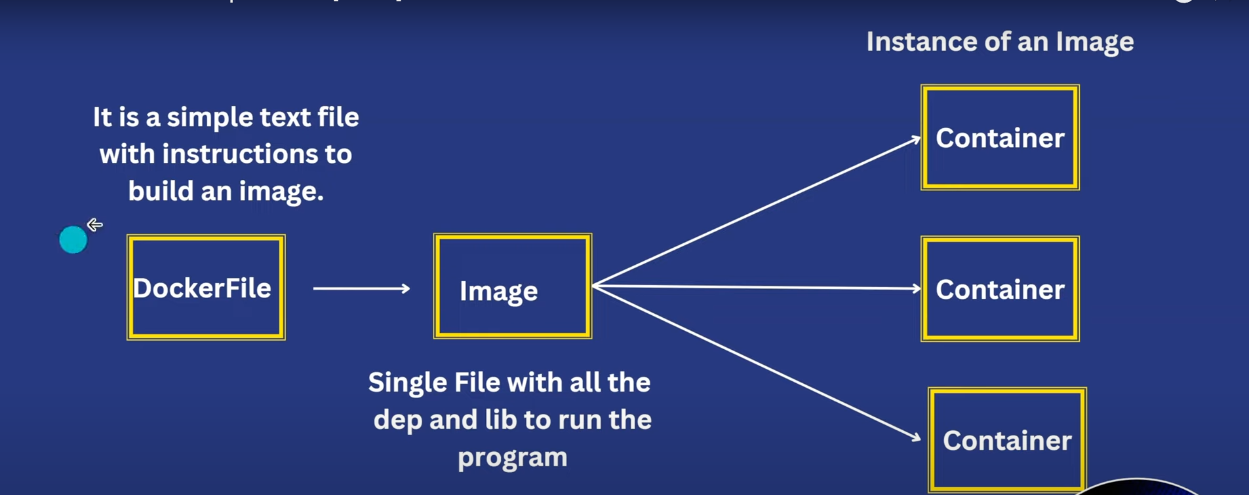

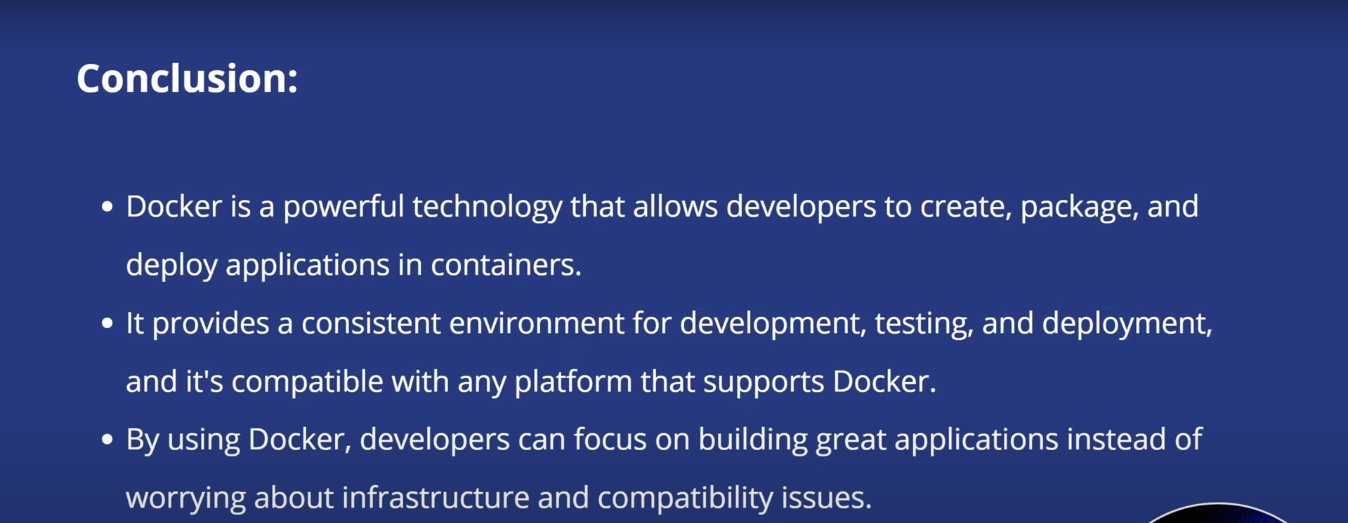

Basic Docker Interview Questions and Answers

**1. What is Docker ?**

Docker is a containerization platform that allows to package an application with all its dependencies into one single entity as single container which can be easily deployed and run on any machine that supports docker. This makes it easier to devlop , test , deploy applications in different environments. It uses container technology to isolate processes and provide a lightweight, portable solution for application

**2. What are the Features of Docker?**

Docker features containerization for providing consistent deployment , using resources efficient shared kernel utilization, and provides seamless portability across environments. It enhances the security through isolation of containers supporting versioning and automated builds. It offers a rich number of pre-built images for streamlined application development and deployment.

**3. What are the Pros and Cons of Docker?**

**Pros of Docker**

Portability: It enables consistent deployment across various environments.

Resource Efficiency: Optimizing of resource usage with a shared kernel will be done effectively.

Isolation: It provides security through isolation of process and file system.

Automation: it supports automated builds and streamlining development workflow

**Cons of Docker**

Learning Curve: Initial learning of the containerization concepts will bit new to understand.

Additional Resources: Containers use some more resources compared to running applications directly on host.

Security Concerns: Misconfigurations may lead to the security risks if not properly managed.

Container Orchestration Complexity: Management of orchestration tools will be complex for larger-scale deployments.

**4.Name and Explain the State of a Docker Container.**

A state of a docker container directly influences its runtime characteristics and how it interacts with the underlying Operating system. A Docker container will be in one of these three states:

A docker container will be in running state it is when actively executing.

A container in paused state means that container is temporarily halted.

The container will be in stopped state when it is inactive.

**5.Can You tell What is the Functionality of a Hypervisor?**

A hypervisor is a virtualization software that helps in running multiple operating systems (Guest OS) on a single physical host system by providing an isolation between the virtual machines (VMs) and manages their resources.

**6.Difference between Docker and Virtualization?**

Docker uses containerization concept, which shares the host OS kernel for efficiency and speed whereas Virtualization involves running complete OS instances ( Guest Operating systems ) on a hypervisor, which may have more overhead on using resources.

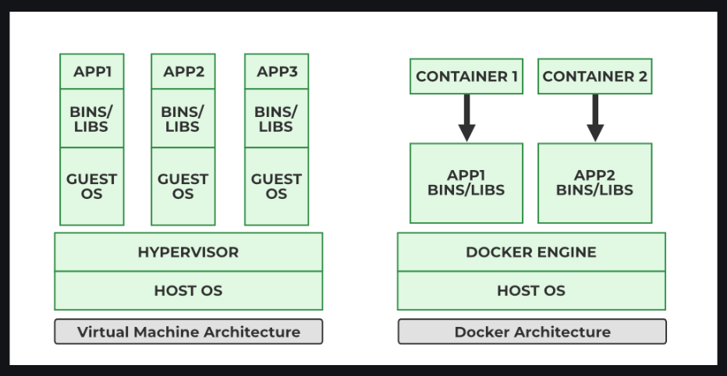

**7.On What Circumstances Will You Lose Data Stored in a Container?**

The Data in a container can be lost whenever the container is deleted, or if docker non-persistent storage ( Ephemeral storage ) is used without proper data management. To make the data persistent , it is recommended to use Docker volumes or volume binding ( volume mounts ) are recommended.

**10. What Command Can You Run to Export a Docker Image As an Archive?**

You can use this following command to export a Docker image as an archive:

→ docker save -o <output_file_name>.tar <image_name>

**11.What Command Can Be Run to Import a Pre-Exported Docker Image Into Another Docker Host?**

We can use this following command to import a pre-exported Docker image into another host:

→ docker load -i <input_file_name>.tar

**12.Can a Paused Container Be Removed From Docker?**

Yes, a paused container can be removed using the command with rm option:

→ docker rm <container_id>

**13. How Do You get the Number Of Containers Running, Paused, and Stopped?**

For obtaining the number of running, paused, and stopped containers in Docker you can use the command such as `docker ps -q` for knowing the list of running containers and `docker ps -q -f "status=paused"` for paused ones. Stopped containers can be counted using `docker ps -aq -f "status=exited"`. These commands will the provide the list of container IDs , and you have to can further process the output to get the counts programmatically like `docker ps -q | wc -l`.

The following command is used to know number of container are in running state:

→ docker ps -q | wc -l

The following command is used to know number of container are in paused state:

→ docker ps -aq -f "status=paused" | wc -l

The following command is used to know number of containers are in stopped state:

→ docker ps -aq -f "status=exited" | wc -l

**14. How to Start, Stop, and Kill a Container?**

In Docker to start , stop and kill a container we using start , stop and kill options on association with the docker command , the usage is given below.

→ docker start < container_name >