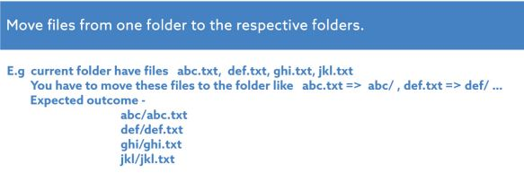

ADMIN@DESKTOP-NTE5JUC MINGW64 ~

$ cd desktop

ADMIN@DESKTOP-NTE5JUC MINGW64 ~/desktop

$ mkdir CIC526

ADMIN@DESKTOP-NTE5JUC MINGW64 ~/desktop

$ cd CIC526

ADMIN@DESKTOP-NTE5JUC MINGW64 ~/desktop/CIC526

$ mkdir Day3

ADMIN@DESKTOP-NTE5JUC MINGW64 ~/desktop/CIC526

$ cd Day3

ADMIN@DESKTOP-NTE5JUC MINGW64 ~/desktop/CIC526/Day3

$ touch abc.txt def.txt ghi.txt jkl.txt

ADMIN@DESKTOP-NTE5JUC MINGW64 ~/desktop/CIC526/Day3

$ ls \*.txt

abc.txt def.txt ghi.txt jkl.txt

ADMIN@DESKTOP-NTE5JUC MINGW64 ~/desktop/CIC526/Day3

$ mkdir abc def ghi jkl

ADMIN@DESKTOP-NTE5JUC MINGW64 ~/desktop/CIC526/Day3

$ mv abc.txt abc

ADMIN@DESKTOP-NTE5JUC MINGW64 ~/desktop/CIC526/Day3

$ mv def.txt def

ADMIN@DESKTOP-NTE5JUC MINGW64 ~/desktop/CIC526/Day3

$ mv ghi.txt ghi

ADMIN@DESKTOP-NTE5JUC MINGW64 ~/desktop/CIC526/Day3

$ mv jkl.txt jkl

ADMIN@DESKTOP-NTE5JUC MINGW64 ~/desktop/CIC526/Day3

$ ls \*/

abc/:

abc.txt

def/:

def.txt

ghi/:

ghi.txt

jkl/:

jkl.txt

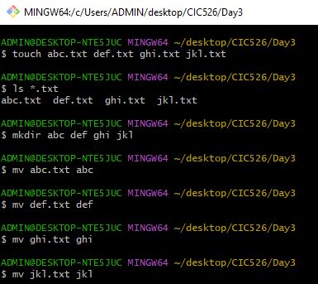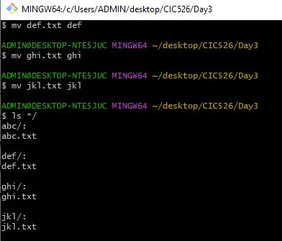



ADMIN@DESKTOP-NTE5JUC MINGW64 ~/desktop/CIC526/Day3

$ touch abc.log.1 def.log.1 ghi.log.1 jkl.log.1

ADMIN@DESKTOP-NTE5JUC MINGW64 ~/desktop/CIC526/Day3

$ ls \*.log.1

abc.log.1 def.log.1 ghi.log.1 jkl.log.1

ADMIN@DESKTOP-NTE5JUC MINGW64 ~/desktop/CIC526/Day3

$ date "+%D"

05/28/22

ADMIN@DESKTOP-NTE5JUC MINGW64 ~/desktop/CIC526/Day3

$ mv abc.log.1 abc-28052022.log

ADMIN@DESKTOP-NTE5JUC MINGW64 ~/desktop/CIC526/Day3

$ mv def.log.1 def-28052022.log

ADMIN@DESKTOP-NTE5JUC MINGW64 ~/desktop/CIC526/Day3

$ mv ghi.log.1 ghi-28052022.log

ADMIN@DESKTOP-NTE5JUC MINGW64 ~/desktop/CIC526/Day3

$ mv jkl.log.1 jkl-28052022.log

ADMIN@DESKTOP-NTE5JUC MINGW64 ~/desktop/CIC526/Day3

$ ls \*.log

abc-28052022.log def-28052022.log ghi-28052022.log jkl-28052022.log

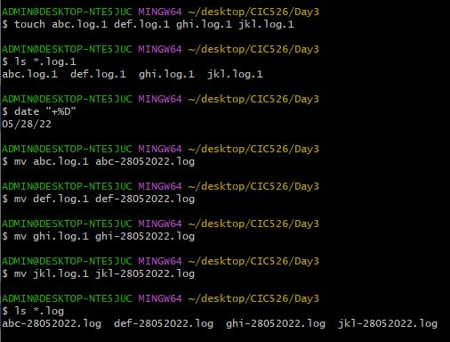

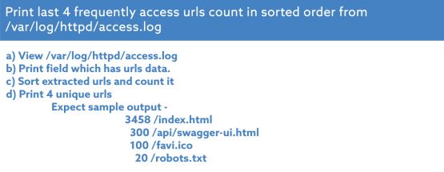

ADMIN@DESKTOP-NTE5JUC MINGW64 ~/desktop/CIC526/Day3

$ cat access.log

.

.

.

ADMIN@DESKTOP-NTE5JUC MINGW64 ~/desktop/CIC526/Day3

$ cat access.log | awk '{print ($ (NF-1) ) }'

+http://www.google.com/bot.html)"

http://cloudsystemnetworks.com)"

+http://www.google.com/bot.html)"

+http://www.google.com/bot.html)"

+http://www.google.com/bot.html)"

+http://www.google.com/bot.html)"

Firefox/62.0"

+http://www.google.com/bot.html)"

+http://www.google.com/bot.html)"

+http://www.google.com/bot.html)"

Favicon"

Favicon"

+http://www.google.com/bot.html)"

+http://www.google.com/bot.html)"

.

.

.

ADMIN@DESKTOP-NTE5JUC MINGW64 ~/desktop/cic526/day3

$ cat access.log | awk '{print ($ (NF-1) ) }' | sort | uniq -c

2 "Go-http-client/1.1"

1 "python-requests/2.22.0"

74 +http://www.google.com/bot.html)"

2 +info@netcraft.com)"

16 Favicon"

7 Firefox/3.6.8"

4 Firefox/62.0"

58 Firefox/68.0"

1 Firefox/68.1.1"

33 Firefox/69.0"

3006 Safari/537.36"

6 http://cloudsystemnetworks.com)"

ADMIN@DESKTOP-NTE5JUC MINGW64 ~/desktop/cic526/day3

$ cat access.log | awk '{print ($ (NF-1) ) }' | sort | uniq -c |head -4

2 "Go-http-client/1.1"

1 "python-requests/2.22.0"

74 +http://www.google.com/bot.html)"

2 +info@netcraft.com)"

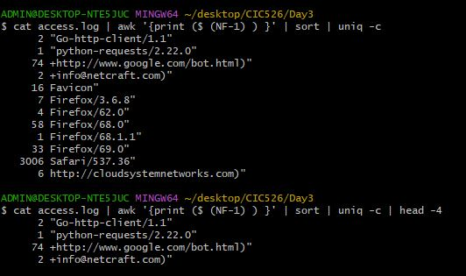

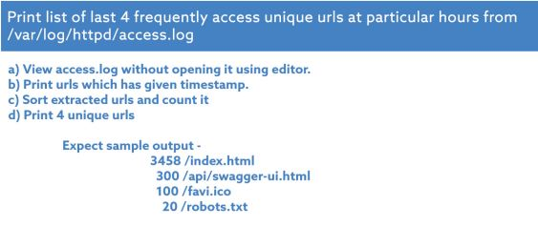

ADMIN@DESKTOP-NTE5JUC MINGW64 ~/desktop/CIC526/Day3

$ cat access.log | awk '{print $4 , $ (NF-1) }'

[11/Sep/2019:22:54:52 +http://www.google.com/bot.html)"

[14/Sep/2019:06:36:37 http://cloudsystemnetworks.com)"

[14/Sep/2019:18:56:46 +http://www.google.com/bot.html)"

[14/Sep/2019:18:56:46 +http://www.google.com/bot.html)"

[14/Sep/2019:20:44:44 +http://www.google.com/bot.html)"

[15/Sep/2019:13:56:11 +http://www.google.com/bot.html)"

[15/Sep/2019:17:37:56 Firefox/62.0"

.

.

.

ADMIN@DESKTOP-NTE5JUC MINGW64 ~/desktop/CIC526/Day3

$ cat access.log | awk '{print $4 , $ (NF-1) }' | sort

[01/Oct/2019:05:44:10 Firefox/68.0"

[01/Oct/2019:05:44:12 Firefox/68.0"

[01/Oct/2019:05:44:12 Firefox/68.0"

[01/Oct/2019:05:44:12 Firefox/68.0"

[01/Oct/2019:05:44:12 Firefox/68.0"

[01/Oct/2019:05:44:13 Firefox/68.0"

[01/Oct/2019:05:44:13 Firefox/68.0"

[01/Oct/2019:05:46:39 Firefox/68.0"

[01/Oct/2019:05:46:41 Firefox/68.0"

.

.

.

.

ADMIN@DESKTOP-NTE5JUC MINGW64 ~/desktop/CIC526/Day3

$ cat access.log | awk '{print $4 , $ (NF-1) }' | sort | uniq -c | head -4

1 [01/Oct/2019:05:44:10 Firefox/68.0"

4 [01/Oct/2019:05:44:12 Firefox/68.0"

2 [01/Oct/2019:05:44:13 Firefox/68.0"

1 [01/Oct/2019:05:46:39 Firefox/68.0"

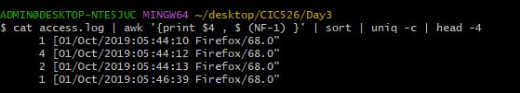

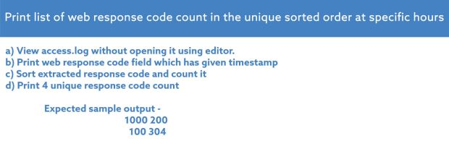

ADMIN@DESKTOP-NTE5JUC MINGW64 ~/desktop/CIC526/Day3

$ cat access.log | awk '{print $9, $9 }'

200 200

200 200

200 200

200 200

200 200

200 200

200 200

.

.

.

ADMIN@DESKTOP-NTE5JUC MINGW64 ~/desktop/CIC526/Day3

$ cat access.log | awk '{print $9, $9 }' | sort

200 200

200 200

200 200

200 200

200 200

200 200

.

ADMIN@DESKTOP-NTE5JUC MINGW64 ~/desktop/CIC526/Day3

$ cat access.log | awk '{print $9, $9 }' | sort | uniq -c

3176 200 200

8 206 206

26 304 304

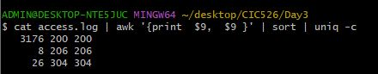

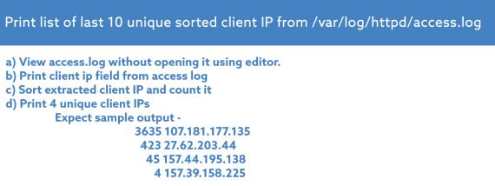

ADMIN@DESKTOP-NTE5JUC MINGW64 ~/desktop/CIC526/Day3

$ cat access.log | awk '{print $1 }'

10.56.2.2

10.56.22.3

10.56.19.3

10.56.19.3

10.56.4.2

10.56.3.4

10.56.4.2

10.56.0.3

10.56.0.3

10.56.0.3

.

.

.

ADMIN@DESKTOP-NTE5JUC MINGW64 ~/desktop/CIC526/Day3

$ cat access.log | awk '{print $1 }' | sort

10.56.0.3

10.56.0.3

10.56.0.3

10.56.0.3

10.56.0.3

10.56.0.3

10.56.0.3

10.56.0.3

10.56.0.3

10.56.0.3

10.56.0.3

.

.

.

ADMIN@DESKTOP-NTE5JUC MINGW64 ~/desktop/CIC526/Day3

$ cat access.log | awk '{print $1 }' | sort | uniq -c

261 10.56.0.3

283 10.56.1.3

213 10.56.10.2

345 10.56.19.3

383 10.56.2.2

323 10.56.21.2

251 10.56.22.3

214 10.56.3.4

9 10.56.34.4

242 10.56.4.2

7 10.56.44.4

40 10.56.46.2

168 10.56.5.2

285 10.56.6.4

186 10.56.9.3

ADMIN@DESKTOP-NTE5JUC MINGW64 ~/desktop/CIC526/Day3

$ cat access.log | awk '{print $1 }' | sort | uniq -c | tail -10

323 10.56.21.2

251 10.56.22.3

214 10.56.3.4

9 10.56.34.4

242 10.56.4.2

7 10.56.44.4

40 10.56.46.2

168 10.56.5.2

285 10.56.6.4

186 10.56.9.3

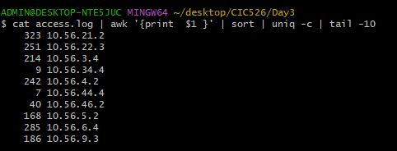

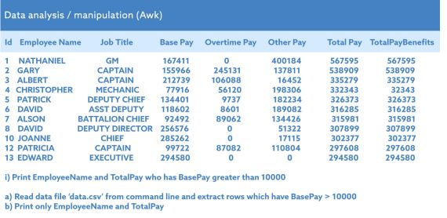

ADMIN@DESKTOP-NTE5JUC MINGW64 ~/desktop/CIC526/Day3

$ cat dataanalysis.csv

Id EmployeeName JobTitle BasePay OvertimePay OtherPay TotalPay TotalPayBenefits

1 NATHANIEL GM 167411 0 400184 567595 567595

2 GARY CAPTAIN 155966 245131 137811 538909 538909

3 ALBERT CAPTAIN 212739 106088 16452 335279 335279

4 CHRISTOPHER MECHANIC 77916 56120 198306 332343 332343

5 PATRICK DEPUTYCHIEF 134401 9737 182234 326373 326373

6 DAVID ASSTDEPUTY 118602 8601 189082 316285 316285

7 ALSON BATTALIONCHIEF 92492 89062 134426 315981 315981

8 DAVID DEPUTYDIRECTOR 256576 0 51322 307899 307899

10 JOANNE CHIEF 285262 0 17115 302377 302377

12 PATRICIA CAPTAIN 99722 87082 110804 297608 297608

13 EDWARD EXECUTIVE 294580 0 0 294580 294580

ADMIN@DESKTOP-NTE5JUC MINGW64 ~/desktop/CIC526/Day3

$ cat dataanalysis.csv | awk '{ if ( $4 >= 10000) print $0 }'

Id EmployeeName JobTitle BasePay OvertimePay OtherPay TotalPay TotalPayBenefits

1 NATHANIEL GM 167411 0 400184 567595 567595

2 GARY CAPTAIN 155966 245131 137811 538909 538909

3 ALBERT CAPTAIN 212739 106088 16452 335279 335279

4 CHRISTOPHER MECHANIC 77916 56120 198306 332343 332343

5 PATRICK DEPUTYCHIEF 134401 9737 182234 326373 326373

6 DAVID ASSTDEPUTY 118602 8601 189082 316285 316285

7 ALSON BATTALIONCHIEF 92492 89062 134426 315981 315981

8 DAVID DEPUTYDIRECTOR 256576 0 51322 307899 307899

10 JOANNE CHIEF 285262 0 17115 302377 302377

12 PATRICIA CAPTAIN 99722 87082 110804 297608 297608

13 EDWARD EXECUTIVE 294580 0 0 294580 294580

ADMIN@DESKTOP-NTE5JUC MINGW64 ~/desktop/CIC526/Day3

$ cat dataanalysis.csv | awk '{ if ( $4 >= 10000) print $2, $7 }'

EmployeeName TotalPay

NATHANIEL 567595

GARY 538909

ALBERT 335279

CHRISTOPHER 332343

PATRICK 326373

DAVID 316285

ALSON 315981

DAVID 307899

JOANNE 302377

PATRICIA 297608

EDWARD 294580

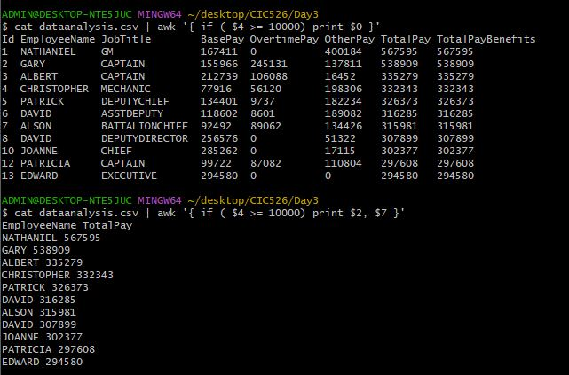

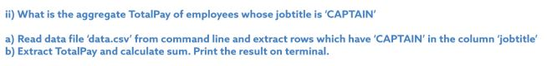

ADMIN@DESKTOP-NTE5JUC MINGW64 ~/desktop/CIC526/Day3

$ cat dataanalysis.csv | grep -i captain

2 GARY CAPTAIN 155966 245131 137811 538909 538909

3 ALBERT CAPTAIN 212739 106088 16452 335279 335279

12 PATRICIA CAPTAIN 99722 87082 110804 297608 297608

ADMIN@DESKTOP-NTE5JUC MINGW64 ~/desktop/CIC526/Day3

$ cat dataanalysis.csv | grep -i captain | awk '{ total += $7; count ++} END { print total/count}'

390599

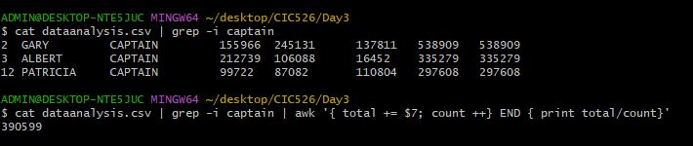

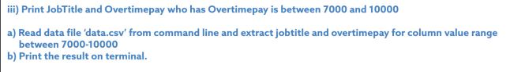

ADMIN@DESKTOP-NTE5JUC MINGW64 ~/desktop/CIC526/Day3

$ cat dataanalysis.csv | awk '{ if ( $5 < 10000 && $5 > 7000 ) print $3, $5}'

DEPUTYCHIEF 9737

ASSTDEPUTY 8601

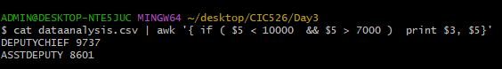

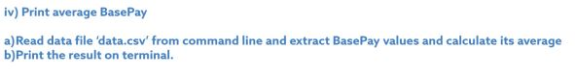

ADMIN@DESKTOP-NTE5JUC MINGW64 ~/desktop/CIC526/Day3

$ cat dataanalysis.csv | awk '{ t += $4; c++ } END { print t/c }'

157972



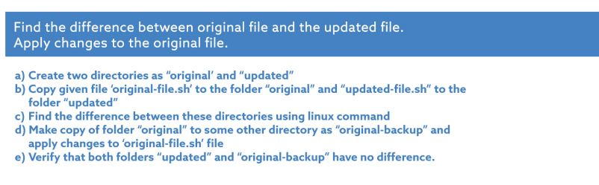

ADMIN@DESKTOP-NTE5JUC MINGW64 ~/desktop/CIC526/Day3

$ mkdir original updated

ADMIN@DESKTOP-NTE5JUC MINGW64 ~/desktop/CIC526/Day3

$ touch original-file.sh updated-file.sh

ADMIN@DESKTOP-NTE5JUC MINGW64 ~/desktop/CIC526/Day3

$ cp original-file.sh original

ADMIN@DESKTOP-NTE5JUC MINGW64 ~/desktop/CIC526/Day3

$ cp updated-file.sh updated

ADMIN@DESKTOP-NTE5JUC MINGW64 ~/desktop/CIC526/Day3

$ diff original updated

Only in original: original-file.sh

Only in updated: updated-file.sh

ADMIN@DESKTOP-NTE5JUC MINGW64 ~/desktop/CIC526/Day3

$ cp -r original updated/original-backup

