Assignment 8

1. Question 1

1. Question 2

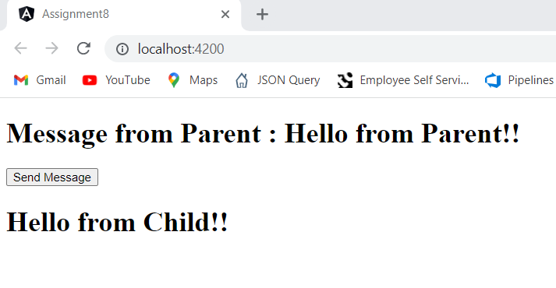

1. Question 3

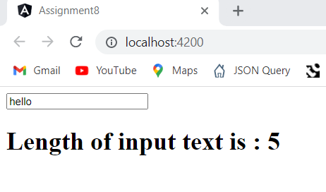

1. Question 4

