Assignment 10

1. Program 1

1. Quetsion 2

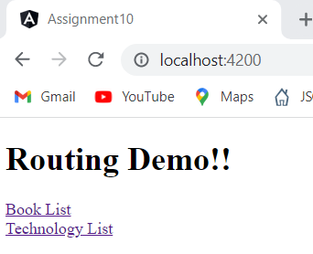

1. Question 3



