Assignment11

1. Question 1

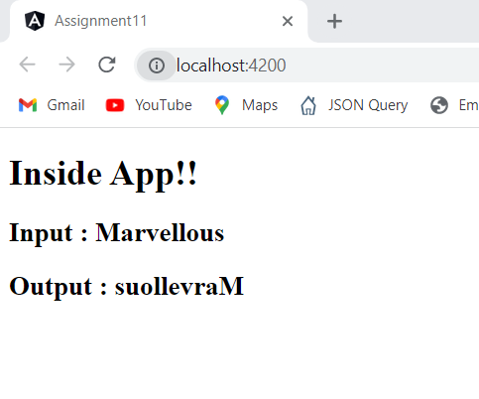

1. Question 2

1. Question 3

