Assignment 7 : Outputs

1. Question 1

1. Question 2

1. Question 3

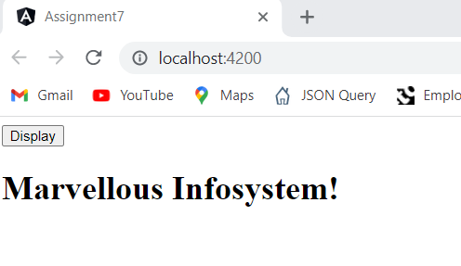

After button click

1. Question 4

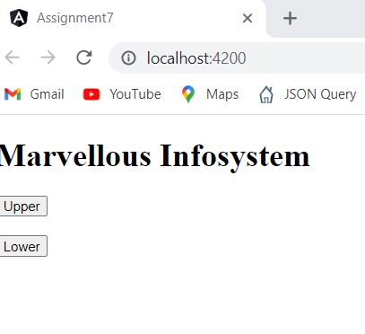

After Upper button click

After Lower button click

