**QUESTION:**

Implement detailed support vector machine using library.

**AIM:**

To implement detailed support vector machine using library.

**ALGORITHM:**

1. Import necessary libraries.
2. Generate synthetic data with two well-separated classes using make_blobs function from sklearn.datasets.
3. Visualize the synthetic data using a scatter plot.
4. Define a range of x-values (xfit) for plotting lines.
5. Plot three lines to potentially separate the two classes.
6. Set limits for the x-axis in the plot.
7. Define a function plot_svc_decision_function to plot decision function for a 2D Support Vector Classifier (SVC).
8. Fit an SVC model with a linear kernel to the synthetic data.
9. Plot the SVC decision function with support vectors using the defined function.
10. Define a function plot_svm to plot SVM decision function for different sample sizes.
11. Create subplots for different sample sizes and plot SVM decision function.
12. Adjust subplot layout and titles.

**PROGRAM:**

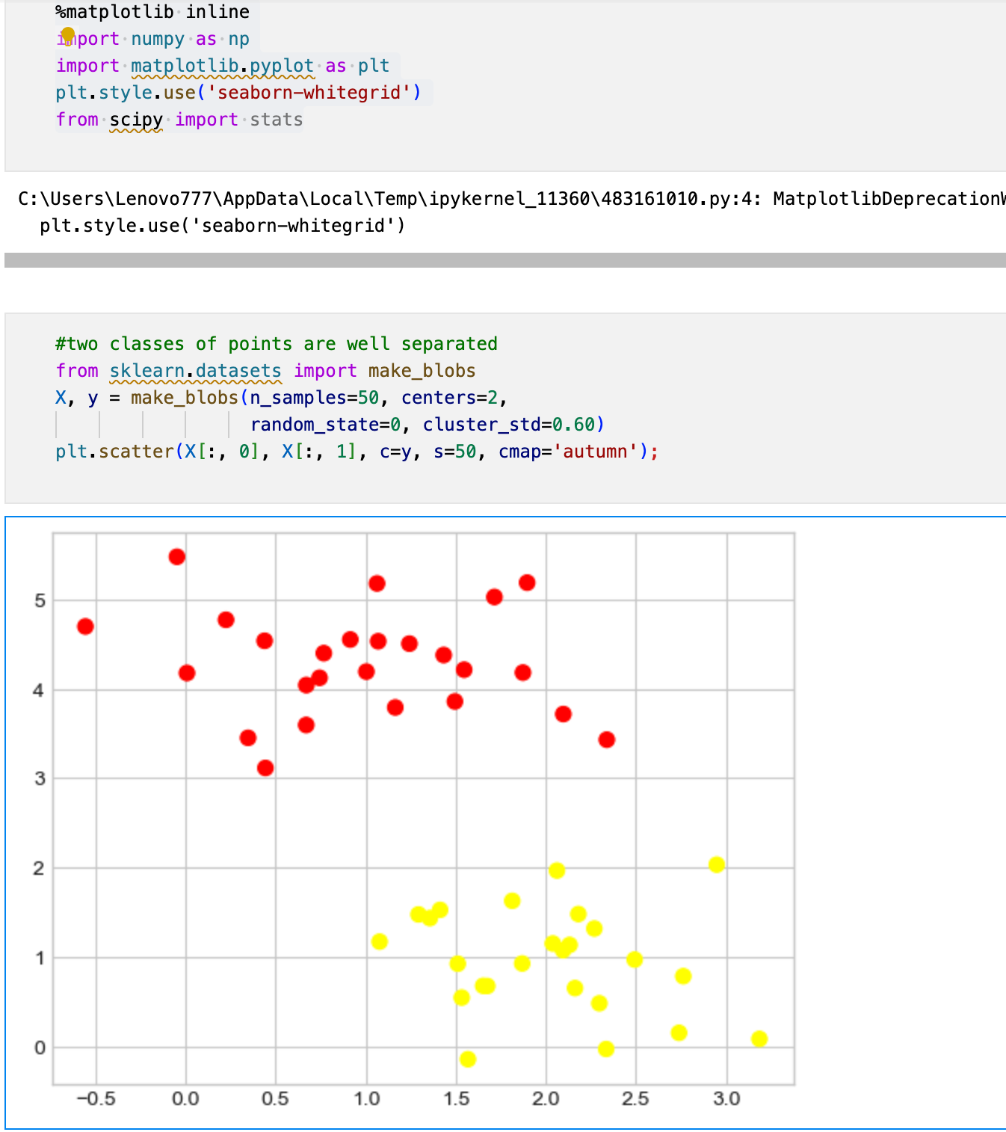

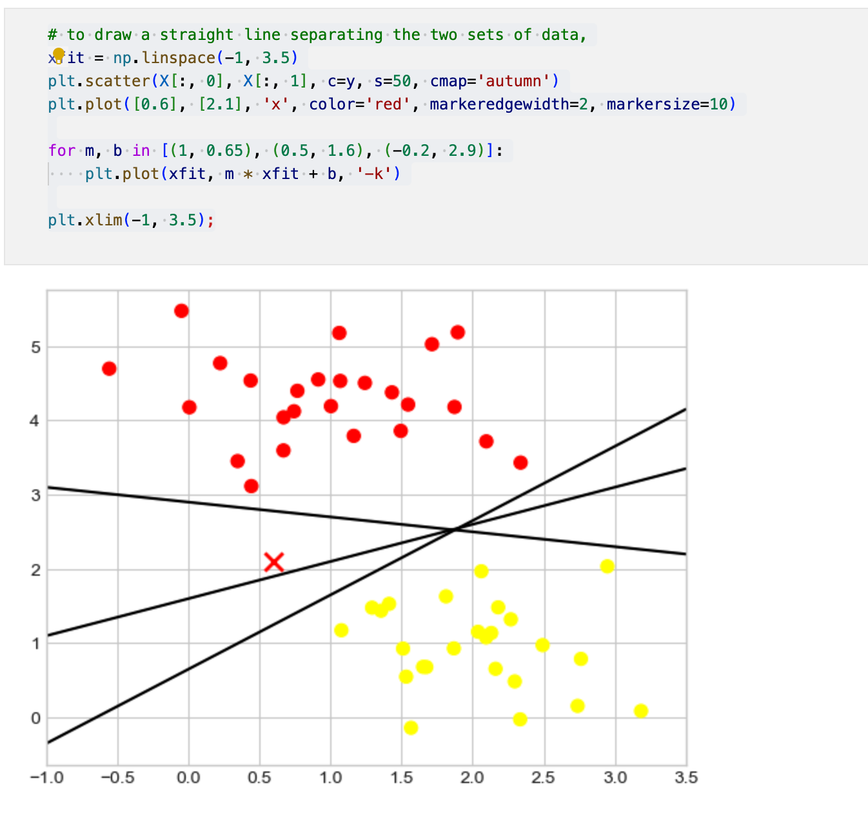

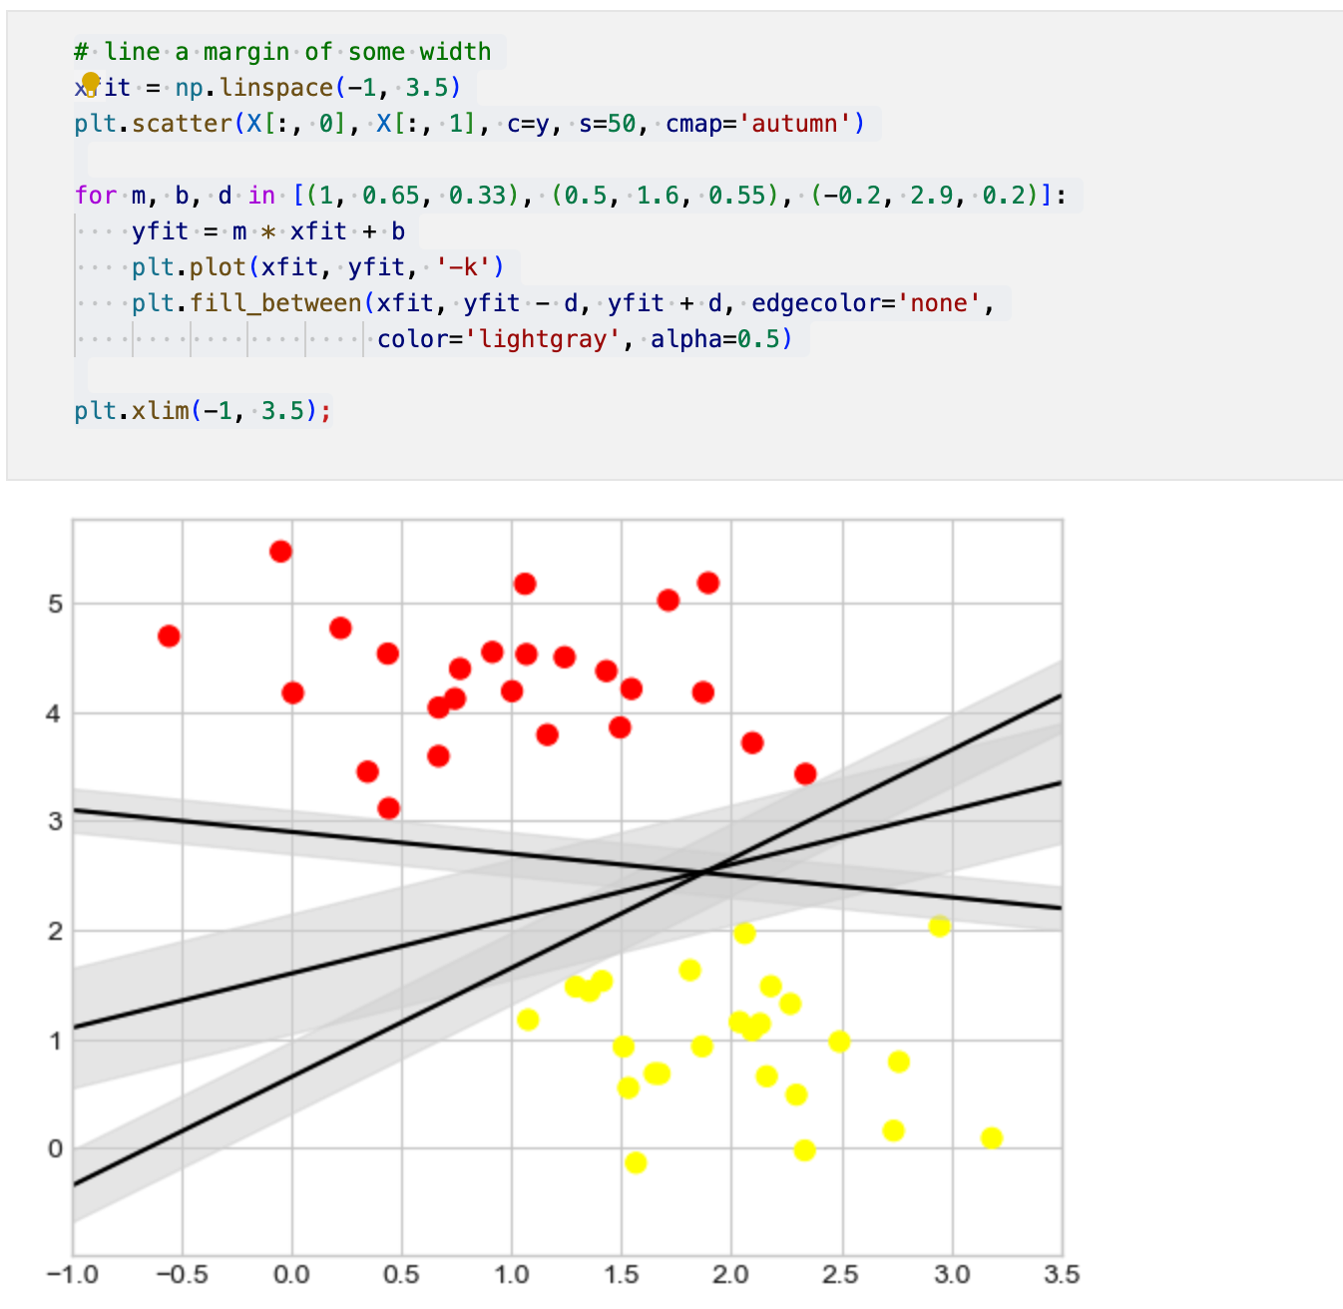

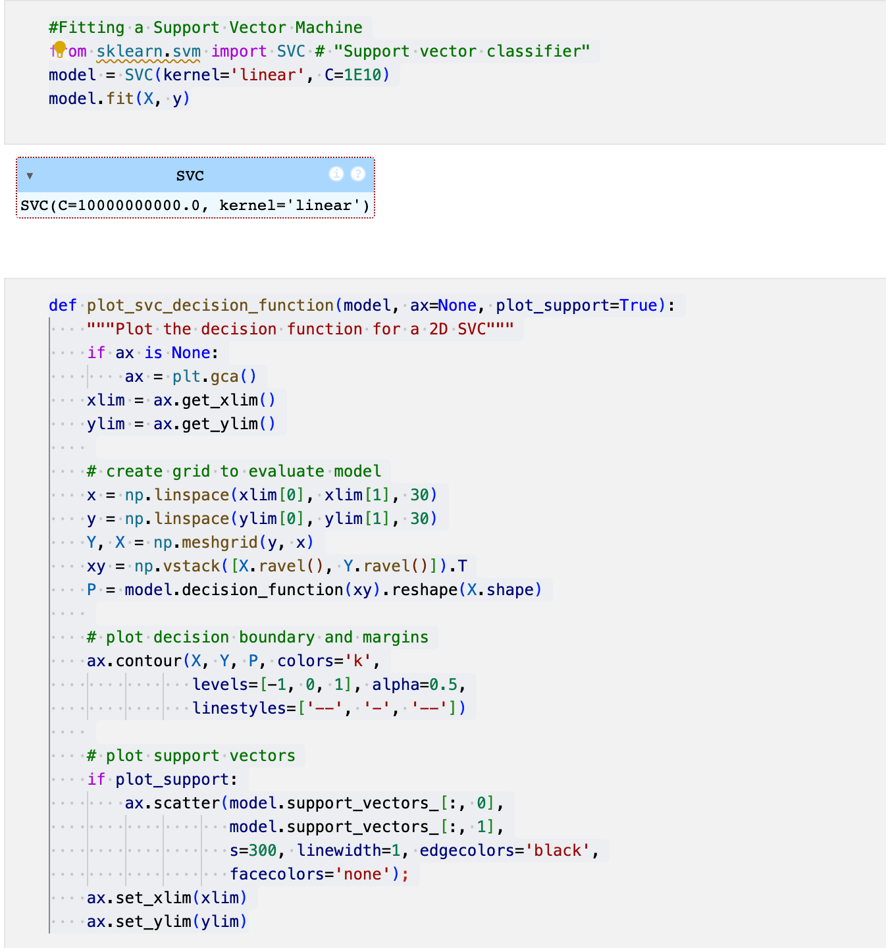

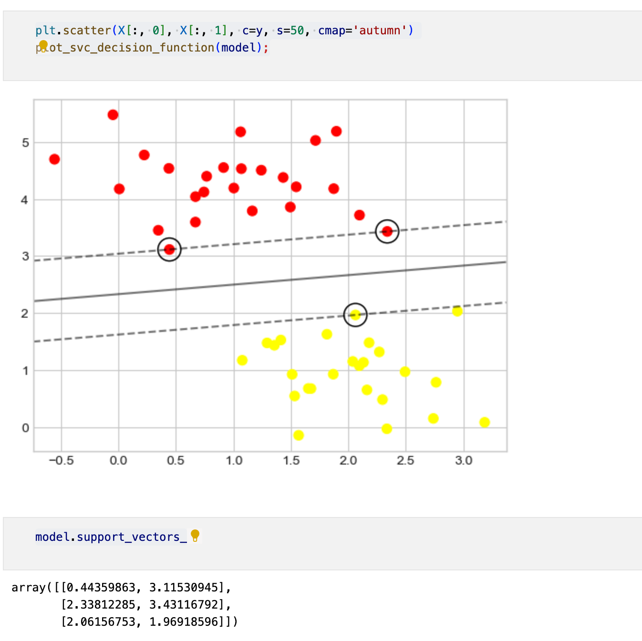

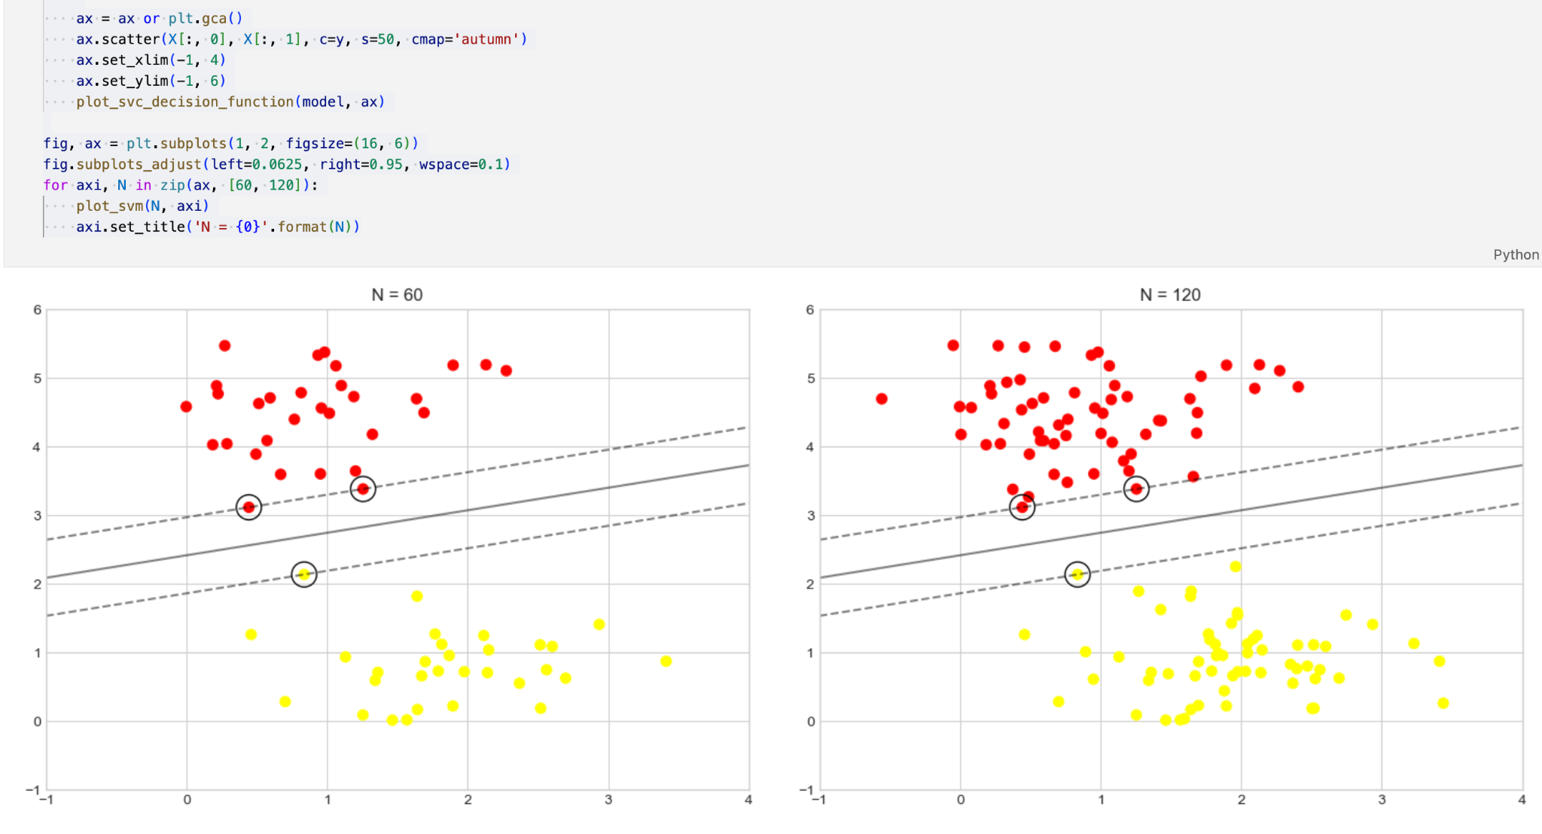

**RESULT:**

Thus the implementation of detailed support vector machine has been executed.