In this project as extension we have used PSO (particle swarm optimization) algorithm to choose optimized features from dataset and then after selecting optimized features we will retrain SVM and CNN with optimized features to get better performance F1_score.

PSO will check fitness of each dataset features or columns and whatever column gives better accuracy that column be selected and the column with less accuracy will be dropped and due to this optimization will get better performance.

In below screen you can see F1-score for SVM and CNN without PSO optimization

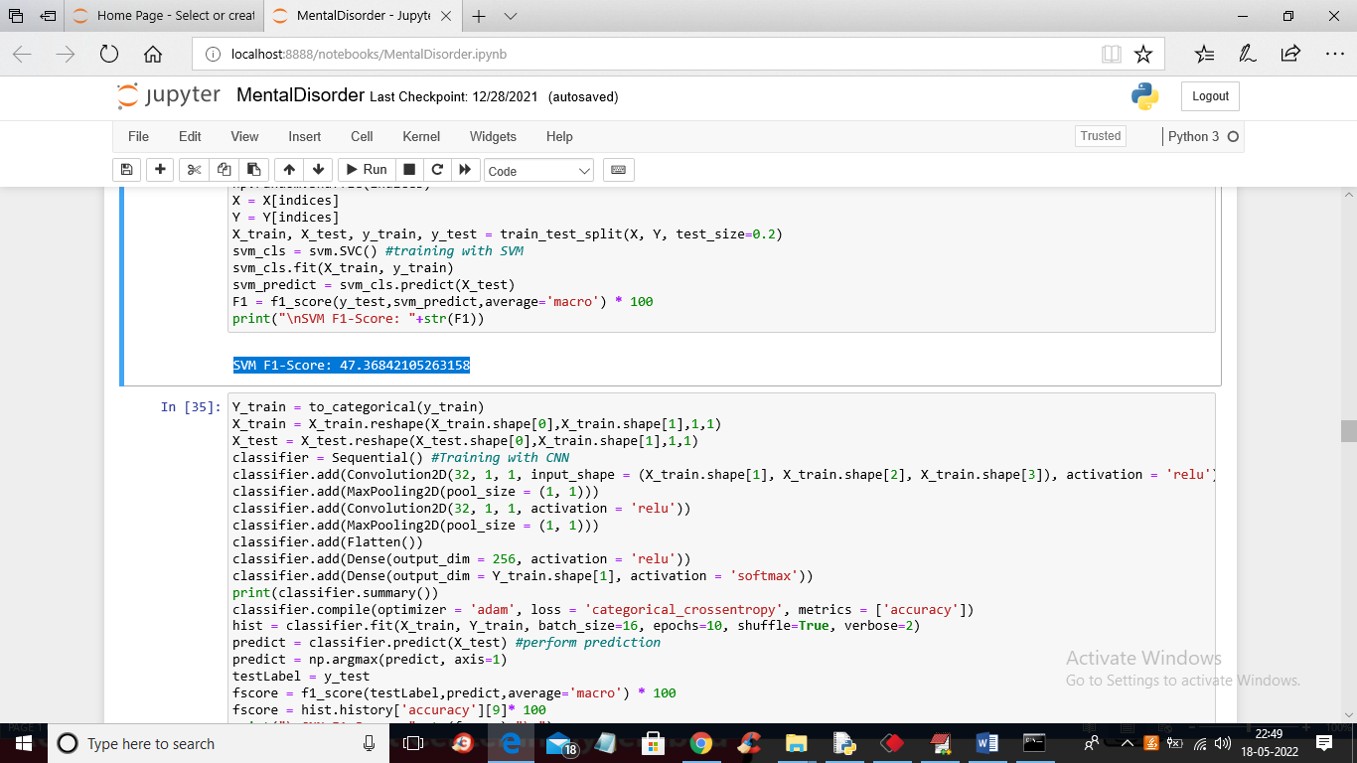

In above screen with SVM without PSO we got 47% accuracy and below is the CNN accuracy without PSO

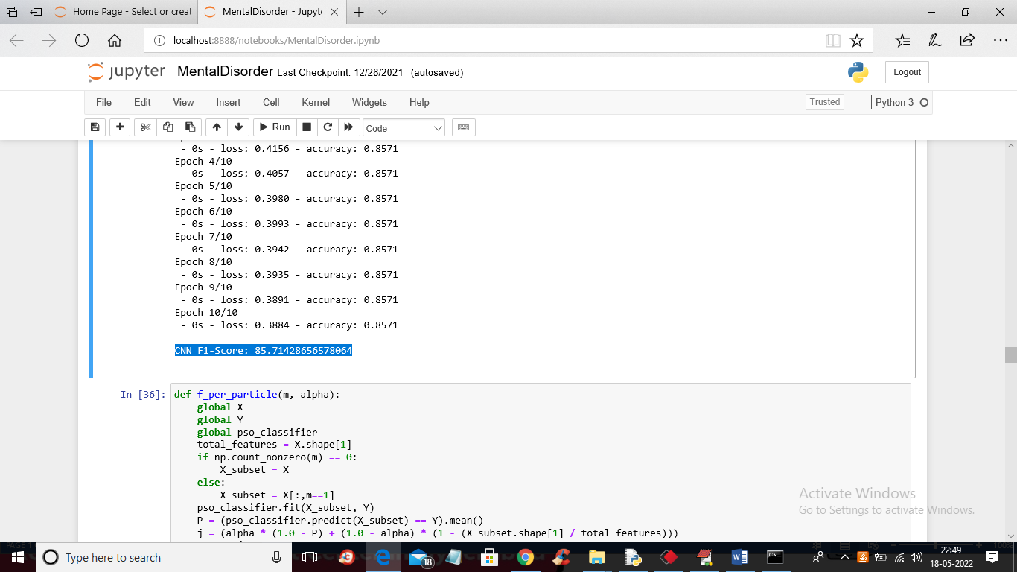

In above screen with CNN we got 85% F1-Score and in below screen you can see code for PSO features selection

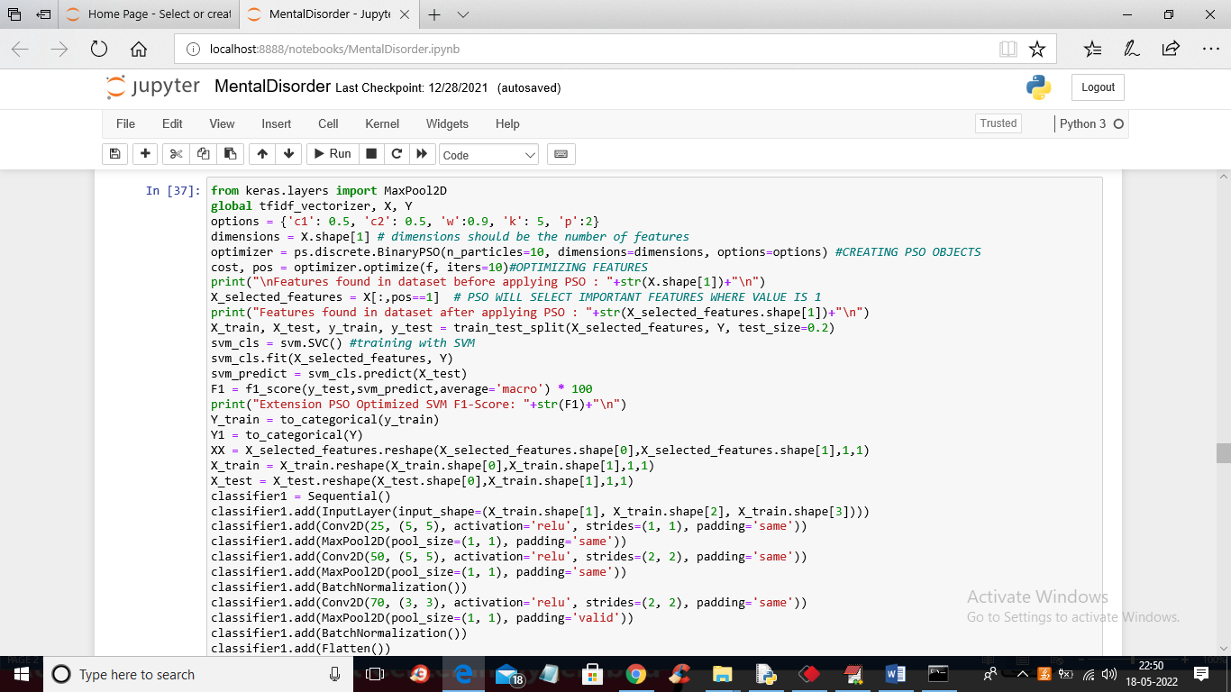

In above screen read blue colour comments to know about PSO features optimization and below is the SVM and CNN PSO optimized F1-Score

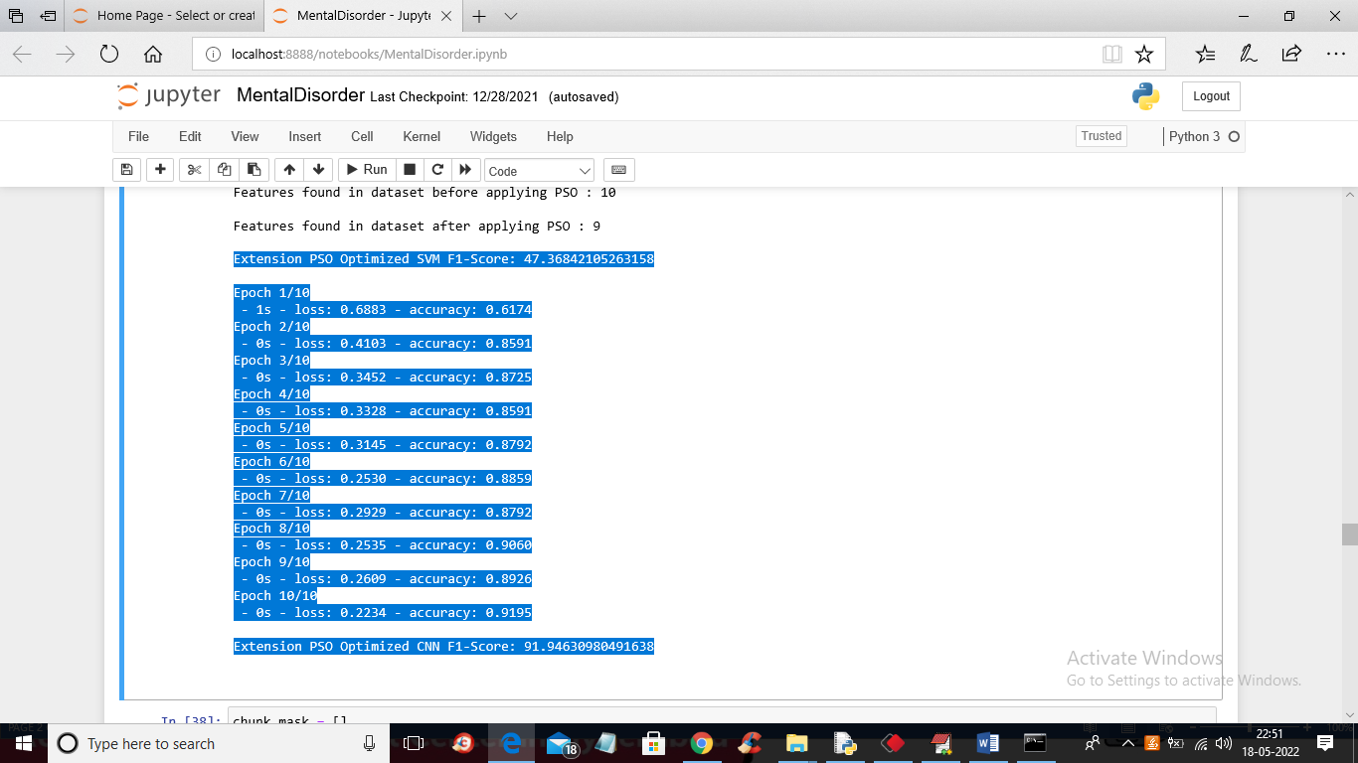

In above screen in first blue line with PSO SVM we got 47% F1-score and in last blue line with PSO CNN we got 91% F1-Score and CNN without PSO we got 85% F1-Score. so by applying PSO optimization technique we can improve CNN performance