Detecting Mental Disorders in Social Media Through Emotional Patterns - The case of Anorexia and Depression

In this project we changed output to GUI TKINTER based application and to get output just double click on ‘run.bat’ file to get below output

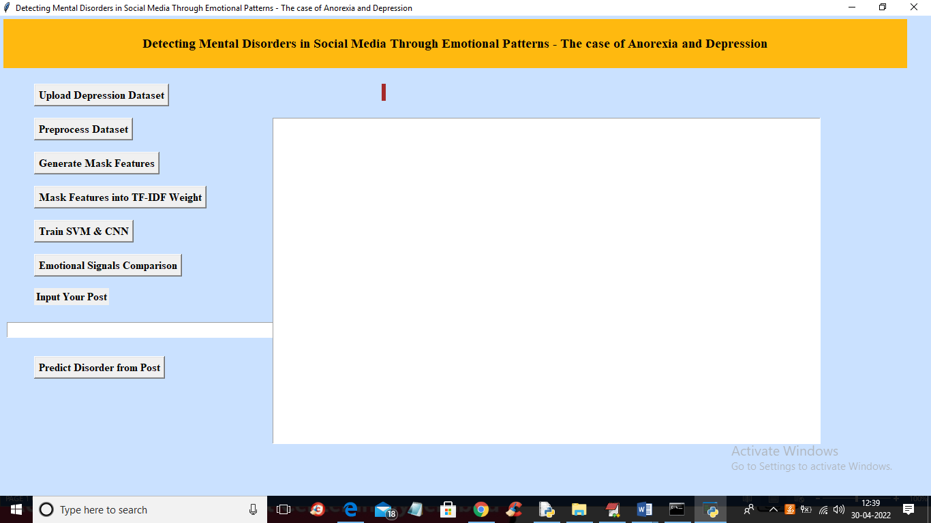

In above screen click on each button one by one as you already familiar with each button functionality and we gave description in previous screen shots and now in above screen click Upload Depression Dataset button to upload dataset called ‘train.csv’

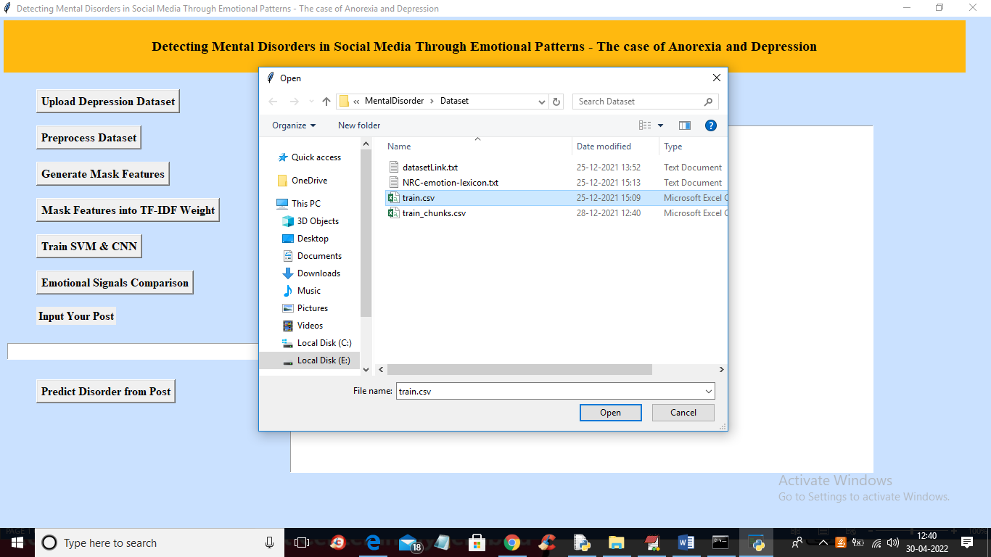

In above screen uploading train.csv dataset file and now click ‘Open’ button to get below output

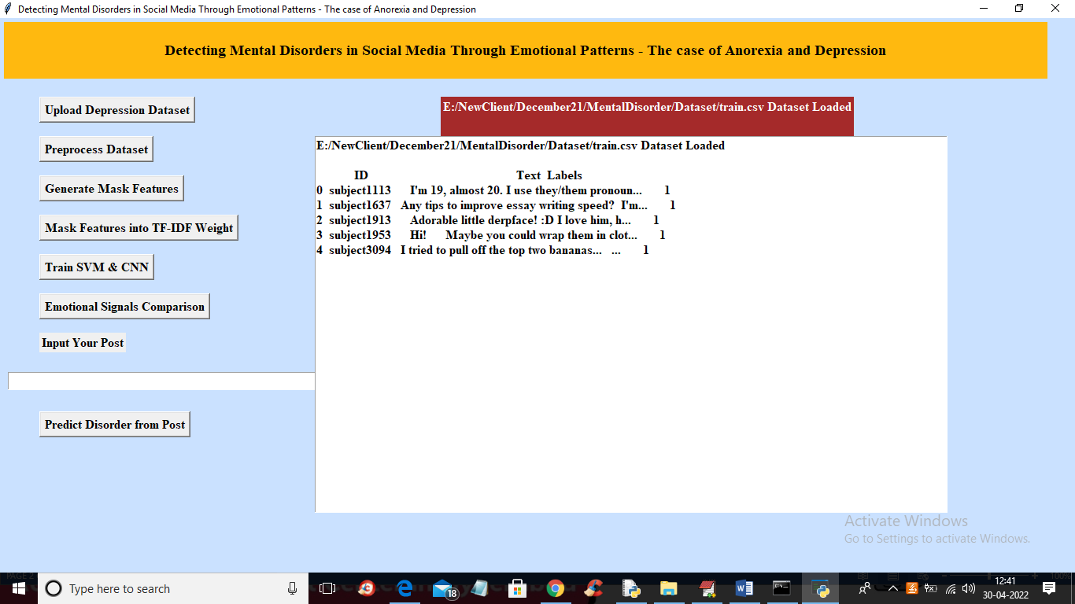

In above screen dataset loaded and now click on ‘Preprocess Dataset’ button to read LEX data and remove special symbols from train data and get below output

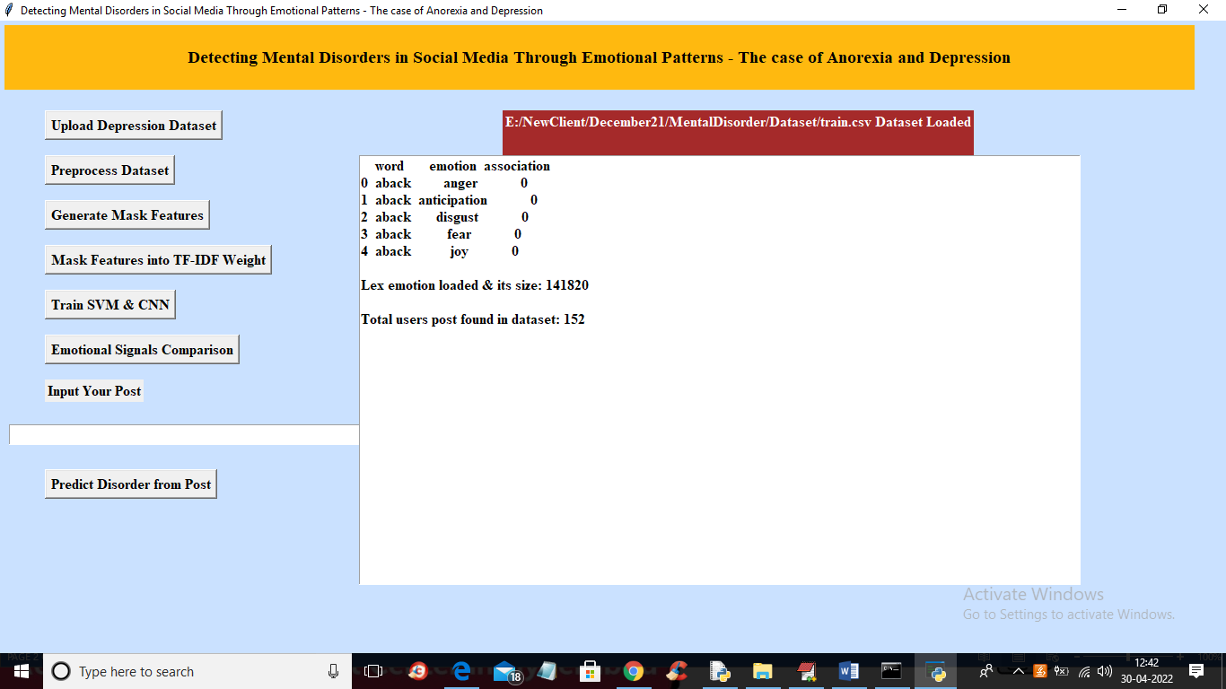

In above screen LEX data reading process completed and total post found in dataset is 152 and now click on ‘Generate Mask features’ to get emotion data like below screen

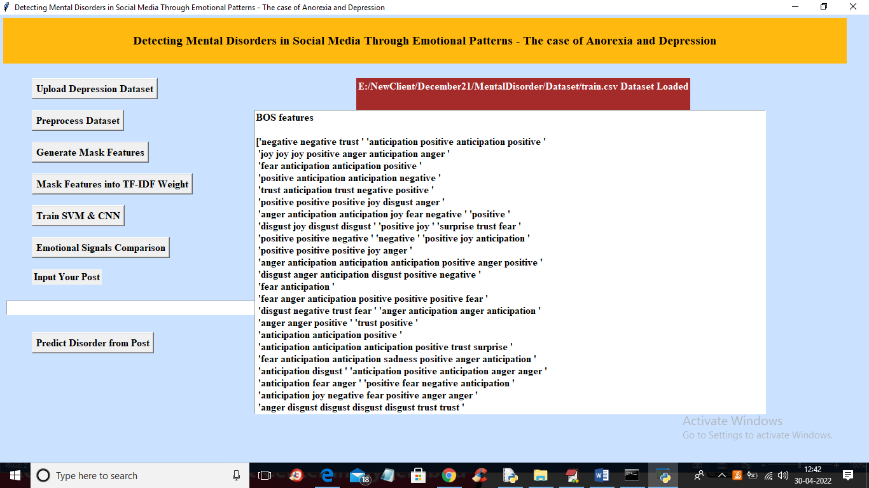

In above screen we can see all emotion mask features and now click on ‘Mask features into TF-IDF Weight’ button to convert mask into numeric vector like below screen

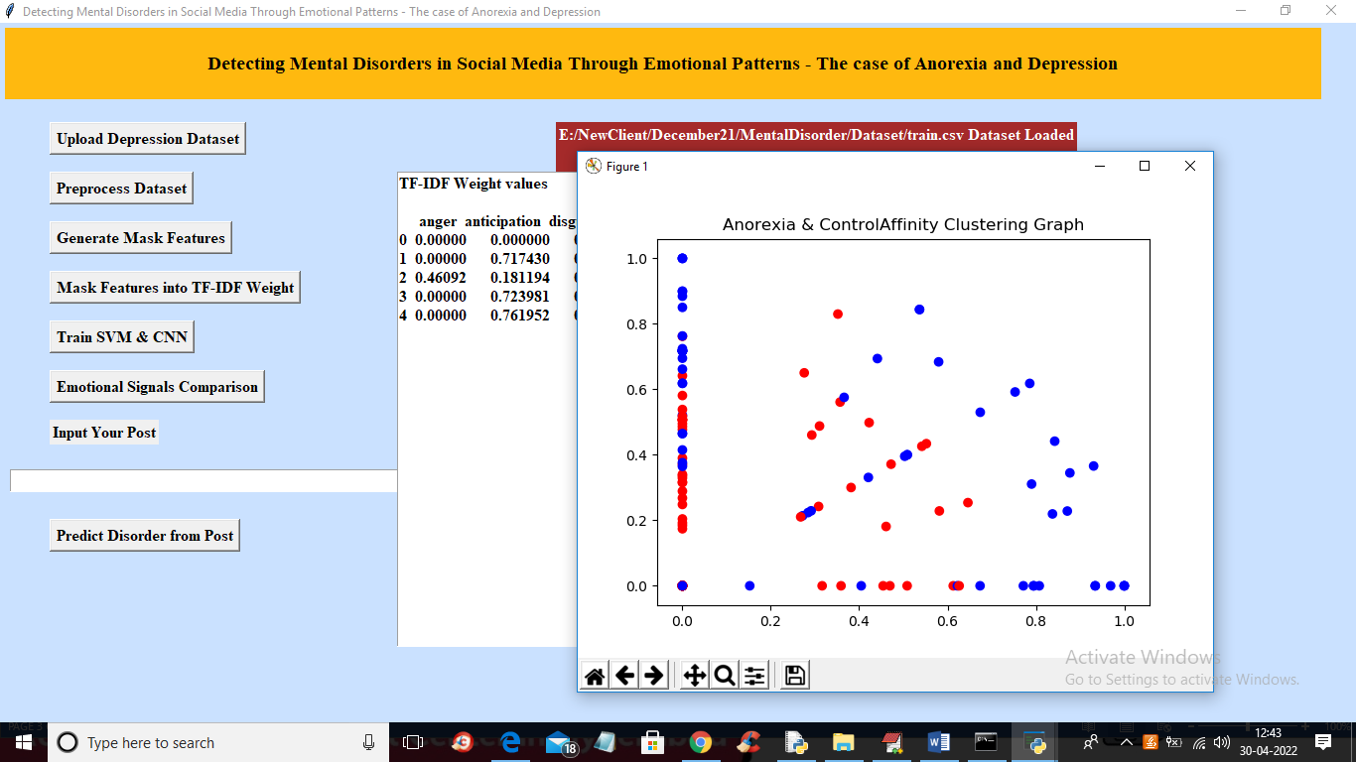

In above screen all values converted to vector and we can clustering graph also and now train SVM and CNN by clicking on ‘Train SVM and CNN’ button

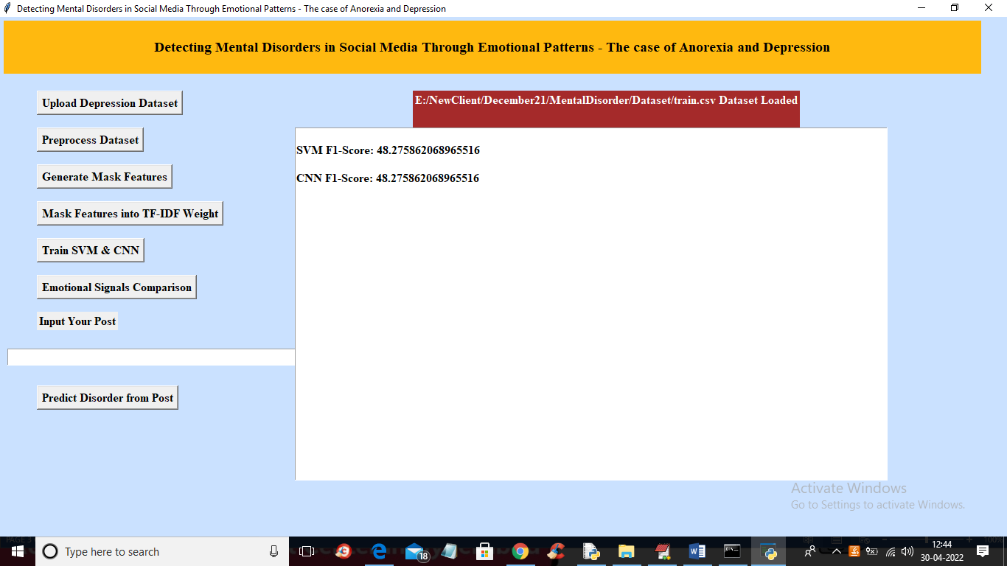

In above screen we got FSCORE for both algorithms and now click on ‘Emotional Signal Comparison’ to get depression for all users

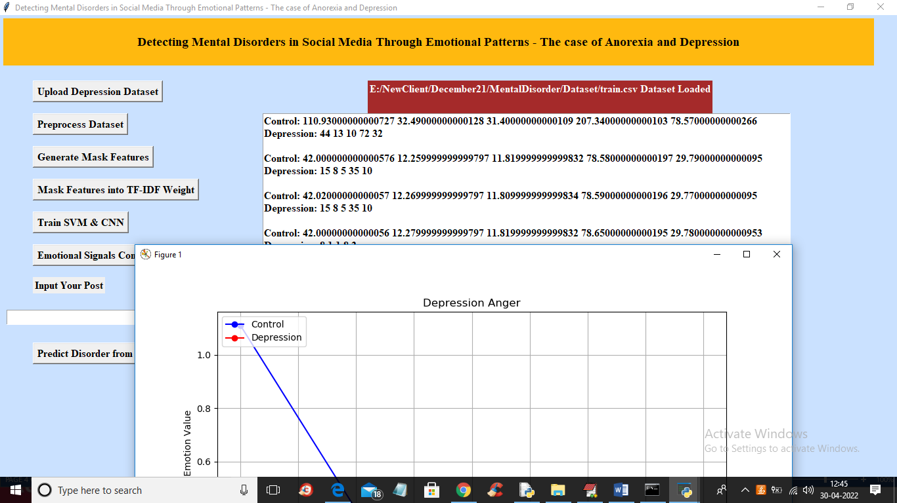

In above screen for all users we got depression and other values and now in last text field you can enter any sentence and then application predict mental disorder and emotion from that sentence

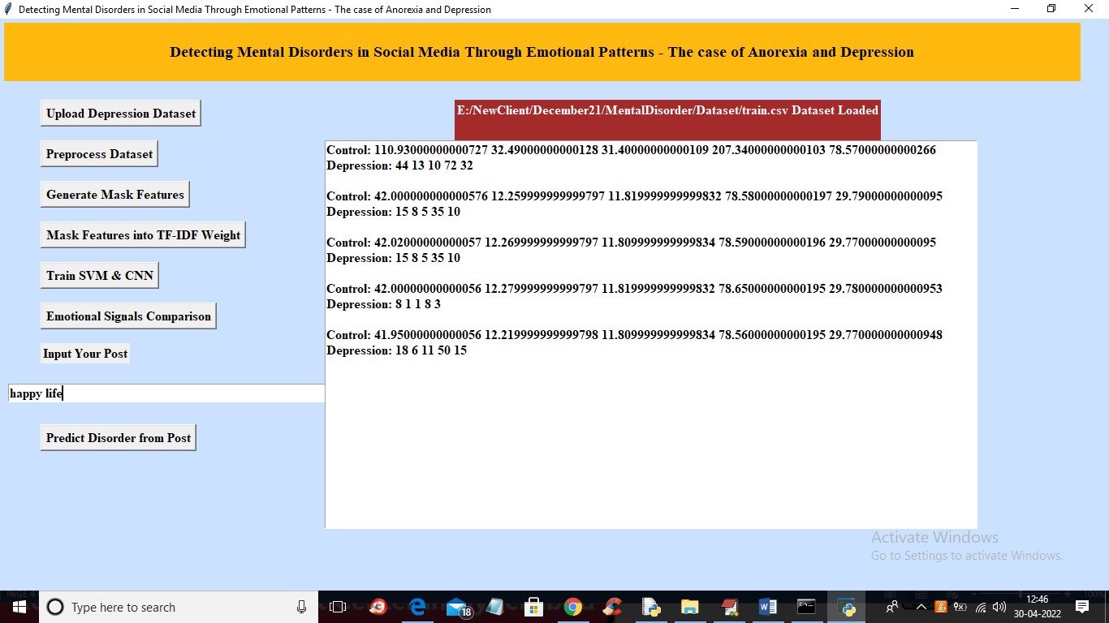

In above screen in text field I entered sentence as ‘happy life’ and press ‘Predict Disorder from Post’ button to get below output

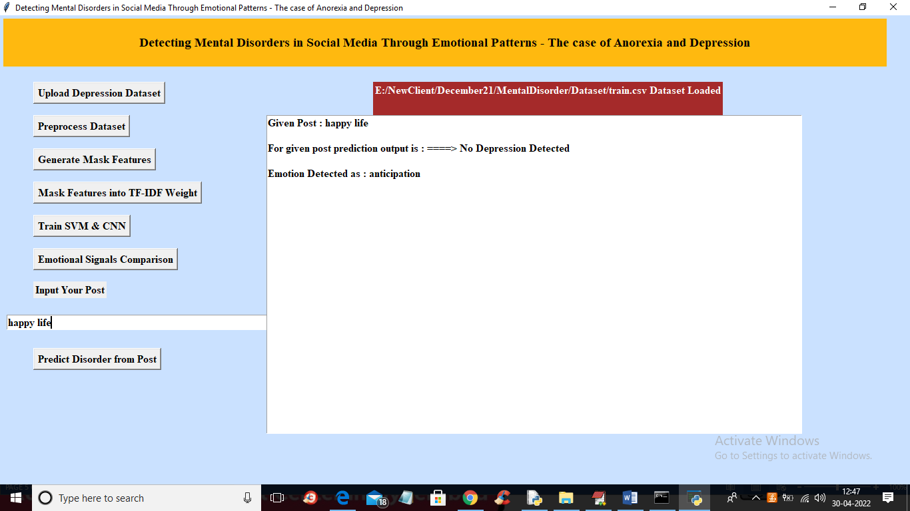

In above screen in text area we got output as ‘No Depression Detected’ with emotion as ‘anticipation’ and now test another POST

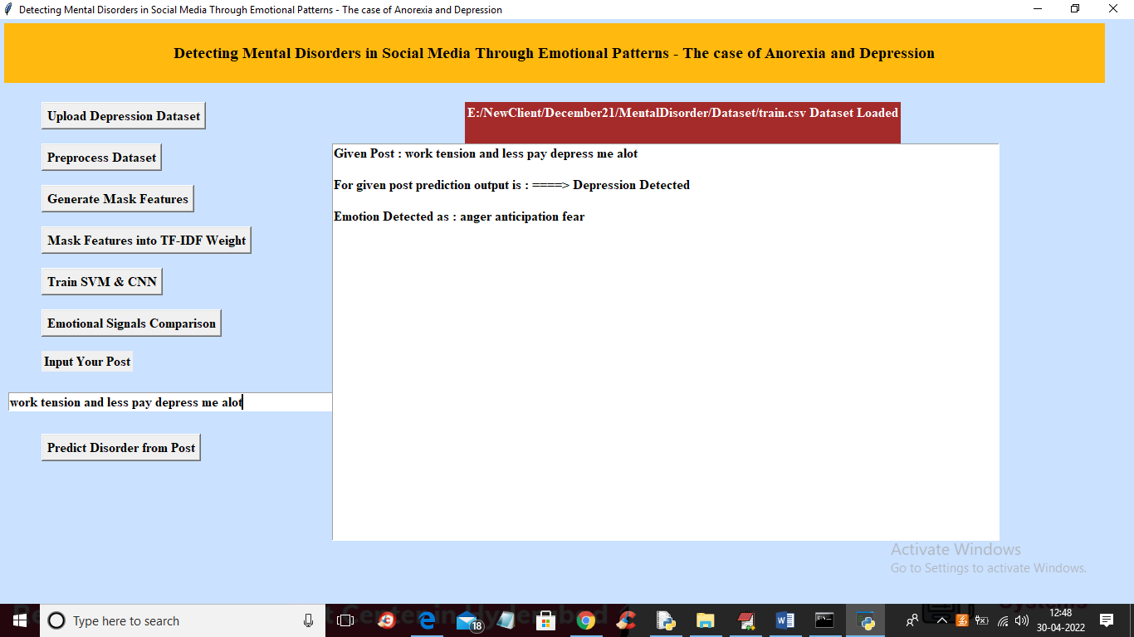

In above screen for given post in text field we got output as ‘Depression Detected’ and similarly you can enter any POST message like person POST and then application will detect disorder from that POST