CLI命令：Show voice sip termination

PPT上的流程图：（与分析的不太一致）

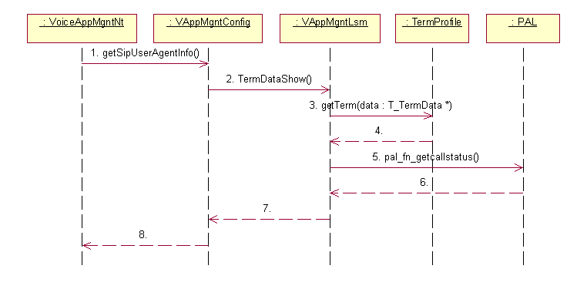

//*************************************NT Board*******************************

步骤1：

//==========================enter VoiceAppMgntNT================================

VoiceSnmpMapper : GetFirstsipTerminationEntry (map[],entry, index_out)

|-🡪 return GetNextsipTerminationEntry(&index_in, map, entry, index_out);

| |-🡪 status = sipTerminationTableIfc_g.getNextSipTerminationIndex(itfIndexIn, itfIndexOut, result);

| | |-🡪 result_o = sipTerminationTblPtr_m->getNextSipTerminationIndex(index, &next_index_o);

| |-🡪 status = sipTerminationTableIfc_g.getSipTerminationEntry(itfIndexOut, voice_types::True, data, result);

| | |-🡪 result_o = sipTerminationTblPtr_m->getSipTerminationEntry(index, &termData_o);

| | | |-🡪 sipTermiation_logicalToLinear(logicalIndex, &linearIndex);

| | |-🡪 result = sipLineIdSynProfTblPtr_m->getNextSipLSPIndex(index_lsp, &index_lsp);

| | |-🡪 status = configNtToLsmIfc_m.getSipTerminationInfo(logicalIndex,termData_lt, result, ris);

//==========================enter VoiceAppMgntConfig=============================

IOCM::Status VoiceAppMgntConfig::VoiceConfig_NtToLsm_ifc::getSipTerminationInfo(term_index, termInfo_o, result_o, _invocation)

|-🡪VoiceAppMgntConfig::VoiceConfig_NtToLsm_ske* _skeP_l = reinterpret_cast<VoiceAppMgntConfig::VoiceConfig_NtToLsm_ske*>(_tmpP_l);

|-🡪_skeP_l->getSipTerminationInfo(term_index, termInfo_o, result_o, _invocation);

//*************************************LT Board*******************************

步骤2：

//==========================enter VAppMgntConfig============================

void VAppMgntConfig::getSipTerminationInfo(term_index,termInfo_o,result_o,invocation)

|-🡪termidx = sipLogicalIndexToTermIndex(term_index);

|-🡪VSIP_OK!=VappLsmSipMgntIfc::GetInstance()->GetTerm(&termInfo_o,termidx)

//==========================enter VoiceAppMgntLsm==============================

errcode VappLsmSipMgntIfc::GetTerm(voice_types::T_SipTerminationData *pTermData, U16 id)

|-🡪SipMgnt_GetStatus((void*)pHdr,(void*) &pRespMsgBody);

| |-🡪ipMgnt::GetStatus((voipMsgHeader_t*)pMsgHeader, resp);

| | |-🡪case MSG_GET_SIPSUBSCRIBER_REQ: SipSubscriberMgr::GetStatus(pMsg,resp);

| | | |-🡪SipTermination::SipTermPointers[dIndex]->ProcessGetReq(respMsg);

| | | | |-🡪pal_fn_getcallstatus(m_lineId, &callstatus);

//==========================enter TermProfile====================================

步骤5：

//==========================enter PAL============================================

void pal_fn_getcallstatus( Pal_ty_u32bit index, Pal_ty_u16bit *callstatus)

|-🡪 TermFsm_getCallStatus(pTermProfile, callstatus);