## 1，主叫端流程

### 1，1~3

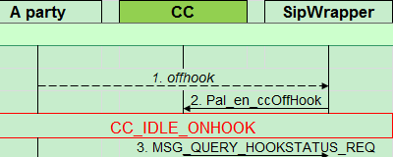

/*****************Enter SIP Wrapper******************************************

Root()

|--🡪application_init()

| |-🡪init_application()

| | |-🡪AccessNeZIPS* pZips = new AccessNeZIPS (queueId);

|-🡪init_SipWrapper

|-🡪xt_start(task_id, T_PREEMPT|T_TSLICE, SipWrapper_main, NULL);

|-🡪SipWrapper_main

handle_HptMsg();

|-🡪Case POTS_EVENT_MSG:

|----🡪 Case GEN_HOOK_STATE_CHANGED

|---🡪 handle_term_ev_offhook()

| ---🡪 sipw_led_on() //Turn led on

|----🡪 sipw_confDCSlope/// assign dsp resource

|---🡪 sipw_assignDsp() //

|---🡪 sipw_allocDspRes() // Get a free DSP resource

|----🡪 gen_voice_hww::getgen_voice_hww()->initiateCall(…..) // Allocates the resources related with basic call

|--🡪 gen_voice_hww::getgen_voice_hww()->configureDataChannel() //

|--🡪 send_event_to_ppu(MG_E_OFF_HOOK,termId);

/*****************Enter PAL***********************************************

* Function pal_fn_msghandler() is the key function for PAL. PAL module is event driven.

* While(1) {} in pal_fn_msghandler to handle event/message(internal and external msg).

* 1. Enter pal_fn_voipManagerMsgHandler to deal with term event and change term state

* machine if there are term state change(e.g. off hook, on hook).

* 2 then, pass msg to CC or MM by pal_fn_internalDerivedCcEvent and change CC or CM state

* machine.

***************************************************************************/

pal_main

|

|-🡪pal_fn_msghandler

|-🡪 pal_fn_voipManagerMsgHandler

|

|--🡪 case MSG_EVT_DETECTED_IND:

| |

| |-> case case MG_E_OFF_HOOK:

| | |🡪pal_fn_sendLineFeedingRequest

| | | |->pal_fn_voipSendRequestToPlatform

| | | | |🡪 pal_fn_print_msg_to_platform

| |

| | |🡪 dCurrentState =(pTermProfile->dTerminalState).dCurrentState; (*pal_glb_stateHandlerArray[dCurrentState])(pTermProfile, g_pCallData, Pal_en_offHook, &dErr);

pal_fn_idleOnHook() // This function handles the events received in IDLE State

|

|

|🡪 case Pal_en_offHook:

| |-> AllocLmId(LMID_BSM_ALLOC, (Pal_ty_u32bit *)&pCallContextData->dCallId, pTermProfile->dLineId);

| |-🡪 pal_fn_printCallStatistics(pTermProfile, pCallContextData, pErr);

| |----🡪 pal_internal_msg_mgr::getInstance()->post_plat_message_on_term

| | |-🡪 pal_internal_msg_mgr::getInstance()->post_plat_message

| | | |-🡪 post_message(orgFsm, dstFsm, event, lineId, ctxId, pmsg, isUrgent);

|--🡪 Exit pal_fn_voipManagerMsgHandler

/*****************Enter CC ***********************************************/

pal_fn_msghandler()

|--🡪 pal_internal_msg_mgr::getInstance()->process_msg();

| |--🡪 case Pal_en_callControlFsm:

| | |--🡪pal_fn_internalDerivedCcEvent //

| | | |--🡪 case Pal_en_callControlFsm:

| | | | |-🡪 (*pal_glb_callStateHandlerArray[dNextPendState])( pTermProfile, pCallData, dInputEvent, pErr)

pal_fn_ccIdleOnHook

|

|-🡪 case Pal_en_ccOffHook

| |🡪 pal_fn_sendQueryHookStatusRequest (pal_getCcPlatformTxnId(pTermProfile),

| | |-🡪 pal_fn_voipSendRequestToPlatform(&dVoipMsg,pErr);

| |🡪 pal_fn_setCallStateInfo() // Changing Call state from [CC_IDLE_ONHOOK] to [CC_WAIT_FOR_PLAT_RESP] [CC_IDLE_ONHOOK] for Event:[Pal_en_ccOffHook

### 2，4~6

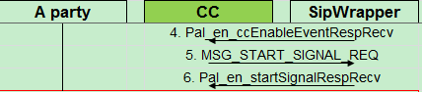

/*****************Enter Sip Wrapper******************************************

SipWrapper_main

|

|🡪 case MSG_QUERY_HOOKSTATUS_REQ:

|🡪 handle_query_hookstatus_req_from_ppu()

| |-🡪 p_resp->msg_id = (msg_id_et)MSG_QUERY_HOOKSTATUS_RESP;

| |🡪 send_msg_to_ppu((unsigned long)p_resp, p_resp->length);

/*****************Enter CC ***********************************************

Receive: Pal_en_ccEnableEventRespRecv from Sip Wrapper

Send: MSG_START_SIGNAL_REQ to SipWrapper

***************************************************************************/

pal_fn_voipManagerMsgHandler

|🡪case MSG_QUERY_HOOKSTATUS_RESP:

| |--🡪 (*pal_glb_callStateHandlerArray[dCurrentCcState])( (pTermProfile, g_pCallData, Pal_en_ccEnableEventRespRecv, &dErr))

| | |-🡪

Pal_ty_retVal pal_fn_ccWaitForPlatResponse()

| |--🡪 case Pal_en_ccEnableEventRespRecv:

| | |-🡪 *pal_glb_callStateHandlerArray[dNextState])(pTermProfile,pCallData,Pal_en_ccEnableEventRespRecv,pErr);

Pal_ty_retVal pal_fn_ccIdleOnHook

|

|--🡪 case Pal_en_ccEnableEventRespRecv:

| |--🡪pal_fn_sendStartSignalBasic(pal_getCcPlatformTxnId(pTermProfile), pTermProfile->dTermId, item, MG_TIMEOUT, duration, pErr);

| | |-🡪pal_fn_sendStartSignalDirection(txn_id, ICF_STREAM_ID_INVALID,scn_term_id, item_id, sig_type, sig_duration, MG_TONE_DIRECT_INTERNAL, pErr);

| |--🡪 pal_fn_setCallStateInfo

Exit pal_fn_ccIdleOnHook

exit pal_fn_voipManagerMsgHandler

/*****************Enter Sip Wrapper********************************************

Receive: MSG_START_SIGNAL_REQ from PAL

Send: MSG_START_SIGNAL_RESP SUCCESS to PAL

***************************************************************************/

SipWrapper_main()

|

|🡪 case MSG_START_SIGNAL_REQ:

**| |🡪** handle_start_signal_req_from_ppu

| | | -🡪 sipw_playTone()

| | |-🡪 send_msg_to_ppu((unsigned long)p_resp, p_resp->length);

/*****************Enter CC********************************************

Receive: MSG_START_SIGNAL_RESP from Sip Wrapper

Send: MSG_START_SIGNAL_RESP SUCCESS to PAL

***************************************************************************/

pal_fn_voipManagerMsgHandler()

|

|--🡪 case MSG_START_SIGNAL_RESP:

| |-🡪 (*pal_glb_callStateHandlerArray[dCurrentCcState])( (pTermProfile, g_pCallData, Pal_en_ccEnableEventRespRecv, &dErr))

| | |-🡪

Pal_ty_retVal pal_fn_ccWaitForPlatResponse()

| |--🡪 case Pal_en_startSignalRespRecv:

| | |-🡪 *pal_glb_callStateHandlerArray[dNextState])(pTermProfile,pCallData,Pal_en_ccEnableEventRespRecv,pErr);

pal_fn_ccIdleOnHook

|

|-🡪 case Pal_en_startSignalRespRecv:

| |-🡪pal_MonitorDM() ///a wrapper over the dl_start_monitor_digitmap

| |-🡪 pal_fn_setCallStateInfo()

Exit pal_fn_ccIdleOnHook

### 3，7~9

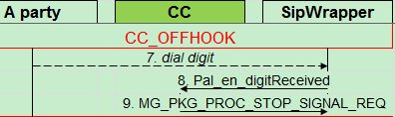

Then terminal dial digit 2, re-enter sipwraper

/*****************Enter SIPWrapper************************************

SipWrapper_main()

|

|-🡪 handle_HptMsg(); // handle POTS proxy events and eqpt msg

| |-🡪case GEN_PULSE_DIGITAL_DETECT_TDM_SIDE:

| | |-🡪 send_dtmf_to_ppu()

handle_HptMsg: port 1 digit 2

/*****************Enter CC********************************************

pal_fn_voipManagerMsgHandler

|🡪case MSG_EVT_DETECTED_IND:

| |--🡪 (*pal_glb_callStateHandlerArray[dCurrentCcState])( (pTermProfile, g_pCallData, Pal_en_ccEnableEventRespRecv, &dErr))

| | |-🡪

pal_fn_ccOffHook()

|

|-🡪case Pal_en_digitReceived:

| |-🡪 pal_TraverseDM()

| | |-🡪 if (DL_SUCCESS == dl_traverse_digit_map(transc_id, digit, p_ecode))

| | | |-🡪 retcode = dl_stop_timer(g_dl_trans_list[transc_id].timer_id,transc_id,p_ecode);

| | | |-🡪(*g_dl_fdig_table[g_dl_trans_list[transc_id].task_id])(transc_id,g_dl_trans_list[transc_id].task_id,、g_dl_trans_list[transc_id].term_id, digit);

| | | | |-🡪pal_first_digit_evt_hdlr(txn_id,service_id,dl_register,index,digit)

| | | | | |-🡪pal_fn_sendStopSignalRequest(0,pTermProfile->dTermId, pTermProfile->dSecondDialTone, &dError);

| | | | | |-🡪pal_fn_setCallStateInfo(&((pTermProfile->pCurrentCallContext)->dCallControlState), DIGIT_RECEIVED,DIGIT_RECEIVED, Pal_en_digitReceived,&dError);

| | | |-🡪num_dm_ptrs = dl_check_digit_in_dm(transc_id, &temp_pat_complete,&temp_complete,&temp_timer_type,

&success,p_temp_dm_stk,digit,&p_digitmap_stk,num_dm_ptrs,counter,&modifier_flag,&immediate_mod_flag,p_ecode);

### 4，11~16

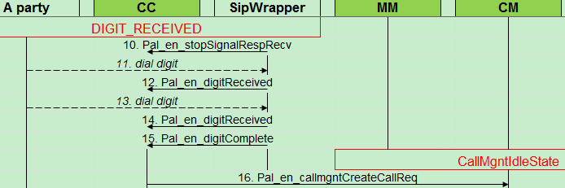

/*****************Enter CC********************************************

pal_fn_voipManagerMsgHandler

|🡪case MSG_EVT_DETECTED_IND:

| |--🡪 (*pal_glb_callStateHandlerArray[dCurrentCcState])( (pTermProfile, g_pCallData, Pal_en_ccEnableEventRespRecv, &dErr))

| | |-🡪

pal_fn_ccOffHook()

|

|-🡪 case Pal_en_digitComplete:

| |-🡪 1 subscrible the number to DB

| |-🡪 pal_fn_createCallReq

| | |-🡪 buildCallRqstInfo

| | | |--🡪 buildCallerInfo

| | | | |🡪 buildLocalUAInfo

| | |-🡪pal_internal_msg_mgr::getInstance()->post_internal_message_on_term(Pal_en_callControlFsm, Pal_en_callmgntFsm, Pal_en_callmgntCreateCallReq, &pGlbTermProfile[dLineId], (icf_msg_st*)pCreateCallRqst);

| |-🡪pal_fn_setCallStateInfo

### 5，17~25

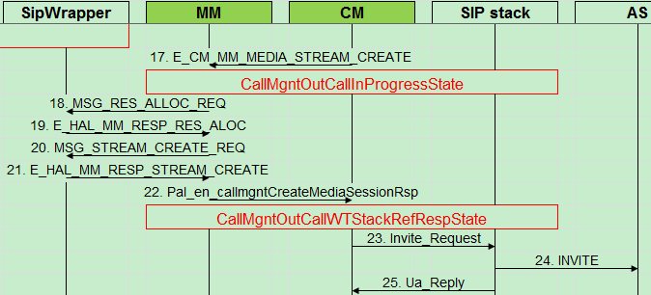

/*****************Enter CM********************************************

pal_fn_internalDerivedCcEvent

|

|-🡪case Pal_en_callmgntFsm

| |-🡪 pal_fn_callmgntFsmMsgHandler()

| | |-🡪 CallMgntMsgHandler()

| | | send Pal_en_callmgntCreateCallReq from CC-🡪 CM

| | | |--🡪 createNewCallReq

| | | | |--🡪 pal_fn_checkCallCxtNum

| | | |--🡪 CallMgntHandler::Instance()->DoSendMsgToMM()

| | | | |---🡪 case E_CM_MM_MEDIA_STREAM_CREATE:

| | | | | |---🡪 pal_internal_msg_mgr::getInstance()->post_internal_message()

pal_fn_internalDerivedCcEvent

/*****************Enter MM********************************************

pal_internal_msg_mgr::process_msg

|

|-🡪 case Pal_en_MediaManagerFsm:

| |--🡪 MM_Handler::handleMsgFromCm(Pal_st_internalMsgStrct *pintlmsg)

| | |--🡪 case E_CM_MM_MEDIA_STREAM_CREATE:

| | | |---🡪 handleMediaStreamCreate

| | | | |---🡪 MM_Handler::getInstance().allocRes(cm_id, sipw_stype, rsvRes)

| | | | | |---🡪 pal_fn_sendResourceAllocRequest()

| | | | | | |--🡪 case Pal_en_audio: ///set Media Type:MG_SDP_AUDIO

/*****************Enter SIPW********************************************

SipWrapper_main()

|

|--🡪 case case MSG_RES_ALLOC_REQ::

| |--🡪 handle_res_alloc_req_from_ppu(userdata,p_msgHeader);

| | | successful then send MSG_RES_ALLOC_RESP to MM

/*****************Enter MM********************************************

pal_fn_mgntMsgHandler()

|

|-🡪 case MSG_RES_ALLOC_RESP:

| |-🡪 MM_Handler::getInstance().handleMsgFromSipw(pMsg);

| | |--🡪 case E_HAL_MM_RESP_RES_ALOC:

| | | |--🡪 ret = createStream(cm_id, reqmsg, port, tmp_body, err_resp);

| | | | |--🡪/// create sdp stream

| | | | |---🡪 pal_fn_sendStreamCreateOrModifyRequest()

/*****************Enter SIPW********************************************

SipWrapper_main()

|

|--🡪 case MSG_STREAM_CREATE_REQ:

| |--🡪 handle_stream_create_req_from_ppu()

| | |-🡪 stream_create_modify

| | |-🡪 stream_create_modify_voice()

| | | |-🡪 sipw_voice_get_rtp_payload

|………………………………………..

|

/*****************Enter MM********************************************

pal_fn_voipManagerMsgHandler

|

|---🡪MM_Handler::getInstance().handleMsgFromSipw(pMsg);

| |--🡪case E_HAL_MM_RESP_STREAM_CREATE:

| | |-🡪pmm_cxt->DStreamType_Set();

| | |---🡪 doSendRespToCm(cm_id,pmsg);

/*****************Enter CM********************************************

pal_fn_internalDerivedCcEvent

CallMgntHandler::CallMgntMsgHandler

|

|-🡪case Pal_en_callmgntCreateMediaSessionRsp:

| |-🡪CallMgntOutCallInProgressState::createMediaSessionRsp()

| | |--🡪 SendInviteToSsapi(pCallMgntData)

| | | |---🡪 CallMgntHandler::Instance()->DoSendMsgToSSAPIW(pCallMgntData, callmgnt_ssapi_invite,body_in_msg)

| | | |---🡪pal_encode_sdp(*pCallMgntData->local_sdp, request.body.sdp);

| | | | | |--🡪 doInviteRequest(pCallMgntData->m_ua_request_id, request, option);

//After DoSendMsgToSSAPIW, the following invite request info will be printed:

allmgnt_ssapi_invite request.uac.display_name.c_str():["1111"],

request.uac.user_name.c_str():[+862111111111], request.uac.random_contact.c_str():[+862111111111],request.uac.domain_name.c_str():[fs5k8.shanghai.com], request.uac.tag.c_str():[]request.uac.m_tag.c_str():[], request.uac.preferred_identity.c_str():[]

callmgnt_ssapi_invite request.uas.display_name.c_str():["22222222"],request.uas.user_name.c_str():[22222222], request.uas.random_contact.c_str():[],request.uas.domain_name.c_str():[192.168.0.2], request.uas.tag.c_str():[]request.uas.m_tag.c_str():[], request.uas.preferred_identity.c_str():[]

callmgnt_ssapi_invite request.req_uri.c_str():[],

request.alert_info.c_str():[], request.call_id.c_str():[0000000c-6ee3ffff-000074d-79-3837038@sipua],request.ua_ref.c_str():[], request.require.option_tag.c_str():[]

callmgnt_ssapi_invite request.replaces.totag.c_str():[],

request.replaces.fromtag.c_str():[], request.replaces.call_id.c_str():[]

callmgnt_ssapi_invite request.referredby.scheme=0,

request.referredby.display_name.c_str():[], request.referredby.user_name.c_str():[]

/*****************Enter SSAPI*******************************************

| | |--🡪 ssapi_parse_uri(request.req_uri, pEncInv);

| | |--🡪 SipSSApiInviteRequest* ss_inv_req = pEncInv->EncodeInv(inv, request_id, request, option);

| | |---🡪 ssapi_send_msg(ss_inv_req);

| | | |--🡪 sendToSipstack(SipSSApiMsg* applmsg) // [SAPI]:send to sipstack

| | | | |----🡪 m_connection.printMsg(applmsg);

| | | | |----🡪 m_connection.writeMsg(buffer, YAPI_FALSE);

The invite request info as following:

[SAPI 07/03/70 00:21:21.990522 ]Invite_Request (103) ; len = 888

nbr of attribs = 8

Application_Reference: 31 32 2d 30

Alert_Timeout: 00 3c

SipMsg: INVITE sip:22222222@192.168.0.2;user=phone SIP/2.0

Route: <sip:192.168.0.2;lr>

From: "1111" <sip:+862111111111@fs5k8.shanghai.com;user=phone>

To: "22222222" <sip:22222222@192.[SAPI 07/03/70 00:21:21.990562 ]168.0.2;user=phone>

Call-ID: 0000000c-6ee3ffff-000074d-79-3837038@sipua

CSeq: 1 INVITE

Contact: "1111" <sip:+862111111111@192.168.0.110:50177>

Accept: application/sdp

Allow: INVITE,ACK,CANCEL,BYE,PRACK,UPDATE,INFO,NOTIFY,OPTIONS,REFER,SUBSCRIBE

Supported: timer

Allow-Events: refer

P-Preferre[SAPI 07/03/70 00:21:21.990642 ]d-Identity: sip:+862111111111@fs5k8.shanghai.com

Content-Type: application/sdp

Content-Length: 232

P-Early-Media: supported

v=0

o=ICF 1 0 IN IP4 192.168.0.110

s=Session

c=IN IP4 192.168.0.110

t=0 0

m=audio 50178 RTP/AVP 8 0 18 13

a=rtpmap:8 PCMA/8000/1

a=ptime:20

a=rtpmap:0 PCMU/8000/1

[SAPI 07/03/70 00:21:21.990682 ]a=rtpmap:18 G729/8000/1

a=rtpmap:13 CN/8000/1

a=sendrecv

100Rel: 00

Session_Expires: 00 00 00 00

UpdateAlertingTO: 01

DNSPool_Id: 00 01

SessionRefresher: 00 00

/*****************Enter SSAPI recv from sipstack *******************************************

onRecvMsg()

|

|--🡪 printMsg(applmsg);

|--🡪 m_client->sendToApplication(applmsg);

====the recv from sip stack as following:

Ua_Reply (104) ; len = 36

nbr of attribs = 3

Application_Reference: 31 32 2d 30

Ua_Ref: 30 30 38 32 2d 30 30 30 30 30

30 30 39 2d 30 33 65 34

Dialog_Ref: 00 00

/*****************Enter CM********************************************

SipDispatcher::onUaReply()

|

|--🡪callmgntH->OnUaReply(request_id, ua_ref, reply);

| |-🡪ret = callmgntData->m_callmgnt_state->InviteReplyWith0(callmgntData, ua_ref, reply);

| | WAIT INVITE ACK STATE: InviteReplyWith0 for Terminal: 1

### 6，26~33

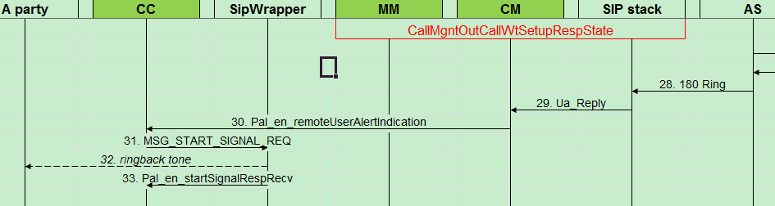

/*****************Enter SSAPI recv from sipstack *******************************************

onRecvMsg()

|

|--🡪 printMsg(applmsg);

|--🡪 m_client->sendToApplication(applmsg);

====the recv from sip stack as following:

[SAPI 06/01/70 00:00:41.015977 ]Ua_Reply (104) ; len = 823

nbr of attribs = 6

Application_Reference: 36 2d 30

Ua_Ref: 30 30 38 32 2d 30 30 30 30 30

30 30 33 2d 30 36 38 30

Dialog_Ref: 00 00

Method: 00 01

SipMsg: SIP/2.0 180 Ringing

From: <sip:+13288615702@qd.lucentlab.com;user=phone>;tag=0082-00000003-0680

To: <sip:8[SAPI 06/01/70 00:00:41.016058 ]8615003@qd.lucentlab.com;user=phone>;tag=54a262c8-552cbbdb3473ec4c-gm-po-lucentPCSF-081753

Call-ID: 00000006-50d1ffff-00015c3-7904-6760920@sipua

CSeq: 1 INVITE

Contact: <sip:lucentNGFS-094565@135.252.37.124:5060>

Allow: INVITE,BYE,REGISTER,ACK,OPTIONS,CANCEL,SUBSCRIBE,NOTIFY,INFO,REFER,UPDATE

S[SAPI 06/01/70 00:00:41.016122 ]erver: Alcatel-Lucent-HPSS/3.0.3

P-Asserted-Identity: <sip:+13288615003@qd.lucentlab.com;user=phone>

P-Access-Network-Info: xDSL;dsl-location=";21.1.1.73;13288615003;;;"

Content-Length: 0

Session-ID: cc35e9806a2f21763564363662343636

HeaderOffsets: 00 03 00 1b 00 5f 00 04 00 66

00 c5 00 05[SAPI 06/01/70 00:00:41.016179 ] 00 d1 00 fc 00 06

01 05 01 0c 00 09 01 18 01 42

00 12 01 4c 01 51 00 12 01 53

01 55 00 12 01 57 01 5e 00 12

01 60 01 62 00 12 01 64 01 6a

00 12 01 6c 01 71 00 12 01 73

01 7b 00 12 01 7d 01 82 00 12

01 84 01 87 00 12 01 89 01 8d

00 12 01 8f 01 94 00 22 01 9f

01 b7 00 38 01 cf 01 fc[SAPI 06/01/70 00:00:41.016229 ] 00 4a

02 16 02 42 00 54 02 55 02 55

00 60 02 64 02 83

/*****************Enter CM********************************************

SipDispatcher::onUaReply()

|

|--🡪callmgntH->OnUaReply(request_id, ua_ref, reply);

| |-🡪 DoSendMsgToPMC(termidx, msgId, isSupported);

| |-🡪ret = callmgntData->m_callmgnt_state->InviteReplyWith1xx(callmgntData, ua_ref, reply);

| | |-🡪 pDialog = CallMgntHandler::Instance()->MultiEarlyDialogsGetActiveDialog(pCallMgntData, ua_ref, reply);

| | |-🡪 CallMgntHandler::Instance()->MultiEarlyDialogsFor18xHandler(pDialog, pCallMgntData, ua_ref, reply);

| | | |-🡪 MuteEarlyMediaAndPlayLocalTone

| | | | |-🡪DoSendMsgToCallHandler (pCallMgntData, Pal_en_requireIndialogInd);

/*****************Enter CC********************************************

pal_fn_internalDerivedCcEvent

|-🡪 case Pal_en_callControlPreHandler:

| |-🡪 pal_call_control_handler(pInternalDerivedEvt);

| | |-🡪 (*pal_glb_callStateHandlerArray[(call_context->dCallControlState).dCurrentState])();

| | | |-🡪 pal_fn_ccCallInitiated(pTermProfile, pCallData, dInputEvent, *pErr);

| | | | case Pal_en_remoteUserAlertIndication:

| | | | pal_fn_sendStartSignalBasic (pal_getCcPlatformTxnId(pTermProfile),pTermProfile->dTermId,MG_S_RING_BACK_TONE, MG_TIMEOUT,MG_S_RING_BACK_TONE_DURATION,pErr);

| | | | |-🡪 pal_fn_sendStartSignalDirection(txn_id, ICF_STREAM_ID_INVALID, scn_term_id, item_id, sig_type, sig_duration, MG_TONE_DIRECT_INTERNAL, pErr);

/*****************Enter SIPW********************************************

SipWrapper_main()

|

|--🡪 case case MSG_START_SIGNAL_REQ::

| |-🡪 handle_start_signal_req_from_ppu(userdata, p_msgHeader);

| | |-🡪 retCode = sipw_playTone(termId, p_ppm_param->stream_id, tone, side);

| | |-🡪 send_msg_to_ppu((unsigned long)p_resp, p_resp->length);

/*****************Enter CC********************************************

pal_fn_voipManagerMsgHandler

|-🡪 case MSG_START_SIGNAL_RESP:

| |-🡪(*pal_glb_callStateHandlerArray[(call_context->dCallControlState).dCurrentState])();

| | |-🡪pal_fn_ccWaitForPlatResponse (pTermProfile, pCallData, dInputEvent, pErr);

| | |-🡪 case Pal_en_startSignalRespRecv:

| | | |-🡪 (*pal_glb_callStateHandlerArray[dNextState]) (pTermProfile,pCallData,Pal_en_startSignalRespRecv,pErr);

| | | | |-🡪 pal_fn_ccCallInitiated(pTermProfile, pCallData, dInputEvent, *pErr);

| | | | | |-🡪 case Pal_en_startSignalRespRecv:

| | | | | | |-🡪 pal_fn_setCallStateInfo(&(pCallContext->dCallControlState), BUSYTONE,BUSYTONE,dInputEvent,pErr);

### 7，34~40

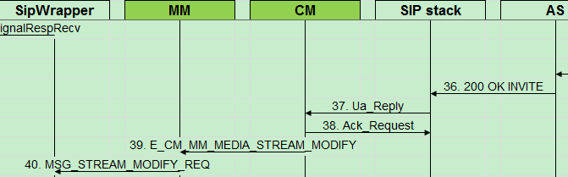

/*****************Enter SSAPI recv from sipstack *******************************************

onRecvMsg()

|

|--🡪 printMsg(applmsg);

|--🡪 m_client->sendToApplication(applmsg);

====the recv from sip stack as following:

[SAPI 06/01/70 00:00:43.320140 ]Ua_Reply (104) ; len = 1183

nbr of attribs = 6

Application_Reference: 36 2d 30

Ua_Ref: 30 30 38 32 2d 30 30 30 30 30

30 30 33 2d 30 36 38 30

Dialog_Ref: 00 00

Method: 00 01

SipMsg: SIP/2.0 200 OK

From: <sip:+13288615702@qd.lucentlab.com;user=phone>;tag=0082-00000003-0680

To: <sip:88615[SAPI 06/01/70 00:00:43.320212 ]003@qd.lucentlab.com;user=phone>;tag=54a262c8-552cbbdb3473ec4c-gm-po-lucentPCSF-081753

Call-ID: 00000006-50d1ffff-00015c3-7904-6760920@sipua

CSeq: 1 INVITE

Contact: <sip:lucentNGFS-094565@135.252.37.124:5060>

Allow: INVITE,BYE,REGISTER,ACK,OPTIONS,CANCEL,SUBSCRIBE,NOTIFY,INFO,REFER,UPDATE

Serve[SAPI 06/01/70 00:00:43.320271 ]r: Alcatel-Lucent-HPSS/3.0.3

P-Asserted-Identity: <sip:+13288615003@qd.lucentlab.com;user=phone>

P-Access-Network-Info: xDSL;dsl-location=";21.1.1.73;13288615003;;;"

Content-Type: application/sdp

Content-Length: 320

Session-ID: cc35e9806a2f21763564363662343636

v=0

o=LucentPCSF 1627728724 16[SAPI 06/01/70 00:00:43.320326 ]27728724 IN IP4 imsgroup0-000.ism01.qd.lucentlab.com

s=-

c=IN IP4 21.1.1.73

t=0 0

m=audio 50182 RTP/AVP 18 97 96

a=rtpmap:18 G729/8000/1

a=rtpmap:97 PCMA/8000/1

a=rtpmap:96 telephone-event/8000

a=fmtp:96 0-15,16-255

a=sendrecv

a=ptime:20

a=gpmd:97 vbd=yes

a=maxmptime:20 20 -

HeaderOff[SAPI 06/01/70 00:00:43.320383 ]sets: 00 03 00 16 00 5a 00 04 00 61

00 c0 00 05 00 cc 00 f7 00 06

01 00 01 07 00 09 01 13 01 3d

00 12 01 47 01 4c 00 12 01 4e

01 50 00 12 01 52 01 59 00 12

01 5b 01 5d 00 12 01 5f 01 65

00 12 01 67 01 6c 00 12 01 6e

01 76 00 12 01 78 01 7d 00 12

01 7f 01 82 00 12 01 84 01 88

00 12 [SAPI 06/01/70 00:00:43.320436 ]01 8a 01 8f 00 22 01 9a

01 b2 00 38 01 ca 01 f7 00 4a

02 11 02 3d 00 53 02 4e 02 5c

00 54 02 6f 02 71 00 60 02 80

02 9f 62 00 02 a4 03 e3

/*****************Enter CM *******************************************

SipDispatcher::onUaReply()

|

|--🡪callmgntH->OnUaReply(request_id, ua_ref, reply);

| |-🡪 ret = callmgntData->m_callmgnt_state->InviteReplyWith2xx(callmgntData, ua_ref, reply);

| | |-🡪 pDialog = CallMgntHandler::Instance()->MultiEarlyDialogsGetActiveDialog(pCallMgntData, ua_ref, reply);

| | |-🡪 CallMgntHandler::Instance()->DoSendMsgToSSAPIW(pCallMgntData, callmgnt_ssapi_ack);

===SSAPI收到ACK后发送给SIP Stack

| | |-🡪 CallMgntHandler::Instance()->MultiEarlyDialogsFor200Handler(pDialog, pCallMgntData, ua_ref, reply);

| | | |-🡪 CallMgntHandler::Instance()->DoSendMsgToMM(pCallMgntData, E_CM_MM_MEDIA_STREAM_MODIFY, VOICE_STREAM);

/*****************Enter MM *******************************************

MM_Handler::handleMsgFromCm(Pal_st_internalMsgStrct *pintlmsg)

|-🡪 case E_CM_MM_MEDIA_STREAM_MODIFY:

| |-🡪 rc = modifyStream(cm_id, nego_localsdp, *cm_reqmsg, send_to_sipw, resp);

| | |-🡪 rc = buildMedialines(remotesdp.media_lines, sipw_lcalmlines, sipw_rmtmlines, negomlines, media_mode, port, session_mode, PEarlyMedia, v152_nego_succ, rule, operation);

| | |-🡪 nego_localsdp.buildUp(host_addr, negomlines, sdp_session_name, remotesdp.time);

| | |-🡪 pmm_cxt->V152_Nego_Set(v152_nego_succ);

| | |-🡪pmm_cxt->Nego_Local_SDP_Set(&nego_localsdp, &remotesdp, cm_reqmsg.sdpOfferAnswerMode);

| | |-🡪ConvertMedialinesToSipw(sipw_lcalmlines, &sipw_lcalstream, &(nego_localsdp.connection));

| | |-🡪Pal_en_fail == pal_fn_sendStreamCreateOrModifyRequest(txn_id, ptermpfl->dTermId, (mg_api_id_et)MSG_STREAM_MODIFY_REQ, dmode,

sipw_stype, &sipw_lcalstream, &sipw_rmtstream, &err,cm_reqmsg.dialog_id, cm_reqmsg.session_state)

### 8，41~45

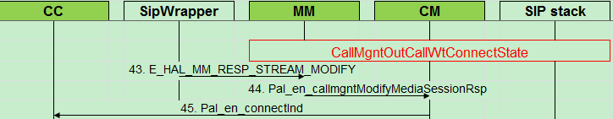

/*****************Enter SIPW*******************************************

SipWrapper_main()

|--🡪 case MSG_STREAM_MODIFY_REQ::

| |-🡪 handle_stream_modify_req_from_ppu(userdata, p_msgHeader);

| | |-🡪 stream_create_modify(termId, p_msg, p_resp, p_stream) != noError

| | | |-🡪 rc |= stream_create_modify_voice(termId, p_msg, p_stream);

| | | | |-🡪rc |= sipw_exchangeDsp(termId, p_stream, voice_side);

| | | | |-🡪sipw_voice_set_rtp_transport(termId, p_stream, p_msgData);

| | | | | |-🡪rc |= sipw_configureRemoteAddress(p_stream->dspRes->connId, p_stream->sessionHdr.srcPort, local_IP, ip_gw, remote_UDP, remote_IP,termId);

| | | | |-🡪sipw_voice_get_rtp_payload(termId, p_msgData, p_msg->msg_id, &conf_mask, &codec_type, &rfc2833_config, &payload_number);

| | | | |-🡪sipw_voice_get_negotiationChnlParam(termId, p_stream->sessionAttr.attr.voice.rfc2833Config.dtmf.payloadType, p_msgData, &negotiationChnlParam, conf_mask, pkt_time, codec_type, rfc2833_config, payload_number);

| | | | |-🡪rc |= sipw_negotiateChannelParam(termId, p_stream, &negotiationChnlParam,FALSE);

| | | | |-🡪rc |= sipw_set_voice_path(p_msgData->stream_mode, p_stream);

| | |-🡪 send_msg_to_ppu((unsigned long)p_resp, p_resp->length);

/*****************Enter MM*******************************************

pal_fn_voipManagerMsgHandler

|

|-🡪MM_Handler::getInstance().handleMsgFromSipw(pMsg);

|-🡪 case E_HAL_MM_RESP_STREAM_MODIFY:

| |-🡪 pmm_cxt->UpdateFSM(pmm_state);

| |-🡪 pmm_cxt->DStreamType_Set();

| |-🡪 doSendRespToCm(cm_id,pmsg);

/*****************Enter CM*******************************************

pal_fn_internalDerivedCcEvent

|-🡪 case Pal_en_CallManagementDisp:

| |-🡪 pal_cm_MediaMsgDispatcher(pInternalDerivedEvt);

| | |-🡪 pal_fn_callmgntFsmMsgHandler(term_profile, pEvent->pCallData, pEvent->dInputEvent.dCallMgntEvent, &dErr);

| | | |-🡪callmgntH->CallMgntMsgHandler(pTermProfile->dLineId, pCallData, dInputEvent, pErr);

| | | | |-🡪case Pal_en_callmgntModifyMediaSessionRsp:

| | | | | |-🡪result = pcallmgntData->m_callmgnt_state->ModifyMediaSessionRsp(pcallmgntData, p_mm_resp);

| | | | | | |-🡪CallMgntHandler::Instance()->DoSendMsgToCallHandler(pCallMgntData, Pal_en_connectInd);

### 9，46~48

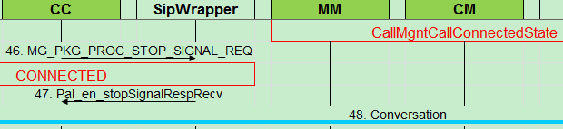

/*****************Enter CC*******************************************

pal_fn_internalDerivedCcEvent

|-🡪 case Pal_en_callControlPreHandler:

| |-🡪 pal_call_control_handler(pInternalDerivedEvt);

| | |-🡪 (*pal_glb_callStateHandlerArray[(call_context->dCallControlState).dCurrentState])();

| | | |-🡪pal_fn_ccRingback(pTermProfile,pCallData,dInputEvent,pErr);

| | | | |-🡪case Pal_en_connectInd:

| | | | | |-🡪if(Pal_en_fail == pal_fn_ccCommonInputEventHandle(pTermProfile, pCallData, dInputEvent, pErr))

| | | | | | |-🡪case Pal_en_connectInd:

| | | | | | | |-🡪(void)pal_fn_sendStopSignalRequest(0,pTermProfile->dTermId, MG_S_RING_BACK_TONE, pErr);

| | | | | |-🡪pal_fn_setCallStateInfo(&(pCallContext->dCallControlState), CONNECTED, CONNECTED, Pal_en_connectInd,pErr);

| | |-🡪 cont = handler->HandleMsgHook(event);

| | | |-🡪pal_setDialogInfoInCallContext(pIcfMsg, call_context, Pal_en_connectInd, pTermProfile, &err);

| | | |-🡪pal_fn_startCallStatisticHandle( pTermProfile, call_context);

/*****************Enter SIPW*******************************************

SipWrapper_main()

|--🡪 case case MSG_STOP_SIGNAL_REQ:::

| |-🡪 handle_stream_modify_req_from_ppu(userdata, p_msgHeader);

| | |-🡪 tone = get_tone_id(p_ppm_param->item_id);

| | |-🡪case 具体哪个case不清楚

| | | |-🡪retCode = sipw_playTone(termId, p_ppm_param->stream_id, 0xFF, GEN_NONE_SIDE);

| | |-🡪retCode |= send_msg_to_ppu((unsigned long)p_resp, p_resp->length);

| | |-🡪sipw_displayDspStreamByTerm(pTerm);

/*****************Enter CC*******************************************

pal_fn_voipManagerMsgHandler

|-🡪 case MSG_STOP_SIGNAL_RESP:

| |-🡪 (*pal_glb_callStateHandlerArray[(pTermProfile->pCurrentCallContext->dCallControlState).dCurrentState]) (pTermProfile, g_pCallData, Pal_en_stopSignalRespRecv, &dErr);

| | |-🡪 pal_fn_ccConnected(pTermProfile, pCallData, dInputEvent, pErr);

| | | |-🡪 case Pal_en_stopSignalRespRecv:

## 2，被叫端流程

### 1，1~6

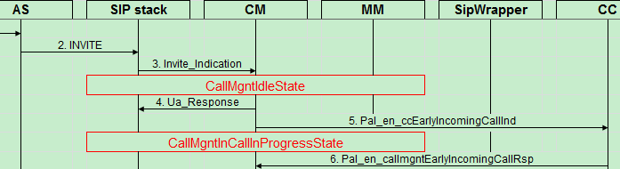

**/======================enter ssapi_wrapper=====================================**

pal_fn_msghandler()

|

|-🡪case ICF_MODULE_ICF:

| |-🡪ssapi_parse_msg()

| | |-🡪case SipSSApiMsg::E_INVITE_INDICATION:

| | | |--🡪ssapi_parse_invite_indication()

| | | |-🡪SipEngine::getInstance().getCb()->onInviteIndication( ind_ref, InviteInd);

**/======================enter CM=====================================**

CallMgntHandler::onInviteIndication(const SSAPIW::UaRef& ua_ref, const SSAPIW::InviteIndication& InviteInd)

|-🡪CallMgntHandler::Instance()->DoSendMsgToPMC(pGlbTermProfile[line_id].dTermId, MSG_PMC_ANSWERED_INCOMING_CALL_NOTIFY, Pal_en_true);

|-🡪 ret = callmgntData->m_callmgnt_state->newCallIncoming(callmgntData, ua_ref, InviteInd);

| |--🡪Pal_en_success != formDisplayInf()

| |--🡪 get incoming number

| |--🡪CallMgntHandler::DoSendMsgToSSAPIW

|-🡪Exit CallMgntHandler::onInviteIndication.

**/======================enter CC=====================================**

Pal_ty_void pal_internal_msg_mgr::process_msg()

|

|-🡪pal_fn_internalDerivedCcEvent(&internalDerivedEvt);

|---|-🡪 case case Pal_en_callControlPreHandler:

| | |-🡪pal_call_control_handler(pInternalDerivedEvt);

| | | |-🡪CallControlMsg<Pal_en_ccEarlyIncomingCallInd,Pal_en_preAct>::HandleMsgHook (Pal_st_internalMsgStrct* event)

| | | |…….

| | | |---🡪 pal_fn_sendEarlyIncCallCfm

| |　| | |--🡪al_internal_msg_mgr::getInstance()->post_internal_message_on_term

### 2，7~13

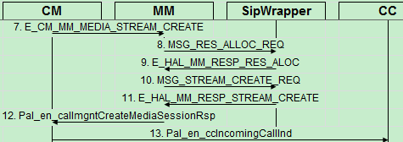

**/======================enter CM=====================================**

pal_fn_internalDerivedCcEvent

|

|-🡪case Pal_en_callmgntFsm:

| |-🡪pal_fn_callmgntFsmMsgHandler

| | |🡪callmgntH->CallMgntMsgHandler(pTermProfile->dLineId, pCallData, dInputEvent, pErr);

| | | |-🡪 case Pal_en_callmgntEarlyIncomingCallRsp:

| | | | |-🡪 pcallmgntData->m_callmgnt_state->earlyIncomingCallRsp(pcallmgntData, early_incall_resp);

| | | | --🡪 DoSendMsgToMM //send MSG_RES_ALLOC_REQ to sipwrapper

**/======================enter MM=====================================**

pal_mm_internalMsgDispatcher:

handleMediaStreamCreate

|

|-🡪allocRes ///

**/======================enter SIPW=====================================**

SipWrapper_main

|

|-🡪case MSG_RES_ALLOC_REQ:

| |-🡪handle_res_alloc_req_from_ppu

| | /*alloc dsp resource */

| |/* return MSG_RES_ALLOC_RESP to PAL*/

**/======================enter MM=====================================**

MM_Handler::handleMsgFromSipw

|

|---🡪Case E_HAL_MM_RESP_RES_ALOC

| |-🡪 createStream() ///send MSG_STREAM_CREATE_REQ

**/======================enter SIPW=====================================**

SipWrapper_main

|

|-🡪case MSG_STREAM_CREATE_REQ:

| |-🡪handle_stream_create_req_from_ppu

| | /*alloc dsp resource */

| |/* return MSG_STREAM_CREATE_RESP

**/======================enter MM=====================================**

pal_fn_msghandler

|

|-🡪pal_fn_voipManagerMsgHandler

| |-🡪 case MSG_STREAM_CREATE_RESP:

| | |-🡪MM_Handler::getInstance().handleMsgFromSipw(pMsg)

| | | |--🡪 doSendRespToCm(cm_id,pmsg);

**/======================enter CM=====================================**

pal_fn_internalDerivedCcEvent // used send msg from CM to CC

|

|----case case Pal_en_CallManagementDisp:

| |-🡪 pal_cm_MediaMsgDispatcher

| | 　|--🡪 pal_fn_callmgntFsmMsgHandler

| | | |---🡪 callmgntH->CallMgntMsgHandler(pTermProfile->dLineId, pCallData, dInputEvent, pErr);

| | | | |-🡪 case Pal_en_callmgntCreateMediaSessionRsp:

| | | | | |-🡪 DoSendMsgToCallHandler

### 3，14~18

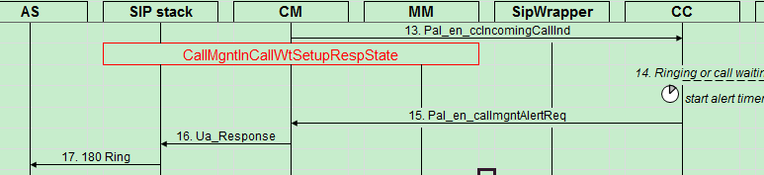

**/======================enter CC=====================================**

pal_call_control_handler

|--🡪 Pal_en_ccIncomingCallInd

pal_fn_ccIdleOnHook

|

|-🡪 case Pal_en_ccIncomingCallInd:

| |-🡪 Pal_en_fail==pal_fn_idleOnHook_IncomingCallInd(pTermProfile,…

| | |-🡪/* /* Play ring tone and display caller id*/ */

| | |-🡪 pal_fn_sendStartSignalRingingCallId

| |--🡪/* pal_fn_idleOnHook_IncomingCallInd: play ringing with callid, cadance is 1*/

| |-🡪exit pal_fn_idleOnHook_IncomingCallInd.

**/======================enter SIPW=====================================**

SipWrapper_main

|

|-🡪 case MSG_START_SIGNAL_REQ:

| |-🡪 handle_start_signal_req_from_ppu

| | |🡪 sipw_getToneSide

| | |--🡪 get_tone_id

| | |--🡪 send MSG_START_SIGNAL_RESP SUCCESS to PAL

| | |-🡪

**/======================enter CC=====================================**

Changing Call state from [CC_IDLE_ONHOOK] to [RINGING]

pal_fn_voipManagerMsgHandler:

|

|--🡪 case MSG_START_SIGNAL_RESP:

| pal_fn_voipManagerMsgHandler

| |--🡪 Pal_en_startSignalRespRecv

pal_fn_ccIdleOnHook

|

|--🡪 pal_fn_sendUserAlertedReq:

| |-🡪 buildAlertRqstInfo

| |-🡪 pal_internal_msg_mgr::getInstance()->post_internal_message_on_term //Send to CM

**/======================enter CM=====================================**

CallMgntHandler::CallMgntMsgHandler

|-🡪 case Pal_en_callmgntAlertReq:

| |--🡪 pcallmgntData->m_callmgnt_state->sendAlertReq(pcallmgntData, alert_req)

| | |--🡪 CallMgntInCallWtSetupRespState::sendAlertReq

| | | |--🡪 CallMgntHandler::Instance()->DoSendMsgToSSAPIW(pCallMgntData

/*send to sipstack**/

180 methord 1 for Terminal:4 in state 9,voiceservertatus=1,lineId=3Contact header params: display_name="2222", user_name=+862122222222, random_contact=+862122222222,

The info sent to sipstack as following:

a_Response (107) ; len = 250

nbr of attribs = 7

Application_Reference: 31 33 2d 30

Ua_Ref: 30 30 38 32 2d 30 30 30 30 30

30 30 61 2d 30 33 65 35

Dialog_Ref: 00 00

Method: 00 01

SipMsg: SIP/2.0 180

Contact: "2222" <sip:+862122222222@192.168.0.110:50177>

Allow: INVITE,ACK,CANCEL,BYE,PR[SAPI 07/03/70 00:21:22.172322 ]ACK,UPDATE,INFO,NOTIFY,OPTIONS,REFER,SUBSCRIBE

Allow-Events: refer

Content-Length: 0

DNSPool_Id: 00 01

SessionRefresher: 00 00

4，

***\*\*\*\*\*\*\*\*\*\*\*\*\*\*\*\*\*\*\*\*\*\*\*\*\*\*\*\*\*\*\*\*\*\*\*\*\*\*\*\*\*\*\*\*\*\*\*\*\*\*\*\*\*\*\*\*\*\*\*\*\*\*\*\*\*\****

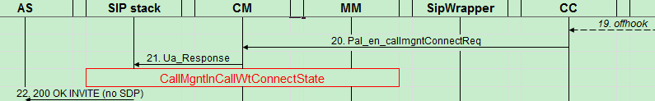

*\*\*\*\*\*\*\*\*\*\*\*\*\*\*\*\*\*\*\*\*\*\*\*\*\*\*\*\*\*\*\*\*\*\*\*\*\*\*\*\*\*\*\*\*\*\*\*\*\*\*\*\*\*\*\*\*\*\*\*\*\*\*\*\*\*\*\*\*\*\*\*\*\*\*\**

**/======================enter SIPW=====================================**

SipWrapper_main

handle_HptMsg

|

|--🡪case GEN_HOOK_STATE_CHANGED:

| |--🡪 handle_term_ev_offhook

| | |--🡪 send_event_to_ppu

**/======================enter CC=====================================**

pal_fn_voipManagerMsgHandler

|

|--🡪 Current Line Feeding is parked, Req Line Feeding is normal

|--🡪 Send MSG_LINE_FEEDING_REQ to Plat, polarType:normal

|--🡪 pal_fn_ccRinging

|--🡪|-🡪 case Pal_en_ccOffHook:

| | |-🡪 pal_fn_sendConnectReq // Sending MG_PKG_PROC_STOP_SIGNAL_REQ(50) for 4

| | | |-🡪 pal_fn_setCallStateInfo

**/======================enter SIPW=====================================**

handle_line_feeding_from_ppu

|

|---🡪 receive MSG_STOP_SIGNAL_REQ from PAL

**/======================enter CC=====================================**

pal_fn_ccRinging

|-🡪case Pal_en_stopSignalRespRecv:

| |--🡪Pal_en_stopSignalRespRecv

| | |--🡪pal_fn_sendConnectReq

| | | |--🡪buildConnectRqstInfo

**| | | | |--🡪buildLocalUAInfo**

**| | |---🡪pal_fn_setCallStateInfo:**

| |--🡪 Sending Connect Request for Incoming Call.

**/======================enter CM=====================================**

CallMgntHandler::CallMgntMsgHandler

|

|--🡪DoSendMsgToSSAPIW

**/======================enter SSAPI=====================================**

receive MSG_PMC_RETRIEVE_CALL_STATIS_INFO_REQ from PAL

the following info is sent to sip stack:

[SAPI 07/03/70 00:21:26.647602 ]Ua_Response (107) ; len = 461

nbr of attribs = 7

Application_Reference: 31 33 2d 30

Ua_Ref: 30 30 38 32 2d 30 30 30 30 30

30 30 61 2d 30 33 65 35

Dialog_Ref: 00 00

Method: 00 01

SipMsg: SIP/2.0 200

Contact: "2222" <sip:+862122222222@192.168.0.110:50177>

Allow: INVITE,ACK,CANCEL,BYE,PR[SAPI 07/03/70 00:21:26.647682 ]ACK,UPDATE,INFO,NOTIFY,OPTIONS,REFER,SUBSCRIBE

Allow-Events: refer

Content-Type: application/sdp

Content-Length: 178

v=0

o=ICF 1 0 IN IP4 192.168.0.110

s=Session

c=IN IP4 192.168.0.110

t=0 0

m=audio 50184 RTP/AVP 8 13

a=rtpmap:8 PCMA/8000/1

a=ptime:20

a=rtpmap:13 CN/8000/1

a=sendrecv