**Instructions on how to enter your new password into your iphone/ipad once you have both successfully enrolled in the TPC password portal and created a new password.**

**Step 1: First on the home screen of your iphone/ipad, go to setings:**

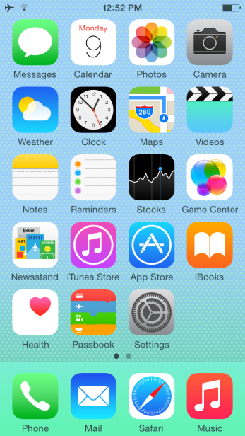

**Step 2: Scroll down then click on Accounts and Passwords:**

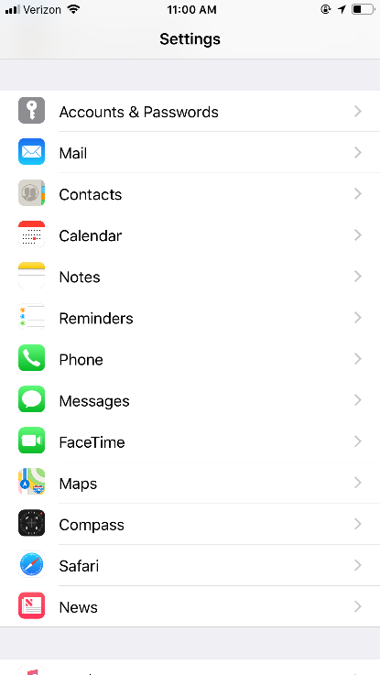

**Step 3: Under where it says accounts, go to your Five Star account. This should be named either Exchange or Five Star.**

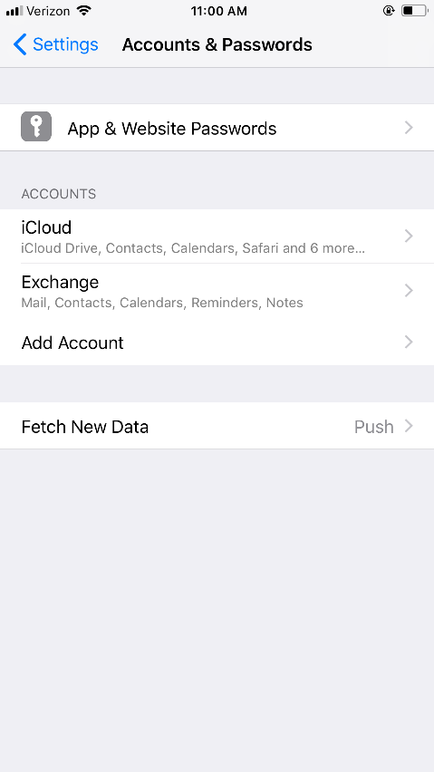

**Step 4: Click on your email address:**

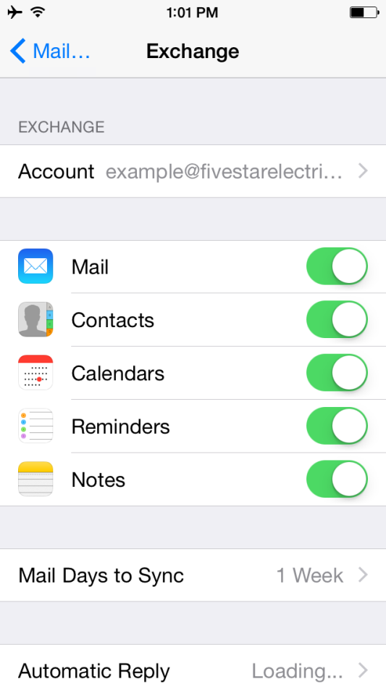

**Step 5: Enter your new password into the Password field, and then click Done:**

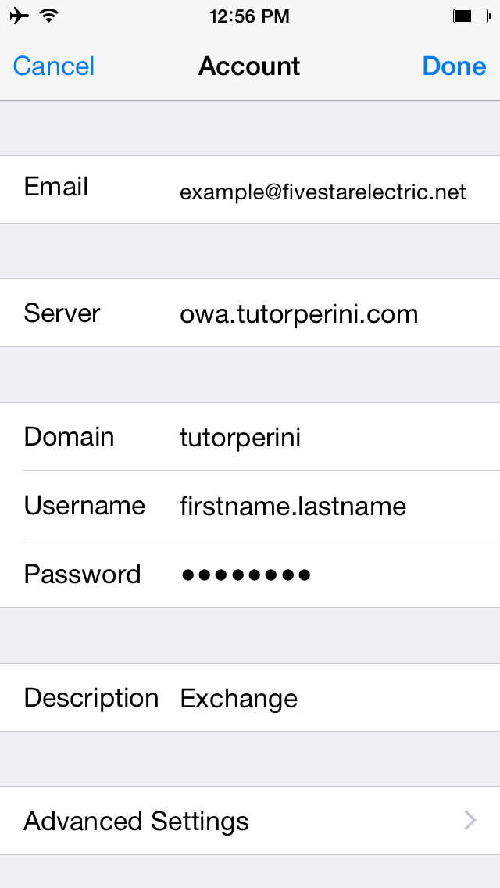

**If everything was successful, you should get check marks next to each entry on the above screen.**