KAPE AGOSTO

Kape Agosto System User Manual
  - Admin Manager and Cashier
Version 1.1 | 28 October 2026

Screen reference Welcome page

Purpose of this manual
Use this manual to sign in, perform the tasks available to your role, review business records, and resolve common operating issues. Follow the numbered steps beside each screen reference and check the expected result before continuing.
The instructions follow the built in Guide and the installed system. Screenshots show example records from the capture date. This manual is intended for cafe staff using the local Kape Agosto system.

Contents and navigation
Start with the role overview on page 3, then turn to the instructions for your assigned account. The payment workflow and troubleshooting pages apply across related tasks.
Section | Pages
Getting started | 4 to 5
Admin instructions | 6 to 26
Manager instructions | 27 to 37
Cashier instructions | 38 to 41
Record payment and complete a sale | 42
Daily operating checklist | 43
Resolve access and record problems | 44
Resolve transaction and stock problems | 45
Terms used in this manual | 46
Inventory and forecasting terms | 47
Use the built in Guide and get help | 48

How to read a procedure
Each screen page explains its purpose, gives the actions in order, and ends with a Check before you continue paragraph. Menu names and button labels follow the installed interface. Some controls appear only when the role and record status allow the action.

Read screenshots at a useful size
Open the PDF on a computer and zoom in when reading small table values. The screenshots retain their landscape proportions. Use your live system to read current balances and transaction values.

Roles and everyday workflow
An Admin assigns each account its role. Use your own account and confirm the role shown in the header. Do not borrow a different role simply to bypass an unavailable action.
Area or action | Admin | Manager | Cashier
Business dashboard and forecasts | Review | Review | POS landing page
Accounts and role assignments | Manage | Ask Admin | Ask Admin
Categories products and recipes | Manage | View menu | View menu
Inventory balances and adjustments | Manage | Review forecasts | Ask Admin
Orders payments and completion | Process | Review history | Process
Voids | Authorized workflow | Ask transaction role | Admin approval when required
Daily reports | View generate export | View generate export | Order receipts
System settings and backups | Manage | Ask Admin | Ask Admin
Own profile | Edit allowed fields | Edit allowed fields | Edit allowed fields

The sale workflow
Build and check the ticket, continue to payment, record the amount actually received, confirm the paid result, mark the order Done, and provide the receipt. Completion records recipe ingredient and packaging usage once. Creating a ticket or saving a recipe alone does not deduct stock.

The review workflow
Managers compare sales, reports, team performance, and material forecasts. Admins maintain the records and system settings that support these views. Review forecasts as planning estimates and verify the underlying records before a correction.

ALL ROLES

Sign in to your account
Use your own assigned account to enter the system. The account role determines which pages and actions are available.
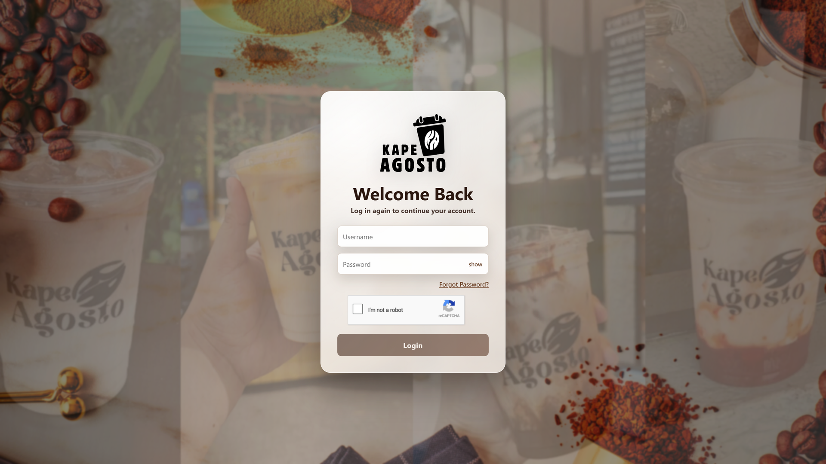
Screen reference Sign in to your account

Steps
1. Open http://localhost/kapeagosto/ on the computer hosting the system. On the welcome page, select PROCEED TO LOGIN.
2. Enter your Username and Password. Use Show password only when you can safely check what you entered.
3. Complete the reCAPTCHA shown on the login form, then select Login.
4. Confirm your account name and role. Admin and Manager accounts open a dashboard; Cashier accounts open the POS register.
Check before you continue If sign in fails, recheck the account details and contact an Admin if access is paused. A login in one browser does not automatically sign you in to another browser.

ALL ROLES

Recover a forgotten password
Use Forgot Password when you cannot remember your password and can access the email registered to your account.

Screen reference Recover a forgotten password

Steps
1. On the login page, select Forgot Password.
2. Enter the registered username or email, then select Send Verification Code.
3. Check the registered email, including the spam folder, for the six digit verification code.
4. Follow the remaining verification and new password steps displayed by the system. Return to Login after the reset succeeds.
Check before you continue Do not request repeated codes unnecessarily. If no email arrives, ask an Admin to check the registered email and outgoing mail configuration. Never give your verification code or password to another user.

ADMIN

Review the sales dashboard
Use Dashboard > Sales & Orders to review sales totals, order activity, and the menu products contributing to sales.
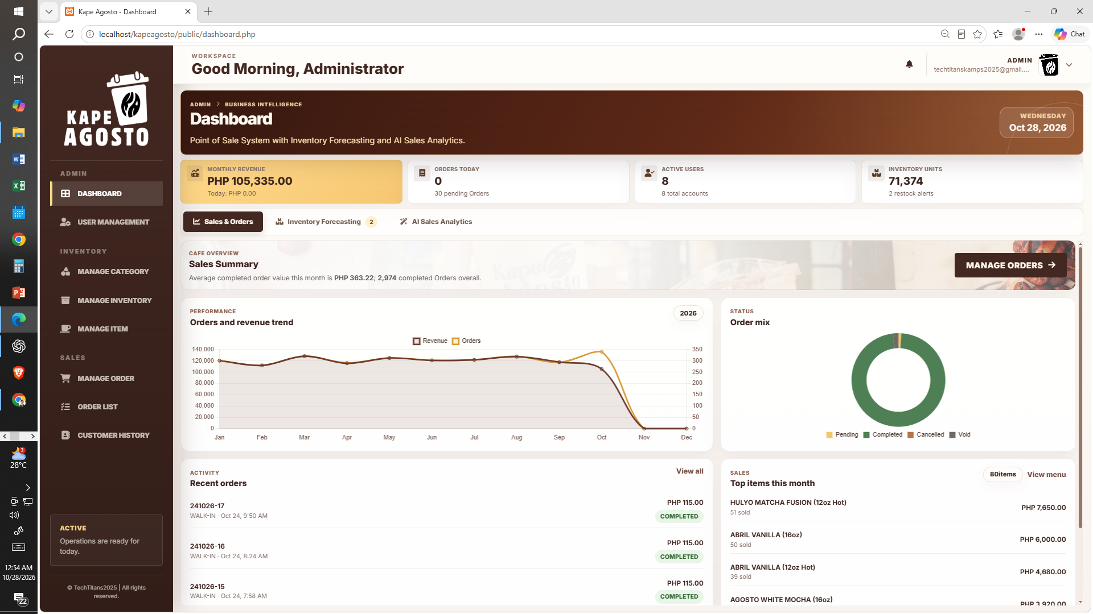
Screen reference Review the sales dashboard

Steps
1. Open Dashboard and select Sales & Orders.
2. Read Monthly Revenue, Orders Today, Active Users, and Inventory Units together with their displayed dates or periods.
3. Review the orders and revenue trend, order mix, recent orders, and top items.
4. Use Manage Orders, View all, or View menu to inspect the related records.
Check before you continue Compare figures for the same period. Completed sales contribute to actual sales analysis; a pending ticket is not a completed sale. Screenshot totals are examples from the capture date.

ADMIN

Review dashboard inventory forecasting
Use Dashboard > Inventory Forecasting to identify materials that may need replenishment and inspect estimated stock coverage.
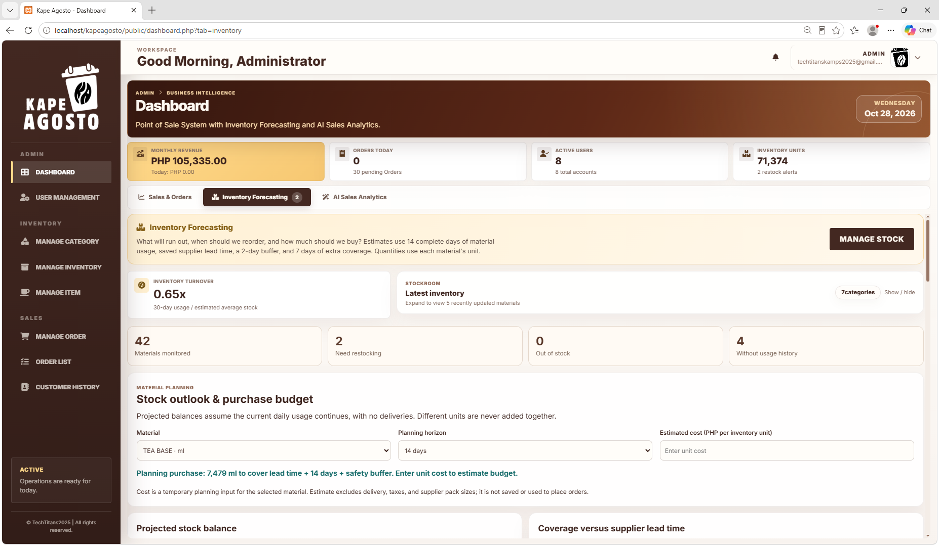
Screen reference Review dashboard inventory forecasting

Steps
1. Select Inventory Forecasting on the Dashboard. Read the restock badge and material summary.
2. Choose a material and planning horizon to review its projected balance and supplier lead time.
3. Use Find material and Restock status to narrow the planning table.
4. Review on hand stock, average usage, coverage, reorder point, and recommended purchase quantity. Open Manage Stock to record a verified stock action.
Check before you continue Forecasts use 14 complete days of usage, saved supplier lead time, a two day buffer, and seven extra days of coverage. Planning does not place purchases or alter stock. Do not combine different material units.

ADMIN

Read AI sales analytics
Use AI Sales Analytics to compare actual sales patterns with forecasts and review product movement.
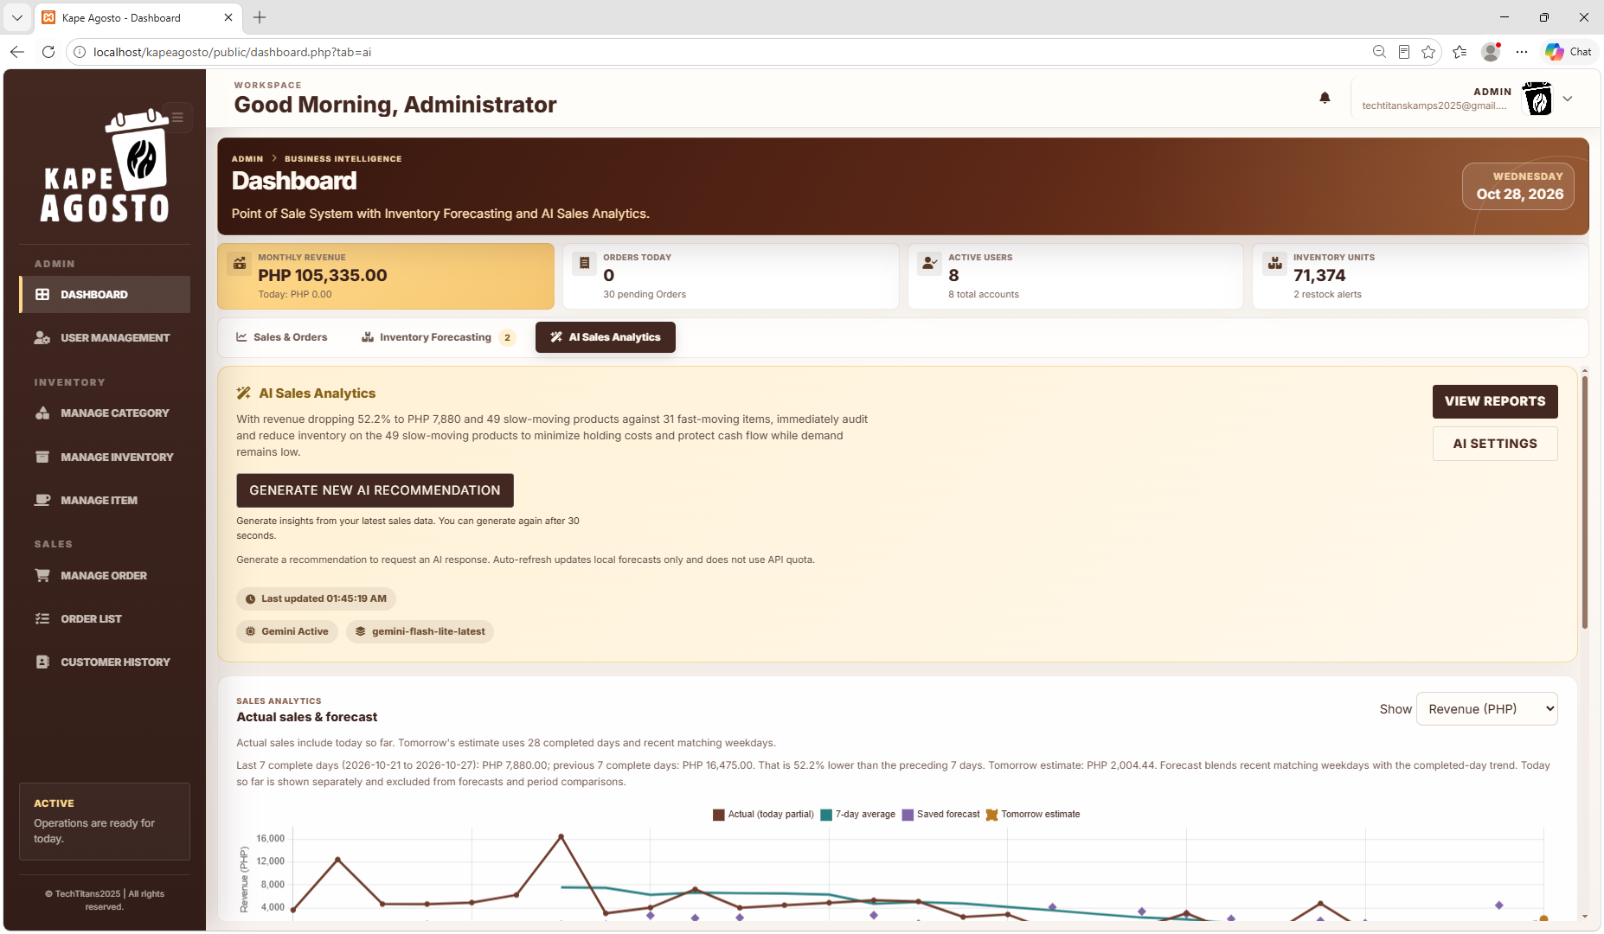
Screen reference Read AI sales analytics

Steps
1. Select AI Sales Analytics on the Dashboard.
2. Use Show to switch between Revenue in PHP and Completed orders. Read the chart period and last updated time.
3. Review the seven day sales trend, tomorrow forecast, product movement, and forecast accuracy.
4. Expand View chart data when you need values in a table. Use View Reports to review underlying records.
Check before you continue Today is incomplete until the day ends. Forecasts are estimates, not confirmed orders or profit. Local statistical analysis remains available without an AI connection; a configured AI service supplies additional recommendations.

ADMIN

Manage team accounts
Use User Management to find accounts, review access, and assign the appropriate Admin, Manager, or Cashier role.
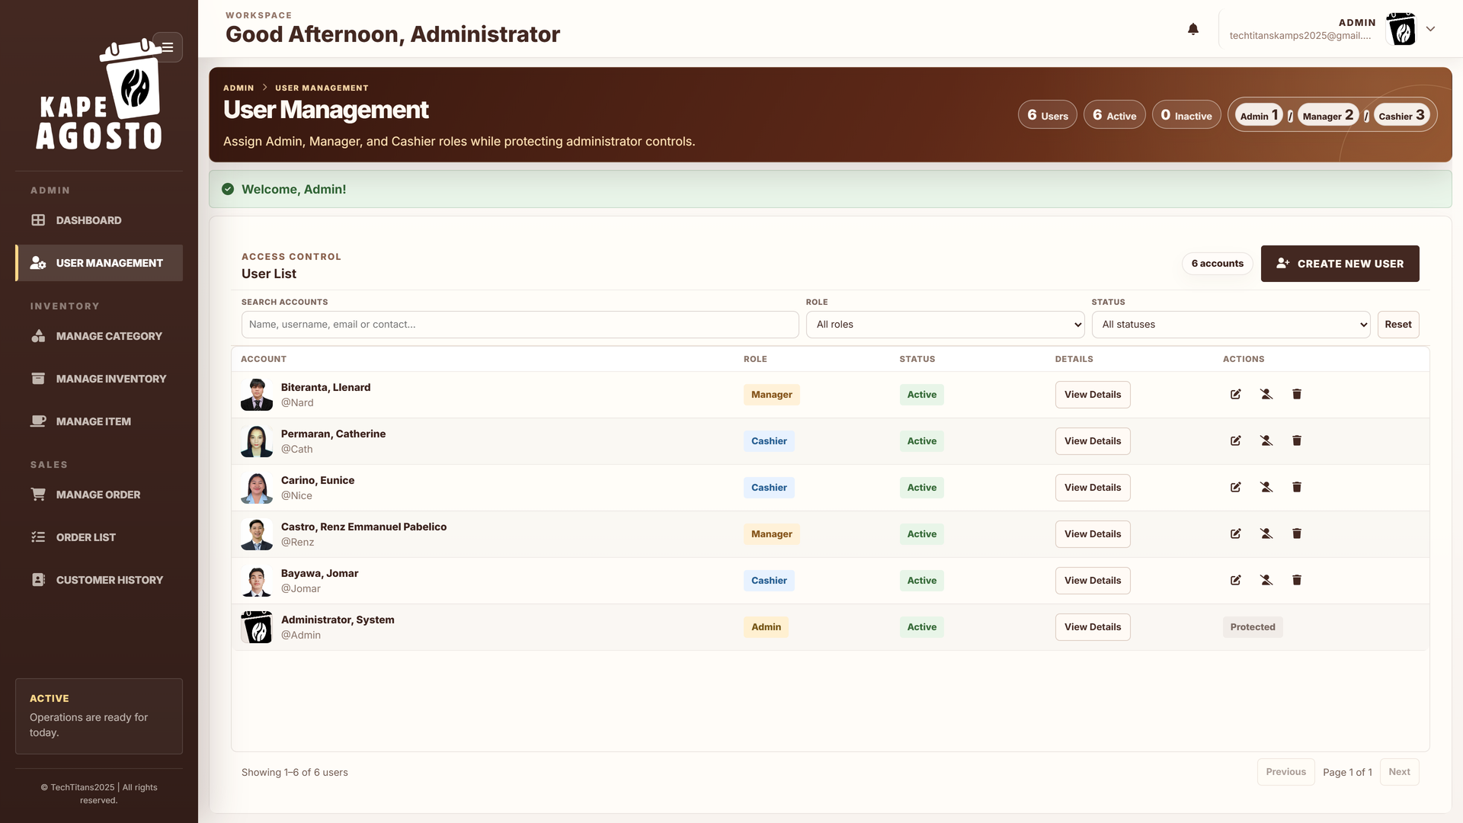
Screen reference Manage team accounts

Steps
1. Open User Management. Review the counts of active and inactive accounts.
2. Search for an account or filter by Role and Status.
3. Use View Details to review the selected person. Use Edit to change the available account fields or assigned role.
4. Use account status actions to pause or restore access when appropriate. Ask the user to refresh or reopen a page after a role change.
Check before you continue Deactivation pauses access; it is different from permanent deletion. Review protected account rules and the selected person before any destructive action. Do not create shared staff accounts.

ADMIN

Create a user account
Create a separate account for each staff member and assign only the role required for that person's duties.
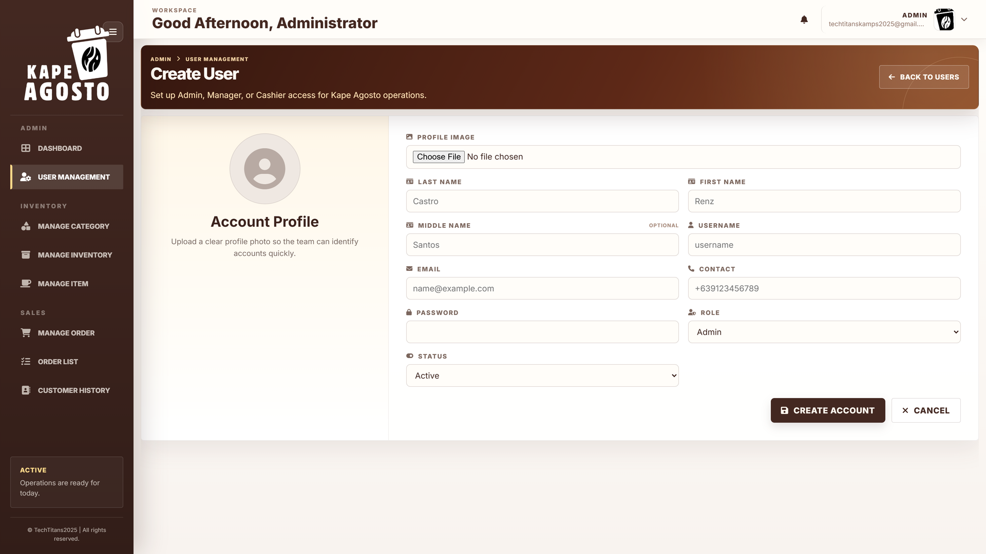
Screen reference Create a user account

Steps
1. In User Management, select Create New User.
2. Enter the required name, username, email, and password fields. Add optional contact information or a supported profile image when needed.
3. Choose Admin, Manager, or Cashier in Role, and select the correct Status.
4. Review the details and select Create Account. Return to the user list and confirm the account appears with the intended role and status.
Check before you continue Required fields and validation messages on the form take priority. Managers review performance and planning; Cashiers process sales. Give account credentials directly to the intended person through your approved process.

ADMIN

Organize menu categories
Use Manage Category to group products so staff can find the correct menu items more easily.
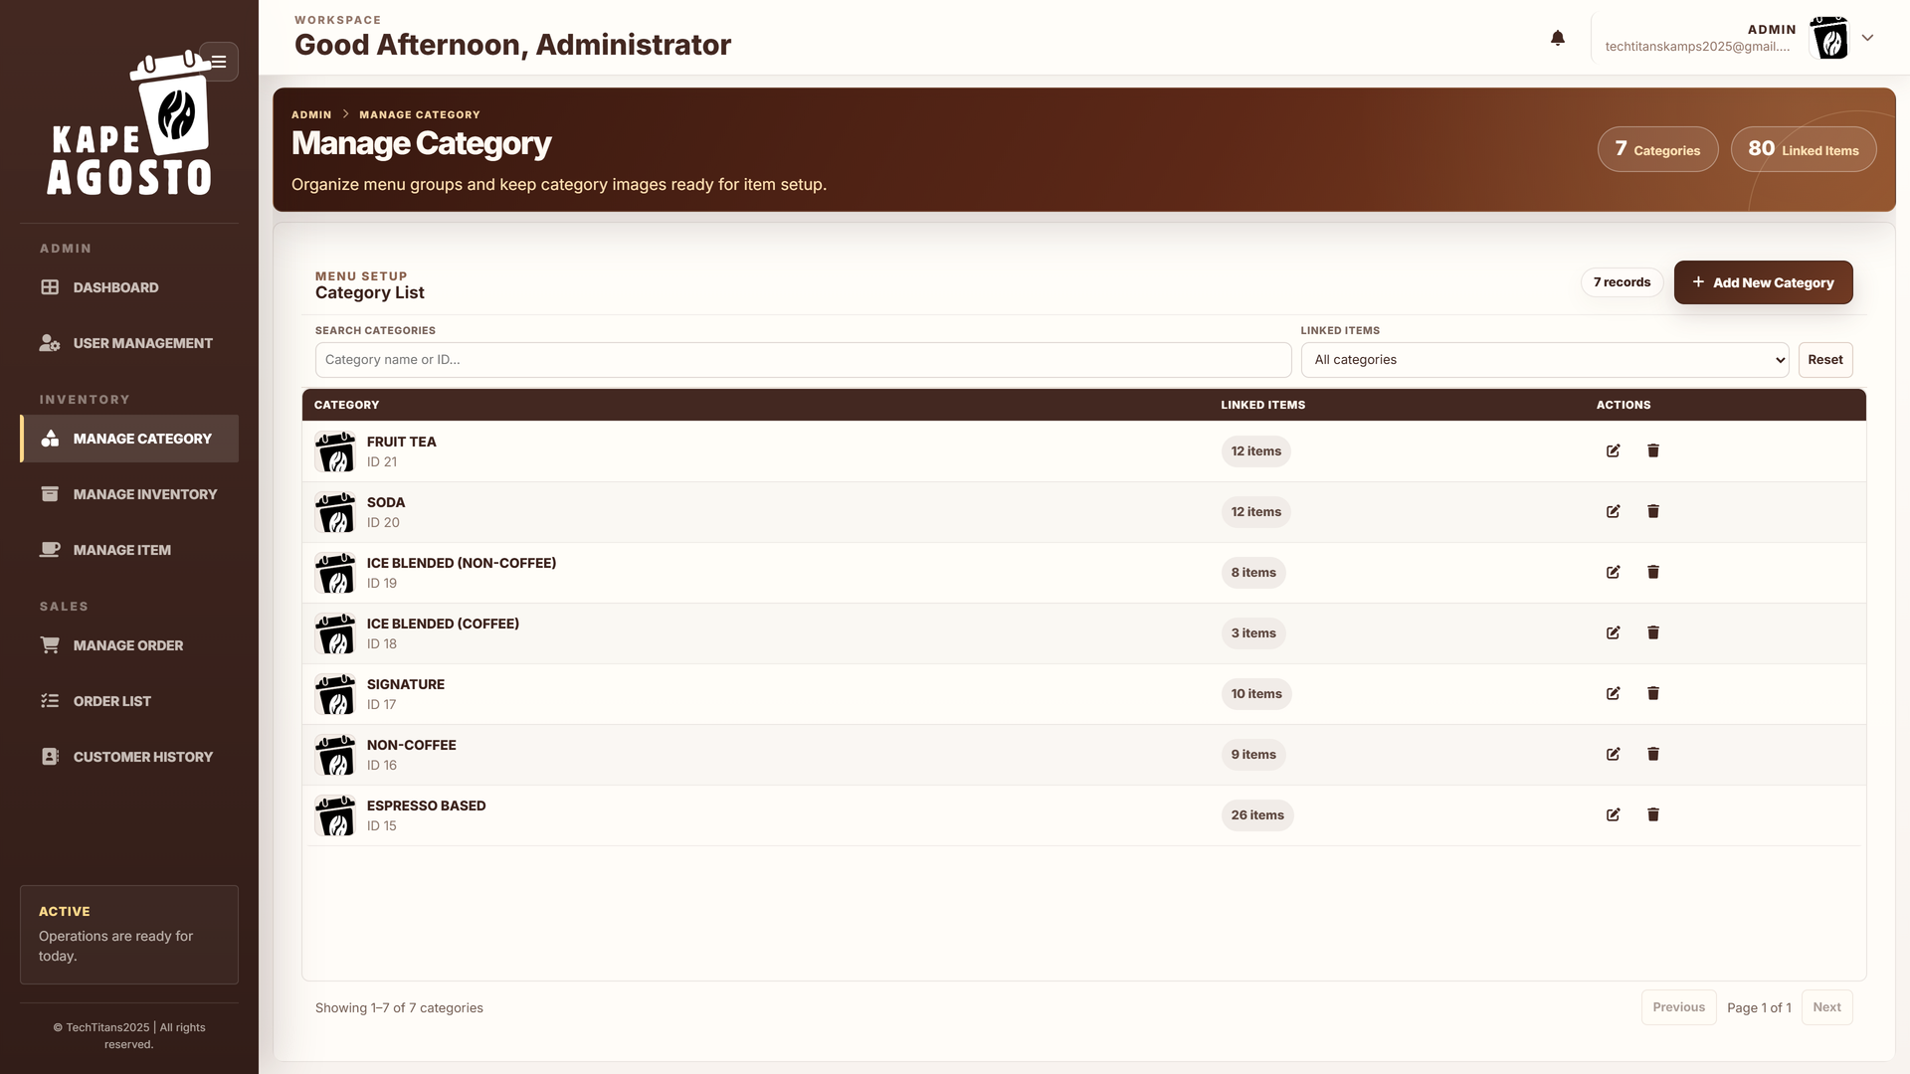
Screen reference Organize menu categories

Steps
1. Open Manage Category.
2. Search by category name or use the Linked items filter.
3. Select a linked item count to view the products belonging to that category.
4. Use Edit to update a category name or image. Review linked products before removing a category.
Check before you continue Keep category names clear and consistent. Category membership is set when adding or editing a menu item. A category record is not an inventory material or a product recipe.

ADMIN

Add a menu category
Use Add New Category when the menu needs a new product group.
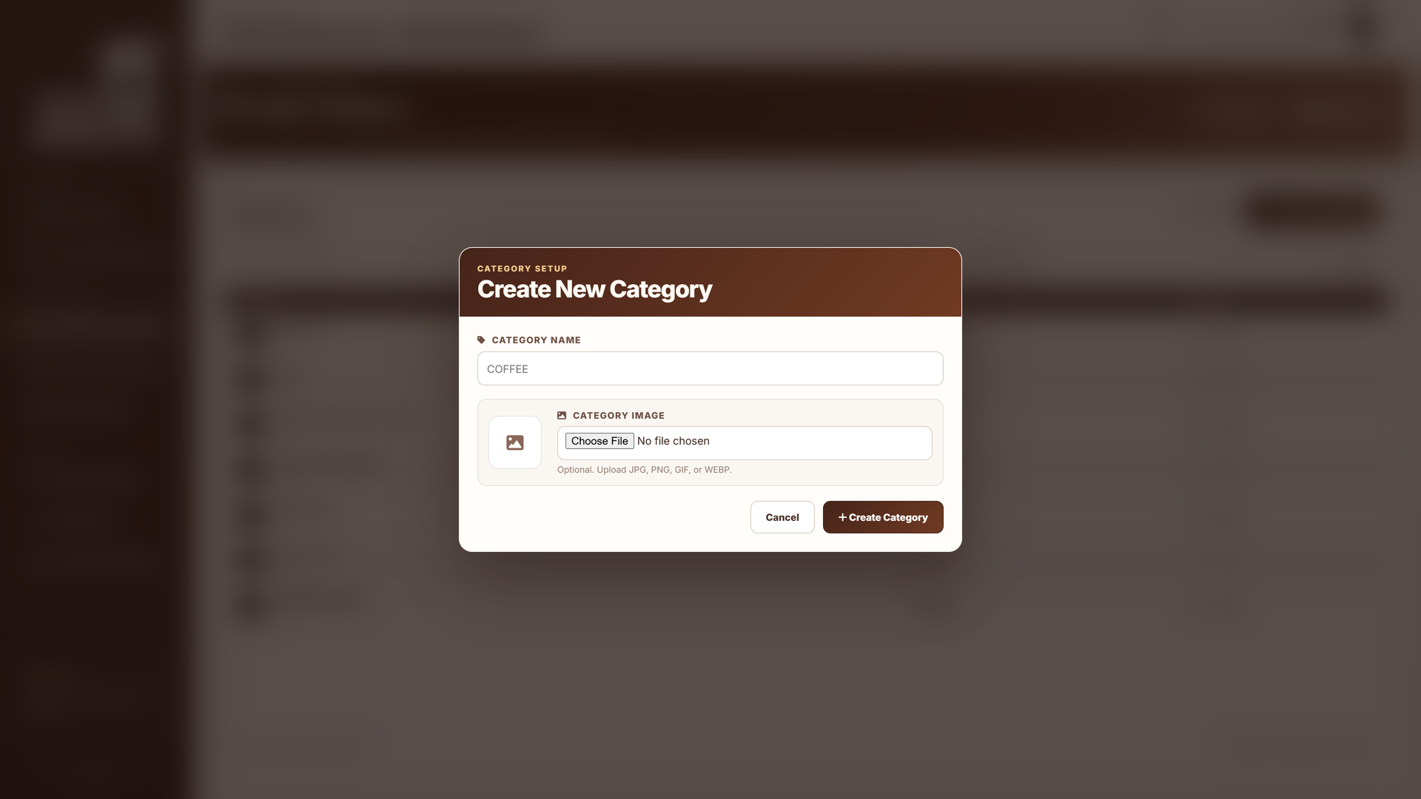
Screen reference Add a menu category

Steps
1. Open Manage Category and select Add New Category.
2. Enter a clear Category Name that is distinct from existing groups.
3. Optionally choose a Category Image in one of the supported formats displayed on the form.
4. Select Create Category and verify the result in the category list. Assign menu items to the new category as needed.
Check before you continue Cancel closes the form without creating a category. Adding a category does not automatically create menu products, prices, stock records, or recipes.

ADMIN

Review current inventory
Use Manage Inventory > Current Stock to maintain raw materials and packaging and review recorded balances.
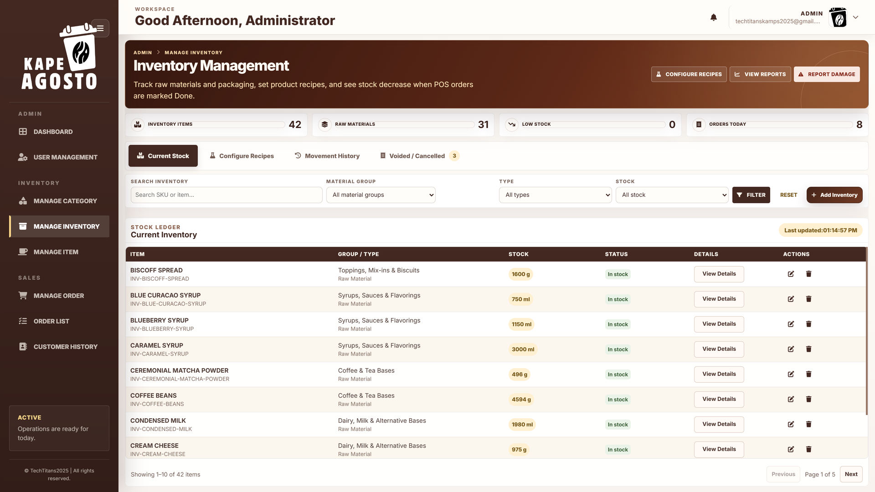
Screen reference Review current inventory

Steps
1. Open Manage Inventory and select Current Stock.
2. Search for the material and apply Material Group, Type, and Stock filters.
3. Use View Details to check the item, unit, quantity, and related information before changing it.
4. Use Add Inventory for a new material. Record received stock or verified deductions through the available stock actions, and check Movement History afterward.
Check before you continue Use the correct unit, such as g, ml, or pcs. A menu product and its ingredients are different records. Record a clear reason for stock adjustments; do not change stock simply to make a forecast look correct.

ADMIN

Configure product recipes
Recipes connect each product and cup size to the ingredient amounts used for one serving.
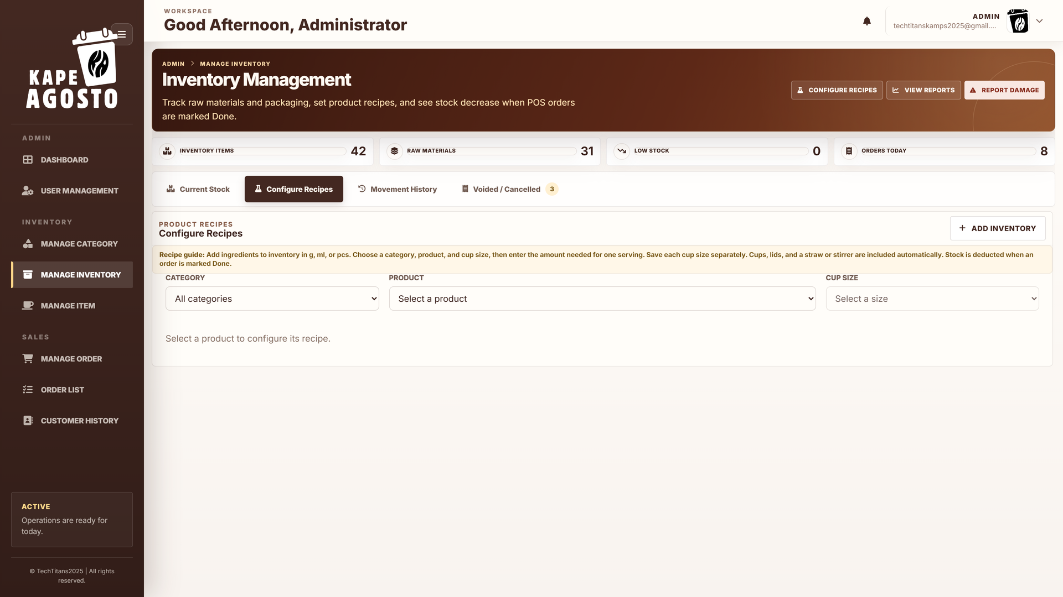
Screen reference Configure product recipes

Steps
1. Open Manage Inventory > Configure Recipes.
2. Choose a Category if needed, select the Product, then select the Cup Size.
3. Use Add Ingredient and enter each amount needed for one serving in the correct inventory unit.
4. Select Save Recipe. Repeat for every cup size and check the saved quantities before staff use the product.
Check before you continue Cups, lids, and a straw or stirrer are included automatically. Saving a recipe does not deduct stock or rewrite earlier sales. Ingredients and packaging are deducted once when a fully paid order is marked Done.

ADMIN

Review inventory movement history
Movement History explains why a material balance changed and helps verify received stock, usage, damage, and adjustments.
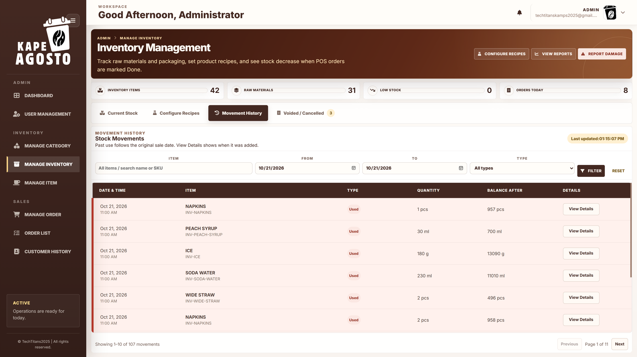
Screen reference Review inventory movement history

Steps
1. Open Manage Inventory > Movement History.
2. Choose an Item and the From and To dates. Select the movement Type when needed.
3. Apply Filter and review the date, item, quantity, and balance after each movement.
4. Open View Details where available to inspect the full record and when it was recorded.
Check before you continue Past use follows the original sale date. Recorded On identifies when an entry was added. A historical record is not necessarily a new stock change today. If a balance is disputed, trace movements before entering another adjustment.

ADMIN

Review voided and cancelled orders
Use the inventory sales exceptions tab to review cancelled or voided orders and their recorded stock effects.
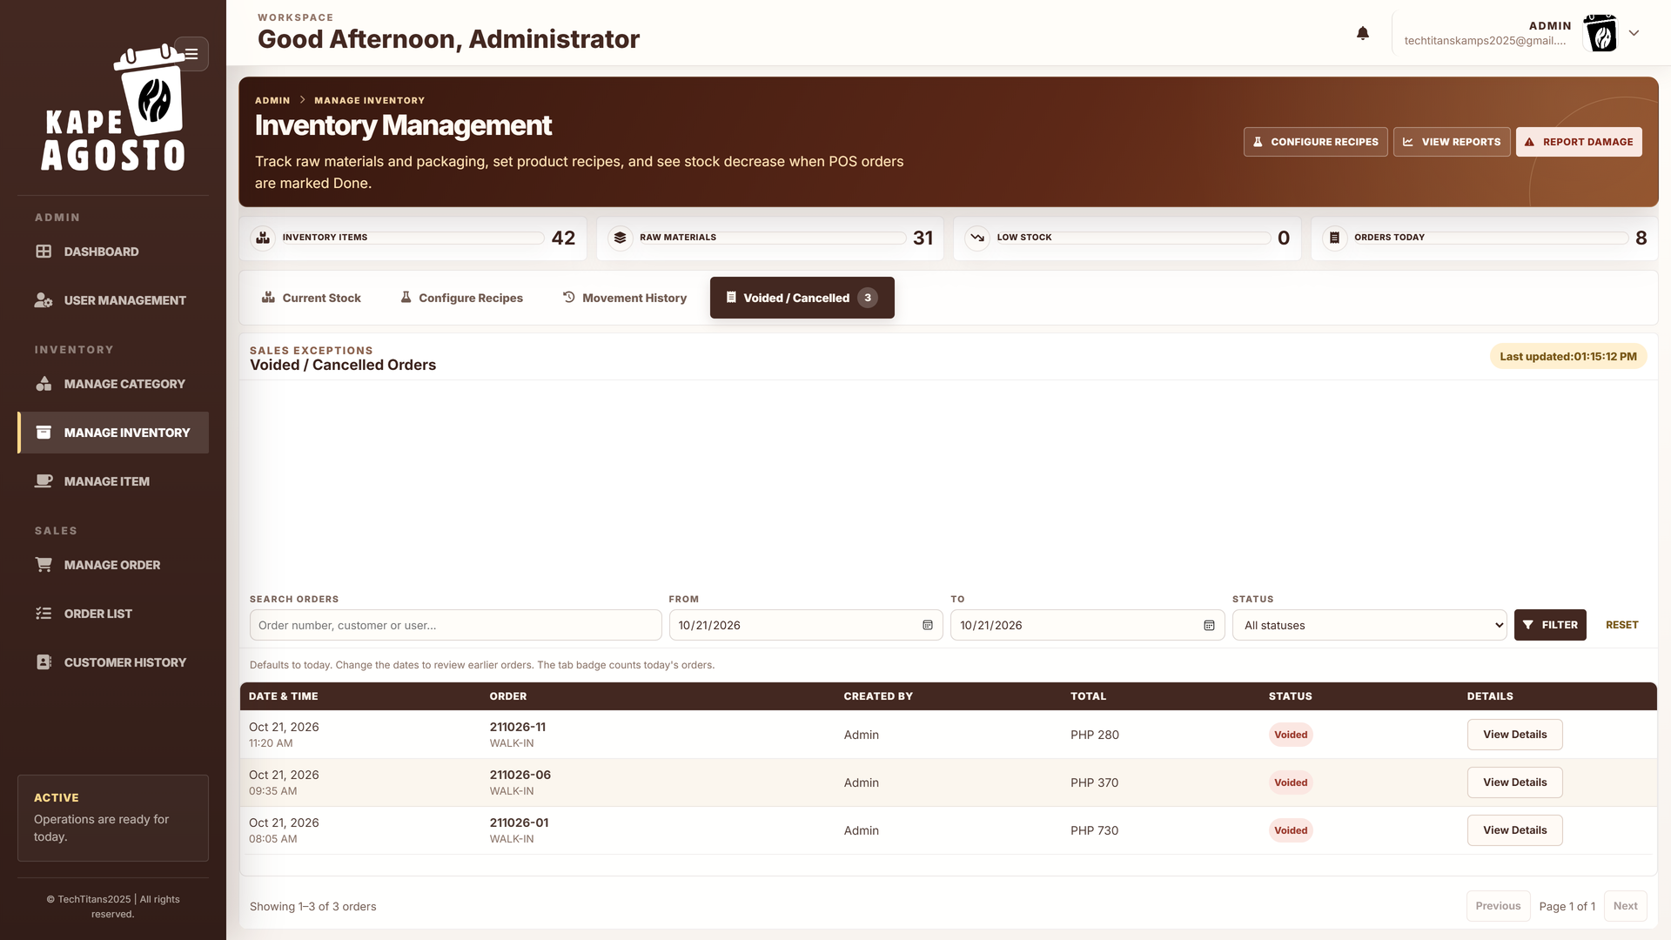
Screen reference Review voided and cancelled orders

Steps
1. Open Manage Inventory > Voided / Cancelled.
2. Set the From and To dates; the default view is today.
3. Search for the order or narrow the Status filter.
4. Review the order details and check Movement History for any recorded stock return.
Check before you continue The tab badge counts today's exceptions. Use the date filters to review earlier orders. Do not assume all cancellations have the same stock effect; inspect the order and movement records before making a correction.

ADMIN

Maintain the menu item list
Manage Item lists menu products, categories, cup sizes, prices, and available details.
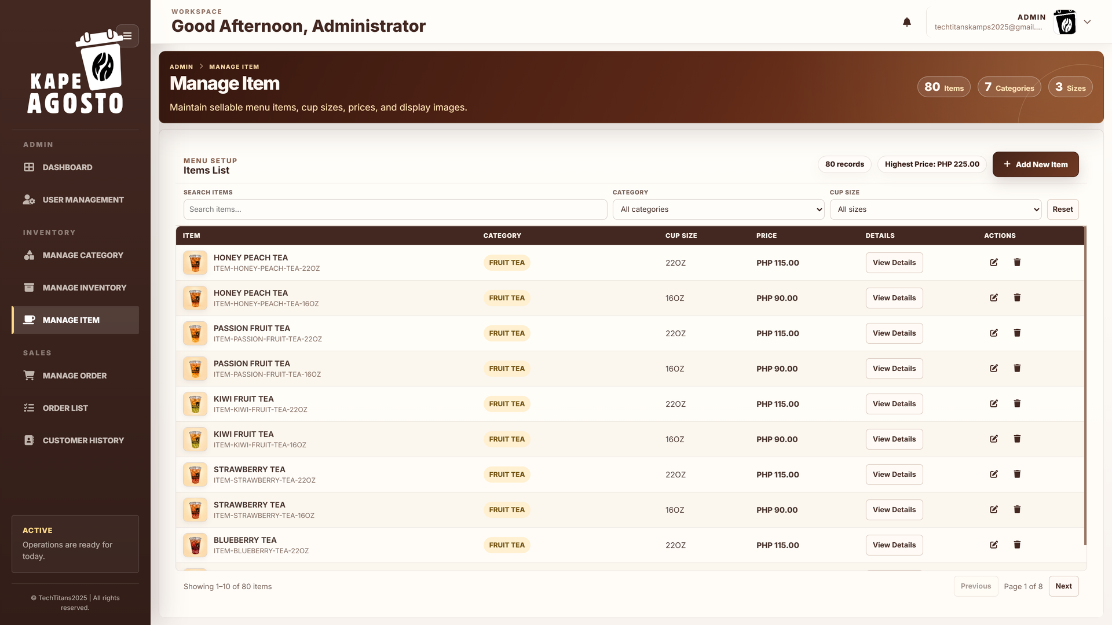
Screen reference Maintain the menu item list

Steps
1. Open Manage Item.
2. Search by product name or filter by Category and Cup size.
3. Use View Details to inspect the selected product. Use Edit to correct available menu fields.
4. Check the resulting name, size, category, and price in the list. Maintain the corresponding recipe in Manage Inventory when necessary.
Check before you continue Select the correct size variant before editing. A price change does not configure ingredients. Review related records before deleting a menu item.

ADMIN

Add a menu item
Use Add New Item to create a real product that can be selected at the POS.
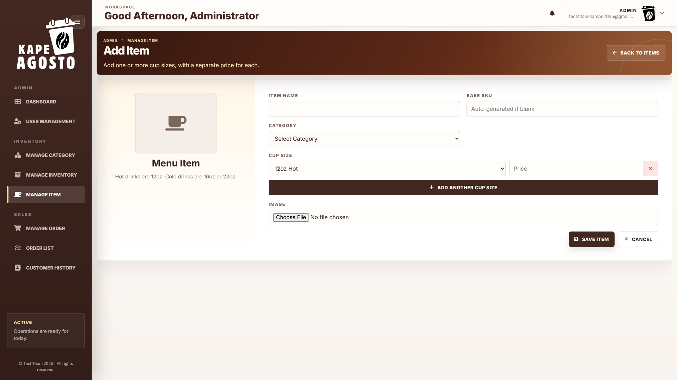
Screen reference Add a menu item

Steps
1. In Manage Item, select Add New Item.
2. Enter the Item Name, select its Category, and add an optional item image. Follow the SKU field guidance if leaving it blank.
3. Choose a Cup size and enter its Price. Use Add Cup Size and Price to add the other sizes required.
4. Review the entries and select Add Item. Then configure and save the recipe for every size under Manage Inventory.
Check before you continue Avoid duplicate or confusing product names. Check that the displayed price belongs to the chosen cup size. The new item must have the correct recipe before completed sales can produce meaningful ingredient usage.

ADMIN

Build a customer order
Admin accounts can use Manage Order to support the register and create customer tickets.
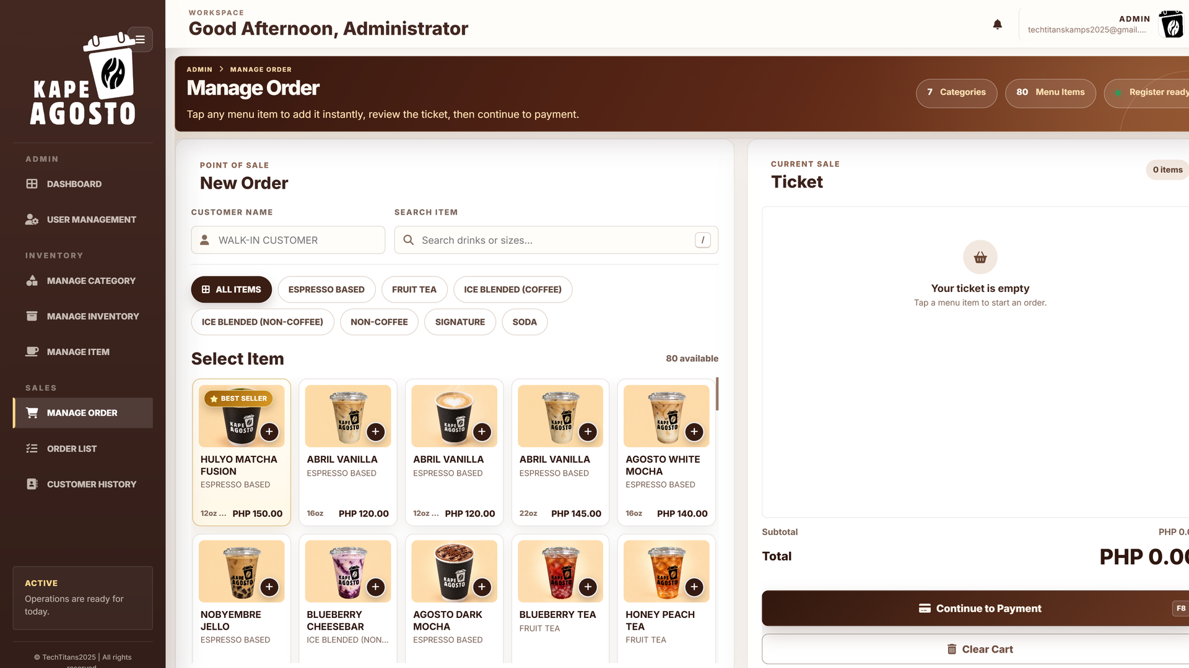
Screen reference Build a customer order

Steps
1. Open Manage Order and enter the Customer Name, or use the walk in name when appropriate.
2. Choose a category or search the menu. Select the correct product and cup size to add it to the ticket.
3. Review quantities, remove incorrect items, and confirm the total.
4. Select Continue to Payment only after checking the ticket. This creates the order and opens its payment page.
Check before you continue Adding an item to the ticket is not a completed sale. Clear removes the current ticket items. Payment recording and order completion are separate steps; see the payment workflow later in this manual.

ADMIN

Review and act on orders
Use Order List to find orders, inspect status, and open the available payment, completion, receipt, or cancellation actions.
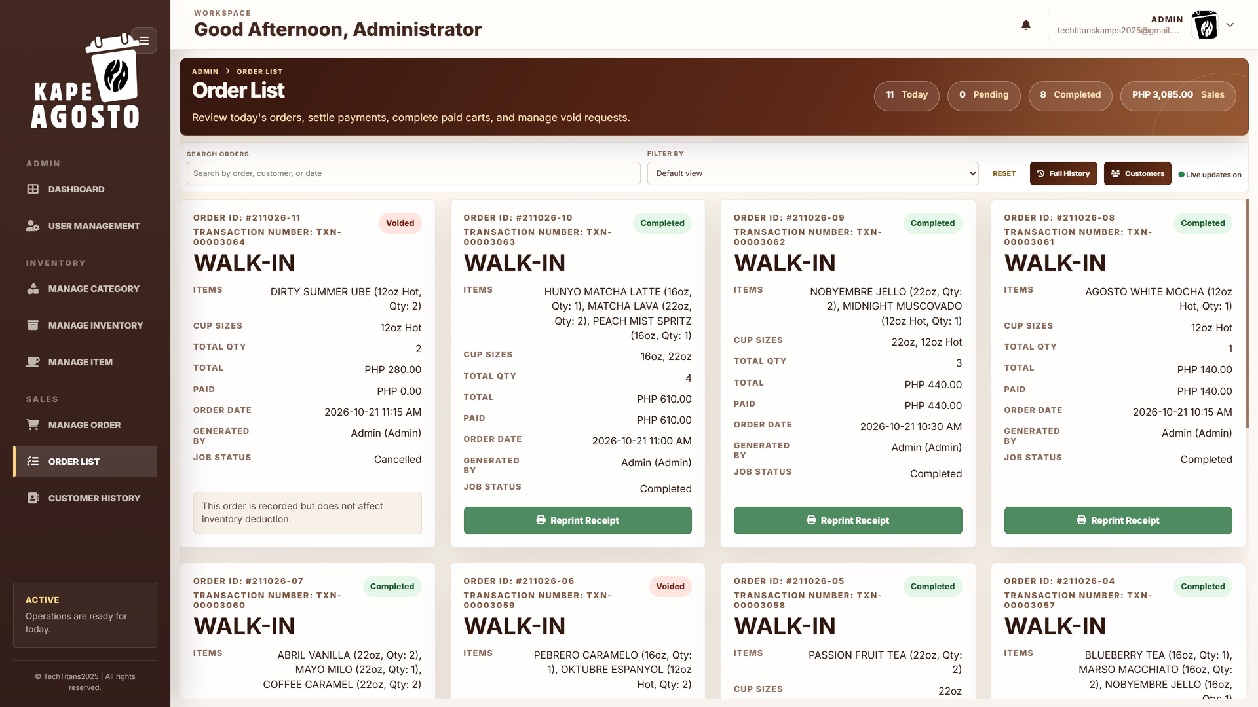
Screen reference Review and act on orders

Steps
1. Open Order List and check the view date.
2. Use Search Orders and Filter by to find the required record. Use Full History when reviewing earlier activity.
3. Check the order number, customer, total, payment status, and completion status before choosing an action.
4. Use Pay for an unpaid order, Done for a fully paid order, or the receipt action when available. Follow the approval steps for a void.
Check before you continue Do not repeat a payment or completion merely because the page is slow. Refresh and inspect the existing record first. Completing an eligible order records its recipe usage once.

ADMIN

Review customer history
Customer History groups recorded activity into customer, walk in, pending, and void records.
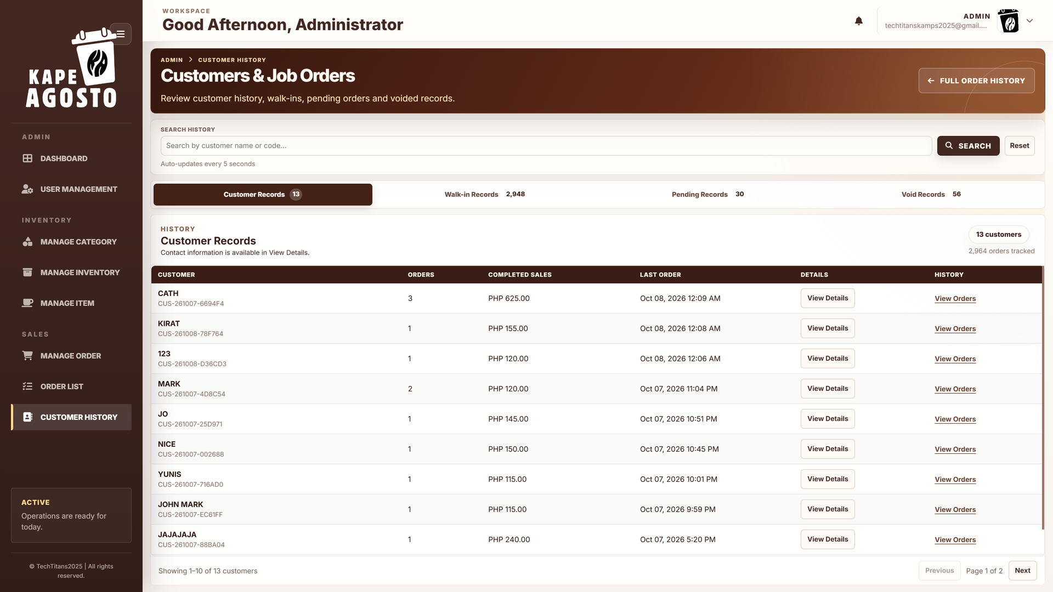
Screen reference Review customer history

Steps
1. Open Customer History and choose the record group required.
2. Enter a search term to narrow the records, or use Reset to return to the default view.
3. Use View Details for customer information and View Orders for related purchases.
4. Check the last order date, completed sales, and order status before drawing a conclusion.
Check before you continue Customer totals and order counts depend on the selected group and filters. View the underlying order when investigating an issue. A pending or void record should not be treated as a completed sale.

ADMIN

Maintain system settings
System Settings controls business details, receipts, localization, transaction availability, outgoing email, and optional AI configuration.
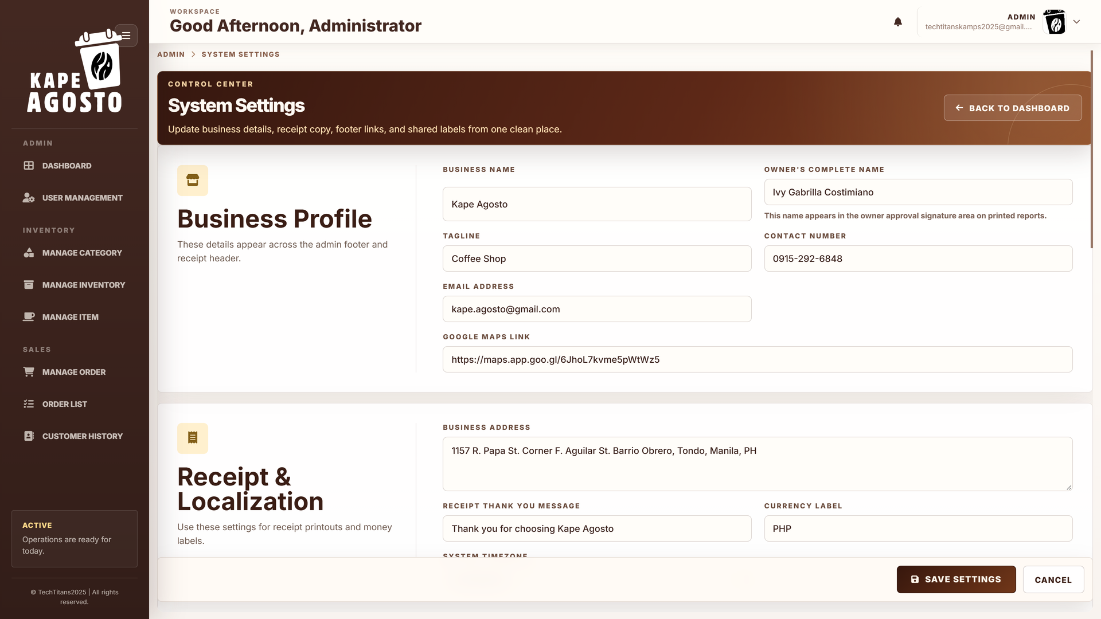
Screen reference Maintain system settings

Steps
1. Open the account menu and select Settings.
2. Update only the relevant section, such as Business Profile or Receipt & Localization.
3. Review the effect of the proposed values, then select Save Settings.
4. Verify the result in the appropriate page or receipt. Use the diagnostic tools when investigating mail delivery rather than repeatedly changing unrelated fields.
Check before you continue Maintenance mode pauses transaction actions for every role. Keep service credentials private. Leave a saved password or API key field blank when its instruction says this preserves the existing value; do not clear stored credentials unintentionally.

ADMIN

Update your profile
Use your own profile page to maintain the personal account fields that the system allows you to edit.
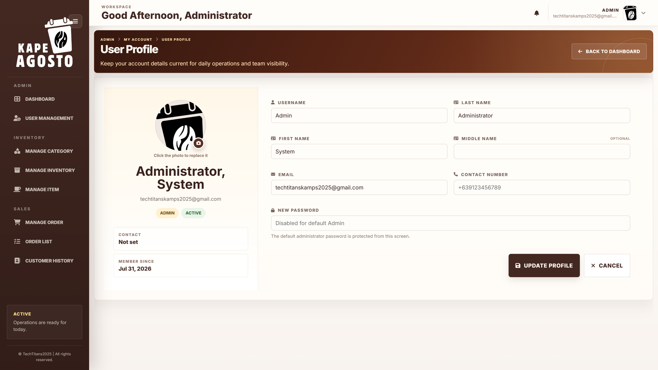
Screen reference Update your profile

Steps
1. Open the account menu and select User Profile.
2. Review your name, username, email, contact number, and profile photo.
3. Change only the fields you intend to update. Use the new password field only when changing a password and when that field is enabled.
4. Select Update Profile and confirm that your details are correct. Use the account menu to log out when finished.
Check before you continue The default Admin account has protected fields and its password is disabled on this screen. Profile editing does not change another user's role; use User Management for account access changes.

ADMIN

Generate and review daily reports
Daily Reports provides saved records of sales and inventory activity for selected dates.
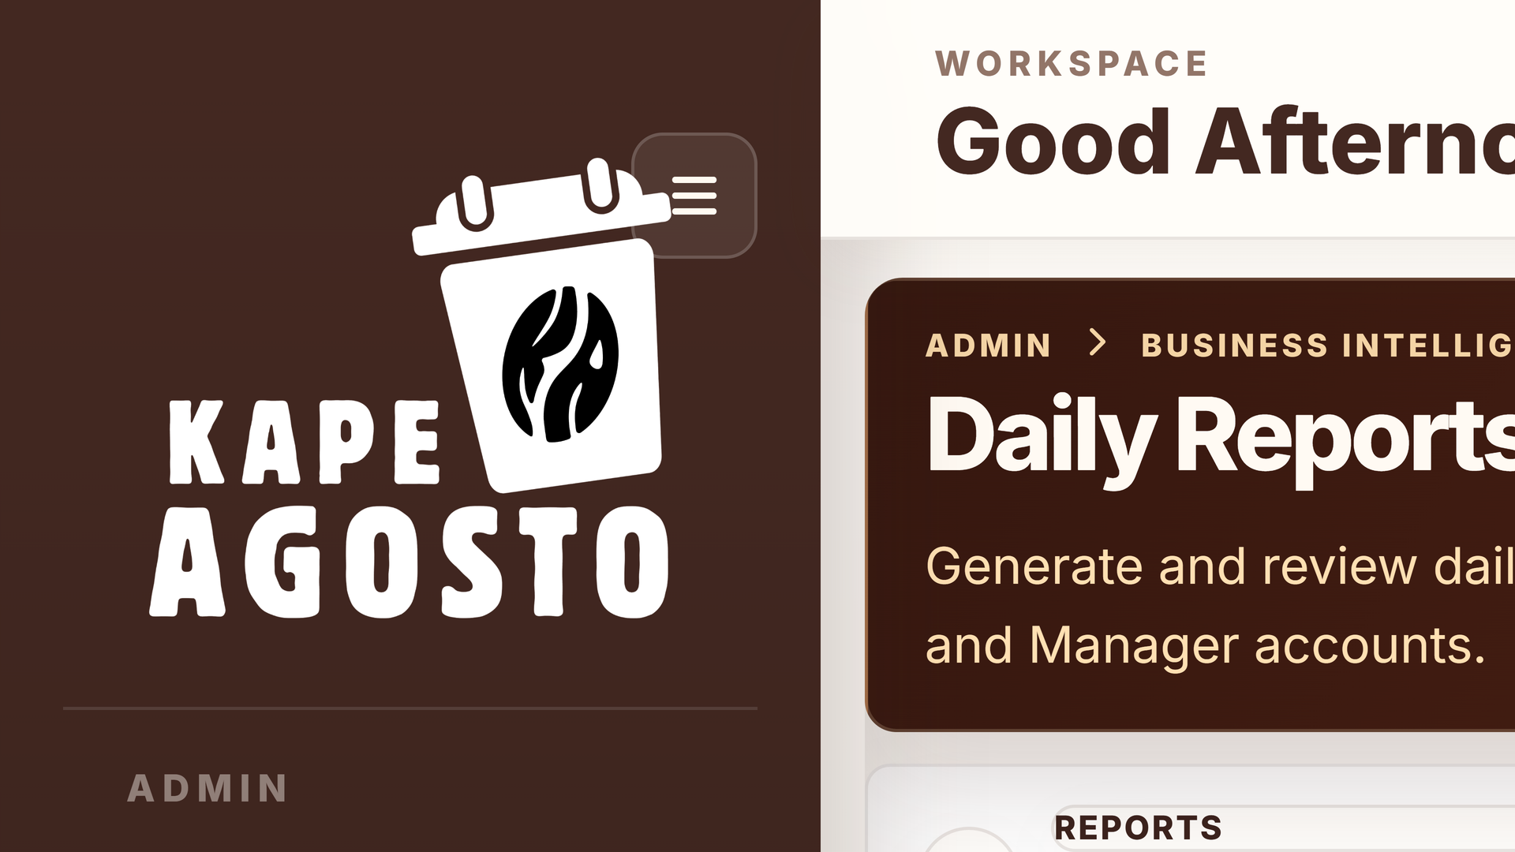
Screen reference Generate and review daily reports

Steps
1. Open View Reports from Manage Inventory or the dashboard analytics area.
2. Set View Date and select Apply to inspect the saved report for that day.
3. If needed, select Generate Date or Generate Report after checking that the relevant completed orders are recorded.
4. Use Range Tools for a date range. Open a report from Generated Reports or use its Excel export action.
Check before you continue Generation creates or updates a saved report. Check the selected dates before generating a range. Today's report can change while business is still in progress; use the underlying transactions to resolve discrepancies.

ADMIN

Read or export a daily report
A daily operations report supports review of the recorded activity for one date and provides print or export controls.
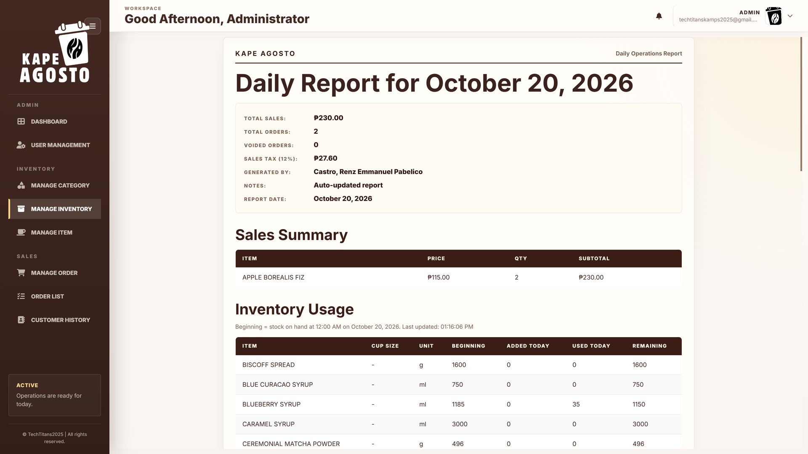
Screen reference Read or export a daily report

Steps
1. Open the matching date from Generated Reports.
2. Confirm the report date and review its sales and inventory sections.
3. Check the prepared by and owner approval areas when using the report for a review or sign off.
4. Use Print Report or the available Excel export control. Review the exported date and totals before distributing the document.
Check before you continue Do not infer that an approval signature has been provided simply because the report contains a signature area. Export formats follow the controls shown by the installed system.

ADMIN

Create and restore database backups
Backup & Restore protects the database before major changes and supports recovery from a selected backup.
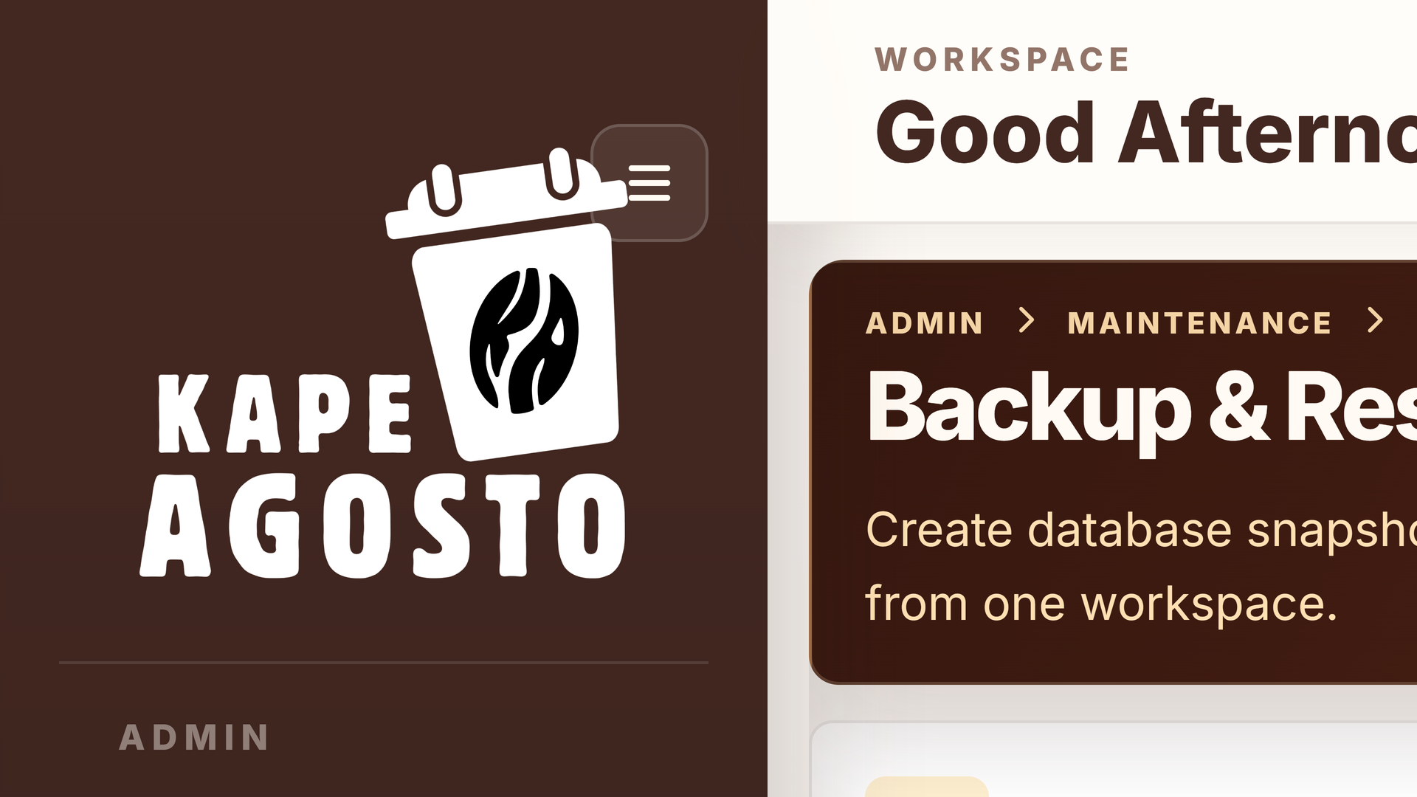
Screen reference Create and restore database backups

Steps
1. Open Backup & Restore from Daily Reports.
2. Use Create Backup and wait for the result. Check the available backup list and its date.
3. Download the intended backup and store it in your approved secure location.
4. For an authorized restore, verify the database, selected SQL file, and backup date before using Restore Backup. Review the result and system records afterward.
Check before you continue Restore replaces the current database with the selected backup. Changes made after that backup may be lost. Create a current backup and obtain your organization's authorization before restoring. Downloading a backup is different from restoring it.

MANAGER

Review the manager sales dashboard
The Manager dashboard is a review and planning workspace. It does not provide the Admin account management or Cashier checkout workflow.
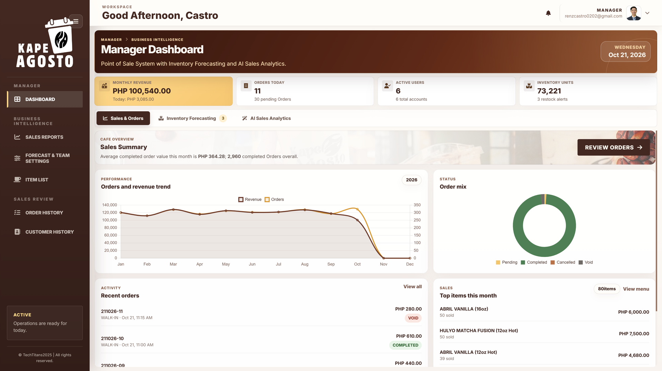
Screen reference Review the manager sales dashboard

Steps
1. Open Dashboard and choose Sales & Orders.
2. Read the displayed sales, order, and inventory summary periods.
3. Compare the sales trend, order mix, recent activity, and top products.
4. Use the manager navigation to open Sales Reports, Item List, Order History, or Customer History for the underlying records.
Check before you continue Use a consistent reporting period when comparing results. Ask an Admin for account, product, recipe, or stock corrections. Payment, completion, and void processing belong to the authorized Admin or Cashier workflow.

MANAGER

Inspect dashboard inventory coverage
Manager inventory forecasting helps identify materials that may need replenishment and compare stock coverage with lead time.
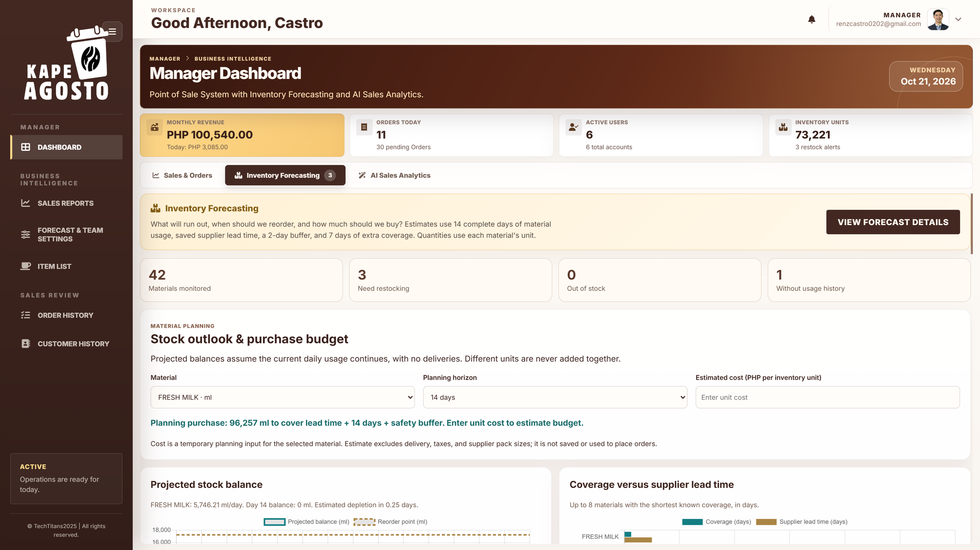
Screen reference Inspect dashboard inventory coverage

Steps
1. Select Inventory Forecasting from Dashboard.
2. Read the monitored material and restock summary.
3. Choose a material or use the search and restock filters to inspect coverage and recommended purchases.
4. Discuss the recommendation with the responsible Admin and check actual availability before planning replenishment.
Check before you continue Review each material in its own unit. A forecast is not a purchase order and does not change on hand stock. Missing usage history must be resolved before treating the estimate as reliable.

MANAGER

Review sales analytics and predictions
The manager analytics view compares recorded sales patterns with demand estimates and recommendations.
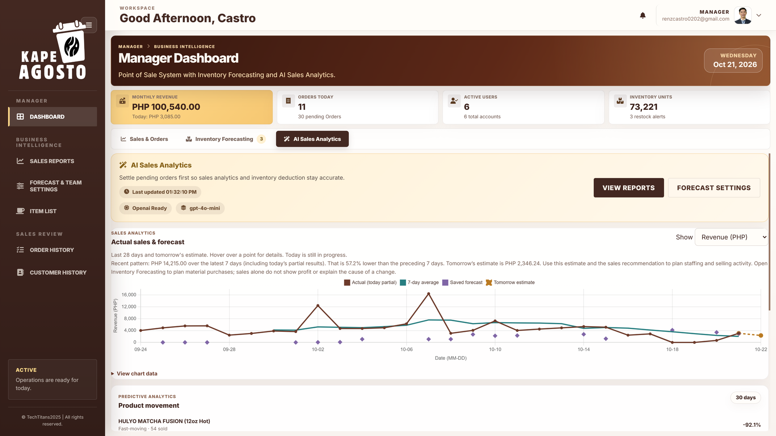
Screen reference Review sales analytics and predictions

Steps
1. Select AI Sales Analytics from Dashboard.
2. Switch the chart between revenue and completed orders using Show.
3. Inspect actual sales, the seven day average, saved forecast markers, and tomorrow's estimate.
4. Read product movement and forecast accuracy alongside the sales recommendation. Open Sales Reports to investigate the source records.
Check before you continue Today's results are partial. Sales changes alone do not explain their cause or prove a profit change. Local calculations drive the forecasts; optional AI support adds a recommendation from summary metrics.

MANAGER

Prepare manager sales reports
Managers can view, generate, and export reports for the required business dates.
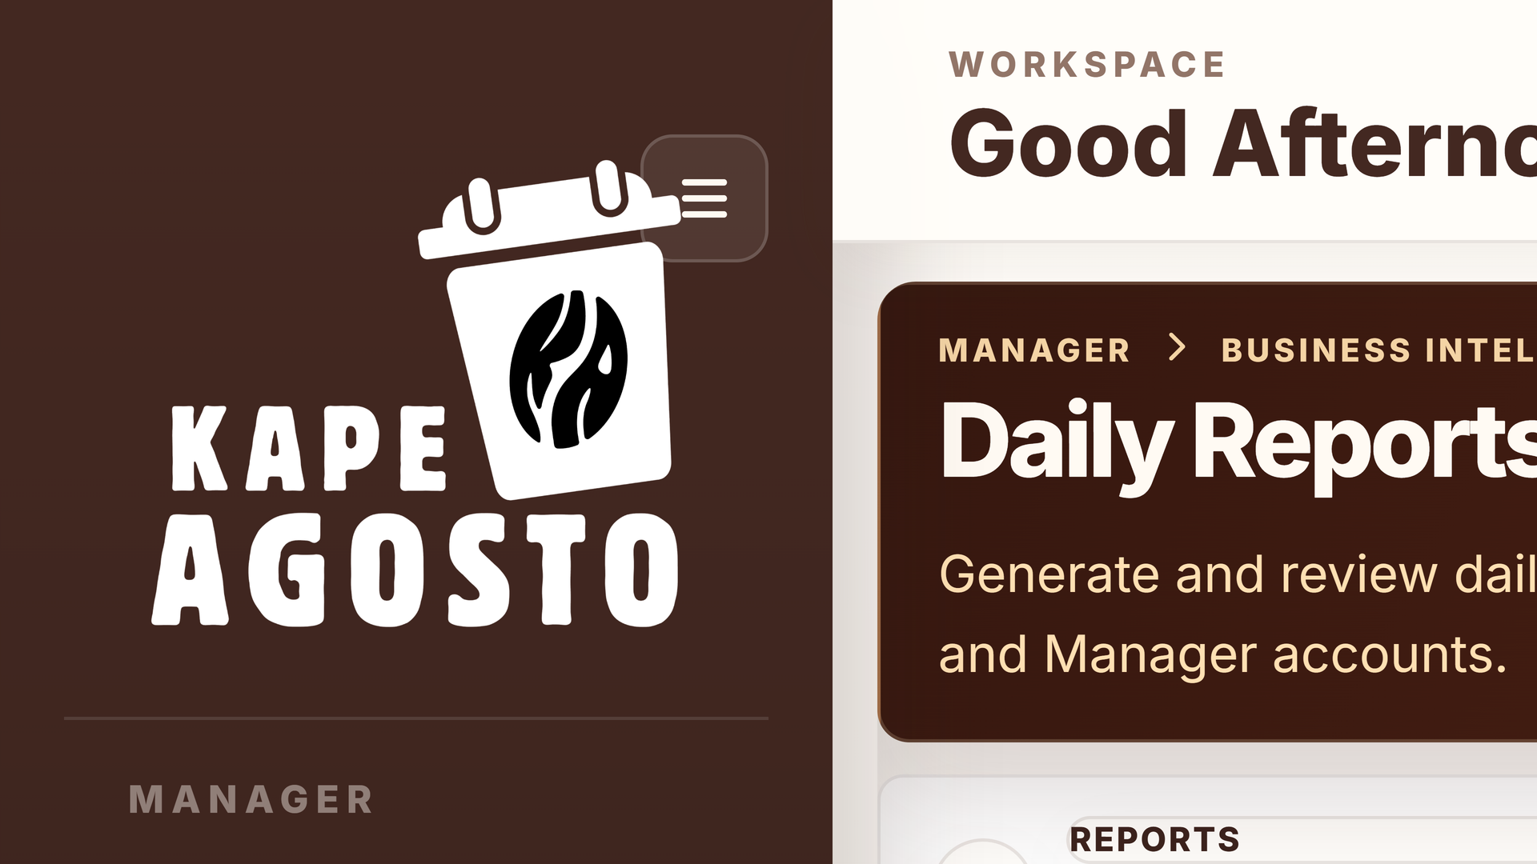
Screen reference Prepare manager sales reports

Steps
1. Open Sales Reports in the manager navigation.
2. Select View Date and Apply, then review the saved report if one is available.
3. Generate the selected date or open Range Tools when a date range is required.
4. Use Generated Reports to open a saved date or export the intended report to Excel.
Check before you continue Check completed transaction records before reporting a discrepancy. A report generated during the business day may not represent the final day total. Keep the report date visible when sharing results.

MANAGER

Review an individual daily report
Use an individual report to review one day's recorded sales and operational activity.
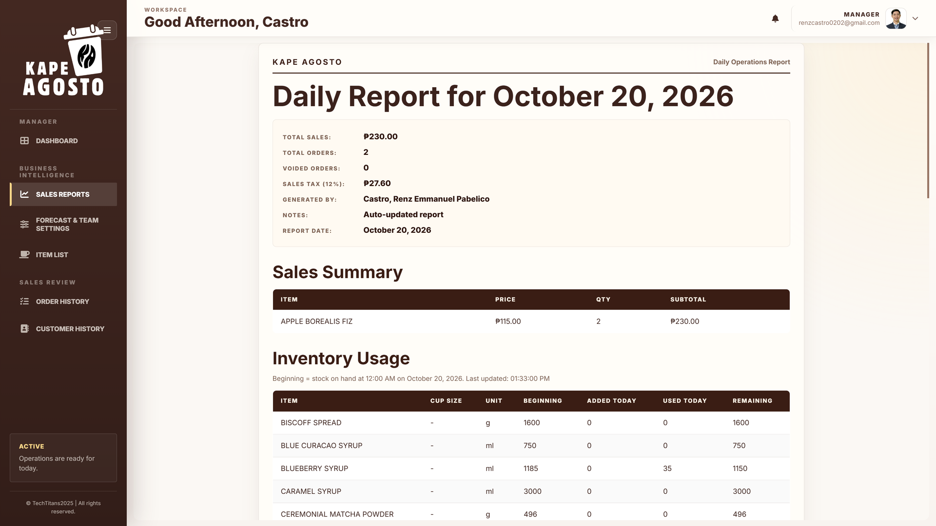
Screen reference Review an individual daily report

Steps
1. Open the correct saved date from Sales Reports.
2. Confirm the displayed date and inspect the available totals and activity sections.
3. Compare unusual figures with Order History and Customer History.
4. Use Print Report or the available export control when a copy is required. Follow the cafe's approval procedure for sign off.
Check before you continue A report view does not authorize a Manager to alter the underlying sale or stock movement. Refer corrections to an Admin or the appropriate transaction operator.

MANAGER

Review menu items and prices
Item List gives Managers a reference for products, categories, cup sizes, and selling prices.
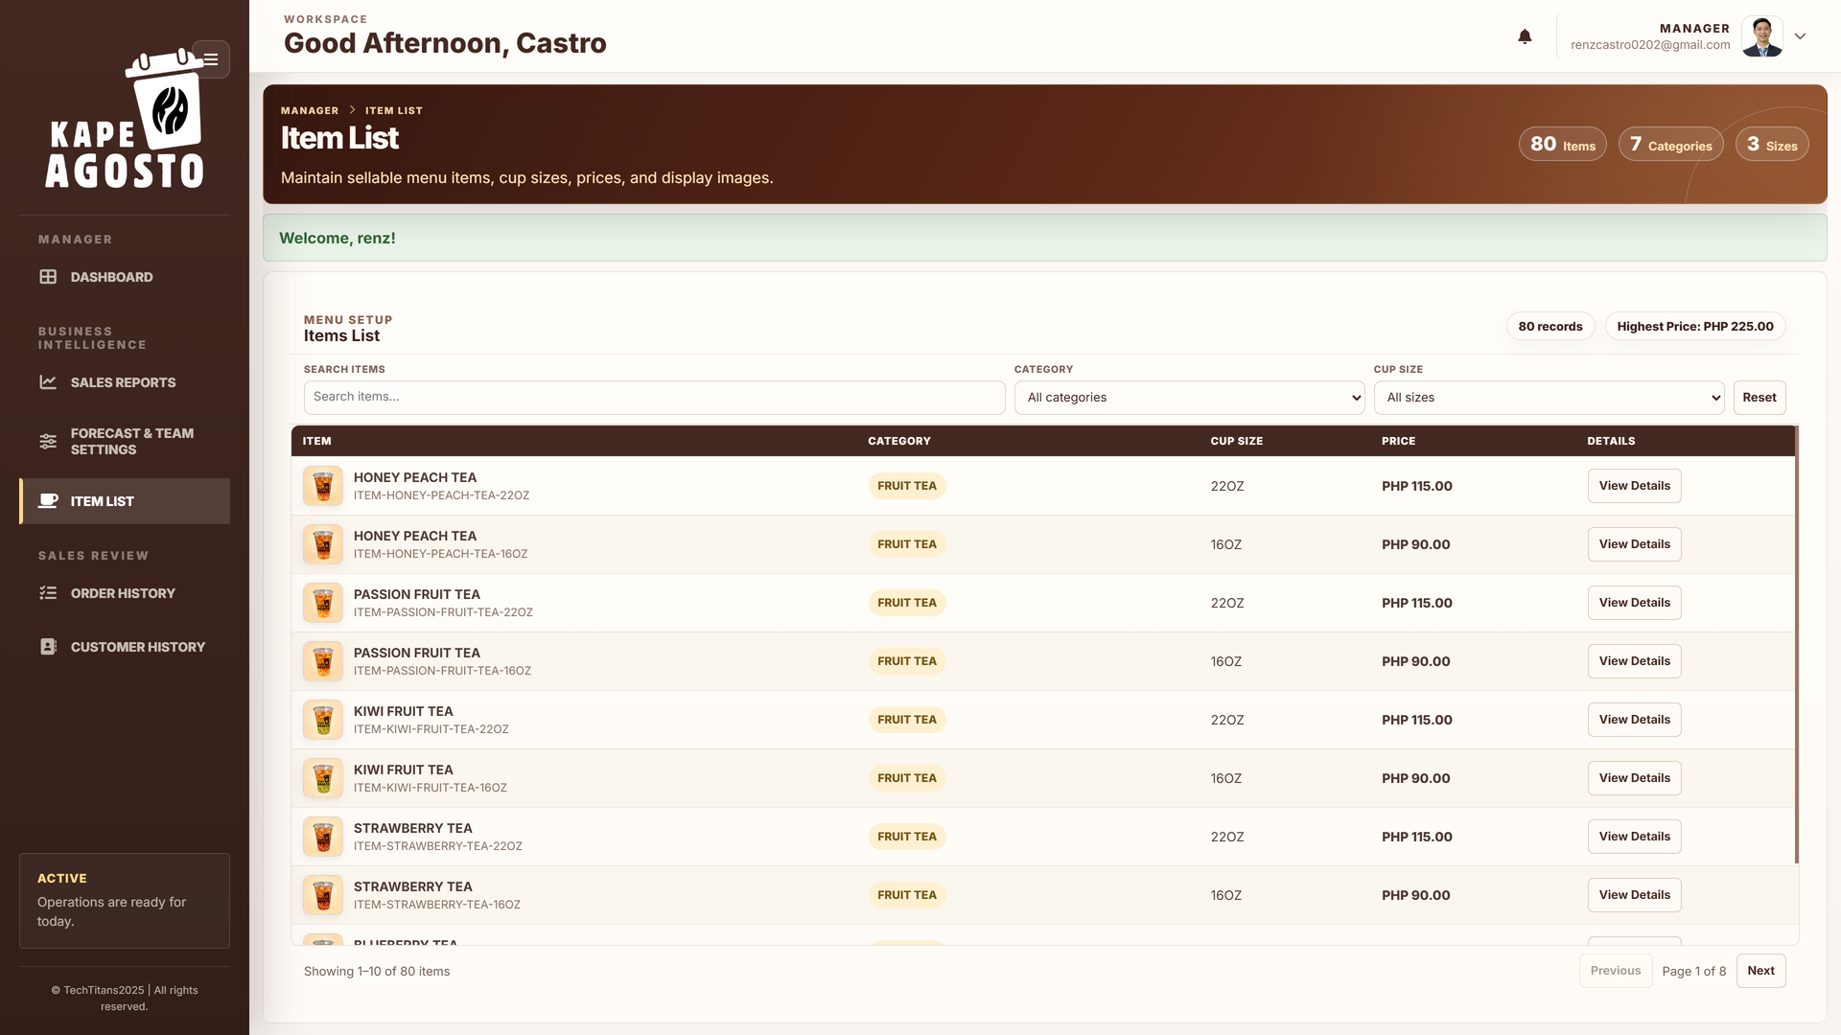
Screen reference Review menu items and prices

Steps
1. Open Item List.
2. Search for the product or filter by category and cup size.
3. Open View Details to review the selected product information.
4. Report incorrect product names, sizes, prices, or recipes to an Admin.
Check before you continue Managers review menu information; Admin accounts maintain menu details and recipes. Confirm the cup size before comparing prices or interpreting product performance.

MANAGER

Review order history
Use Order History to inspect recorded transactions and their statuses without processing the register workflow.
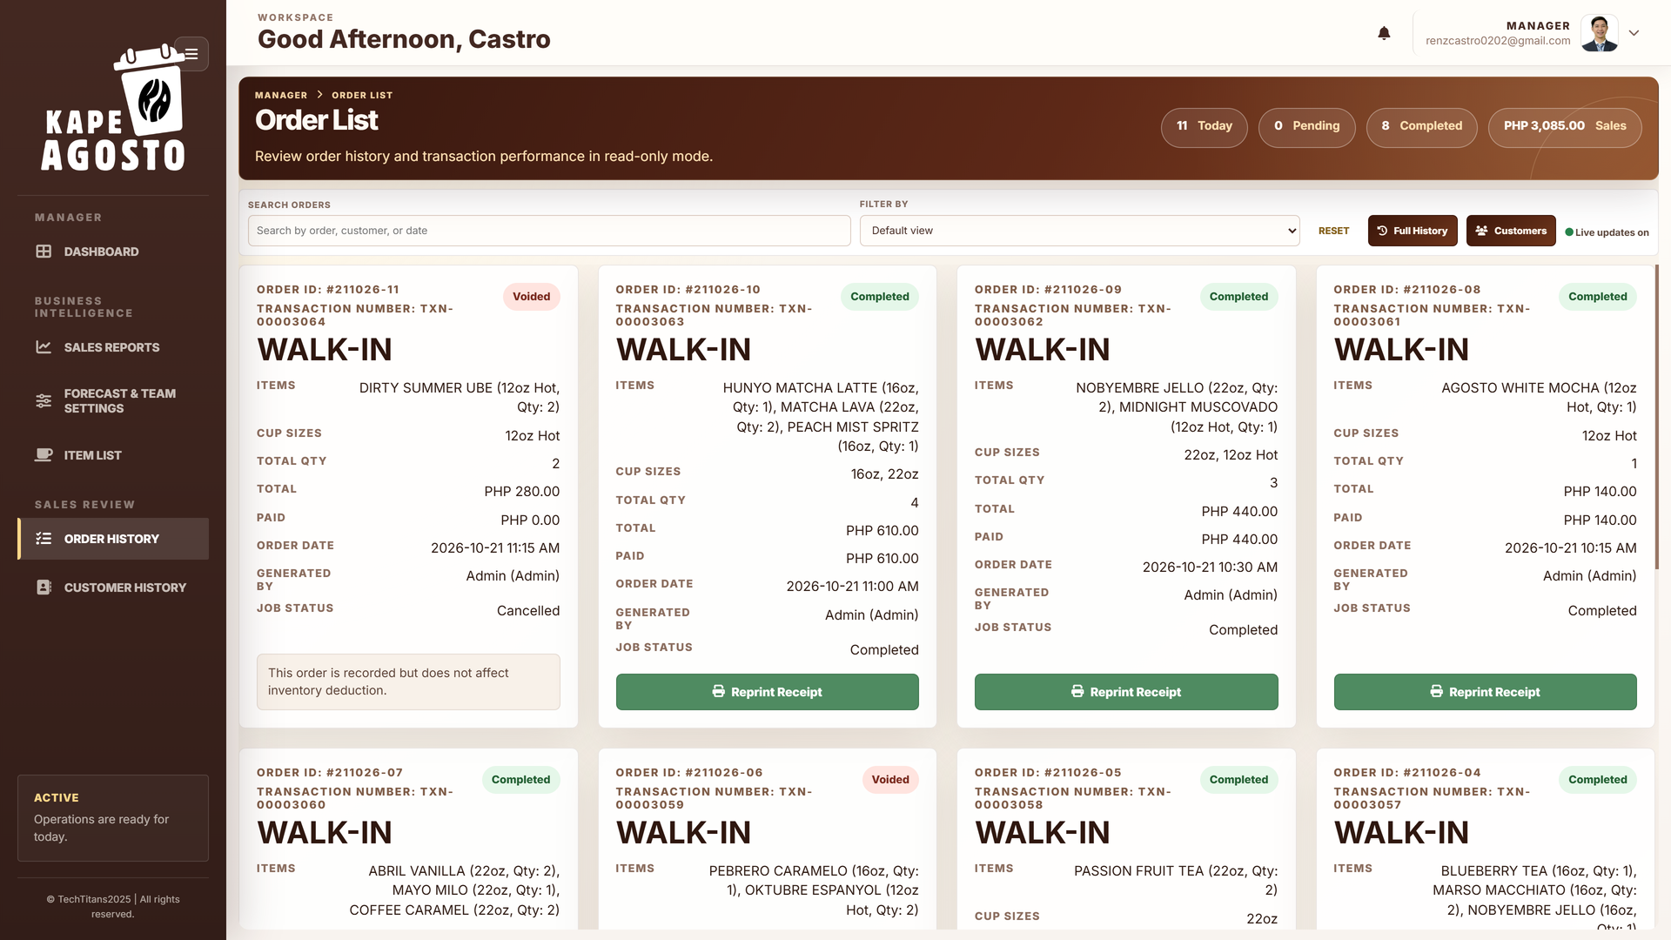
Screen reference Review order history

Steps
1. Open Order History from the manager navigation.
2. Check the selected date. Use the available search and date filters to find the order.
3. Use Full History when available to inspect earlier activity.
4. Review the matching order details or receipt, then discuss payment or cancellation issues with an Admin or Cashier.
Check before you continue Managers review order history and receipts. Payments, Done, and void actions are handled by authorized Admin and Cashier accounts. Recheck the order number and date before requesting a correction.

MANAGER

Review customer and walk in records
Customer History helps Managers review customer purchases and related pending or void records.
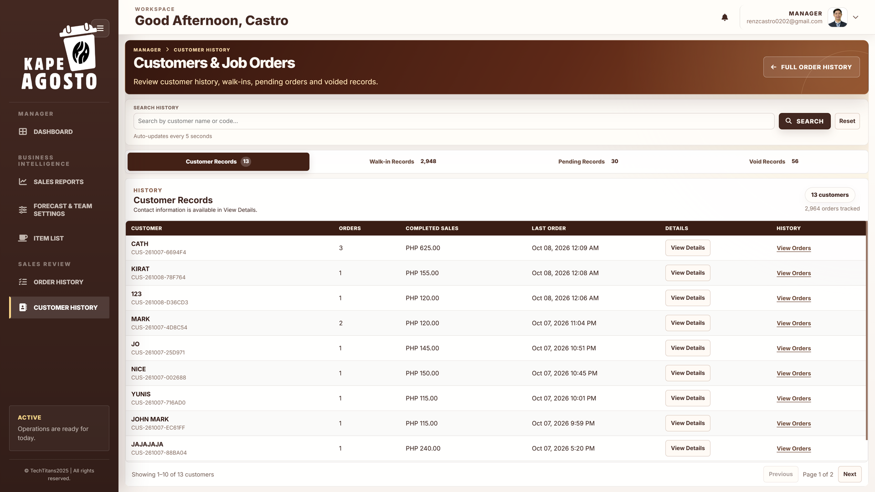
Screen reference Review customer and walk in records

Steps
1. Open Customer History.
2. Choose Customer Records, Walk in Records, Pending Records, or Void Records.
3. Search within the selected group. Use View Details for customer information or View Orders for the associated transactions.
4. Review the order dates, status, and completed sales before summarizing customer activity.
Check before you continue The selected record group changes the meaning of the totals. Pending and voided activity should be distinguished from completed sales when preparing a review.

MANAGER

Read automatic sales forecasts
Forecast & Team Settings > Sales Forecast presents automatically calculated daily, weekly, and monthly sales estimates.
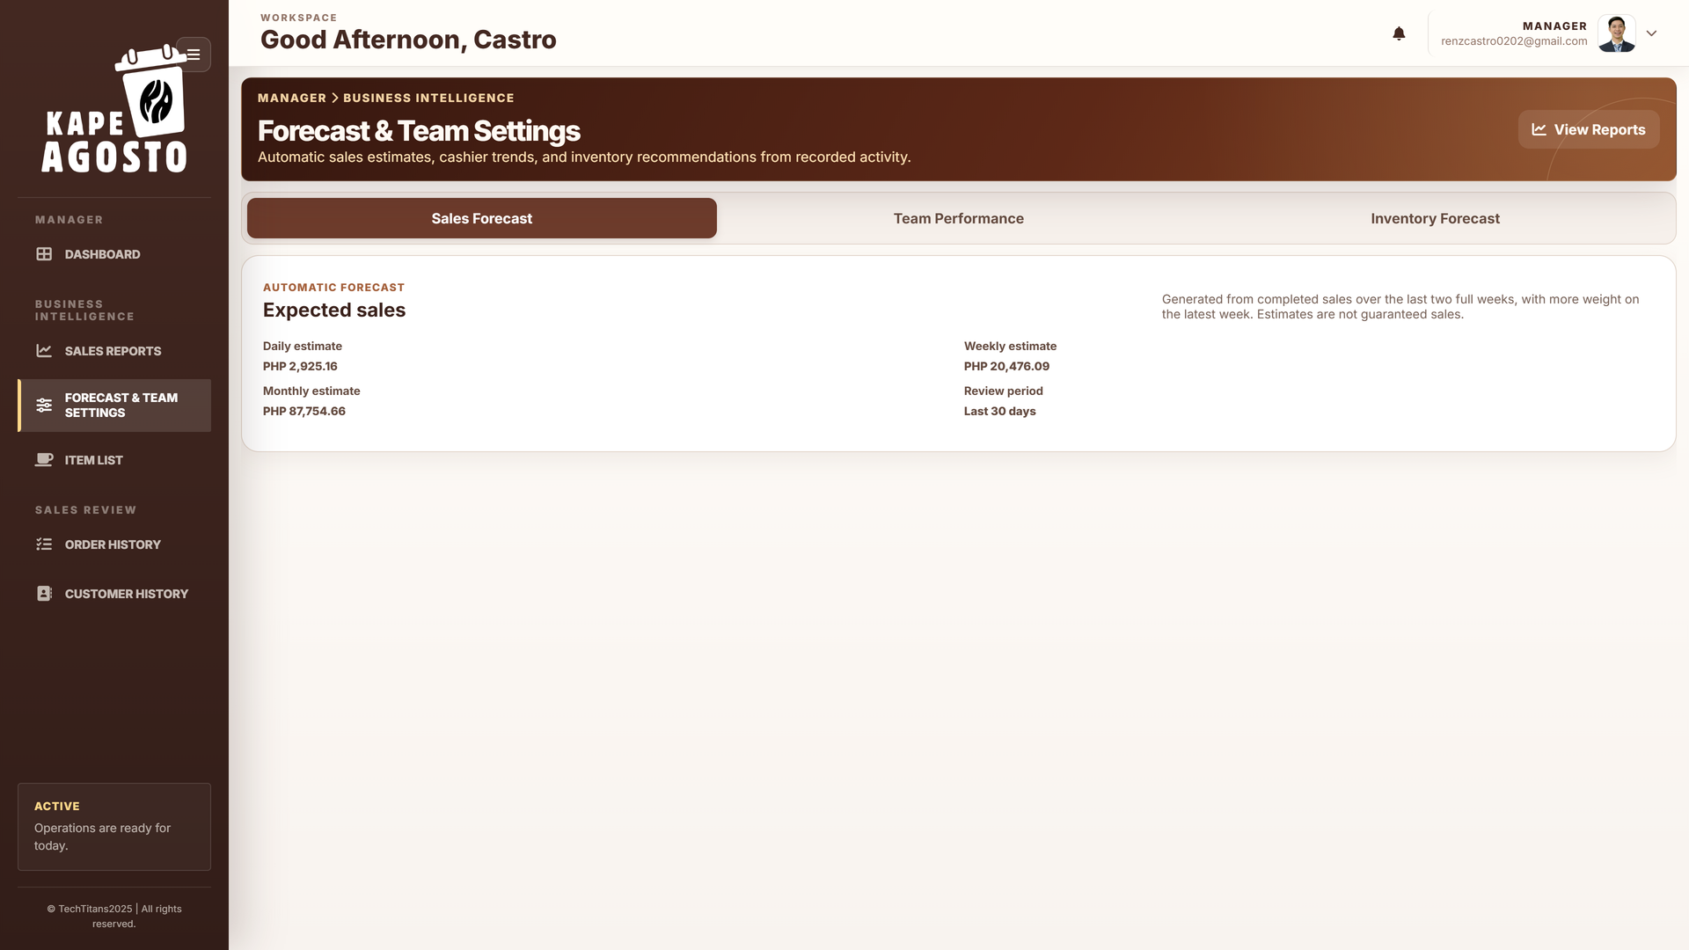
Screen reference Read automatic sales forecasts

Steps
1. Open Forecast & Team Settings and select Sales Forecast.
2. Read the daily, weekly, and monthly estimates and the displayed review period.
3. Compare the estimate with the sales dashboard and recent business conditions.
4. Use the result for planning staffing and selling activity, then continue to Team Performance or Inventory Forecast for related review.
Check before you continue These are automatically generated estimates from completed sales history. No manual sales goal or Save action is required. They do not guarantee future sales or change recorded transactions.

MANAGER

Compare cashier team performance
Team Performance compares each active cashier's recent recorded results with the previous comparison period.
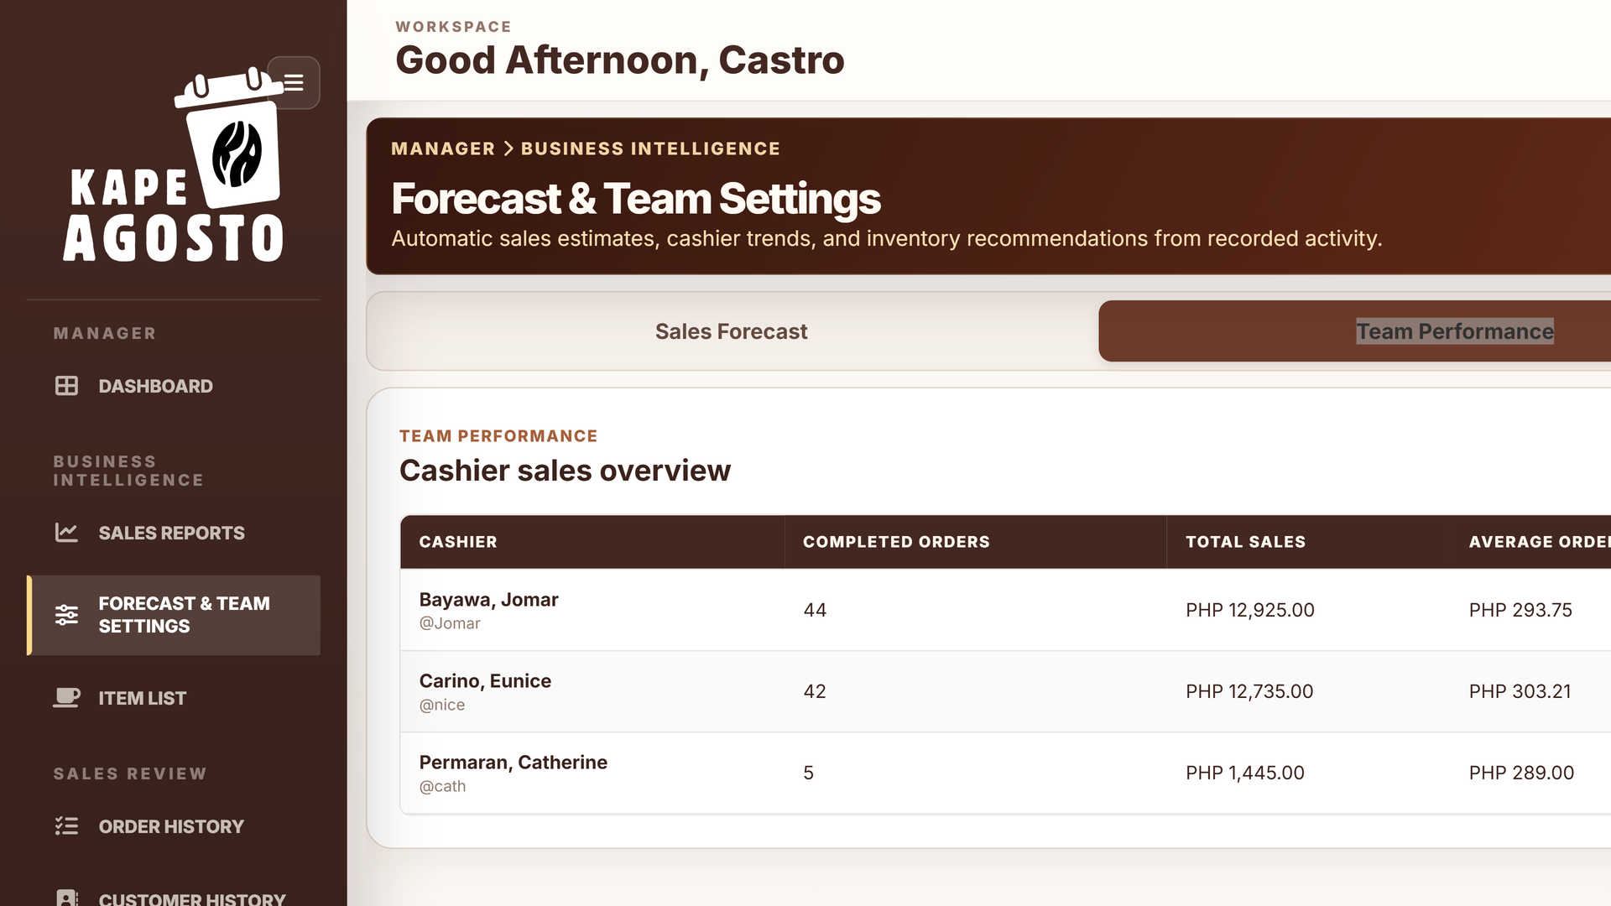
Screen reference Compare cashier team performance

Steps
1. Open Forecast & Team Settings > Team Performance.
2. Review Completed Orders, Total Sales, and Average Order for each cashier.
3. Compare Previous 30 Days and Sales Change with the latest 30 days, including today.
4. Use the recorded results to guide a review, and check transaction records before drawing conclusions about a discrepancy.
Check before you continue Awaiting prior history means a valid previous period comparison is unavailable. Differences may reflect shifts, assigned work, product mix, or incomplete periods; the table alone does not explain the reason for a change.

MANAGER

Review automatic restock recommendations
Inventory Forecast provides material level coverage, safety stock, reorder points, supplier lead time, and target stock.
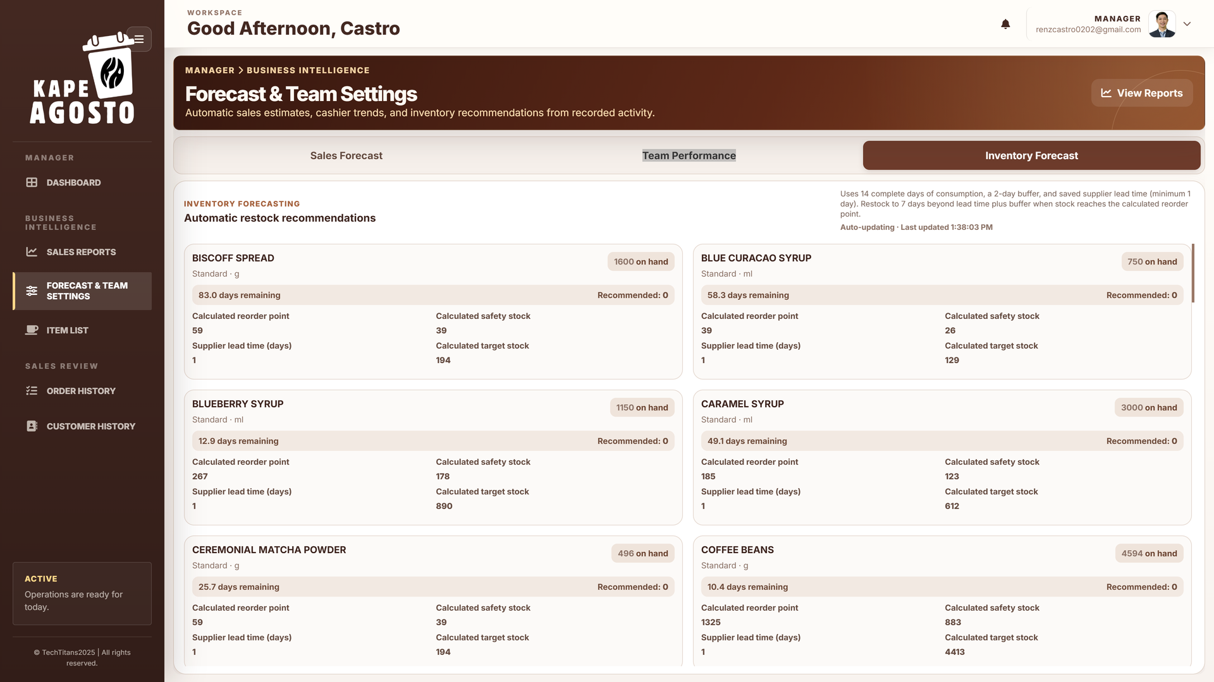
Screen reference Review automatic restock recommendations

Steps
1. Open Forecast & Team Settings > Inventory Forecast.
2. Read the material name, unit, on hand quantity, estimated days remaining, and Recommended quantity.
3. Compare Calculated reorder point, Calculated safety stock, Supplier lead time, and Calculated target stock.
4. Discuss materials needing attention with the Admin responsible for stock and supplier coordination.
Check before you continue Recommendations use 14 complete days of consumption, a two day buffer, and saved supplier lead time of at least one day. They target seven extra days beyond lead time and buffer. Forecasts neither change balances nor place purchases.

CASHIER

Build a POS ticket
The Cashier opens directly into the POS register. Use Manage Order to build and review the customer's ticket.
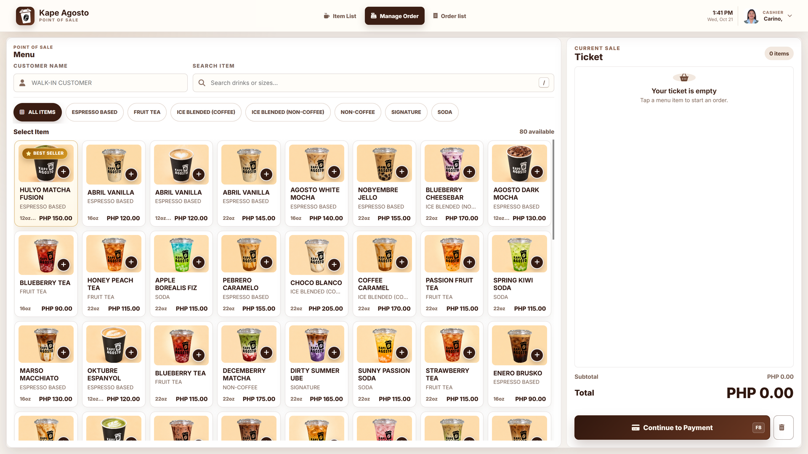
Screen reference Build a POS ticket

Steps
1. Confirm that your own Cashier name is shown in the header.
2. Enter Customer Name if needed. Search drinks or sizes, or choose a menu category.
3. Select the correct product and cup size. Review the ticket quantities, remove mistakes, and verify the total.
4. Select Continue to Payment only when the ticket is correct. Record payment and complete the paid order using the payment workflow.
Check before you continue The ticket is not a completed sale. Continue to Payment creates the order. Do not create duplicate tickets when an existing pending order can be reopened from Order list.

CASHIER

Check the item list
Item List is the Cashier reference for product details, categories, cup sizes, and prices.
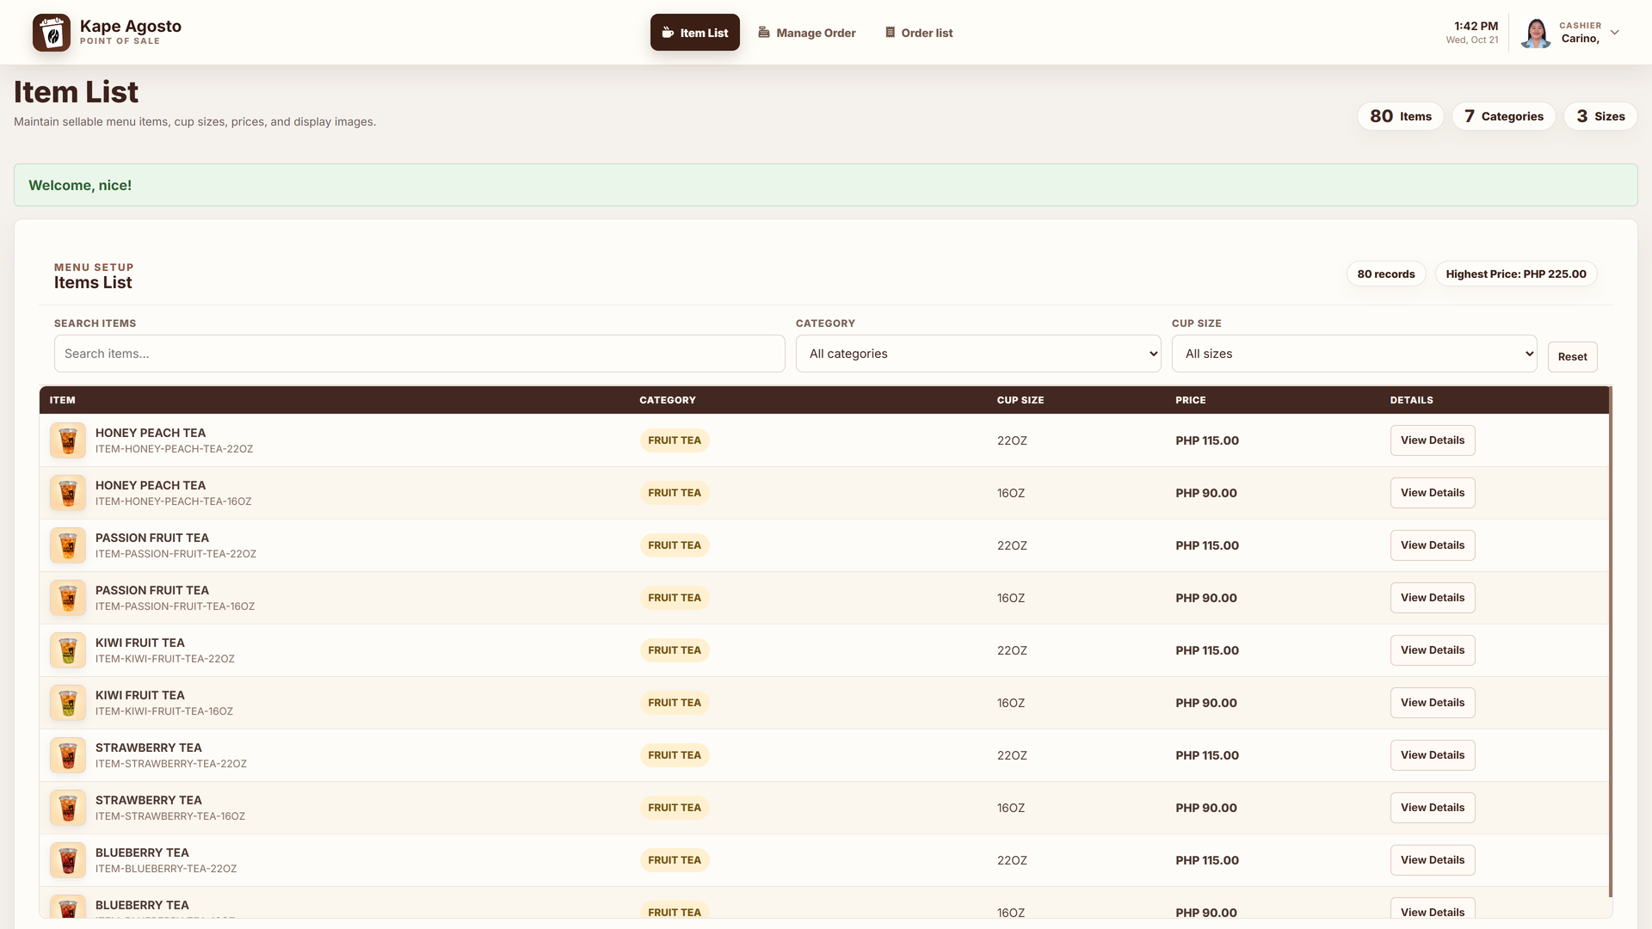
Screen reference Check the item list

Steps
1. Select Item List in the Cashier header.
2. Use search or the category and cup size filters to locate the product.
3. Check the displayed size and price. Open View Details where available.
4. Return to Manage Order to build the customer's ticket. Ask an Admin to correct menu or recipe information.
Check before you continue Cashiers view menu information rather than maintain product prices or recipes. A product with multiple sizes can have different prices and ingredient quantities for each size.

CASHIER

Find orders and receipts
Order list helps Cashiers find existing sales, confirm status, and use the actions available for that record.
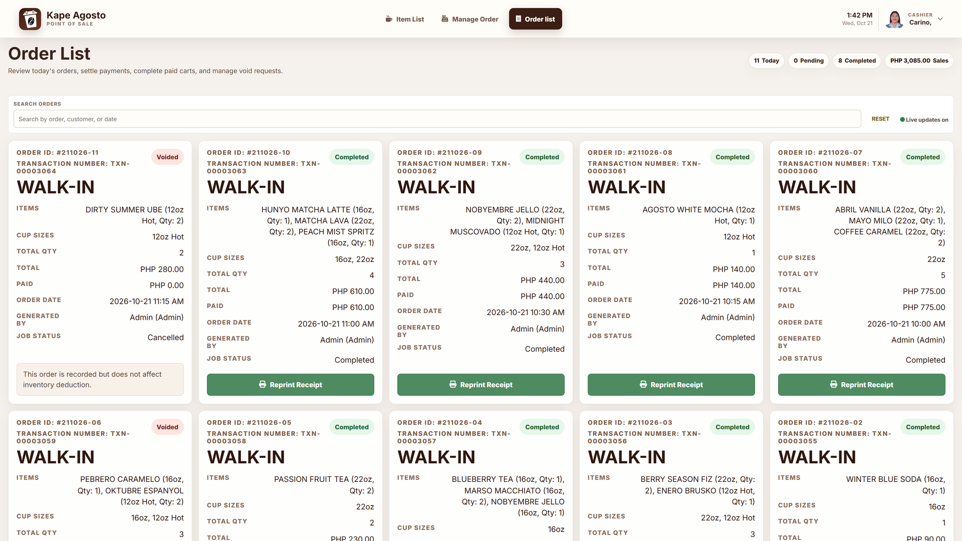
Screen reference Find orders and receipts

Steps
1. Select Order list in the Cashier header.
2. Use Search Orders and the available date filter to find the matching order.
3. Review the customer, order number, total, and payment or completion status.
4. Open payment for an unpaid order, complete a fully paid order when eligible, or use Reprint Receipt for a completed sale. Follow the required approval process for voids.
Check before you continue An action is shown only when allowed for the role and order status. Check whether a payment or completion already succeeded before retrying. Always confirm the correct order before printing a receipt or requesting cancellation.

CASHIER

Maintain your Cashier profile
User Profile allows a Cashier to maintain the personal account details available on the form.
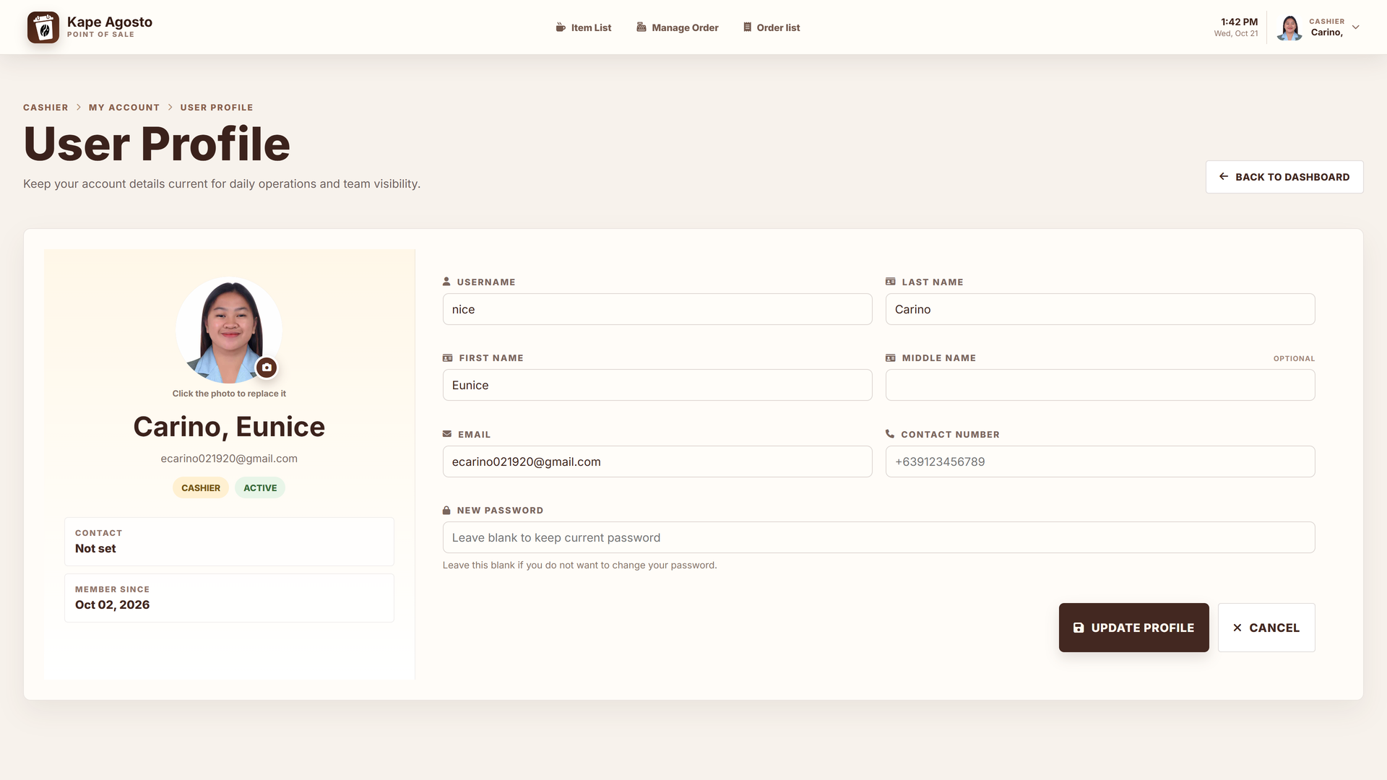
Screen reference Maintain your Cashier profile

Steps
1. Open the Cashier account menu and select User Profile.
2. Review the displayed name, username, email, contact number, and profile photo.
3. Update the intended fields. Enter a new password only when you intend to change it and follow the requirements shown.
4. Select Update Profile and verify the result. Log out through your account menu when leaving the workstation.
Check before you continue Profile changes do not grant additional permissions. Ask an Admin to change an account role, restore access, or correct protected account fields.

Record payment and complete a sale
Admin and Cashier accounts use this workflow. Managers review history and ask an authorized transaction operator to process payments or completion.

1 Review the ticket
Confirm the customer, product names, cup sizes, quantities, and total before selecting Continue to Payment. This action creates an order and opens Payment.

2 Confirm the order
On Payment, check the transaction number, order items, Order Total, Total Paid, and Amount Remaining. Do not accept payment against the wrong ticket.

3 Record cash received
Enter the full cash handed to the cashier in Cash Received from Customer, then select Enter as instructed on the page. The system records the payment and change on the receipt.

4 Check the result
Verify the updated Total Paid, Amount Remaining, recorded cash received, and change due. If an amount is still due, follow the remaining payment controls; do not mark the order complete prematurely.

5 Complete the paid order
When the order is fully paid, select Mark as Done or the corresponding Done action. Completion records the recipe ingredient and packaging usage once.

6 Provide the receipt
Use the displayed receipt or print option. Check the order number, items, cash received, and change before giving the customer copy.

Corrections and void requests
If a recorded payment or completed order is wrong, inspect the existing record and follow the required correction or void approval process. Obtain Admin approval where requested. Check any inventory effects in the order and movement records rather than manually deducting or returning ingredients a second time.
Payment is described here from the built in Guide and installed Payment page instructions. No sample sale is required to learn the sequence; staff should use the actual controls shown for the customer's order.

Daily operating checklist
Use this checklist alongside the procedures for your role. The cafe determines the timing of review, reporting, backup, and approval activities.

Before opening
1. Sign in with your own account and confirm the displayed role.
2. Check that the system is Active and review any relevant alerts.
3. Admin verifies menu prices, recipes, and recorded stock. Manager reviews sales and material outlook. Cashier checks the menu and register.

During service
1. Cashier checks every product, cup size, quantity, and ticket total before checkout.
2. Record only the payment actually received. Confirm change and complete fully paid orders.
3. Reopen an existing pending ticket rather than creating a duplicate. Escalate voids and incorrect records through the required approval process.

At review or closing
1. Review pending and exception records, completed sales, and receipts.
2. Admin traces unusual stock balances through Movement History. Manager checks the intended report dates and planning summaries.
3. Generate or export reports at the appropriate time. Admin creates a backup before major data changes. Log out of the account when finished.

Resolve access and record problems
Check the current role, selected record, dates, filters, and displayed message before trying a corrective action.

Login does not succeed
Recheck the username and password, complete reCAPTCHA, and confirm that the account is active. Ask an Admin if access is paused. Signing in to one browser does not create a session in another browser.

No reset email arrives
Check the registered email and spam folder. Ask an Admin to review the account email and outgoing SMTP configuration. Avoid repeatedly requesting new verification codes.

A page or button is unavailable
Check your current role and order status. Managers review business activity; Cashiers and Admins process sales. Refresh after an Admin changes your role.

No orders or movements appear
Check the selected date, search term, status, and other filters. Today is the default on several screens. Reset filters or choose the intended earlier date where available.

Escalation details
Give the Admin the page name, time, order number or material name, filter dates, and exact error message. Explain what you expected and what appeared. Do not share passwords, reset codes, SMTP credentials, or API keys.

Resolve transaction and stock problems
Check the current role, selected record, dates, filters, and displayed message before trying a corrective action.

Payment or completion seems slow
Wait for the result, then inspect the order record before retrying. Check Total Paid, Amount Remaining, and order status so that you do not submit a duplicate payment or ticket.

Stock did not change
Check that the order is fully paid and marked Done. Confirm the product and cup size recipe, ingredient units, and relevant Movement History entries. Saving a recipe alone does not deduct stock.

Forecast is missing or unusual
Review completed sales and material usage history, the selected unit, and saved supplier lead time. Treat Awaiting usage history as missing evidence, not as zero demand.

Transactions are paused
Read the maintenance notice and contact the Admin. Resume only after the system returns to Active. Do not change stock or create duplicate orders to work around maintenance.

Escalation details
Give the Admin the page name, time, order number or material name, filter dates, and exact error message. Explain what you expected and what appeared. Do not share passwords, reset codes, SMTP credentials, or API keys.

Terms used in this manual

Account role
The assigned access level: Admin, Manager, or Cashier.

Category
A menu group used to organize products.

Cup size
A product variant with its own price and recipe.

Ticket
The set of selected items being reviewed before checkout.

Pending
An order that has not completed the sale workflow.

Paid
The recorded payment covers the amount due; completion is a separate action.

Done or completed
A finished eligible sale whose recipe usage is recorded once.

Void or cancelled
A sales exception; inspect the actual order and stock movement effects.

Inventory and forecasting terms

On hand
The currently recorded material quantity in its inventory unit.

Recipe
Ingredient quantities needed for one serving of a product and cup size.

Coverage
Estimated days before current stock runs out at the calculated usage rate.

Lead time
Saved supplier replenishment time, expressed in days.

Reorder point
Calculated stock threshold used to flag a replenishment need.

Safety stock
Calculated buffer to support planning for material demand.

Target stock
Calculated planning quantity covering the defined future period.

Forecast
An estimate derived from recorded activity, not a confirmed sale or purchase.

Use the built in Guide and get help

Open help for your current page
Open the account menu and choose Guide when it is available. The guide shows instructions for your current page and role. Search for a page, tab, or action when you need a specific topic.

Understand your role
Read Your Role & Tasks to see the access assigned by an Admin and the work usually performed by that role. The guide explains existing permissions; it does not grant new access or assign individual work.

Find a control
Use Find a control on this page to focus and highlight a visible control. Explain controls enters a help mode that labels controls and explains their purpose. Exit guide mode or press Escape before resuming business actions.

Welcome and replay
New accounts may receive the introductory welcome. Finish, Skip, close, or Escape dismisses it. Replay welcome is available inside Guide. Existing accounts can open Guide manually.

Ask for help
For access, menu, recipe, stock, or system issues, contact the cafe Admin. Provide the page, date, order or material identifier, selected filters, and the displayed message. Do not send passwords, reset codes, SMTP passwords, or API keys.

Document basis
This manual follows the installed Kape Agosto built in Guide, its role descriptions, visible interface controls, and the Admin dashboard screenshots refreshed on 28 October 2026. Other screenshots in the Admin, Manager, and Cashier sections were captured on 21 October 2026. Amounts, stock balances, names, and timestamps in screenshots illustrate the interface and will change during use.

Maintaining the manual
Update the instructions and screenshots when the installed interface, account roles, payment procedure, or inventory rules change. The live form labels, validation messages, and access checks remain authoritative.

