### Author Guidelines for ICIP 2019 Proceedings authors

*Renzo Teruya*

Author Affiliation(s)

#### Abstract

This paper details an approach to analyzing a physical chess board. With a bird’s-eye view of the chess set used to train this model, by using piece recognition the board can be reconstructed virtually. From there it is then parsed into FEN notation and further returns a “highly optimal” move. The practical use for such a tool can be seen in live blitz games of chess or as a method to take a physical chess game to-go electronically. The approach and the model used are far from perfect and leave much room for further improvement. Cropping to the board is done through a multitude of edge detection techniques. The model used is a Keras image classification model and is trained using a small set of self-created data. Lastly, the suggested move is done using Stockfish. The overall purpose for this is to showcase image processing techniques learned throughout the span of the Fall 2020 Image Processing Class at U.T. Austin.

**1. Introduction**

The ancient game of chess is ever evolving. Especially with the exponential growth of computing, we learn more about the game every day. On websites such as Chess.com hundreds of millions of matches are played out and stored monthly. These games are crucial to learning the game. Every match likely has a never seen position and thus there is something to learn from them.

It is also important to note that computer analysis is essential to player development. What makes chess such an interesting game, is that it is impossible to play perfectly. Nobody plays optimally, that is why it is important to recognize when a move is not optimal – to learn from one’s mistake.

The

**2. Board recognition**

Before any image recognition with the pieces can be done, the board must be fully captured. Ideally, the image can be cropped/rotated to be solely capture the 64 squares on the board. For consistency in this project, the board was captured bird’s eye-view with flash on.

The board is processed in grayscale first for the purpose of edge detection.

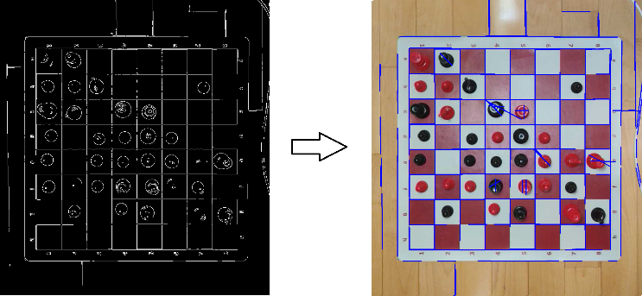

Figure 1. showcases the process used to capture the board. Through a series of Canny Edge detection and Hough Line Transformations, the original image is continually cropped to the largest rectangular object in the frame. This is done based on the intersection of extended Hough Lines.

A major reason for the use of flash in all pictures ultimately came down to the line detection. In certain environments based on the amount of natural light or where the board was located, effected the canny edge detection. So, for the sake of consistency, flash was deemed essential.

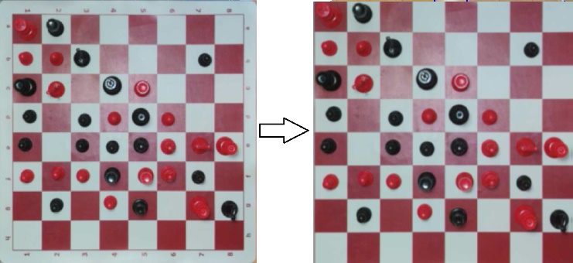

Figure 2. on the left represents the board after the first iteration of this cropping. The right represents the final product – the results of the second iteration. In between these two note the letters and numbers are lost. The orientation of the board is crucial in later steps (as it is passed through Stockfish). Thus, this program currently leaves the option to rotate the board manually.

**3. Piece Selection**

This was arguably the hardest part of the project. The neural network ultimately worked with a reasonable degree of accuracy. In order to make this easier, the chess set selected was black and red with red and white squares. Ultimately, a decision had to be made. Either there are red pieces on a red square, black pieces on black squares, or white pieces on white squares. Visually, the one that appeared the most contrasting was the red – hence the choice.

Back to the board, this program has captured and cropped to the 64 squares. The difficult question is how to processes the individual pieces. A similar approach with the squares from the Hough Line Transformation could be used, but there was a significantly simpler solution. Since the board was captured using a bird’s-eye view, the image can simply be sliced up to 64 squares.

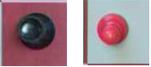

Figure 3. showcases the sliced individual pieces.

For this chess set, it was hard to discern the bishop with the pawns. Surely with more data, a better model can be formed. Yet, with the limited data it was passable.

**3.1. Data Set**

A data set of certain chess pieces could have been pulled from the internet; the issue is that the pieces are very situational. Firstly, it is not the standard white and black, but rather red and black. The board is also red and white. There are many variations of chess sets so piece recognition is near impossible. Lastly, all images that need to be classified are top-down, it should be trained by similar images.

To do so, the pieces were captured the same as above. Each board provided 64 images as part of the training dataset. Sorting these images was done manually. Ultimately a composite of around 1600 images were used to train the model.

**4. Type-style and fonts**

To achieve the best rendering both in the proceedings and from the CD-ROM, we strongly encourage you to use Times-Roman font. In addition, this will give the proceedings a more uniform look. Use a font that is no smaller than nine point type throughout the paper, including figure captions.

In nine point type font, capital letters are 2 mm high. **If you use the smallest point size, there should be no more than 3.2 lines/cm (8 lines/inch) vertically.** This is a minimum spacing; 2.75 lines/cm (7 lines/inch) will make the paper much more readable. Larger type sizes require correspondingly larger vertical spacing. Please do not double-space your paper. TrueType or Postscript Type 1 fonts are preferred.

The first paragraph in each section should not be indented, but all following paragraphs within the section should be indented as these paragraphs demonstrate.

**5. MAjor headings**

Major headings, for example, “1. Introduction”, should appear in all capital letters, bold face if possible, centered in the column, with one blank line before, and one blank line after. Use a period (“.”) after the heading number, not a colon.

**5.1. Subheadings**

Subheadings should appear in lower case (initial word capitalized) in boldface.  They should start at the left margin on a separate line.

*5.1.1. Sub-subheadings*

Sub-subheadings, as in this paragraph, are discouraged. However, if you must use them, they should appear in lower case (initial word capitalized) and start at the left margin on a separate line, with paragraph text beginning on the following line.  They should be in italics.

**6. Printing your paper**

Print your properly formatted text on high-quality, 8.5 x 11-inch white printer paper. A4 paper is also acceptable, but please leave the extra 0.5 inch (12 mm) empty at the BOTTOM of the page and follow the top and left margins as specified. If the last page of your paper is only partially filled, arrange the columns so that they are evenly balanced if possible, rather than having one long column.

**7. Page numbering**

Please do **not** paginate your paper. Page numbers, session numbers, and conference identification will be inserted when the paper is included in the proceedings.

8. Illustrations, graphs, and photographs

Illustrations must appear within the designated margins. They may span the two columns. If possible, position illustrations at the top of columns, rather than in the middle or at the bottom. Caption and number every illustration. All halftone illustrations must be clear black and white prints. If you use color, make sure that the color figures are clear when printed on a black-only printer.

**9. Footnotes**

Use footnotes sparingly (or not at all!) and place them at the bottom of the column on the page on which they are referenced. Use Times 9-point type, single-spaced. To help your readers, avoid using footnotes altogether and include necessary peripheral observations in the text (within parentheses, if you prefer, as in this sentence).

**10. Copyright forms**

You must include your fully completed, signed IEEE copyright release form when you submit your paper. We **must** have this form before your paper can be published in the proceedings.

**11. References**

List and number all bibliographical references at the end of the paper. The references can be numbered in alphabetic order or in order of appearance in the document. When referring to them in the text, type the corresponding reference number in square brackets as shown at the end of this sentence [2]. An additional final page (the fifth page, in most cases) is allowed, but must contain only references to the prior literature.

[1] A.B. Smith, C.D. Jones, and E.F. Roberts, “Article Title,” *Journal*, Publisher, Location, pp. 1-10, Date.

[2] Jones, C.D., A.B. Smith, and E.F. Roberts, *Book Title*, Publisher, Location, Date.